Table S1. Descriptives statistics of study variables at baseline in excluded and included cases and χ² or t-test for group comparisons
 | Included  (n=2,099) | Excluded  (n=184) | χ², p
Males  Females | 44.0%  56.0% | 49.5%  50.5% | 0.155
Ethnic background
Immigrant | 18.2% | 54.3%
Swedish | 81.8% | 45.7% | <0.001
Parents’ education
Primary school | 3.4% | 14.4%
Secondary school | 26.4% | 35.6%
Post-secondary school | 70.2% | 50.0% | <0.001
Traditional bullying victimization  No  Yes | 89.0%  11.0% | 82.7%  17.3% | 0.011
Cyberbullying victimization  No  Yes | 92.1%  7.9% | 86.1%  13.9% | 0.005
 | Mean (95%CI) | Mean (95%CI) | t-test, p
Age | 13.6 (13.5-13.6) | 13.7 (13.6-13.7) | 0.002
Self-perceived stress | 15.5 (15.2-15.7) | 16.7 (15.8-17.8) | 0.006
CI: Confidence interval

Table S2. Perceived stress, expressed as Mean (95% confidence interval), in traditional bullying victimization groups identified using the cutoff “2 or 3 times per month”.
Traditional bullying  victimization groups | No  (N=1974) | T1  (N=67) | T2  (N=45) | T1&T2  (N=13) | ANOVA p
Baseline (T1) | 15.2  (14.9-15.5) | 20.1ª  (18.4-21.8) | 17.3  (15.6-19.1) | 23.5ª  (18.8-28.2) | <0.001
2-year follow-up (T2) | 16.7  (16.4-17) | 19.6ª  (18-21) | 22.4ª  (21-24) | 23.4ª  (19-27.6) | <0.001
ªindicates that values in the same row did not differ significantly from each other, p < .001.

Table S3. Perceived stress, expressed as Mean (95% confidence interval), in cyberbullying victimization groups identified using the cutoff “2 or 3 times per month”.
Cyberbullying victimization groups | No  (N=2023) | T1  (N=44) | T2  (N=25) | T1&T2  (N=7) | ANOVA p
Baseline (T1) | 15.2  (15-15.4) | 23.5ª  (21.4-25.6) | 16.2  (13.6-18.8) | 28.1ª  (21.4-34.8) | <0.001
2-year follow-up (T2) | 16.8  (16.5-17.1) | 20.5ª  (18.4-22.7) | 19.3ª  (15.6-22.6) | 27ª  (20.4-33.6) | <0.001

ªindicates that values in the same row did not differ significantly from each other, p < .001.

Figure S1
Levels of perceived stress across only traditionally bullied (a) and only cyberbullied (b) group in the total sample, excluding individuals who experienced both forms of victimization.
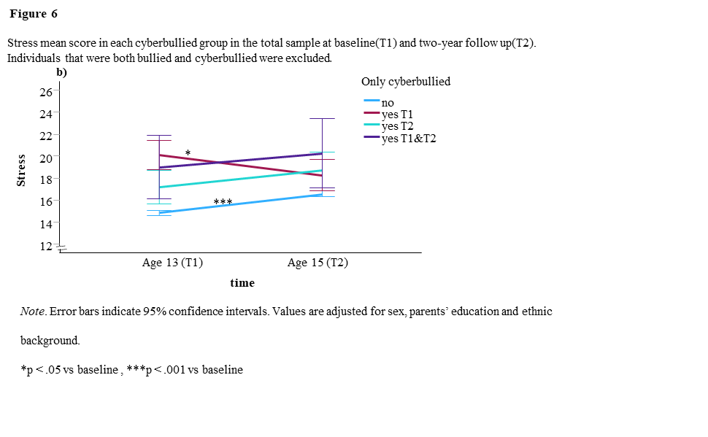
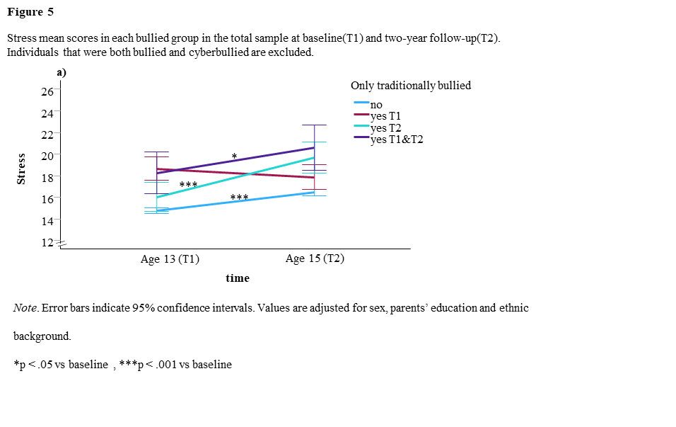
Values are adjusted for sex, parental education and immigrant background, and expressed as means with error bars showing 95% confidence intervals. *p < .05, ***p < .001 vs T1.

