Supplementary materials
Study designs of the CHARLS
The China Health and Retirement Longitudinal Study (CHARLS) was a prospective cohort study conducted in China. In wave 1, a nationally representative sample of 17,708 participants was recruited from 28 provinces in 2011 via multistage probability sampling. The primary aim of this study was to recruit participants aged ≥ 45 years, but some participants aged 40 to 44 years also attended the baseline survey. The baseline (2011) survey of CHARLS targeted community-dwelling individuals, excluding older adults residing in nursing homes. However, in subsequent follow-up surveys, baseline survey participants who had moved into nursing homes were tracked. All 17,708 participants underwent face-to-face interviews by the trained staff using the standardized questionnaire to collect data on sociodemographic information, lifestyles, and health-related information. Among 17,708 participants, 13,978 participants conducted anthropometric measurements to collect data on height, weight, waist circumference, hip circumference, blood pressure, grip strength, and so on. In addition, 11,847 participants provided blood samples for the laboratory test. Biochemical indicators, including total cholesterol, high-density lipoprotein cholesterol, low-density lipoprotein cholesterol, glycated hemoglobin, fasting blood glucose, and C-reactive protein were measured by the blood test. The follow-up surveys were conducted in 2013 (wave 2), 2015 (wave 3), and 2018 (wave 4) with questionnaire interviews and anthropometric measurements. This study includes data from the third (2015) and fourth (2018) rounds of the CHARLS survey.
Table S1. The 32 items used to construct the frailty index
Table S2. The missing rates of covariates in this analyses.
Table S3. Basic characteristics between participants included in the analysis and those lost to follow-up.
Table S4. City characteristics and sample count.
Table S5. Summary of ETEs exposure.
Table S6. Association between Cumulative ETEs exposure and change in FI without adjusting changes in lifestyle.
Table S7. Association between ΔETE exposure and change in FI without adjusting changes in lifestyle.
Figure S1. Association between ETE exposure and change in FI using data not being imputed.
Figure S2. Association of changes in frailty status with CS exposure when using another two cut-off values of FI to define frailty status.
Figure S3. Association of changes in frailty status with CS exposure when using another two cut-off values of FI to define frailty status.
Figure S4. Association between ETE exposure and change in FI after adjusting for the household income.

No | Description of the item | Cut-off value
1 | Self-reported physician diagnosed hypertension | Yes = 1, No = 0
2 | Self-reported physician diagnosed diabetes | Yes = 1, No = 0
3 | Self-reported physician diagnosed cancer | Yes = 1, No = 0
4 | Self-reported physician diagnosed heart disease | Yes = 1, No = 0
5 | Self-reported physician diagnosed stroke | Yes = 1, No = 0
6 | Self-reported physician diagnosed asthma | Yes = 1, No = 0
7 | Self-reported physician diagnosed arthritis | Yes = 1, No = 0
8 | Self-reported physician diagnosed chronic lung disease | Yes = 1, No = 0
9 | Self-reported physician diagnosed any emotional, nervous, or psychiatric problems | Yes = 1, No = 0
10 | Self-reported physician diagnosed memory-related disease | Yes = 1, No = 0
11 | Self-reported vision problems | Yes = 1, No = 0
12 | Self-reported hearing problems | Yes = 1, No = 0
13 | Self-reported general health status | Very poor or poor = 1,  Very good, good, or fair = 0
14 | Difficulty with dressing | Yes = 1, No = 0
15 | Difficulty with bathing or showering | Yes = 1, No = 0
16 | Difficulty with eating | Yes = 1, No = 0
17 | Difficulty with getting in and out of bed | Yes = 1, No = 0
18 | Difficulty with using the toilet | Yes = 1, No = 0
19 | Difficulty with managing money | Yes = 1, No = 0
20 | Difficulty with taking medication | Yes = 1, No = 0
21 | Difficulty with shopping for groceries | Yes = 1, No = 0
22 | Difficulty with preparing meals | Yes = 1, No = 0
23 | Difficulty with doing housework | Yes = 1, No = 0
24 | Mobility: difficulty with walking 100 yards or one block | Yes = 1, No = 0
25 | Mobility: difficulty with getting up from a chair after sitting for long periods | Yes = 1, No = 0
26 | Mobility: difficulty with climbing several flights of stairs without resting | Yes = 1, No = 0
27 | Mobility: difficulty with lifting or carrying weights over 10 pounds/jins | Yes = 1, No = 0
28 | Mobility: difficulty with picking up a coin from the table | Yes = 1, No = 0
29 | Mobility: difficulty with stooping, kneeling, or crouching | Yes = 1, No = 0
30 | Mobility: difficulty with reaching arms above shoulder level | Yes = 1, No = 0
31 | Depression: CESD-10 questionnaire | CESD-10 > 10 = 1, ≤10 = 0
32 | Cognition: (memory test score + orientation test score) / 14 | Continuous variable, ranging from 0 to 1
Table S1. The 32 items used to construct the frailty index.
Memory-related disease included Alzheimer’s disease, dementia, organic brain senility, and other serious memory impairment. Depression was assessed by the Center for Epidemiological Studies Depression Scale (CESD). In the CHARLS, CESD-10 was used, and the total score ranged from 0 to 30. A higher score indicated more severe depressive symptoms. The memory score was the average of words which were not recalled in the immediate and delayed word recall tasks. The memory score ranged from 0 to 10. The orientation test comprised 4 questions about the day of the week, the month, the date of the month, and the year. One point was given for each wrong answer, and the range was from 0 to 4.
Abbreviations: CHARLS, China Health and Retirement Longitudinal Study.

Table S2. The missing rates of covariates in this analyses.
Covariats | Total number | Missing number | Missing rate, %
Age | 20083 | 371 | 1.84
Sex | 20083 | 371 | 1.84
Marital status | 20083 | 374 | 1.86
Education | 20083 | 2051 | 10.21
Residence | 20083 | 371 | 1.84
Drink status | 20083 | 510 | 2.53
Smoke status | 20083 | 504 | 2.50
Wage | 20083 | 1714 | 8.53

Table S3. Basic characteristics between participants included in the analysis and those lost to follow-up.
Variable |  |  |  | Participants lost to follow-up |  | Participants included in the analysis
No. of Participants |  |  |  | 8562 |  | 4955
Demographic characteristics, n (%)
 | Age, mean ± SD, years |  |  | 61.16 ± 9.13 |  | 60.97 ± 8.82
 | Gender
 |  | Women |  | 4536 (53.0) |  | 2611 (52.7)
 |  | Men |  | 4026 (47.0) |  | 2344 (47.3)
 | Education attainment
 |  | Illiterate |  | 2187 (25.6) |  | 1190 (24.0)
 |  | Literate |  | 1559 (18.2) |  | 1001 (20.2)
 |  | Elementary school and above |  | 4813 (56.2) |  | 2762 (55.8)
 | Economic status
 |  | Low level |  | 6654 (77.7) |  | 4101 (82.8)
 |  | High level |  | 1908 (22.3) |  | 854 (17.2)
 | Residence
 |  | Rural |  | 5244 (61.2) |  | 3342 (67.4)
 |  | Urban |  | 3318 (38.8) |  | 1613 (32.6)
 | Marital status
 |  | Married |  | 7460 (87.1) |  | 4331 (87.4)
 |  | Others |  | 1102 (12.9) |  | 624 (12.6)
 | Smoking status at baseline
 |  | Never |  | 5051 (59.0) |  | 2922 (59.0)
 |  | Quit |  | 1119 (13.1) |  | 653 (13.2)
 |  | Current |  | 2392 (27.9) |  | 1380 (27.9)
 | Drinking status at baseline
 |  | Never |  | 5622 (65.7) |  | 3168 (63.9)
 |  | Less than once a month |  | 2167 (25.3) |  | 1402 (28.3)
 |  | More than once a month |  | 773 (9.0) |  | 385 (7.8)
Changes in characteristics (2018-2015)
 | Smoking status, n (%)
 |  | No change |  | 8518 (99.5) |  | 4927 (99.4)
 |  | From no to yes |  | 44 (0.5) |  | 28 (0.6)
 |  | From yes to no |  | 0 (0) |  | 0 (0)
 | Drinking status, n (%)
 |  | No change |  | 7506 (87.7) |  | 4338 (87.5)
 |  | From no to yes |  | 619 (7.2) |  | 335 (6.8)
 |  | From yes to no |  | 437 (5.1) |  | 282 (5.7)

Abbreviation: SD, standard deviation; IQR, interquartile range.
Table S4. City characteristics and sample count.
City |  |  | Sample count
City name  (Chinese) | City name  (English) | Location | Sample count
保定市 | Baoding | North China | 204
四平市 | Siping | North China | 157
济南市 | Jinan | North China | 129
信阳市 | Xinyang | North China | 115
潍坊市 | Weifang | North China | 104
阜阳市 | Fuyang | North China | 93
朝阳市 | Chaoyang | North China | 85
徐州市 | Xuzhou | North China | 77
赤峰市 | Chifeng | North China | 76
锦州市 | Jinzhou | North China | 75
承德市 | Chengde | North China | 74
运城市 | Yuncheng | North China | 74
平凉市 | Pingliang | North China | 69
张掖市 | Zhangye | North China | 69
榆林市 | Yulin | North China | 56
锡林郭勒盟 | Xilingol | North China | 43
鸡西市 | Jixi | North China | 38
本溪市 | NA | North China | 23
张家口市 | Zhangjiakou | North China | 13
松原市 | Songyuan | North China | 12
通辽市 | Tongliao | North China | 5
玉林市 | Yulin | South China | 157
邵阳市 | Shaoyang | South China | 157
楚雄彝族自治州 | Chuxiong | South China | 154
宜宾市 | Yibin | South China | 143
昭通市 | Zhaotong | South China | 109
丽水市 | Lishui | South China | 102
成都市 | Chengdu | South China | 98
襄阳市 | Xiangyang | South China | 93
赣州市 | Ganzhou | South China | 89
安阳市 | Anyang | South China | 84
扬州市 | Yangzhou | South China | 82
恩施土家族苗族自治州 | Enshi | South China | 79
河池市 | Hechi | South China | 77
绵阳市 | Mianyang | South China | 70
保山市 | Baoshan | South China | 67
汉中市 | Hanzhong | South China | 65
宜春市 | Yichun | South China | 63
常德市 | Changde | South China | 61
临沧市 | Lincang | South China | 60
长沙市 | Changsha | South China | 60
安庆市 | Anqing | South China | 57
清远市 | Qingyuan | South China | 50
福州市 | Fuzhou | South China | 50
吉安市 | Ji'an | South China | 43
盐城市 | Yancheng | South China | 43
岳阳市 | Yueyang | South China | 32
景德镇市 | Jingdezhen | South China | 29
芜湖市 | Wuhu | South China | 19
杭州市 | Hangzhou | South China | 16
河南省 | Henan Province | South China | 16
Location indicates the geographical position of each city. Sample count refers to the number of samples collected from each city. ETE day counts are reported based on the P90_4d definition (temperature greater than 90th percentile threshold with a duration of at least 4 days) and the P10_4d definition (temperature less than 10th percentile threshold with a duration of at least 4 days). Abbreviations: ETE, extreme temperature events; HW, heat wave; CS, cold spell.
Table S5. Summary of ETE exposure.
ETE Definition |  | △ ETE, mean ± SD |  | Accumulative ETE, mean ± SD
 |  | Event counts | Day counts | Event counts | Day counts
﻿Heat wave
 | 90th Pctl, ≥2d | 1.65±2.2 | 14.87±12.7 | 16.17±11.7 | 98.04±86.7
 | 90th Pctl, ≥3d | 1.15±2 | 13.88±12.8 | 11.19±9.3 | 88.07±82.7
 | 90th Pctl, ≥4d | 1.15±1.9 | 13.86±12.9 | 8.3±7.1 | 79.41±76.3
 | 92.5th Pctl, ≥2d | 1.59±2 | 11.26±11.3 | 11.57±9.9 | 66.76±68
 | 92.5th Pctl, ≥3d | 1.25±1.8 | 10.57±11.7 | 8.06±7.3 | 59.73±63.3
 | 92.5th Pctl, ≥4d | 0.95±1.4 | 9.69±11 | 6.33±5.9 | 54.55±59.8
 | 95th Pctl, ≥2d | 1.03±2 | 8.89±10.5 | 8.28±8.1 | 46.39±52.5
 | 95th Pctl, ≥3d | 0.99±1.7 | 8.8±10.2 | 6.2±6.4 | 42.23±49.6
 | 95th Pctl, ≥4d | 0.7±1.2 | 7.93±9.6 | 4.53±4.8 | 37.23±46
﻿Cold spell
 | 10th Pctl, ≥2d | 0.45±2.4 | 8.47±8.7 | 8.75±10.1 | 78.77±112.1
 | 10th Pctl, ≥3d | 0.3±1.4 | 8.18±9.3 | 6.67±8.3 | 74.62±109.1
 | 10th Pctl, ≥4d | 0.28±1.2 | 8.12±9.9 | 5.43±7.3 | 70.9±106.7
 | 7.5th Pctl, ≥2d | -0.13±1.5 | 6.11±9.7 | 6.96±10.5 | 49.2±85
 | 7.5th Pctl, ≥3d | 0.39±0.9 | 7.15±11.4 | 5.01±7.9 | 45.3±80.7
 | 7.5th Pctl, ≥4d | 0.6±1.1 | 7.76±12.2 | 4.23±7 | 42.94±78.3
 | 5th Pctl, ≥2d | 0.85±1.8 | 5.63±9.4 | 5.1±8.6 | 28.69±59.5
 | 5th Pctl, ≥3d | 0.84±1.5 | 5.6±9.5 | 3.54±6.4 | 25.57±55.8
 | 5th Pctl, ≥4d | 0.62±1.2 | 4.93±9.2 | 2.6±5.1 | 22.74±52.4
The definitions for HW and CS are based on temperature percentile thresholds and minimum durations. △ETE is reported as the difference in event counts and day counts between baseline and follow-up, encompassing both HW and CS for the 12 months preceding FI assessment, with data presented as mean±SD. Accumulative ETE is reported as the total of event counts and day counts, including both HW and CS, experienced from the baseline FI assessment until the follow-up FI assessment, with data also presented as mean±SD. Abbreviations: ETE, extreme temperature events; HW, heat wave; CS, cold spell; SD, standard deviation; Pctl, percentile.
Table S6. Association between Cumulative ETE exposure and change in FI without adjusting changes in lifestyle.
ETE Definition |  | Model 1 (Crude) |  |  |  | Model 2 (Baseline covariates)
 |  | Beta | 95%CI | P value |  | Beta | 95%CI | P value
CS days
 | 10th Pctl, ≥2d | 0.037 | (0.010,0.063) | 0.007 |  | 0.047 | (0.022,0.073) | <0.001
 | 10th Pctl, ≥3d | 0.038 | (0.011,0.065) | 0.007 |  | 0.049 | (0.023,0.076) | <0.001
 | 10th Pctl, ≥4d | 0.038 | (0.010,0.065) | 0.008 |  | 0.05 | (0.023,0.077) | <0.001
 | 7.5th Pctl, ≥2d | 0.033 | (-0.002,0.067) | 0.067 |  | 0.052 | (0.018,0.086) | 0.003
 | 7.5th Pctl, ≥3d | 0.033 | (-0.003,0.07) | 0.074 |  | 0.054 | (0.018,0.09) | 0.003
 | 7.5th Pctl, ≥4d | 0.032 | (-0.006,0.07) | 0.096 |  | 0.054 | (0.017,0.091) | 0.004
 | 5th Pctl, ≥2d | 0.024 | (-0.025,0.074) | 0.338 |  | 0.052 | (0.004,0.101) | 0.034
 | 5th Pctl, ≥3d | 0.020 | (-0.033,0.073) | 0.452 |  | 0.053 | (0.001,0.104) | 0.045
 | 5th Pctl, ≥4d | 0.021 | (-0.036,0.077) | 0.477 |  | 0.057 | (0.002,0.112) | 0.044
HW days
 | 90th Pctl, ≥2d | -0.033 | (-0.067,0.002) | 0.061 |  | -0.026 | (-0.061,0.008) | 0.138
 | 90th Pctl, ≥3d | -0.036 | (-0.071,0) | 0.051 |  | -0.028 | (-0.064,0.008) | 0.132
 | 90th Pctl, ≥4d | -0.036 | (-0.075,0.003) | 0.069 |  | -0.026 | (-0.065,0.014) | 0.203
 | 92.5th Pctl, ≥2d | -0.045 | (-0.088,-0.001) | 0.045 |  | -0.029 | (-0.074,0.015) | 0.198
 | 92.5th Pctl, ≥3d | -0.049 | (-0.095,-0.002) | 0.042 |  | -0.031 | (-0.079,0.017) | 0.208
 | 92.5th Pctl, ≥4d | -0.048 | (-0.098,0.001) | 0.056 |  | -0.03 | (-0.081,0.021) | 0.244
 | 95th Pctl, ≥2d | -0.050 | (-0.107,0.006) | 0.081 |  | -0.033 | (-0.091,0.025) | 0.262
 | 95th Pctl, ≥3d | -0.052 | (-0.112,0.007) | 0.086 |  | -0.033 | (-0.095,0.029) | 0.296
 | 95th Pctl, ≥4d | -0.059 | (-0.123,0.006) | 0.075 |  | -0.04 | (-0.107,0.027) | 0.242
CS events
 | 10th Pctl, ≥2d | 0.552 | (0.259,0.845) | <0.001 |  | 0.559 | (0.273,0.845) | <0.001
 | 10th Pctl, ≥3d | 0.726 | (0.371,1.081) | <0.001 |  | 0.761 | (0.415,1.107) | <0.001
 | 10th Pctl, ≥4d | 0.827 | (0.421,1.233) | <0.001 |  | 0.905 | (0.51,1.3) | <0.001
 | 7.5th Pctl, ≥2d | 0.403 | (0.121,0.686) | 0.005 |  | 0.493 | (0.218,0.768) | <0.001
 | 7.5th Pctl, ≥3d | 0.564 | (0.190,0.938) | 0.003 |  | 0.69 | (0.326,1.053) | <0.001
 | 7.5th Pctl, ≥4d | 0.584 | (0.161,1.007) | 0.007 |  | 0.739 | (0.328,1.151) | <0.001
 | 5th Pctl, ≥2d | 0.361 | (0.018,0.703) | 0.039 |  | 0.47 | (0.137,0.803) | 0.006
 | 5th Pctl, ≥3d | 0.381 | (-0.081,0.843) | 0.106 |  | 0.602 | (0.152,1.052) | 0.009
 | 5th Pctl, ≥4d | 0.510 | (-0.071,1.090) | 0.085 |  | 0.834 | (0.269,1.4) | 0.004
HW events
 | 90th Pctl, ≥2d | -0.169 | (-0.424,0.085) | 0.191 |  | -0.192 | (-0.444,0.059) | 0.134
 | 90th Pctl, ≥3d | -0.256 | (-0.574,0.063) | 0.116 |  | -0.264 | (-0.58,0.051) | 0.101
 | 90th Pctl, ≥4d | -0.214 | (-0.629,0.201) | 0.313 |  | -0.186 | (-0.597,0.225) | 0.375
 | 92.5th Pctl, ≥2d | -0.273 | (-0.572,0.026) | 0.074 |  | -0.236 | (-0.533,0.062) | 0.121
 | 92.5th Pctl, ≥3d | -0.401 | (-0.81,0.007) | 0.054 |  | -0.329 | (-0.737,0.078) | 0.113
 | 92.5th Pctl, ≥4d | -0.398 | (-0.902,0.106) | 0.122 |  | -0.357 | (-0.858,0.143) | 0.162
 | 95th Pctl, ≥2d | -0.335 | (-0.701,0.031) | 0.073 |  | -0.278 | (-0.645,0.089) | 0.138
 | 95th Pctl, ≥3d | -0.423 | (-0.889,0.043) | 0.076 |  | -0.322 | (-0.792,0.148) | 0.18
 | 95th Pctl, ≥4d | -0.655 | (-1.266,-0.043) | 0.036 |  | -0.601 | (-1.222,0.021) | 0.058
Adjusted Beta (95% CI) were calculated using generalized linear models and presented as multiplied by 103 to reflect the association between cumulative ETEs exposure and changes in FI, without adjusting for changes in lifestyle. Model 1 is adjusted for none. Model 2 is adjusted for baseline covariates including age, gender, educational attainment, economic status, residence, region, marital status, smoking status, drinking status and baseline FI.
Abbreviations: ETE, extreme temperature events; FI, frailty index; CI, confidence interval; HW, heat wave; CS, cold spell; Pctl, percentile.
Table S7. Association between ΔETE exposure and change in FI without adjusting changes in lifestyle.
ETE |  | Model 1 (Crude) |  |  |  | Model 2 (Baseline covariates)
 |  | Beta | 95%CI | P value |  | Beta | 95%CI | P value
CS days
 | 10th Pctl, ≥2d | 0.781 | (0.443,1.119) | <0.001 |  | 0.732 | ( 0.4 , 1.064 ) | <0.001
 | 10th Pctl, ≥3d | 0.65 | (0.33,0.97) | <0.001 |  | 0.651 | ( 0.339 , 0.963 ) | <0.001
 | 10th Pctl, ≥4d | 0.515 | (0.217,0.813) | 0.001 |  | 0.513 | ( 0.222 , 0.804 ) | 0.001
 | 7.5th Pctl, ≥2d | 0.434 | (0.127,0.74) | 0.006 |  | 0.581 | ( 0.282 , 0.879 ) | <0.001
 | 7.5th Pctl, ≥3d | 0.375 | (0.116,0.634) | 0.005 |  | 0.45 | ( 0.198 , 0.702 ) | <0.001
 | 7.5th Pctl, ≥4d | 0.383 | (0.141,0.626) | 0.002 |  | 0.452 | ( 0.216 , 0.688 ) | <0.001
 | 5th Pctl, ≥2d | 0.465 | (0.151,0.779) | 0.004 |  | 0.57 | ( 0.265 , 0.876 ) | <0.001
 | 5th Pctl, ≥3d | 0.51 | (0.199,0.82) | 0.001 |  | 0.627 | ( 0.326 , 0.929 ) | <0.001
 | 5th Pctl, ≥4d | 0.63 | (0.308,0.951) | <0.001 |  | 0.779 | ( 0.466 , 1.091 ) | <0.001
HW days
 | 90th Pctl, ≥2d | 0.051 | (-0.183,0.285) | 0.67 |  | -0.063 | ( -0.292 , 0.166 ) | 0.59
 | 90th Pctl, ≥3d | 0.012 | (-0.22,0.244) | 0.917 |  | -0.084 | ( -0.311 , 0.143 ) | 0.47
 | 90th Pctl, ≥4d | 0.04 | (-0.19,0.27) | 0.735 |  | -0.065 | ( -0.29 , 0.16 ) | 0.571
 | 92.5th Pctl, ≥2d | 0.017 | (-0.244,0.279) | 0.896 |  | -0.096 | ( -0.351 , 0.16 ) | 0.463
 | 92.5th Pctl, ≥3d | -0.004 | (-0.258,0.251) | 0.977 |  | -0.089 | ( -0.336 , 0.159 ) | 0.482
 | 92.5th Pctl, ≥4d | -0.02 | (-0.29,0.25) | 0.883 |  | -0.128 | ( -0.391 , 0.134 ) | 0.338
 | 95th Pctl, ≥2d | 0.067 | (-0.217,0.35) | 0.645 |  | -0.081 | ( -0.357 , 0.196 ) | 0.567
 | 95th Pctl, ≥3d | 0.012 | (-0.278,0.301) | 0.936 |  | -0.089 | ( -0.372 , 0.193 ) | 0.536
 | 95th Pctl, ≥4d | -0.049 | (-0.358,0.259) | 0.755 |  | -0.179 | ( -0.483 , 0.125 ) | 0.248
CS events
 | 10th Pctl, ≥2d | 0.802 | (-0.451,2.055) | 0.21 |  | 0.137 | ( -1.094 , 1.368 ) | 0.827
 | 10th Pctl, ≥3d | 1.341 | (-0.84,3.522) | 0.228 |  | 0.498 | ( -1.626 , 2.622 ) | 0.646
 | 10th Pctl, ≥4d | 0.61 | (-1.883,3.103) | 0.631 |  | -0.527 | ( -2.949 , 1.894 ) | 0.67
 | 7.5th Pctl, ≥2d | 0.61 | (-1.883,3.103) | 0.631 |  | -0.527 | ( -2.949 , 1.894 ) | 0.67
 | 7.5th Pctl, ≥3d | 0.259 | (-2.955,3.473) | 0.875 |  | -0.708 | ( -3.832 , 2.416 ) | 0.657
 | 7.5th Pctl, ≥4d | 2.232 | (-0.352,4.815) | 0.091 |  | 1.722 | ( -0.795 , 4.239 ) | 0.18
 | 5th Pctl, ≥2d | 0.985 | (-0.667,2.636) | 0.243 |  | 0.62 | ( -0.985 , 2.226 ) | 0.449
 | 5th Pctl, ≥3d | 2.638 | (0.624,4.652) | 0.01 |  | 2.405 | ( 0.445 , 4.365 ) | 0.016
 | 5th Pctl, ≥4d | 5.41 | (2.98,7.841) | <0.001 |  | 5.501 | ( 3.137 , 7.866 ) | <0.001
HW events
 | 90th Pctl, ≥2d | 1.547 | (0.175,2.918) | 0.027 |  | 0.777 | ( -0.571 , 2.126 ) | 0.259
 | 90th Pctl, ≥3d | 1.044 | (-0.445,2.532) | 0.17 |  | 0.449 | ( -1.002 , 1.901 ) | 0.544
 | 90th Pctl, ≥4d | 1.6 | (0.025,3.174) | 0.047 |  | 0.766 | ( -0.764 , 2.297 ) | 0.327
 | 92.5th Pctl, ≥2d | 1.166 | (-0.289,2.62) | 0.116 |  | 0.408 | ( -1.011 , 1.828 ) | 0.573
 | 92.5th Pctl, ≥3d | 1.076 | (-0.575,2.727) | 0.202 |  | 0.545 | ( -1.06 , 2.151 ) | 0.506
 | 92.5th Pctl, ≥4d | 1.44 | (-0.678,3.558) | 0.183 |  | 0.319 | ( -1.748 , 2.386 ) | 0.762
 | 95th Pctl, ≥2d | 1.487 | (-0.004,2.978) | 0.051 |  | 0.318 | ( -1.14 , 1.776 ) | 0.669
 | 95th Pctl, ≥3d | 0.972 | (-0.76,2.704) | 0.271 |  | 0.339 | ( -1.346 , 2.024 ) | 0.693
 | 95th Pctl, ≥4d | 0.594 | (-1.787,2.974) | 0.625 |  | -0.857 | ( -3.211 , 1.497 ) | 0.475
Adjusted Beta (95% CI) were calculated using generalized linear models and presented as multiplied by 1000 to reflect the association between ΔETE exposure and changes in FI, without adjusting for changes in lifestyle. Model 1 is adjusted for none. Model 2 is adjusted for baseline covariates including age, gender, educational attainment, economic status, residence, region, marital status, smoking status, drinking status and baseline FI.
Abbreviations: ETE, extreme temperature events; FI, frailty index; CI, confidence interval; HW, heat wave; CS, cold spell; Pctl, percentile.
Figure 1. Association between ETE exposure and change in FI using data not being imputed.
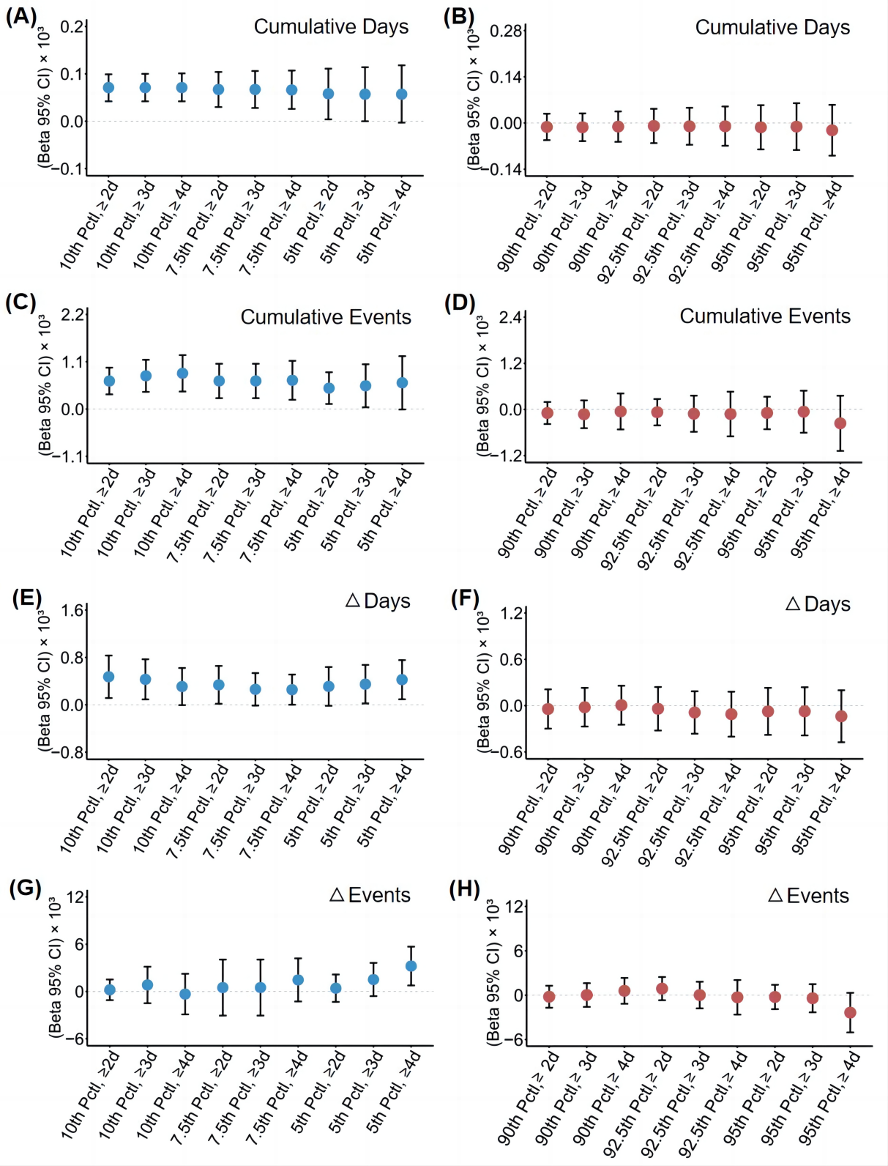
The results in this figure were based on fully intact 32-item FI data that was not imputed. Adjusted Beta coefficients with 95% confidence intervals of changes in FI for different definitions of ETEs exposure including both HW and CS using the data not being imputed. To better present the results, all beta (95% CIs) were multiplied by 10³. (A): Cumulative Days of CS and changes in FI; (B): Cumulative Days of HW and changes in FI; (C): Cumulative Events of CS and changes in FI; (D): Cumulative Events of HW and changes in FI; (E): △Days of CS and changes in FI; (F): △Days of HW and changes in FI; (G): △Events of CS and changes in FI; (H): △Events of HW and changes in FI. Model 3 was adjusted for baseline covariates including age, gender, educational attainment, economic status, residence, region, marital status, smoking status, drinking status, baseline FI and further adjusted for changes in smoking status, drinking status. Abbreviations: ETE, extreme temperature events; HW, heat wave; CS, cold spell; FI, frailty index; CI, confidence interval; Pctl, percentile.

Figure 2. Association of changes in frailty status with Cold spell exposure when using another two cut-off values of FI to define frailty status.
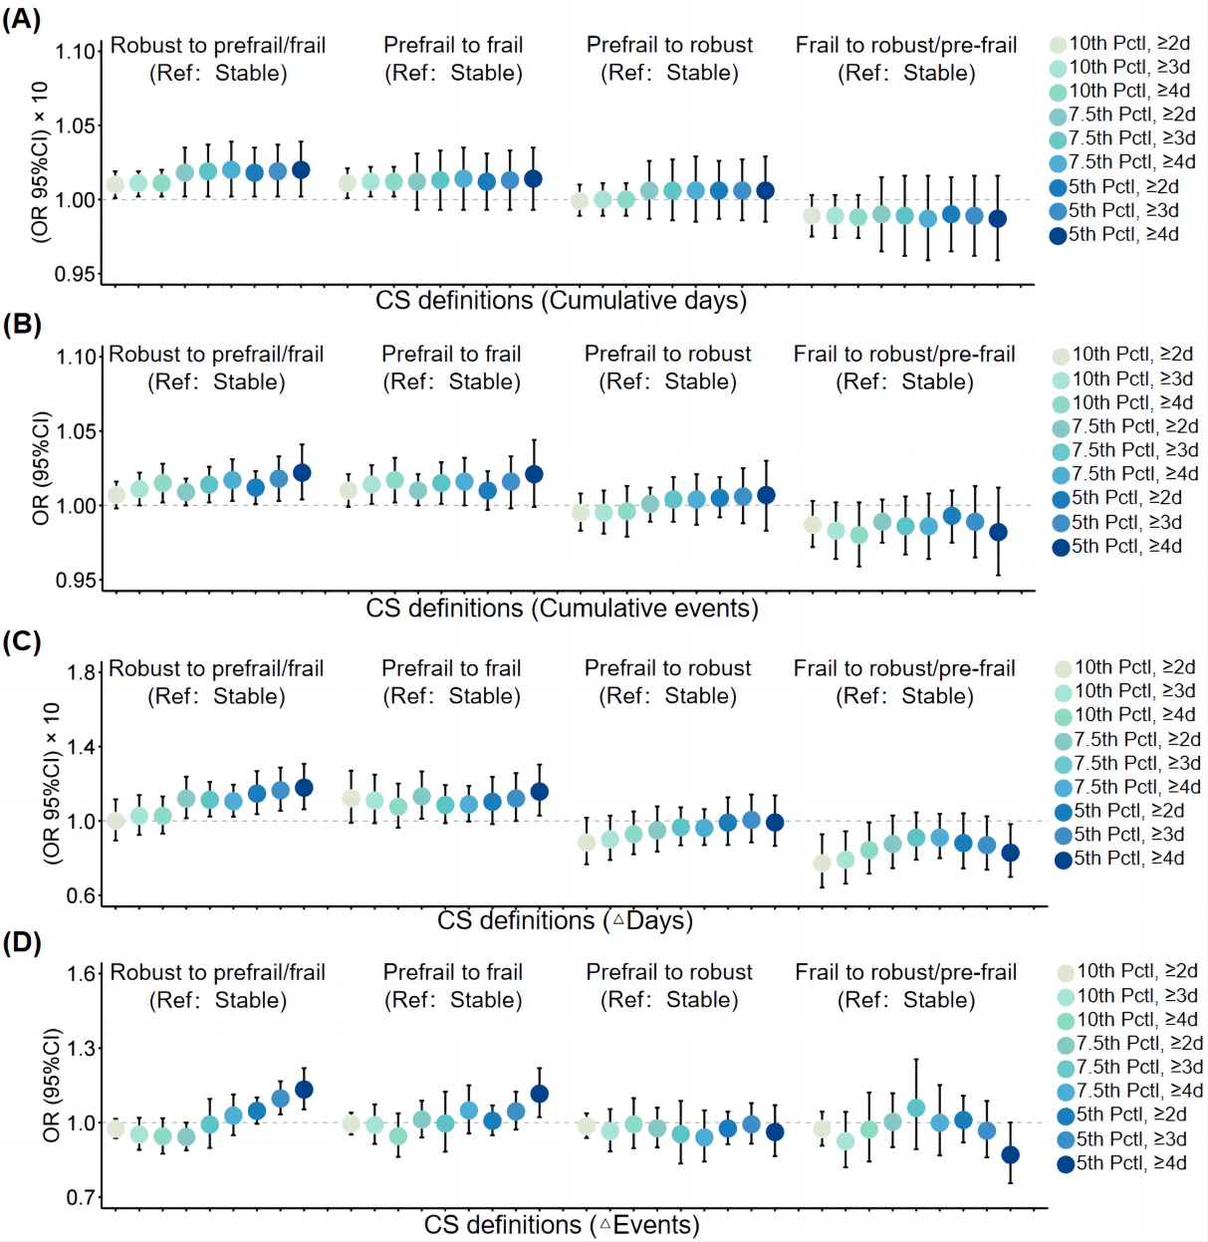

In this cut-off value, robust was defined as FI ≤0.08, pre-frail was defined as 0.08< FI <0.25, frail was defined as FI ≥0.25. To present the results more clearly, odds ratio (95% CIs) for different definitions of CS days were multiplied by 10. (A): Cumulative days of CS and changes in frailty status; (B): Cumulative events of CS and changes in frailty status; (C): △Days of CS and changes in frailty status; (D): △Events of CS and changes in frailty status. Model 3 was adjusted for baseline covariates including age, gender, educational attainment, economic status, residence, region, marital status, smoking status, drinking status and further adjusted for changes in smoking status, drinking status. Abbreviations: CS, cold spell; CI, confidence interval; Pctl, percentile.

Figure 3. Association of changes in frailty status with Cold spell exposure when using another two cut-off values of FI to define frailty status.
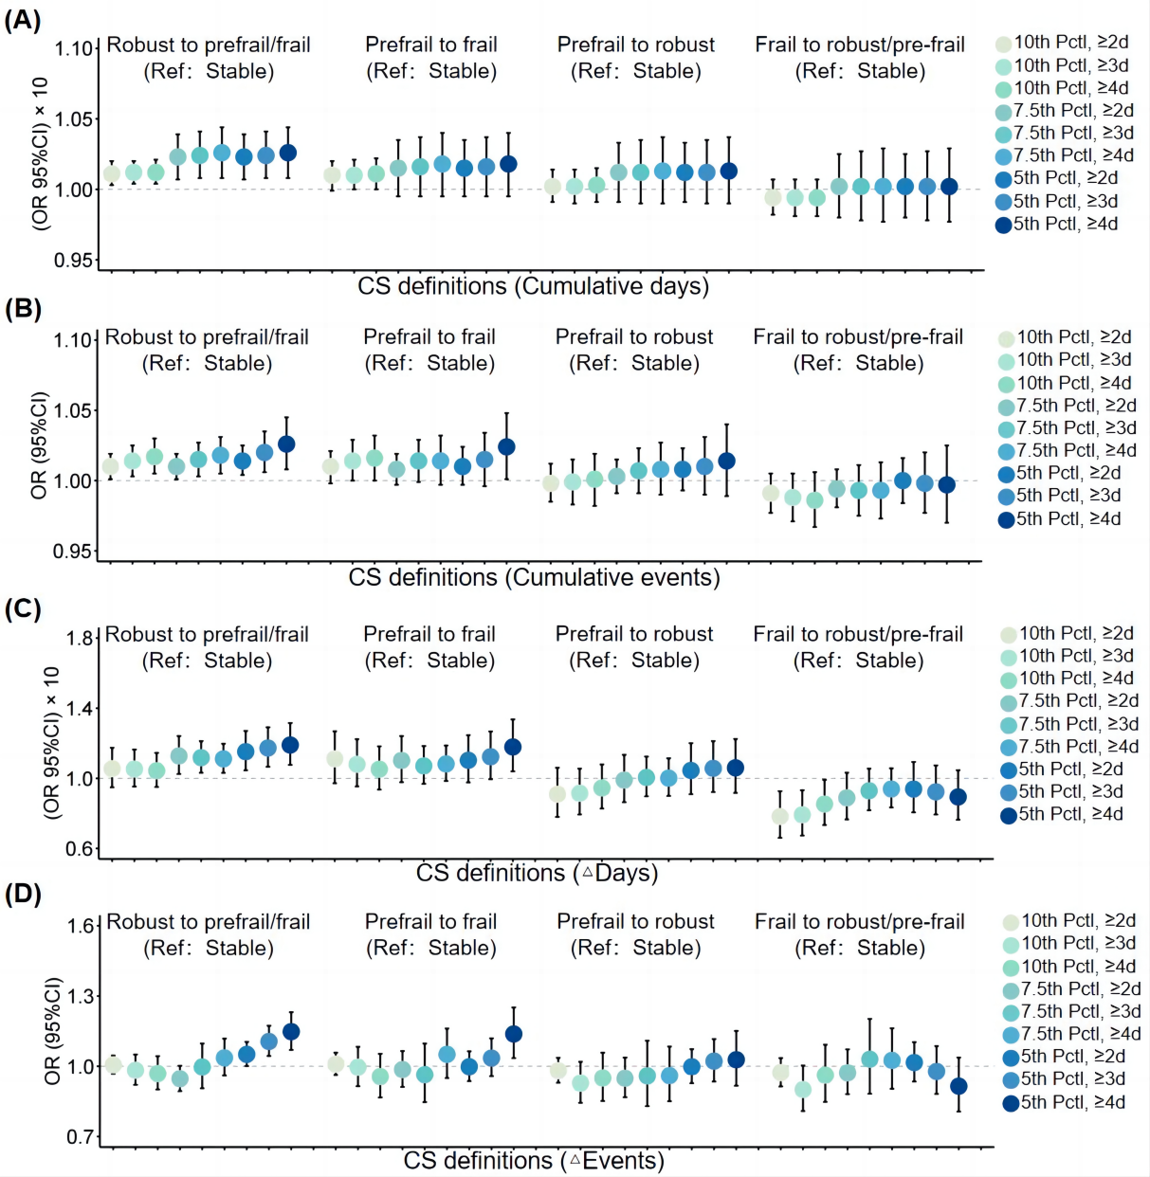
In this cut-off value, robust was defined as FI ≤0.10, pre-frail was defined as 0.10< FI ≤0.21, frail was defined as FI >0.21. To present the results more clearly, odds ratio (95% CIs) for different definitions of CS days were multiplied by 10. (A): Cumulative days of CS and changes in frailty status; (B): Cumulative events of CS and changes in frailty status; (C): △Days of CS and changes in frailty status; (D): △Events of CS and changes in frailty status. Model 3 was adjusted for baseline covariates including age, gender, educational attainment, economic status, residence, region, marital status, smoking status, drinking status and further adjusted for changes in smoking status, drinking status. Abbreviations: CS, cold spell; CI, confidence interval; Pctl, percentile.

Figure S4. Association between ETE exposure and change in FI after adjusting for the household income.
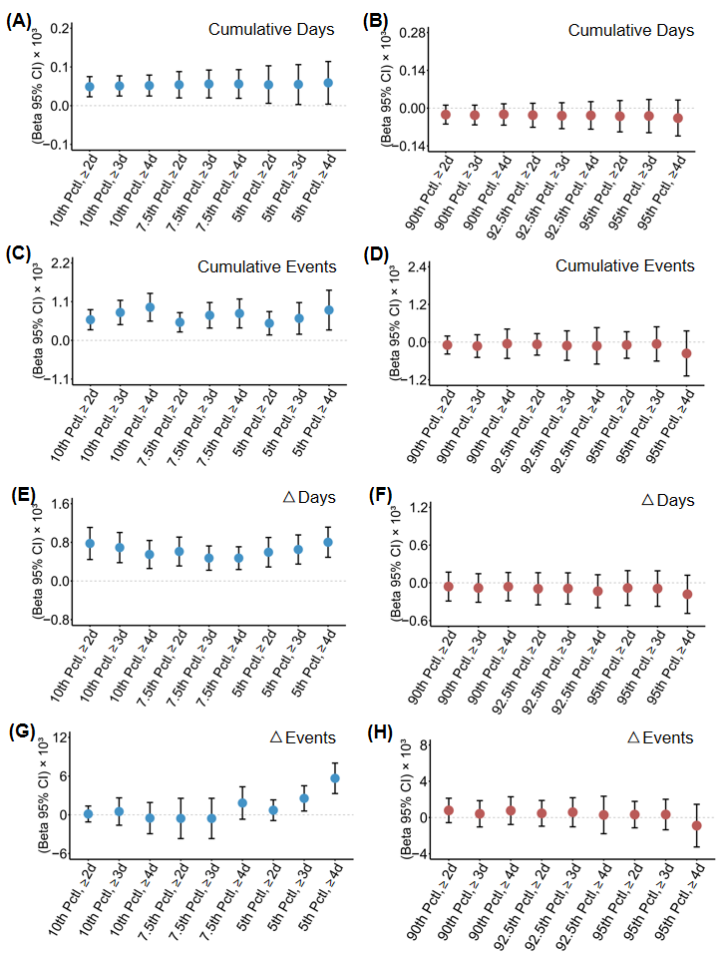
The figure shows the association between ETE exposure and changes inFI after replacing the individual wage income variable with household total income. To better present the results, all beta (95% CIs) were multiplied by 10³. (A): Cumulative Days of CS and changes in FI; (B): Cumulative Days of HW and changes in FI; (C): Cumulative Events of CS and changes in FI; (D): Cumulative Events of HW and changes in FI; (E): △Days of CS and changes in FI; (F): △Days of HW and changes in FI; (G): △Events of CS and changes in FI; (H): △Events of HW and changes in FI. Model 3 was adjusted for baseline covariates including age, gender, educational attainment, household total income, residence, region, marital status, smoking status, drinking status, baseline FI and further adjusted for changes in smoking status, drinking status. Abbreviations: ETE, extreme temperature events; HW, heat wave; CS, cold spell; FI, frailty index; CI, confidence interval; Pctl, percentile.

