Supplementary data

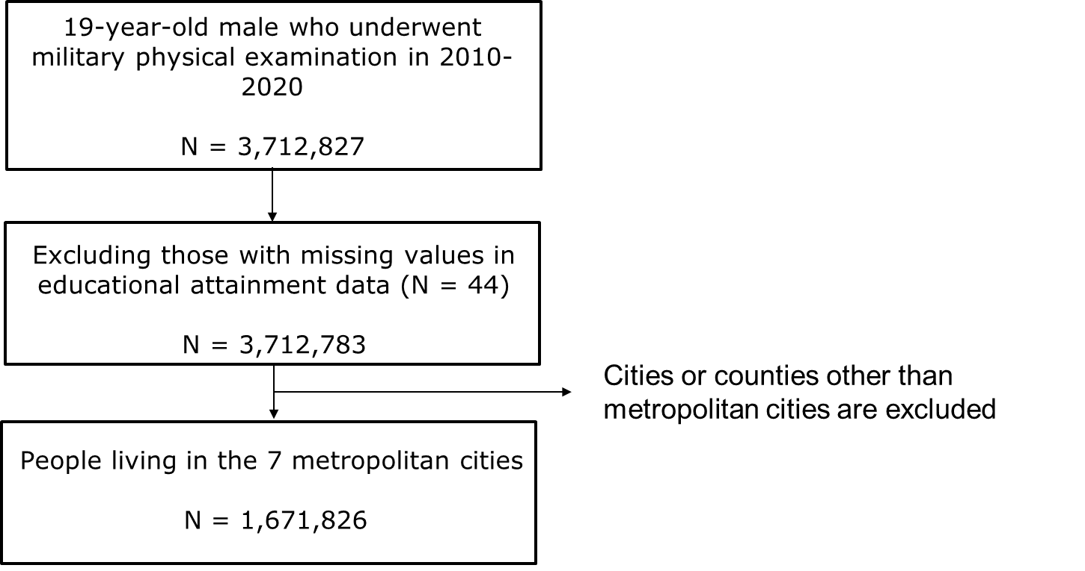
Figure S1. Flow of study population selection

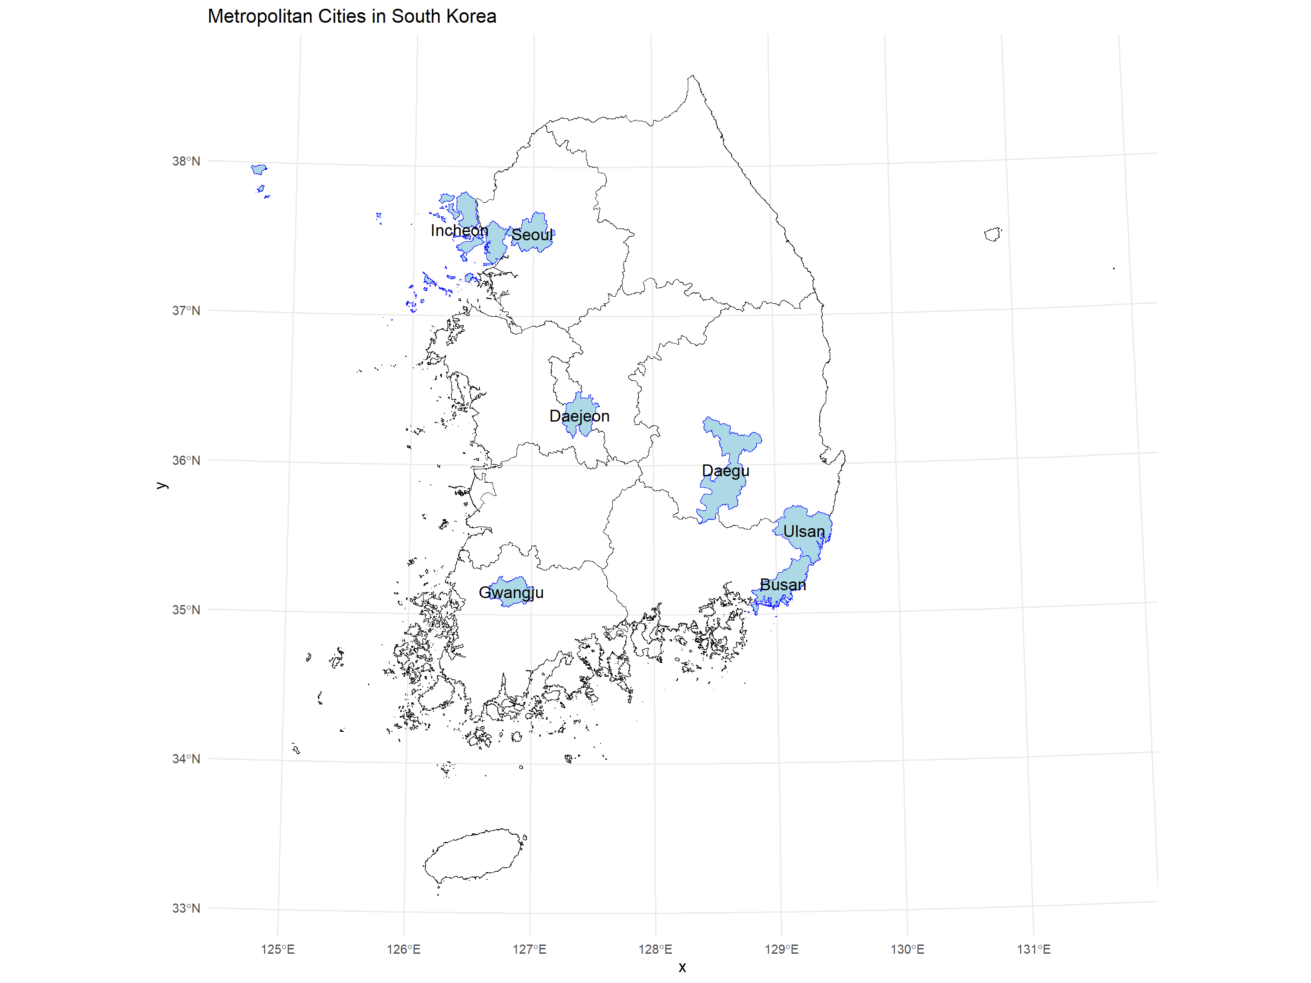
Figure S2. Map of the seven metropolitan cities included in the analysis: Seoul, Busan, Daegu, Incheon, Gwangju, Daejeon, and Ulsan

Table S1. Association Between 1-Year Average Exposure to PM and NO₂ and the Prevalence of Myopia: Continuous Exposure Models
Pollutants | Type of  Myopia | Model 1 | Model 2 | Model 3
PM₁₀ | Myopia | 0.963 (0.958–0.969) | 1.042 (1.036–1.048) | 1.007 (1.001–1.013)
PM₁₀ | Low myopia | 0.987 (0.981–0.992) | 1.058 (1.051–1.065) | 1.029 (1.022–1.036)
PM₁₀ | High myopia | 0.912 (0.905–0.919) | 1.006 (0.997–1.014) | 0.957 (0.949–0.965)
NO₂ | Myopia | 1.157 (1.150–1.164) | 1.259 (1.252–1.268) | 1.147 (1.134–1.160)
NO₂ | Low myopia | 1.138 (1.131–1.146) | 1.224 (1.215–1.232) | 1.135 (1.121–1.150)
NO₂ | High myopia | 1.199 (1.189–1.209) | 1.347 (1.335–1.359) | 1.176 (1.157–1.195)
PM_{2.5} | Myopia | 0.935 (0.929–0.942) | 0.943 (0.937–0.950) | 0.945 (0.938–0.951)
PM_{2.5} | Low myopia | 0.939 (0.932–0.946) | 0.945 (0.939–0.953) | 0.947 (0.940–0.955)
PM_{2.5} | High myopia | 0.927 (0.918–0.936) | 0.938 (0.929–0.947) | 0.939 (0.929–0.948)
* Odds ratios (ORs) and 95% confidence intervals (CIs) estimated per interquartile range (IQR) increase in pollutant concentration.
* Model 1: Unadjusted
* Model 2: Adjusted for individual covariates
* Model 3: Adjusted for individual and regional covariates.

Table S2. Association Between 1-Year Average Exposure to PM and NO₂ and the Prevalence of Myopia: Quartile-Based Exposure Models
Pollutants | Type of Myopia | Exposure Category | Model 1 | Model 2 | Model 3
PM₁₀ | Myopia | Q2 | 0.928 (0.920–0.936) | 0.958 (0.949–0.966) | 0.945 (0.937–0.954)
PM₁₀ | Myopia | Q3 | 0.913 (0.905–0.921) | 0.979 (0.970–0.989) | 0.937 (0.928–0.946)
PM₁₀ | Myopia | Q4 | 0.926 (0.917–0.935) | 1.047 (1.036–1.058) | 1.009 (0.999–1.020)
PM₁₀ | Low myopia | Q2 | 0.940 (0.931–0.949) | 0.963 (0.954–0.973) | 0.954 (0.945–0.964)
PM₁₀ | Low myopia | Q3 | 0.923 (0.914–0.931) | 0.979 (0.969–0.989) | 0.943 (0.934–0.953)
PM₁₀ | Low myopia | Q4 | 0.965 (0.955–0.975) | 1.074 (1.062–1.086) | 1.043 (1.031–1.055)
PM₁₀ | High myopia | Q2 | 0.904 (0.893–0.915) | 0.945 (0.933–0.957) | 0.925 (0.913–0.937)
PM₁₀ | High myopia | Q3 | 0.892 (0.881–0.903) | 0.982 (0.969–0.995) | 0.922 (0.910–0.934)
PM₁₀ | High myopia | Q4 | 0.842 (0.830–0.853) | 0.986 (0.971–1.001) | 0.934 (0.920–0.949)
NO₂ | Myopia | Q2 | 1.097 (1.076–1.118) | 1.088 (1.067–1.110) | 1.007 (0.982–1.032)
NO₂ | Myopia | Q3 | 1.076 (1.056–1.098) | 1.126 (1.104–1.149) | 0.975 (0.949–1.000)
NO₂ | Myopia | Q4 | 1.262 (1.238–1.287) | 1.383 (1.356–1.411) | 1.091 (1.061–1.122)
NO₂ | Low myopia | Q2 | 1.082 (1.059–1.105) | 1.074 (1.051–0.973) | 1.001 (0.974–1.028)
NO₂ | Low myopia | Q3 | 1.037 (1.015–1.059) | 1.078 (1.055–1.101) | 0.953 (0.926–0.981)
NO₂ | Low myopia | Q4 | 1.219 (1.194–1.245) | 1.318 (1.290–1.346) | 1.069 (1.037–1.102)
NO₂ | High myopia | Q2 | 1.135 (1.103–1.168) | 1.125 (1.093–1.159) | 1.021 (0.984–1.059)
NO₂ | High myopia | Q3 | 1.174 (1.141–1.208) | 1.251 (1.215–1.287) | 1.026 (0.988–1.067)
NO₂ | High myopia | Q4 | 1.368 (1.329–1.407) | 1.552 (1.507–1.597) | 1.146 (1.100–1.194)
PM_{2.5} | Myopia | Q2 | 0.981 (0.968–0.995) | 0.988 (0.974–1.001) | 1.002 (0.988–1.016)
PM_{2.5} | Myopia | Q3 | 0.958 (0.945–0.970) | 0.959 (0.947–0.972) | 0.977 (0.964–0.990)
PM_{2.5} | Myopia | Q4 | 0.886 (0.874–0.897) | 0.902 (0.890–0.914) | 0.912 (0.900–0.925)
PM_{2.5} | Low myopia | Q2 | 0.997 (0.982–1.012) | 1.002 (0.987–1.018) | 1.015 (1.000–1.031)
PM_{2.5} | Low myopia | Q3 | 0.985 (0.971–0.999) | 0.986 (0.972–1.001) | 0.999 (0.985–1.014)
PM_{2.5} | Low myopia | Q4 | 0.894 (0.881–0.907) | 0.907 (0.894–0.920) | 0.918 (0.904–0.932)
PM_{2.5} | High myopia | Q2 | 0.949 (0.931–0.967) | 0.956 (0.939–0.975) | 0.975 (0.956–0.993)
PM_{2.5} | High myopia | Q3 | 0.901 (0.884–0.918) | 0.903 (0.887–0.920) | 0.929 (0.912–0.947)
PM_{2.5} | High myopia | Q4 | 0.869 (0.853–0.885) | 0.890 (0.874–0.907) | 0.900 (0.884–0.918)
* Odds ratios (ORs) and 95% confidence intervals (CIs) comparing higher quartiles (Q2–Q4) with the lowest quartile (Q1, reference group) of pollutant exposure
* Model 1: Unadjusted
* Model 2: Adjusted for individual covariates
* Model 3: Adjusted for individual and regional covariates.
Table S3. Association Between 6-Year Average Exposure to PM₁₀ and NO₂ and the Prevalence of Myopia: Continuous Exposure Models
Pollutants | Type of  Myopia | Model 1 | Model 2 | Model 3
PM₁₀ | Myopia | 0.919 (0.915–0.924) | 1.046 (1.038–1.055) | 0.984 (0.976–0.993)
PM₁₀ | Low myopia | 0.935 (0.930–0.941) | 1.049 (1.040–1.058) | 0.999 (0.989–1.008)
PM₁₀ | High myopia | 0.884 (0.877–0.890) | 1.041 (1.029–1.053) | 0.950 (0.939–0.962)
NO₂ | Myopia | 1.154 (1.147–1.162) | 1.259 (1.251–1.268) | 1.128 (1.114–1.142)
NO₂ | Low myopia | 1.130 (1.122–1.137) | 1.216 (1.207–1.225) | 1.098 (1.084–1.113)
NO₂ | High myopia | 1.212 (1.202–1.223) | 1.366 (1.354–1.379) | 1.201 (1.180–1.222)
* Odds ratios (ORs) and 95% confidence intervals (CIs) estimated per interquartile range (IQR) increase in pollutant concentration.
* Model 1: Unadjusted
* Model 2: Adjusted for individual covariates
* Model 3: Adjusted for individual and regional covariates.

Table S4. Association Between 6-Year Average Exposure to PM₁₀ and NO₂ and the Prevalence of Myopia: Quartile-Based Exposure Models
Pollutants | Type of Myopia | Exposure Category | Model 1 | Model 2 | Model 3
PM₁₀ | Myopia | Q2 | 0.983 (0.974–0.991) | 1.052 (1.042–1.061) | 0.984 (0.974–0.993)
PM₁₀ | Myopia | Q3 | 0.872 (0.864–0.880) | 1.010 (0.998–1.021) | 0.954 (0.943–0.965)
PM₁₀ | Myopia | Q4 | 0.882 (0.874–0.890) | 1.068 (1.054–1.083) | 0.965 (0.952–0.979)
PM₁₀ | Low myopia | Q2 | 0.979 (0.970–0.989) | 1.036 (1.026–1.047) | 0.979 (0.969–0.989)
PM₁₀ | Low myopia | Q3 | 0.876 (0.868–0.885) | 0.990 (0.979–1.002) | 0.944 (0.932–0.956)
PM₁₀ | Low myopia | Q4 | 0.901 (0.892–0.910) | 1.059 (1.044–1.075) | 0.974 (0.959–0.989)
PM₁₀ | High myopia | Q2 | 0.991 (0.979–1.003) | 1.087 (1.074–1.101) | 0.995 (0.982–1.008)
PM₁₀ | High myopia | Q3 | 0.863 (0.852–0.874) | 1.055 (1.039–1.072) | 0.978 (0.963–0.994)
PM₁₀ | High myopia | Q4 | 0.839 (0.829–0.850) | 1.089 (1.068–1.110) | 0.945 (0.926–0.964)
NO₂ | Myopia | Q2 | 1.092 (1.069–1.116) | 1.064 (1.041–1.087) | 0.980 (0.954–1.007)
NO₂ | Myopia | Q3 | 1.066 (1.044–1.089) | 1.101 (1.077–1.125) | 0.952 (0.926–0.979)
NO₂ | Myopia | Q4 | 1.247 (1.221–1.274) | 1.347 (1.319–1.377) | 1.060 (1.028–1.092)
NO₂ | Low myopia | Q2 | 1.070 (1.046–1.095) | 1.045 (1.021–1.070) | 0.962 (0.934–0.991)
NO₂ | Low myopia | Q3 | 1.024 (1.001–1.048) | 1.052 (1.028–1.077) | 0.920 (0.893–0.949)
NO₂ | Low myopia | Q4 | 1.193 (1.166–1.220) | 1.272 (1.243–1.302) | 1.013 (0.980–1.046)
NO₂ | High myopia | Q2 | 1.149 (1.113–1.185) | 1.112 (1.077–1.148) | 1.026 (0.987–1.068)
NO₂ | High myopia | Q3 | 1.174 (1.137–1.211) | 1.228 (1.190–1.268) | 1.034 (0.993–1.078)
NO₂ | High myopia | Q4 | 1.387 (1.344–1.430) | 1.545 (1.497–1.595) | 1.180 (1.130–1.233)
* Odds ratios (ORs) and 95% confidence intervals (CIs) comparing higher quartiles (Q2–Q4) with the lowest quartile (Q1, reference group) of pollutant exposure
* Model 1: Unadjusted
* Model 2: Adjusted for individual covariates
* Model 3: Adjusted for individual and regional covariates.

Table S5. Association between 3-year average exposure to PM₁₀ and NO₂ and the prevalence of myopia: temporal sensitivity analysis restricted to 2018–2020: Continuous exposure models
Pollutants | Type of Myopia | Model 1 | Model 2 | Model 3
PM₁₀ | Myopia | 0.908 (0.892–0.924) | 0.957 (0.940–0.974) | 0.890 (0.873–0.907)
PM₁₀ | Low myopia | 0.907 (0.889–0.924) | 0.948 (0.930–0.966) | 0.894 (0.876–0.913)
PM₁₀ | High myopia | 0.910 (0.888–0.932) | 0.976 (0.952–1.001) | 0.880 (0.856–0.903)
NO₂ | Myopia | 1.191 (1.173–1.210) | 1.239 (1.219–1.259) | 1.177 (1.142–1.213)
NO₂ | Low myopia | 1.141 (1.122–1.161) | 1.181 (1.160–1.201) | 1.160 (1.122–1.200)
NO₂ | High myopia | 1.305 (1.278–1.334) | 1.375 (1.345–1.405) | 1.214 (1.164–1.266)
Analysis restricted to examinations conducted during 2018–2020 (N = 455,892). Odds ratios (ORs) and 95% confidence intervals (CIs) are presented per interquartile range (IQR) increase in pollutant concentration. Model 1: unadjusted. Model 2: adjusted for individual covariates. Model 3: adjusted for individual and regional covariates.
PM, particulate matter; NO₂, nitrogen dioxide

Table S6. Association between 3-year average exposure to PM₁₀ and NO₂ and the prevalence of myopia: temporal sensitivity analysis restricted to 2018–2020: Quartile-based exposure models
Pollutants | Type of Myopia | Exposure Category | Model 1 | Model 2 | Model 3
PM₁₀ | Myopia | Q2 | 0.983 (0.966–1.001) | 0.999 (0.981–1.018) | 0.969 (0.951–0.987)
PM₁₀ |  | Q3 | 0.969 (0.952–0.987) | 1.008 (0.990–1.027) | 0.949 (0.930–0.967)
PM₁₀ |  | Q4 | 0.922 (0.905–0.938) | 0.971 (0.953–0.989) | 0.918 (0.901–0.936)
PM₁₀ | Low myopia | Q2 | 0.981 (0.962–1.001) | 0.995 (0.976–1.015) | 0.972 (0.952–0.992)
PM₁₀ |  | Q3 | 0.970 (0.951–0.990) | 1.003 (0.984–1.024) | 0.957 (0.937–0.978)
PM₁₀ |  | Q4 | 0.923 (0.905–0.941) | 0.964 (0.945–0.984) | 0.923 (0.904–0.943)
PM₁₀ | High myopia | Q2 | 0.987 (0.963–1.012) | 1.008 (0.984–1.034) | 0.963 (0.939–0.988)
PM₁₀ |  | Q3 | 0.968 (0.944–0.992) | 1.020 (0.994–1.045) | 0.930 (0.906–0.955)
PM₁₀ |  | Q4 | 0.919 (0.896–0.942) | 0.984 (0.960–1.009) | 0.908 (0.884–0.932)
NO₂ | Myopia | Q2 | 1.075 (1.055–1.094) | 1.091 (1.071–1.111) | 1.073 (1.050–1.096)
NO₂ |  | Q3 | 1.066 (1.047–1.085) | 1.128 (1.107–1.148) | 1.071 (1.044–1.098)
NO₂ |  | Q4 | 1.240 (1.217–1.263) | 1.282 (1.259–1.306) | 1.183 (1.148–1.219)
NO₂ | Low myopia | Q2 | 1.047 (1.027–1.068) | 1.061 (1.040–1.082) | 1.061 (1.036–1.086)
NO₂ |  | Q3 | 1.042 (1.021–1.062) | 1.093 (1.072–1.115) | 1.074 (1.045–1.104)
NO₂ |  | Q4 | 1.176 (1.153–1.200) | 1.211 (1.187–1.235) | 1.164 (1.127–1.202)
NO₂ | High myopia | Q2 | 1.138 (1.109–1.167) | 1.160 (1.131–1.190) | 1.100 (1.067–1.133)
NO₂ |  | Q3 | 1.122 (1.094–1.151) | 1.209 (1.179–1.240) | 1.063 (1.026–1.102)
NO₂ |  | Q4 | 1.389 (1.354–1.424) | 1.453 (1.417–1.490) | 1.223 (1.175–1.275)
Analysis restricted to examinations conducted during 2018–2020 (N = 455,892). Odds ratios (ORs) and 95% confidence intervals (CIs) comparing higher quartiles (Q2–Q4) with the lowest quartile (Q1, reference group). Model 1: unadjusted. Model 2: adjusted for individual covariates. Model 3: adjusted for individual and regional covariates.
PM, particulate matter; NO₂, nitrogen dioxide

