Supplementary Materials for “The Effect of Retirement Experiences on Depression and Life Satisfaction in the Older Adults: Roles of Social Participation and Grandparental Childcare”

Competing/Alternative Model Testing
We specified and tested a reverse-path model as a competing explanation (i.e., social participation → positive/negative retirement experiences → depression/life satisfaction) and compared its fit with that of the proposed model. The model fit results showed that our theoretical model exhibited superior fit indices across multiple criteria relative to the reverse model.
The alternative model results showed that the model fit was not very good [χ²/df = 2.33, CFI = 0.953, TLI = 0.824, RMSEA (90% CI) = 0.067 (0.027–0.107), SRMR = 0.043]. Figure S1 presented the path results of the alternative mediation model for retired older adults. The results showed that, after controlling for gender, age, monthly income and physical health status, social participation only had a significant positive predictive effect on life satisfaction (β = 0.16, p < 0.05) but did not significantly predict depression. Social participation positively predicted positive retirement experiences (β = 0.34, p < 0.001) and negative retirement experiences (β = 0.11, p < 0.05). Positive retirement experiences directly and negatively predicted depression (β = -0.17, p < 0.01) and positively predicted life satisfaction (β = 0.44, p < 0.001). Similarly, negative retirement experiences not only directly and positively predicted depression (β = 0.31, p < 0.001) but also negatively predicted life satisfaction (β = -0.16, p < 0.01). These results suggest that positive and negative retirement experiences play significant mediating roles in the relationship between social participation and life satisfaction.
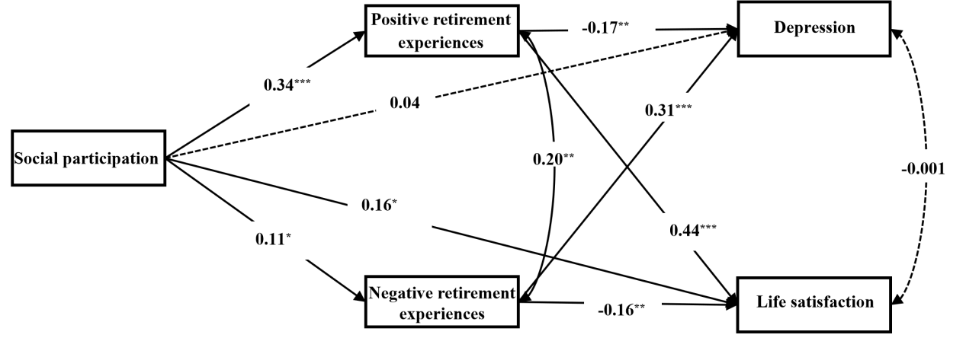
Figure S1 The Mediating Model of Retirement Experiences, Social Participation, and Depression and Life Satisfaction in Retired Older Adults (Alternative Model)

