Supplementary Figure 1. Flowchart for the unweighted analytic sample – Michigan COVID-19 Recovery Surveillance Study (MI CReSS) – 2020-2025.
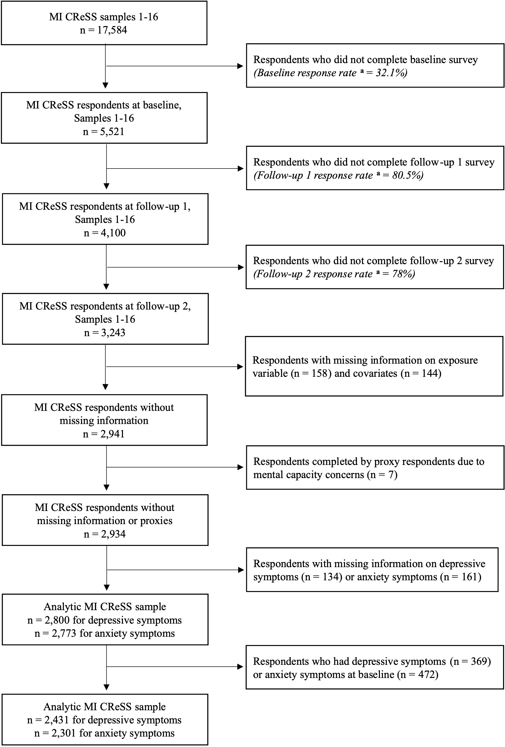
ª The numerator of the response rate includes both partial and complete surveys.
Supplementary Table 1. Weighted prevalence of Long COVID by sociodemographic and clinical factors, Michigan COVID-19 Recovery Surveillance Study, 2020-2025
 | Analytic sample for depressive symptoms  (n = 2,431) |  | Analytic sample for anxiety symptoms  (n = 2,301)
 | Long COVID |  | Long COVID
 | Weighted % (95% CI) | p-value | Weighted % (95% CI) | p-value
Depressive symptoms at follow-up 2 |  | <0.001
Yes | 27.1 (20.9 – 34.2)
No | 12.9 (11.5 – 14.5)
Anxiety symptoms at follow-up 2 |  |  |  | <0.001
Yes |  |  | 23.5 (18.1 – 29.9)
No |  |  | 13.1 (11.6 – 14.8)
Age |  | <0.001 |  | <0.001
18–34 | 7.4 (5.5 – 9.8) |  | 8.2 (6.1 – 11.0)
35–54 | 15.2 (12.8 – 18.0) |  | 13.9 (11.5 – 16.7)
55–64 | 22.7 (18.8 – 27.2) |  | 22.3 (18.4 – 26.8)
≥ 65 | 18.3 (14.6 – 22.7) |  | 19.1 (15.2 – 23.6)
Sex |  | <0.001 |  | 0.007
Male | 10.7 (8.8 – 13.0) |  | 11.9 (9.8 – 14.4)
Female | 17.2 (15.2 – 19.4) |  | 16.3 (14.3 – 18.6)
Race and ethnicity |  | 0.157 |  | 0.001
Hispanic | 19.4 (12.7 – 28.5) |  | 25.9 (18.0 – 35.8)
NH White | 13.6 (12.0 – 15.4) |  | 12.7 (11.2 – 14.5)
NH Black | 17.1 (12.7 – 22.7) |  | 18.6 (13.8 – 24.6)
Another NH race or ethnicity | 11.9 (8.1 – 17.1) |  | 12.4 (8.4 – 18.0)
Marital status |  | 0.626 |  | 0.824
Married/cohabiting | 13.6 (11.3 – 16.3) |  | 14.0 (12.2 – 16.1)
Not married/cohabiting | 14.4 (12.6 – 16.4) |  | 14.4 (11.9 – 17.3)
Education |  | <0.001 |  | <0.001
High school or less | 16.8 (13.4 – 20.9) |  | 18.(15.1 – 23.2)
Some college | 17.2 (14.5 – 20.2) |  | 16.3 (13.6 – 19.5)
College graduate | 10.5 (8.8 – 12.5) |  | 10.2 (8.5 – 12.2)
Household income |  | 0.002 |  | <0.001
< $35,000 | 16.9 (13.8 – 20.5) |  | 18.0 (14.7 – 22.0)
$35,000–74,999 | 16.3 (13.7 – 19.4) |  | 16.5 (13.7 – 19.6)
≥ $75,000 | 11.0 (9.2 – 13.1) |  | 10.3 (8.5 – 12.5)
Health insurance |  | 0.510 |  | 0.484
Private insurance | 14.1 (12.5 – 15.9) |  | 13.7 (12.1 – 15.6)
Medicare/Medicaid/another type | 15.3 (12.2 – 19.1) |  | 16.2 (12.8 – 20.2)
None | 11.0 (6.2 – 18.9) |  | 12.9 (7.7 – 20.7)
Pre-existing physical conditions |  | <0.001 |  | <0.001
Yes | 19.0 (16.7 – 21.5) |  | 19.3 (16.9 – 21.9)
No | 9.7 (8.0 – 11.6) |  | 9.4 (7.7 – 11.5)
Pre-existing psychiatric or psychological conditions |  | 0.002 |  | 0.089
Yes | 21.1 (16.2 – 27.2) |  | 18.6 (13.3 – 25.3)
No | 13.3 (11.9 – 15.0) |  | 13.7 (12.2 – 15.4)
Hospitalized for COVID-19 |  | <0.001 |  | <0.001
Yes | 44.4 (36.9 – 52.2) |  | 46.4 (38.8 – 54.2)
No | 11.4 (10.0 – 12.9) |  | 11.1 (9.7 – 12.7)
Rurality |  | <0.001 |  | <0.001
Metropolitan | 12.5 (11.0 – 14.2) |  | 12.8 (11.2 – 14.5)
Nonmetropolitan | 23.0 (18.9 – 27.7) |  | 22.0 (17.9 – 26.8)
COVID-19 phase |  | <0.001 |  | <0.001
03/2020–09/2020 | 19.5 (16.3 – 23.1) |  | 19.6 (16.4 – 23.3)
10/2020–02/2021 | 17.9 (14.6 – 21.9) |  | 17.0 (13.5 – 21.1)
03/2021–09/2021 | 12.1 (9.3 – 15.5) |  | 12.3 (9.4 – 16.1)
10/2021–05/2022 | 8.9 (7.0 – 11.4) |  | 8.9 (6.9 – 11.4)
Abbreviations: COVID-19=coronavirus disease 2019, NH=non-Hispanic
Notes: We excluded adults who reported depressive symptoms at baseline in the analysis for depressive symptoms. In the analysis for anxiety symptoms, we excluded adults who reported anxiety symptoms at baseline.

