Supplemental Table S1. Comparison of the sociodemographic characteristics of the Adolescent Brain Cognitive Development (ABCD) Study participants included vs. excluded in the analysis
Sociodemographic characteristics | Included  (n = 4,443) | Excluded  (n = 7,519) | p
Age (years) (mean, 95% CI) | 11.9 (11.93, 11.98) | 12.0 (11.99, 12.02) | <0.001
Sex (%) |  |  | 0.310
Female | 48.50% | 47.50%
Male | 51.50% | 52.50%
Race and ethnicity (%) |  |  | <0.001
Asian | 5.60% | 6.20%
Black | 14.50% | 23.70%
Latino/Hispanic | 14.20% | 19.00%
Native American | 3.70% | 3.30%
Other | 0.70% | 1.10%
White | 61.20% | 46.80%
Household income (%) |  |  | <0.001
Less than $75,000 | 65.60% | 59.40%
$75,000 or more | 34.40% | 40.60%
Parent's marital status (%) |  |  | <0.001
Parent married/partnered | 78.50% | 71.70%
Parent not married/unpartnered | 21.50% | 28.30%
Parent's highest education (%) |  |  | <0.001
High school education or less | 8.80% | 17.10%
College education or more | 91.20% | 82.90%
CI = confidence interval. Note: Excluded participants were missing screen time data, step count data, Year 4 cardiovascular disease risk outcomes, or Year 2 sociodemographic covariates.

Supplemental Table S2. Associations between Year 2 screen time and step count categories and Year 4 cardiovascular disease (CVD) risk outcomes in the Adolescent Brain Cognitive Development (ABCD) Study participants, including adjustment for respective CVD outcomes at Year 2
Screen time (hrs/day) | B (95% CI) | p | Steps/day | B (95% CI) | p
Systolic blood pressure percentile (n = 2,029)
Low (0-4) | Reference |  | High (>12,000) | Reference
Medium (4-8) | -0.51 (-3.22 to 2.19) | 0.710 | Medium (6,000-12,000) | -1.51 (-5.24 to 2.22) | 0.427
High (>8) | 0.81 (-2.32 to 3.94) | 0.612 | Low (1,000-6,000) | -0.83 (-5.40 to 3.73) | 0.720
Diastolic blood pressure percentile (n = 2,029)
Low (0-4) | Reference |  | High (>12,000) | Reference
Medium (4-8) | 2.06 (-0.61 to 4.72) | 0.130 | Medium (6,000-12,000) | 1.97 (0.44 to 4.39) | 0.028
High (>8) | 2.16 (-0.92 to 5.24) | 0.036 | Low (1,000-6,000) | 6.75 (3.62 to 9.22) | 0.003
Hemoglobin A1c (%) (n = 238)
Low (0-4) | Reference |  | High (>12,000) | Reference
Medium (4-8) | 0.01 (-0.07 to 0.08) | 0.545 | Medium (6,000-12,000) | 0.02 (-0.05 to 0.09) | 0.514
High (>8) | -0.08 (-0.16 to 0.003) | 0.331 | Low (1,000-6,000) | 0.06 (-0.02 to 0.14) | 0.161
Total cholesterol (mg/dL) (n = 241)
Low (0-4) | Reference |  | High (>12,000) | Reference
Medium (4-8) | -0.54 (-8.04 to 6.97) | 0.888 | Medium (6,000-12,000) | -2.52 (-13.64 to 8.61) | 0.657
High (>8) | 0.89 (-7.37 to 9.14) | 0.833 | Low (1,000-6,000) | -2.29 (-15.19 to 10.62) | 0.727
HDL cholesterol (mg/dL) (n = 272)
Low (0-4) | Reference |  | High (>12,000) | Reference
Medium (4-8) | 0.71 (-2.02 to 3.45) | 0.608 | Medium (6,000-12,000) | -4.11 (-6.21 to -2.01) | 0.050
High (>8) | -0.23 (-3.34 to 2.88) | 0.885 | Low (1,000-6,000) | -4.27 (-7.21 to -3.01) | 0.036
Non-HDL cholesterol (mg/dL) (n = 241)
Low (0-4) | Reference |  | High (>12,000) | Reference
Medium (4-8) | 0.71 (-2.02 to 3.45) | 0.112 | Medium (6,000-12,000) | 3.96 (1.76 to 4.24) | 0.050
High (>8) | 1.23 (0.96 to 2.88) | 0.002 | Low (1,000-6,000) | 4.72 (3.43 to 5.98) | 0.020
All models include screen time and physical activity (step count) as the joint independent variables and were adjusted for Year 2 age, sex, race/ethnicity, household income, parental educational level, parental marital status, calendar month, data collection period (i.e., before or during the COVID-19), and respective Year 2 blood pressure, hemoglobin A1c, or cholesterol values. Participants with a prior diagnosis of diabetes were excluded from the analysis of hemoglobin A1c and participants on hypertension medications were excluded from analyses of systolic and diastolic blood pressure. Bold indicates statistical significance at p<0.05.

Supplemental Table S3. Associations between self-reported total recreational screen time and step count categories and cardiovascular disease (CVD) risk outcomes in the Adolescent Brain Cognitive Development (ABCD) Study, including adjustment for body mass index (BMI) percentile
Screen time (hrs/day) | B (95% CI) | p | Steps/day | B (95% CI) | p
Systolic blood pressure percentile
Low (0-4) | Reference |  | High (>12,000) | Reference
Medium (4-8) | -1.04 (-2.97 to 0.90) | 0.294 | Medium (6,000-12,000) | 1.97 (-0.45 to 2.52) | 0.121
High (>8) | 1.04 (-1.15 to 3.23) | 0.353 | Low (1,000-6,000) | 2.84 (-0.93 to 4.75) | 0.098
Diastolic blood pressure percentile
Low (0-4) | Reference |  | High (>12,000) | Reference
Medium (4-8) | 1.96 (-0.28 to 3.49) | 0.096 | Medium (6,000-12,000) | 1.97 (0.44 to 4.39) | 0.011
High (>8) | 3.20 (0.54 to 4.80) | 0.014 | Low (1,000-6,000) | 5.93 (4.93 to 7.94) | <0.001
Hemoglobin A1c (%)
Low (0-4) | Reference |  | High (>12,000) | Reference
Medium (4-8) | -0.017 (-0.07 to 0.04) | 0.545 | Medium (6,000-12,000) | 0.02 (-0.05 to 0.091) | 0.514
High (>8) | -0.031 (-0.09 to 0.03) | 0.331 | Low (1,000-6,000) | 0.06 (-0.024 to 0.14) | 0.161
Total cholesterol (mg/dL)
Low (0-4) | Reference |  | High (>12,000) | Reference
Medium (4-8) | -3.96 (-8.55 to 0.63) | 0.091 | Medium (6,000-12,000) | -0.90 (-2.88 to 2.43) | 0.098
High (>8) | -3.74 (-9.06 to 1.58) | 0.168 | Low (1,000-6,000) | 0.94 (-0.28 to 3.17) | 0.121
HDL cholesterol (mg/dL)
Low (0-4) | Reference |  | High (>12,000) | Reference
Medium (4-8) | -0.32 (-2.18 to 1.53) | 0.732 | Medium (6,000-12,000) | -1.66 (-3.75 to -0.07) | 0.005
High (>8) | -2.31 (-3.47 to 0.84) | 0.232 | Low (1,000-6,000) | -3.14 (-6.23 to -0.23) | 0.035
Non-HDL cholesterol (mg/dL)
Low (0-4) | Reference |  | High (>12,000) | Reference
Medium (4-8) | 0.82 (-1.08 to 1.53) | 0.067 | Medium (6,000-12,000) | -0.86 (-2.75 to 0.87) | 0.089
High (>8) | 2.42 (-0.47 to 3.40) | 0.145 | Low (1,000-6,000) | 4.74 (-0.23 to 6.23) | 0.047
All models include screen time and physical activity (step count) as the joint independent variables and were adjusted for Year 2 age, sex, race/ethnicity, BMI percentile, household income, parental educational level, parental marital status, calendar month, and data collection period (i.e., before or during the COVID-19). Participants with a prior diagnosis of diabetes were excluded from the analysis of hemoglobin A1c and participants on hypertension medications were excluded from analyses of systolic and diastolic blood pressure. Bold indicates statistical significance at p<0.05.

Supplemental Table S4. Associations between self-reported total recreational screen time and step count categories and cardiovascular disease (CVD) risk outcomes in the Adolescent Brain Cognitive Development (ABCD) Study, including adjustment for waist circumference percentile
Screen time (hrs/day) | B (95% CI) | p | Steps/day | B (95% CI) | p
Systolic blood pressure percentile
Low (0-4) | Reference |  | High (>12,000) | Reference
Medium (4-8) | -0.95 (-2.80 to 0.90) | 0.312 | Medium (6,000-12,000) | -1.85 (-2.40 to 0.42) | 0.129
High (>8) | 0.98 (-1.10 to 3.15) | 0.364 | Low (1,000-6,000) | -2.70 (-3.20 to 0.88) | 0.102
Diastolic blood pressure percentile
Low (0-4) | Reference |  | High (>12,000) | Reference
Medium (4-8) | 1.85 (-0.40 to 3.42) | 0.101 | Medium (6,000-12,000) | 2.88 (0.40 to 4.35) | 0.012
High (>8) | 3.05 (0.46 to 4.72) | 0.016 | Low (1,000-6,000) | 5.68 (2.80 to 8.76) | <0.001
Hemoglobin A1c (%)
Low (0-4) | Reference |  | High (>12,000) | Reference
Medium (4-8) | -0.016 (-0.068 to 0.036) | 0.561 | Medium (6,000-12,000) | 0.021 (-0.045 to 0.088) | 0.524
High (>8) | -0.030 (-0.090 to 0.031) | 0.334 | Low (1,000-6,000) | 0.058 (-0.026 to 0.139) | 0.164
Total cholesterol (mg/dL)
Low (0-4) | Reference |  | High (>12,000) | Reference
Medium (4-8) | -3.82 (-8.41 to 0.77) | 0.102 | Medium (6,000-12,000) | -0.85 (-6.72 to 2.48) | 0.110
High (>8) | -3.60 (-8.90 to 1.71) | 0.179 | Low (1,000-6,000) | 0.92 (-0.31 to 3.09) | 0.125
HDL cholesterol (mg/dL)
Low (0-4) | Reference |  | High (>12,000) | Reference
Medium (4-8) | -0.28 (-2.10 to 1.51) | 0.751 | Medium (6,000-12,000) | -1.60 (-3.70 to -0.05) | 0.041
High (>8) | -2.25 (-3.45 to 0.78) | 0.240 | Low (1,000-6,000) | -3.05 (-6.10 to -0.20) | 0.038
Non-HDL cholesterol (mg/dL)
Low (0-4) | Reference |  | High (>12,000) | Reference
Medium (4-8) | 0.75 (-1.00 to 1.48) | 0.071 | Medium (6,000-12,000) | -0.82 (-2.60 to 0.85) | 0.094
High (>8) | 2.35 (-0.50 to 3.25) | 0.153 | Low (1,000-6,000) | 4.58 (-0.18 to 6.10) | 0.049
All models include screen time and physical activity (step count) as the joint independent variables and were adjusted for Year 2 age, sex, race/ethnicity, waist circumference percentile, household income, parental educational level, parental marital status, calendar month, data collection period (i.e., before or during the COVID-19), and calendar month. Participants with a prior diagnosis of diabetes were excluded from the analysis of hemoglobin A1c and participants on hypertension medications were excluded from analyses of systolic and diastolic blood pressure. Bold indicates statistical significance at p<0.05.

Supplemental Table S5. Unadjusted associations between self-reported total recreational screen time and step count categories and cardiovascular disease (CVD) risk outcomes in the Adolescent Brain Cognitive Development (ABCD) Study
Screen time (hrs/day) | B (95% CI) | p | Steps/day | B (95% CI) | p
Systolic blood pressure percentile
Low (0-4) | Reference |  | High (>12,000) | Reference
Medium (4-8) | 0.42 (-1.85, 2.69) | 0.715 | Medium (6,000-12,000) | 1.65 (-0.15, 3.45) | 0.072
High (>8) | 1.68 (-0.89, 4.25) | 0.198 | Low (1,000-6,000) | 3.28 (0.95, 5.61) | 0.006
Diastolic blood pressure percentile
Low (0-4) | Reference |  | High (>12,000) | Reference
Medium (4-8) | 3.45 (1.35, 5.55) | 0.001 | Medium (6,000-12,000) | 3.82 (1.85, 5.79) | <0.001
High (>8) | 5.82 (3.15, 8.49) | <0.001 | Low (1,000-6,000) | 8.45 (5.92, 10.98) | <0.001
Hemoglobin A1c (%)
Low (0-4) | Reference |  | High (>12,000) | Reference
Medium (4-8) | -0.01 (-0.06, 0.04) | 0.635 | Medium (6,000-12,000) | 0.02 (-0.04, 0.07) | 0.525
High (>8) | -0.02 (-0.08, 0.04) | 0.558 | Low (1,000-6,000) | 0.04 (-0.03, 0.11) | 0.238
Total cholesterol (mg/dL)
Low (0-4) | Reference |  | High (>12,000) | Reference
Medium (4-8) | 0.01 (0.03, 1.12) | 0.258 | Medium (6,000-12,000) | 0.65 (0.25, 3.95) | 0.818
High (>8) | 1.42 (0.85, 1.92) | 0.405 | Low (1,000-6,000) | 0.98 (0.82, 4.18) | 0.835
HDL cholesterol (mg/dL)
Low (0-4) | Reference |  | High (>12,000) | Reference
Medium (4-8) | 0.28 (0.20, 1.79) | 0.788 | Medium (6,000-12,000) | -4.15 (-4.90, 0.05) | 0.056
High (>8) | 1.58 (0.15, 2.39) | 0.228 | Low (1,000-6,000) | -6.28 (-7.25, -5.31) | 0.005
Non-HDL cholesterol (mg/dL)
Low (0-4) | Reference |  | High (>12,000) | Reference
Medium (4-8) | 0.58 (-3.25, 4.41) | 0.765 | Medium (6,000-12,000) | 0.72 (0.25, 2.81) | 0.685
High (>8) | 2.15 (-2.18, 6.48) | 0.328 | Low (1,000-6,000) | 8.85 (7.52, 9.82) | 0.044
All models include screen time and physical activity (step count) as the joint independent variables. The continuous step count is for 1,000 steps per day. Participants with a prior diagnosis of diabetes were excluded from the analysis of hemoglobin A1c and participants on hypertension medications were excluded from analyses of systolic and diastolic blood pressure. Bold indicates statistical significance at p<0.05.

Supplemental Figure Captions
Supplemental Figure S1
Title: Flow diagram of participant inclusion criteria
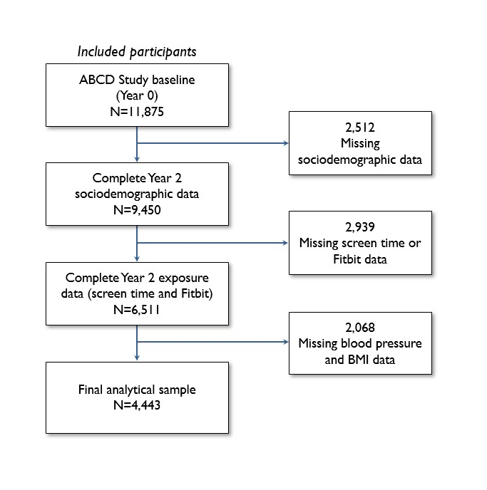

Supplemental Figure S2.
Title: Associations between self-reported screen time and step count category combinations at Year 2 and diastolic blood pressure percentile at Year 4 in 4,443 participants of the Adolescent Brain Cognitive Development (ABCD) Study, including adjustment for body mass index (BMI) percentile
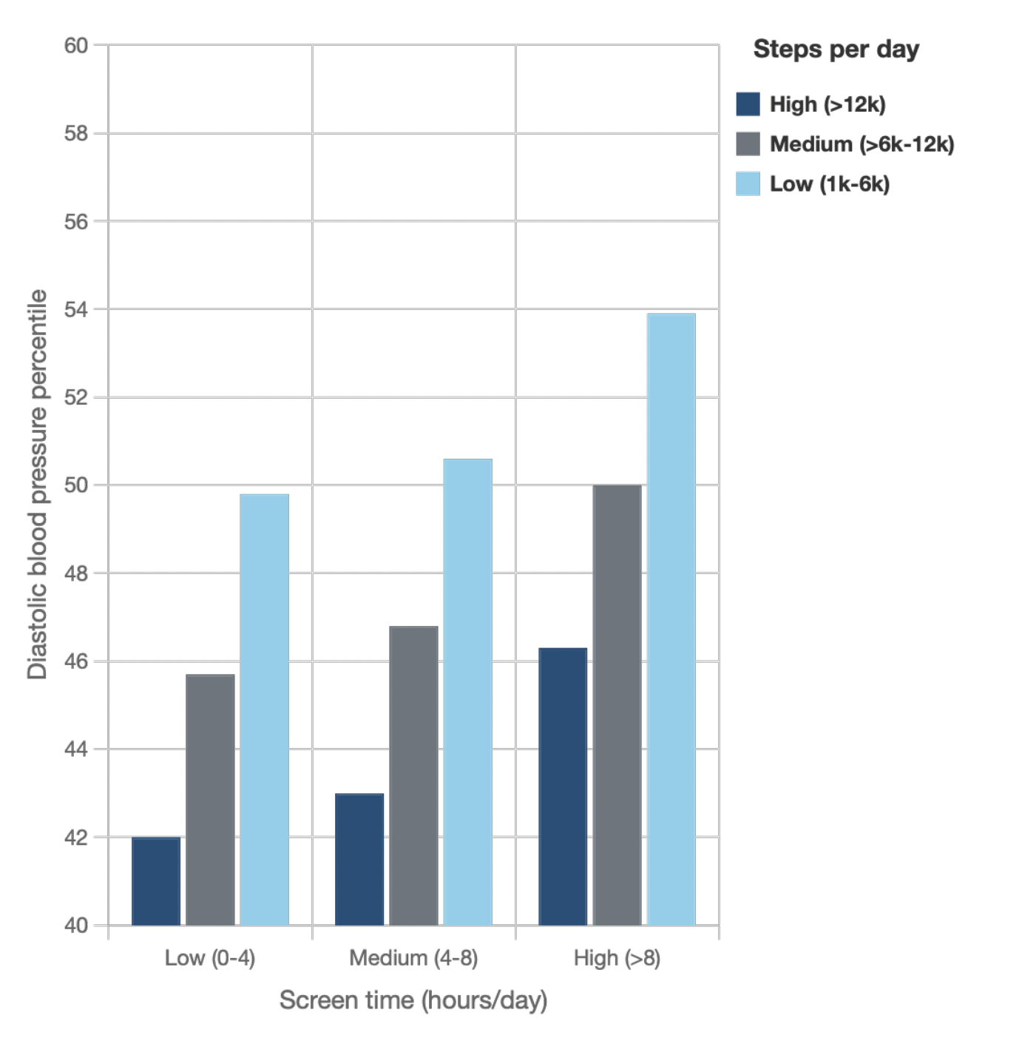

Legend: Results correspond to coefficients from a linear regression model with nine categories of screen time and step combinations as the independent variable and diastolic blood pressure percentile as the dependent variable, adjusting for age, sex, race/ethnicity, household income, parental education, parent marital status, BMI percentile, calendar month, and data collection period (i.e., before or during the COVID-19) at Year 2. Daily step categories included: low (1,000–6,000), medium (6,000–12,000), and high (>12,000). Daily screen time categories (hours) included: low (0–4), medium (4–8), high (>8). The low screen time and high step category was the reference category.

Supplemental Figure S3.
Title: Associations between self-reported screen time and step count category combinations at Year 2 and HDL cholesterol at Year 4 in 4,443 participants of the Adolescent Brain Cognitive Development (ABCD) Study, including adjustment for body mass index (BMI) percentile
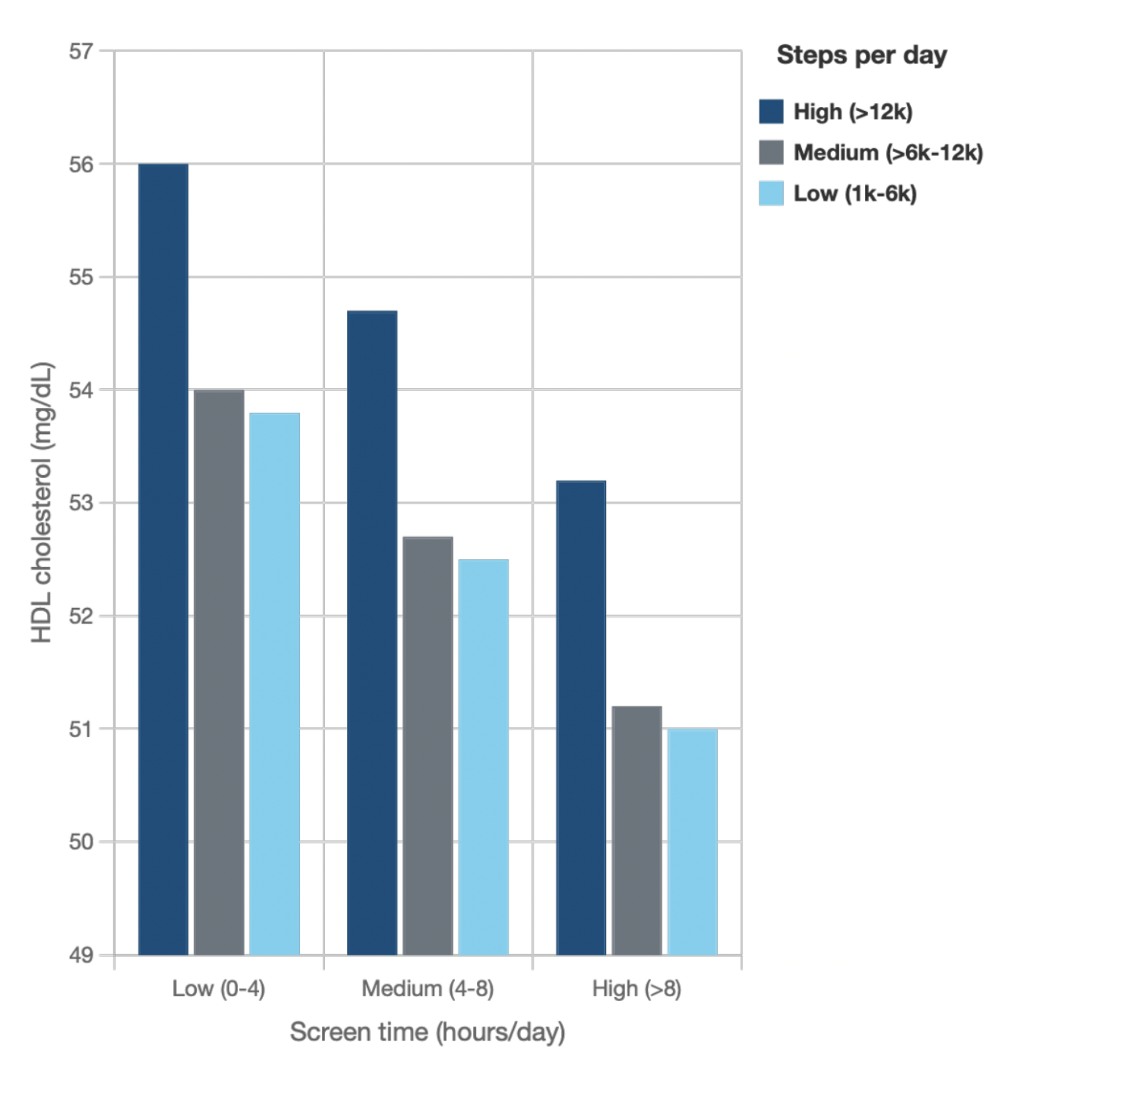
Legend: Results correspond to coefficients from a linear regression model with nine categories of screen time and step combinations as the independent variable and HDL cholesterol as the dependent variable, adjusting for age, sex, race/ethnicity, household income, parental education, parent marital status, BMI percentile, calendar month, and data collection period (i.e., before or during the COVID-19) at Year 2. Daily step categories included: high (>12,000), medium (6,000–12,000), and low (1,000–6,000). Daily screen time categories (hours) included: low (0–4); medium (4–8), high (>8). The low screen time and high step category was the reference category.

