Table S1 Edge weights in the network of the divorced group
Edge | Edge weight | CIlower | CIupper | p
PHQ1--PHQ2 | 0.41167657 | 0.2928996349 | 0.53045351 | 0.000
PHQ1--PHQ3 | 0.13234776 | -0.0159532085 | 0.28064873 | 0.209
PHQ1--PHQ4 | 0.10928036 | -0.0342914062 | 0.25285212 | 0.264
PHQ1--PHQ5 | 0.00000000 | -0.1131916269 | 0.11319163 | 0.741
PHQ1--PHQ6 | 0.00000000 | -0.0760084425 | 0.07600844 | 0.861
PHQ1--PHQ7 | 0.15040620 | 0.0184711595 | 0.28234125 | 0.143
PHQ1--PHQ8 | 0.00000000 | -0.0743377131 | 0.07433771 | 0.871
PHQ1--PHQ9 | 0.12013024 | -0.0008925606 | 0.24115303 | 0.229
PHQ1--SAS1 | 0.00000000 | -0.0207035995 | 0.02070360 | 0.980
PHQ1--SAS2 | 0.00000000 | -0.0507224506 | 0.05072245 | 0.882
PHQ1--SAS3 | 0.00000000 | -0.0671537091 | 0.06715371 | 0.808
PHQ2--PHQ3 | 0.00000000 | -0.1385908657 | 0.13859087 | 0.539
PHQ2--PHQ4 | 0.14899081 | 0.0111976343 | 0.28678399 | 0.120
PHQ2--PHQ5 | 0.00000000 | -0.0670906581 | 0.06709066 | 0.912
PHQ2--PHQ6 | 0.17022869 | 0.0265123565 | 0.31394502 | 0.083
PHQ2--PHQ7 | 0.00000000 | -0.1307535985 | 0.13075360 | 0.558
PHQ2--PHQ8 | 0.00000000 | -0.1290546246 | 0.12905462 | 0.555
PHQ2--PHQ9 | 0.12342515 | -0.0061899852 | 0.25304028 | 0.148
PHQ2--SAS1 | 0.00000000 | -0.0203744130 | 0.02037441 | 0.980
PHQ2--SAS2 | 0.00000000 | -0.0137589732 | 0.01375897 | 0.990
PHQ2--SAS3 | 0.00000000 | -0.0463615244 | 0.04636152 | 0.910
PHQ3--PHQ4 | 0.33253093 | 0.2106912189 | 0.45437064 | 0.000
PHQ3--PHQ5 | 0.00000000 | -0.1292020110 | 0.12920201 | 0.766
PHQ3--PHQ6 | 0.00000000 | -0.1087556580 | 0.10875566 | 0.784
PHQ3--PHQ7 | 0.00000000 | -0.0641066511 | 0.06410665 | 0.933
PHQ3--PHQ8 | 0.00000000 | -0.1019434756 | 0.10194348 | 0.808
PHQ3--PHQ9 | 0.00000000 | -0.0396342029 | 0.03963420 | 0.972
PHQ3--SAS1 | 0.00000000 | -0.0736419898 | 0.07364199 | 0.821
PHQ3--SAS2 | 0.00000000 | -0.0292882609 | 0.02928826 | 0.976
PHQ3--SAS3 | 0.00000000 | -0.0601460590 | 0.06014606 | 0.923
PHQ4--PHQ5 | 0.25464802 | 0.1284415452 | 0.38085450 | 0.006
PHQ4--PHQ6 | 0.00000000 | -0.0518126105 | 0.05181261 | 0.946
PHQ4--PHQ7 | 0.14124336 | -0.0076556775 | 0.29014240 | 0.167
PHQ4--PHQ8 | 0.00000000 | -0.0673037986 | 0.06730380 | 0.912
PHQ4--PHQ9 | 0.00000000 | -0.0405928927 | 0.04059289 | 0.957
PHQ4--SAS1 | 0.00000000 | -0.0803330990 | 0.08033310 | 0.705
PHQ4--SAS2 | 0.00000000 | -0.0916173711 | 0.09161737 | 0.611
PHQ4--SAS3 | 0.00000000 | -0.0469521194 | 0.04695212 | 0.938
PHQ5--PHQ6 | 0.12145102 | -0.0328206323 | 0.27572267 | 0.306
PHQ5--PHQ7 | 0.16017527 | -0.0174590657 | 0.33780961 | 0.230
PHQ5--PHQ8 | 0.00000000 | -0.1478548965 | 0.14785490 | 0.579
PHQ5--PHQ9 | 0.00000000 | -0.0651454163 | 0.06514542 | 0.928
PHQ5--SAS1 | 0.00000000 | -0.0289148822 | 0.02891488 | 0.979
PHQ5--SAS2 | 0.00000000 | -0.0521675064 | 0.05216751 | 0.931
PHQ5--SAS3 | 0.00000000 | -0.0323738512 | 0.03237385 | 0.978
PHQ6--PHQ7 | 0.00000000 | -0.1283922808 | 0.12839228 | 0.621
PHQ6--PHQ8 | 0.00000000 | -0.1488063631 | 0.14880636 | 0.514
PHQ6--PHQ9 | 0.35057488 | 0.2412741349 | 0.45987562 | 0.000
PHQ6--SAS1 | 0.09083907 | -0.0219055179 | 0.20358366 | 0.311
PHQ6--SAS2 | -0.07512108 | -0.1803311081 | 0.03008894 | 0.630
PHQ6--SAS3 | 0.16303791 | 0.0577687735 | 0.26830704 | 0.035
PHQ7--PHQ8 | 0.23644999 | 0.1007981362 | 0.37210184 | 0.019
PHQ7--PHQ9 | 0.00000000 | -0.0662151318 | 0.06621513 | 0.910
PHQ7--SAS1 | 0.00000000 | -0.0735344219 | 0.07353442 | 0.817
PHQ7--SAS2 | 0.00000000 | -0.0416855812 | 0.04168558 | 0.944
PHQ7--SAS3 | 0.00000000 | -0.0861786322 | 0.08617863 | 0.753
PHQ8--PHQ9 | 0.36035026 | 0.2390981838 | 0.48160233 | 0.000
PHQ8--SAS1 | 0.07169317 | -0.0463746227 | 0.18976096 | 0.418
PHQ8--SAS2 | 0.00000000 | -0.0386881837 | 0.03868818 | 0.952
PHQ8--SAS3 | 0.00000000 | -0.0433315626 | 0.04333156 | 0.952
PHQ9--SAS1 | 0.00000000 | -0.0808524782 | 0.08085248 | 0.801
PHQ9--SAS2 | 0.00000000 | -0.0460261906 | 0.04602619 | 0.914
PHQ9--SAS3 | 0.00000000 | -0.0726153638 | 0.07261536 | 0.822
SAS1--SAS2 | 0.53394456 | 0.4473107488 | 0.62057837 | 0.000
SAS1--SAS3 | 0.35633750 | 0.2584396560 | 0.45423535 | 0.000
SAS2--SAS3 | 0.36422725 | 0.2751090847 | 0.45334541 | 0.000

Table S2 Edge weights in the network of the non-divorced group
Edge | Edge weight | CIlower | CIupper | p
PHQ1--PHQ2 | 0.31040616 | 0.268106156 | 0.352706159 | 0.000
PHQ1--PHQ3 | 0.09282469 | 0.046627251 | 0.139022120 | 0.002
PHQ1--PHQ4 | 0.19298100 | 0.147174346 | 0.238787652 | 0.000
PHQ1--PHQ5 | 0.09483900 | 0.052630528 | 0.137047477 | 0.003
PHQ1--PHQ6 | 0.03388392 | -0.020797832 | 0.088565669 | 0.448
PHQ1--PHQ7 | 0.10087094 | 0.047532421 | 0.154209457 | 0.007
PHQ1--PHQ8 | 0.00000000 | -0.008303233 | 0.008303233 | 0.987
PHQ1--PHQ9 | 0.00000000 | -0.042685226 | 0.042685226 | 0.698
PHQ1--SAS1 | 0.00000000 | -0.009865747 | 0.009865747 | 0.970
PHQ1--SAS2 | 0.05223175 | 0.017718460 | 0.086745032 | 0.066
PHQ1--SAS3 | 0.00000000 | -0.025605475 | 0.025605475 | 0.845
PHQ2--PHQ3 | 0.09687749 | 0.050774227 | 0.142980747 | 0.001
PHQ2--PHQ4 | 0.14993675 | 0.106044925 | 0.193828584 | 0.000
PHQ2--PHQ5 | 0.00000000 | -0.045981708 | 0.045981708 | 0.678
PHQ2--PHQ6 | 0.17754571 | 0.132213524 | 0.222877898 | 0.000
PHQ2--PHQ7 | 0.00000000 | -0.038064794 | 0.038064794 | 0.758
PHQ2--PHQ8 | 0.10210654 | 0.053512118 | 0.150700957 | 0.002
PHQ2--PHQ9 | 0.14920120 | 0.109188212 | 0.189214189 | 0.000
PHQ2--SAS1 | 0.02449203 | -0.012609437 | 0.061593504 | 0.516
PHQ2--SAS2 | 0.00000000 | -0.005585042 | 0.005585042 | 0.991
PHQ2--SAS3 | 0.04052683 | -0.002386594 | 0.083440251 | 0.174
PHQ3--PHQ4 | 0.29474820 | 0.247283087 | 0.342213314 | 0.000
PHQ3--PHQ5 | 0.15505258 | 0.107255323 | 0.202849839 | 0.000
PHQ3--PHQ6 | 0.00000000 | -0.011966152 | 0.011966152 | 0.978
PHQ3--PHQ7 | 0.09242388 | 0.045728219 | 0.139119549 | 0.006
PHQ3--PHQ8 | 0.04035559 | -0.015986920 | 0.096698101 | 0.430
PHQ3--PHQ9 | 0.00000000 | -0.035126177 | 0.035126177 | 0.847
PHQ3--SAS1 | 0.00000000 | -0.014717173 | 0.014717173 | 0.946
PHQ3--SAS2 | 0.00000000 | -0.024168907 | 0.024168907 | 0.863
PHQ3--SAS3 | 0.00000000 | -0.002018886 | 0.002018886 | 0.999
PHQ4--PHQ5 | 0.14371524 | 0.097425594 | 0.190004885 | 0.000
PHQ4--PHQ6 | 0.03401970 | -0.017938681 | 0.085978091 | 0.454
PHQ4--PHQ7 | 0.10859120 | 0.060891164 | 0.156291242 | 0.000
PHQ4--PHQ8 | 0.00000000 | -0.039295813 | 0.039295813 | 0.728
PHQ4--PHQ9 | 0.00000000 | -0.006764667 | 0.006764667 | 0.994
PHQ4--SAS1 | 0.00000000 | -0.017521306 | 0.017521306 | 0.919
PHQ4--SAS2 | 0.07063539 | 0.041941397 | 0.099329376 | 0.004
PHQ4--SAS3 | 0.00000000 | -0.005945430 | 0.005945430 | 0.993
PHQ5--PHQ6 | 0.05225704 | -0.006219028 | 0.110733100 | 0.215
PHQ5--PHQ7 | 0.13639034 | 0.088909773 | 0.183870915 | 0.000
PHQ5--PHQ8 | 0.14313381 | 0.098023051 | 0.188244564 | 0.000
PHQ5--PHQ9 | 0.00000000 | -0.048926773 | 0.048926773 | 0.661
PHQ5--SAS1 | 0.00000000 | -0.031154673 | 0.031154673 | 0.755
PHQ5--SAS2 | 0.00000000 | -0.028206378 | 0.028206378 | 0.828
PHQ5--SAS3 | 0.00000000 | -0.007402865 | 0.007402865 | 0.991
PHQ6--PHQ7 | 0.21101850 | 0.162337827 | 0.259699164 | 0.000
PHQ6--PHQ8 | 0.12952321 | 0.079765642 | 0.179280786 | 0.000
PHQ6--PHQ9 | 0.25957649 | 0.216525572 | 0.302627416 | 0.000
PHQ6--SAS1 | 0.07613075 | 0.042832726 | 0.109428770 | 0.008
PHQ6--SAS2 | 0.00000000 | -0.019556774 | 0.019556774 | 0.916
PHQ6--SAS3 | 0.00000000 | -0.026522934 | 0.026522934 | 0.840
PHQ7--PHQ8 | 0.23303318 | 0.182717286 | 0.283349070 | 0.000
PHQ7--PHQ9 | 0.00000000 | -0.036943893 | 0.036943893 | 0.780
PHQ7--SAS1 | 0.00000000 | -0.031464771 | 0.031464771 | 0.714
PHQ7--SAS2 | 0.03273460 | -0.009449393 | 0.074918590 | 0.329
PHQ7--SAS3 | 0.00000000 | -0.030295636 | 0.030295636 | 0.786
PHQ8--PHQ9 | 0.28376750 | 0.236509337 | 0.331025665 | 0.000
PHQ8--SAS1 | 0.00000000 | -0.035909651 | 0.035909651 | 0.672
PHQ8--SAS2 | 0.00000000 | -0.051202905 | 0.051202905 | 0.579
PHQ8--SAS3 | 0.03550798 | -0.010450782 | 0.081466741 | 0.320
PHQ9--SAS1 | 0.00000000 | -0.009490779 | 0.009490779 | 0.986
PHQ9--SAS2 | -0.11982445 | -0.149400293 | -0.090248611 | 0.000
PHQ9--SAS3 | 0.08774116 | 0.050321143 | 0.125161185 | 0.000
SAS1--SAS2 | 0.51242143 | 0.481164416 | 0.543678436 | 0.000
SAS1--SAS3 | 0.42441961 | 0.389724485 | 0.459114730 | 0.000
SAS2--SAS3 | 0.31080355 | 0.272163200 | 0.349443891 | 0.000

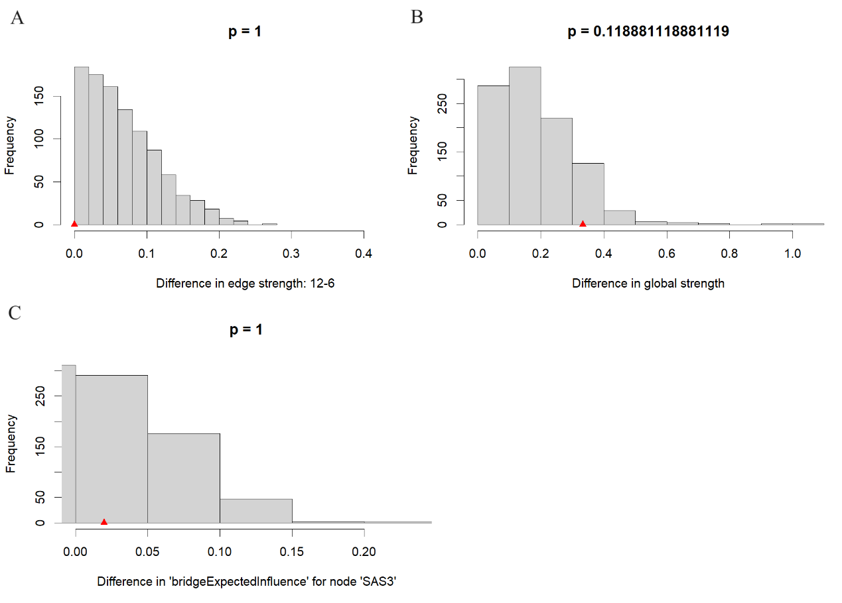
Figure S1. The results of the network comparison test (NCT) between edge strengths, global strengths, and BEI value of the original non-divorced group and the resampled non-divorced group. A. the results of NCT between edge strengths. B. the results of NCT between global strengths. C. the results of NCT between BEI values.

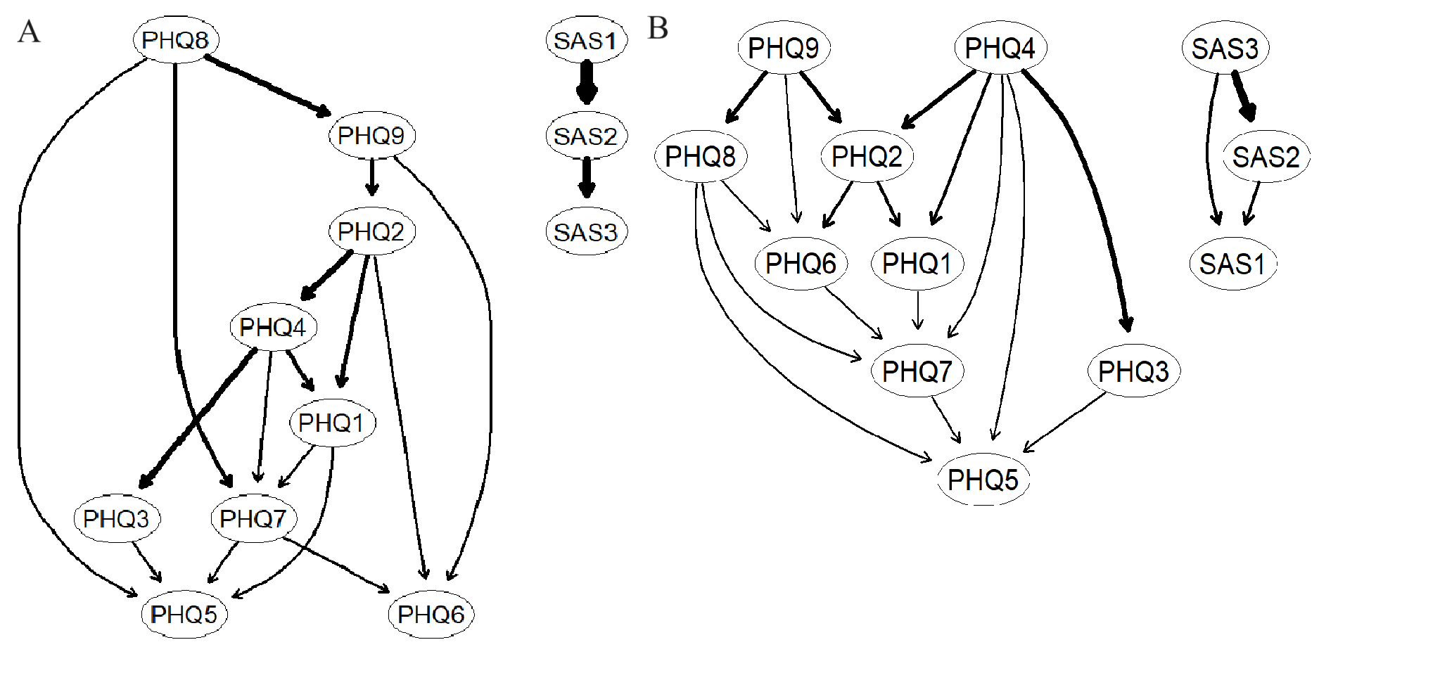
Figure S2. The DAG network based on the resampled non-divorced group. A. the DAG network based on the resampled non-divorce group. B. DAG network based on the mean value of 200 times of resampling based on the non-divorced group.

