Association between frailty status and depression among older adults: panel data analysis of three longitudinal cohort studies
Content
Supplemental Methods.
A brief introduction to the three cohorts
Multiple Imputation
Supplemental Tables
Table S1. The 27 items used to construct the frailty index.
Table S2. VIF Collinearity Screening.
Table S3. The Relationship Between Covariates and Depression
Table S4. Changes in the regression coefficients of the exposed variables（Frailty status) after covariates are removed
Table S5. Descriptions of covariates.
Table S6. The missing number and rate of covariates.
Table S7. Sensitivity analysis of the association between frail and depression was performed by excluding participants with depression at baseline
Table S8.Association Between Frailty Index and Depression (Using Poisson Binomial Regression)
Table S9.Subgroup analyses of age and gender
Table S10.Subgroup analyses of chronic diseases
Table S11.Associations between Frailty index and Depression（CHARLS)
Table S12.Associations between Frailty index and Depression（HRS)
Table S13.Associations between Frailty index and Depression（ELSA)
Supplemental Figures
Figure S1. Causal directed acyclic graph.

Supplemental Methods.

A brief introduction to the three cohorts
CHARLS: The purpose of the China Health and Retirement Longitudinal Study (CHARLS) is to collect a set of high-quality microdata representing families and individuals of middle-aged and elderly people aged 45 years and older in China, so as to analyze the aging problem of the Chinese population and promote interdisciplinary research on the aging problem. The survey covers 150 county-level units, 450 village-level units, and about 17,000 people in 10,000 families. The survey included basic demographic information of respondents and their families, transfer payments between family members, respondents' health status, medical care and insurance, employment, income, expenditure, and assets. CHARLS has published four waves of data for this article, including a national baseline survey (wave 1, 2011), a first follow-up survey (wave 2, 2013), a second follow-up survey (wave 3, 2015), and a third follow-up survey (wave 4, 2018). CHARLS related data can be downloaded at the CHARLS home page at https://charls.pku.edu.cn/ ¹.
ELSA: The English Longitudinal Study of Ageing (ELSA) is a prospective cohort study involving the health, social, welfare and economic environmental dynamics of the UK population aged 50 years and older. Included cohort studies included wave 7 (2014 - 2015), wave 8 (2016 - 2017), and wave 9 (2018 - 2019). For more information about ELSA, visit http://www.elsa-project.ac.uk/ ².
HRS: Health and Retirement Study (HRS, https://hrs.isr.umich.edu/ ), a nationally representative longitudinal study of older adults that included detailed economic and health information, surveyed a representative sample of approximately 20,000 people in the United States. The survey has been followed up every 2 years since 1992 until 2020 ^{3,4}. Cohort studies included in the HRS included wave 10 (2010 - 2011), wave 11 (2012 - 2013), wave 12 (2014 - 2015), and wave 13 (2016 - 2017).
1. Hu Y, Peng W, Ren R, Wang Y, Wang G. Sarcopenia and mild cognitive impairment among elderly adults: The first longitudinal evidence from CHARLS. J Cachexia Sarcopenia Muscle. 2022 Dec;13(6):2944–52.
2. Na-Ek N, Srithong J, Aonkhum A, Boonsom S, Charoen P, Demakakos P. Educational level as a cause of type 2 diabetes mellitus: Caution from triangulation of observational and genetic evidence. Acta Diabetol. 2022 Jan;59(1):127–35.
3. Ellwardt L, Hank K, Mendes de Leon CF. Grandparenthood and risk of mortality: Findings from the Health and Retirement Study. Soc Sci Med. 2021 Jan;268:113371.
4. Sonnega A, Faul JD, Ofstedal MB, Langa KM, Phillips JWR, Weir DR. Cohort Profile: the Health and Retirement Study (HRS). Int J Epidemiol. 2014 Apr;43(2):576–85.
Multiple Imputation
For missing covariate data, we employed the “Chained Equations Multiple Imputation” method for imputation. Within each chain, we performed five imputations, generating five imputed datasets. Effect estimates were calculated separately for each of the five datasets, then combined according to Rubin's rules. Multiple imputation was conducted using the R package “mice”.
Tables S1.The 27 items used to construct the frailty index
No | Description of the item | Cut-off value
1 | Self-reported physician diagnosed hypertension | Yes = 1, No = 0
2 | Self-reported physician diagnosed diabetes | Yes = 1, No = 0
3 | Self-reported physician diagnosed cancer | Yes = 1, No = 0
4 | Self-reported physician diagnosed arthritis | Yes = 1, No = 0
5 | Self-reported physician diagnosed chronic lung disease | Yes = 1, No = 0
6 | Self-reported physician diagnosed any emotional, nervous, or psychiatric problems | Yes = 1, No = 0
7 | Self-reported physician diagnosed memory-related disease | Yes = 1, No = 0
8 | Self-reported eyesight (while using lenses if appropriate) | Yes = 1, No = 0 in the CHARLS; Poor or fair = 1, excellent, very good, or good = 0 in the ELSA and HRS
9 | Self-reported hearing (while using hearing aid  if appropriate) | Yes = 1, No = 0 in the CHARLS; Poor or fair = 1, excellent, very good, or good = 0 in the ELSA and HRS
10 | Self-reported general health status | Very poor or poor = 1,  Very good, good, or fair = 0
11 | Difficulty with dressing | Yes = 1, No = 0
12 | Difficulty with bathing or showering | Yes = 1, No = 0
13 | Difficulty with eating | Yes = 1, No = 0
14 | Difficulty with getting in and out of bed | Yes = 1, No = 0
15 | Difficulty with using the toilet | Yes = 1, No = 0
16 | Difficulty with managing money | Yes = 1, No = 0
17 | Difficulty with taking medication | Yes = 1, No = 0
18 | Difficulty with shopping for groceries | Yes = 1, No = 0
19 | Difficulty with preparing meals | Yes = 1, No = 0
20 | Mobility: difficulty with walking 100 yards or one block | Yes = 1, No = 0
21 | Mobility: difficulty with getting up from a chair after sitting for long periods | Yes = 1, No = 0
22 | Mobility: difficulty with climbing several flights of stairs without resting | Yes = 1, No = 0
23 | Mobility: difficulty with lifting or carrying weights over 10 pounds/jins | Yes = 1, No = 0
24 | Mobility: difficulty with picking up a coin from the table | Yes = 1, No = 0
25 | Mobility: difficulty with stooping, kneeling, or crouching | Yes = 1, No = 0
26 | Mobility: difficulty with reaching arms above shoulder level | Yes = 1, No = 0
27 | Cognition: (memory test score + orientation test score) / 14 | Continuous variable, ranging from 0 to 1

The memory score is the average of the words not recalled in the immediate and delayed vocabulary recall tasks. The memory score ranges from 0 to 10 points. The orientation test consists of four questions, which ask about the day of the week, the month, the date of the month, and the year. Each incorrect answer adds 1 point, and the score ranges from 0 to 4 points.
CHARLS, China Health and Retirement Longitudinal Study; HRS, Health and Retirement Study;ELSA, English Longitudinal Study of Ageing.
Table S2. VIF Collinearity Screening.
Variables | VIF
Age | 1.6
Gender | 1.3
Marital status | 1.2
Education | 1.3
employment status | 1.5
Residential area | 1.2
Co-residence with children | 1
Smoking | 1.2
Drinking | 1.2
BMI | 1.2
physical activity | 1.1
multimorbidity count | 1.5
Psychiatric medication use | 1.1
pain | 1.2

Table S3.The Relationship Between Covariates and Depression
Covariates | term | beta | Se. | exp  (beta) | 95%CI Low | 95%CI Upp | P.value
Age | AGE | -0.0011 | 0.0006 | 0.9989 | 0.9977 | 1.0001 | 0.0848
Gender | factor(Gender)1 | -0.4932 | 0.0126 | 0.6107 | 0.5957 | 0.626 | <0.0001
Marital status | factor(Marital status)1 | -0.5123 | 0.013 | 0.5991 | 0.584 | 0.6146 | <0.0001
Education | factor(Education)2 | -0.7288 | 0.0136 | 0.4825 | 0.4698 | 0.4955 | <0.0001
 | factor(Education)3 | -1.2651 | 0.024 | 0.2822 | 0.2693 | 0.2958 | <0.0001
employment status | factor(employment status)1 | -0.171 | 0.0127 | 0.8429 | 0.8222 | 0.864 | <0.0001
Residential area | factor(Residential area)1 | 0.4426 | 0.0155 | 1.5568 | 1.5102 | 1.6048 | <0.0001
Co-residence with children | factor(Co-residence with children)1 | 0.0826 | 0.0124 | 1.0861 | 1.06 | 1.1129 | <0.0001
Smoking | factor(Smoking)1 | 0.3188 | 0.0156 | 1.3754 | 1.334 | 1.4182 | <0.0001
Drinking | factor(Drinking)1 | -0.6364 | 0.0124 | 0.5292 | 0.5165 | 0.5423 | <0.0001
BMI | BMI | -0.004 | 0.0012 | 0.9961 | 0.9937 | 0.9984 | 0.0009
physical activity | factor(physical activity)1 | -0.7277 | 0.0129 | 0.483 | 0.4709 | 0.4954 | <0.0001
multimorbidity count | factor(multimorbidity count)1 | 0.3223 | 0.0175 | 1.3802 | 1.3338 | 1.4283 | <0.0001
 | factor(multimorbidity count)2 | 0.7464 | 0.0161 | 2.1094 | 2.0437 | 2.1772 | <0.0001
Psychiatric medication use | factor(Psychiatric medication use)1 | 0.7595 | 0.0263 | 2.1372 | 2.0298 | 2.2502 | <0.0001
pain | factor(pain)1 | 1.2656 | 0.0128 | 3.5453 | 3.4575 | 3.6352 | <0.0001
The p-value for the regression coefficient of the covariate on the outcome variable (depression) is <0.1:Age、Gender、Marital status、Education、employment status、Residential area、Co-residence with children、Smoking、Drinking、BMI、physical activity、multimorbidity count、Psychiatric medication use、pain.
Table S4. Changes in the regression coefficients of the exposed variables（Frailty status) after covariates are removed.
covariate | +/- term | basic model |  | full model |  | elect
covariate | +/- term | Frailty status=1 | Frailty status=2 | Frailty status=1 | Frailty status=2 | elect
/ | Initial regression coefficient | 0.7683 | 2.1566 | 0.6021 | 1.5828
Age | / | 0.8872 * | 2.3156 * | 0.5649 | 1.5255 | Yes
Gender | / | 0.7309 | 2.1015 | 0.6174 | 1.5965
Marital status | / | 0.7473 | 2.1282 | 0.5955 | 1.5789
Education | / | 0.7996 | 2.0399 | 0.6524 | 1.7363
employment status | / | 0.8175 | 2.2339 | 0.6017 | 1.5807
Residential area | / | 0.7774 | 2.1285 | 0.6097 | 1.6035
Co-residence with children | / | 0.7683 | 2.1567 | 0.6022 | 1.583
Smoking | / | 0.7917 | 2.185 | 0.6012 | 1.58
Drinking | / | 0.7462 | 2.0806 | 0.6039 | 1.595
BMI | / | 0.8109 | 2.2019 | 0.5952 | 1.575
physical activity | / | 0.755 | 2.106 | 0.6057 | 1.6074
multimorbidity count | / | 0.8627 * | 2.2734 * | 0.624 | 1.607 | Yes
Psychiatric medication use | / | 0.7464 | 2.1251 | 0.609 | 1.6009
pain | / | 0.5550 * | 1.7020 * | 0.7820 * | 1.9700 * | Yes

Observng changes ih the regression coehicient of frailty status when introducing covariates into the basic model versus removing them ftom the full model
*Indicates a changel exceeding 10% compared to the initial regression coefficient
Frailty status is categorized into three levels: robust = 0 (FI<0.10), pre-fail = 1 (0.10 < F< 0.25), and ftail= 2 (FI> 0.25).
The eliect of introdicing cowarates in the basic model or removing ovanates imn the fill model on the regresion coeticient of frailty statusexceeds10%: age、 multimorbidiy count. pain

Tables S5. Descriptions of covariates
Variables | Brief Description
Age | The age was calculated from the date of interview and the date of birth.
Gender | The gender was reported as either male or female.
Marital status | Marital status was classified as married/partnered or single, single covered separated, divorced, widowed, and never married.
Education | According to the International Standard Classification of Education (ISCED) 1997, education is classified as lower secondary, upper secondary and vocational training, and tertiary.
Residential area | Residence status is classified as urban or rural.
employment status | Based on the question regarding participants' current employment status, labor force status was coded into two groups: currently not working and currently working.
Co-residence with children | Co-residence was viewed as a binary question, and no children missing was viewed as no co-residence.
Smoking | Smoking is described as current smoking behavior.
Drinking | Drinking is about whether alcohol was consumed last week, last year, or earlier.
BMI | Weight (kg) / Height (m)²
physical activity | Engage in at least 10 minutes of moderate-to-vigorous physical activity each week.
multimorbidity count | A total of seven diseases were included in the calculation:HypertensionDiabetesCancerLung diseaseHeart disease, stroke, and arthritis.
Psychiatric medication use | This refers to whether psychotropic drugs are used.
pain | Ask respondents whether they frequently experience pain in a specific area.

Table S6. The missing number and rate of covariates
Variables | CHARLS |  |  | HRS |  |  | ELSA
Variables | All (n=44041) |  |  | All (n=39767) |  |  | All (n=55705)
Age | 0 | 0.00% |  | 0 | 0.00% |  | 0 | 0.00%
Gender | 0 | 0.00% |  | 0 | 0.00% |  | 0 | 0.00%
Marital status | 4 | 0.01% |  | 4 | 0.01% |  | 0 | 0.00%
Education | 0 | 0.00% |  | 5 | 0.01% |  | 11 | 0.02%
employment status | 241 | 0.55% |  | 23 | 0.06% |  | 4735 | 8.50%
Residential area | 0 | 0.00% |  | 129 | 0.32% |  | 4 | 0.01%
Co-residence with children | 646 | 1.47% |  | 7644 | 19.22% |  | 8061 | 14.47%
Smoking | 2441 | 5.54% |  | 184 | 0.46% |  | 36 | 0.06%
Drinking | 12 | 0.03% |  | 4 | 0.01% |  | 4684 | 8.41%
BMI | 7861 | 17.85% |  | 465 | 1.17% |  | 10309 | 18.51%
physical activity | 7054 | 16.02% |  | 5002 | 12.58% |  | 1 | 0.00%
multimorbidity count | 4524 | 10.27% |  | 0 | 0.00% |  | 0 | 0.00%
Psychiatric medication use | 185 | 0.42% |  | 7180 | 18.06% |  | 6861 | 12.32%
pain | 18 | 0.04% |  | 19 | 0.05% |  | 12 | 0.02%
CHARLS, China Health and Retirement Longitudinal Study; HRS, Health and Retirement Study;ELSA, English Longitudinal Study of Ageing.

Table S7. Sensitivity analysis of the association between frail and depression was performed by excluding participants with depression at baseline
 | CHARLS |  |  |  | HRS |  |  |  | ELSA
 | OR(95% CI)P |  |  |  | OR(95% CI)P |  |  |  | OR(95% CI)P
 | Model 1 | Model 2 | Model 3 |  | Model 1 | Model 2 | Model 3 |  | Model 1 | Model 2 | Model 3
FI | 2.0 (2.0, 2.1) <0.001 | 2.0 (2.0, 2.1) <0.001 | 1.8 (1.8, 1.8) <0.001 |  | 2.7 (2.6, 2.8) <0.001 | 2.4 (2.3, 2.6) <0.001 | 2.0 (1.9, 2.1) <0.001 |  | 1.9 (1.8, 1.9) <0.001 | 1.7 (1.7, 1.8) <0.001 | 1.6 (1.5, 1.6) <0.001
faril3
Robust | 1(reference) | 1(reference) | 1(reference) |  | 1(reference) | 1(reference) | 1(reference) |  | 1(reference) | 1(reference) | 1(reference)
Pre-frail | 2.6 (2.5, 2.7) <0.001 | 2.5 (2.3, 2.6) <0.001 | 2.1 (1.9, 2.2) <0.001 |  | 2.4 (2.2, 2.6) <0.001 | 2.0 (1.8, 2.2) <0.001 | 1.7 (1.5, 1.8) <0.001 |  | 2.3 (2.1, 2.4) <0.001 | 2.0 (1.9, 2.2) <0.001 | 1.7 (1.6, 1.9) <0.001
Frail | 8.8 (8.2, 9.4) <0.001 | 8.4 (7.8, 9.1) <0.001 | 5.7 (5.3, 6.2) <0.001 |  | 11.9 (10.7, 13.2) <0.001 | 7.3 (6.4, 8.3) <0.001 | 4.6 (4.1, 5.3) <0.001 |  | 8.6 (8.0, 9.2) <0.001 | 5.8 (5.2, 6.3) <0.001 | 4.1 (3.7, 4.6) <0.001
faril tertile
T1 | 1(reference) | 1(reference) | 1(reference) |  | 1(reference) | 1(reference) | 1(reference) |  | 1(reference) | 1(reference) | 1(reference)
T2 | 1.7 (1.6, 1.8) <0.001 | 1.7 (1.6, 1.8) <0.001 | 1.5 (1.4, 1.6) <0.001 |  | 1.6 (1.5, 1.7) <0.001 | 1.5 (1.3, 1.7) <0.001 | 1.3 (1.2, 1.5) <0.001 |  | 1.6 (1.5, 1.8) <0.001 | 1.6 (1.5, 1.8) <0.001 | 1.4 (1.3, 1.6) <0.001
T3 | 5.5 (5.2, 5.8) <0.001 | 5.1 (4.8, 5.4) <0.001 | 3.7 (3.5, 4.0) <0.001 |  | 4.9 (4.5, 5.4) <0.001 | 3.9 (3.5, 4.3) <0.001 | 2.8 (2.5, 3.2) <0.001 |  | 5.9 (5.5, 6.4) <0.001 | 4.2 (3.8, 4.6) <0.001 | 3.0 (2.7, 3.3) <0.001
CHARLS China Health and Retirement Longitudinal Study,HRS Health and Retirement Study ,ELSA English Longitudinal Study of Ageing.
Model 1: unadjusted
Model 2: Adjusted for the minimal sufficient adjustment set (MSAS) identified using a causal directed acyclic graph (DAG) including further adjusted for age and gender,marital status,education,residential area, employment status,smoking and drinking status,BMI,physical activity,multimorbidity count.
Model 3: Further adjusted for cohabitation with children、Psychiatric medication use、pain based on Model 2 ;
the FI is a continuous variable ranging from 0 to 1, where a higher value indicates a greater degree of frailty.
Robust（FI≤ 0.10）、pre-frail（0.10< FI< 0.25）、frail（FI≥ 0.25）
T1 was the lower tertile of total FI, T2 was the middle tertile of total FI, and T3 was the upper tertile of total
Table S8.Association Between Frailty Index and Depression (Using Poisson Binomial Regression)
 | CHARLS |  |  |  | HRS |  |  |  |  | ELSA
 | RR(95% CI)P |  |  |  | RR(95% CI)P |  |  |  |  | RR(95% CI)P
 | Model 1 | Model 2 | Model 3 |  | Model 1 |  | Model 2 | Model 3 |  | Model 1 | Model 2 | Model 3
FI | 1.4 (1.3, 1.4) <0.001 | 1.3 (1.3, 1.3) <0.001 | 1.2 (1.2, 1.3) <0.001 |  |  | 1.8 (1.8, 1.8) <0.001 | 1.6 (1.5, 1.6) <0.001 | 1.4 (1.3, 1.4) <0.001 |  | 1.4 (1.4, 1.5) <0.001 | 1.3 (1.3, 1.3) <0.001 | 1.3 (1.3, 1.3) <0.001
faril3
Robust | 1(reference) | 1(reference) | 1(reference) |  |  | 1(reference) | 1(reference) | 1(reference) |  | 1(reference) | 1(reference) | 1(reference)
Pre-frail | 1.9 (1.8, 2.0) <0.001 | 1.8 (1.7, 1.9) <0.001 | 1.6 (1.5, 1.6) <0.001 |  |  | 2.0 (1.9, 2.1) <0.001 | 1.7 (1.6, 1.8) <0.001 | 1.5 (1.4, 1.6) <0.001 |  | 1.9 (1.8, 2.0) <0.001 | 1.8 (1.7, 1.9) <0.001 | 1.6 (1.5, 1.7) <0.001
Frail | 3.3 (3.1, 3.4) <0.001 | 3.0 (2.9, 3.1) <0.001 | 2.3 (2.2, 2.4) <0.001 |  |  | 5.0 (4.7, 5.3) <0.001 | 3.2 (3.0, 3.5) <0.001 | 2.3 (2.1, 2.5) <0.001 |  | 4.6 (4.4, 4.9) <0.001 | 3.5 (3.3, 3.7) <0.001 | 2.8 (2.6, 3.0) <0.001
faril tertile
T1 | 1(reference) | 1(reference) | 1(reference) |  |  | 1(reference) | 1(reference) | 1(reference) |  | 1(reference) | 1(reference) | 1(reference)
T2 | 1.5 (1.4, 1.5) <0.001 | 1.4 (1.4, 1.5) <0.001 | 1.3 (1.3, 1.4) <0.001 |  |  | 1.5 (1.4, 1.6) <0.001 | 1.4 (1.3, 1.5) <0.001 | 1.3 (1.2, 1.4) <0.001 |  | 1.5 (1.4, 1.6) <0.001 | 1.5 (1.4, 1.6) <0.001 | 1.4 (1.3, 1.5) <0.001
T3 | 2.8 (2.7, 3.0) <0.001 | 2.6 (2.5, 2.7) <0.001 | 2.1 (2.0, 2.2) <0.001 |  |  | 3.4 (3.2, 3.6) <0.001 | 2.6 (2.4, 2.9) <0.001 | 2.1 (1.9, 2.3) <0.001 |  | 3.9 (3.7, 4.2) <0.001 | 3.1 (2.9, 3.3) <0.001 | 2.5 (2.3, 2.7) <0.001
CHARLS China Health and Retirement Longitudinal Study,HRS Health and Retirement Study ,ELSA English Longitudinal Study of Ageing.
Model 1: unadjusted
Model 2: Adjusted for the minimal sufficient adjustment set (MSAS) identified using a causal directed acyclic graph (DAG) including further adjusted for age and gender,marital status,education,residential area, employment status,smoking and drinking status,BMI,physical activity,multimorbidity count.
Model 3: Further adjusted for cohabitation with children、Psychiatric medication use、pain based on Model 2 ;
the FI is a continuous variable ranging from 0 to 1, where a higher value indicates a greater degree of frailty.
Robust（FI≤ 0.10）、pre-frail（0.10< FI< 0.25）、frail（FI≥ 0.25）
T1 was the lower tertile of total FI, T2 was the middle tertile of total FI, and T3 was the upper tertile of total
Table S9. Subgroup analyses of age and gender.
 | CHARLS |  |  |  | HRS |  |  |  | ELSA
 | robust | Frail | P for interaction |  | robust | Frail | P for interaction |  | robust | Frail | P for interaction
Age |  |  | 0.45 |  |  |  | 0.1695 |  |  |  | 0.7615
<65 | 1（reference) | 5.1 (4.7, 5.7) |  |  | 1（reference) | 9.1 (5.1, 15.9) |  |  | 1（reference) | 5.0 (4.5, 5.6)
>=65 | 1（reference) | 4.8 (4.3, 5.3) |  |  | 1（reference) | 5.2 (4.7, 5.7) |  |  | 1（reference) | 5.1 (4.6, 5.5)
Gender |  |  | 0.02 |  |  |  | 0.0375 |  |  |  | 0.0001
Female | 1（reference) | 4.2 (3.8, 4.6) |  |  | 1（reference) | 4.8 (4.2, 5.4) |  |  | 1（reference) | 4.1 (3.8, 4.5)
Male | 1（reference) | 5.3 (4.7, 5.9) |  |  | 1（reference) | 6.1 (5.2, 7.2) |  |  | 1（reference) | 6.2 (5.6, 6.9)

Table S10. Subgroup analyses of chronic diseases
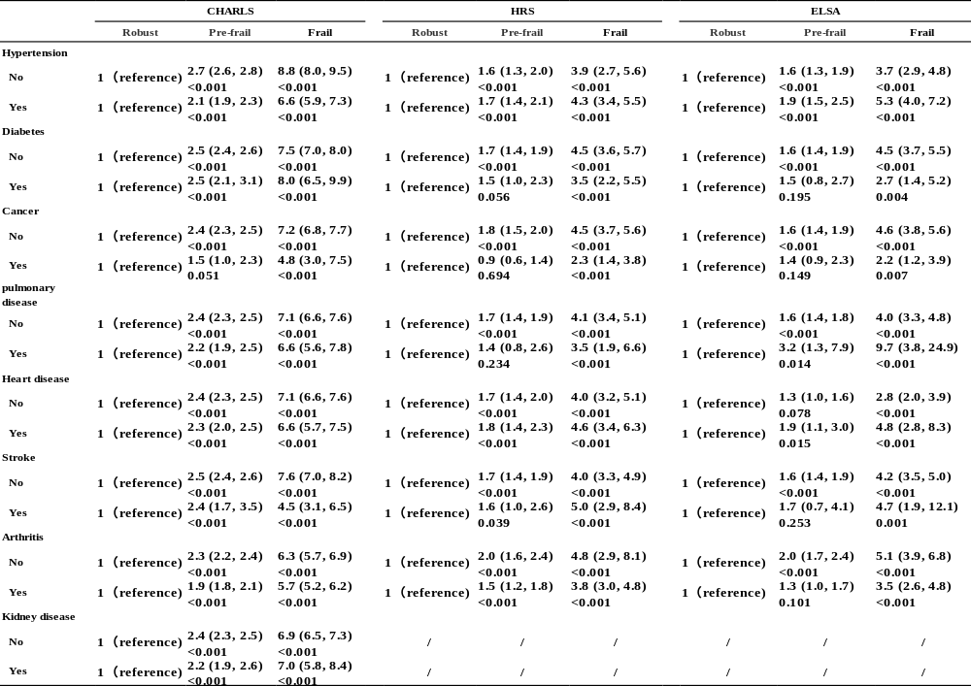
Table S11.Associations between Frailty index and Depression（CHARLS)
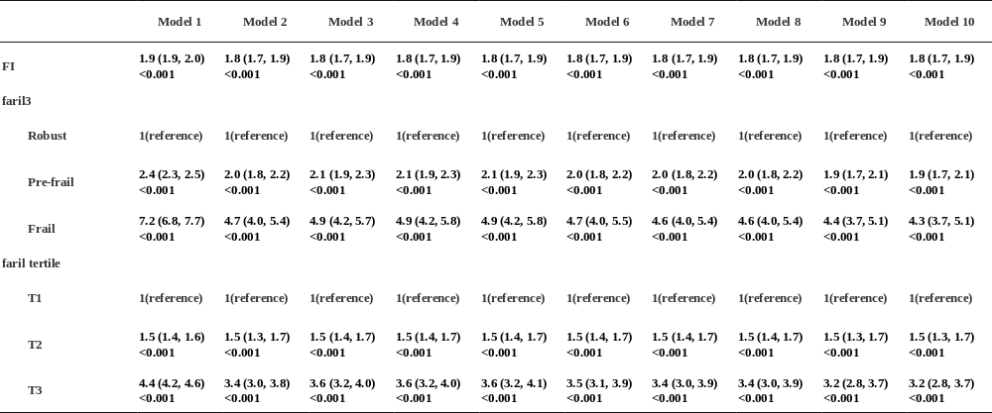
Model 1: unadjusted ;Model 2: Adjusted for the minimal sufficient adjustment set (MSAS) identified using a causal directed acyclic graph (DAG) including further adjusted for age and gender,marital status,education,residential area, employment status,smoking and drinking status,BMI,physical activity;Model 3: Further adjusted for Hypertension on Model 2 ; Model 4: Further adjusted for Diabetes on Model 3 ; Model 5: Further adjusted for Cancer on Model 4 ; Model 6: Further adjusted for pulmonary disease on Model 5 ; Model 7: Further adjusted for Heart disease on Model 6 ; Model 8: Further adjusted for Stroke on Model 7 ; Model 9: Further adjusted for Arthritis on Model 8 ; Model 10: Further adjusted for Kidney disease on Model 9 ;
the FI is a continuous variable ranging from 0 to 1, where a higher value indicates a greater degree of frailty.
Robust（FI≤ 0.10）、pre-frail（0.10< FI< 0.25）、frail（FI≥ 0.25）
T1 was the lower tertile of total FI, T2 was the middle tertile of total FI, and T3 was the upper tertile of total
Table S12.Associations between Frailty index and Depression（HRS)

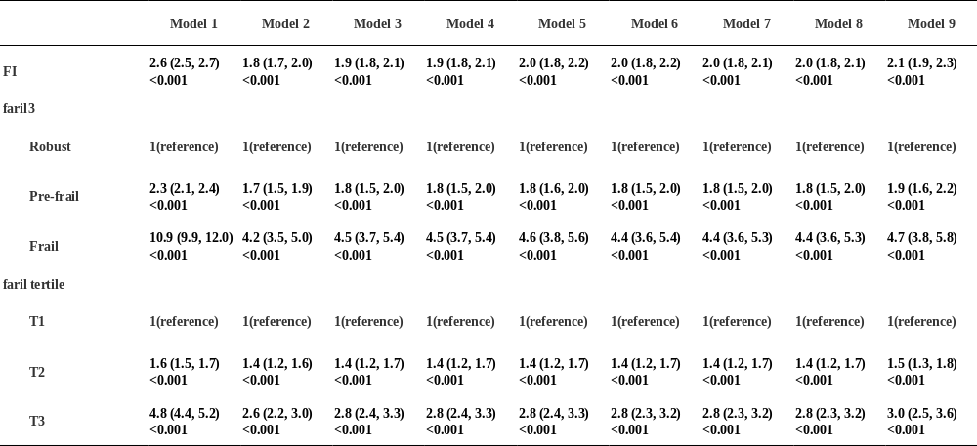

Model 1: unadjusted ;Model 2: Adjusted for the minimal sufficient adjustment set (MSAS) identified using a causal directed acyclic graph (DAG) including further adjusted for age and gender,marital status,education,residential area, employment status,smoking and drinking status,BMI,physical activity;Model 3: Further adjusted for Hypertension on Model 2 ; Model 4: Further adjusted for Diabetes on Model 3 ; Model 5: Further adjusted for Cancer on Model 4 ; Model 6: Further adjusted for pulmonary disease on Model 5 ; Model 7: Further adjusted for Heart disease on Model 6 ; Model 8: Further adjusted for Stroke on Model 7 ; Model 9: Further adjusted for Arthritis on Model 8 ;
the FI is a continuous variable ranging from 0 to 1, where a higher value indicates a greater degree of frailty.
Robust（FI≤ 0.10）、pre-frail（0.10< FI< 0.25）、frail（FI≥ 0.25）
T1 was the lower tertile of total FI, T2 was the middle tertile of total FI, and T3 was the upper tertile of total.
Table S13.Associations between Frailty index and Depression（ELSA)
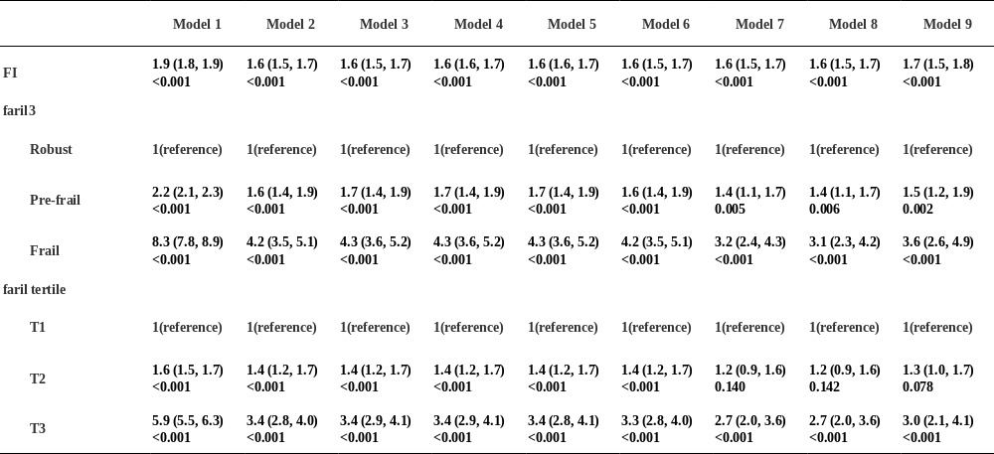

Model 1: unadjusted ;Model 2: Adjusted for the minimal sufficient adjustment set (MSAS) identified using a causal directed acyclic graph (DAG) including further adjusted for age and gender,marital status,education,residential area, employment status,smoking and drinking status,BMI,physical activity;Model 3: Further adjusted for Hypertension on Model 2 ; Model 4: Further adjusted for Diabetes on Model 3 ; Model 5: Further adjusted for Cancer on Model 4 ; Model 6: Further adjusted for pulmonary disease on Model 5 ; Model 7: Further adjusted for Heart disease on Model 6 ; Model 8: Further adjusted for Stroke on Model 7 ; Model 9: Further adjusted for Arthritis on Model 8 ;
the FI is a continuous variable ranging from 0 to 1, where a higher value indicates a greater degree of frailty.
Robust（FI≤ 0.10）、pre-frail（0.10< FI< 0.25）、frail（FI≥ 0.25）
T1 was the lower tertile of total FI, T2 was the middle tertile of total FI, and T3 was the upper tertile of total.
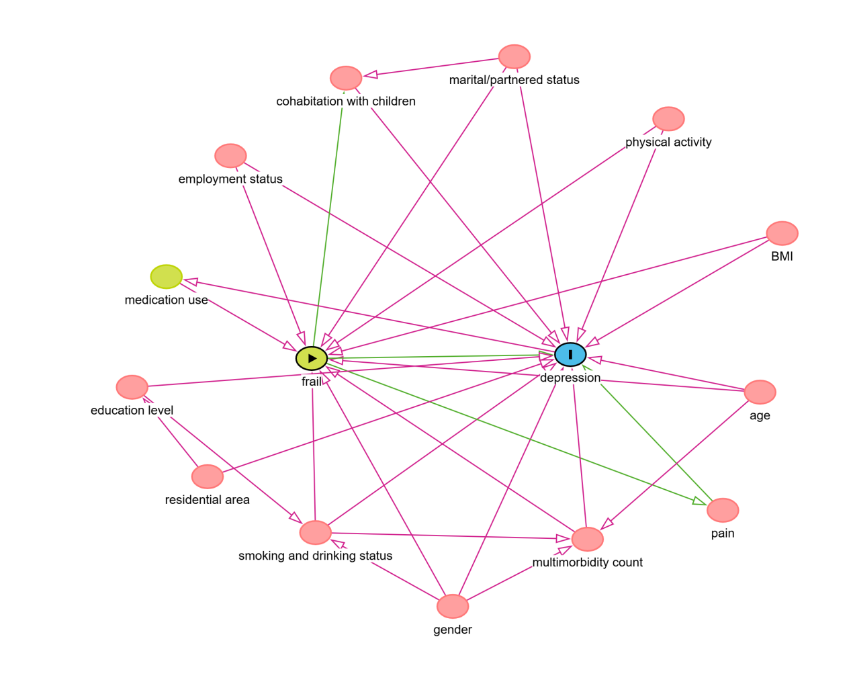
Figure S1. Causal directed acyclic graph.

Note: The minimal sufficient adjustment set includes age and gender,marital status,education,residential area, employment status,smoking and drinking status,BMI,physical activity,multimorbidity count.

