Supplementary materials for manuscript
1. Search Strategies
2. Methods for Evidence Certainty Assessment
3. Table S1 Certainty assessment of the studies
4. Risk of bias in included studies
4.1 Table S2 Risk of bias for cross-sectional studies
4.2 Table S3 Risk of bias for cohort studies
5. Publication bias and sensitivity analysis
5.1 Figure S1 Forest plot of sensitivity analysis for the association between screen time and depression risk
5.2 Figure S2 Forest plot of sensitivity analysis for the association between screen time and anxiety risk
5.3 Figure S3 Forest plot of sensitivity analysis for the association between screen time and stress risk
5.4 Figure S4 Forest plot of sensitivity analysis for the association between screen time and physical pain
5.5 Figure S5 Forest plot of sensitivity analysis for the association between screen time and sleep duration
5.6 Figure S6 Forest plot of sensitivity analysis for the association between screen time and sleep quality
5.7 Figure S7 Results of Trim-and-Fill analysis for sleep quality
5.8 Figure S8 Forest plot of sensitivity analysis for the association between screen time and digital eye strain
5.9 Figure S9 Results of trim-and-fill Analysis for digital eye strain
5.10 Figure S10 Forest plot of sensitivity analysis for the association between screen time and physical activity
5.11 Figure S11 Egger's funnel plot for publication bias in academic performance
5.12 Figure S12 Begg's funnel plot of publication bias in academic performance
5.13 Figure S13 Funnel plot for the association between screen time and depression risk
5.14 Figure S14 Egger's funnel plot for publication bias in depression risk
5.15 Figure S15 Begg's funnel plot of publication bias in depression risk
5.16 Figure S16 Egger's funnel plot for publication bias in anxiety risk
5.17 Figure S17 Begg's funnel plot of publication bias in anxiety risk
5.18 Figure S18 Egger's funnel plot for publication bias in stress risk
5.19 Figure S19 Begg's funnel plot of publication bias in stress risk
5.20 Figure S20 Egger's funnel plot for publication bias in physical pain
5.21 Figure S21 Begg's funnel plot of publication bias in physical pain
5.22 Figure S22 Egger's funnel plot for publication bias in sleep duration
5.23 Figure S23 Begg's funnel plot of publication bias in sleep duration
5.24 Figure S24 Funnel plot for the association between screen time and sleep quality
5.25 Figure S25 Egger's funnel plot for publication bias in sleep quality
5.26 Figure S26 Begg's funnel plot of publication bias in sleep quality
5.27 Figure S27 Funnel plot for the association between screen time and digital eye strain
5.28 Figure S28 Egger's funnel plot for publication bias in digital eye strain
5.29 Figure S29 Begg's funnel plot of publication bias in digital eye strain
5.30 Figure S30 Egger's funnel plot for publication bias in BMI
5.31 Figure S31 Begg's funnel plot of publication bias in BMI
5.32 Figure S32 Egger's funnel plot for publication bias in physical activity
5.33 Figure S33 Begg's funnel plot of publication bias in physical activity
6. Subgroup analysis
6.1 Table S4 Subgroup analysis of the association between screen time and depression risk
6.2 Table S5 Subgroup analysis of the association between screen time and sleep quality
6.3 Table S6 Subgroup analysis of the association between screen time and digital eye strain

Search Strategies

The following databases were searched on June 01, 2025:
- Pubmed
- Web of Science
- Cochrane Library
- Embase
- PsycINFO

1 Pubmed
#1 (((((((screen time[MeSH Terms]) OR (digital screen[MeSH Terms])) OR (television[MeSH Terms])) OR (computer[MeSH Terms])) OR (smartphone[MeSH Terms])) OR (video game[MeSH Terms])) OR (electronic game[MeSH Terms]))
#2 (((college student[MeSH Terms]) OR (university student[MeSH Terms])) OR (tertiary student[MeSH Terms])) OR (undergraduate[MeSH Terms])
#3 #1 AND #2

2 Web of Science
#1 (((((((TI=(screen time)) OR TI=(digital screen)) OR TI=(television)) OR TI=(computer)) OR TI=(smartphone)) OR TI=(video game)) OR TI=(electronic game))
#2 (((TI=(college student)) OR TI=(university student)) OR TI=(tertiary student)) OR TI=(undergraduate)
#3 #1 AND #2

3 Cochrane Library
#1 ((screen time) OR (digital screen) OR (television) OR (computer) OR (smartphone) OR (video game) OR (electronic game)):ti,ab,kw
#2 ((college student) OR (university student) OR (tertiary student) OR (undergraduate)):ti,ab,kw
#3 #1 AND #2

4 Embase
#1 screen:ti AND time:ti OR (digital:ti AND screen:ti) OR television:ti OR computer:ti OR smartphone:ti OR (video:ti AND game:ti) OR (electronic:ti AND game:ti)
#2 (screen:ab AND time:ab) OR (digital:ab AND screen:ab) OR television:ab OR computer:ab OR smartphone:ab OR (video:ab AND game:ab) OR (electronic:ab AND game:ab)
#3 #1 OR #2
#4 college:ti AND student:ti OR (university:ti AND student:ti) OR (tertiary:ti AND student:ti) OR undergraduate:ti
#5 college:ab AND student:ab OR (university:ab AND student:ab) OR (tertiary:ab AND student:ab) OR undergraduate:ab
#6 #4 OR #5
#7 #3 AND #6

5 PsycINFO
#1 (Title: screen time)OR (Title: digital screen) OR (Title: television) OR (Title: computer) OR (Title: smartphone) OR (Title: video game) OR (Title: electronic game)
#2 (Abstract: screen time)OR (Abstract: digital screen) OR (Abstract: television) OR (Abstract: computer) OR (Abstract: smartphone) OR (Abstract: video game) OR (Abstract: electronic game)
#3 #1 OR #2
#4 (Title: college student) OR (Title: university student) OR (Title: tertiary student) OR (Title: undergraduate)
#5 (Abstract: college student) OR (Abstract: university student) OR (Abstract: tertiary student) OR (Abstract: undergraduate)
#6 #4 OR #5
#7 #3 AND #6

Methods for Evidence Certainty Assessment
Evidence from cross-sectional and longitudinal studies was initially considered "low" certainty. It was graded down if there were concerns regarding risk of bias (ROB), indirectness, inconsistency, imprecision or publication bias, as these factors reduce confidence in the estimated effects. If there was no cause to downgrade, it was upgraded if applicable according to the GRADE criteria (such as large magnitude of effect, evidence of dose response).
The ROB of included studies was independently and systematically assessed by two researchers according to study design using the JBI Manual for Evidence Synthesis. Any discrepancies were resolved through discussions or by consulting a third researcher. The JBI checklist was used to determine the extent to which a study had addressed the possibility of bias in its design, conduct and analysis. Specifically, all studies were screened for potential sources of bias, including unclear inclusion criteria, flawed measurement of exposure and outcomes, unidentified confounding factors and inappropriate statistical analyses. The overall ROB for the study was defined as high risk when more than one-third of the factors (cross-sectional studies: ≥3 of 8 factors; cohort studies: ≥4 of 11 factors) were rated as high risk [S1-S2].
The ROB across studies was considered “serious” when studies with the greatest influence on the pooled result (the study with a weight >50% in the forest plot) presented high ROB. Inconsistency across studies was assessed through statistical tests and visual inspection of forest plots, and the I² statistic was employed to quantify the magnitude of statistical heterogeneity between studies. In the case where high statistical heterogeneity (I²>50%) was observed, the evidence was considered for downgrading if the direction of effect was inconsistent across most studies, with minimal overlap of CIs, and the heterogeneity remained unexplained after meta-analysis or subgroup analysis. Imprecision was considered “serious” or “very serious” when the sample size was small (n<300 or n<100) and/or when the effect estimate was imprecise with wide CIs including the no effect value.
[S1] Jones PAT, Ruchat SM, Khan-Afridi Z, et al. Impact of postpartum physical activity on maternal sleep: a systematic review and meta-analysis. Br J Sports Med 2025; 59(8):576-583. doi: 10.1136/bjsports-2024-108839.
[S2] Deprato A, Ruchat SM, Ali MU, et al. Impact of postpartum physical activity on maternal depression and anxiety: a systematic review and meta-analysis. Br J Sports Med 2025; 59(8):550-561. doi: 10.1136/bjsports-2024-108478.

Table S1 Certainty assessment of the studies
Study (year) | Design | Risk of bias | Indirectness | Inconsistency | Imprecision | Other  considerations | Certainty
Liebig et al ¹  (2023) | CS | seriousb | not serious | not serious | not serious | none | ⨁○○○  verylow
Wright et al-NP ⁴  (2024) | CS | seriousb | not serious | not serious | not serious | none | ⨁○○○  verylow
Wright et al-CP ⁴  (2024) | CS | seriousb | not serious | not serious | not serious | none | ⨁○○○  verylow
Saxena et al ⁶  (2021) | CS | seriousb | not serious | not serious | very seriousf | none | ⨁○○○  verylow
Akçay et al ⁷  (2021) | CS | not seriousa | not serious | not serious | not serious | none | ⨁⨁○○  low
Sapci et al ¹⁰  (2021) | CS | not seriousa | not serious | not serious | seriouse | none | ⨁○○○  verylow
Albalawi et al ¹¹  (2023) | CS | not seriousa | not serious | not serious | not serious | none | ⨁⨁○○  low
Wu et al ¹⁴  (2015) | CS | not seriousa | not serious | not serious | not serious | none | ⨁⨁○○  low
Wang et al ¹⁵  (2023) | CS | not seriousa | not serious | not serious | not serious | none | ⨁⨁○○  low
Saavedra Vallejos et al ¹⁷  (2025) | CS | seriousb | not serious | not serious | not serious | none | ⨁○○○  verylow
Xu et al ²⁰  (2018) | CS | not seriousa | not serious | not serious | not serious | none | ⨁⨁○○  low
Iqbal et al ²¹  (2021) | CS | not seriousa | not serious | not serious | not serious | none | ⨁⨁○○  low
Garcia et al ³⁵  (2024) | CS | not seriousa | not serious | not serious | not serious | none | ⨁⨁○○  low
Sy et al ³⁶  (2024) | CS | not seriousa | not serious | not serious | not serious | none | ⨁⨁○○  low
Zeyrek et al ³⁷  (2024) | CS | seriousb | not serious | not serious | not serious | none | ⨁○○○  verylow
Almutairi et al ³⁸  (2024) | CS | not seriousa | not serious | not serious | not seriousc | none | ⨁⨁○○  low
Sharma et al ³⁹  (2023) | CS | seriousb | not serious | not serious | not serious | none | ⨁○○○  verylow
Gadain Hassan et al ⁴⁰  (2023) | CS | seriousb | not serious | not serious | seriousd | none | ⨁○○○  verylow
Fernandez-Villacorta et al ⁴¹  (2021) | CS | seriousb | not serious | not serious | not seriousc | none | ⨁○○○  verylow
Lulla et al ⁴²  (2023) | CS | seriousb | not serious | not serious | not seriousc | none | ⨁○○○  verylow
Sserunkuuma et al ⁴³  (2023) | CS | seriousb | not serious | not serious | seriousd | none | ⨁○○○  verylow
Fang et al ⁴⁴  (2023) | CS | seriousb | not serious | not serious | not serious | none | ⨁○○○  verylow
Yang et al ⁴⁵  (2022) | LC | not seriousa | not serious | not serious | not serious | none | ⨁⨁○○  low
Islam et al ⁴⁶  (2021) | CS | seriousb | not serious | not serious | seriousd | none | ⨁○○○  verylow
Hammoudi et al ⁴⁷  (2021) | CS | seriousb | not serious | not serious | not serious | none | ⨁○○○  verylow
Feng et al ⁴⁸  (2014) | CS | not seriousa | not serious | not serious | not serious | none | ⨁⨁○○  low
Arshad et al ⁴⁹  (2021) | LC | not seriousa | not serious | not serious | not seriousc | none | ⨁⨁○○  low
Goel et al ⁵⁰  (2023) | CS | not seriousa | not serious | not serious | not seriousc | none | ⨁⨁○○  low
Ma et al ⁵¹  (2020) | CS | not seriousa | not serious | not serious | not serious | not serious | ⨁⨁○○  low
Kalirathinam et al ⁵²  (2019) | CS | seriousb | not serious | not serious | not serious | none | ⨁○○○  verylow
Ng et al ⁵³  (2017) | CS | seriousb | not serious | not serious | not seriousc | none | ⨁○○○  verylow
Gao et al ⁵⁴  (2021) | CS | seriousb | not serious | not serious | seriousd | none | ⨁○○○  verylow
Tanriverdi et al ⁵⁵  (2023) | CS | not seriousa | not serious | not serious | not serious | none | ⨁⨁○○  low
Ge et al ⁵⁶  (2020) | CS | not seriousa | not serious | not serious | not serious | none | ⨁⨁○○  low
Rosenthal et al ⁵⁷  (2021) | CS | not seriousa | not serious | not serious | not serious | none | ⨁⨁○○  low
Zhang et al ⁵⁸  (2021) | CS | not seriousa | not serious | not serious | not serious | not serious | ⨁⨁○○  low
Montagni et al ⁵⁹  (2016) | CS | not seriousa | not serious | not serious | not serious | none | ⨁⨁○○  low
Maqbool et al ⁶⁰  (2024) | CS | seriousb | not serious | not serious | not serious | none | ⨁○○○  verylow
Abudawood et al ⁶¹  (2020) | CS | seriousb | not serious | not serious | not serious | none | ⨁○○○  verylow
Shantakumari et al ⁶²  (2014) | CS | seriousb | not serious | not serious | not serious | none | ⨁○○○  verylow
Lindo-Cano et al ⁶³  (2022) | CS | seriousb | not serious | not serious | not serious | none | ⨁○○○  verylow
Venkateshvaran et al ⁶⁴  (2023) | CS | not seriousa | not serious | not serious | not serious | none | ⨁⨁○○  low
Imran et al ⁶⁵  (2022) | CS | not seriousa | not serious | not serious | seriousd | none | ⨁○○○  verylow
Talens-Estarelles et al ⁶⁶  (2022) | CS | seriousb | not serious | not serious | not serious | none | ⨁○○○  verylow
Alqurashi et al ⁶⁷  (2024) | CS | not seriousa | not serious | not serious | not serious | not serious | ⨁⨁○○  low
Rehman et al ⁶⁸  (2023) | CS | not seriousa | not serious | not serious | seriousd | none | ⨁○○○  verylow
Preoteasa et al ⁶⁹  (2024) | CS | not seriousa | not serious | not serious | not seriousc | not serious | ⨁⨁○○  low
Sitaula et al ⁷⁰  (2018) | CS | seriousb | not serious | not serious | not seriousc | none | ⨁○○○  verylow
Maroof et al ⁷¹  (2022) | CS | not seriousa | not serious | not serious | not serious | none | ⨁⨁○○  low
Gebresellassie et al ⁷²  (2022) | CS | seriousb | not serious | not serious | not serious | none | ⨁○○○  verylow
Al Tawil et al ⁷³  (2020) | CS | seriousb | not serious | not serious | not serious | none | ⨁○○○  verylow
Indriyani et al ⁷⁴  (2022) | CS | seriousb | not serious | not serious | not seriousc | none | ⨁○○○  verylow
Wang et al ⁷⁵  (2021) | CS | not seriousa | not serious | not serious | not seriousc | none | ⨁⨁○○  low
Peltzer et al ⁷⁶  (2019) | CS | seriousb | not serious | not serious | not serious | none | ⨁○○○  verylow
Xie et al ⁷⁷  (2022) | CS | not seriousa | not serious | not serious | not serious | none | ⨁⨁○○  low
Muhsin et al ⁷⁸  (2018) | CS | seriousb | not serious | not serious | very seriousf | none | ⨁○○○  verylow
Benaich et al ⁷⁹  (2021) | CS | not seriousa | not serious | not serious | not serious | none | ⨁⨁○○  low
Pellerine et al ⁸⁰  (2023) | CS | seriousb | not serious | not serious | not serious | none | ⨁○○○  verylow
Ballard et al ⁸¹  (2009) | CS | seriousb | not serious | not serious | not seriousc | none | ⨁○○○  verylow
Laghari et al ⁸²  (2023) | CS | seriousb | not serious | not serious | seriousd | none | ⨁○○○  verylow
Cheng et al ⁸³  (2023) | CS | not seriousa | not serious | not serious | not serious | none | ⨁⨁○○  low
Guo et al ⁸⁴  (2022) | LC | not seriousa | not serious | not serious | very seriousf | none | ⨁○○○  verylow
Batham et al ⁸⁵  (2023) | CS | not seriousa | not serious | not serious | not serious | none | ⨁⨁○○  low
Waheed et al ⁸⁶  (2019) | CS | not seriousa | not serious | not serious | seriousd | none | ⨁○○○  verylow
Kim et al ⁸⁷  (2024) | CS | not seriousa | not serious | not serious | not serious | none | ⨁⨁○○  low
Maayah et al ⁸⁸  (2023) | CS | not seriousa | not serious | not serious | not serious | none | ⨁⨁○○  low
Alqassim et al ⁸⁹  (2024) | CS | seriousb | not serious | not serious | not serious | none | ⨁○○○  verylow
Abou Hashish et al ⁹⁰  (2022) | CS | seriousb | not serious | not serious | not serious | none | ⨁○○○  verylow
İkinci Keleş et al ⁹¹  (2021) | CS | seriousb | not serious | not serious | not serious | none | ⨁○○○  verylow
Liu et al ⁹²  (2023) | CS | not seriousa | not serious | not serious | not serious | none | ⨁⨁○○  low
Koly et al ⁹³  (2021) | CS | not seriousa | not serious | not serious | not serious | none | ⨁⨁○○  low
Tashiro et al ⁹⁴  (2022) | CS | not seriousa | not serious | not serious | not serious | none | ⨁⨁○○  low
Zhou et al ⁹⁵  (2021) | CS | not seriousa | not serious | not serious | not serious | none | ⨁⨁○○  low
Explanations:
a (no risk of bias): less than one third of the factors evaluated were marked as high risk of bias
b (serious risk of bias): more than one third of the factors evaluated were marked as high risk of bias
c (no imprecision): the sample size was not adequate (100≤n<300), but the effect estimate was precise with confidence intervals not including the no effect value
d (serious imprecision): the sample size was not adequate (100≤n<300), and the effect estimate was imprecise with confidence intervals including the no effect value
e (no imprecision): the sample size was small (<100) but the effect estimate didn’t include the no effect value
f (very serious imprecision): The sample size was small (<100) in each arm, and the effect estimate was imprecise with wide confidence intervals, including the no effect value

Table S2 Risk of bias for cross-sectional studies
Study (Year) | Were the criteria for inclusion in the sample clearly defined? | Were the study subjects and the setting described in detail? | Was the exposure measured in a valid and reliable way? | Were objective, standard criteria used for measurement of the condition? | Were confounding factors identified? | Were strategies to deal with confounding factors stated? | Were the outcomes measured in a valid and reliable way? | Was appropriate statistical analysis used? | Risk of bias
Liebig et al ¹  (2023) | No | Yes | Yes | Yes | No | No | Yes | Yes | high risk
Wright et al-NP ⁴  (2024) | No | Yes | Yes | Yes | No | No | No | Yes | high risk
Wright et al-CP ⁴  (2024) | No | Yes | Yes | Yes | No | No | No | Yes | high risk
Saxena et al ⁶  (2021) | No | Yes | Yes | Yes | No | No | Yes | No | high risk
Akçay et al ⁷  (2021) | Yes | Yes | Yes | Yes | No | No | Yes | Yes | Low risk
Sapci et al ¹⁰  (2021) | No | No | Yes | Yes | Yes | Yes | Yes | Yes | Low risk
Albalawi et al ¹¹  (2023) | Yes | Yes | Yes | Yes | No | No | Yes | Yes | Low risk
Wu et al ¹⁴  (2015) | No | Yes | Yes | Yes | Yes | Yes | Yes | Yes | Low risk
Wang et al ¹⁵  (2023) | Unclear | Yes | Yes | Yes | Yes | Yes | Yes | Yes | Low risk
Saavedra Vallejos et al ¹⁷  (2025) | No | Yes | Yes | Yes | No | No | Yes | Yes | high risk
Xu et al ²⁰  (2018) | Yes | Yes | Yes | Yes | No | No | Yes | Yes | Low risk
Iqbal et al ²¹  (2021) | Yes | Yes | Yes | Yes | No | No | Yes | Yes | Low risk
Garcia et al ³⁵  (2024) | Yes | Yes | No | No | Yes | Yes | Yes | Yes | Low risk
Sy et al ³⁶  (2024) | Yes | Yes | Yes | Yes | No | No | Yes | Yes | Low risk
Zeyrek et al ³⁷  (2024) | No | Yes | Yes | Yes | No | No | Yes | Yes | high risk
Almutairi et al ³⁸  (2024) | Yes | Yes | Yes | Yes | No | No | Yes | Yes | Low risk
Sharma et al ³⁹  (2023) | No | Yes | Unclear | Yes | No | No | Yes | Yes | high risk
Gadain Hassan et al ⁴⁰  (2023) | No | No | Yes | Yes | No | No | Yes | No | high risk
Fernandez-Villacorta et al ⁴¹  (2021) | No | Yes | No | Yes | No | No | Yes | No | high risk
Lulla et al ⁴²  (2023) | Yes | No | No | Yes | No | No | Yes | Yes | high risk
Sserunkuuma et al ⁴³  (2023) | Unclear | Yes | Yes | Yes | No | No | Yes | Yes | high risk
Fang et al ⁴⁴  (2023) | No | Yes | Yes | Yes | No | No | Yes | Yes | high risk
Islam et al ⁴⁶  (2021) | No | Yes | Yes | Yes | No | No | Yes | Yes | high risk
Hammoudi et al ⁴⁷  (2021) | No | Yes | No | Yes | No | No | Yes | Yes | high risk
Feng et al ⁴⁸  (2014) | No | Yes | Yes | Yes | Yes | Yes | Yes | Yes | Low risk
Goel et al ⁵⁰  (2023) | Yes | Yes | Yes | Yes | Yes | Yes | Yes | No | Low risk
Ma et al ⁵¹  (2020) | Yes | Yes | Yes | Yes | Yes | Yes | Yes | Yes | Low risk
Kalirathinam et al ⁵²  (2019) | Yes | No | Yes | Yes | No | No | Yes | No | high risk
Ng et al ⁵³  (2017) | No | No | Yes | Yes | No | No | Yes | Yes | high risk
Gao et al ⁵⁴  (2021) | No | No | Yes | Yes | No | No | Yes | Yes | high risk
Tanriverdi et al ⁵⁵  (2023) | Yes | Yes | Yes | Yes | No | No | Yes | Yes | Low risk
Ge et al ⁵⁶  (2020) | No | Yes | Yes | Yes | Yes | Yes | Yes | Yes | Low risk
Rosenthal et al ⁵⁷  (2021) | No | No | Yes | Yes | Yes | Yes | Yes | Yes | Low risk
Zhang et al ⁵⁸  (2021) | No | Yes | Yes | Yes | Yes | Yes | Yes | Yes | Low risk
Montagni et al ⁵⁹  (2016) | Yes | Yes | No | Yes | Yes | Yes | Yes | Yes | Low risk
Maqbool et al ⁶⁰  (2024) | Yes | No | Yes | Yes | No | No | Yes | No | high risk
Abudawood et al ⁶¹  (2020) | Yes | Yes | No | Yes | No | No | Yes | No | high risk
Shantakumari et al ⁶²  (2014) | Yes | Yes | Yes | No | No | No | No | Yes | high risk
Lindo-Cano et al ⁶³  (2022) | Yes | No | No | Yes | No | No | Yes | No | high risk
Venkateshvaran et al ⁶⁴  (2023) | Yes | Yes | Yes | Yes | No | No | Yes | Yes | Low risk
Imran et al ⁶⁵  (2022) | Yes | Yes | Yes | Yes | No | No | Yes | Yes | Low risk
Talens-Estarelles et al ⁶⁶  (2022) | No | Yes | Yes | Yes | No | No | Yes | Yes | high risk
Alqurashi et al ⁶⁷  (2024) | Yes | Yes | Yes | Yes | No | No | Yes | Yes | Low risk
Rehman et al ⁶⁸  (2023) | Yes | Yes | Yes | Yes | No | No | Yes | Yes | Low risk
Preoteasa et al ⁶⁹  (2024) | Yes | Yes | Yes | Yes | No | No | Yes | Yes | Low risk
Sitaula et al ⁷⁰  (2018) | No | Yes | Yes | Yes | No | No | No | No | high risk
Maroof et al ⁷¹  (2022) | Yes | Yes | Yes | Yes | No | No | Yes | Yes | Low risk
Gebresellassie et al ⁷²  (2022) | No | Yes | Yes | Yes | No | No | Yes | No | high risk
Al Tawil et al ⁷³  (2020) | No | No | Yes | Yes | No | No | No | Yes | high risk
Indriyani et al ⁷⁴  (2022) | No | Yes | Yes | Yes | No | No | Yes | No | high risk
Wang et al ⁷⁵  (2021) | Yes | Yes | Yes | Yes | No | No | Yes | Yes | Low risk
Peltzer et al ⁷⁶  (2019) | No | Yes | Yes | Yes | Yes | Yes | No | No | high risk
Xie et al ⁷⁷  (2022) | Yes | Yes | Yes | Yes | No | No | Yes | Yes | Low risk
Muhsin et al ⁷⁸  (2018) | No | No | Yes | Yes | No | No | Yes | No | high risk
Benaich et al ⁷⁹  (2021) | Yes | Yes | Yes | Yes | No | No | Yes | Yes | Low risk
Pellerine et al ⁸⁰  (2023) | No | Yes | Yes | Yes | No | No | Yes | Yes | high risk
Ballard et al ⁸¹  (2009) | No | No | Yes | Yes | No | No | Yes | Yes | high risk
Laghari et al ⁸²  (2023) | No | Yes | Yes | Yes | No | No | Yes | Yes | high risk
Cheng et al ⁸³  (2023) | Yes | Yes | Yes | Yes | No | No | Yes | Yes | Low risk
Batham et al ⁸⁵  (2023) | Yes | Yes | Yes | Yes | No | No | Yes | Yes | Low risk
Waheed et al ⁸⁶  (2019) | Yes | Yes | Yes | Yes | No | No | Yes | Yes | Low risk
Kim et al ⁸⁷  (2024) | Yes | Yes | Yes | Yes | Yes | Yes | Yes | Yes | Low risk
Maayah et al ⁸⁸  (2023) | Yes | Yes | Yes | Yes | No | No | Yes | Yes | Low risk
Alqassim et al ⁸⁹  (2024) | Yes | Yes | Yes | Yes | Yes | Yes | No | No | Low risk
Abou Hashish et al ⁹⁰  (2022) | Yes | Yes | Yes | Yes | No | No | No | No | high risk
İkinci Keleş et al ⁹¹  (2021) | No | Yes | Yes | Yes | No | No | No | No | high risk
Liu et al ⁹²  (2023) | Yes | Yes | Yes | Yes | Yes | Yes | Yes | Yes | Low risk
Koly et al ⁹³  (2021) | No | Yes | Yes | Yes | No | No | Yes | Yes | Low risk
Tashiro et al ⁹⁴  (2022) | Yes | Yes | Yes | Yes | Yes | Yes | Yes | Yes | Low risk
Zhou et al ⁹⁵  (2021) | Yes | Yes | Yes | Yes | No | No | Yes | Yes | Low risk
Explanations:
high risk: more than one third of the factors evaluated were marked as high risk of bias (≥4)
low risk: less than one third of the factors evaluated were marked as high risk of bias (＜4)

Table S3 Risk of bias for cohort studies
Study (Year) | Yang et al  (2022) | Guo et al  (2022) | Arshad et al  (2021)
Were the two groups similar and recruited from the same population? | Yes | Yes | Yes
Were the exposures measured similarly to assign people to both exposed and unexposed groups? | Yes | Yes | Yes
Was the exposure measured in a valid and reliable way? | No | Yes | Yes
Were confounding factors identified? | Yes | Yes | No
Were strategies to deal with confounding factors stated? | Yes | Yes | No
Were the groups/participants free of the outcome at the start of the study (or at the moment of exposure)? | No | Yes | Yes
Were the outcomes measured in a valid and reliable way? | Yes | No | Yes
Was the follow up time reported and sufficient to be long enough for outcomes to occur? | Yes | No | No
Was follow up complete, and if not, were the reasons to loss to follow up described and explored? | Yes | Yes | Yes
Were strategies to address incomplete follow up utilized? | No | Yes | Yes
Was appropriate statistical analysis used? | Yes | Yes | Yes
Risk of bias | Low risk | Low risk | Low risk
Explanations:
high risk: more than one third of the factors evaluated were marked as high risk of bias (≥4)
low risk: less than one third of the factors evaluated were marked as high risk of bias (＜4)

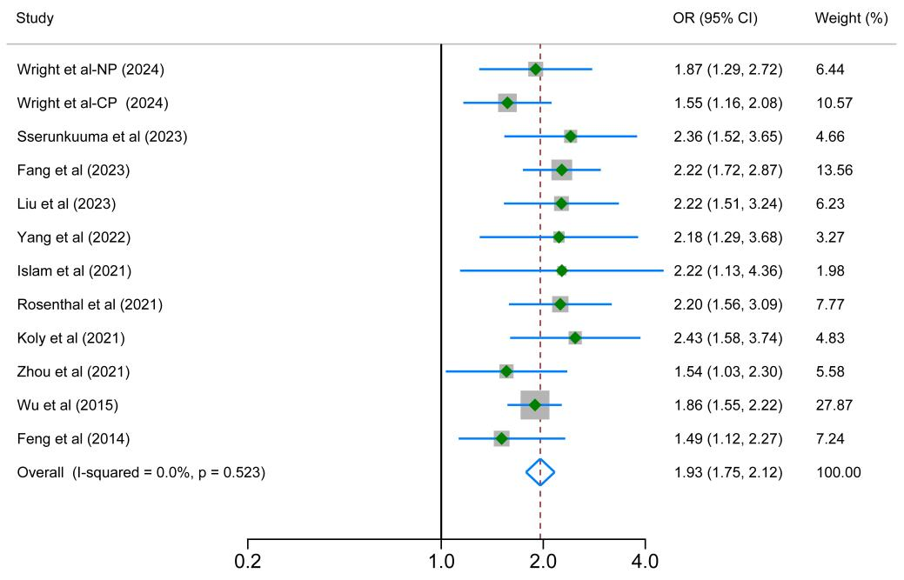
Figure S1 Forest plot of sensitivity analysis for the association between screen time and depression risk

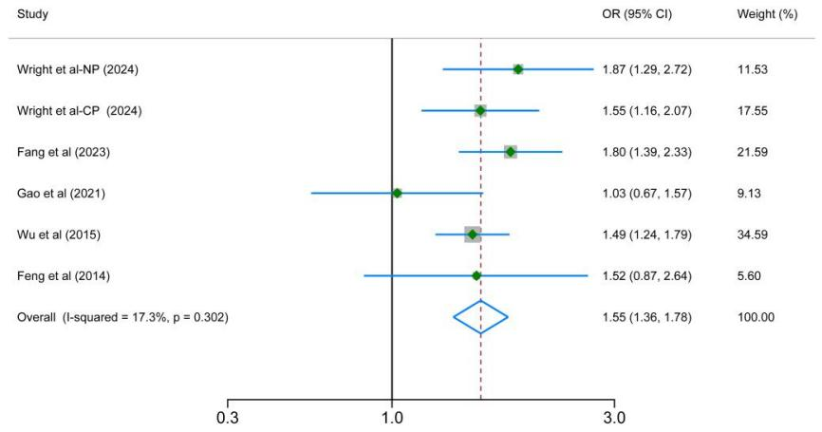
Figure S2 Forest plot of sensitivity analysis for the association between screen time and anxiety risk

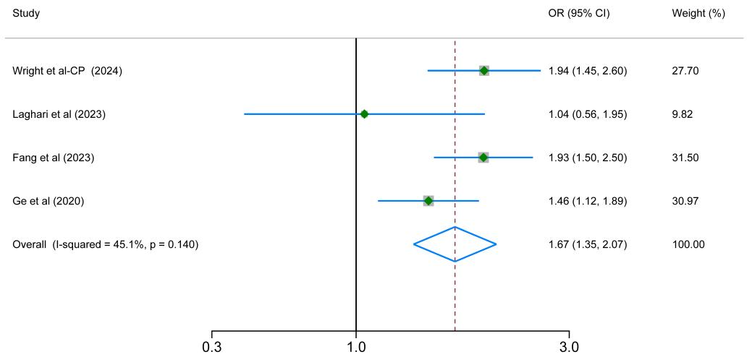
Figure S3 Forest plot of sensitivity analysis for the association between screen time and stress risk

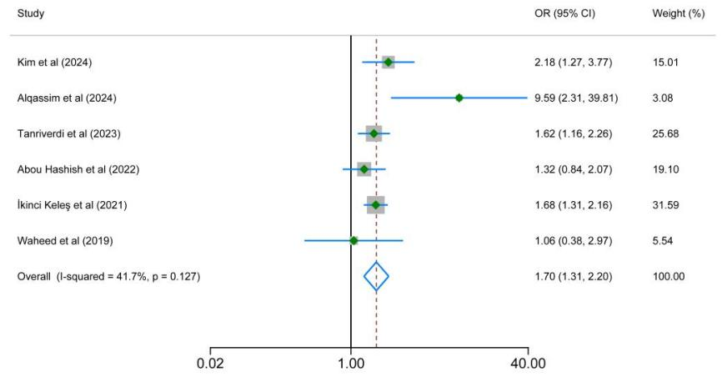
Figure S4 Forest plot of sensitivity analysis for the association between screen time and physical pain

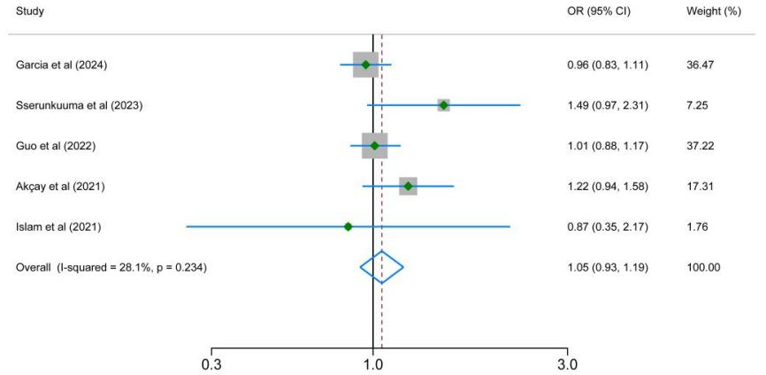
Figure S5 Forest plot of sensitivity analysis for the association between screen time and sleep duration

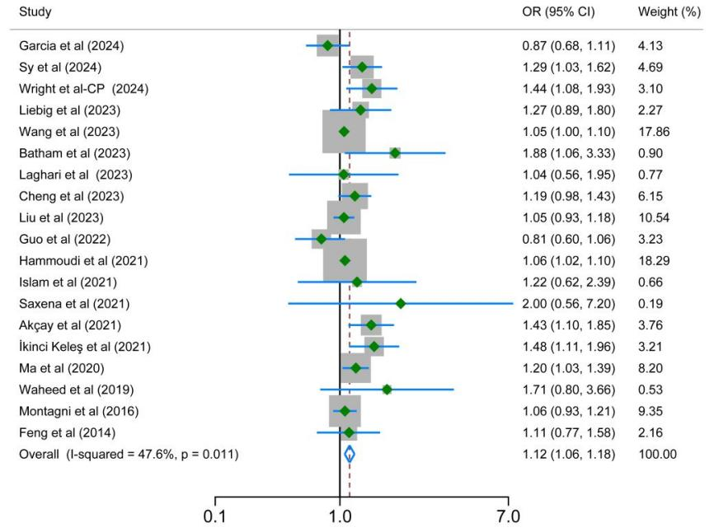
Figure S6 Forest plot of sensitivity analysis for the association between screen time and sleep quality

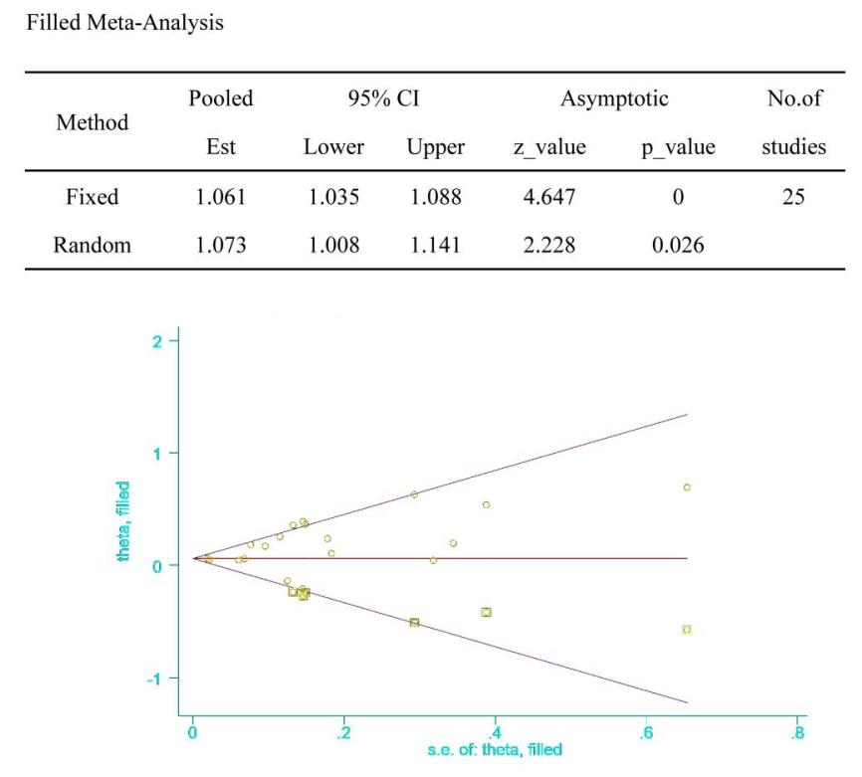
Figure S7 Results of Trim-and-Fill analysis for sleep quality

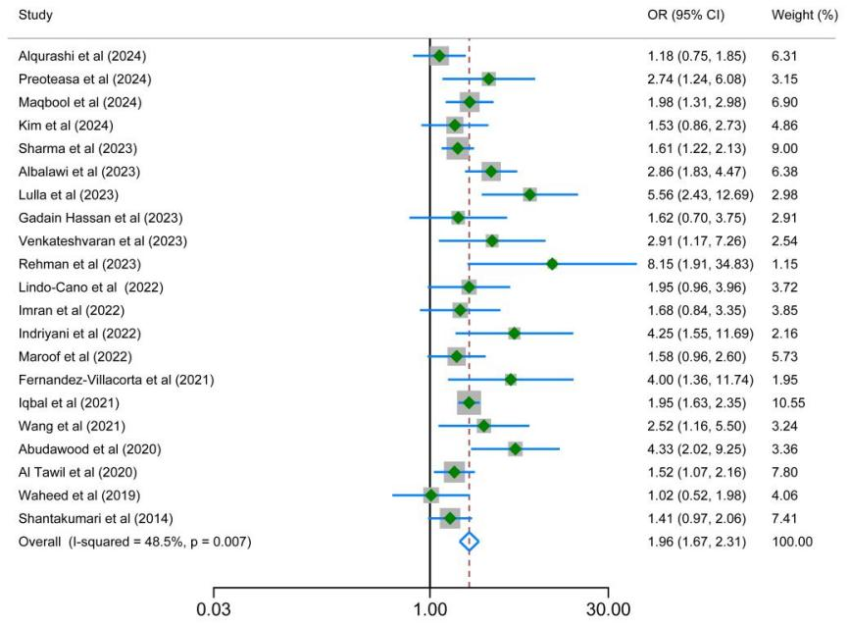
Figure S8 Forest plot of sensitivity analysis for the association between screen time and digital eye strain
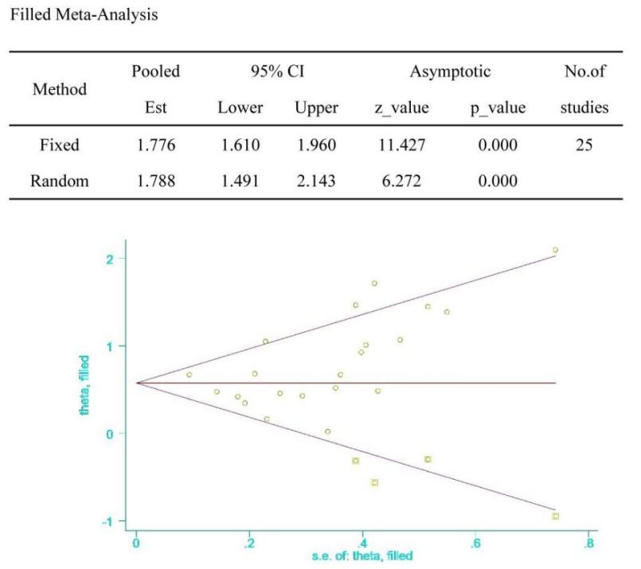
Figure S9 Results of trim-and-fill Analysis for digital eye strain

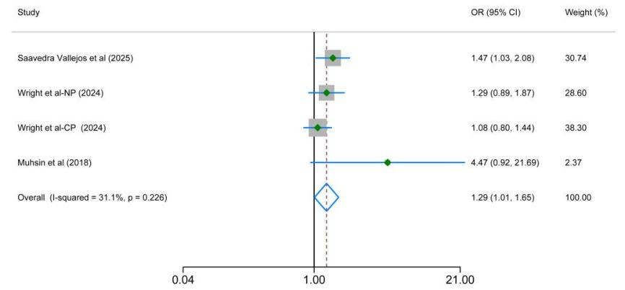
Figure S10 Forest plot of sensitivity analysis for the association between screen time and physical activity

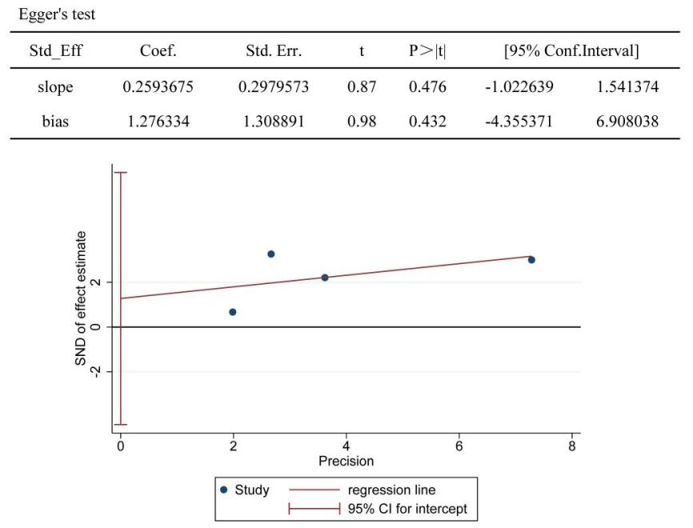
Figure S11 Egger's funnel plot for publication bias in academic performance
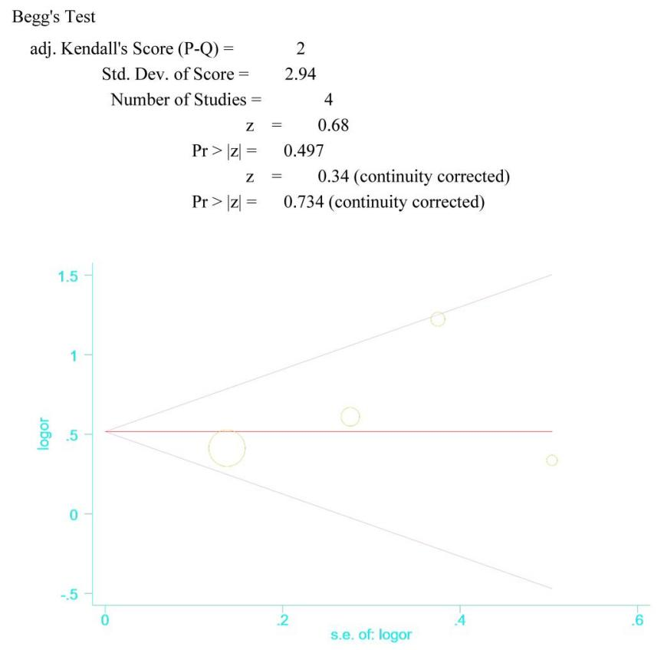
Figure S12 Begg's funnel plot of publication bias in academic performance
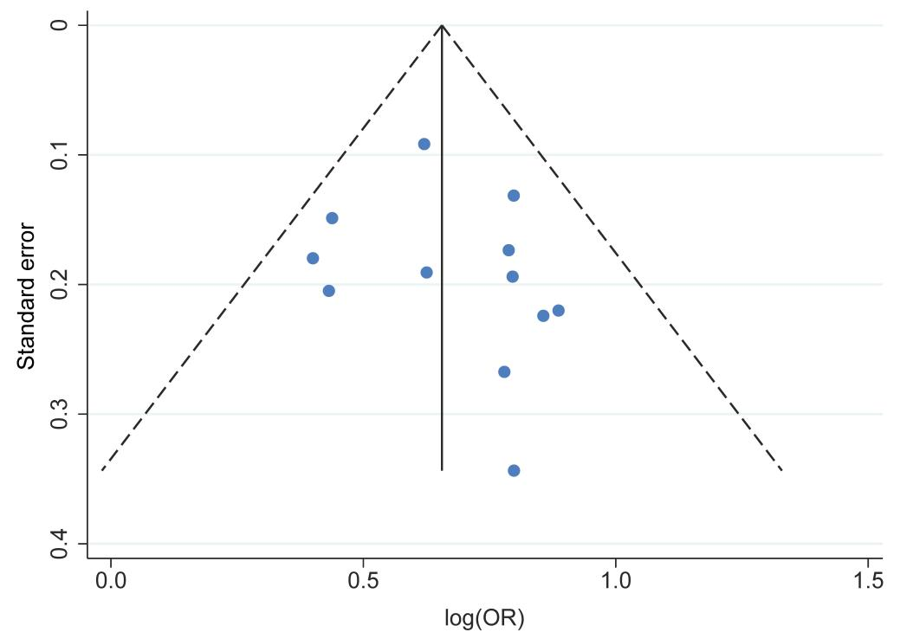
Figure S13 Funnel plot for the association between screen time and depression risk

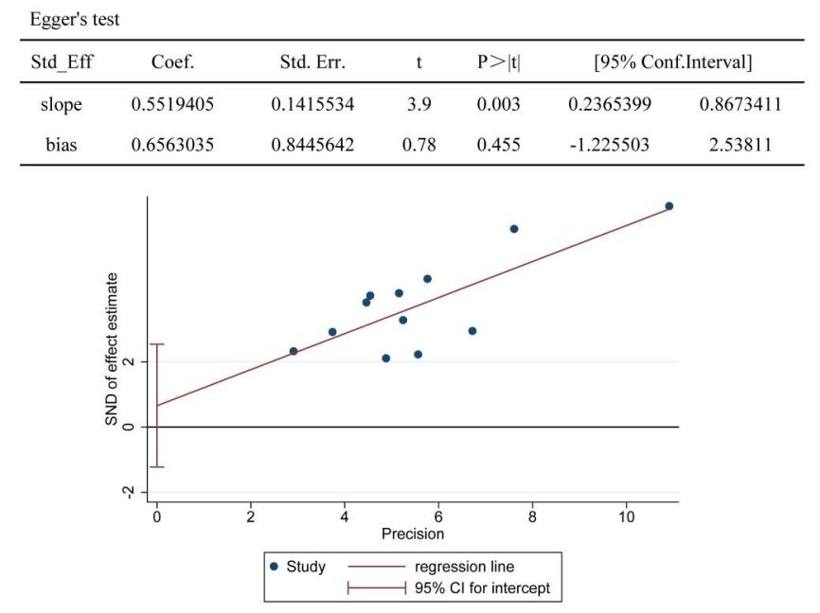
Figure S14 Egger's funnel plot for publication bias in depression risk
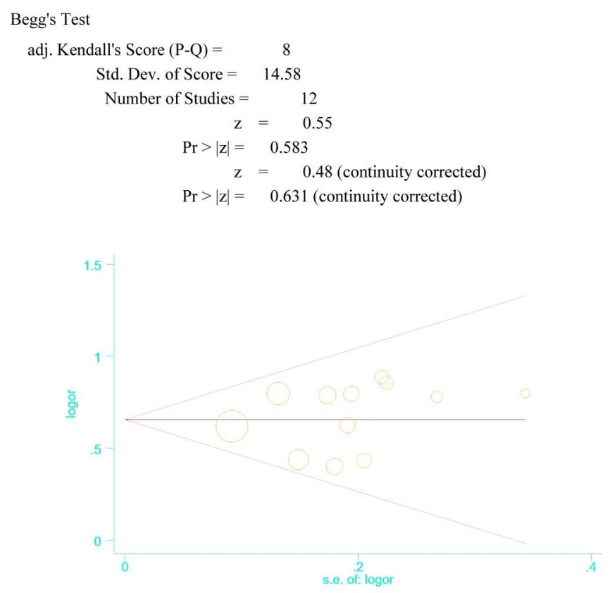
Figure S15 Begg's funnel plot of publication bias in depression risk
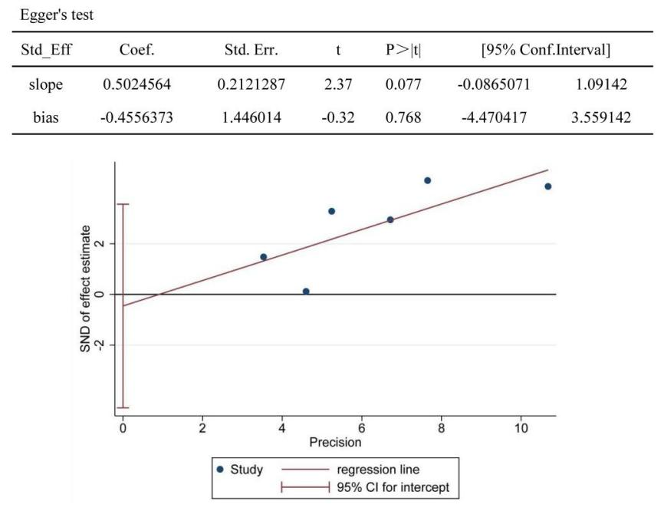
Figure S16 Egger's funnel plot for publication bias in anxiety risk

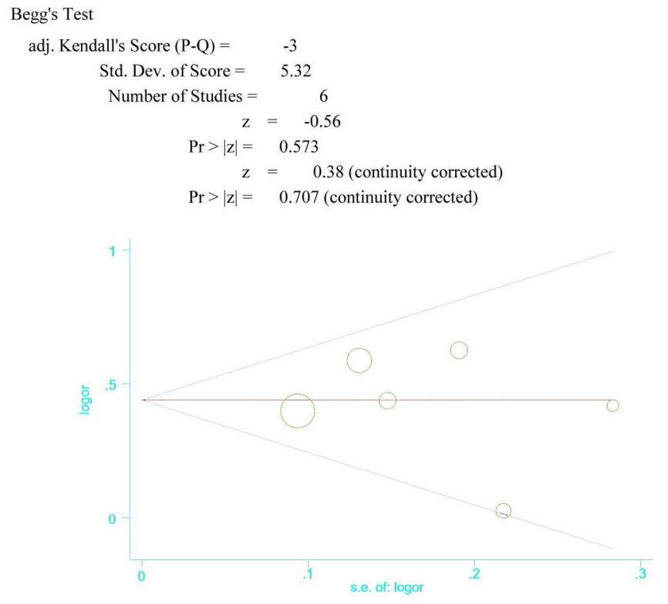
Figure S17 Begg's funnel plot of publication bias in anxiety risk
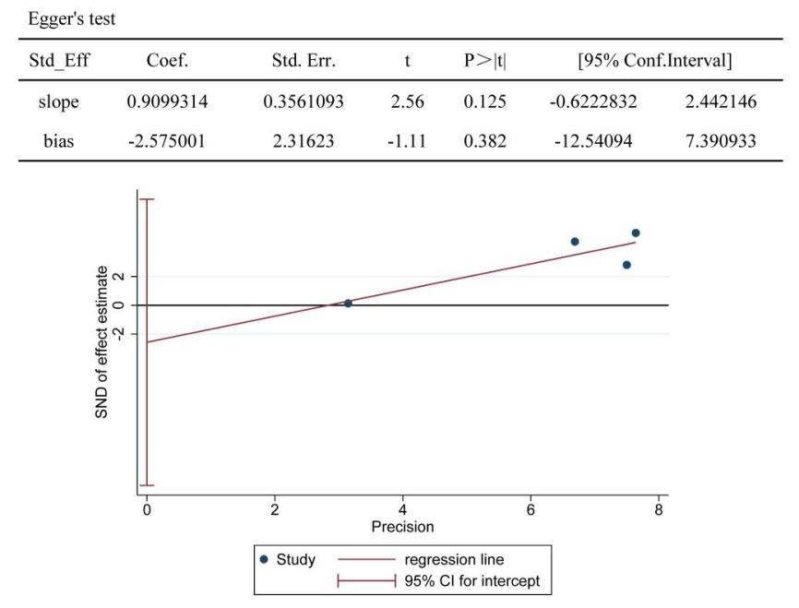
Figure S18 Egger's funnel plot for publication bias in stress risk
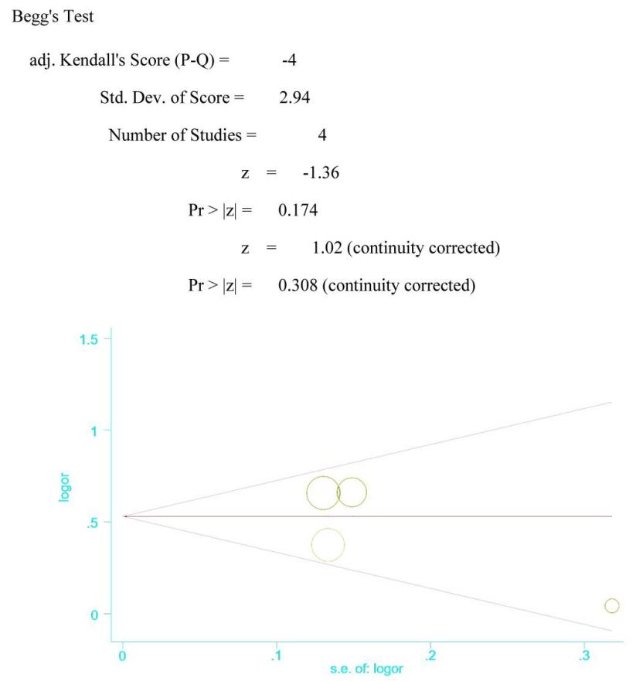
Figure S19 Begg's funnel plot of publication bias in stress risk
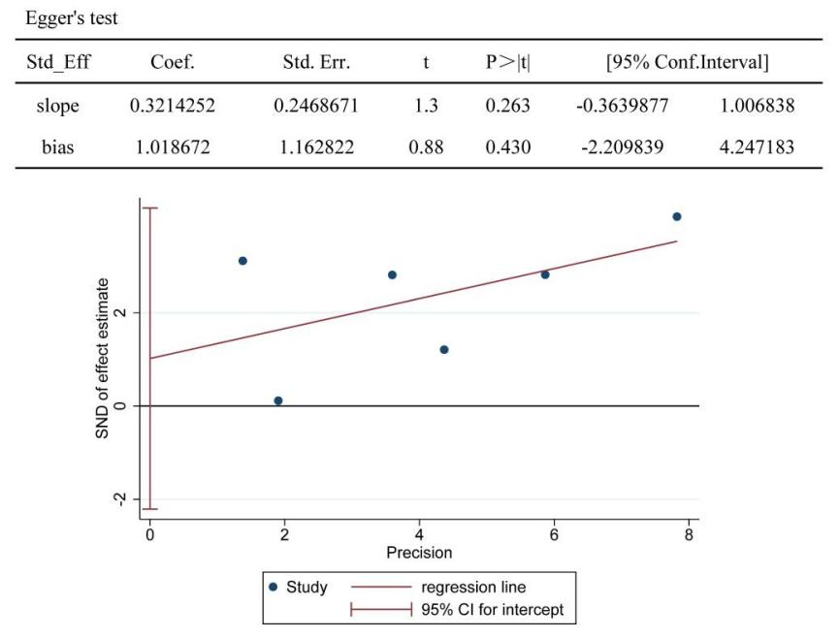
Figure S20 Egger's funnel plot for publication bias in physical pain
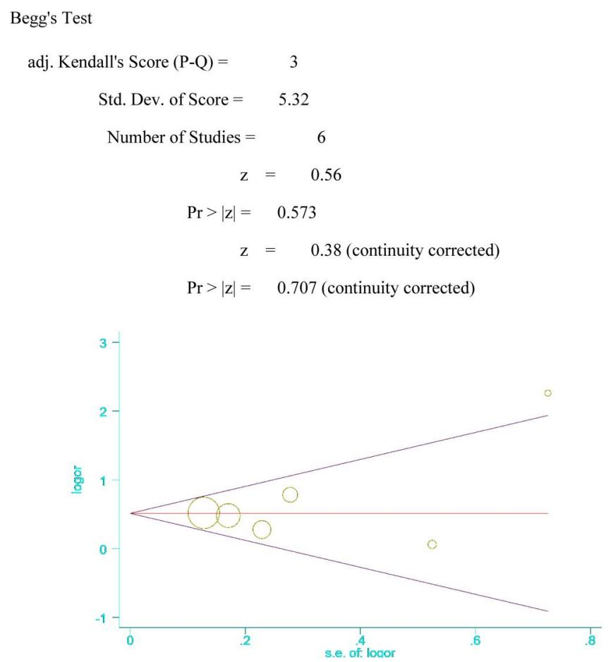
Figure S21 Begg's funnel plot of publication bias in physical pain
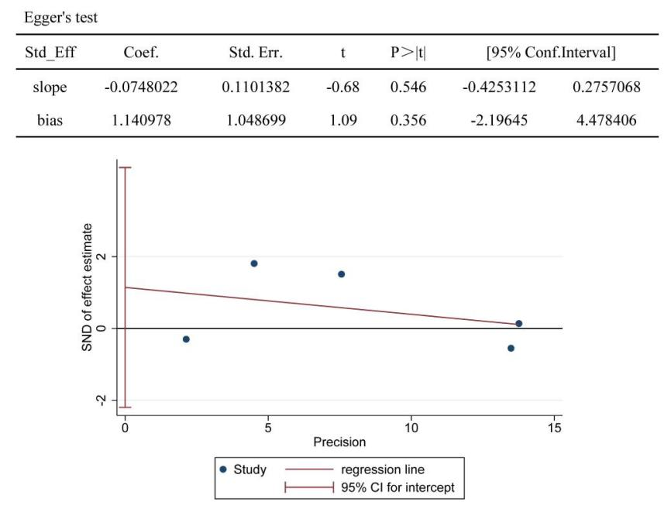
Figure S22 Egger's funnel plot for publication bias in sleep duration
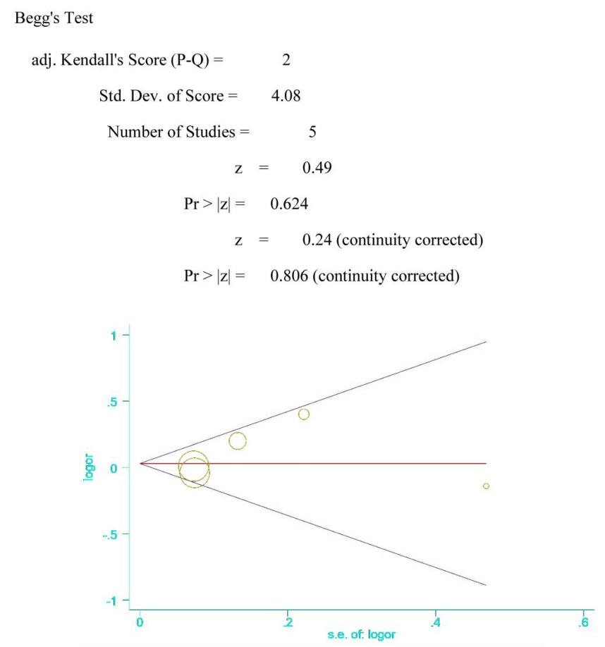
Figure S23 Begg's funnel plot of publication bias in sleep duration
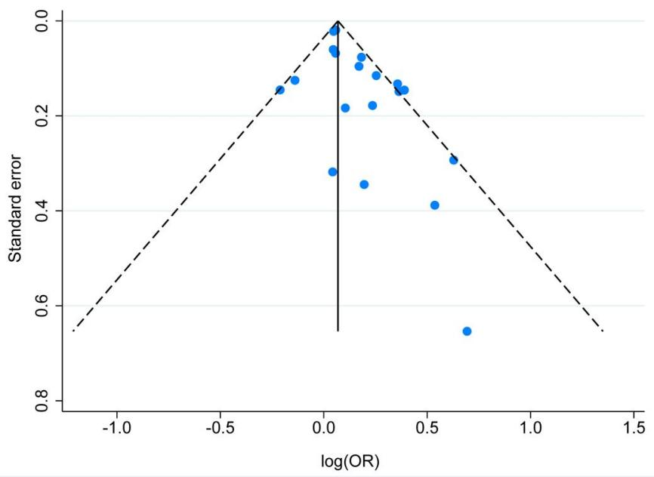
Figure S24 Funnel plot for the association between screen time and sleep quality
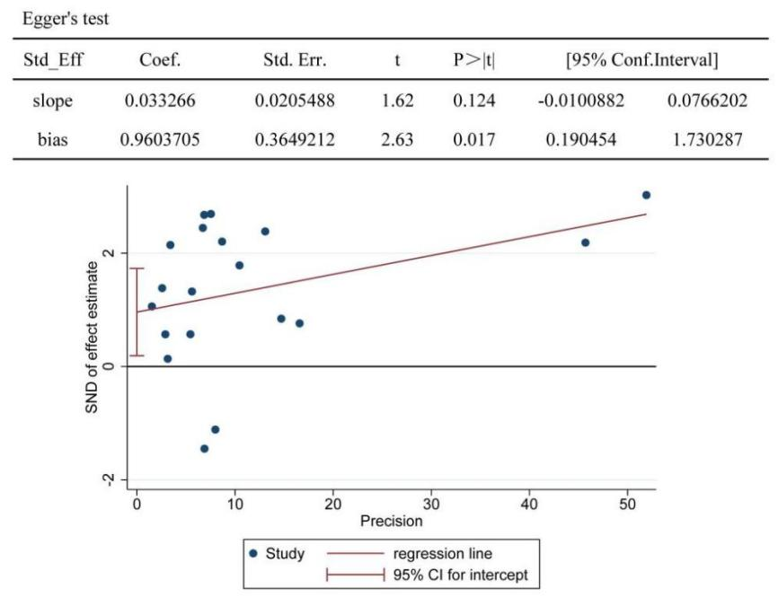
Figure S25 Egger's funnel plot for publication bias in sleep quality
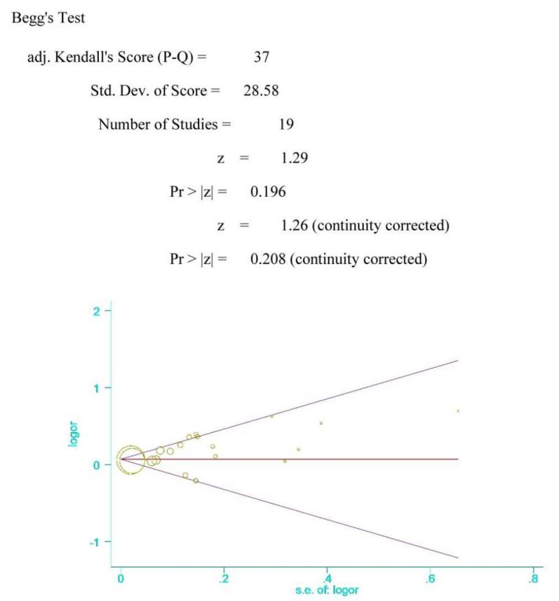
Figure S26 Begg's funnel plot of publication bias in sleep quality
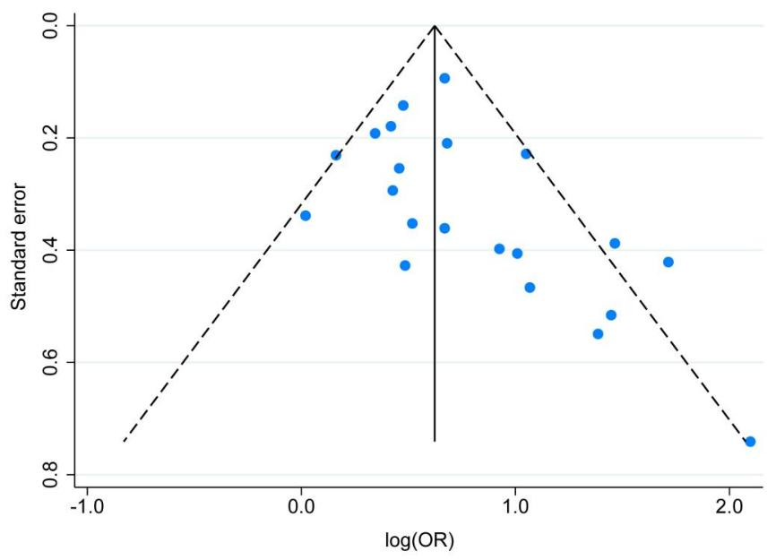
Figure S27 Funnel plot for the association between screen time and digital eye strain

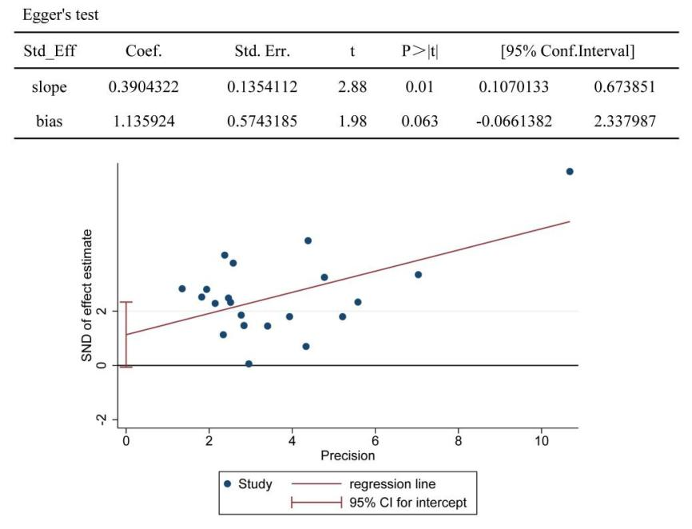
Figure S28 Egger's funnel plot for publication bias in digital eye strain
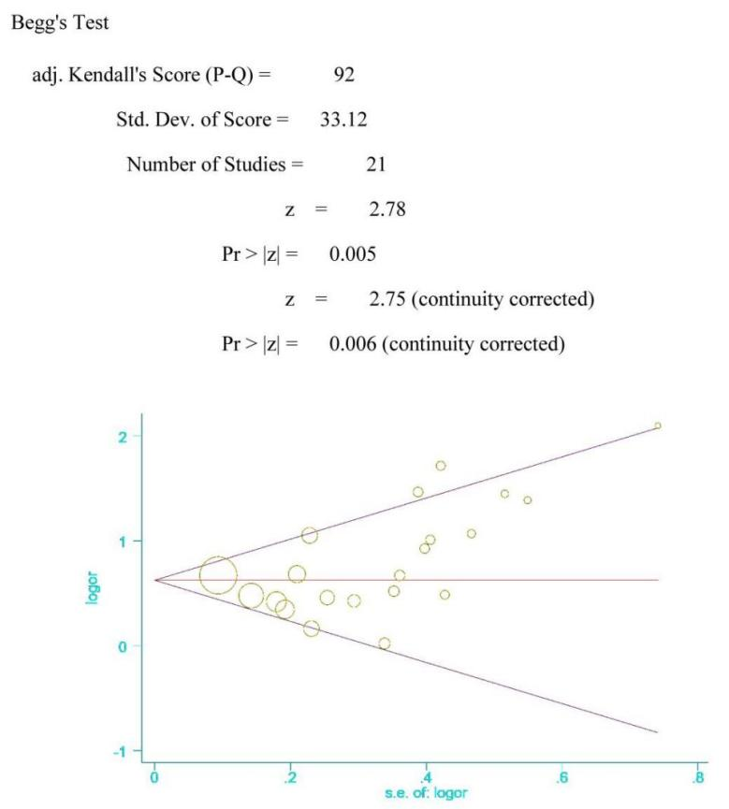
Figure S29 Begg's funnel plot of publication bias in digital eye strain
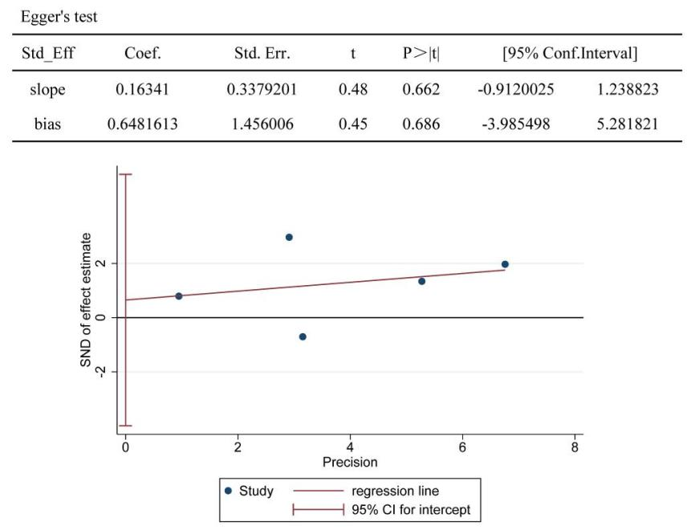
Figure S30 Egger's funnel plot for publication bias in BMI
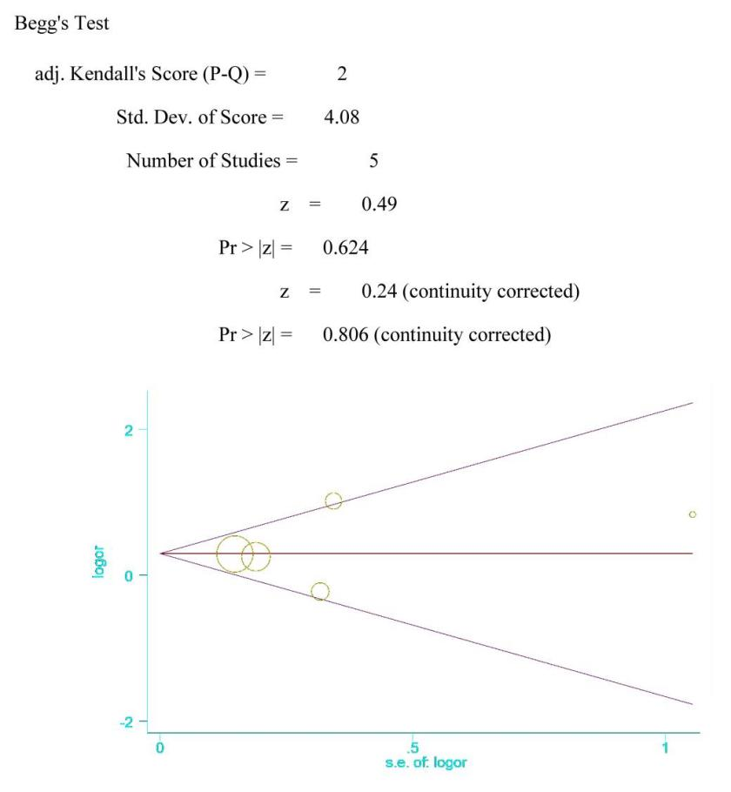
Figure S31 Begg's funnel plot of publication bias in BMI
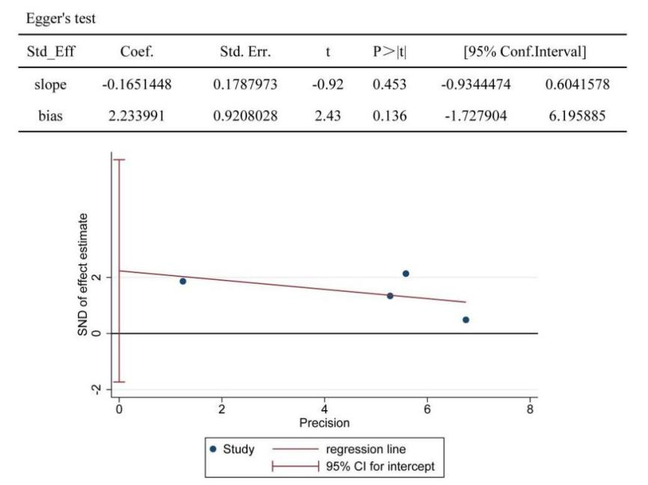
Figure S32 Egger's funnel plot for publication bias in physical activity
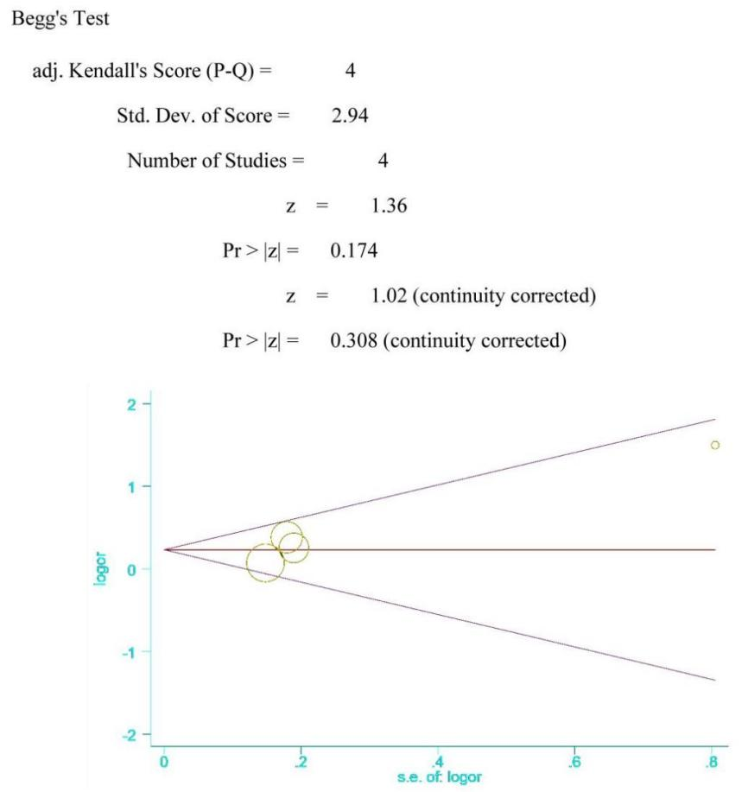
Figure S33 Begg's funnel plot of publication bias in physical activity

Table S4 Subgroup analysis of the association between screen time and depression risk
Subgroup |  | N | OR(95%CI) | P Value | I²(%)
Study period | COVID-19 pandemic period | 10 | 1.37(1.22,1.53) | ＜0.001 | 95.00%
Study period | Non-pandemic period | 7 | 1.76(1.38,2.25) | ＜0.001 | 77.30%
Screen type | Smartphone | 5 | 1.87(1.13,3.11) | ＜0.001 | 94.40%
Screen type | Personal Computer | 2 | 1.71(1.20,2.45) | 0.239 | 27.80%
Screen type | Multiple devices | 6 | 1.42(1.18,1.72) | ＜0.001 | 92.00%
Study quality | Low | 11 | 1.48(1.30,1.70) | ＜0.001 | 95.30%
Study quality | Very low | 6 | 1.75(1.18,2.61) | ＜0.001 | 92.70%
Population | Asia | 12 | 1.45(1.30,1.63) | ＜0.001 | 95.30%
Population | Africa | 1 | 2.36(1.52,3.65) | NA | NA
Population | Europe and America | 4 | 1.59(1.13,2.23) | 0.001 | 81.20%

Table S5 Subgroup analysis of the association between screen time and sleep quality
Subgroup |  | N | OR(95%CI) | P Value | I²(%)
Study period | COVID-19 pandemic period | 15 | 1.20(1.09,1.31) | ＜0.001 | 72.30%
Study period | Non-pandemic period | 10 | 1.41(1.15,1.72) | ＜0.001 | 82.70%
Screen type | Smartphone | 9 | 1.49(1.17,1.90) | ＜0.001 | 86.10%
Screen type | Personal Computer | 2 | 1.19(1.03,1.36) | 0.695 | 0.00%
Screen type | Multiple devices | 12 | 1.34(1.15,1.57) | ＜0.001 | 79.80%
Study quality | Low | 14 | 1.30(1.15,1.47) | ＜0.001 | 82.70%
Study quality | Very low | 11 | 1.36(1.11,1.67) | ＜0.001 | 75.40%
Population | Asia | 19 | 1.29(1.18,1.43) | ＜0.001 | 80.30%
Population | South America | 1 | 0.87(0.68,1.11) | NA | NA
Population | Europe and America | 5 | 1.37(1.09,1.72) | 0.003 | 75.40%

Table S6 Subgroup analysis of the association between screen time and digital eye strain
Subgroup |  | N | OR(95%CI) | P Value | I²(%)
Study period | COVID-19 pandemic period | 16 | 2.28(1.70,3.05) | ＜0.001 | 84.40%
Study period | Non-pandemic period | 10 | 1.93(1.37,2.73) | ＜0.001 | 89.80%
Screen type | Smartphone | 2 | 1.89(0.50,7.15) | 0.034 | 77.70%
Screen type | Personal Computer | 6 | 2.39(1.64,3.48) | ＜0.001 | 95.00%
Screen type | Multiple devices | 13 | 2.01(1.58,2.54) | ＜0.001 | 67.70%
Study quality | Low | 10 | 1.97(1.54,2.52) | ＜0.001 | 74.40%
Study quality | Very low | 16 | 2.22(1.61,3.07) | ＜0.001 | 89.20%
Population | Asia | 19 | 2.36(1.81,3.07) | ＜0.001 | 83.50%
Population | Africa | 3 | 1.32(0.64,2.70) | 0.001 | 86.40%
Population | South America | 1 | 1.95(0.96,3.96) | NA | NA
Population | Europe and America | 3 | 2.05(0.86,4.86) | 0.005 | 80.90%
symptom | CVS | 13 | 2.33(1.66,3.26) | ＜0.001 | 84.20%
symptom | Eye strain | 8 | 1.37(1.13,1.66) | ＜0.001 | 74.50%
symptom | Dry eye | 5 | 2.93(1.61,5.33) | 0.001 | 78.70%

