Supplementary table 1: Cluster’s characteristics (descriptive statistics)
 | Steady (N=760) | Increasing (N=616) | Decreasing (N=264) | Overall (N=1640)
SES
poorest | 161 (21.2%) | 108 (17.5%) | 47 (17.8%) | 316 (19.3%)
poorer | 146 (19.2%) | 111 (18.0%) | 62 (23.5%) | 319 (19.5%)
middle | 141 (18.6%) | 121 (19.6%) | 38 (14.4%) | 300 (18.3%)
richer | 135 (17.8%) | 122 (19.8%) | 54 (20.5%) | 311 (19.0%)
richest | 177 (23.3%) | 154 (25.0%) | 63 (23.9%) | 394 (24.0%)
Age
Mean (SD) | 53.2 (14.7) | 57.1 (16.0) | 55.6 (15.4) | 55.0 (15.4)
Median [Min, Max] | 52.0 [17.0, 95.0] | 57.0 [20.0, 102] | 53.0 [18.0, 99.0] | 54.0 [17.0, 102]
Education
Secondary & Higher education | 171 (22.5%) | 126 (20.5%) | 59 (22.3%) | 356 (21.7%)
Primary | 429 (56.4%) | 348 (56.5%) | 140 (53.0%) | 917 (55.9%)
Never been school | 160 (21.1%) | 142 (23.1%) | 65 (24.6%) | 367 (22.4%)
Marital Status
Single | 99 (13.0%) | 71 (11.5%) | 24 (9.1%) | 194 (11.8%)
Married | 142 (18.7%) | 126 (20.5%) | 49 (18.6%) | 317 (19.3%)
divorced or widowed | 87 (11.4%) | 83 (13.5%) | 16 (6.1%) | 186 (11.3%)
other | 432 (56.8%) | 336 (54.5%) | 175 (66.3%) | 943 (57.5%)
Ever worked | 597 (78.6%) | 492 (79.9%) | 200 (75.8%) | 1289 (78.6%)
Currently working | 347 (45.7%) | 286 (46.4%) | 122 (46.2%) | 755 (46.0%)
Average time between visits (weeks)
Mean (SD) | 5.03 (0.912) | 4.99 (0.892) | 4.55 (0.935) | 4.94 (0.923)
Median [Min, Max] | 5.21 [2.60, 7.53] | 5.04 [3.00, 7.00] | 4.41 [3.00, 6.89] | 5.04 [2.60, 7.53]
Length of follow up (weeks)
Mean (SD) | 170 (92.0) | 164 (91.0) | 133 (93.7) | 162 (92.8)
Median [Min, Max] | 181 [16.0, 482] | 164 [16.0, 376] | 126 [15.0, 359] | 168 [15.0, 482]
Gender head of household
female | 311 (40.9%) | 256 (41.6%) | 95 (36.0%) | 662 (40.4%)
male | 449 (59.1%) | 360 (58.4%) | 169 (64.0%) | 978 (59.6%)
Refugee | 158 (20.8%) | 114 (18.5%) | 44 (16.7%) | 316 (19.3%)
known diabetes | 57 (7.5%) | 67 (10.9%) | 16 (6.1%) | 140 (8.5%)
known ASTHMA | 7 (0.9%) | 7 (1.1%) | 2 (0.8%) | 16 (1.0%)
known raised BP | 24 (3.2%) | 14 (2.3%) | 21 (8.0%) | 59 (3.6%)
known TB | 8 (1.1%) | 6 (1.0%) | 5 (1.9%) | 19 (1.2%)
known HIV | 288 (37.9%) | 163 (26.5%) | 114 (43.2%) | 565 (34.5%)
Age at first marriage (women)
Mean (SD) | 23.4 (8.23) | 22.7 (8.14) | 24.6 (9.14) | 23.3 (8.34)
Median [Min, Max] | 22.0 [9.00, 66.0] | 21.0 [10.0, 69.0] | 23.0 [2.00, 66.0] | 21.0 [2.00, 69.0]
Missing | 322 (42.4%) | 249 (40.4%) | 133 (50.4%) | 704 (42.9%)
Gender
Female | 532 (70.0%) | 468 (76.0%) | 157 (59.5%) | 1157 (70.5%)
Male | 228 (30.0%) | 148 (24.0%) | 107 (40.5%) | 483 (29.5%)
Number of deaths | 58 (7.6%) | 63 (10.2%) | 25 (9.5%) | 146 (8.9%)

Supplementary table 2. BP trajectories
 | Cluster1: Steady |  |  |  |  |  |  |  |  | Cluster2: Increasing |  |  |  |  |  |  |  |  | Cluster3: Decreasing
 | Systolic |  |  | Diastolic |  |  | Weight |  |  | Systolic |  |  | Diastolic |  |  | Weight |  |  | Systolic |  |  | Diastolic |  |  | Weight
Month | Mean | 95% CI |  | Mean | 95% CI |  | Mean | 95% CI |  | Mean | 95% CI |  | Mean | 95% CI |  | Mean | 95% CI |  | Mean | 95% CI |  | Mean | 95% CI |  | Mean | 95% CI
0 | 153 | 152 | 154 | 90 | 89 | 90 | 78 | 77 | 79 | 170 | 168 | 172 | 96 | 95 | 98 | 79 | 77 | 80 | 137 | 136 | 138 | 80 | 79 | 81 | 76 | 75 | 77
1 | 148 | 147 | 148 | 87 | 86 | 87 | 78 | 77 | 79 | 168 | 166 | 170 | 95 | 94 | 96 | 79 | 78 | 81 | 131 | 130 | 132 | 77 | 76 | 77 | 76 | 75 | 77
2 | 145 | 145 | 146 | 86 | 85 | 86 | 78 | 77 | 79 | 167 | 165 | 168 | 93 | 92 | 94 | 78 | 77 | 80 | 130 | 129 | 130 | 76 | 75 | 76 | 75 | 74 | 76
3 | 145 | 144 | 145 | 85 | 85 | 86 | 78 | 77 | 79 | 164 | 162 | 166 | 93 | 91 | 94 | 79 | 77 | 80 | 128 | 128 | 129 | 75 | 75 | 76 | 76 | 75 | 77
4 | 145 | 144 | 145 | 85 | 85 | 86 | 78 | 77 | 79 | 164 | 162 | 166 | 93 | 91 | 94 | 79 | 77 | 80 | 127 | 127 | 128 | 75 | 74 | 76 | 75 | 74 | 76
5 | 144 | 143 | 145 | 84 | 84 | 85 | 78 | 77 | 79 | 164 | 162 | 166 | 93 | 92 | 94 | 79 | 77 | 81 | 127 | 126 | 128 | 75 | 74 | 75 | 75 | 74 | 76
6 | 143 | 142 | 144 | 84 | 83 | 85 | 78 | 77 | 78 | 164 | 162 | 166 | 93 | 92 | 94 | 79 | 77 | 80 | 127 | 126 | 128 | 75 | 74 | 76 | 76 | 75 | 77
7 | 142 | 141 | 143 | 83 | 83 | 84 | 78 | 77 | 79 | 165 | 163 | 167 | 94 | 92 | 95 | 80 | 78 | 81 | 126 | 125 | 127 | 74 | 73 | 75 | 75 | 74 | 76
8 | 143 | 142 | 143 | 83 | 83 | 84 | 78 | 77 | 79 | 166 | 164 | 168 | 95 | 93 | 96 | 79 | 78 | 81 | 126 | 125 | 127 | 74 | 74 | 75 | 75 | 74 | 76
9 | 142 | 142 | 143 | 84 | 83 | 84 | 78 | 77 | 79 | 165 | 163 | 168 | 94 | 92 | 96 | 79 | 77 | 81 | 126 | 125 | 127 | 74 | 74 | 75 | 75 | 74 | 76
10 | 142 | 141 | 143 | 83 | 83 | 84 | 78 | 77 | 79 | 165 | 163 | 167 | 94 | 92 | 96 | 79 | 77 | 81 | 125 | 124 | 126 | 74 | 73 | 74 | 75 | 74 | 76
11 | 143 | 142 | 144 | 84 | 83 | 84 | 78 | 77 | 79 | 167 | 165 | 169 | 93 | 92 | 95 | 80 | 78 | 82 | 125 | 124 | 126 | 74 | 73 | 74 | 75 | 74 | 76
12 | 142 | 141 | 143 | 83 | 82 | 83 | 77 | 76 | 78 | 166 | 164 | 168 | 93 | 92 | 95 | 80 | 78 | 82 | 125 | 124 | 126 | 74 | 73 | 74 | 75 | 74 | 76
13 | 142 | 141 | 143 | 83 | 82 | 84 | 78 | 77 | 79 | 167 | 164 | 170 | 94 | 92 | 96 | 79 | 77 | 81 | 126 | 125 | 127 | 74 | 73 | 75 | 75 | 74 | 77
14 | 143 | 142 | 144 | 84 | 83 | 84 | 78 | 77 | 79 | 167 | 164 | 170 | 94 | 92 | 96 | 80 | 78 | 82 | 126 | 125 | 128 | 74 | 73 | 75 | 75 | 74 | 76
15 | 143 | 142 | 144 | 83 | 82 | 83 | 78 | 76 | 79 | 168 | 165 | 171 | 94 | 92 | 96 | 80 | 78 | 82 | 125 | 124 | 126 | 73 | 72 | 74 | 75 | 74 | 76
16 | 142 | 141 | 143 | 83 | 82 | 83 | 78 | 77 | 79 | 168 | 165 | 171 | 95 | 92 | 97 | 79 | 76 | 81 | 125 | 123 | 126 | 72 | 72 | 73 | 75 | 74 | 76
17 | 143 | 142 | 144 | 83 | 82 | 84 | 78 | 77 | 79 | 170 | 167 | 173 | 94 | 92 | 96 | 80 | 78 | 82 | 125 | 124 | 126 | 73 | 72 | 74 | 75 | 74 | 76
18 | 142 | 141 | 143 | 83 | 82 | 83 | 77 | 76 | 78 | 167 | 165 | 170 | 94 | 92 | 97 | 78 | 76 | 81 | 123 | 122 | 124 | 71 | 71 | 72 | 76 | 74 | 77
19 | 143 | 142 | 144 | 82 | 81 | 83 | 78 | 77 | 79 | 170 | 167 | 173 | 94 | 92 | 96 | 80 | 78 | 82 | 123 | 121 | 124 | 71 | 71 | 72 | 75 | 74 | 76
20 | 142 | 141 | 143 | 83 | 82 | 84 | 78 | 77 | 79 | 168 | 165 | 171 | 95 | 92 | 98 | 80 | 78 | 82 | 123 | 122 | 124 | 72 | 71 | 72 | 75 | 74 | 76
21 | 143 | 142 | 144 | 83 | 82 | 84 | 78 | 77 | 79 | 172 | 169 | 174 | 96 | 94 | 98 | 79 | 77 | 81 | 123 | 121 | 124 | 71 | 70 | 71 | 75 | 73 | 76
22 | 142 | 141 | 143 | 82 | 82 | 83 | 78 | 77 | 79 | 168 | 165 | 171 | 95 | 92 | 98 | 80 | 78 | 82 | 122 | 121 | 123 | 71 | 70 | 72 | 76 | 74 | 77
23 | 142 | 141 | 143 | 83 | 82 | 83 | 78 | 77 | 79 | 171 | 168 | 175 | 97 | 93 | 100 | 79 | 77 | 81 | 123 | 121 | 124 | 71 | 69 | 72 | 75 | 73 | 76
24 | 143 | 142 | 144 | 83 | 82 | 83 | 78 | 77 | 79 | 169 | 167 | 172 | 96 | 93 | 99 | 81 | 78 | 83 | 123 | 122 | 125 | 71 | 70 | 72 | 76 | 75 | 77

Supplementary Figure 1.a Multinomial logistic regression to characterize cluster trajectories (Marginal Probabilities)
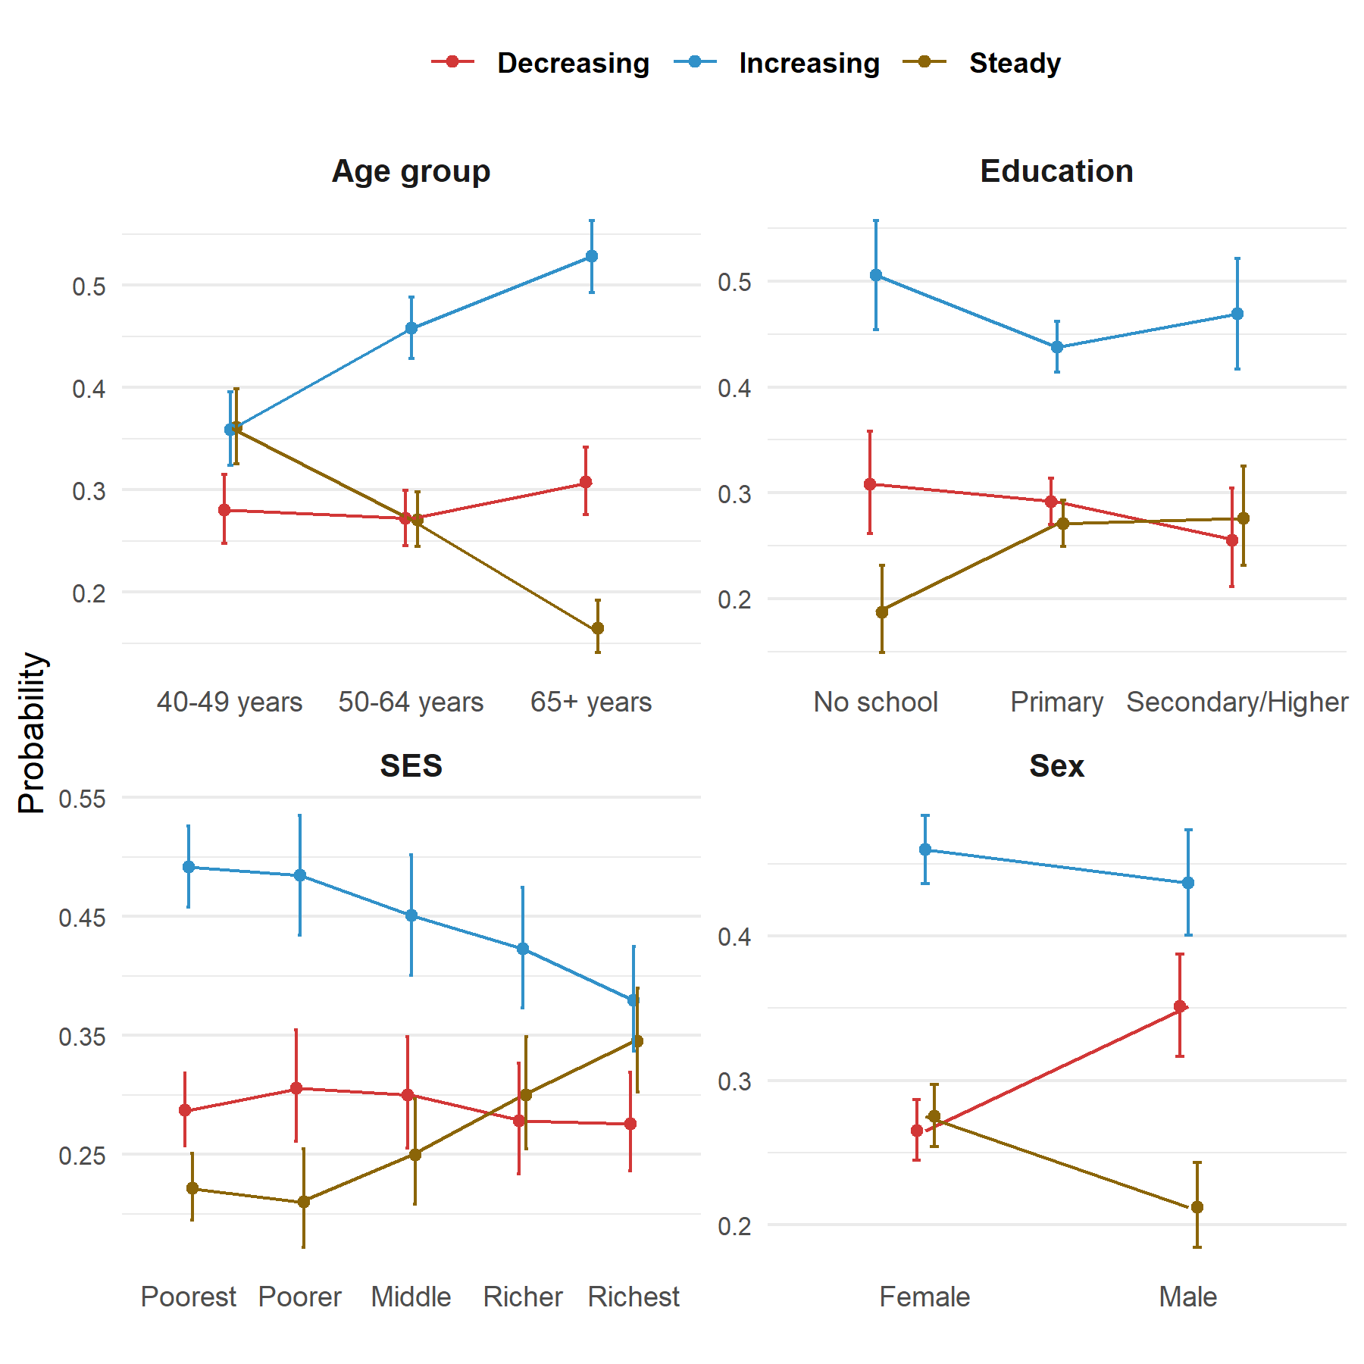

Supplementary Figure 1.b Multinomial logistic regression to characterize cluster trajectories (Marginal Probabilities)
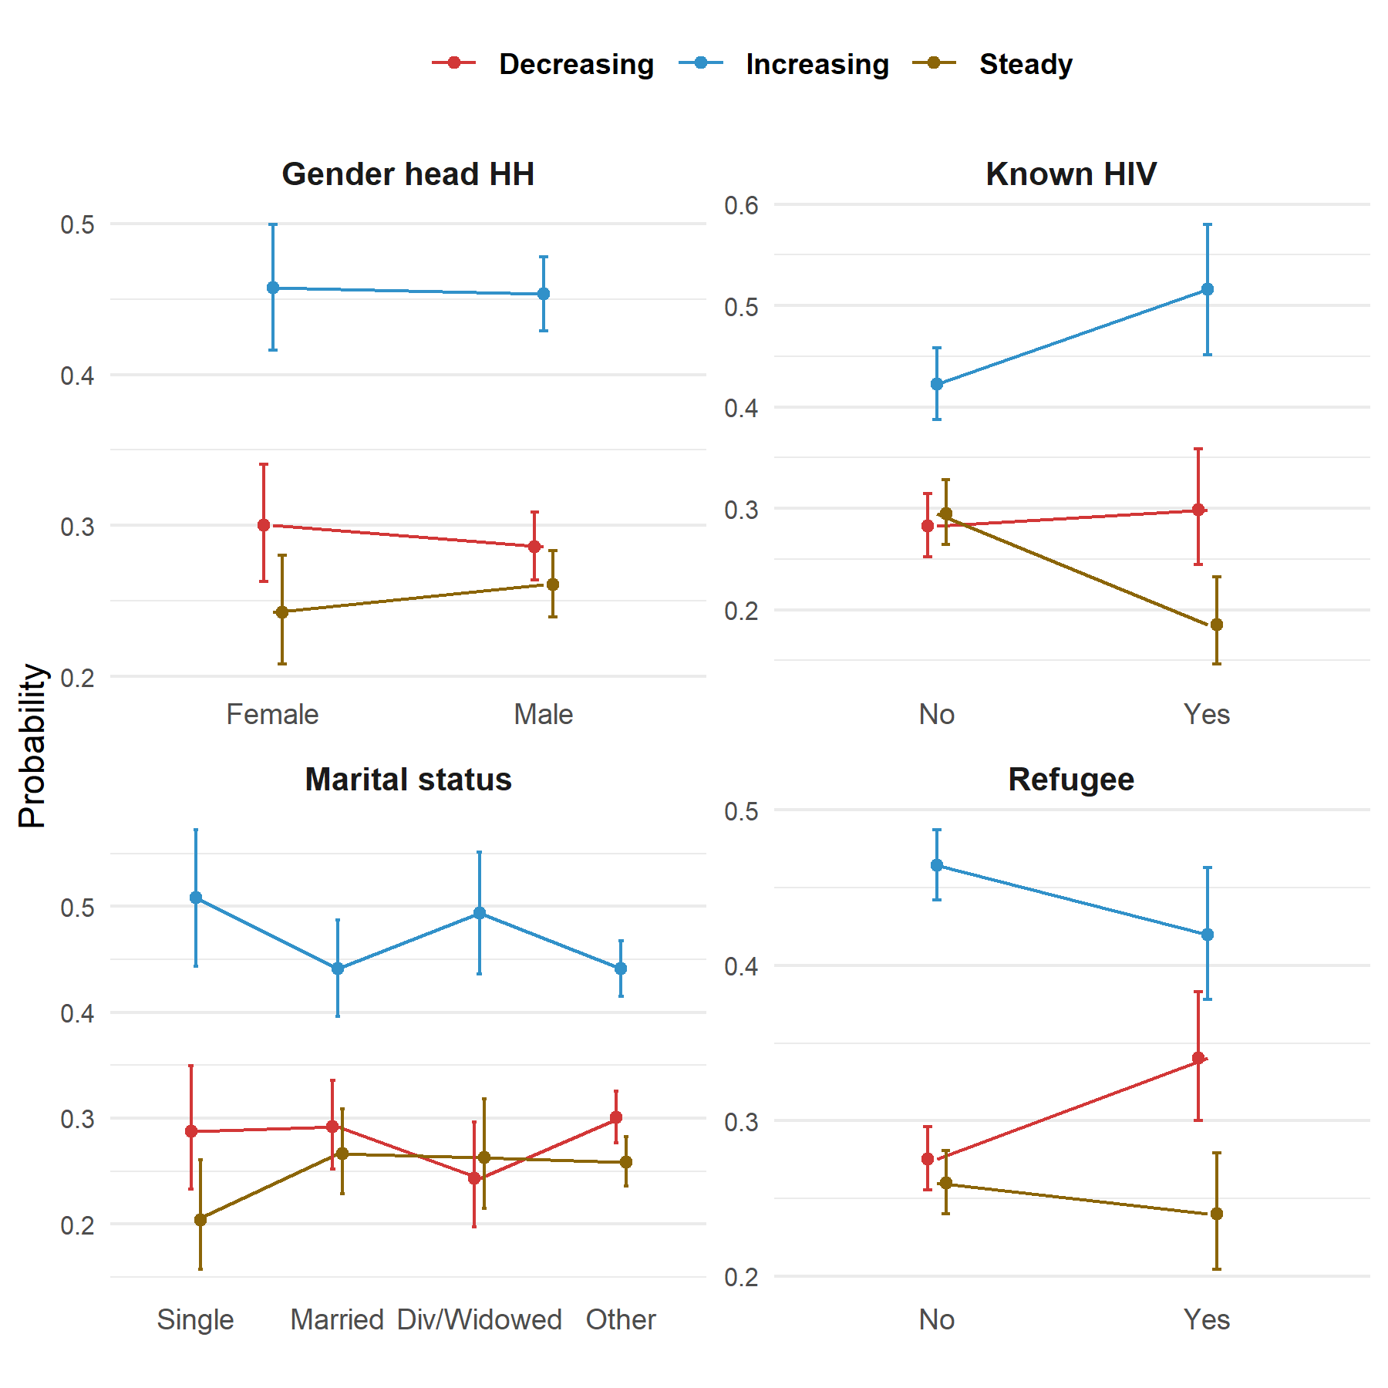

Supplementary table 3. Association between blood pressure trajectories and risk of death using the ( Adjusted Cox proportional hazards regression model)
variable | HR | LL | UL | P value
Cluster/ Group
Decreasing | 0.68 | 0.12 | 3.70 | 0.653
Increasing | 2.80 | 0.90 | 8.74 | 0.076
Age group
50-64 years | 1.74 | 0.98 | 3.07 | 0.057
65+ years | 3.69 | 2.15 | 6.34 | 0.000
Interaction
Steady * Age 50-64 | 2.11 | 0.65 | 6.82 | 0.214
Increasing* Age 50-64 | 0.93 | 0.44 | 1.95 | 0.843
Decreasing * Age 50-64 | 6.39 | 1.46 | 27.94 | 0.014
Steady * Age 65+ | 6.62 | 2.17 | 20.19 | 0.001
Increasing * Age 65+ | 2.46 | 1.28 | 4.73 | 0.007
Decreasing * Age 65+ | 7.98 | 1.83 | 34.73 | 0.006
Steady * known HIV | 0.53 | 0.18 | 1.54 | 0.242
Increasing * known HIV | 1.07 | 0.62 | 1.84 | 0.814
Decreasing * known HIV | 0.45 | 0.20 | 1.00 | 0.049
Supplementary table 4 Overview of Patient count, clinic visits, and deaths

Total number of clinic visit recorded | Death count | Death count (cumulative) | Patients count (cumulative)
1 | 35 | 35 | 457
2 | 44 | 79 | 810
3 | 23 | 102 | 1105
4 | 35 | 137 | 1392
5 | 24 | 161 | 1687
6 | 22 | 183 | 1970
7 | 23 | 206 | 2278
8 | 24 | 230 | 2592
9 | 20 | 250 | 2887
10 | 25 | 275 | 3124
11 | 18 | 293 | 3367
12 | 14 | 307 | 3576
13 | 20 | 327 | 3781
14 | 22 | 349 | 3987
15 | 20 | 369 | 4188
16 | 14 | 383 | 4358
17 | 12 | 395 | 4529
18 | 16 | 411 | 4696
19 | 18 | 429 | 4850
20 | 21 | 450 | 5011
21 | 15 | 465 | 5145
22 | 12 | 477 | 5295
23 | 11 | 488 | 5458
24 | 8 | 496 | 5630
25 | 15 | 511 | 5823
26 | 14 | 525 | 6031
27 | 14 | 539 | 6256
28 | 10 | 549 | 6461
29 | 14 | 563 | 6699
30 | 7 | 570 | 6903
31 | 16 | 586 | 7131
32 | 9 | 595 | 7343
33 | 9 | 604 | 7530
34 | 9 | 613 | 7705
35 | 8 | 621 | 7855
36 | 5 | 626 | 7996
37 | 6 | 632 | 8135
38 | 4 | 636 | 8249
39 | 1 | 637 | 8363
40 | 5 | 642 | 8471
41 | 5 | 647 | 8581
42 | 3 | 650 | 8661
43 | 4 | 654 | 8729
44 | 3 | 657 | 8797
45 | 5 | 662 | 8870
46 | 4 | 666 | 8943
47 | 0 | 666 | 9008
48 | 3 | 669 | 9071
49 | 1 | 670 | 9119
50 | 3 | 673 | 9163
51 | 0 | 673 | 9205
52 | 4 | 677 | 9257
53 | 5 | 682 | 9298
54 | 1 | 683 | 9336
55 | 3 | 686 | 9379
56 | 1 | 687 | 9408
57 | 0 | 687 | 9436
58 | 0 | 687 | 9458
59 | 0 | 687 | 9483
60 | 0 | 687 | 9497
61 | 0 | 687 | 9517
62 | 0 | 687 | 9527
63 | 0 | 687 | 9536
64 | 0 | 687 | 9542
65 | 1 | 688 | 9551

