Supplementary material
Methods. Overview of Included Aging Cohorts
I.HRS (the US Health and Retirement Study)
II.MHAS (the Mexican Health and Ageing Study)
III.ELSA (the English Longitudinal Study on Ageing)
IV.SHARE (the Survey of Health, Ageing and Retirement in Europe)
V.CRELES (the Costa Rican Longevity and Healthy Aging Study)
VI.JSTAR (the Japanese Study of Aging and Retirement)
VII.CHARLS (the China Health and Retirement Longitudinal Study)
VIII.LASI (the Longitudinal Aging Study in India）
Figure S1. Flowchart of multi-cohort participants selection.
Table S1. Definitions of Key Variables Across Cohorts
Table S2. Baseline Characteristics of the Study Population by Socioeconomic Status (SES) Groups
Table S3. Multivariable-adjusted odds ratios for functional outcomes by SES level, stratified by depressive symptoms.
Figure S2. Specific and pooled effect of socioeconomic status on the risk of low muscle strength
Figure S3. Specific and pooled effect of socioeconomic status on the risk of low physical performance
Figure S4. Specific and pooled effect of socioeconomic status on the risk of low community participation
Figure S5. Subgroup analysis- Associations of education-wealth combinations with odds of low muscle strength.
Figure S6. Subgroup analysis- Associations of education-wealth combinations with odds of low physical performance.
Figure S7. Subgroup analysis- Associations of education-wealth combinations with odds of low community participation.
Figure S8. Sensitive analysis—Associations of education-wealth combinations with odds of low muscle strength, physical performance, and community participation in participants without cancer, heart problem and stroke.
Figure S9. Associations between socioeconomic status and functional impairments, stratified by depressive symptoms.
Figure S10. Sensitive analysis—specific and pooled effect of household income on the odds of low muscle strength
Figure S11. Sensitive analysis—specific and pooled effect of household income on the odds of low physical performance
Figure S12. Sensitive analysis—specific and pooled effect of household income on the odds of low community participation

Methods . Overview of Included Aging Cohorts
I. Health and Retirement Study (HRS)[1]
HRS, administered by the University of Michigan’s Institute for Social Research and primarily funded by the National Institute on Aging (NIA U01AG009740), is a nationally representative longitudinal survey of >20,000 U.S. adults aged ≥50. Established in 1992 with biennial follow-ups, it incorporates rotating psychosocial self-administered questionnaires since 2006, capturing social engagement, subjective well-being, and lifestyle factors. Ethical approval was granted by the University of Michigan Institutional Review Board (HUM0061128).
II. Mexican Health and Aging Study (MHAS)[2]
MHAS, directed by the University of Texas Medical Branch ,and supported by the National Institutes of Health/National Institute on AgingNIA/NIH funding (R01 AG018016 and R01 AG030153) and by the INEGI in Mexico, is a nationally representative longitudinal cohort of >15,000 Mexicans aged ≥50. Initiated in 2001 with 5-year follow-up intervals, it employs face-to-face interviews to collect biomarker data, chronic disease histories, and social participation metrics. Ethical approval was obtained from the Institutional Review Board or Ethics Committee of the University of Texas Medical Branch, the INEGI in Mexico, and the Instituto Nacional de Salud Pública (INSP) in Mexico.
III. English Longitudinal Study of Ageing (ELSA)[3]
ELSA, funded by the National Institute of Aging [grants 2RO1AG7644-01A1 and 2RO1AG017644] and a consortium of UK government departments coordinated by the Office for National Statistics, follows >12,000 English adults aged ≥50. Launched in 2002 with biennial assessments, it combines nurse-administered physical measurements with computer-assisted personal interviews to document wealth dynamics, social networks, and functional limitations. ELSA wave6 received ethical approval from the NRES Committee South Central - Berkshire(11/SC/0374).
IV. Survey of Health, Ageing and Retirement in Europe (SHARE)[4]
During the first three Waves, the SHARE data collection has been primarily funded by the European Commission through the fifth framework programme (QLK6-CT-2001- 00360 in the thematic programme Quality of Life), through the sixth framework programme (SHARE-I3, RII-CT- 2006-062193, COMPARE,CIT5-CT-2005-028857, SHARELIFE, CIT4-CT-2006-028812) and through the seventh framework programme (SHARE-PREP, 211909, SHARE-LEAP,227822). SHARE includes >150,000 adults aged ≥50 across 28 countries.Conducted biennially since 2004 using computer-assisted personal interviewing (CAPI) and self-interviewing (CASI), it provides harmonized data on health economics, social support systems, and physical performance. Starting with Wave 4, SHARE has changed to a decentralized funding model and became an international organization (SHARE-ERIC) funded by its member countries. Ethical compliance is monitored by the SHARE-ERIC.
V. Costa Rican Longevity and Healthy Aging Study (CRELES)[5]
CRELES, led by the University of Costa Rica with NIA support (R01AG031716), is a longitudinal cohort of >2,800 Costa Ricans aged ≥60. Initiated in 2004 with 5-year follow-ups, it uniquely integrates national mortality registry data with comprehensive assessments of biological aging markers, social integration, and economic vulnerability. Ethical approval was granted by the University of Costa Rica IRB.
VI. Japanese Study of Aging and Retirement (JSTAR)[6]
The Japanese Study of Aging and Retirement (JSTAR) was conducted by the Research Institute of Economy, Trade and Industry (RIETI), Hitotsubashi University, and the University of Tokyo. JSTAR, managed by Hitotsubashi University with funding from RIETI and MEXT, follows >7,000 Japanese adults aged 50–75. Established in 2007 with triennial waves, it employs municipality-stratified probability sampling to examine work-retirement transitions, intergenerational support, and health disparities. Ethical approval was provided by Hitotsubashi University IRB.
VII. China Health and Retirement Longitudinal Study (CHARLS)[7]
CHARLS, directed by Peking University , represents >17,000 Chinese adults aged ≥45. Commencing in 2011 with biennial surveys, it uses village-based probability sampling to document pension systems, caregiving burdens, and disability trajectories. Ethical approval was obtained from the Peking University IRB (IRB00001052-11015 and IRB00001052-11014).
VIII. Longitudinal Aging Study in India (LASI)[8]
LASI, operated by the International Institute for Population Sciences (IIPS) with NIA/Harvard funding , surveys >72,000 Indians aged ≥45 across all states. Initiated in 2010 with 3-year intervals, it addresses methodological challenges in cognitive assessment within multi-generational households and health system utilization patterns. Ethical approvals were obtained from Indian Council of Medical Research (ICMR), Delhi; IRB, International Institute for Population Sciences (IIPS), Mumbai; IRB, Harvard T.H. Chan School of Public Health (HSPH), Boston; IRB, University of Southern California (USC), Los Angeles; IRB, ICMR National AIDS Research Institute (NARI), Pune; and IRB, Regional Geriatric Centres (RGCs), MoHFW.

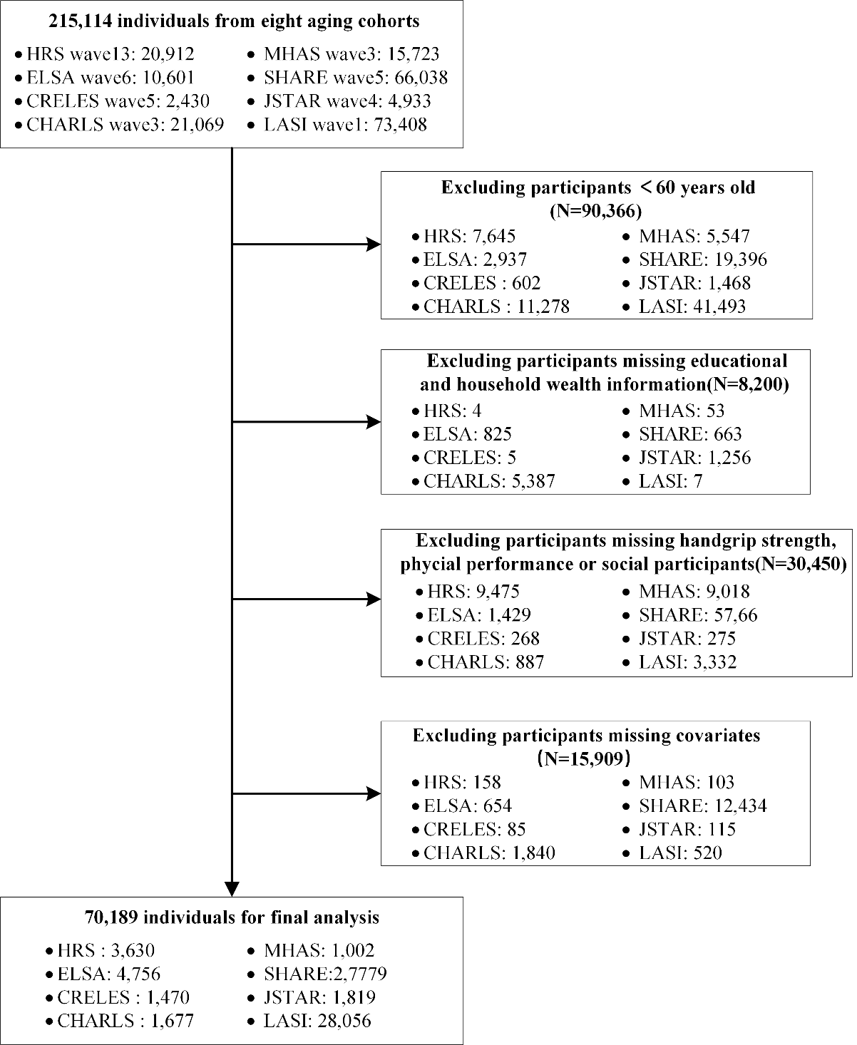
Figure S1. Flowchart of multi-cohort participants selection.
Abbreviations: HRS = the US Health and Retirement Study; MHAS = the Mexican Health and Ageing Study; ELSA = the English Longitudinal Study on Ageing; SHARE = the Survey of Health, Ageing and Retirement in Europe; CRELES = the Costa Rican Longevity and Healthy Aging Study; JSTAR= the Japanese Study of Aging and Retirement; CHARLS = the China Health and Retirement Longitudinal Study; LASI = the Longitudinal Aging Study in India.

Table S1. Definitions of Key Variables Across Cohorts
Variable |  | HRS |  | MHAS | ELSA | SHARE | CRELES | JSTAR | CHARLS | LASI
Muscle strength（low）[9-11] |  | Men: <28 kg  Women: <18 kg |  |  |  | Men: <27 kg  Women: <16 kg |  | Men: <28 kg  Women: <18 kg |  | Men: <19.5 kg  Women: <12.5 kg
Physical performance (low)[12, 13] |  | Composite score <5/8:  - Balance (0-4)  - Gait speed (0-4) |  | Failure to complete:  - Tandem stand OR  - Gait speed <0.5 m/s | Composite score <7/12:  - Balance (0-4)  - Gait speed (0-4)  - Chair stands (0-4) | Failure to complete:  - Walking test  - 100m walk  - Balance test | Composite score <7/12:  - Pencil pickup (0-4)  - Gait speed (0-4)  - Chair stands (0-4) | Inability to perform ≥1 item:  1. Walk 100m  2. Sit 2hrs  3. Rise from chair  4. Climb stairs (multiple)  5. Climb one flight  6. Squat/kneel  7. Raise arms  8. Push/pull object  9. Lift ≥5kg  10. Pick small object | Composite score <7/12:  - Balance (0-4)  - Gait speed (0-4)  - Chair stands (0-4) | Composite score <6/8:  - Gait speed (0-4)  - Balance (0-4)
Community participation (low)[14, 15] |  | 2 items (monthly):  1. Sports/ social clubs  2. Non-religious orgs  Low: No participation |  | 6 items (past year):  1. Volunteer work  2. Training courses  3. Sport/social clubs  4. Puzzles  5. Games  6. Communication  Low: No participation | Membership + participation:  Member of organization/club with ≥1 activity/year  Low: No membership and no participation | 5 items (past year):  1. Voluntary work  2. Education courses  3. Sport/social clubs  4. Religious orgs  5. Political/community orgs  Low: No participation | 4 items (weekly hours):  1. Recreational  2. Social outings  3. Contact closest friend  4. Interact neighbors  *Low: <1 hour/week* | 9 items (past month):  1. Community events  2. Helped neighbors  3. Volunteering  4. Religious  5. Political  6. Hobbies/travel  7. Studying  8. Sports  9. Other  Low: No participation | 11 items (past month):  1. Interacted with friends  2. Played Mahjong/cards  3. Helped non-cohabiting others  4. Attended club  5. Community organization  6. Volunteer work  7. Cared for sick  8. Education course  9. Stock investment  10. Internet use  11. Other  Low: No participation | Membership + frequency:  Member of group with participation:  - Daily  - Weekly  - Monthly  - Yearly  Low: No participation
Educational level | Low | ≤Primary | <Upper secondary |  | <High school | <Upper secondary | <Upper secondary | Primary/Jr high/High school | Below primary | - Never attended  - <Primary (1-4)  - Primary (5-7)
Educational level | Medium | Secondary | Upper secondary/  Vocational |  | High school/  Vocational | Upper secondary/  Vocational | Upper secondary/  Vocational | Jr college/  Vocational | Primary | - Middle (8-9)  - Secondary (10-11)  - Higher secondary (12)
Educational level | High | ≥University | Tertiary |  | Higher education | Tertiary | Tertiary | University/Graduate | ≥Jr high | - Diploma/Certificate  - Bachelor's  - Postgraduate  - Professional
Household wealth | Low | $80000 | ₱536996.6 |  | £171,000 | Country-specific  tertiles | $17,000 | ¥12,000,000 | ¥24,825 | ₹42,600
Household wealth | Medium | $80000-  $326918 | ₱536996.6-  ₱1546844 |  | £171,000-  £349,040 | Country-specific  tertiles | $17,000 -$50,000 | ¥12,000,000-  ¥25,000,000 | ¥24,825-¥144,110 | ₹42,600-  ₹153,500
Household wealth | High | 326918$ | ₱1546844 |  | £349,040 | Country-specific  tertiles | $50,000 | ¥25,000,000 | ¥144,110 | ₹153,500
Household income | Low | $31304 | ₱6,000 |  | £16,479 | Country-specific  tertiles | $1,440 | ¥220,000 | ¥2,270 | ₹500
Household income | Medium | $31304-  $75800 | ₱6,000-₱39,600 |  | £16,479-  £27,772 | Country-specific  tertiles | $1,440 –  $4,200 | ¥220,000-¥380,000 | ¥2,270-¥16,200 | ₹500-  ₹10,000
Household income | High | $75800 | ₱39,600 |  | £27,772 | Country-specific  tertiles | $4,200 | ¥380,000 | ¥16,200 | ₹10,000
Depressive symptoms | depressive symptom | 8-item CES-D ≥ 3 | 9-item Mod. CES-D ≥ 5 |  | 8-item CES-D ≥ 3 | 12-item EURO-D ≥ 4 | 15-item GDS ≥ 5 | 20-item CES-D ≥ 20 | 10-item CES-D ≥ 10 | 10-item CES-D ≥ 10
Notes: CES-D= Center for Epidemiologic Studies Depression Scale; GDS = Geriatric Depression Scale.
Table S2. Baseline Characteristics of the Study Population by Socioeconomic Status (SES) Groups
 | Total population  (N=70,189) | High SES  (N=17,030) | Middle-high SES (N=18,563) | Lower-middle SES (N=18,753) | Low SES (N=15,843) | P-value
Median Age (IQR) | 68 (63-74) | 67(63-73) | 68 (63-74) | 68 (64-74) | 68 (64-75) | <0.001
Gender |  |  |  |  |  | <0.001
Male | 34428 (49.1) | 9849 (57.8) | 8880 (47.8) | 8823 (47.0) | 6876 (43.4)
Female | 35761 (50.9) | 7181 (42.2) | 9683 (52.2) | 9930 (53.0) | 8967 (56.6)
Marital status |  |  |  |  |  | <0.001
Married | 45368 (64.6) | 12473 (73.2) | 12176 (65.6) | 11676 (62.3) | 9043 (57.1)
Single | 24821 (35.4) | 4557 (26.8) | 6387 (34.4) | 7077 (37.7) | 6800 (42.9)
BMI group |  |  |  |  |  | <0.001
Underweight | 7133 (10.2) | 467 (2.7) | 1685 (9.1) | 2564 (13.7) | 2417 (15.3)
Normal | 25576 (36.4) | 6526 (38.3) | 6621 (35.7) | 6639 (35.4) | 5790 (36.5)
Overweight | 24573 (35.0) | 6932 (40.7) | 6640 (35.8) | 6112 (32.6) | 4889 (30.9)
Obesity | 12907 (18.4) | 3105 (18.2) | 3617 (19.5) | 3438 (18.3) | 2747 (17.3)
Smoke |  |  |  |  |  | <0.001
Never | 47289 (67.4) | 11204 (65.8) | 12510 (67.4) | 12488 (66.6) | 11087 (70.0)
Current | 22900 (32.6) | 5826 (34.2) | 6053 (32.6) | 6265 (33.4) | 4756 (30.0)
Drink |  |  |  |  |  | <0.001
Never | 29967 (42.7) | 4133 (24.3) | 8073 (43.5) | 8917 (47.5) | 8844 (55.8)
Current | 40222 (57.3) | 12897 (75.7) | 10490 (56.5) | 9836 (52.5) | 6999 (44.2)
Physical activity (PA) |  |  |  |  |  | <0.001
Low PA | 46570 (66.3) | 9020 (53.0) | 12214 (65.8) | 13165 (70.2) | 12171 (76.8)
High PA | 23619 (33.7) | 8010 (47.0) | 6349 (34.2) | 5588 (29.8) | 3672 (23.2)
Chronic conditions |  |  |  |  |  | <0.001
0 | 25323 (36.1) | 5584 (32.8) | 6466 (34.8) | 7064 (37.7) | 6209 (39.2)
1 | 22356 (31.9) | 5762 (33.8) | 6069 (32.7) | 5803 (30.9) | 4722 (29.8)
2 | 13851 (19.7) | 3519 (20.7) | 3783 (20.4) | 3596 (19.2) | 2953 (18.6)
≥2 | 8659 (12.3) | 2165 (12.7) | 2245 (12.1) | 2290 (12.2) | 1959 (12.4)
Muscle strength |  |  |  |  |  | <0.001
Normal | 59815 (85.2) | 15588 (91.5) | 16073 (86.6) | 15689 (83.7) | 12465 (78.7)
low | 10374 (14.8) | 1442 (8.5) | 2490 (13.4) | 3064 (16.3) | 3378 (21.3)
Physical performance |  |  |  |  |  | <0.001
Normal | 55813 (79.5) | 14928 (87.7) | 14889 (80.2) | 14569 (77.7) | 11427 (72.1)
low | 14376 (20.5) | 2102 (12.3) | 3674 (19.8) | 4184 (22.3) | 4416 (27.9)
Community participants |  |  |  |  |  | <0.001
Normal | 24729 (35.2) | 9753 (57.3) | 6591 (35.5) | 5083 (27.1) | 3302 (20.8)
low | 45460 (64.8) | 7277 (42.7) | 11972 (64.5) | 13670 (72.9) | 12541 (79.2)

Table S3. Multivariable-adjusted odds ratios for functional outcomes by SES level, stratified by depressive symptoms.
Outcome & SES Level | Non-Depressed (n=47,392) aOR (95% CI) | Depressed (n=21,152) aOR (95% CI) | Interaction P-value
Low Muscle Strength |  |  | P = 0.218
Highest SES (Reference) | 1.00 (Ref) | 1.00 (Ref)
Lowest SES (Level 9) | 1.97 (1.73–2.24) | 2.58 (2.04–3.28)
Poor Physical Performance |  |  | P = 0.642
Highest SES (Reference) | 1.00 (Ref) | 1.00 (Ref)
Lowest SES (Level 9) | 1.91 (1.71–2.13) | 1.73 (1.44–2.09)
Low Community Participation |  |  | P = 0.086
Highest SES (Reference) | 1.00 (Ref) | 1.00 (Ref)
Lowest SES (Level 9) | 4.77 (4.39–5.17) | 3.78 (3.21–4.44)
Notes: aOR = adjusted Odds Ratio; CI = Confidence Interval. All models were adjusted for age, sex, BMI, marital status, chronic conditions, smoking, alcohol consumption, and physical activity.

Figure S2. Specific and pooled effect of socioeconomic status on the odds of low muscle strength
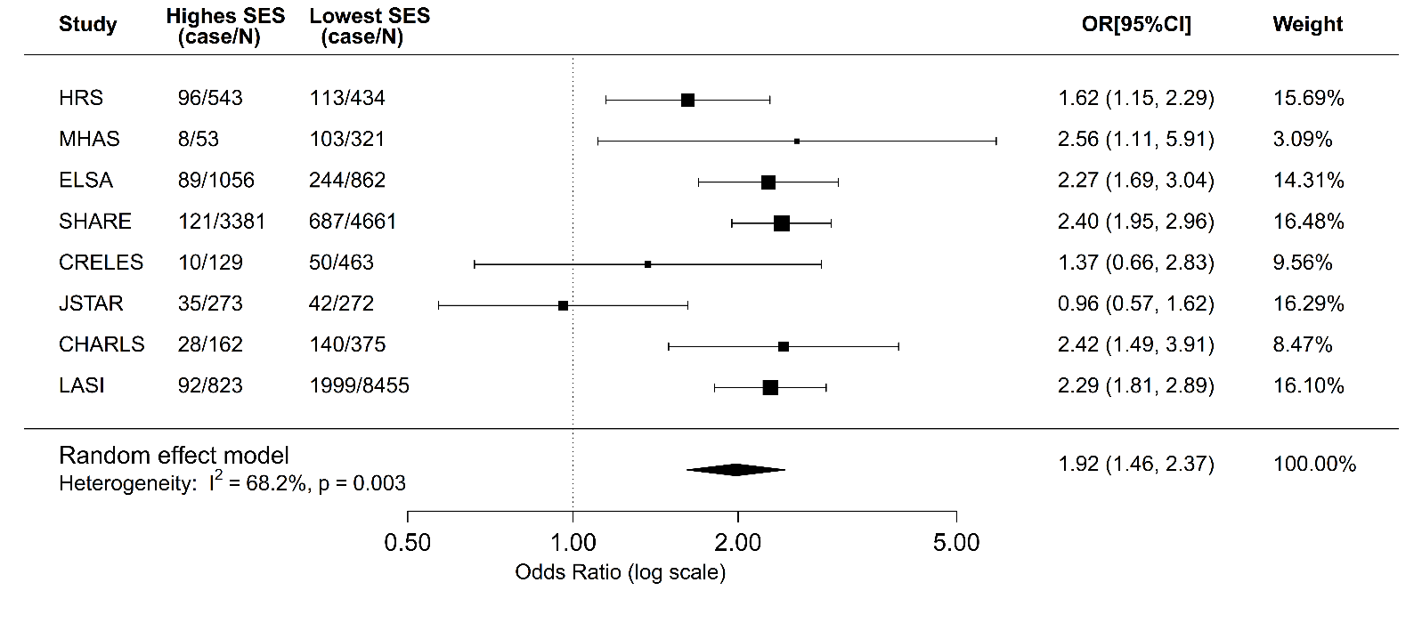
Models were fully adjusted for demographic factors (age, sex, and marital status), lifestyle factors (BMI, smoking, alcohol consumption, and physical activity), and chronic health conditions. Abbreviations: HRS = the US Health and Retirement Study; MHAS = the Mexican Health and Ageing Study; ELSA = the English Longitudinal Study on Ageing; SHARE = the Survey of Health, Ageing and Retirement in Europe; CRELES = the Costa Rican Longevity and Healthy Aging Study; JSTAR= the Japanese Study of Aging and Retirement; CHARLS = the China Health and Retirement Longitudinal Study; LASI = the Longitudinal Aging Study in India.

Figure S3. Specific and pooled effect of socioeconomic status on the odds of low physical performance
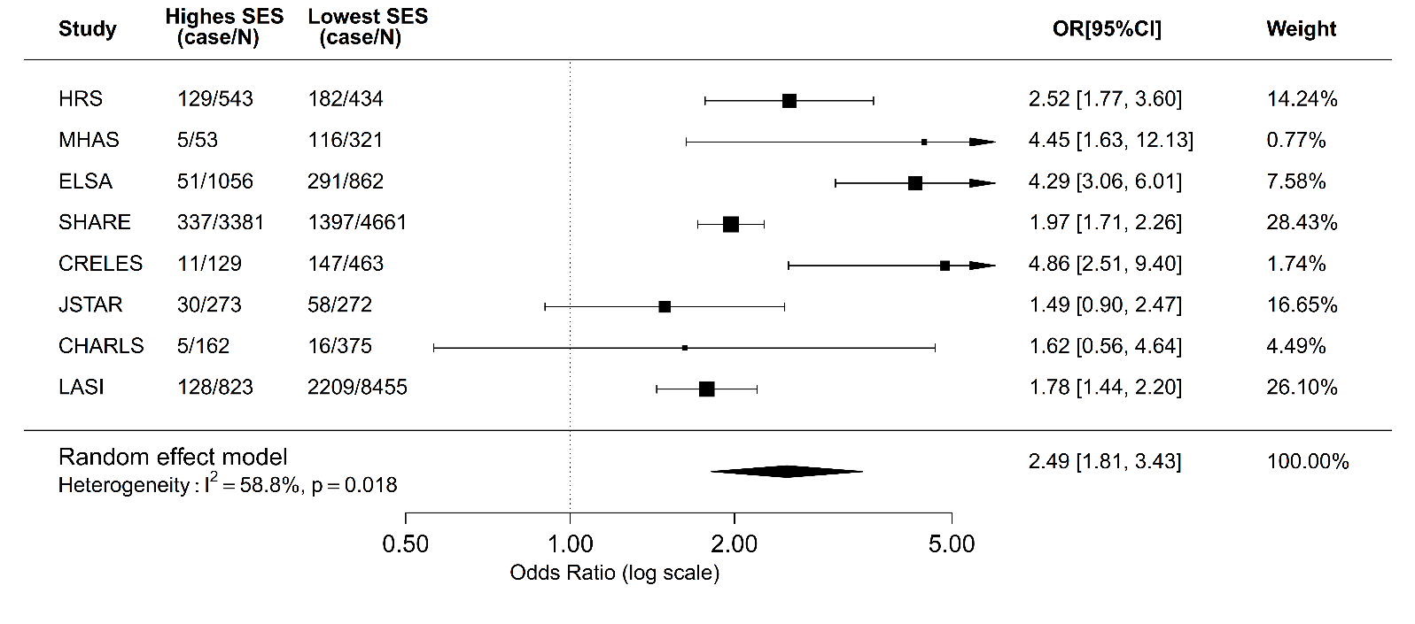
Models were fully adjusted for demographic factors (age, sex, and marital status), lifestyle factors (BMI, smoking, alcohol consumption, and physical activity), and chronic health conditions. Abbreviations: HRS = the US Health and Retirement Study; MHAS = the Mexican Health and Ageing Study; ELSA = the English Longitudinal Study on Ageing; SHARE = the Survey of Health, Ageing and Retirement in Europe; CRELES = the Costa Rican Longevity and Healthy Aging Study; JSTAR= the Japanese Study of Aging and Retirement; CHARLS = the China Health and Retirement Longitudinal Study; LASI = the Longitudinal Aging Study in India.
Figure S4. Specific and pooled effect of socioeconomic status on the odds of low community participation
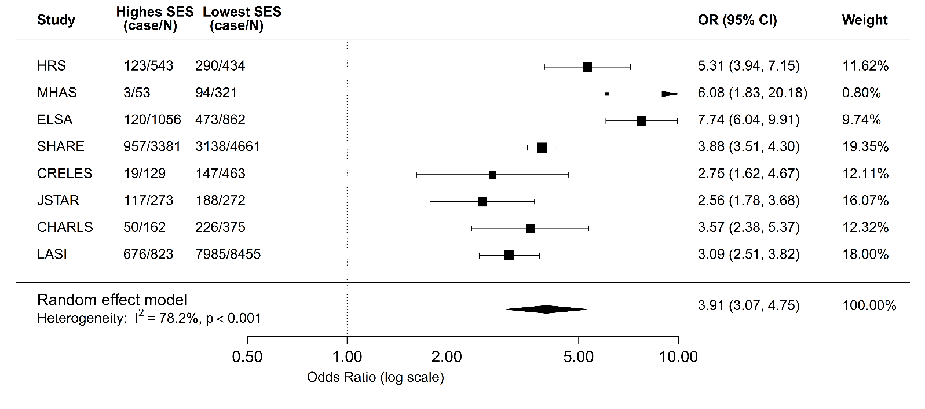
Models were fully adjusted for demographic factors (age, sex, and marital status), lifestyle factors (BMI, smoking, alcohol consumption, and physical activity), and chronic health conditions. Abbreviations: HRS = the US Health and Retirement Study; MHAS = the Mexican Health and Ageing Study; ELSA = the English Longitudinal Study on Ageing; SHARE = the Survey of Health, Ageing and Retirement in Europe; CRELES = the Costa Rican Longevity and Healthy Aging Study; JSTAR= the Japanese Study of Aging and Retirement; CHARLS = the China Health and Retirement Longitudinal Study; LASI = the Longitudinal Aging Study in India.

Figure S5. Subgroup analysis- Associations of education-wealth combinations with odds of low muscle strength.
Models were adjusted for demographic factors (age, sex, and marital status), lifestyle factors (BMI, smoking, alcohol consumption, and physical activity), and chronic physical conditions (excluding subgroup variable).

Figure S6. Subgroup analysis- Associations of education-wealth combinations with risks of low physical performance.
Models were adjusted for demographic factors (age, sex, and marital status), lifestyle factors (BMI, smoking, alcohol consumption, and physical activity), and chronic physical conditions (excluding subgroup variable).

Figure S7. Subgroup analysis- Associations of education-wealth combinations with odds of low community participation.
Models were adjusted for demographic factors (age, sex, and marital status), lifestyle factors (BMI, smoking, alcohol consumption, and physical activity), and chronic physical conditions (excluding subgroup variable).

Figure S8. Sensitive analysis—Associations of education-wealth combinations with odds of low muscle strength, physical performance, and community participation in participants without cancer, heart problem and stroke. (N=56,197)
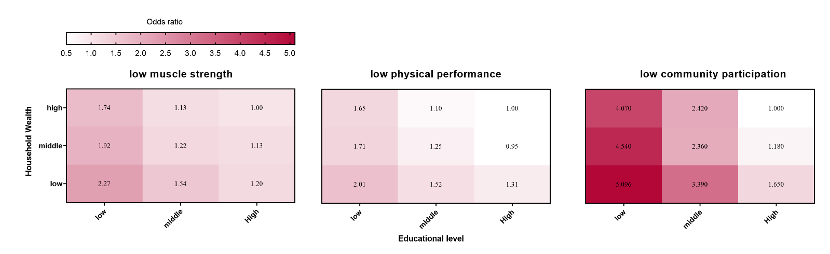
Analysis was conducted after excluding participants diagnosed with cancer (n=4,561), heart problem(n=8,784) and stroke(n=2.783). Models were adjusted for demographic factors (age, sex, and marital status), lifestyle factors (BMI, smoking, alcohol consumption, and physical activity), and chronic physical conditions (excluding cancer, heart problem and stroke).
Figure S9. Associations between socioeconomic status and functional impairments, stratified by depressive symptoms.
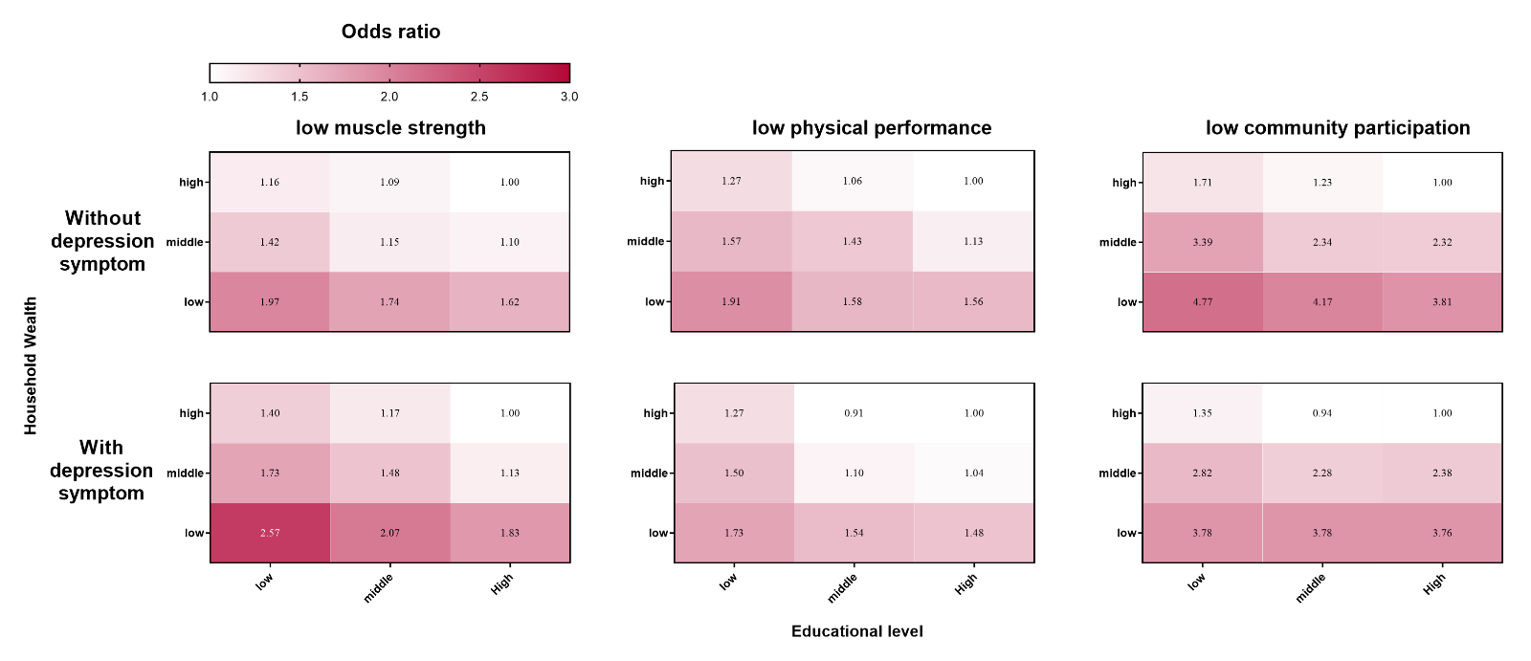
Models were fully adjusted for demographic factors (age, sex, and marital status), lifestyle factors (BMI, smoking, alcohol consumption, and physical activity), and chronic health conditions.
Figure S10. Sensitive analysis—specific and pooled effect of household income on the risk of low muscle strength
Models were fully adjusted for demographic factors (age, sex, and marital status), lifestyle factors (BMI, smoking, alcohol consumption, and physical activity), and chronic health conditions. Abbreviations: HRS = the US Health and Retirement Study; MHAS = the Mexican Health and Ageing Study; ELSA = the English Longitudinal Study on Ageing; SHARE = the Survey of Health, Ageing and Retirement in Europe; CRELES = the Costa Rican Longevity and Healthy Aging Study; JSTAR= the Japanese Study of Aging and Retirement; CHARLS = the China Health and Retirement Longitudinal Study; LASI = the Longitudinal Aging Study in India.

Figure S11. Sensitive analysis—specific and pooled effect of household income on the risk of low physical performance
Models were fully adjusted for demographic factors (age, sex, and marital status), lifestyle factors (BMI, smoking, alcohol consumption, and physical activity), and chronic health conditions. Abbreviations: HRS = the US Health and Retirement Study; MHAS = the Mexican Health and Ageing Study; ELSA = the English Longitudinal Study on Ageing; SHARE = the Survey of Health, Ageing and Retirement in Europe; CRELES = the Costa Rican Longevity and Healthy Aging Study; JSTAR= the Japanese Study of Aging and Retirement; CHARLS = the China Health and Retirement Longitudinal Study; LASI = the Longitudinal Aging Study in India.
Figure S12.Sensitive analysis—specific and pooled effect of household income on the risk of low community participation
Models were fully adjusted for demographic factors (age, sex, and marital status), lifestyle factors (BMI, smoking, alcohol consumption, and physical activity), and chronic health conditions. Abbreviations: HRS = the US Health and Retirement Study; MHAS = the Mexican Health and Ageing Study; ELSA = the English Longitudinal Study on Ageing; SHARE = the Survey of Health, Ageing and Retirement in Europe; CRELES = the Costa Rican Longevity and Healthy Aging Study; JSTAR= the Japanese Study of Aging and Retirement; CHARLS = the China Health and Retirement Longitudinal Study; LASI = the Longitudinal Aging Study in India.
Reference
1. Juster FT, Suzman R. An Overview of the Health and Retirement Study. The Journal of Human Resources. 1995;30:S7-S56.
2. Wong R, Michaels-Obregón A, Palloni A, Gutiérrez-Robledo LM, González-González C, López-Ortega M, et al. Progression of aging in Mexico: the Mexican Health and Aging Study (MHAS) 2012. Salud Publica Mex. 2015;57 Suppl 1(0 1):S79-89.
3. Steptoe A, Breeze E, Banks J, Nazroo J. Cohort Profile: The English Longitudinal Study of Ageing. International Journal of Epidemiology. 2012;42(6):1640-8.
4. Börsch-Supan A, Brandt M, Hunkler C, Kneip T, Korbmacher J, Malter F, et al. Data Resource Profile: The Survey of Health, Ageing and Retirement in Europe (SHARE). International Journal of Epidemiology. 2013;42(4):992-1001.
5. Rosero-Bixby L, Fernández X, Dow WH. CRELES: Costa Rican Longevity and Healthy Aging Study-Wave 1, 2005 (Costa Rica Estudio de Longevidad y Envejecimiento Saludable). 2024.
6. Ichimura H, Shimizutani S, Hashimoto H. JSTAR first results 2009 report. Research Institute of Economy, Trade and Industry (RIETI); 2009.
7. Zhao Y, Hu Y, Smith JP, Strauss J, Yang G. Cohort Profile: The China Health and Retirement Longitudinal Study (CHARLS). International Journal of Epidemiology. 2012;43(1):61-8.
8. Perianayagam A, Bloom D, Lee J, Parasuraman S, Sekher TV, Mohanty SK, et al. Cohort Profile: The Longitudinal Ageing Study in India (LASI). Int J Epidemiol. 2022;51(4):e167-e76.
9. Chen LK, Woo J, Assantachai P, Auyeung TW, Chou MY, Iijima K, et al. Asian Working Group for Sarcopenia: 2019 Consensus Update on Sarcopenia Diagnosis and Treatment. J Am Med Dir Assoc. 2020;21(3):300-7.e2.
10. Cruz-Jentoft AJ, Bahat G, Bauer J, Boirie Y, Bruyère O, Cederholm T, et al. Sarcopenia: revised European consensus on definition and diagnosis. Age Ageing. 2019;48(1):16-31.
11. Pai M, Muhammad T. Examining factors contributing to the socioeconomic inequalities in handgrip strength among older adults in India: a decomposition analysis. Sci Rep. 2024;14(1):442.
12. Li W, Rao Z, Fu Y, Schwebel DC, Li L, Ning P, et al. Value of the short physical performance battery (SPPB) in predicting fall and fall-induced injury among old Chinese adults. BMC Geriatr. 2023;23(1):574.
13. de Fátima Ribeiro Silva C, Ohara DG, Matos AP, Pinto A, Pegorari MS. Short Physical Performance Battery as a Measure of Physical Performance and Mortality Predictor in Older Adults: A Comprehensive Literature Review. Int J Environ Res Public Health. 2021;18(20).
14. Wang Y, Liu M, Yang F, Chen H, Wang Y, Liu J. The associations of socioeconomic status, social activities, and loneliness with depressive symptoms in adults aged 50 years and older across 24 countries: findings from five prospective cohort studies. Lancet Healthy Longev. 2024;5(9):100618.
15. Schrempft S, Jackowska M, Hamer M, Steptoe A. Associations between social isolation, loneliness, and objective physical activity in older men and women. BMC Public Health. 2019;19(1):74.

