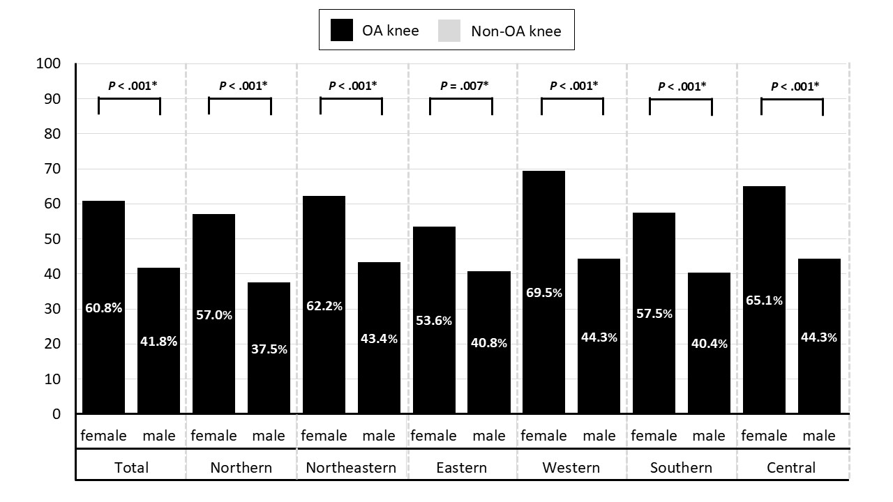

Supplementary Fig 1 Prevalence of symptomatic knee osteoarthritis by sex and geographic region in community-dwelling Thai older adults.
Symptomatic knee OA was defined by American College of Rheumatology clinical criteria. Regions correspond to the 6 standard Thai geographic regions.
Abbreviations: OA, osteoarthritis

