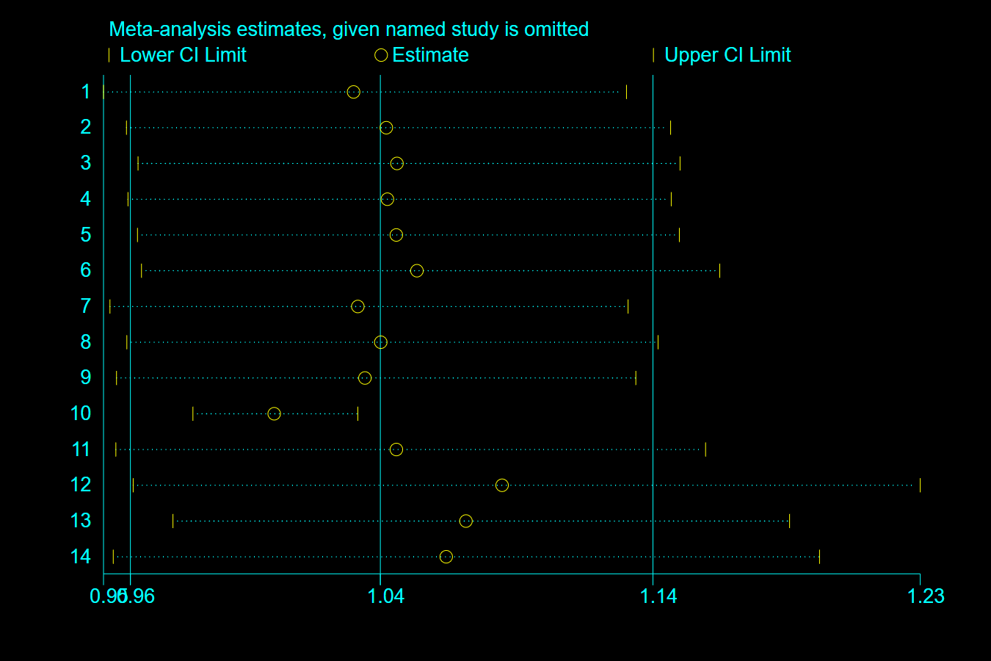
Sensitivity Analysis of the Pooled Effect Estimates for Vaccine Uptake
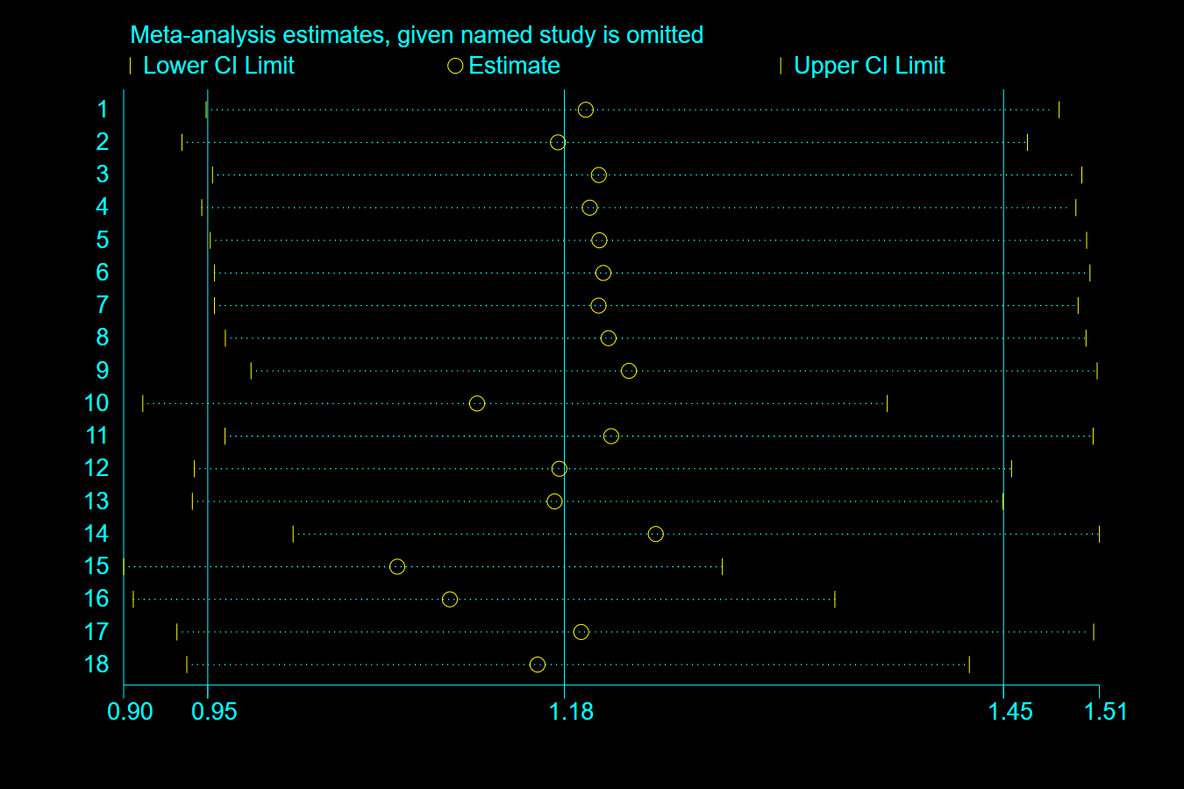
Sensitivity Analysis of the Pooled Effect Estimates for Effects on Positive Vaccine Outcomes (RR-based)
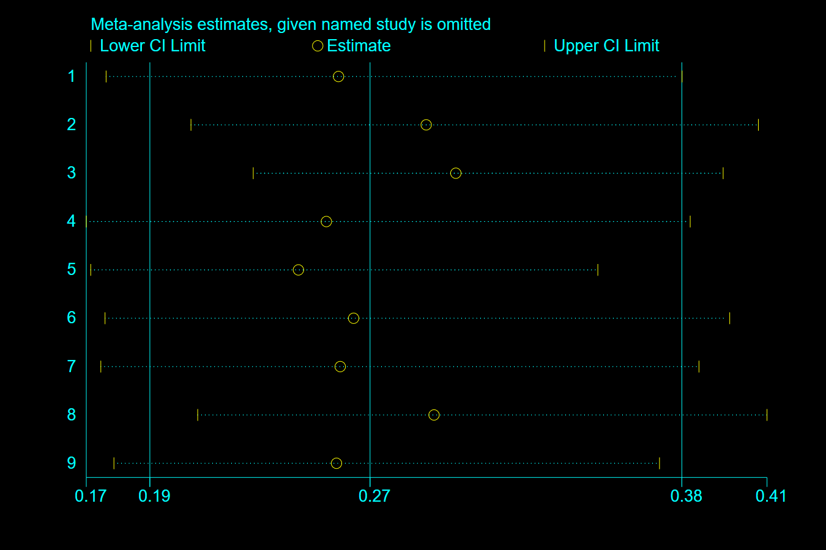
Sensitivity Analysis of the Pooled Effect Estimates for Effects on Negative Vaccine Outcomes (RR-based)

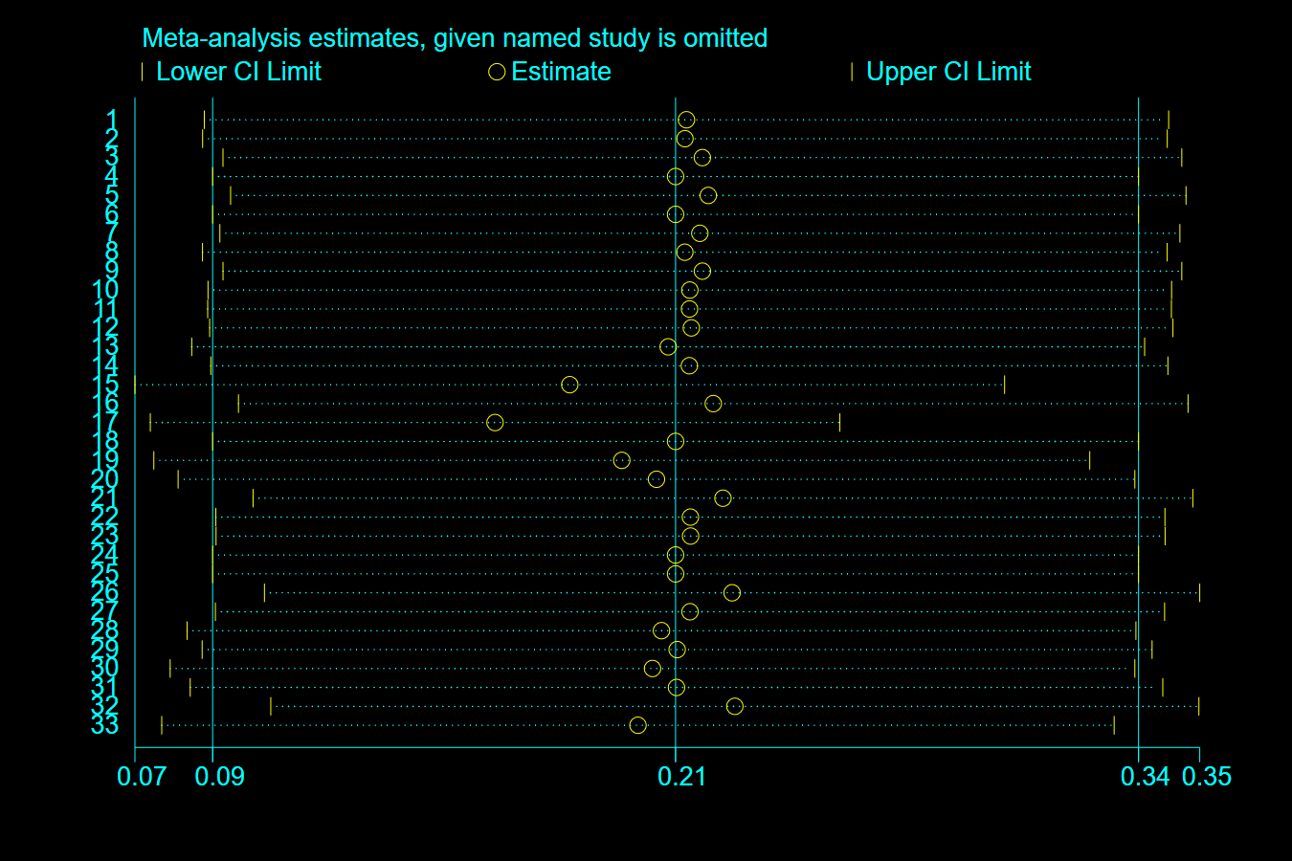
Sensitivity Analysis of the Pooled Effect Estimates for Effects on Effects on Positive Vaccine Outcomes (SMD-based)

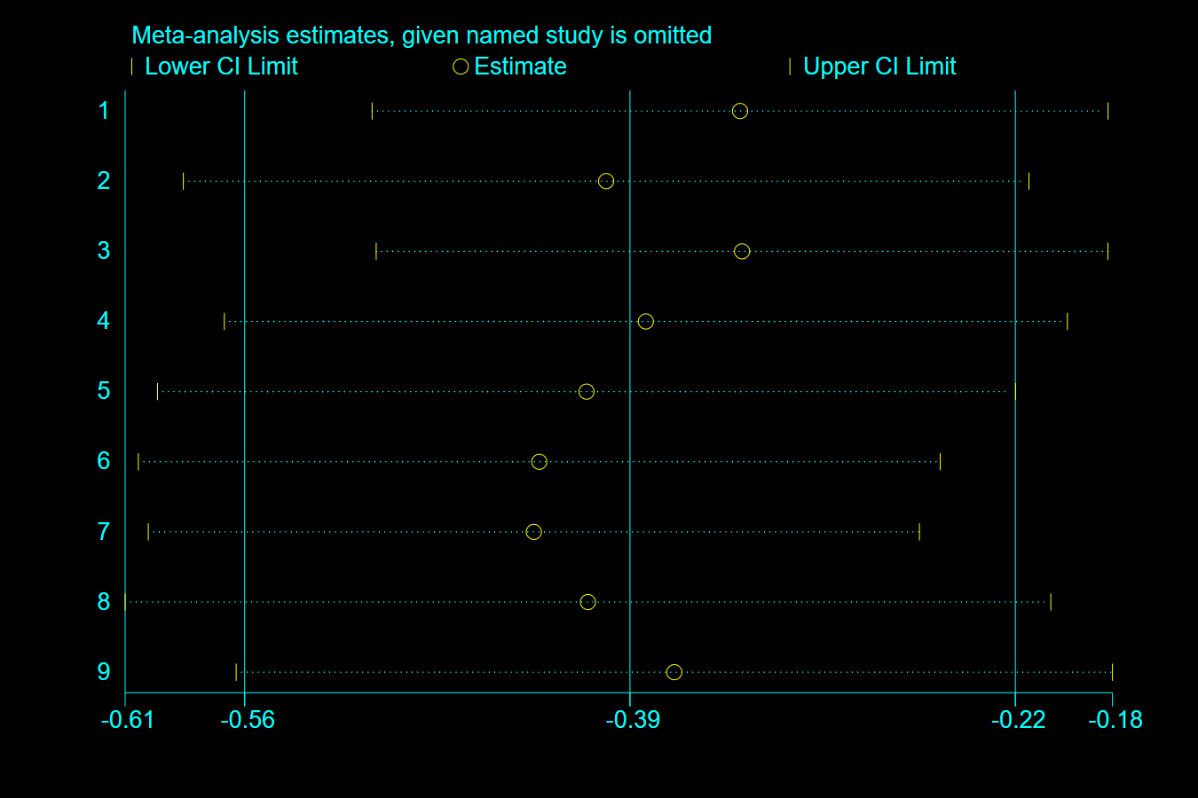
Sensitivity Analysis of the Pooled Effect Estimates for Effects on Effects on Effects on Negative Vaccine Outcomes (SMD-based)

