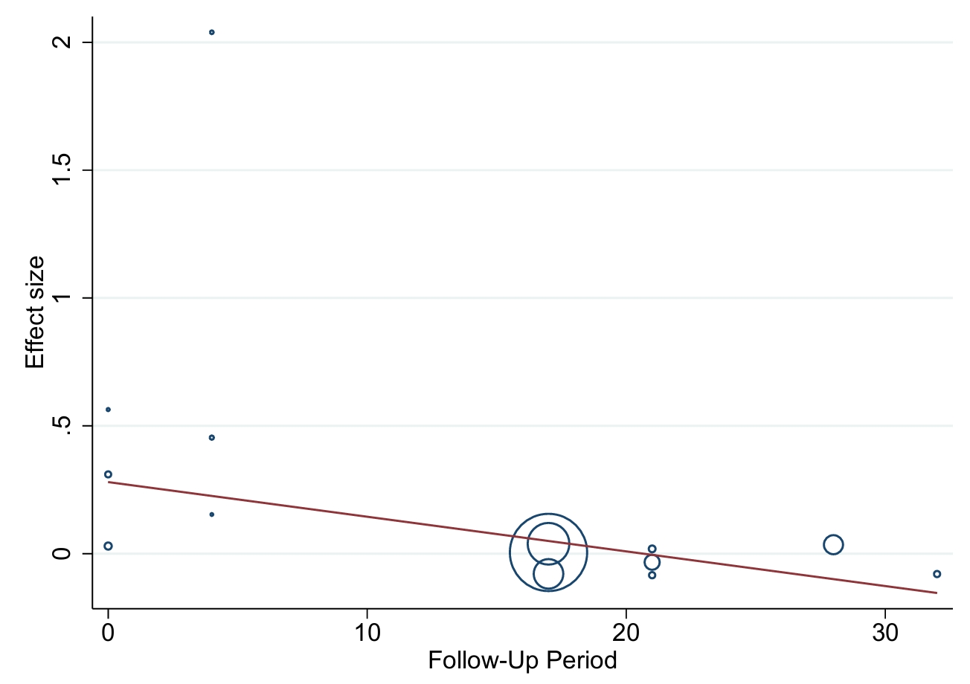
Meta-Regression Analysis of Effect Size by Follow-up period for Vaccine Uptake
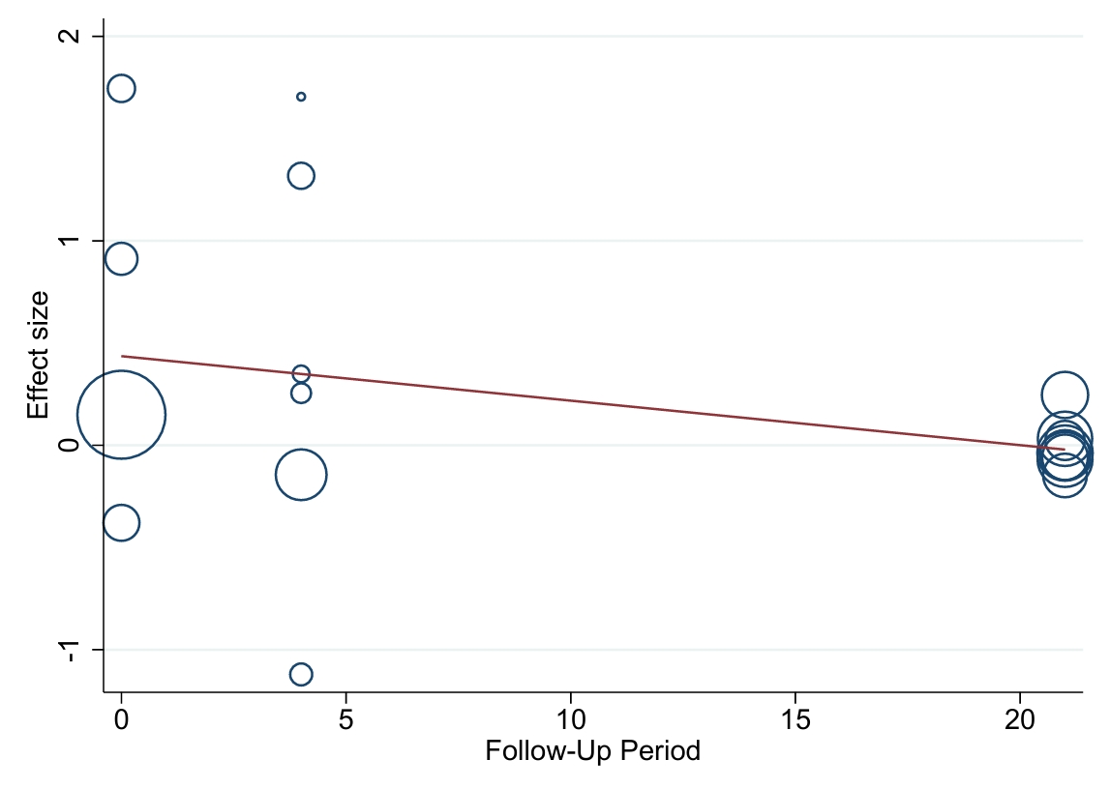
Meta-Regression Analysis of Effect Size by Follow-up period for Positive Vaccine Outcomes (RR-based)

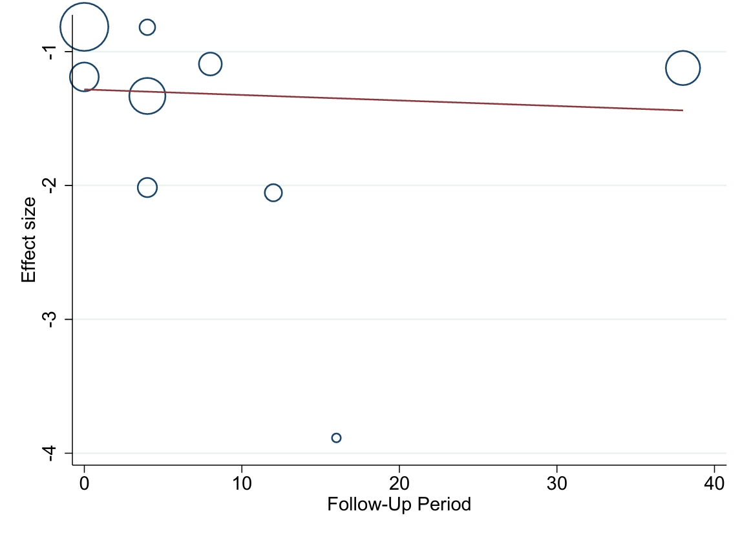
Meta-Regression Analysis of Effect Size by Follow-up period for Negative Vaccine Outcomes (RR-based)

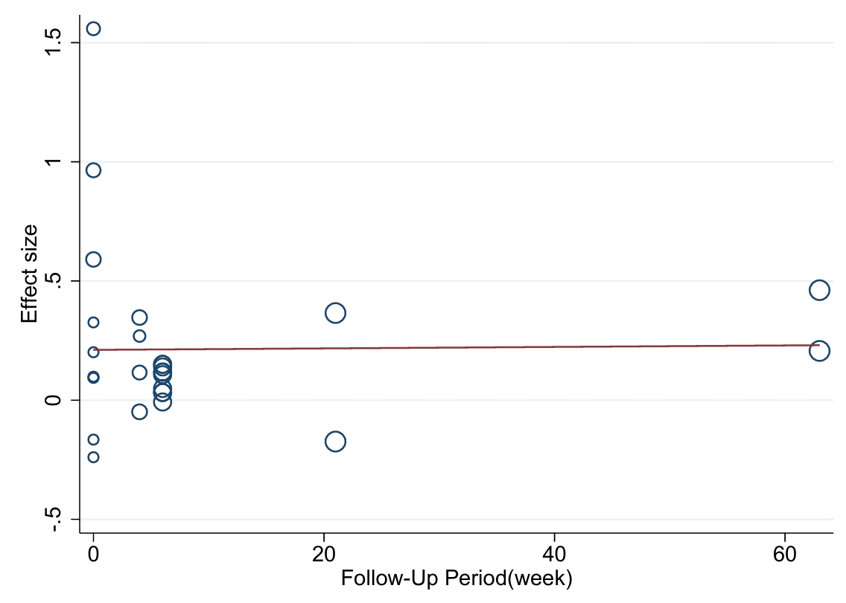
Meta-Regression Analysis of Effect Size by Follow-up period for Positive Vaccine Outcomes (SMD-based)

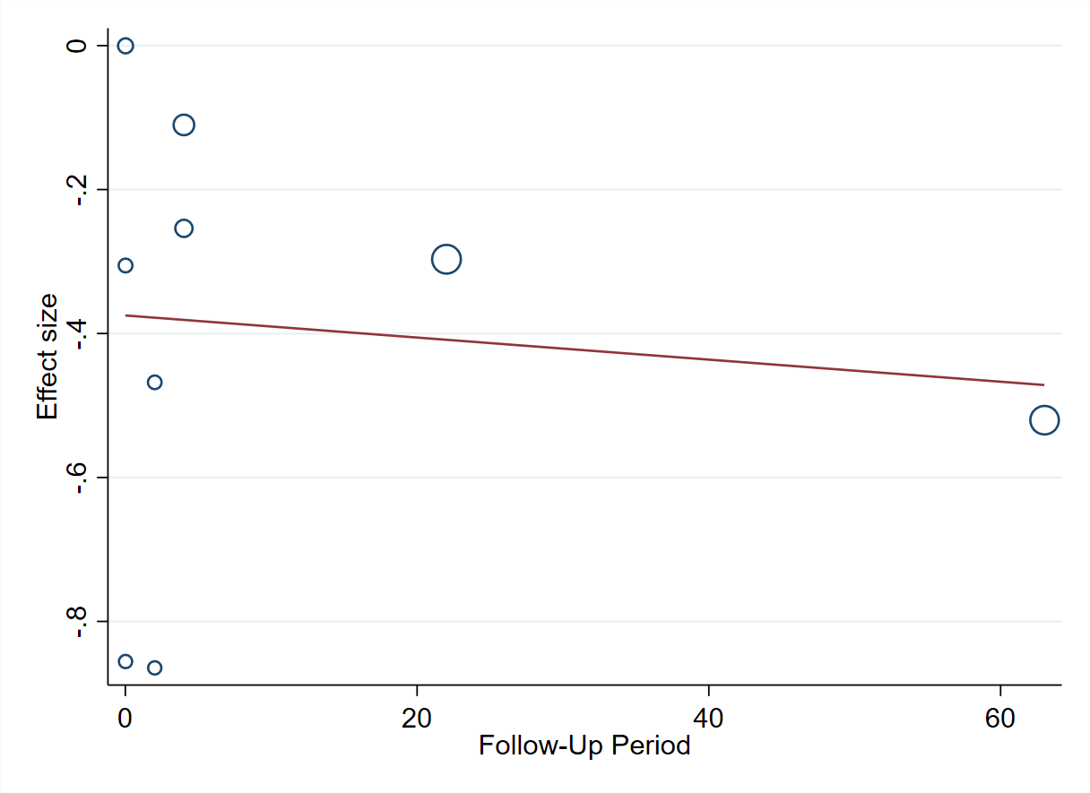
Meta-Regression Analysis of Effect Size by Follow-up period for Negative Vaccine Outcomes (SMD-based)

