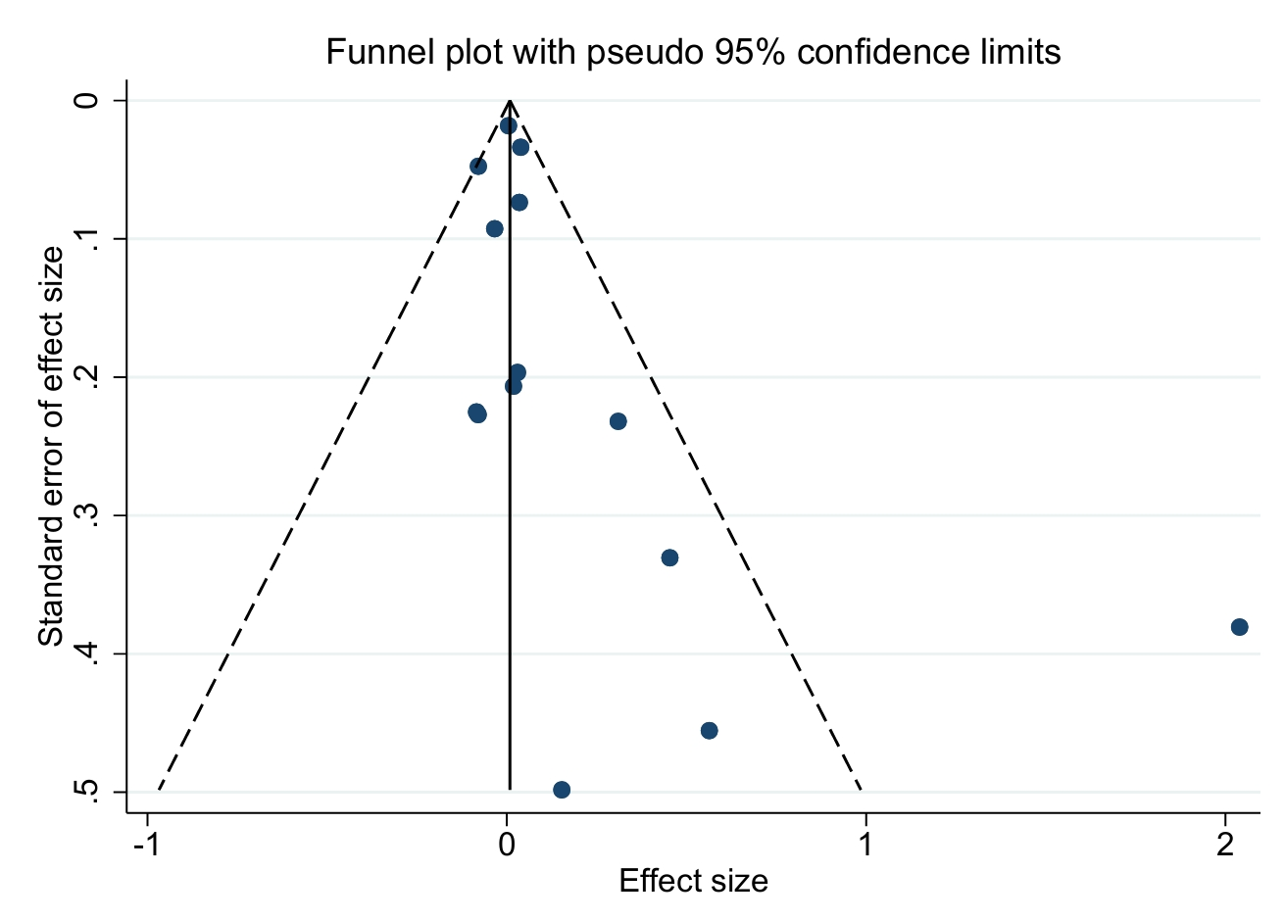
Funnel Plot Analysis for Vaccine Uptake
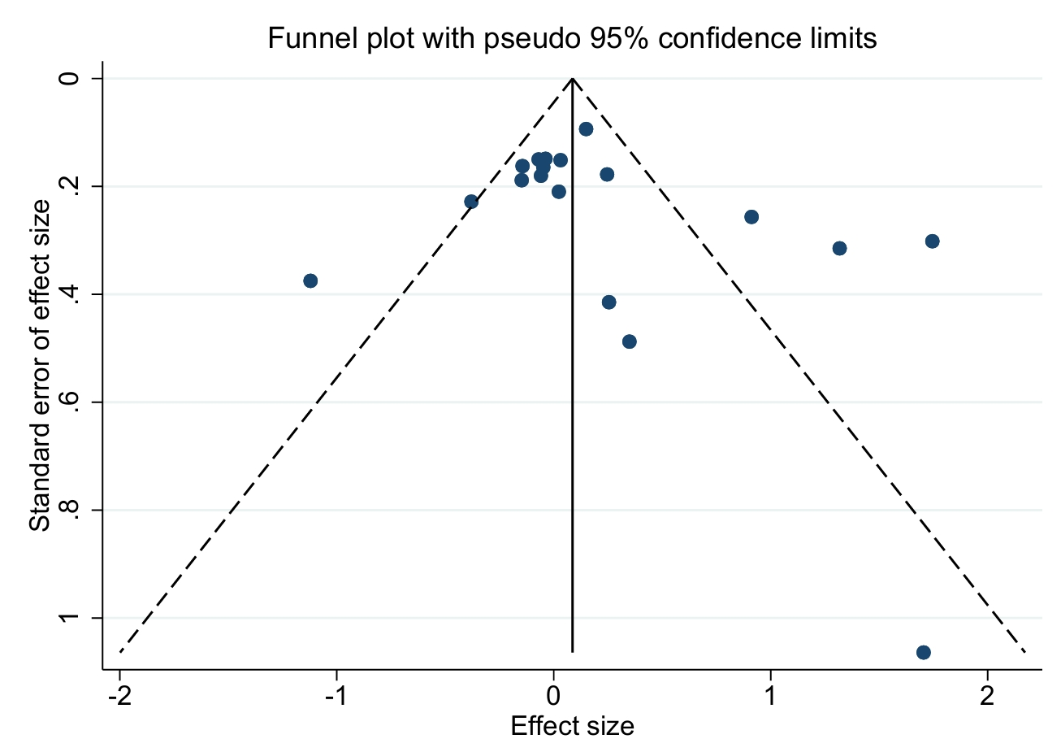
Funnel Plot Analysis for Effects on Positive Vaccine Outcomes (RR-based)
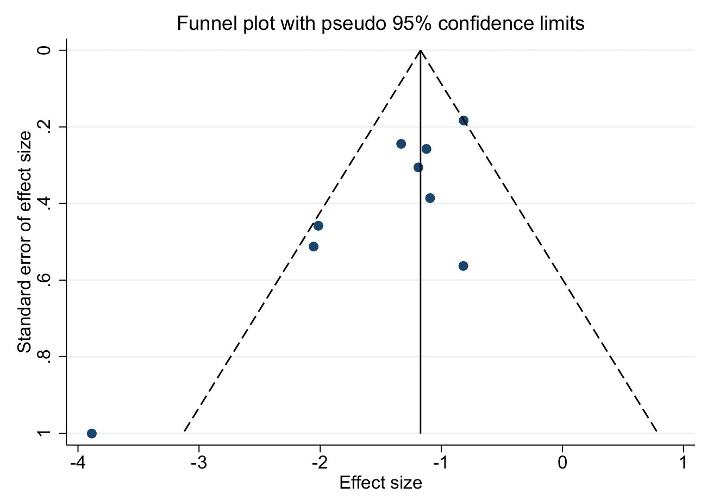
Funnel Plot Analysis for Effects on Negative Vaccine Outcomes (RR-based)

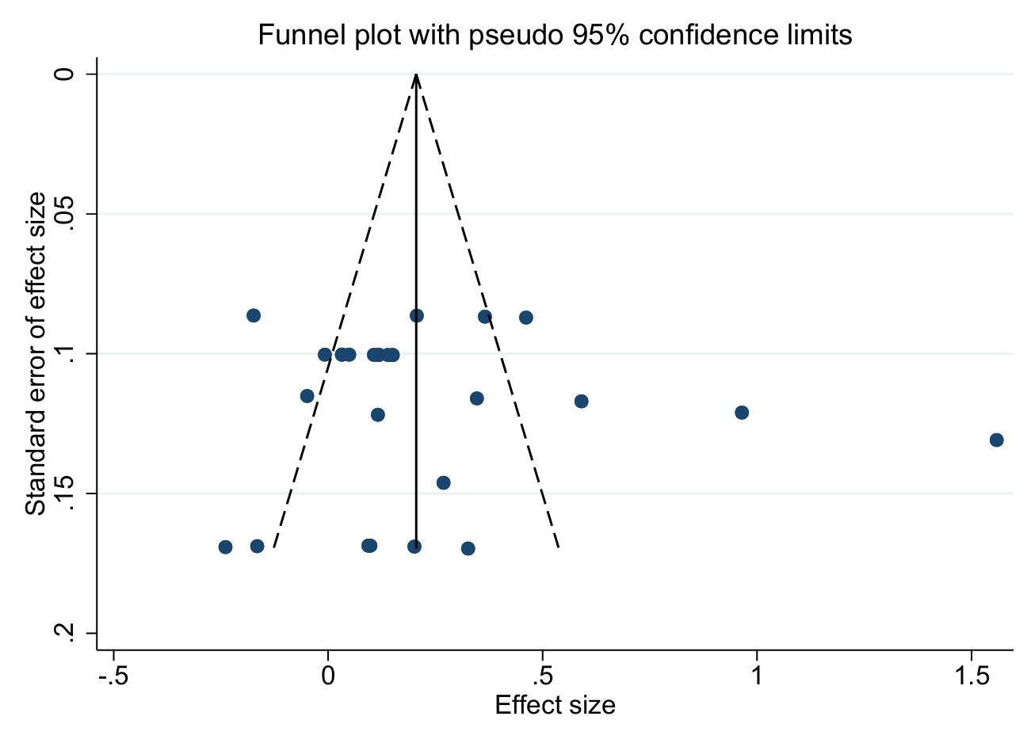
Funnel Plot Analysis for Effects on Effects on Positive Vaccine Outcomes (SMD-based)

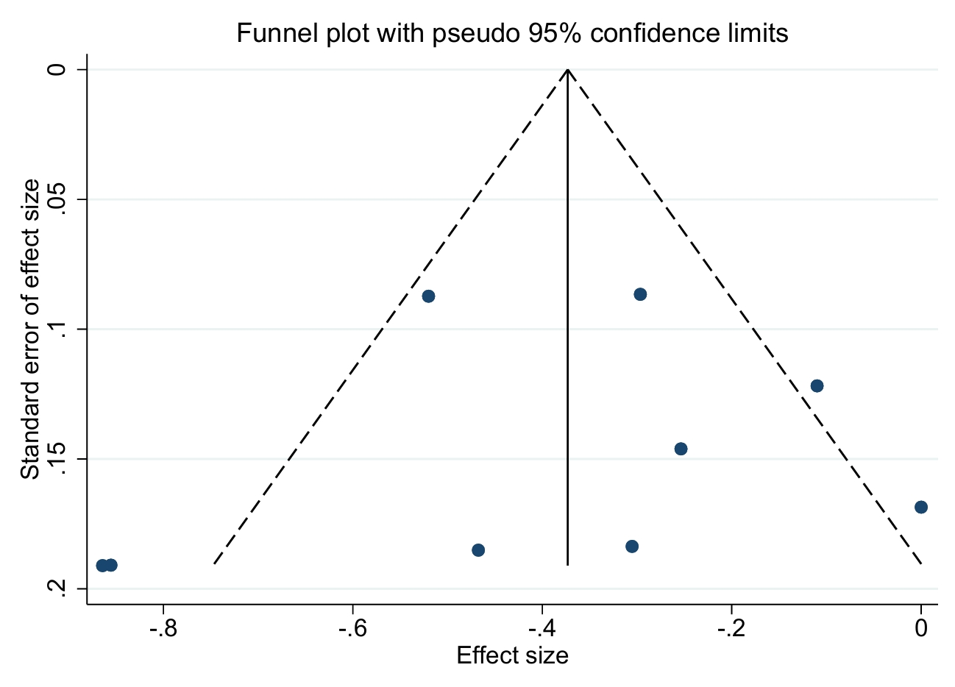
Funnel Plot Analysis for Effects on Effects on Effects on Negative Vaccine Outcomes (SMD-based)

