Supplementary Material

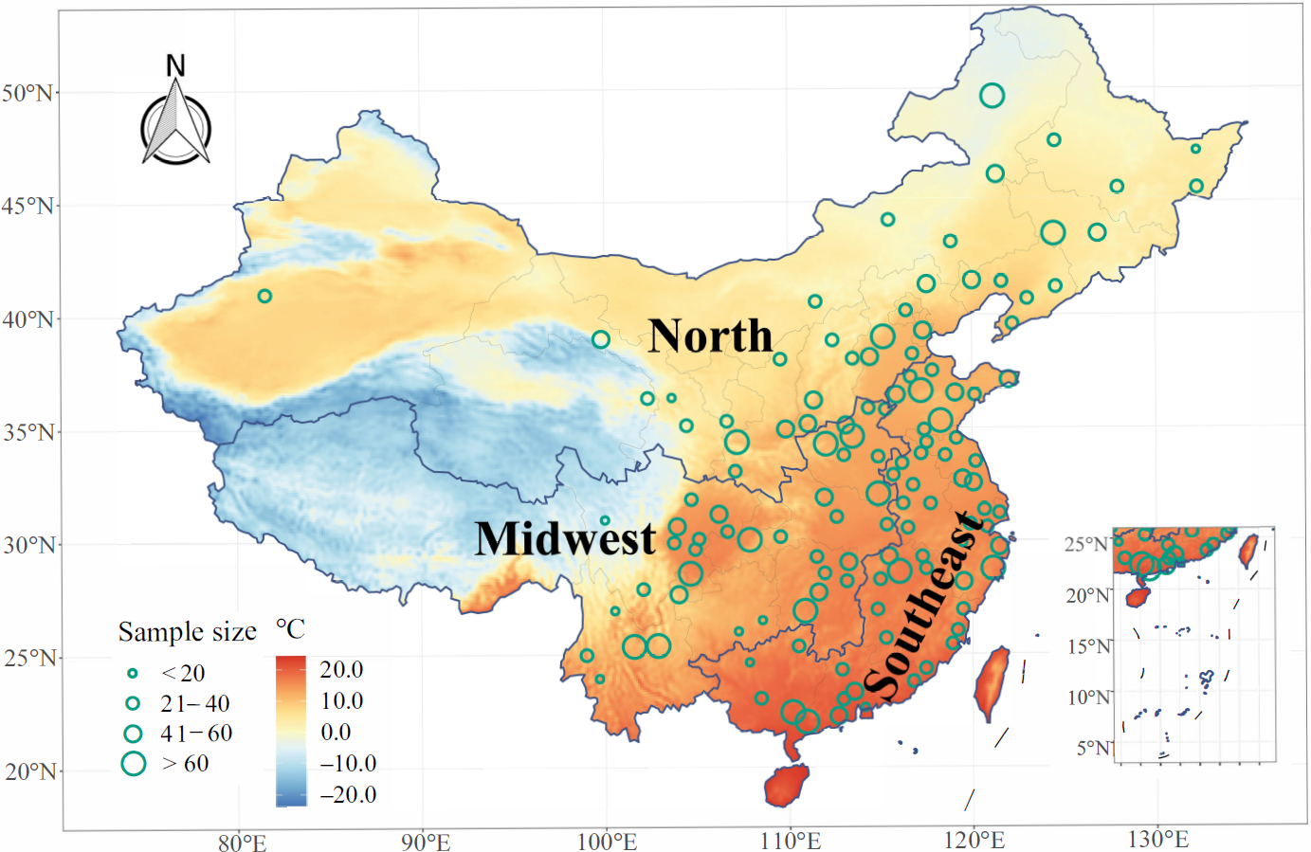
Fig. S1 Geographic distribution of study participants and annual mean temperature at each 0.1°×0.1° grid from 2011 to 2020.
Table S1 Detailed description of selected covariates.
Covariates | Definition
Sociodemographic characteristics
Age | Recorded the middle-aged and elderly’s age at the time of the interview as a continuous variable with a minimum unit of 1 year. We divided the participants into age groups of 45–64 years and ≥65 years.
Sex | Recorded the sex of the middle-aged and elderly at the time  of the interview. It is divided into male and female.
Educational attainment | Recorded the educational level of the middle-aged and elderly at the time of the interview. Educational attainment was classified into two categories by schooling years: (1) below primary school (≤6 years meaning that that participants had not attended or completed primary school) (2) above middle school (>6 years meaning that they had completed middle school and continued to study upward).
Marital status | Recorded the marital status of the middle-aged and elderly at the time of the interview. Marital status was a dummy variable, with 1 suggesting that the participant has married and lived with spouse or cohabitation, and 0 denoting single (i.e., widowed/separated/divorced/never married).
Urbanicity | The urbanicity was classified as rural and urban according to the participants’ residences at the time of the interview.
Behavioral factors
Cigarette smoking | The cigarette drinking status of respondents was recorded and divided into former or current smokers (yes) and never-smokers (no).
Alcohol drinking | The alcohol drinking status of respondents was recorded and divided into former or current drinkers (yes) and those who never drank (no).
Social activity | The respondents were considered to participate in social activities if they did at least one of the enumerated activities (e.g., interacting with friends; playing Ma-jong, chess, cards, or went to community club; taking part in a community-related organization, etc.) during the last month.
Night sleep | Night sleep duration was categorized into three groups: ≤6 h, 6–8 h, and more than 8 h.
Physical activity | Physical activity intensity was categorized into very low, low, medium, or high according to the quartiles of its distribution (very low: Q1; low: Q2; medium: Q3; high: Q4)
Health status
Chronic diseases | Chronic disease prevalence was equal to 1 (present) if participants had one or more physician-diagnosed chronic diseases, including hypertension, stroke, diabetes, heart disease, respiratory diseases, dyslipidemia, arthritis, and asthma.
Depression | Depressive symptom was measured using the 10-item Center for Epidemiologic Studies Depression (CES-D) scale, and a cut-off of 10 (CES-D ≥10) was used to define a binary variable of depression episode.
Self-rated health | Recorded respondents' subjective evaluation of their own physical condition, which was categorized into three groups: poor, fair, and good.

Table S2 Estimated changes in overall physical function score associated with per 10-days increase in extreme temperature events and per IQR increase in PM_{2.5} and its constituents under a 2-year exposure window.

Extreme temperature events | Change per IQR/10-day increase
Extreme temperature events | Estimate (95% CI) | P-value
PM_{2.5} and its constituents, per IQR
PM_{2.5} mass | -0.327 (-0.407, -0.247) | <0.001
BC | -0.438 (-0.514, -0.362) | <0.001
OM | -0.320 (-0.399, -0.240) | <0.001
SO₄²⁻ | -0.399 (-0.483, -0.315) | <0.001
NO₃⁻ | -0.257 (-0.340, -0.173) | <0.001
NH₄⁺ | -0.320 (-0.406, -0.234) | <0.001
Heat wave, per 10-days
HW90_2 | -0.155 (-0.175, -0.135) | <0.001
HW90_3 | -0.147 (-0.167, -0.127) | <0.001
HW90_4 | -0.130 (-0.149, -0.110) | <0.001
HW92.5_2 | -0.157 (-0.180, -0.135) | <0.001
HW92.5_3 | -0.135 (-0.158, -0.113) | <0.001
HW92.5_4 | -0.130 (-0.153, -0.107) | <0.001
HW95_2 | -0.146 (-0.174, -0.118) | <0.001
HW95_3 | -0.123 (-0.152, -0.094) | <0.001
HW95_4 | -0.134 (-0.163, -0.105) | <0.001
HW97.5_3 | -0.139 (-0.179, -0.099) | <0.001
HW97.5_3 | -0.137 (-0.178, -0.097) | <0.001
HW97.5_4 | -0.116 (-0.159, -0.073) | <0.001
Cold spell, per 10-days
CS2.5_2 | -0.163 (-0.181, -0.145) | <0.001
CS2.5_3 | -0.145 (-0.161, -0.128) | <0.001
CS2.5_4 | -0.139 (-0.155, -0.122) | <0.001
CS5_2 | -0.178 (-0.197, -0.160) | <0.001
CS5_3 | -0.170 (-0.188, -0.152) | <0.001
CS5_4 | -0.181 (-0.201, -0.161) | <0.001
CS7.5_2 | -0.210 (-0.232, -0.187) | <0.001
CS7.5_3 | -0.224 (-0.248, -0.199) | <0.001
CS7.5_3 | -0.244 (-0.272, -0.216) | <0.001
CS10_2 | -0.304 (-0.343, -0.264) | <0.001
CS10_3 | -0.319 (-0.368, -0.270) | <0.001
CS10_4 | -0.318 (-0.372, -0.263) | <0.001
Abbreviations: PM_{2.5}, fine particulate matter with aerodynamic diameter ≤2.5 μm; BC, black carbon; OM, organic matter; NO₃⁻, nitrate; SO₄²⁻, sulfate; NH₄⁺, ammonium; IQR, interquartile range; CI, confidence interval.

