1 Supplementary Table S1. Absolute sample sizes for subgroup analyses (total n = 23,635)
Subgroup Variable | Category | Absolute Sample Size (N)
Age (years) | < 40 | 7,223
 | 40–60 | 7,521
 | > 60 | 8,891
Gender | Male | 11,500
 | Female | 12,135
BMI (kg/m²) | < 25 | 6,526
 | 25–30 | 7,679
 | > 30 | 9,430
Race/Ethnicity | Mexican American | 3,111
 | Other Hispanic | 2,311
 | Non-Hispanic White | 10,275
 | Non-Hispanic Black | 5,057
 | Other Race | 2,881
Poverty-to-income ratio (PIR) | ≤ 1.3 | 7,170
 | 1.3–3.5 | 8,928
 | > 3.5 | 7,537
Smoking status | Yes | 10,483
 | No | 13,152
Alcohol consumption | Yes | 17,688
 | No | 5,947
Hyperlipidemia | Yes | 8,903
 | No | 14,732

2 Supplementary Table S2. Calibration metrics of logistic regression and Gradient Boosting Classifier (GBC) on the independent test set
Model | Brier Score | Calibration Slope
Logistic Regression | 0.139 | 0.88
Gradient Boosting Classifier | 0.116 | 0.961

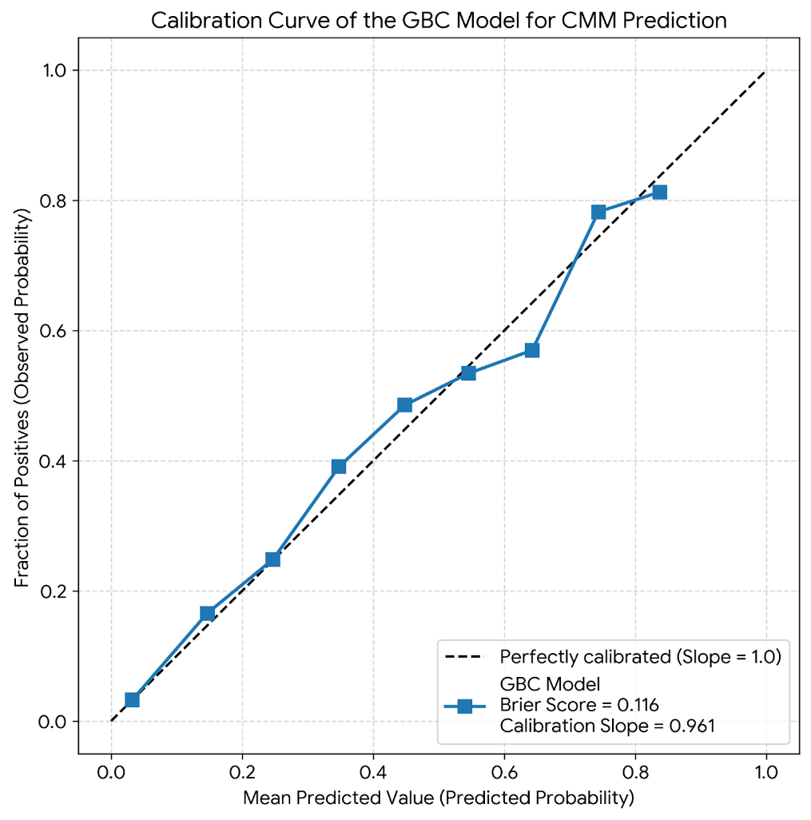
3 Supplementary Methods: Additional details on quartile derivation
Quartiles for total physical activity (TMET) and sitting time were calculated on the full analytic sample (n = 23,635) prior to the train/test split to ensure consistent epidemiological thresholds across all analyses. Sensitivity analyses were performed by recalculating quartiles using only the training set (n = 16,544); the resulting cut-points and model performance were nearly identical to those derived from the full sample, indicating negligible risk of data leakage.

