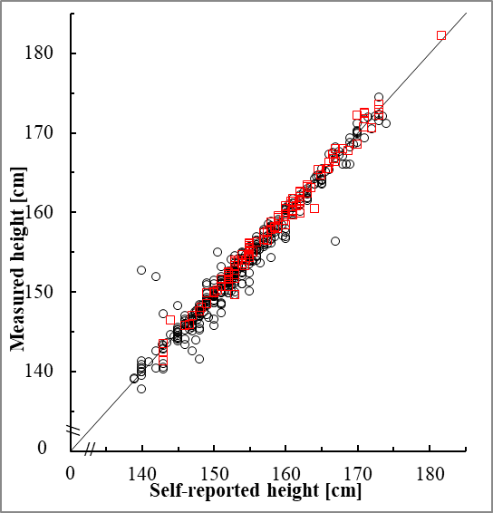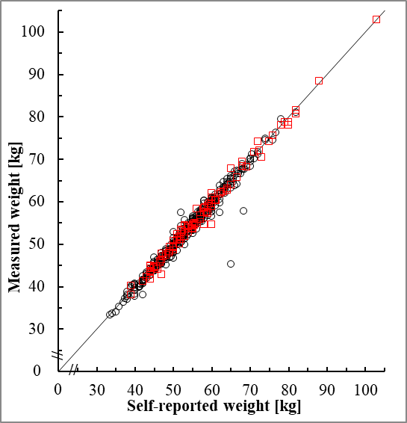
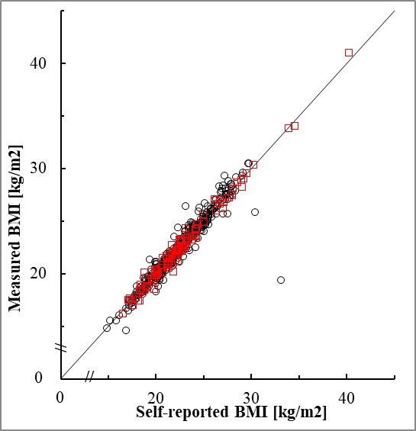
Supplementary Figure 1. Scatter-plots of the intraclass correlation coefficients comparing the self-reported and measured height, weight, and BMI in the age <65 years (red square) and ≥65 years (black circle) groups

