Fig.S1 K‒M plot of CMM incidence according to CTI groups.
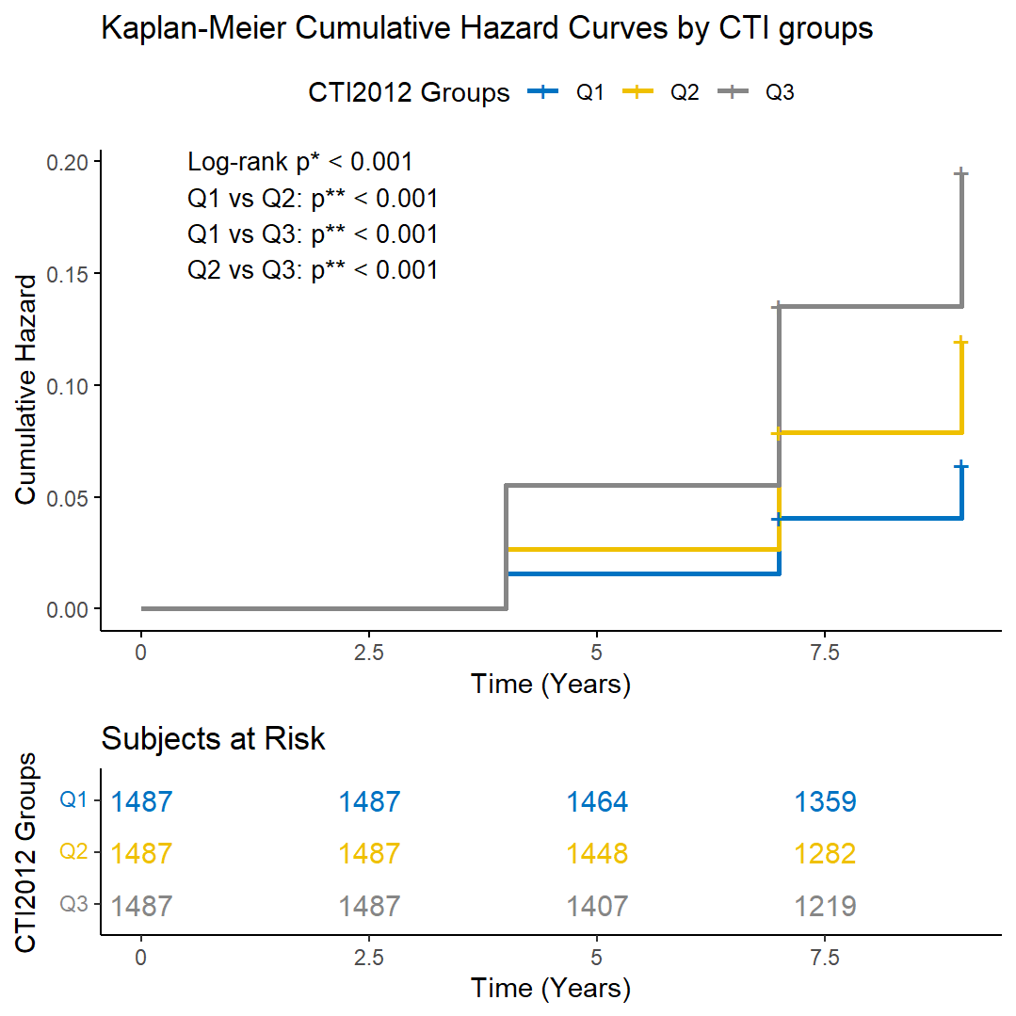

Group comparisons were performed using the log-rank test (p*, overall P-value; p**, Bonferroni-adjusted pairwise P-value). All comparisons, including overall and pairwise analyses for CTI groups, were statistically significant (P < 0.001).

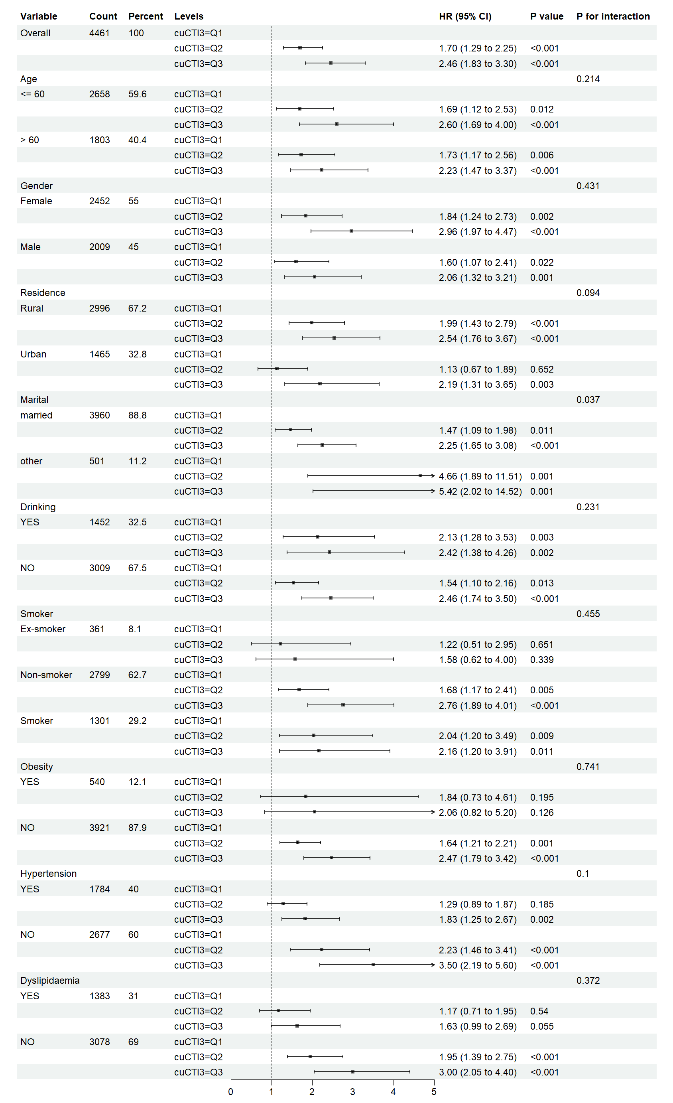
Fig.S2 Subgroup and interaction analyses of the associations between tertiles of cuCTI and CMM.

HR: Hazard Ratio; CI: Confidence Interval; cuCTI; cumulative C-reactive protein-triglyceride-glucose index. Adjusted for sex, age, residence, marital status, education level, smoking status, drinking status, hypertension, dyslipidemia, cancer, obesity, SBP, DBP, BMI, TC, HDL and LDL.
Fig.S3 Subgroup and interaction analyses of the associations between Cluster and CMM.
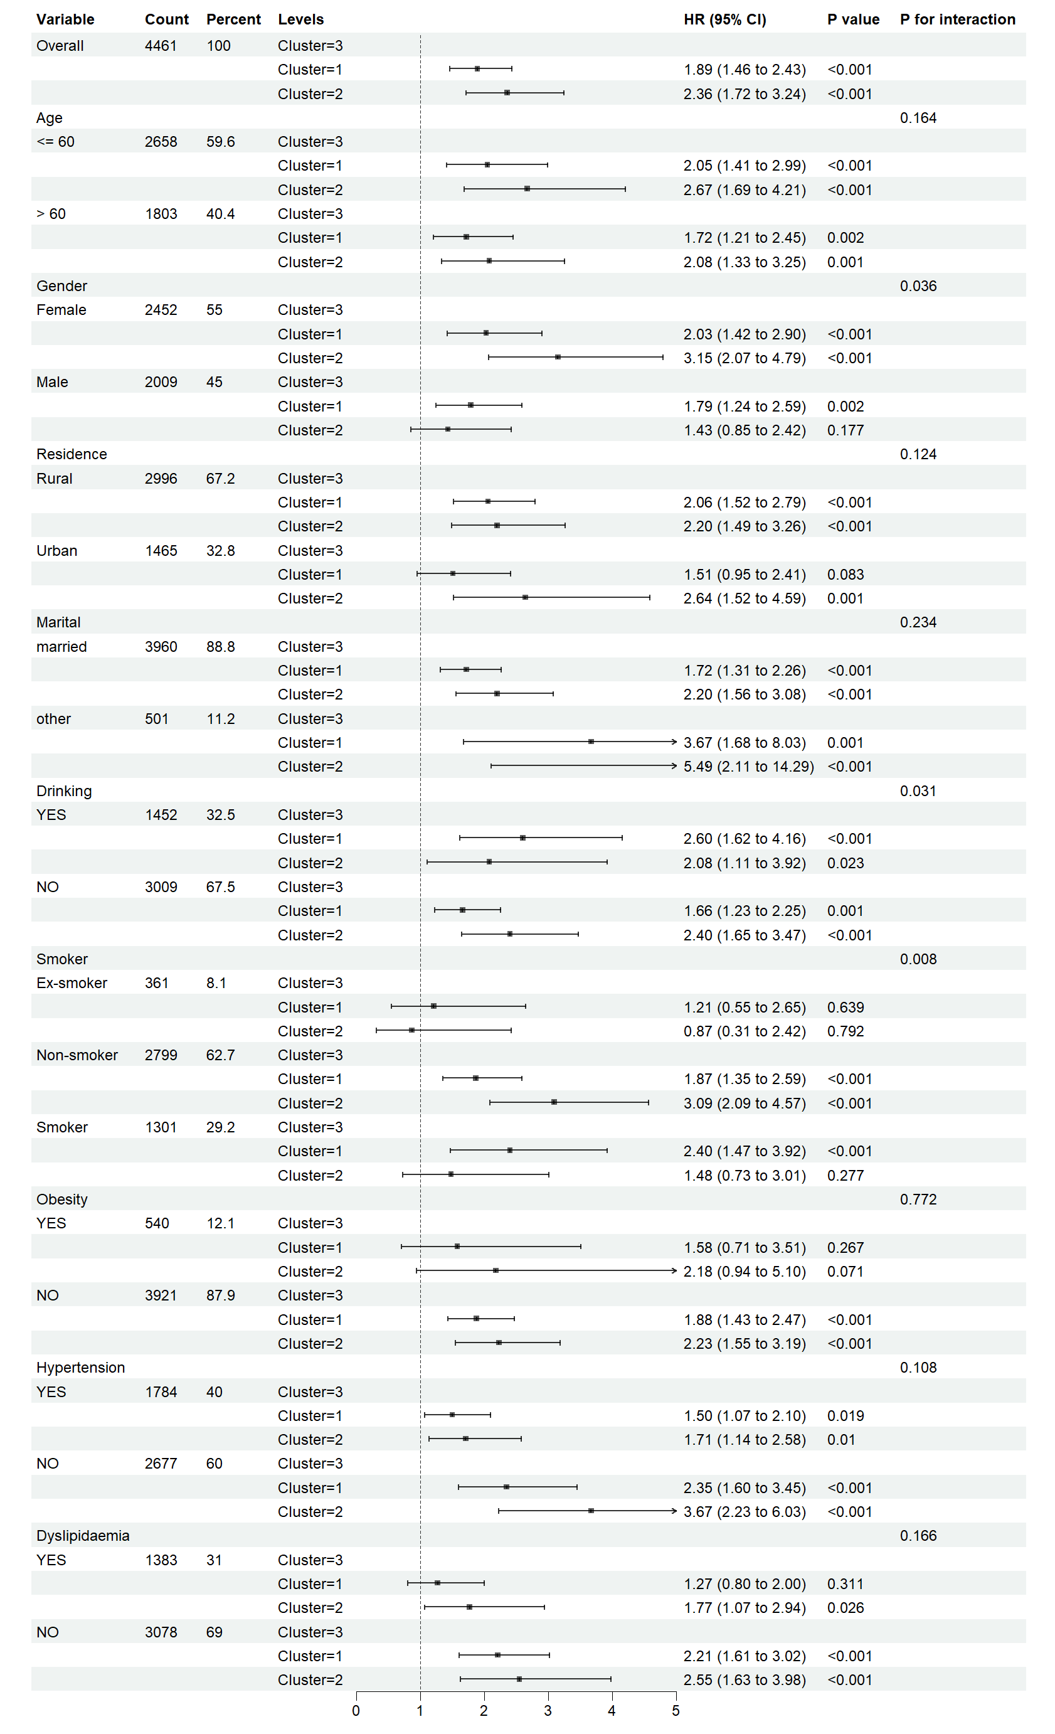

HR: Hazard Ratio; CI: Confidence Interval. Adjusted for sex, age, residence, marital status, education level, smoking status, drinking status, hypertension, dyslipidemia, cancer, obesity, SBP, DBP, BMI, TC, HDL and LDL. Cluster 1: moderately elevated group; Cluster 2: persistently high-level group; Cluster 3: stable low-level group.

