Supplementary Materials

- Longitudinal CFA of the CES-D-10
- Standard CPLM Models
- Main Mplus Syntax——taking Model 2 as an example.

- Longitudinal CFA of the CES-D-10
Longitudinal CFA of the CES-D-10 examined configural, metric (weak), scalar (strong) and strict invariance across waves (Table S2). Fit indices for the configural model indicated acceptable fit (χ2 = 5554.54, df = 674, CFI = 0.904, TLI = 0.898, RMSEA = 0.037). Imposing equality of factor loadings (weak/metric invariance) yielded minimal change in fit (ΔCFI = −0.003, ΔRMSEA = 0.000; χ2 = 5722.90, df = 701, CFI = 0.901, RMSEA = 0.037), supporting metric invariance. Further constraining item intercepts (strong/scalar invariance) produced ΔCFI = −0.009 and ΔRMSEA = 0.005 (χ2 = 6868.60, df = 728, CFI = 0.892, RMSEA = 0.042), and additional equality of residual variances (strict invariance) resulted in ΔCFI = −0.008 and ΔRMSEA = 0.001 (χ2 = 7552.31, df = 758, CFI = 0.884, RMSEA = 0.043). All changes in CFI and RMSEA were below the predefined thresholds (ΔCFI < 0.01 and ΔRMSEA < 0.015), indicating that measurement invariance held across waves up to the strict level. Thus, the CES-D-10 demonstrated stable factor structure, equivalent factor loadings, intercepts and residuals over time, supporting valid longitudinal comparisons of depressive symptoms in this sample.

Table S2 Longitudinal CFA of the CES-D-10
Model | χ2 | df | CFI | TLI | RMSEA | ∆CFI | ∆RMSEA
M1: Configural invariance | 5554.537 | 674 | 0.904 | 0.898 | 0.037
M2: Weak invariance | 5722.902 | 701 | 0.901 | 0.890 | 0.037 | -0.003 | 0.000
M3: Strong invariance | 6868.596 | 728 | 0.892 | 0.882 | 0.042 | -0.009 | 0.005
M4: Strict invariance | 7552.311 | 758 | 0.884 | 0.876 | 0.043 | -0.008 | 0.001

- Standard CPLM Models
Standard CPLM models were constructed to examine the longitudinal associations between multimorbidity, depression, and intensity of CHE at the between-person level. Middle-aged and older people's age, gender, marital status, region of residence, educational attainment, and earnings after tax were entered in all CLPMS as time-invariant covariates and were regressed on all variables at all four time points.
All longitudinal structural parameters (i.e., stability paths, correlated change, and cross-lagged paths) of the baseline CLPM were set to be time-free, Subsequently, constraints were progressively added one by one, including a fully constrained model with all cross-lagged paths, autoregressive paths, and occasional covariances set to be time-invariant, a several constrained models with all cross-lagged paths and autoregressive paths being constrained equal over time.
cross-lagged panel model between multimorbidity and depression
The first CLPM (Model 1) represented the association between multimorbidity and depression. As shown in Table S3, a several constrained models with all cross-lagged paths and autoregressive paths being constrained equal fit the data well. Considering parsimony, the final RICLPM use the several constrained model for Model 1.
As shown in Figure 1, the results supported a reciprocal relation between multimorbidity and depression, suggesting thatgreater multimorbidity at one time-point predicted a rise in depressive symptoms at follow-up, while elevated depressive symptoms at one time-point led to an increase in multimorbidity at follow-up. Combining the findings from RI-CLPMs, only minor changes in parameters, no change in path saliency.

Table S3 Model Fit of CLPMs for Model 1 and Model 2
Models | χ2(df) | CFI | TLI | RMSEA | SRMR | ΔCFI | ΔRMSEA
MODE1 MMD—CES
CLPM-free | 1263.061(84) | 0.964 | 0.947 | 0.052 | 0.047 | - | -
CLPM-several constrained | 1548.137(92) | 0.956 | 0.94 | 0.055 | 0.051 | -0.008 | 0.003
CLPM-fully constrained | 7779.401(107) | 0.766 | 0.728 | 0.117 | 0.084 | -0.19 | 0.062
MODE2 MMD-E—CES
CLPM-free | 2148.116(136) | 0.943 | 0.912 | 0.053 | 0.051 | - | -
CLPM-several constrained | 2466.926(153) | 0.934 | 0.91 | 0.054 | 0.054 | -0.009 | 0.001
CLPM-fully constrained | 9169.118(177) | 0.745 | 0.698 | 0.098 | 0.079 | -0.189 | 0.044
Note. CFI = Comparative Fit Index; RMSEA = Root Mean Square Error of Approximation; CI = Confidence Interval.

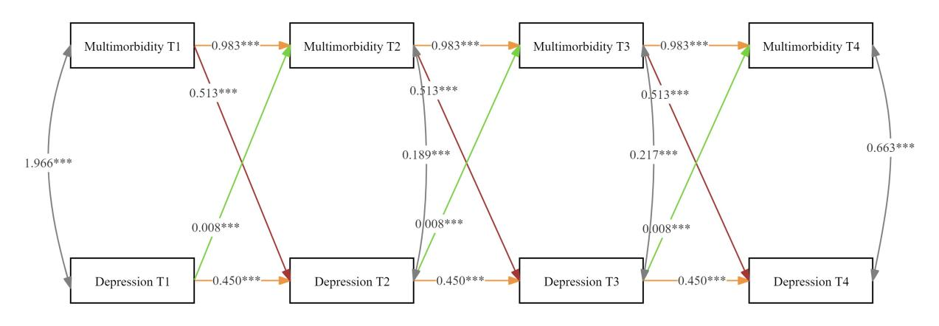
Figure 1. CLPM for multimorbidity and depression (Model 1). The observed variables were shown in grey. Dotted lines represent non-significant associations. T1=2011. T2=2013. T3=2015. T4=2018. *p < 0.05; **p < 0.01; ***p < 0.001.

cross-lagged panel model among multimorbidity, depression and intensity of CHE
Next, cross-lagged panel model with indirect effects were estimated to determine whether the intensity of CHE mediated paths between multimorbidity and depression (Model 2).Similarly, as shown in Table S3, the final RICLPM use the several constrained model for Model 2.
As shown in Figure 2, all pairwise interactions between these three variables were significantly positive. The indirect paths of “multimorbidity→the intensity of CHE→depression”, and”depression→the intensity of CHE→multimorbidity”were also tested and significant. For instance, the path from multimorbidity T-1 to depression T+1 via CHE intensity T was significant (indirect effect = 0.024, 95% CI = [0.016, 0.031]), as was the path from depression T-1 to multimorbidity T+1 via CHE intensity T (indirect effect = 0.001, 95% CI = [0.000, 0.001]).

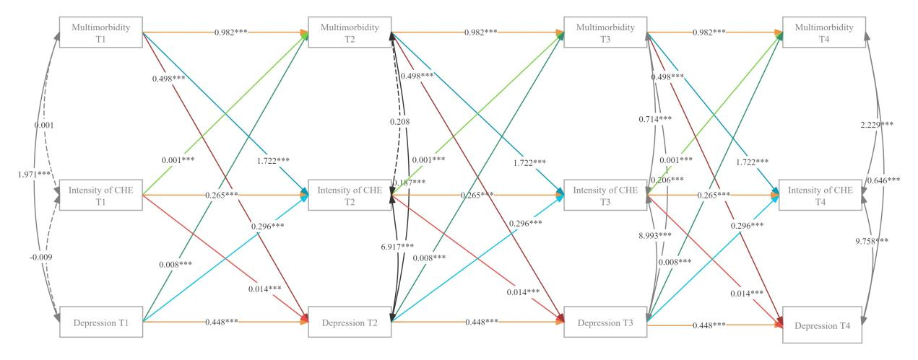
Figure 2. CLPM for multimorbidity, depression and intensity of CHE (Model 2). The observed variables were shown in grey. Dotted lines represent non-significant associations. T1=2011. T2=2013. T3=2015. T4=2018. *p < 0.05; **p < 0.01; ***p < 0.001.

- Main Mplus Syntax——taking Model 2 as an example.

TITLE: Multiple indicator RI-CLPM, 4 waves, MODE2 MMD-CHE—CES-several constrained.
DATA: FILE = TVDATA1.dat;
VARIABLE: NAMES = ID houseid X1 X2 X3 X4 C1 C2 C3 C4 T1 T2 T3 T4 I1 I2 I3 I4 A G M R E L M1 M2 M3 M4 L1 L2 L3 L4;
USEVARIABLES = X1 X2 X3 X4 C1 C2 C3 C4 I1 I2 I3 I4 A G R E M1 M2 M3 M4 L1 L2 L3 L4;
ANALYSIS: MODEL = NOCOV; ! Sets all default covariances to zero

MODEL:
!!!!!!!!!!!!!!!!
! BETWEEN PART !
!!!!!!!!!!!!!!!!

! Create between factors (random intercepts) for each indicator separately
RMD BY X1@1 X2@1 X3@1 X4@1;
RC BY C1@1 C2@1 C3@1 C4@1;
RT BY I1@1 I2@1 I3@1 I4@1;
! Estimate covariance between random intercepts
RMD WITH RC;
RMD WITH RT;
RC WITH RT;

!!!!!!!!!!!!!!!!!!!!!!!!!!!!!!!!!!
! WITHIN PART: MEASUREMENT MODEL !
!!!!!!!!!!!!!!!!!!!!!!!!!!!!!!!!!!

! Factor models for X at 4 waves
WMD1 BY X1@1;
WMD2 BY X2@1;
WMD3 BY X3@1;
WMD4 BY X4@1;

WC1 BY C1@1;
WC2 BY C2@1;
WC3 BY C3@1;
WC4 BY C4@1;

WT1 BY I1@1;
WT2 BY I2@1;
WT3 BY I3@1;
WT4 BY I4@1;

! Constrain measurement error variances to 0
X1-I4@0;

! Regression of observed variables on z1 (unconstrained)
X1-X4 ON A (s1);
X1-X4 ON G (s2);
X1-X4 ON E (s3);
C1-C4 ON A (s4);
C1-C4 ON G (s5);
C1-C4 ON E (s6);
!X1-X4 ON M (s7);
!C1-C4 ON M (s8);
X1-X4 ON R (s9);
C1-C4 ON R (s10);
!X1-X4 ON L (s11);
!C1-C4 ON L (s12);
I1-I4 ON A (s13);
I1-I4 ON G (s14);
I1-I4 ON E (s15);
!I1-I4 ON M (s16);
I1-I4 ON R (s17);
!I1-I4 ON L (s18);
X1 ON M1(s19);
C1 ON M1(s20);
I1 ON M1(s21);
X2 ON M2(s22);
C2 ON M2(s23);
I2 ON M2(s24);
X3 ON M3(s25);
C3 ON M3(s26);
I3 ON M3(s27);
X4 ON M4(s28);
C4 ON M4(s29);
I4 ON M4(s30);
X1 ON L1(s31);
C1 ON L1(s32);
I1 ON L1(s33);
X2 ON L2(s34);
C2 ON L2(s35);
I2 ON L2(s36);
X3 ON L3(s37);
C3 ON L3(s38);
I3 ON L3(s39);
X4 ON L4(s40);
C4 ON L4(s41);
I4 ON L4(s42);

!!!!!!!!!!!!!!!!!!!!!!!!!
! WITHIN PART: DYNAMICS !
!!!!!!!!!!!!!!!!!!!!!!!!!

! Specify lagged effects between within-person centered latent variables

WMD2 WC2 WT2 ON WMD1 WC1 WT1 (a1 b1 e1 f1 h1 j1 k1 m1 n1 );
WMD3 WC3 WT3 ON WMD2 WC2 WT2 (a1 b1 e1 f1 h1 j1 k1 m1 n1 );
WMD4 WC4 WT4 ON WMD3 WC3 WT3 (a1 b1 e1 f1 h1 j1 k1 m1 n1 );

! Estimate correlations within the same wave
WMD1 WITH WC1 WT1; WC1 WITH WT1;
WMD2 WITH WC2 WT2; WC2 WITH WT2;
WMD3 WITH WC3 WT3; WC3 WITH WT3;
WMD4 WITH WC4 WT4; WC4 WITH WT4;

MODEL indirect:WMD4 IND WT3 WC2; WC4 IND WT3 WMD2;WMD3 IND WT2 WC1; WC3 IND WT2 WMD1;

OUTPUT: TECH1 STDYX SAMPSTAT CINTERVAL;

