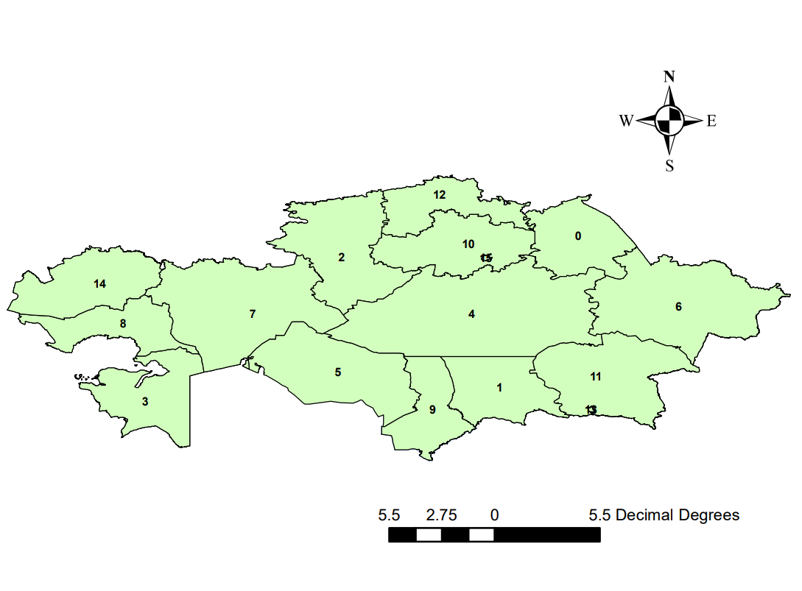

Figure S1. The 16 administrative regions of Kazakhstan with their corresponding codes
0- Pavlodar Region, 1- Jambyl Region, 2- Kostanay Region, 3- Mangystau Region, 4- Karaganda Region, 5- Kyzylorda Region, 6- East Kazakhstan Region, 7- Aktobe Region, 8- Atyrau Region, 9- South Kazakhstan Region, 10- Akmola Region, 11- Almaty Region, 12- North Kazakhstan Region, 13- Almaty, 14- West Kazakhstan Region, and 15- Astana.

