Supplementary Table 1. Sex differences in adherence to the 24-hour movement behaviour guidelines across study waves.
Wave-specific comparison of boys and girls using two-sample tests of proportions.
Age  (years) | Boys  adherent (%) | Girls  adherent (%) | 95% CI for  difference | p-value
6-7 | 24.4% | 24.5% | (-2.6, 2.4) | 0.951
8-9 | 19.3% | 21.1% | (-4.2, 0.6) | 0.144
10-11 | 20.0% | 23.0% | (-5.5, -0.5) | 0.021*
12-13 | 11.3% | 11.4% | (-2.1, 1.9) | 0.911
14-15 | 6.4% | 8.1% | (-3.4, 0.0) | 0.056
Note. P-values are from two-sample tests of proportions conducted separately at each age. * p < 0.05, ** p < 0.01, *** p < 0.001.

Supplementary Table S2. Wave-specific mean differences in health-related quality of life according to previous-wave adherence to the 24-hour movement behaviour guidelines, stratified by sex.
Values compare mean scores between adherent and non-adherent participants at the previous wave, shown separately for boys and girls.
Outcome | Wave  (age, years) | Boys |  | Girls
 |  | Mean scores | p-value | Mean scores | p-value
Physical  functioning | 8–9 | 85.5 vs 82.9 | <0.001*** | 83.9 vs 83.5 | 0.571
Physical  functioning | 10–11 | 81.0 vs 79.2 | 0.081 | 82.4 vs 78.1 | <0.001***
Physical  functioning | 12–13 | 86.1 vs 82.5 | <0.001*** | 85.3 vs 81.8 | <0.001***
Physical  functioning | 14–15 | 85.6 vs 82.3 | 0.013* | 84.4 vs 79.3 | <0.001***
Physical  functioning | 16–17 | 88.0 vs 84.0 | 0.003** | 85.7 vs 80.4 | <0.001***
Psychosocial  functioning | 8–9 | 76.5 vs 74.8 | 0.017* | 76.9 vs 77.3 | 0.536
Psychosocial  functioning | 10–11 | 77.7 vs 75.2 | 0.002** | 80.1 vs 77.2 | <0.001**
Psychosocial  functioning | 12–13 | 79.4 vs 75.8 | <0.001*** | 79.9 vs 77.9 | 0.010
Psychosocial  functioning | 14–15 | 79.1 vs 76.5 | 0.019* | 79.4 vs 74.8 | <0.001***
Psychosocial  functioning | 16–17 | 82.2 vs 77.7 | <0.001*** | 80.8 vs 76.0 | <0.001***
Overall HRQoL | 8–9 | 79.7 vs 77.6 | 0.002** | 79.3 vs 79.4 | 0.862
Overall HRQoL | 10–11 | 78.9 vs 76.6 | 0.005** | 80.9 vs 77.5 | <0.001***
Overall HRQoL | 12–13 | 81.7 vs 78.2 | <0.001*** | 81.8 vs 79.3 | <0.001***
Overall HRQoL | 14–15 | 81.4 vs 78.5 | 0.007** | 81.1 vs 76.3 | <0.001***
Overall HRQoL | 16–17 | 84.2 vs 79.9 | <0.001*** | 82.5 vs 77.5 | <0.001***
Note. Mean scores are shown as adherent versus non-adherent at the previous wave. * p < 0.05, ** p < 0.01, *** p < 0.001.
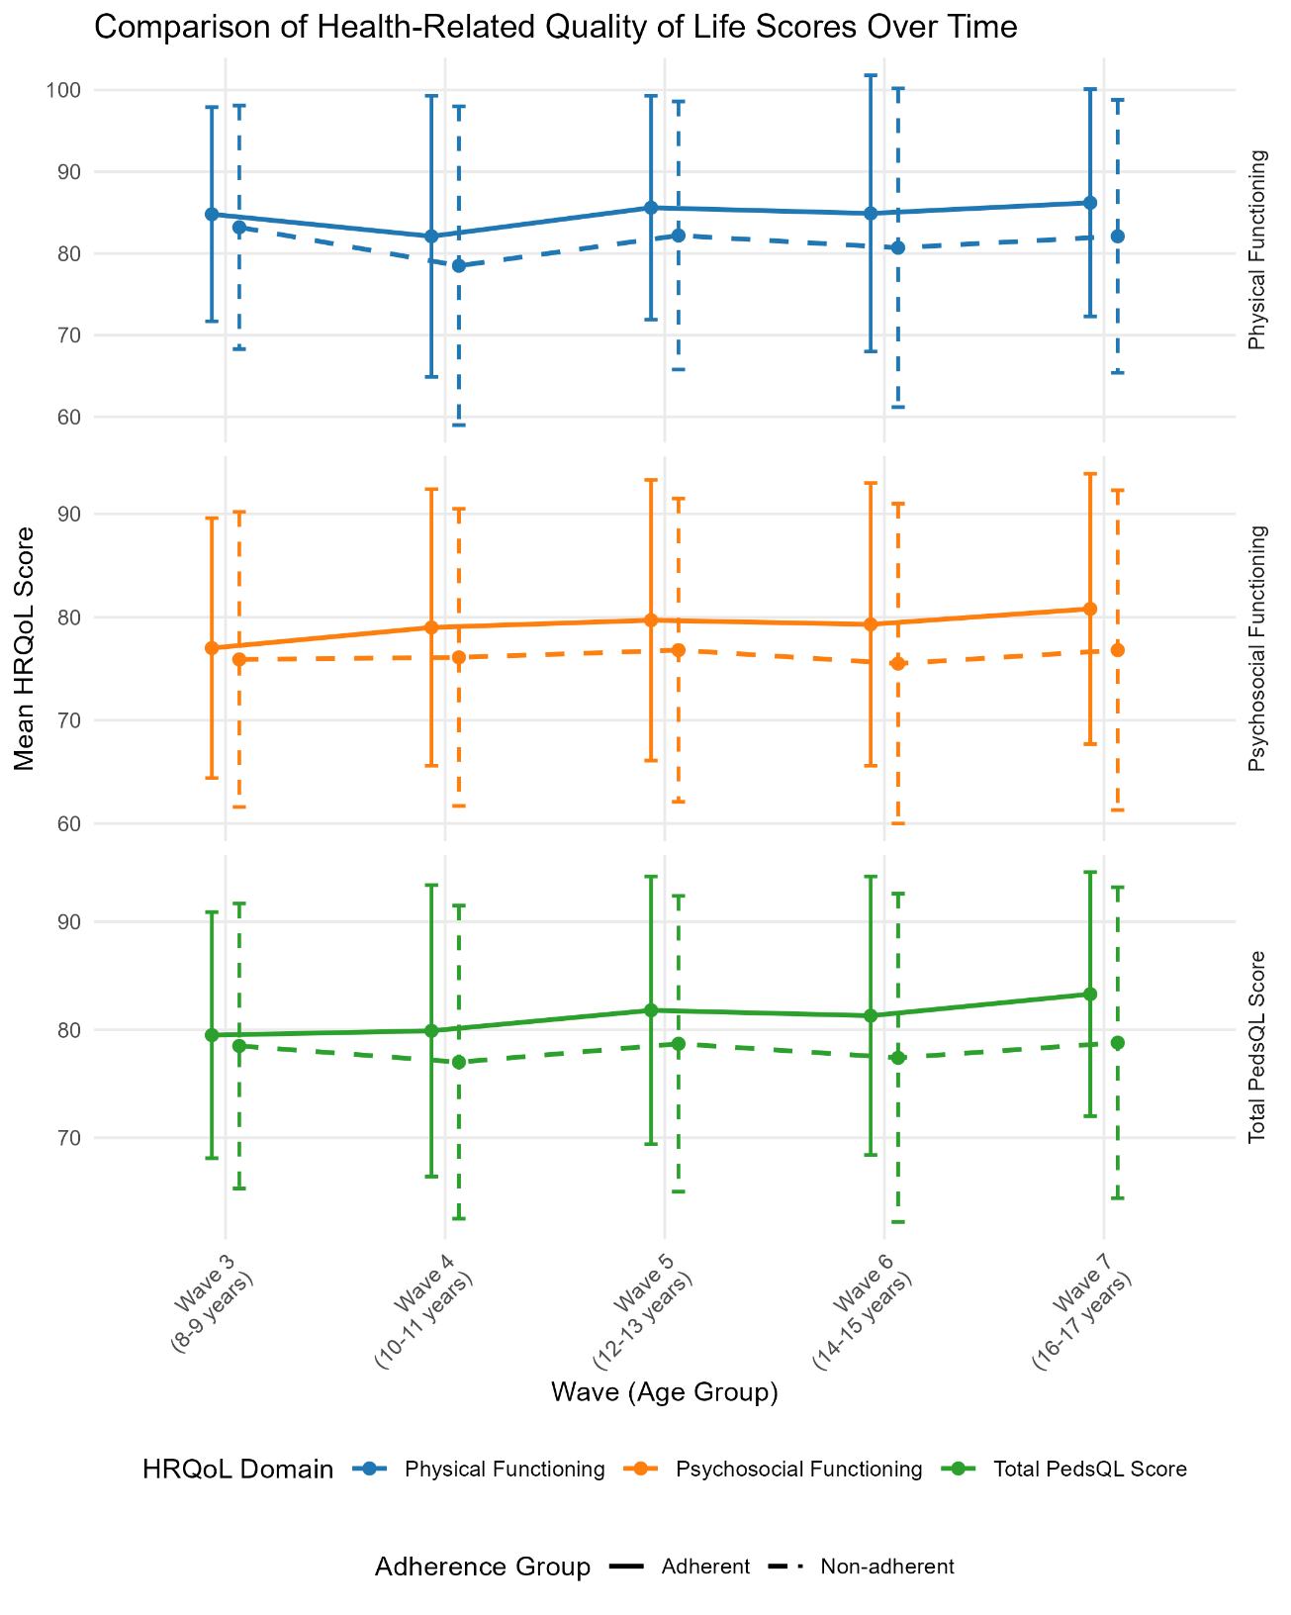
Supplementary Figure 1. Comparison of Health-Related Quality of Life Scores at Successive Waves by Adherence Status to 24-Hour Movement Behaviours Guidelines in the Previous Wave

