Supplementary files
Associations of activities of daily living disability and instrumental activities of daily living disability with all-cause mortality: Evidence from Five Major Longitudinal Studies

Running title: ADL/IADL and all-cause mortality

Heng Wang, MSc^{1,2}, Cong Li, PhD³, Kaibo Yang, PhD², Chingyu Cheng, PhD^{4,5,6,7}, Jinghua Jiao, PhD^{8,#}, Lei Liu, PhD^{3,9,#}, Han Zhang, PhD^{2,#}

1. School of clinical medicine, China Medical University, Shenyang, China.
2. Department of Ophthalmology, First Hospital of China Medical University, Shenyang, China.
3. Department of ophthalmology, Guangdong Eye Institute, Guangdong Provincial People's Hospital (Guangdong Academy of Medical Sciences), Southern Medical University, Guangzhou, China.
4. Singapore Eye Research Institute, Singapore National Eye Centre, Singapore, Singapore;
5. Centre for Innovation and Precision Eye Health, Yong Loo Lin School of Medicine, National University of Singapore, Singapore, Singapore;
6. Department of Ophthalmology, Yong Loo Lin School of Medicine, National University of Singapore, Singapore, Singapore;
7. Ophthalmology & Visual Sciences Academic Clinical Program (Eye ACP), Duke-NUS Medical School, Singapore, Singapore.
8. Department of Anesthesiology, Guangzhou Eighth People's Hospital, Guangzhou Medical University, Guangzhou, China.
9. Medical Big Data Center, Guangdong Provincial People's Hospital (Guangdong Academy of Medical Sciences), Southern Medical University, Guangzhou, China.

Brief introduction to all cohorts
China Health and Retirement Longitudinal Study: The purpose of the China Health and Retirement Longitudinal Study (CHARLS) is to collect a set of high-quality microdata representing families and individuals of middle-aged and elderly people aged 45 years and older in China, so as to analyze the aging problem of the Chinese population and promote interdisciplinary research on the aging problem (1). The survey covers 150 county-level units, 450 village-level units, and about 17,000 people in 10,000 families. The survey included basic demographic information of respondents and their families, transfer payments between family members, respondents' health status, medical care and insurance, employment, income, expenditure, and assets. In addition, CHARLS includes 13 body measurements and blood sampling. CHARLS related data can be downloaded at the CHARLS home page at https://charls.pku.edu.cn/.

English Longitudinal Study of Ageing: The English Longitudinal Study of Ageing (ELSA) is a panel study of a representative cohort of men and women living in England aged ≥50 years (2). It was designed as a sister study to the Health and Retirement Study in the USA and is multidisciplinary in orientation, involving the collection of economic, social, psychological, cognitive, health, biological and genetic data. The study commenced in 2002, and the sample has been followed up every 2 years. Data are collected using computer-assisted personal interviews and self-completion questionnaires, with additional nurse visits for the assessment of biomarkers every 4 years. The original sample consisted of 11,391 members ranging in age from 50 to 100 years. ELSA is harmonized with ageing studies in other countries to facilitate international comparisons, and is linked to financial and health registry data. For more information about ELSA, visit http://www.elsa-project.ac.uk/ .

Health and Retirement Study: The Health and Retirement Study (HRS: https://hrs.isr.umich.edu/) is a nationally representative longitudinal survey of more than 37 000 individuals over age 50 in 23 000 households in the USA (3). The survey, which has been fielded every 2 years since 1992, was established to provide a national resource for data on the changing health and economic circumstances associated with ageing at both individual and population levels. Its multidisciplinary approach is focused on four broad topics—income and wealth; health, cognition and use of healthcare services; work and retirement; and family connections. HRS data are also linked at the individual level to administrative records from Social Security and Medicare, Veteran’s Administration, the National Death Index and employer-provided pension plan information. Since 2006, data collection has expanded to include biomarkers and genetics as well as much greater depth in psychology and social context. This blend of economic, health and psychosocial information provides unprecedented potential to study increasingly complex questions about ageing and retirement.

Mexican Health and Aging Study: The Mexican Health and Aging Study (MHAS: https://www.mhasweb.org/) was designed to prospectively evaluate the impact of disease on the health, function and mortality of adults over the age of 50 in both urban and rural areas of Mexico (4). The overall goal of the study is to examine the ageing process and its disease and disability burden in a large representative panel of older Mexicans, using a wide socioeconomic perspective. The study protocols and survey instruments are highly comparable to the U.S. Health and Retirement Study (HRS). The MHAS 2001 baseline is a national and urban-rural representative survey of individuals born in 1951 or earlier. Three waves of data have been collected so far: baseline in 2001 and follow-ups in 2003 and 2012.

SHARE: The Survey of Health, Ageing and Retirement in Europe (SHARE, https://share-eric.eu/), is a study used to investigate the impact of health, social, economic and environmental policies in the life course of European citizens (5). From 2004 to the present, 530,000 in-depth interviews have been conducted with 140,000 people over the age of 50 from 28 European countries and Israel.

References
(1). Zhao Y, Hu Y, Smith JP, Strauss J, Yang G. Cohort profile: the China Health and Retirement Longitudinal Study (CHARLS). Int J Epidemiol 2014; 43 (1): 61-8.
(2). Steptoe A, Breeze E, Banks J, Nazroo J. Cohort profile: the English longitudinal study of ageing. Int J Epidemiol 2013; 42 (6): 1640-8.
(3). Sonnega A, Faul JD, Ofstedal MB, Langa KM, Phillips JW, Weir DR. Cohort Profile: the Health and Retirement Study (HRS). Int J Epidemiol 2014; 43 (2): 576-85.
(4). Wong R, Michaels-Obregon A, Palloni A. Cohort Profile: The Mexican Health and Aging Study (MHAS). Int J Epidemiol 2017; 46 (2): e2.
(5). Börsch-Supan A, Brandt M, Hunkler C, et al. Data Resource Profile: the Survey of Health, Ageing and Retirement in Europe (SHARE). Int J Epidemiol 2013; 42 (4): 992-1001.

Supplementary Figure S1. Start and end time of each cohort’s follow-up

China Health and Retirement Longitudinal Study: waves 1 to 4, 2011-2019
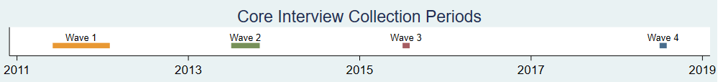

English Longitudinal Study of Ageing:waves 2 to 7, 2004-2014
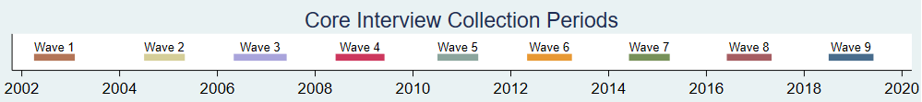

Health and Retirement Study: waves 10 to 15, 2010-2020
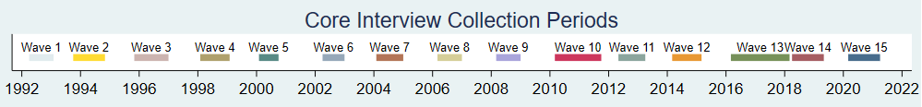

Mexican Health and Aging Study: waves 1 to 3, 2001-2012
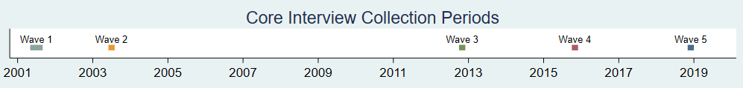

Survey of Health, Ageing and Retirement in Europe: waves 2 to 7, 2007-2017
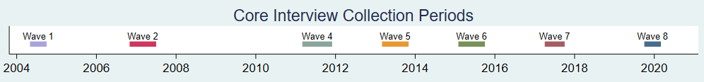
Supplementary Table S1. Data coding and definition of covariates
Covariates | Definition
Age | The age of the individual is calculated using the year of birth and the year at the baseline of the cohort.
Gender | The gender is identified as male or female as reported in the dataset.
Education | According to the International Standard Classification of Education 1997, educational levels were a three-tier variable, including below high school, high school, and college and above. Different countries may have different definitions of education levels. We use the information from the harmonized dataset, which has been standardized through Global Aging Data. This ensures that education level information is comparable across different countries.
Marital status | Marital status was recoded as below:  Married: Married and living together with.  Other: Divorced; Widowed; Separated from spouse; Partnered. Never married.
SES (income quartiles) | Total Household Income is divided into four quartiles from low to high (Q1-Q4). Total Household Income represents the sum of all incomes received in the past year at the household level.
Alcohol Consumption | The level of alcohol consumption is categorized into 'ever' (including current drinkers, past drinkers, and those who used to drink but have now quit) and 'never' (those who have never consumed alcohol).
Smoking | Smoking is categorized into 'ever' (including current smokers, past smokers, and those who used to smoke but have now quit) and 'never' (those who have never smoked).
BMI | BMI, or Body Mass Index, can be determined through two methods. One is through actual measurements taken on-site, such as in a clinic or health fair. The second method is through self-reporting.
CES-D Z-Score | CHARLS uses a 10-item CES-D scale, ELSA, HRS, and SHARE use an 8-item CES-D scale, and MHAS uses a 9-item CES-D scale.  CES-D (HRS):RwDEPRES, RwEFFORT, RwSLEEPR, RwWHAPPY, RwFLONE, RwFSAD, RwGOING, and RwENLIFE  CES-D (ELSA):RwDEPRES, RwEFFORT, RwSLEEPR, RwFLONE, RwFSAD, RwGOING, RwWHAPPY, and RwENLIFE  CES-D (MHAS):RwDEPRES, RwEFFORT, RwSLEEPR, RwWHAPPY, RwFLONE, RwENLIFE, RwFSAD, RwFTIRED and RwENERG  CES-D (CHARLS):RwDEPRESL, RwEFFORTL, RwSLEEPRL, RwWHAPPYL, RwFLONEL, RwBOTHERL, RwGOINGL, RwMINDTSL, RwFHOPEL and RwFEARLL  CES-D (SHARE):RwDEPRES, RwEFFORT, RwSLEEPR, RwFLONE, RwFSAD, RwGOING, RwWHAPPY, and RwENLIFE  The total score is obtained by summing the items on the CES-D scale provided within the cohort; a higher score indicates a greater likelihood of depression. After standardization within the cohort, a Z-score is obtained. Because individual weights within the cohort are used in the standardization calculation, the mean is not necessarily 0. A higher standardized Z-score indicates a greater likelihood of depression.
Chronic Diseases | This variable represents the number of chronic diseases diagnosed in an individual by a doctor; details are provided below.

Abbreviations: CHARLS: China Health and Retirement Longitudinal Study; ELSA: English Longitudinal Study of Ageing; HRS: Health and Retirement Study; SHARE: Survey of Health, Ageing and Retirement in Europe; MHAS: Mexican Health and Aging Study; SES (IQR): Socioeconomic status; CES-D: Center for Epidemiologic Studies Depression.

Supplementary Table S2. Definition of chronic diseases diagnosed by doctors in each cohort
Chronic Diseases | Description | CHARLS | ELSA | HRS | MHAS | SHARE
Arthritis | Arthritis questions include questions capturing whether the respondent has ever been diagnosed with arthritis or rheumatism | ✓ | ✓ | ✓ | ✓ | ✓
Cancer | Cancer questions include questions capturing whether the respondent has ever been diagnosed with cancer (or cancer or a malignant tumor of any kind except skin cancer) | ✓ | ✓ | ✓ | ✓ | ✓
Diabetes | Diabetes questions include questions capturing whether the respondent has ever been diagnosed with diabetes (or high blood sugar) | ✓ | ✓ | ✓ | ✓ | ✓
Heart conditions | Heart conditions questions include questions capturing whether the respondent has ever been diagnosed with either heart attack, coronary heart disease, angina, congestive heart failure or other heart problems | ✓ | ✓ | ✓ | X | ✓
High blood pressure | High blood pressure variables include variables capturing whether the respondent has ever been diagnosed with high blood pressure (or hypertension) | ✓ | ✓ | ✓ | ✓ | ✓
Lung disease | Lung disease questions include questions capturing whether the respondent has ever been diagnosed with chronic lung disease (except asthma) such as chronic bronchitis or emphysema | ✓ | ✓ | ✓ | ✓ | ✓
Stroke | Stroke questions include questions capturing whether the respondent has ever been diagnosed with stroke or transient ischemic attack (TIA) | ✓ | ✓ | ✓ | ✓ | ✓
Supplementary Table S3. Measurement methods and definition for ADL/IADL disability in each cohort
Cohort | Variables | Description
CHARLS | ADL Variables | These variables pertain to questions regarding Activities of Daily Living (ADLs) and whether the respondent experiences some difficulty performing said tasks. This line of questioning is not asked to respondents who are younger than 50 and report good health as jointly defined by self-reported positive health and no self-reported disabilities. A code of 0 indicates that the respondent did not report any problems with the activity. A code of 1 indicates that the respondent reported some difficulty with the activity. In the CHARLS, these variables are recoded from 1.) No, I don’t have any difficulty, 2.) I have difficulty but can still do it, 3.) Yes, I have difficulty and need help, and 4.) I cannot do it. If the respondent answers 2, 3 or 4 to any difficulty with an activity, the variable is set to 1 for some difficulty. If the respondent answers 1, the variable is set to 0 for no difficulty.
CHARLS | IADL Variables | These variables pertain to questions regarding Instrumental Activities of Daily Living (IADLs) and whether the respondent experiences any difficulty performing said tasks. A code of 0 indicates that the respondent did not report any problems with the instrumental activity. A code of 1 indicates that the respondent reported some difficulty with the instrumental activity. In the CHARLS, these variables are recoded from 1.) No, I don’t have any difficulty, 2.) I have difficulty but can still do it, 3.) Yes, I have difficulty and need help and 4.) I cannot do it. If respondent answers 2, 3 or 4 to any difficulty with an activity, the variable is set to 1 for some difficulty. If respondent answers 1, the variable is set to 0 for no difficulty.
ELSA | ADL Variables | These variables indicate difficulty with activities of daily living (ADLs). A code of 0 indicates that the respondent did not report any problems with the activity. A code of 1 indicates that the respondent reported some difficulty with the activity. In the ELSA, respondents identify ADLs by selecting activities they have difficulty with from a card containing a list of activities. Respondents are asked to exclude any difficulties they expect to last less than three months.
ELSA | IADL Variables | These variables indicate difficulty with instrumental activities of daily living (IADLs). A code of 0 indicates that the respondent did not report any problems with the instrumental activity. A code of 1 indicates that the respondent reported some difficulty with the instrumental activity. In the ELSA, respondents identify IADLs by selecting instrumental activities they have difficulty with from a card containing a list of activities. Respondents are asked to exclude any difficulties they expect to last less than three months.
HRS | ADL Variables | In the RAND HRS, the binary indicators of some difficulty with ADL’s are recoded from no, yes or can’t do. If the respondent answers yes or can’t do to whether they have any difficulty with an activity, the variable is set to 1 for some difficulty. If the respondent answers no, the variable is set to 0 for no difficulty.
HRS | IADL Variables | In the RAND HRS, the binary indicators of some difficulty with IADL’s are recoded from no, yes or can’t do. If the respondent answers yes or can’t do to whether they have any difficulty with an activity, the variable is set to 1 for some difficulty. If respondent answers no, the variable is set to 0 for no difficulty.
MHAS | ADL Variables | These variables indicate difficulty with activities of daily living (ADLs). A code of 0 indicates that the respondent did not report any problems with the activity. A code of 1 indicates that the respondent reported some difficulty with the activity or if they reported "can't do".
MHAS | IADL Variables | These variables indicate difficulty with instrumental activities of daily living (IADLs). A code of 0 indicates that the respondent did not report any problems with the activity. A code of 1 indicates that either the respondent reported some difficulty with the activity or the respondent answered "Can't Do" or "Don't do" to the initial question about the activity and they answered that this was because of a health problem in the follow-up question.
SHARE | ADL Variables | These variables indicate difficulty with activities of daily living (ADLs). A code of 0 indicates that the respondent did not report any problems with the activity. A code of 1 indicates that the respondent reported some difficulty with the activity.
SHARE | IADL Variables | These variables indicate difficulty with instrumental activities of daily living (IADLs). A code of 0 indicates that the respondent did not report any problems with the instrumental activity. A code of 1 indicates that the respondent reported some difficulty with the instrumental activity.

Supplementary Table S4. Complete ADL/IADL scales in each cohort
 | CHARLS | ELSA | HRS | MHAS | SHARE
ADL |  | Walk across room | Walk across room | Walk across room | Walk across room
ADL | Dressing | Dressing | Dressing | Dressing | Dressing
ADL | Bathing | Bathing | Bathing | Bathing | Bathing
ADL | Eating | Eating | Eating | Eating | Eating
ADL | Get in/out of bed | Get in/out of bed | Get in/out of bed | Get in/out of bed | Get in/out of bed
ADL | Using the toilet | Using the toilet | Using the toilet | Using the toilet | Using the toilet
ADL | Controlling urination and defecation
IADL |  | Use a map | Use a map |  | Use a map
IADL | Use telephone | Use telephone | Use telephone |  | Use telephone
IADL | Managing money | Managing money | Managing money | Managing money | Managing money
IADL | Take medications | Take medications | Take medications | Take medications | Take medications
IADL | Shop for grocery | Shop for grocery | Shop for grocery | Shop for grocery | Shop for grocery
IADL | Prepare hot meal | Prepare hot meal | Prepare hot meal | Prepare hot meal | Prepare hot meal
IADL | Doing work around the house or garden | Doing work around the house or garden |  |  | Doing work around the house or garden
To reconcile differences in design and culture between the cohorts, we selected relatively basic items to make up the final dataset (i.e., ADL include dressing, bathing, eating, getting in and out of bed, and using the toilet, while IADL include preparing hot meals, shopping, taking medication, and managing money). The items are indicated in bold in the table above. Previous research has shown that the ADL/IADL scales maintain acceptable measurement equivalence even with differences in economic and cultural factors. This is also confirmed by the results of the difference item function (DIF) analysis in the Athlos study.
Abbreviations: CHARLS: China Health and Retirement Longitudinal Study; ELSA: English Longitudinal Study of Ageing; HRS: Health and Retirement Study; SHARE: Survey of Health, Ageing and Retirement in Europe; MHAS: Mexican Health and Aging Study. ADL: Activities of Daily Living; IADL: Instrumental Activities of Daily Living

Supplementary Table S5. Missing patterns of ADL/IADL scales in each cohort

Cohort | ADL missing item = 1  (n) | ADL missing item = 2  (n) | ADL missing item = 3  (n) | ADL missing item = 4  (n) | ADL missing item = 5  (n) | IADL missing item = 1  (n) | IADL missing item = 2  (n) | IADL missing item = 3  (n) | IADL missing item = 4  (n)
CHARLS (n = 13466) | 19 | 0 | 0 | 0 | 245 | 63 | 12 | 2 | 109
ELSA ( n = 9171) | 0 | 0 | 0 | 0 | 3 | 0 | 0 | 0 | 3
HRS ( n = 21042) | 89 | 13 | 3 | 3 | 117 | 1237 | 222 | 45 | 124
MHAS ( n = 13463) | 1046 | 7 | 0 | 153 | 37 | 562 | 261 | 40 | 1038
SHARE ( n = 35934) | 0 | 0 | 0 | 0 | 139 | 0 | 0 | 0 | 139

Abbreviations: CHARLS: China Health and Retirement Longitudinal Study; ELSA: English Longitudinal Study of Ageing; HRS: Health and Retirement Study; SHARE: Survey of Health, Ageing and Retirement in Europe; MHAS: Mexican Health and Aging Study. ADL: Activities of Daily Living; IADL: Instrumental Activities of Daily Living

Supplementary Figure S2. Kaplan-Meier survival curves by different ADL/IADL status
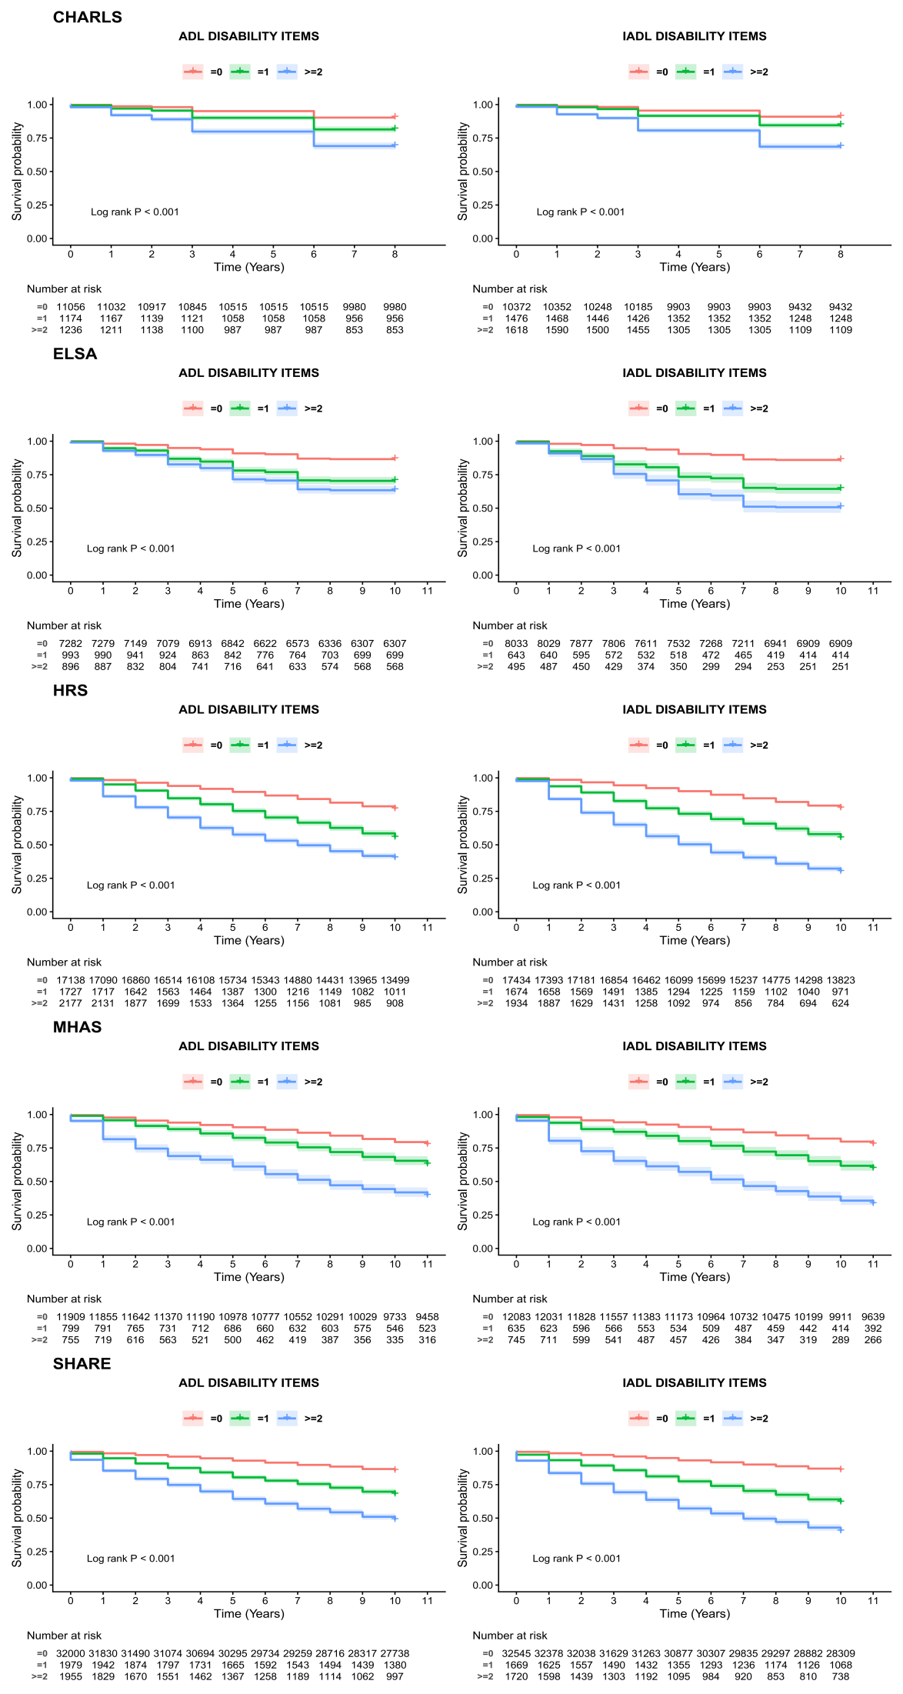
The p-value was calculated using the log-rank test.

Abbreviations: CHARLS: China Health and Retirement Longitudinal Study; ELSA: English Longitudinal Study of Ageing; HRS: Health and Retirement Study; SHARE: Survey of Health, Ageing and Retirement in Europe; MHAS: Mexican Health and Aging Study. ADL: Activities of Daily Living; IADL: Instrumental Activities of Daily Living.

Supplementary Figure S3. Directed Acyclic Graph
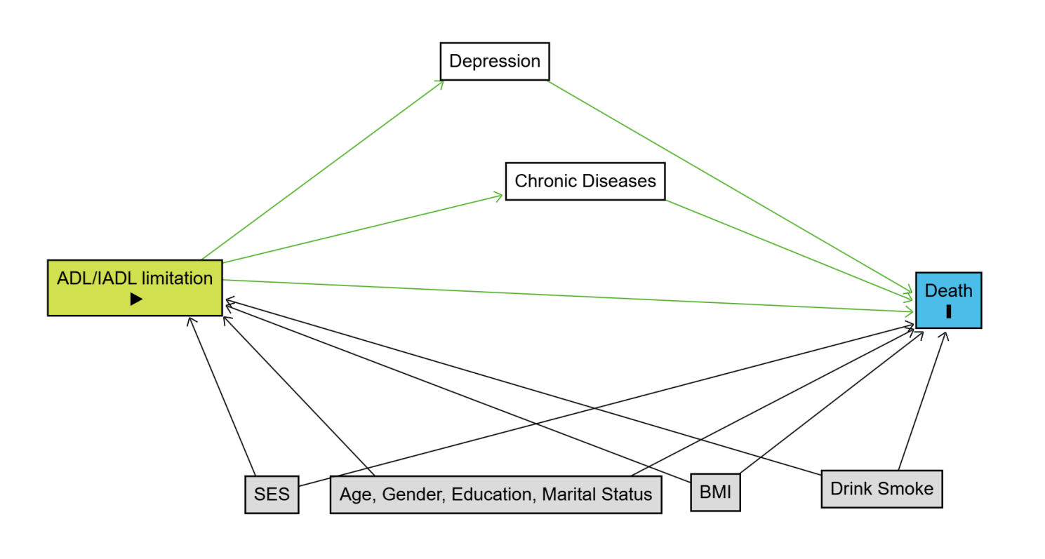
Abbreviations: ADL: Activities of Daily Living; IADL: Instrumental Activities of Daily Living; SES (income quartiles): Socioeconomic status.
Green arrows represent causal paths, while black arrows represent backdoor paths.

Supplementary Table S6. Description of missing data for each cohort before multiple imputation
 | CHARLS (n = 13466) |  | ELSA ( n = 9171) |  | HRS ( n = 21042) |  | MHAS ( n = 13463) |  | SHARE ( n = 35934)
Variable | CHARLS_Missing | % | ELSA_Missing | % | HRS_Missing | % | MHAS_Missing | % | SHARE_Missing | %
BMI | 2,913 | 21.6 | 1,946 | 21.2 | 395 | 1.9 | 3,445 | 25.6 | 1,225 | 3.4
C-ESD | 1,819 | 13.5 | 263 | 2.9 | 1,560 | 7.4 | 1,356 | 10.1 | 1,556 | 4.3
Total Household Income | 3,960 | 29.4 | 122 | 1.3 | 0 | <1 | 52 | <1 | 517 | 1.4
ADL
Dressing | 247 | 1.8 | 3 | <1 | 135 | <1 | 1,071 | 8 | 139 | <1
Bathing | 258 | 1.9 | 3 | <1 | 133 | <1 | 194 | 1.4 | 139 | <1
Eating | 245 | 1.8 | 3 | <1 | 149 | <1 | 196 | 1.5 | 139 | <1
Get in/out of bed | 247 | 1.8 | 3 | <1 | 145 | <1 | 192 | 1.4 | 139 | <1
Using the toilet | 247 | 1.8 | 3 | <1 | 159 | <1 | 204 | 1.5 | 139 | <1
IADL
Managing money | 148 | 1.1 | 3 | <1 | 717 | 3.4 | 1,106 | 8.2 | 139 | <1
Take medications | 130 | <1 | 3 | <1 | 409 | 1.9 | 1,091 | 8.1 | 139 | <1
Shop for grocery | 133 | <1 | 3 | <1 | 503 | 2.4 | 1,406 | 10.4 | 139 | <1
Prepare hot meal | 118 | <1 | 3 | <1 | 683 | 3.2 | 1,753 | 13 | 139 | <1
Chronic Diseases
Arthritis | 127 | <1 | 1 | <1 | 0 | <1 | 402 | 3 | 142 | <1
Cancer | 154 | 1.1 | 1 | <1 | 0 | <1 | 395 | 2.9 | 151 | <1
Diabetes | 210 | 1.6 | 1 | <1 | 0 | <1 | 408 | 3 | 144 | <1
Heart conditions | 171 | 1.3 | 1 | <1 | 0 | <1 | NA | NA | 145 | <1
High blood pressure | 152 | 1.1 | 1 | <1 | 0 | <1 | 421 | 3.1 | 138 | <1
Lung disease | 147 | 1.1 | 1 | <1 | 0 | <1 | 387 | 2.9 | 152 | <1
Stroke | 126 | <1 | 1 | <1 | 0 | <1 | 398 | 3 | 152 | <1
ADL: activities of daily living; IADL: instrumental activities of daily living; HRS: Health and Retirement Study; ELSA: English Longitudinal Study of Ageing; SHARE: Survey of Health, Ageing and Retirement in Europe; CHARLS: China Health and Retirement Longitudinal Study; MHAS: Mexican Health and Aging Study; CES-D: Center for Epidemiologic Studies Depression.

Supplementary Table S7. Original surveys’ ethical approvals
Cohorts | Ethical approval
HRS | Authorized by the National Institute on Aging and the Social Security Administration (NIA U01AG009740).
CHARLS | Approved by the Peking University Institutional Review Board (IRB00001052-11015).
SHARE | Approved by the Max Planck Society’s Ethics Committee.
ELSA | Approved by the National Research and Ethics Service Committee South Central - Berkshire.
MHAS | Approved by the National Institutes of Health/National Institute on Aging (NIH R01AG018016).
All participants in these studies provided written informed consent, as stipulated by the original survey documents.
Supplementary Figure S4. Flowchart of including and excluding process in all cohorts
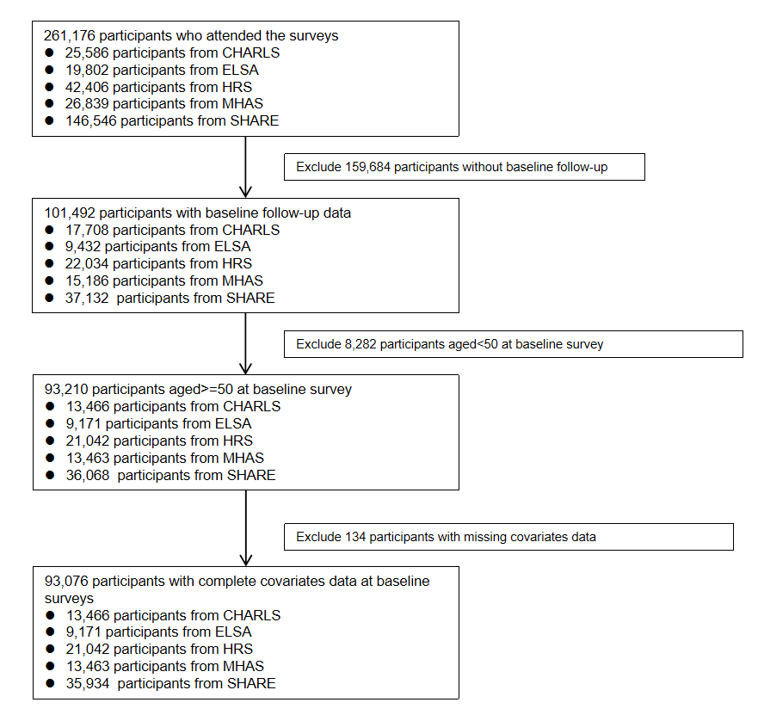

Abbreviations: CHARLS: China Health and Retirement Longitudinal Study; ELSA: English Longitudinal Study of Ageing; HRS: Health and Retirement Study; SHARE: Survey of Health, Ageing and Retirement in Europe; MHAS: Mexican Health and Aging Study. ADL: Activities of Daily Living; IADL: Instrumental Activities of Daily Living.

Supplementary Figure S5. Meta analysis of association between ADL/IADL status and mortality(ADL disability and IADL disability as exposure, model 2 adjusted)
Model 2 was adjusted for age, gender, education, marital status, BMI, smoking, drinking status, and SES (income quartiles).

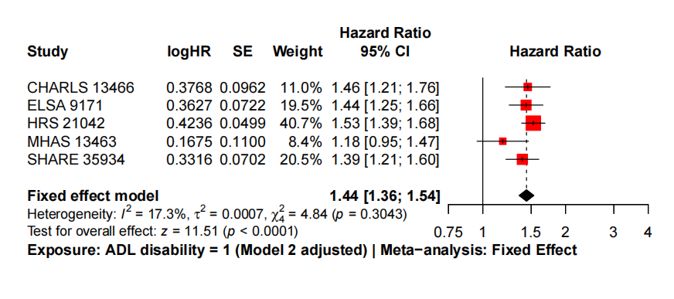
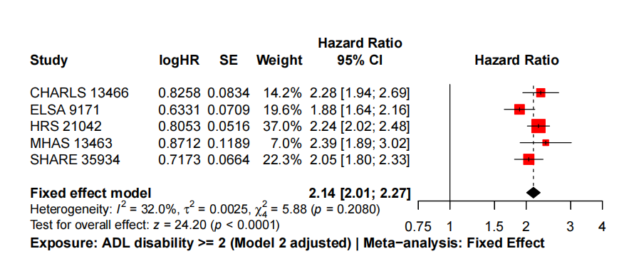
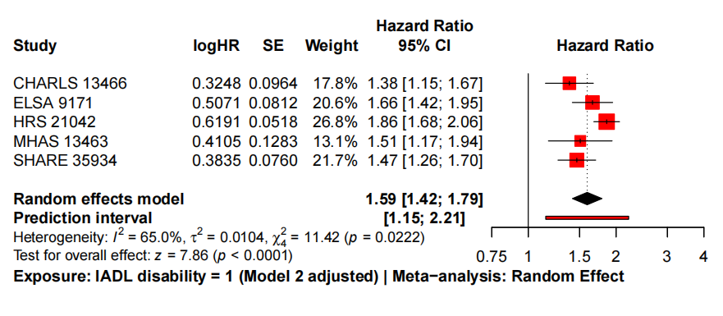
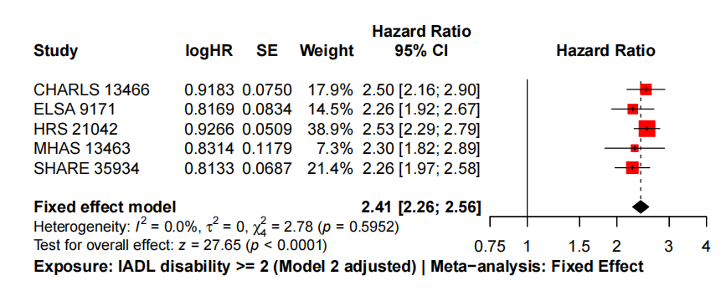

Supplementary Figure S6. Time-dependent Cox models
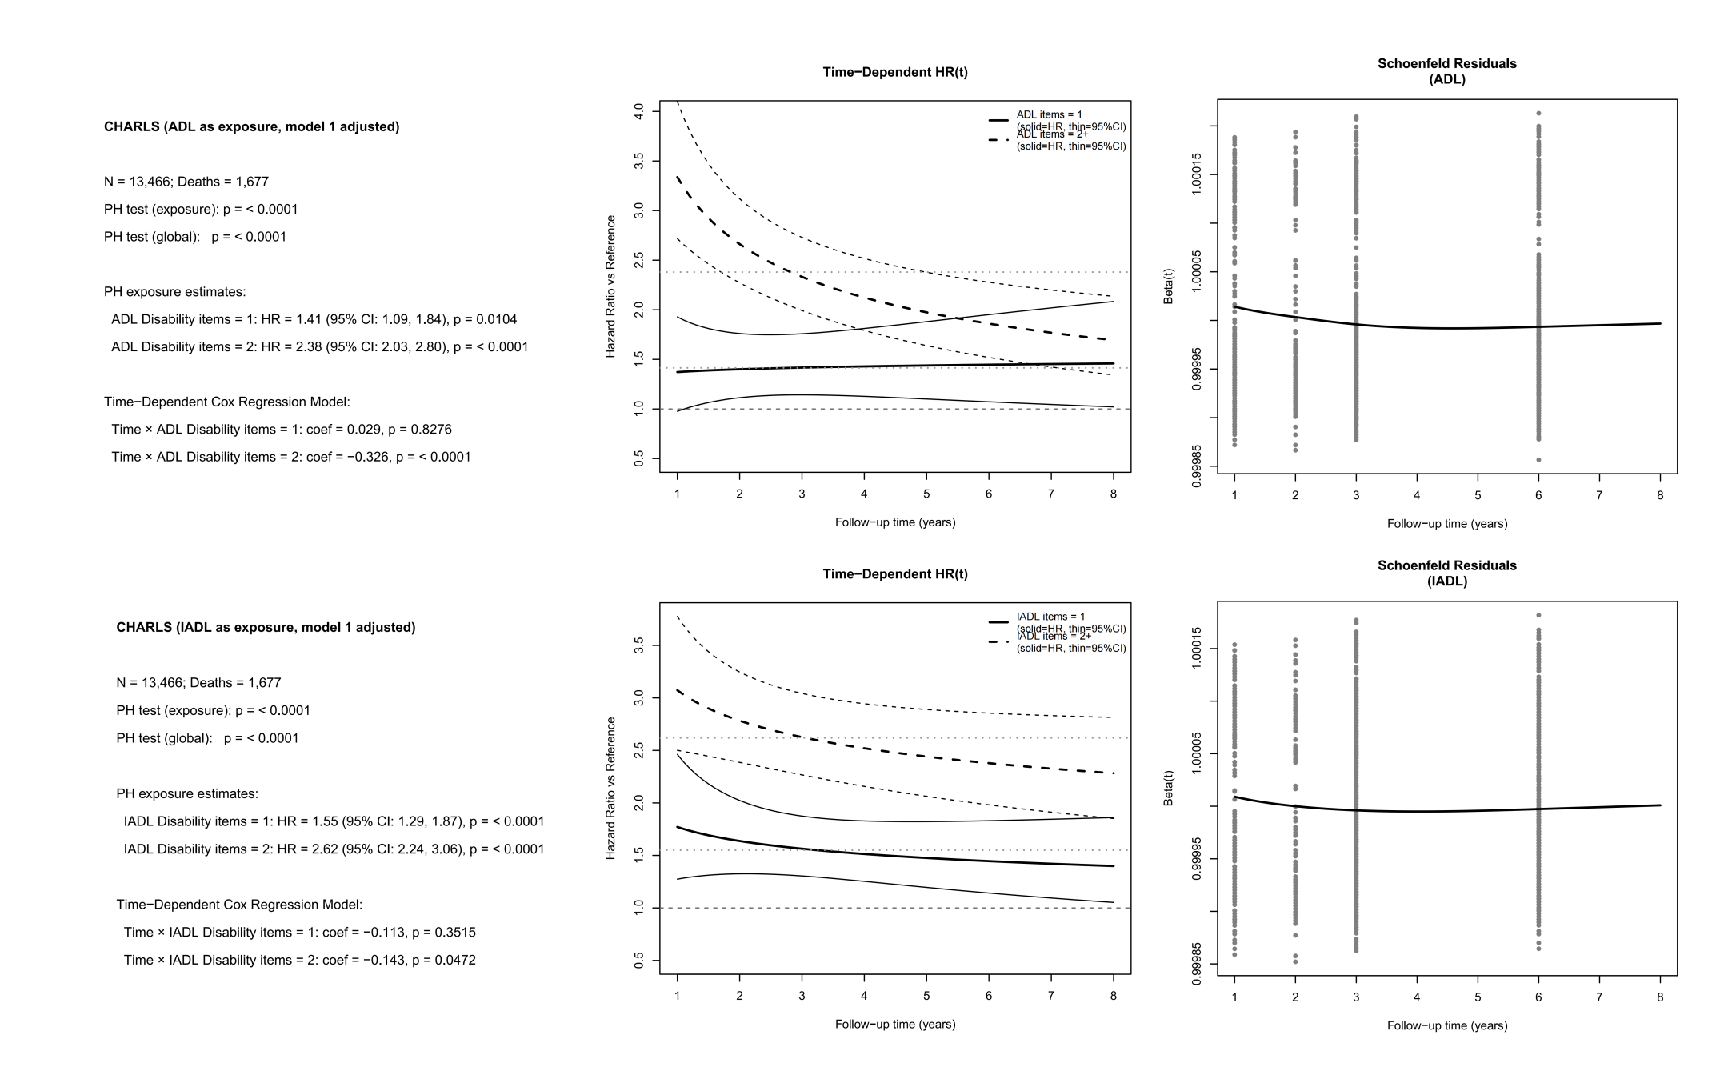
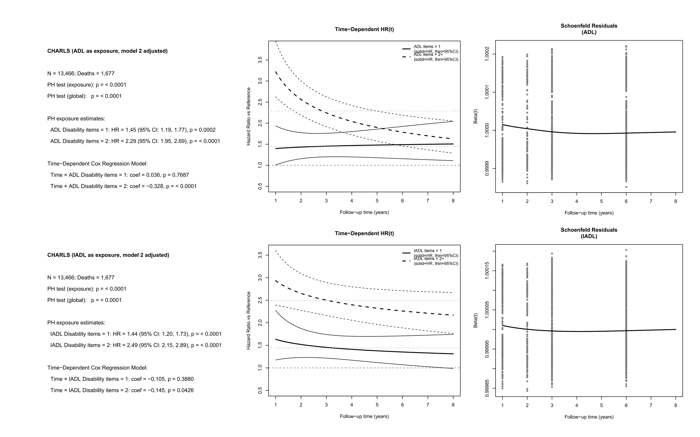

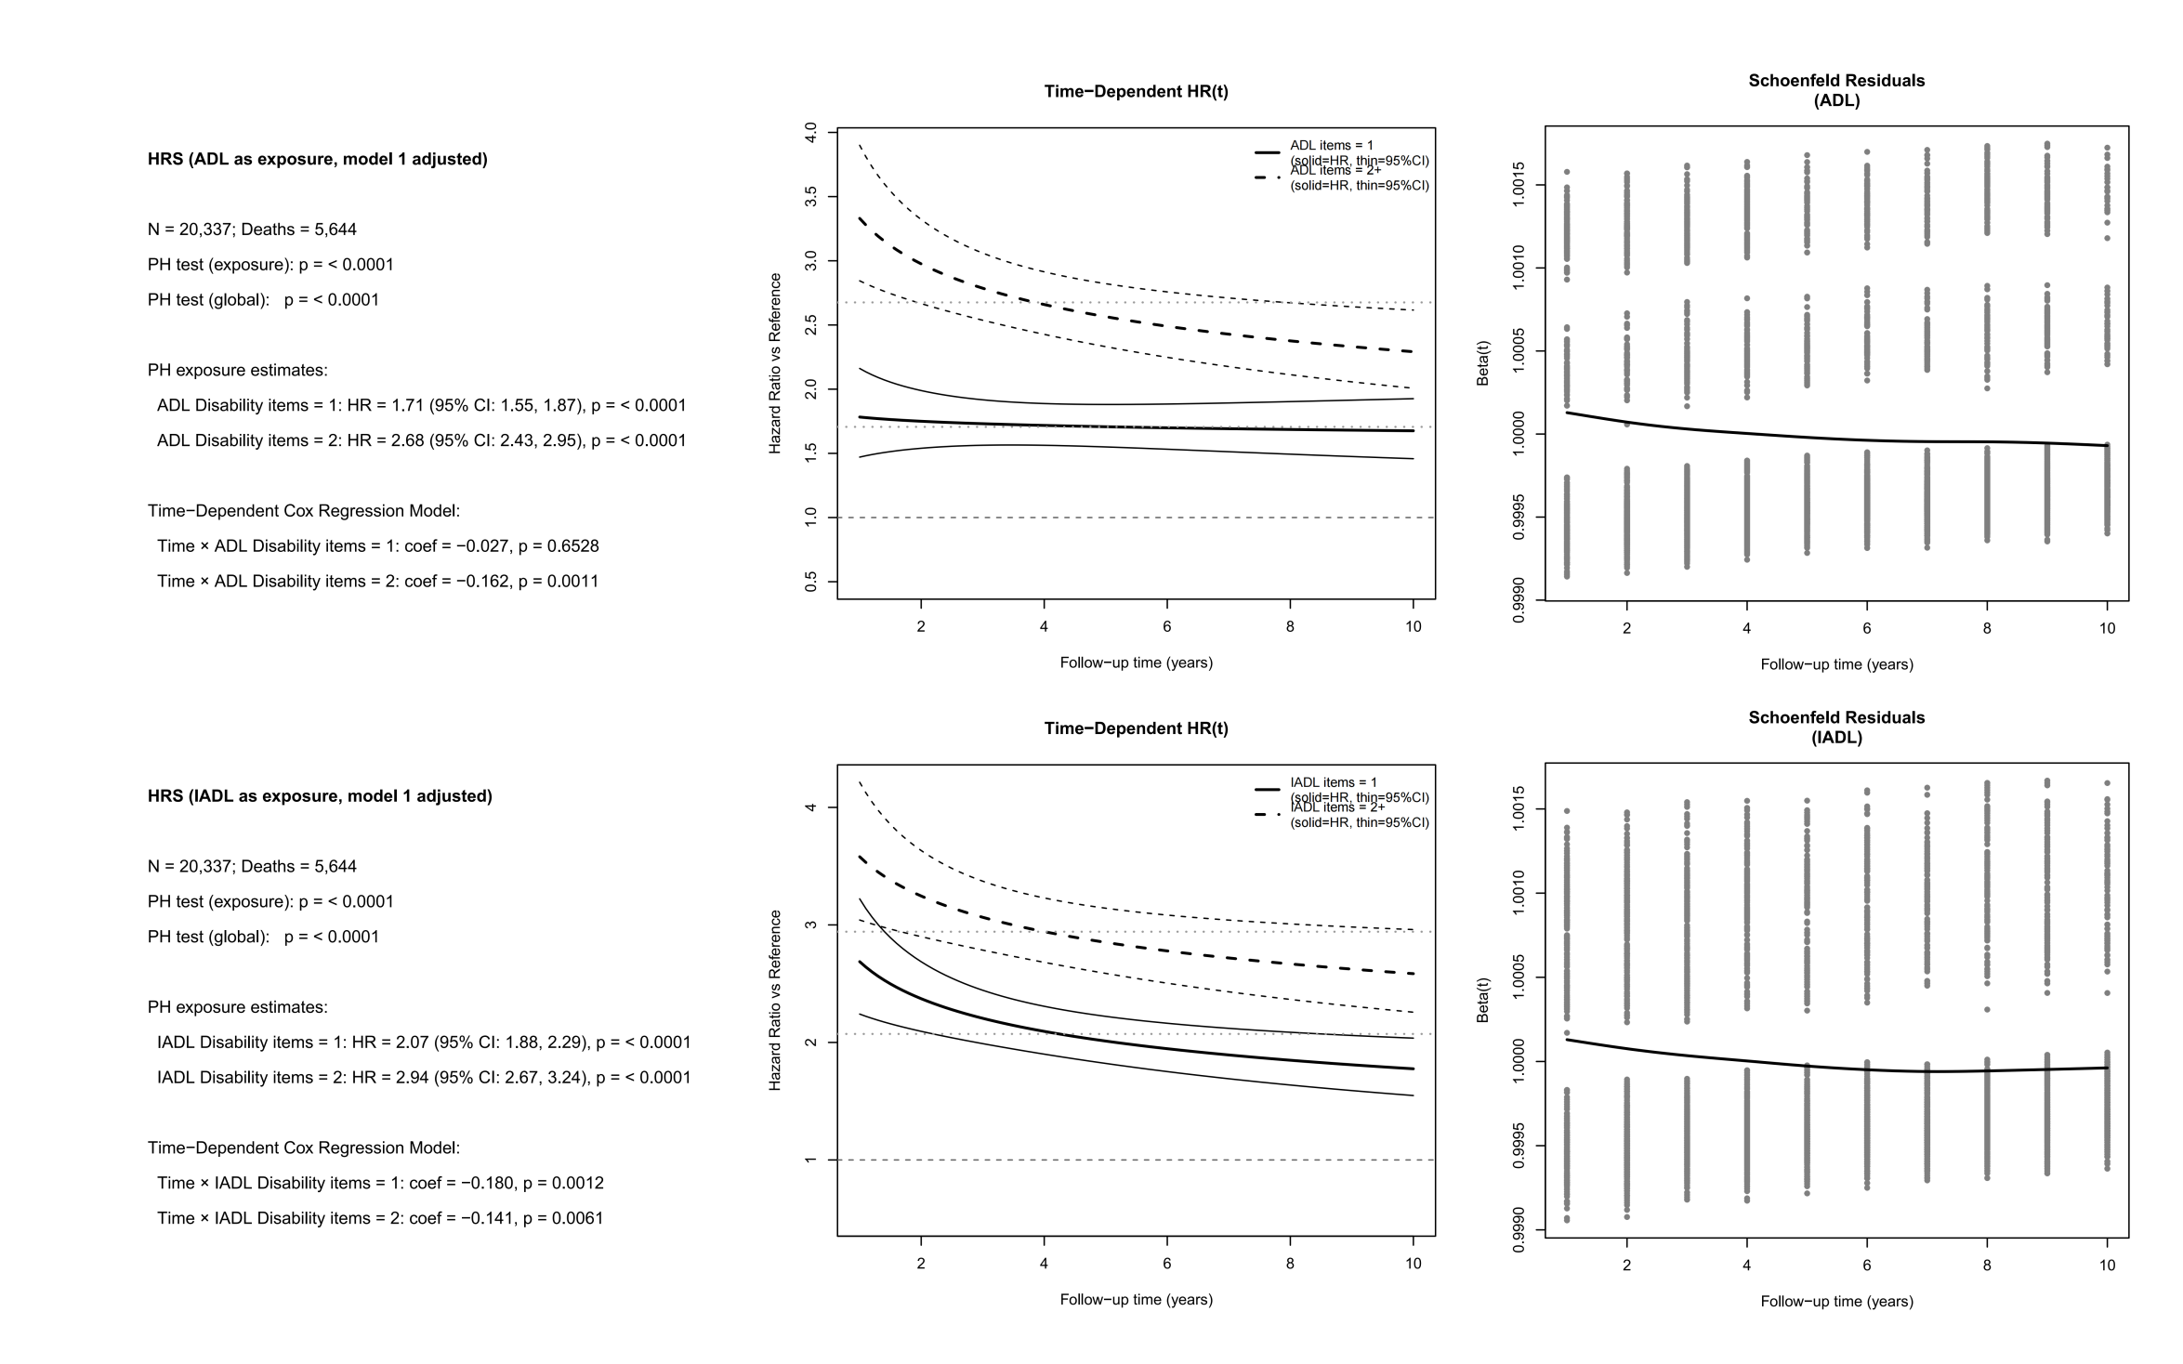
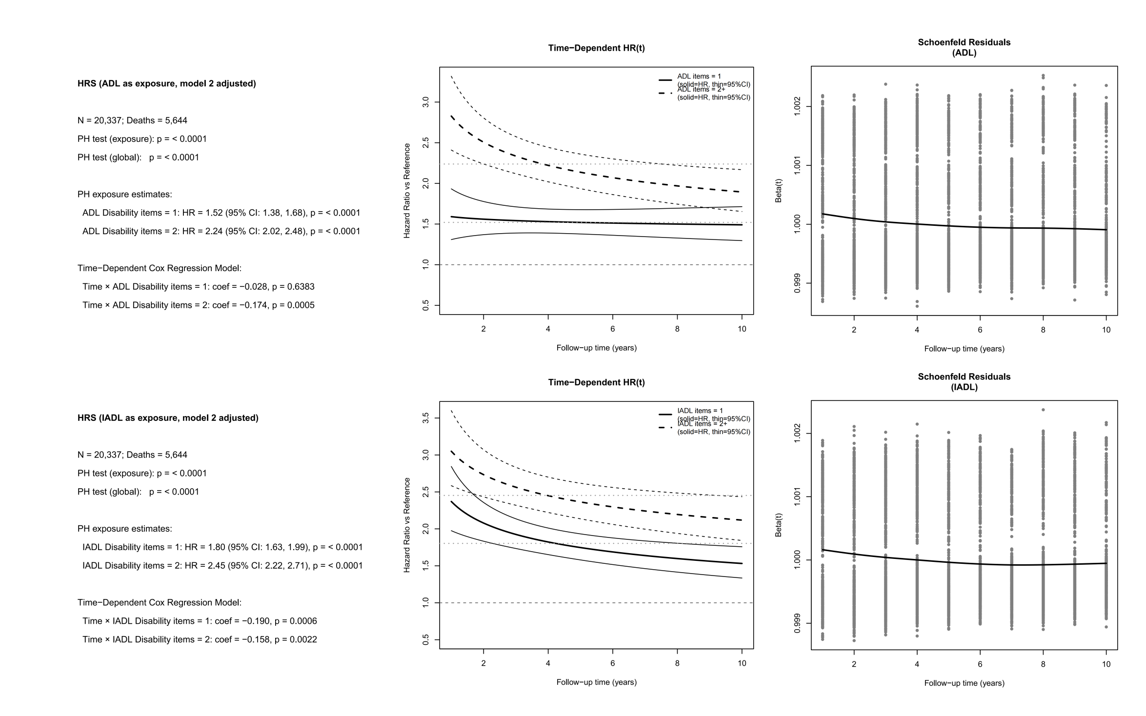

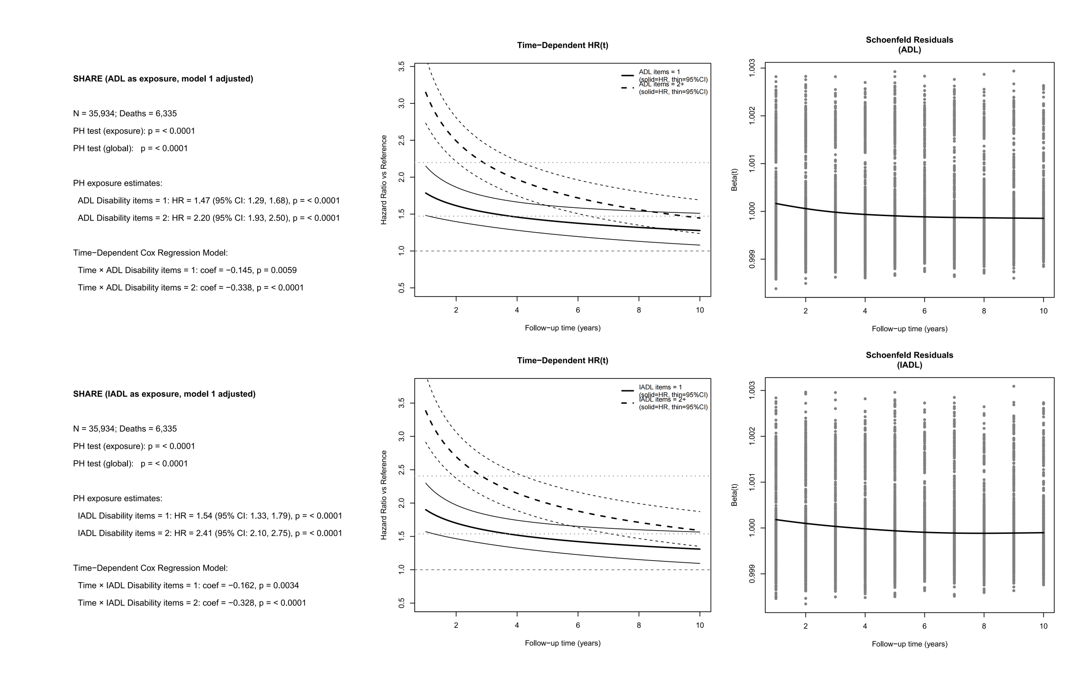

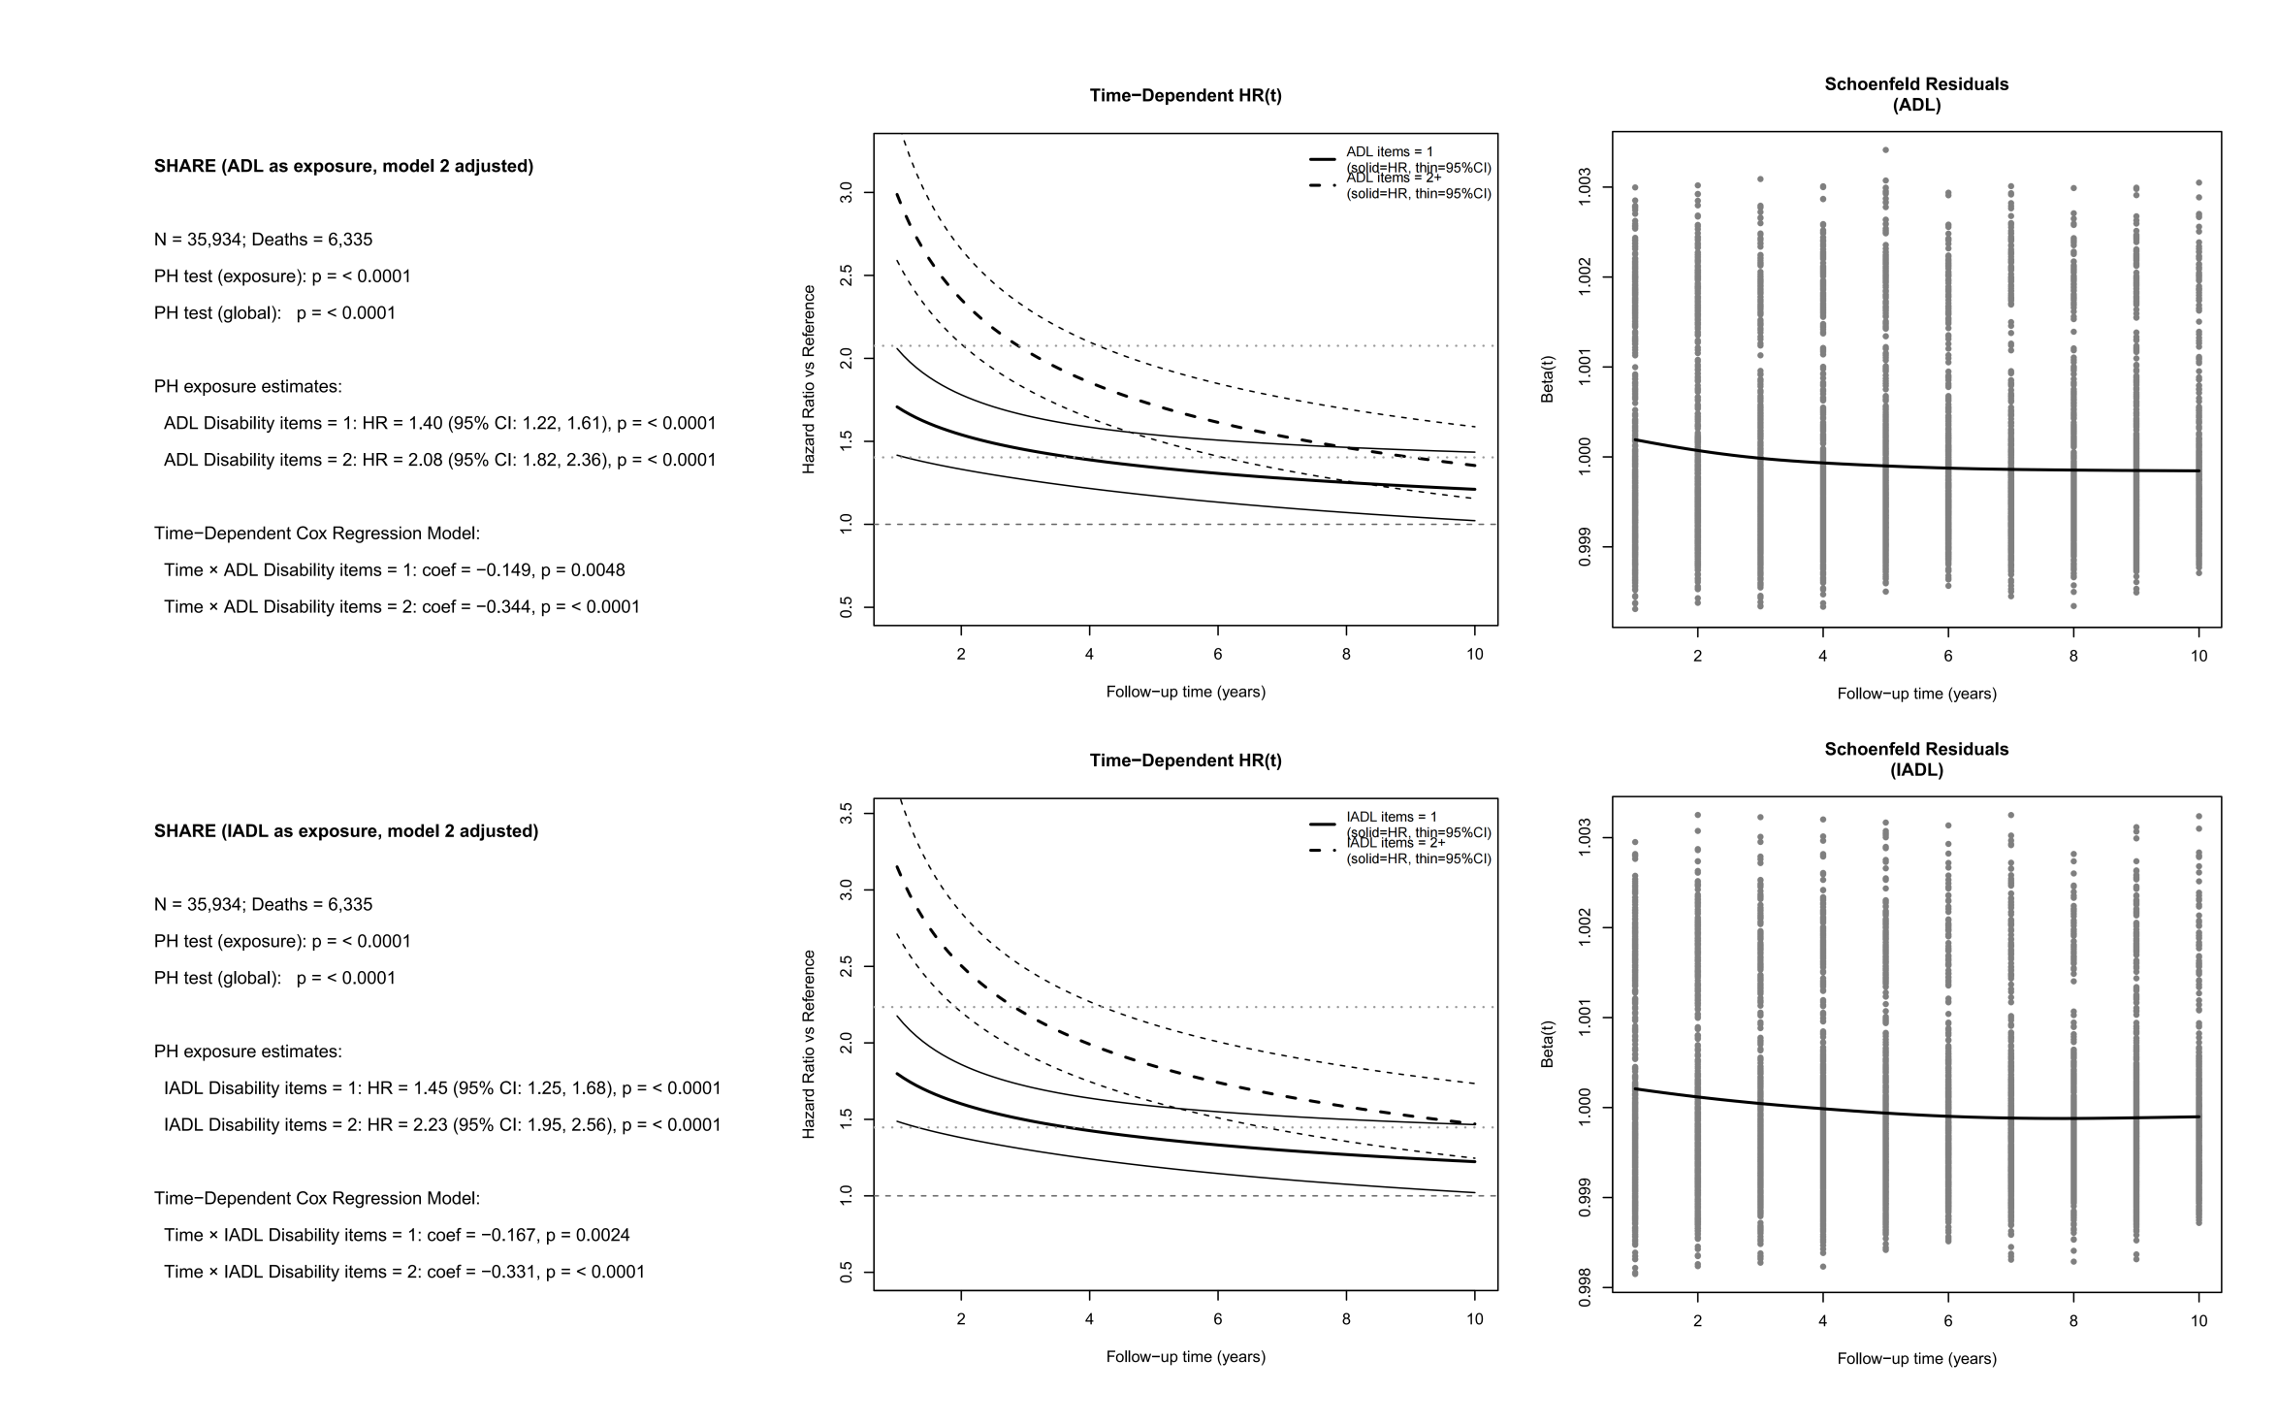

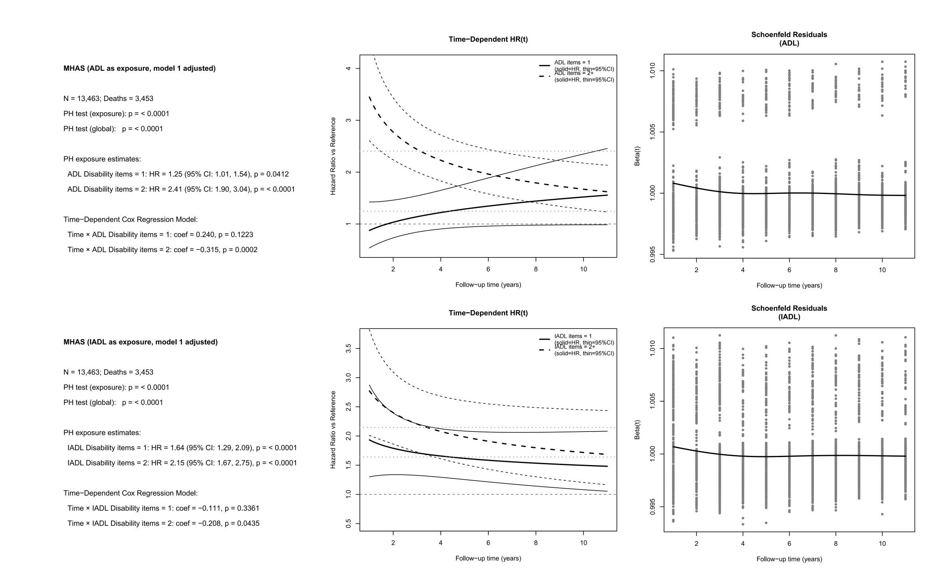

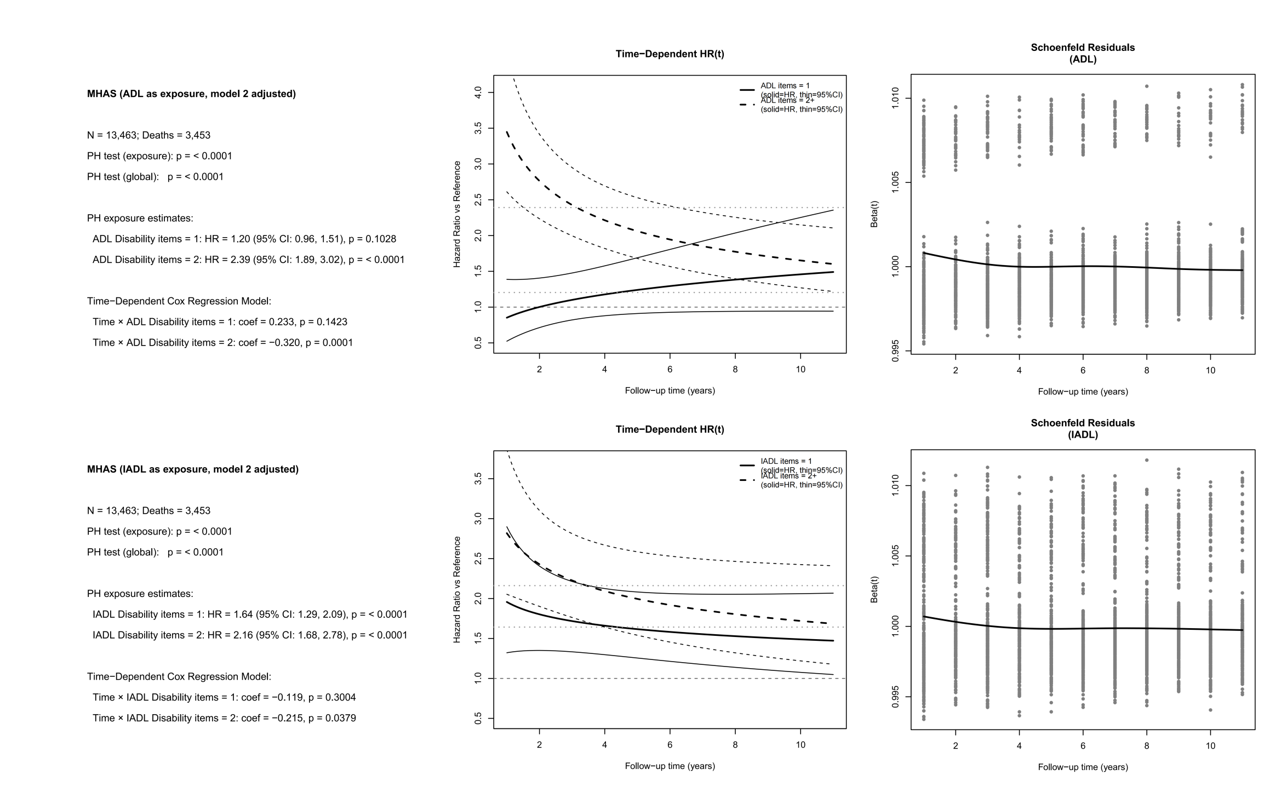

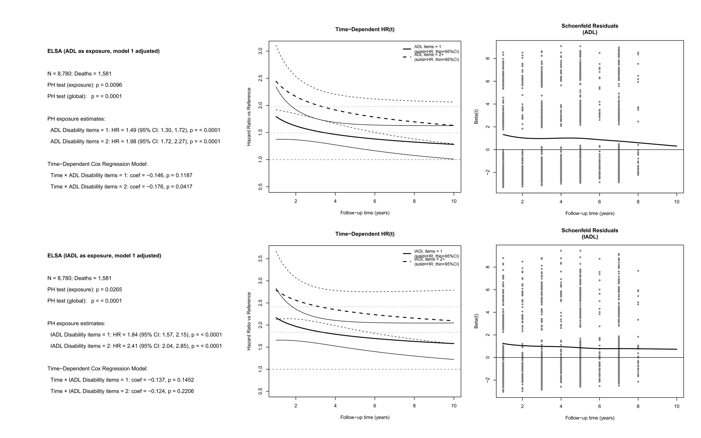

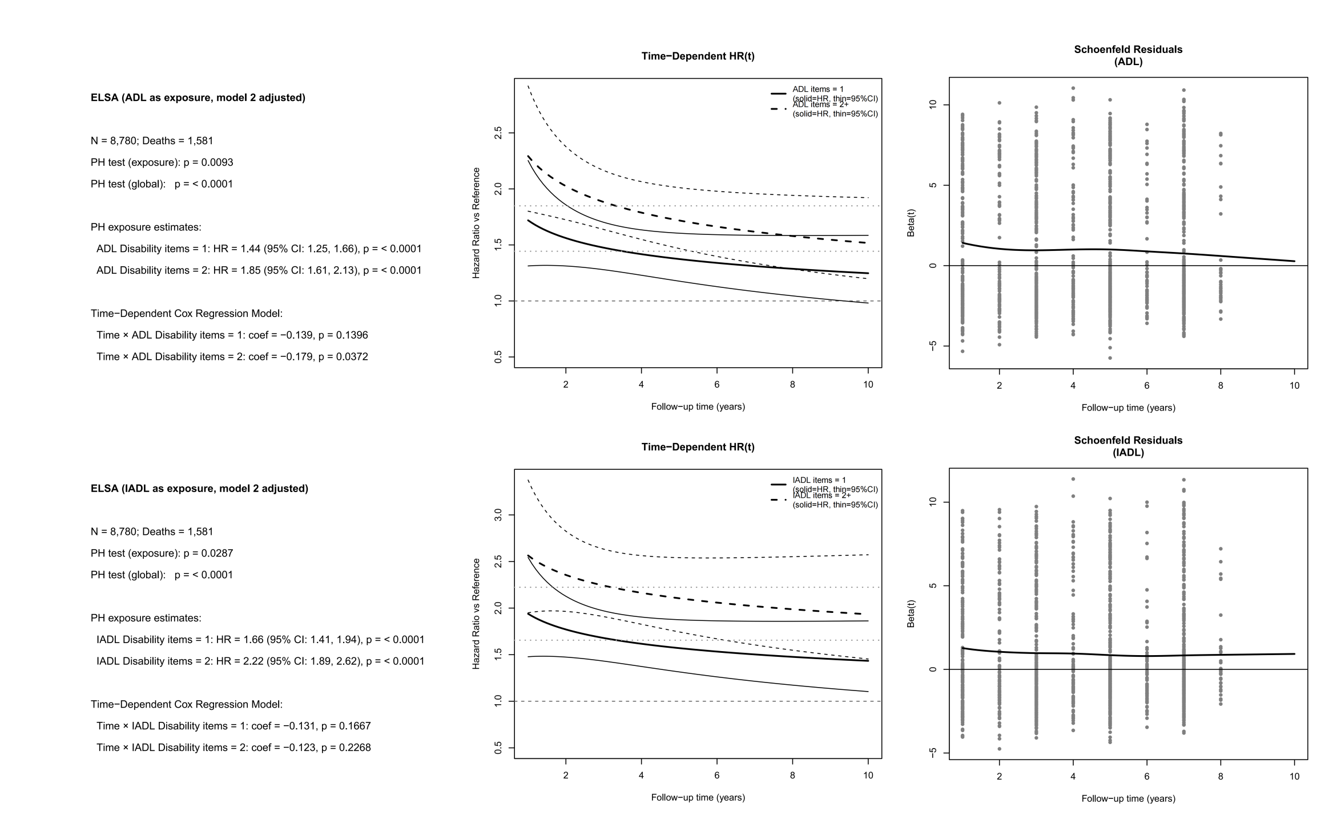
Supplementary Table S8. Subgroup analysis - Association between ADL/IADL status and mortality rate in CHARLS

CHARLS | Exposure | Sex |  | Age |  | Education
CHARLS | Exposure | Female | Male | <60 | >=60 | College or above | High school or equivalent | Less than high school
ADL Status | Deceased / Total | 693 / 6770 | 984 / 6696 | 287 / 6176 | 1390 / 7290 | 22 / 241 | 61 / 1200 | 1594 / 12025
 | Disability items = 0 | ref | ref | ref | ref | ref | ref | ref
 | Disability items = 1 | 1.51 (1.21, 1.89) | 1.49 (1.22, 1.81) | 1.55 (1.01, 2.38) | 1.70 (1.45, 1.98) | 1.79 (0.53, 6.01) | 1.11 (0.34, 3.65) | 1.47 (1.27, 1.71)
 | Disability items >= 2 | 2.18 (1.82, 2.60) | 2.35 (1.99, 2.78) | 3.19 (2.26, 4.52) | 2.90 (2.56, 3.29) | 11.45 (3.10, 42.22) | 3.67 (1.69, 7.96) | 2.19 (1.94, 2.48)
 | p for interaction (FDR-BH) | 0.979 |  | 0.912 |  | 0.556
IADL Status | Deceased / Total | 693 / 6770 | 984 / 6696 | 287 / 6176 | 1390 / 7290 | 22 / 241 | 61 / 1200 | 1594 / 12025
 | Disability items = 0 | ref | ref | ref | ref | ref | ref | ref
 | Disability items = 1 | 1.29 (1.03, 1.62) | 1.43 (1.18, 1.74) | 1.83 (1.29, 2.59) | 1.51 (1.28, 1.77) | 1.79 (0.37, 8.61) | 1.86 (0.73, 4.75) | 1.35 (1.16, 1.56)
 | Disability items >= 2 | 2.29 (1.93, 2.72) | 2.50 (2.13, 2.93) | 3.40 (2.49, 4.66) | 3.32 (2.95, 3.74) | 3.61 (1.22, 10.69) | 4.80 (2.42, 9.50) | 2.34 (2.08, 2.63)
 | p for interaction (FDR-BH) | 0.979 |  | 0.807 |  | 0.681

Abbreviations: CHARLS: China Health and Retirement Longitudinal Study; ADL: Activities of Daily Living; IADL: Instrumental Activities of Daily Living; NA, not applicable.

Model was adjusted for age, gender, education, marital status, BMI, smoking, drinking status, and SES (income quartiles).

Supplementary Table S9. Subgroup analysis - Association between ADL/IADL status and mortality rate in ELSA

ELSA | Exposure | Sex |  | Age |  | Education
ELSA | Exposure | Female | Male | <60 | >=60 | College or above | High school or equivalent | Less than high school
ADL Status | Deceased / Total | 783 / 5087 | 814 / 4084 | 118 / 2925 | 1479 / 6246 | 144 / 1232 | 497 / 4009 | 956 / 3930
 | Disability items = 0 | ref | ref | ref | ref | ref | ref | ref
 | Disability items = 1 | 1.50 (1.25, 1.80) | 1.39 (1.14, 1.70) | 1.85 (0.97, 3.54) | 1.93 (1.68, 2.21) | 1.74 (1.05, 2.90) | 1.64 (1.29, 2.09) | 1.34 (1.13, 1.59)
 | Disability items >= 2 | 1.73 (1.43, 2.08) | 2.11 (1.75, 2.53) | 4.91 (3.13, 7.70) | 2.32 (2.02, 2.65) | 2.04 (1.25, 3.33) | 2.27 (1.78, 2.89) | 1.75 (1.49, 2.06)
 | p for interaction (FDR-BH) | 0.556 |  | 0.031 |  | 0.489
IADL Status | Deceased / Total | 783 / 5087 | 814 / 4084 | 118 / 2925 | 1479 / 6246 | 144 / 1232 | 497 / 4009 | 956 / 3930
 | Disability items = 0 | ref | ref | ref | ref | ref | ref | ref
 | Disability items = 1 | 1.63 (1.34, 1.98) | 1.61 (1.27, 2.03) | 3.89 (2.28, 6.63) | 2.15 (1.84, 2.51) | 1.63 (0.87, 3.08) | 1.87 (1.39, 2.51) | 1.55 (1.30, 1.86)
 | Disability items >= 2 | 2.06 (1.69, 2.52) | 2.71 (2.19, 3.37) | 5.58 (3.21, 9.68) | 3.45 (2.98, 4.01) | 3.17 (1.69, 5.93) | 2.96 (2.26, 3.88) | 2.12 (1.77, 2.54)
 | p for interaction (FDR-BH) | 0.489 |  | 0.274 |  | 0.489

Abbreviations: ELSA: English Longitudinal Study of Ageing; ADL: Activities of Daily Living; IADL: Instrumental Activities of Daily Living

Model was adjusted for age, gender, education, marital status, BMI, smoking, drinking status, and SES (income quartiles).

Supplementary Table S10. Subgroup analysis - Association between ADL/IADL status and mortality rate in HRS

HRS | Exposure | Sex |  | Age |  | Education
HRS | Exposure | Female | Male | <60 | >=60 | College or above | High school or equivalent | Less than high school
ADL Status | Deceased / Total | 3284 / 12059 | 2807 / 8983 | 630 / 7204 | 5461 / 13838 | 915 / 4585 | 3492 / 12267 | 1684 / 4190
 | Disability items = 0 | ref | ref | ref | ref | ref | ref | ref
 | Disability items = 1 | 1.56 (1.41, 1.74) | 1.59 (1.41, 1.79) | 1.76 (1.37, 2.25) | 1.99 (1.83, 2.16) | 1.75 (1.40, 2.17) | 1.62 (1.46, 1.79) | 1.38 (1.19, 1.60)
 | Disability items >= 2 | 2.42 (2.22, 2.65) | 2.40 (2.16, 2.66) | 2.13 (1.70, 2.66) | 3.20 (2.98, 3.43) | 3.13 (2.58, 3.80) | 2.73 (2.49, 2.99) | 1.88 (1.67, 2.10)
 | p for interaction (FDR-BH) | 0.979 |  | 0.681 |  | <0.001
IADL Status | Deceased / Total | 3284 / 12059 | 2807 / 8983 | 630 / 7204 | 5461 / 13838 | 915 / 4585 | 3492 / 12267 | 1684 / 4190
 | Disability items = 0 | ref | ref | ref | ref | ref | ref | ref
 | Disability items = 1 | 1.87 (1.68, 2.09) | 1.82 (1.62, 2.05) | 1.71 (1.35, 2.16) | 2.24 (2.06, 2.43) | 1.76 (1.40, 2.23) | 2.02 (1.82, 2.24) | 1.51 (1.30, 1.75)
 | Disability items >= 2 | 2.74 (2.51, 3.00) | 2.50 (2.24, 2.79) | 3.09 (2.46, 3.87) | 3.93 (3.67, 4.22) | 2.85 (2.32, 3.49) | 2.86 (2.60, 3.14) | 2.28 (2.03, 2.56)
 | p for interaction (FDR-BH) | 0.984 |  | 0.979 |  | <0.001

Abbreviations: HRS: Health and Retirement Study; ADL: Activities of Daily Living; IADL: Instrumental Activities of Daily Living

Model was adjusted for age, gender, education, marital status, BMI, smoking, drinking status, and SES (income quartiles).

Supplementary Table S11. Subgroup analysis - Association between ADL/IADL status and mortality rate in MHAS

MHAS | Exposure | Sex |  | Age |  | Education
MHAS | Exposure | Female | Male | <60 | >=60 | College or above | High school or equivalent | Less than high school
ADL Status | Deceased / Total | 1680 / 7191 | 1773 / 6272 | 700 / 6292 | 2753 / 7171 | 157 / 990 | 52 / 290 | 3244 / 12183
 | Disability items = 0 | ref | ref | ref | ref | ref | ref | ref
 | Disability items = 1 | 1.22 (1.03, 1.44) | 1.32 (1.10, 1.57) | 1.27 (0.91, 1.76) | 1.62 (1.42, 1.84) | 2.12 (1.13, 3.99) | 1.38 (0.51, 3.75) | 1.25 (1.10, 1.41)
 | Disability items >= 2 | 2.09 (1.81, 2.40) | 2.60 (2.23, 3.03) | 3.14 (2.33, 4.23) | 3.05 (2.74, 3.40) | 2.01 (1.11, 3.65) | 1.13 (0.32, 3.91) | 2.32 (2.09, 2.58)
 | p for interaction (FDR-BH) | 0.556 |  | 0.681 |  | 0.681
IADL Status | Deceased / Total | 1680 / 7191 | 1773 / 6272 | 700 / 6292 | 2753 / 7171 | 157 / 990 | 52 / 290 | 3244 / 12183
 | Disability items = 0 | ref | ref | ref | ref | ref | ref | ref
 | Disability items = 1 | 1.43 (1.22, 1.69) | 1.36 (1.10, 1.69) | 2.19 (1.60, 3.00) | 1.65 (1.44, 1.90) | 1.94 (0.89, 4.21) | 5.24 (1.11, 24.77) | 1.40 (1.22, 1.60)
 | Disability items >= 2 | 2.43 (2.12, 2.79) | 2.27 (1.94, 2.65) | 2.98 (2.15, 4.14) | 3.56 (3.21, 3.95) | 2.53 (1.49, 4.29) | 2.17 (0.72, 6.50) | 2.36 (2.12, 2.62)
 | p for interaction (FDR-BH) | 0.807 |  | 0.489 |  | 0.843

Abbreviations: MHAS: Mexican Health and Aging Study; ADL: Activities of Daily Living; IADL: Instrumental Activities of Daily Living

Model was adjusted for age, gender, education, marital status, BMI, smoking, drinking status, and SES (income quartiles).

Supplementary Table S12. Subgroup analysis - Association between ADL/IADL status and mortality rate in SHARE

SHARE | Exposure | Sex |  | Age |  | Education
SHARE | Exposure | Female | Male | <60 | >=60 | College or above | High school or equivalent | Less than high school
ADL Status | Deceased / Total | 3038 / 19679 | 3297 / 16255 | 559 / 12485 | 5776 / 23449 | 751 / 6905 | 1536 / 11448 | 4048 / 17581
 | Disability items = 0 | ref | ref | ref | ref | ref | ref | ref
 | Disability items = 1 | 1.43 (1.27, 1.60) | 1.27 (1.11, 1.44) | 1.75 (1.21, 2.53) | 1.95 (1.79, 2.12) | 1.48 (1.13, 1.95) | 1.32 (1.10, 1.58) | 1.35 (1.22, 1.49)
 | Disability items >= 2 | 2.04 (1.85, 2.25) | 1.91 (1.71, 2.14) | 3.54 (2.55, 4.92) | 3.24 (3.01, 3.48) | 2.49 (1.97, 3.16) | 1.90 (1.60, 2.25) | 1.95 (1.79, 2.12)
 | p for interaction (FDR-BH) | 0.047 |  | 0.798 |  | 0.489
IADL Status | Deceased / Total | 3038 / 19679 | 3297 / 16255 | 559 / 12485 | 5776 / 23449 | 751 / 6905 | 1536 / 11448 | 4048 / 17581
 | Disability items = 0 | ref | ref | ref | ref | ref | ref | ref
 | Disability items = 1 | 1.46 (1.30, 1.64) | 1.55 (1.36, 1.76) | 2.33 (1.57, 3.47) | 2.27 (2.08, 2.47) | 1.69 (1.29, 2.21) | 1.48 (1.22, 1.79) | 1.47 (1.33, 1.63)
 | Disability items >= 2 | 2.00 (1.81, 2.21) | 2.10 (1.88, 2.35) | 5.78 (4.02, 8.32) | 3.94 (3.66, 4.23) | 2.37 (1.84, 3.06) | 2.04 (1.70, 2.43) | 2.05 (1.88, 2.24)
 | p for interaction (FDR-BH) | 0.7 |  | 0.489 |  | 0.681

Abbreviations: SHARE: Survey of Health, Ageing and Retirement in Europe; ADL: Activities of Daily Living; IADL: Instrumental Activities of Daily Living

Model was adjusted for age, gender, education, marital status, BMI, smoking, drinking status, and SES (income quartiles).

Supplementary Table S13. Sensitivity Analysis - Association between ADL/IADL status and mortality rate (Complete Case Analysis)

Cohort |  | CHARLS (n=13,132) |  | ELSA (n=8,778) |  | HRS (n=18,756) |  | MHAS (n=11,364) |  | SHARE (n=35,795)
Exposure |  | Model 1  HR  (95%CI) | Model 2  HR  (95%CI) | Model 1  HR  (95%CI) | Model 2  HR  (95%CI) | Model 1  HR  (95%CI) | Model 2  HR  (95%CI) | Model 1  HR  (95%CI) | Model 2  HR  (95%CI) | Model 1  HR  (95%CI) | Model 2  HR  (95%CI)
ADL | Disability items = 0 | ref | ref | ref | ref | ref | ref | ref | ref | ref | ref
ADL | Disability items = 1 | 1.40  (1.07, 1.84) | 1.45  (1.20, 1.76) | 1.49  (1.30, 1.72) | 1.44  (1.25, 1.66) | 1.74  (1.57, 1.93) | 1.52  (1.36, 1.69) | 1.21  (0.97, 1.49) | 1.17  (0.93, 1.47) | 1.47  (1.28, 1.68) | 1.40  (1.22, 1.61)
ADL | Disability items >= 2 | 2.44  (2.07, 2.87) | 2.32  (1.97, 2.74) | 1.98  (1.72, 2.27) | 1.88  (1.64, 2.16) | 2.83  (2.55, 3.13) | 2.31  (2.08, 2.58) | 2.58  (2.06, 3.23) | 2.54  (2.02, 3.20) | 2.19  (1.92, 2.49) | 2.08  (1.82, 2.36)
IADL | Disability items = 0 | ref | ref | ref | ref | ref | ref | ref | ref | ref | ref
IADL | Disability items = 1 | 1.50  (1.24, 1.82) | 1.39  (1.15, 1.68) | 1.84  (1.57, 2.15) | 1.66  (1.42, 1.95) | 2.20  (1.97, 2.45) | 1.87  (1.68, 2.09) | 1.51  (1.15, 1.98) | 1.48  (1.12, 1.96) | 1.55  (1.33, 1.80) | 1.47  (1.26, 1.70)
IADL | Disability items >= 2 | 2.70  (2.31, 3.15) | 2.57  (2.21, 2.98) | 2.42  (2.04, 2.86) | 2.26  (1.92, 2.67) | 3.19  (2.87, 3.53) | 2.60  (2.33, 2.90) | 2.61  (1.99, 3.41) | 2.66  (2.08, 3.40) | 2.42  (2.12, 2.77) | 2.25  (1.97, 2.58)

Abbreviations: CHARLS: China Health and Retirement Longitudinal Study; ELSA: English Longitudinal Study of Ageing; HRS: Health and Retirement Study; SHARE: Survey of Health, Ageing and Retirement in Europe; MHAS: Mexican Health and Aging Study. ADL: Activities of Daily Living; IADL: Instrumental Activities of Daily Living.

Model 1 was adjusted for age, gender.

Model 2 was adjusted for age, gender, education, marital status, BMI, smoking, drinking status, and SES (income quartiles).

In the complete case analysis, only individuals whose ADL and IADL scale items were not missing before multiple imputation were included. The missing ADL and IADL scale models for each cohort are described above (Supplementary Table S5. Missing patterns of ADL/IADL scales in each cohort).
Supplementary Table S14. Sensitivity Analysis - Association between ADL/IADL status and mortality rate (Exclude individuals who died within the first year of follow-up)

Cohort |  | CHARLS (n=13,194) |  | ELSA (n=8,536) |  | HRS (n=19,803) |  | MHAS (n=13,023) |  | SHARE (n=35,034)
Exposure |  | Model 1  HR  (95%CI) | Model 2  HR  (95%CI) | Model 1  HR  (95%CI) | Model 2  HR  (95%CI) | Model 1  HR  (95%CI) | Model 2  HR  (95%CI) | Model 1  HR  (95%CI) | Model 2  HR  (95%CI) | Model 1  HR  (95%CI) | Model 2  HR  (95%CI)
ADL | Disability items = 0 | ref | ref | ref | ref | ref | ref | ref | ref | ref | ref
ADL | Disability items = 1 | 1.39  (1.04, 1.84) | 1.45  (1.18, 1.77) | 1.41  (1.21, 1.64) | 1.36  (1.16, 1.58) | 1.68  (1.52, 1.86) | 1.49  (1.34, 1.65) | 1.22  (0.97, 1.52) | 1.19  (0.95, 1.50) | 1.39  (1.20, 1.61) | 1.32  (1.13, 1.53)
ADL | Disability items = >= 2 | 2.09  (1.74, 2.51) | 1.97  (1.63, 2.38) | 1.91  (1.63, 2.22) | 1.80  (1.54, 2.10) | 2.48  (2.23, 2.75) | 2.05  (1.83, 2.28) | 1.98  (1.53, 2.55) | 1.97  (1.53, 2.54) | 1.77  (1.52, 2.06) | 1.66  (1.43, 1.93)
IADL | Disability items = 0 | ref | ref | ref | ref | ref | ref | ref | ref | ref | ref
IADL | Disability items = 1 | 1.48  (1.21, 1.82) | 1.36  (1.11, 1.67) | 1.72  (1.44, 2.04) | 1.56  (1.31, 1.86) | 2.02  (1.82, 2.25) | 1.75  (1.57, 1.95) | 1.40  (1.07, 1.84) | 1.41  (1.08, 1.84) | 1.45  (1.23, 1.71) | 1.37  (1.16, 1.62)
IADL | Disability items = >= 2 | 2.43  (2.05, 2.89) | 2.30  (1.95, 2.71) | 2.37  (1.97, 2.86) | 2.22  (1.85, 2.67) | 2.80  (2.54, 3.10) | 2.33  (2.09, 2.59) | 1.92  (1.51, 2.43) | 1.93  (1.52, 2.45) | 1.97  (1.68, 2.30) | 1.83  (1.56, 2.14)

Abbreviations: CHARLS: China Health and Retirement Longitudinal Study; ELSA: English Longitudinal Study of Ageing; HRS: Health and Retirement Study; SHARE: Survey of Health, Ageing and Retirement in Europe; MHAS: Mexican Health and Aging Study. ADL: Activities of Daily Living; IADL: Instrumental Activities of Daily Living.

Model 1 was adjusted for age, gender.

Model 2 was adjusted for age, gender, education, marital status, BMI, smoking, drinking status, and SES (income quartiles).

Supplementary Table S15. Description of samples included and excluded
Cohort | CHARLS |  | ELSA |  | HRS |  | MHAS |  | SHARE
Variable | Excluded in the final analysis  (n=4242) | Included in the final analysis  (n=13466) | Excluded in the final analysis  (n=261) | Included in the final analysis  (n=9171) | Excluded in the final analysis  (n=992) | Included in the final analysis  (n=21042) | Excluded in the final analysis  (n=1723) | Included in the final analysis  (n=13463) | Excluded in the final analysis  (n=1198) | Included in the final analysis  (n=35934)
Age (Year), Median (Q1, Q3) | 47.0 (45.0, 48.0) | 60.0 (56.0, 68.0) | 46.0 (43.0, 48.0) | 65.0 (58.0, 74.0) | 46.0 (43.0, 48.0) | 66.0 (57.0, 75.0) | 46.0 (42.0, 48.0) | 60.0 (54.0, 68.0) | 47.0 (45.0, 49.0) | 64.0 (57.0, 72.0)
BMI (Kg/m2), Median (Q1, Q3) | 23.9 (21.6, 26.4) | 22.9 (20.6, 25.5) | - | 27.3 (24.7, 30.6) | 28.3 (24.4, 33.3) | 27.5 (24.3, 31.6) | 27.2 (24.6, 30.9) | 26.7 (23.9, 29.7) | 24.8 (22.5, 28.1) | 26.1 (23.7, 29.1)
Total household income, Median (Q1, Q3) | 77775.0 (24407.5, 173850.0) | 53000.0 (12002.5, 144600.0) | 177700.0 (78000.0, 294200.0) | 188001.0 (90000.0, 321000.0) | 50000.0 (2000.0, 225100.0) | 137000.0 (17100.0, 420000.0) | 220883.1 (81274.2, 495010.0) | 205000.0 (68583.1, 459316.9) | 173800.0 (63429.9, 354369.8) | 152000.0 (38176.2, 332671.8)
Sex, n (%)
Male | 1782 (42.0) | 6696 (49.7) | 42 (16.1) | 4084 (44.5) | 236 (23.8) | 8983 (42.7) | 233 (13.5) | 6272 (46.6) | 138 (11.5) | 16255 (45.2)
Female | 2458 (57.9) | 6770 (50.3) | 219 (83.9) | 5087 (55.5) | 756 (76.2) | 12059 (57.3) | 1490 (86.5) | 7191 (53.4) | 1060 (88.5) | 19679 (54.8)
Miss | 2 (0.0) | - | - | - | - | - | - | - | - | -
Education, n (%)
Less than high school | 3526 (83.1) | 12019 (89.3) | 62 (23.8) | 3563 (38.9) | 171 (17.2) | 4190 (19.9) | 1501 (87.1) | 12166 (90.4) | 426 (35.6) | 17581 (48.9)
High school or equivalent | 593 (14.0) | 1200 (8.9) | 145 (55.6) | 3687 (40.2) | 606 (61.1) | 12263 (58.3) | 69 (4.0) | 290 (2.2) | 500 (41.7) | 11448 (31.9)
College or above | 113 (2.7) | 241 (1.8) | 47 (18.0) | 1124 (12.3) | 215 (21.7) | 4585 (21.8) | 152 (8.8) | 989 (7.3) | 272 (22.7) | 6905 (19.2)
Miss | 10 (0.2) | 6 (0.0) | 7 (2.7) | 797 (8.7) | - | 4 (0.0) | 1 (0.1) | 18 (0.1) | - | -
Alcohol Consumption, n (%)
Never | 2699 (63.6) | 8019 (59.5) | 22 (8.4) | 861 (9.4) | 325 (32.8) | 9410 (44.7) | 1192 (69.2) | 9249 (68.7) | 249 (20.8) | 5888 (16.4)
Ever | 1493 (35.2) | 5330 (39.6) | 201 (77.0) | 7060 (77.0) | 667 (67.2) | 11629 (55.3) | 530 (30.8) | 4204 (31.2) | 937 (78.2) | 29658 (82.5)
Miss | 50 (1.2) | 117 (0.9) | 38 (14.6) | 1250 (13.6) | - | 3 (0.0) | 1 (0.1) | 10 (0.1) | 12 (1.0) | 388 (1.1)
Smoking, n (%)
Never | 2817 (66.4) | 7811 (58.0) | 119 (45.6) | 3360 (36.6) | 467 (47.1) | 9055 (43.0) | 1180 (68.5) | 7472 (55.5) | 639 (53.3) | 18626 (51.8)
Ever | 1378 (32.5) | 5553 (41.2) | 142 (54.4) | 5809 (63.3) | 521 (52.5) | 11861 (56.4) | 542 (31.5) | 5979 (44.4) | 541 (45.2) | 16817 (46.8)
Miss | 47 (1.1) | 102 (0.8) | - | 2 (0.0) | 4 (0.4) | 126 (0.6) | 1 (0.1) | 12 (0.1) | 18 (1.5) | 491 (1.4)
Dressing, n (%)
Not disabled | 4051 (95.5) | 12402 (92.1) | 249 (95.4) | 7895 (86.1) | 923 (93.0) | 18405 (87.5) | 1617 (93.8) | 11530 (85.6) | 1172 (97.8) | 33046 (92.0)
Disabled | 89 (2.1) | 817 (6.1) | 12 (4.6) | 1273 (13.9) | 53 (5.3) | 2502 (11.9) | 37 (2.1) | 862 (6.4) | 17 (1.4) | 2749 (7.7)
Miss | 102 (2.4) | 247 (1.8) | - | 3 (0.0) | 16 (1.6) | 135 (0.6) | 69 (4.0) | 1071 (8.0) | 9 (0.8) | 139 (0.4)
Bathing, n (%)
Not disabled | 4027 (94.9) | 12141 (90.2) | 248 (95.0) | 8050 (87.8) | 945 (95.3) | 19083 (90.7) | 1684 (97.7) | 12716 (94.5) | 1183 (98.7) | 33661 (93.7)
Disabled | 114 (2.7) | 1067 (7.9) | 13 (5.0) | 1118 (12.2) | 32 (3.2) | 1826 (8.7) | 14 (0.8) | 553 (4.1) | 6 (0.5) | 2134 (5.9)
Miss | 101 (2.4) | 258 (1.9) | - | 3 (0.0) | 15 (1.5) | 133 (0.6) | 25 (1.5) | 194 (1.4) | 9 (0.8) | 139 (0.4)
Eating, n (%)
Not disabled | 4088 (96.4) | 12743 (94.6) | 257 (98.5) | 8950 (97.6) | 964 (97.2) | 19977 (94.9) | 1690 (98.1) | 12965 (96.3) | 1184 (98.8) | 35102 (97.7)
Disabled | 53 (1.2) | 478 (3.5) | 4 (1.5) | 218 (2.4) | 13 (1.3) | 916 (4.4) | 8 (0.5) | 302 (2.2) | 5 (0.4) | 693 (1.9)
Miss | 101 (2.4) | 245 (1.8) | - | 3 (0.0) | 15 (1.5) | 149 (0.7) | 25 (1.5) | 196 (1.5) | 9 (0.8) | 139 (0.4)
Get in/out of bed, n (%)
Not disabled | 4044 (95.3) | 12343 (91.7) | 250 (95.8) | 8577 (93.5) | 928 (93.5) | 19221 (91.3) | 1661 (96.4) | 12513 (92.9) | 1172 (97.8) | 34312 (95.5)
Disabled | 97 (2.3) | 876 (6.5) | 11 (4.2) | 591 (6.4) | 49 (4.9) | 1676 (8.0) | 37 (2.1) | 758 (5.6) | 17 (1.4) | 1483 (4.1)
Miss | 101 (2.4) | 247 (1.8) | - | 3 (0.0) | 15 (1.5) | 145 (0.7) | 25 (1.5) | 192 (1.4) | 9 (0.8) | 139 (0.4)
Using the toilet, n (%)
Not disabled | 3934 (92.7) | 11413 (84.8) | 257 (98.5) | 8861 (96.6) | 953 (96.1) | 19398 (92.2) | 1673 (97.1) | 12712 (94.4) | 1187 (99.1) | 34886 (97.1)
Disabled | 207 (4.9) | 1806 (13.4) | 4 (1.5) | 307 (3.3) | 24 (2.4) | 1485 (7.1) | 23 (1.3) | 547 (4.1) | 2 (0.2) | 909 (2.5)
Miss | 101 (2.4) | 247 (1.8) | - | 3 (0.0) | 15 (1.5) | 159 (0.8) | 27 (1.6) | 204 (1.5) | 9 (0.8) | 139 (0.4)
Managing money, n (%)
Not disabled | 3894 (91.8) | 11360 (84.4) | 257 (98.5) | 8860 (96.6) | 904 (91.1) | 18475 (87.8) | 1647 (95.6) | 12046 (89.5) | 1178 (98.3) | 34187 (95.1)
Disabled | 290 (6.8) | 1958 (14.5) | 4 (1.5) | 308 (3.4) | 61 (6.1) | 1850 (8.8) | 8 (0.5) | 311 (2.3) | 11 (0.9) | 1608 (4.5)
Miss | 58 (1.4) | 148 (1.1) | - | 3 (0.0) | 27 (2.7) | 717 (3.4) | 68 (3.9) | 1106 (8.2) | 9 (0.8) | 139 (0.4)
Take medications, n (%)
Not disabled | 4013 (94.6) | 12285 (91.2) | 259 (99.2) | 8965 (97.8) | 930 (93.8) | 19622 (93.3) | 1647 (95.6) | 12045 (89.5) | 1184 (98.8) | 35011 (97.4)
Disabled | 172 (4.1) | 1051 (7.8) | 2 (0.8) | 203 (2.2) | 29 (2.9) | 1011 (4.8) | 8 (0.5) | 327 (2.4) | 5 (0.4) | 784 (2.2)
Miss | 57 (1.3) | 130 (1.0) | - | 3 (0.0) | 33 (3.3) | 409 (1.9) | 68 (3.9) | 1091 (8.1) | 9 (0.8) | 139 (0.4)
Shop for grocery, n (%)
Not disabled | 4016 (94.7) | 11870 (88.1) | 245 (93.9) | 8251 (90.0) | 936 (94.4) | 18234 (86.7) | 1621 (94.1) | 11237 (83.5) | 1170 (97.7) | 33203 (92.4)
Disabled | 173 (4.1) | 1463 (10.9) | 16 (6.1) | 917 (10.0) | 39 (3.9) | 2305 (11.0) | 24 (1.4) | 820 (6.1) | 19 (1.6) | 2592 (7.2)
Miss | 53 (1.2) | 133 (1.0) | - | 3 (0.0) | 17 (1.7) | 503 (2.4) | 78 (4.5) | 1406 (10.4) | 9 (0.8) | 139 (0.4)
Prepare hot meal, n (%)
Not disabled | 4023 (94.8) | 11916 (88.5) | 252 (96.6) | 8697 (94.8) | 947 (95.5) | 18701 (88.9) | 1620 (94.0) | 11221 (83.3) | 1181 (98.6) | 34191 (95.1)
Disabled | 165 (3.9) | 1432 (10.6) | 9 (3.4) | 471 (5.1) | 23 (2.3) | 1658 (7.9) | 13 (0.8) | 489 (3.6) | 8 (0.7) | 1604 (4.5)
Miss | 54 (1.3) | 118 (0.9) | - | 3 (0.0) | 22 (2.2) | 683 (3.2) | 90 (5.2) | 1753 (13.0) | 9 (0.8) | 139 (0.4)
High blood pressure, n (%)
Not disabled | 3488 (82.2) | 9447 (70.2) | 205 (78.5) | 5377 (58.6) | 685 (69.1) | 8902 (42.3) | 1161 (67.4) | 7992 (59.4) | 1004 (83.8) | 21633 (60.2)
Disabled | 668 (15.7) | 3867 (28.7) | 56 (21.5) | 3793 (41.4) | 307 (30.9) | 12140 (57.7) | 501 (29.1) | 5050 (37.5) | 183 (15.3) | 14163 (39.4)
Miss | 86 (2.0) | 152 (1.1) | - | 1 (0.0) | - | - | 61 (3.5) | 421 (3.1) | 11 (0.9) | 138 (0.4)
Diabetes, n (%)
Never diagnosed | 4003 (94.4) | 12343 (91.7) | 256 (98.1) | 8426 (91.9) | 862 (86.9) | 16438 (78.1) | 1494 (86.7) | 10943 (81.3) | 1143 (95.4) | 31358 (87.3)
Ever diagnosed | 149 (3.5) | 913 (6.8) | 5 (1.9) | 744 (8.1) | 130 (13.1) | 4604 (21.9) | 172 (10.0) | 2112 (15.7) | 44 (3.7) | 4432 (12.3)
Miss | 90 (2.1) | 210 (1.6) | - | 1 (0.0) | - | - | 57 (3.3) | 408 (3.0) | 11 (0.9) | 144 (0.4)
Cancer, n (%)
Never diagnosed | 4140 (97.6) | 13179 (97.9) | 255 (97.7) | 8501 (92.7) | 943 (95.1) | 18137 (86.2) | 1627 (94.4) | 12807 (95.1) | 1169 (97.6) | 33533 (93.3)
Ever diagnosed | 34 (0.8) | 133 (1.0) | 6 (2.3) | 669 (7.3) | 49 (4.9) | 2905 (13.8) | 38 (2.2) | 261 (1.9) | 18 (1.5) | 2250 (6.3)
Miss | 68 (1.6) | 154 (1.1) | - | 1 (0.0) | - | - | 58 (3.4) | 395 (2.9) | 11 (0.9) | 151 (0.4)
Lung disease, n (%)
Never diagnosed | 3936 (92.8) | 11856 (88.0) | 256 (98.1) | 8589 (93.7) | 947 (95.5) | 19110 (90.8) | 1584 (91.9) | 12244 (90.9) | 1163 (97.1) | 33457 (93.1)
Ever diagnosed | 241 (5.7) | 1463 (10.9) | 5 (1.9) | 581 (6.3) | 45 (4.5) | 1932 (9.2) | 82 (4.8) | 832 (6.2) | 24 (2.0) | 2325 (6.5)
Miss | 65 (1.5) | 147 (1.1) | - | 1 (0.0) | - | - | 57 (3.3) | 387 (2.9) | 11 (0.9) | 152 (0.4)
Heart conditions, n (%)
Never diagnosed | 3871 (91.3) | 11466 (85.1) | 240 (92.0) | 7496 (81.7) | 930 (93.8) | 16269 (77.3) | - | - | 1152 (96.2) | 30333 (84.4)
Ever diagnosed | 301 (7.1) | 1829 (13.6) | 21 (8.0) | 1674 (18.3) | 62 (6.2) | 4773 (22.7) | - | - | 35 (2.9) | 5456 (15.2)
Miss | 70 (1.7) | 171 (1.3) | - | 1 (0.0) | - | - | 1723 (100.0) | 13463 (100.0) | 11 (0.9) | 145 (0.4)
Stroke, n (%)
Never diagnosed | 4129 (97.3) | 12911 (95.9) | 259 (99.2) | 8728 (95.2) | 958 (96.6) | 19235 (91.4) | 1651 (95.8) | 12688 (94.2) | 1179 (98.4) | 34001 (94.6)
Ever diagnosed | 57 (1.3) | 429 (3.2) | 2 (0.8) | 442 (4.8) | 34 (3.4) | 1807 (8.6) | 14 (0.8) | 377 (2.8) | 8 (0.7) | 1781 (5.0)
Miss | 56 (1.3) | 126 (0.9) | - | 1 (0.0) | - | - | 58 (3.4) | 398 (3.0) | 11 (0.9) | 152 (0.4)
Arthritis, n (%)
Never diagnosed | 3085 (72.7) | 8733 (64.9) | 226 (86.6) | 5963 (65.0) | 800 (80.6) | 9541 (45.3) | 1492 (86.6) | 10354 (76.9) | 1066 (89.0) | 26790 (74.6)
Ever diagnosed | 1100 (25.9) | 4606 (34.2) | 35 (13.4) | 3207 (35.0) | 192 (19.4) | 11501 (54.7) | 174 (10.1) | 2707 (20.1) | 121 (10.1) | 9002 (25.1)
Miss | 57 (1.3) | 127 (0.9) | - | 1 (0.0) | - | - | 57 (3.3) | 402 (3.0) | 11 (0.9) | 142 (0.4)

Abbreviations: CHARLS: China Health and Retirement Longitudinal Study; ELSA: English Longitudinal Study of Ageing; HRS: Health and Retirement Study; SHARE: Survey of Health, Ageing and Retirement in Europe; MHAS: Mexican Health and Aging Study; CES-D: Center for Epidemiologic Studies Depression; -: not applicable.
Supplementary Figure S7. Density distributions of observed and imputed BMI across five cohorts.
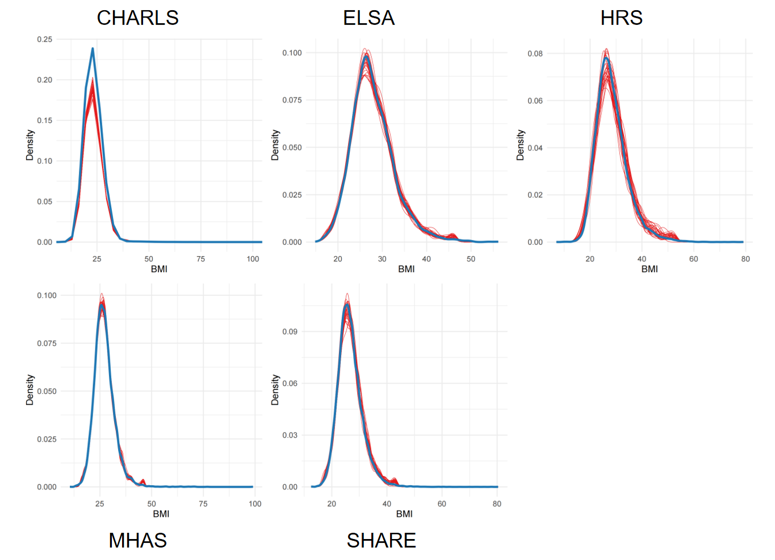
The thick blue line represents the density distribution of the original observed data, while the 30 thin red lines represent the distributions of the 30 independently imputed datasets

Supplementary Figure S8. Trace plots of mean and standard deviation for imputed BMI.
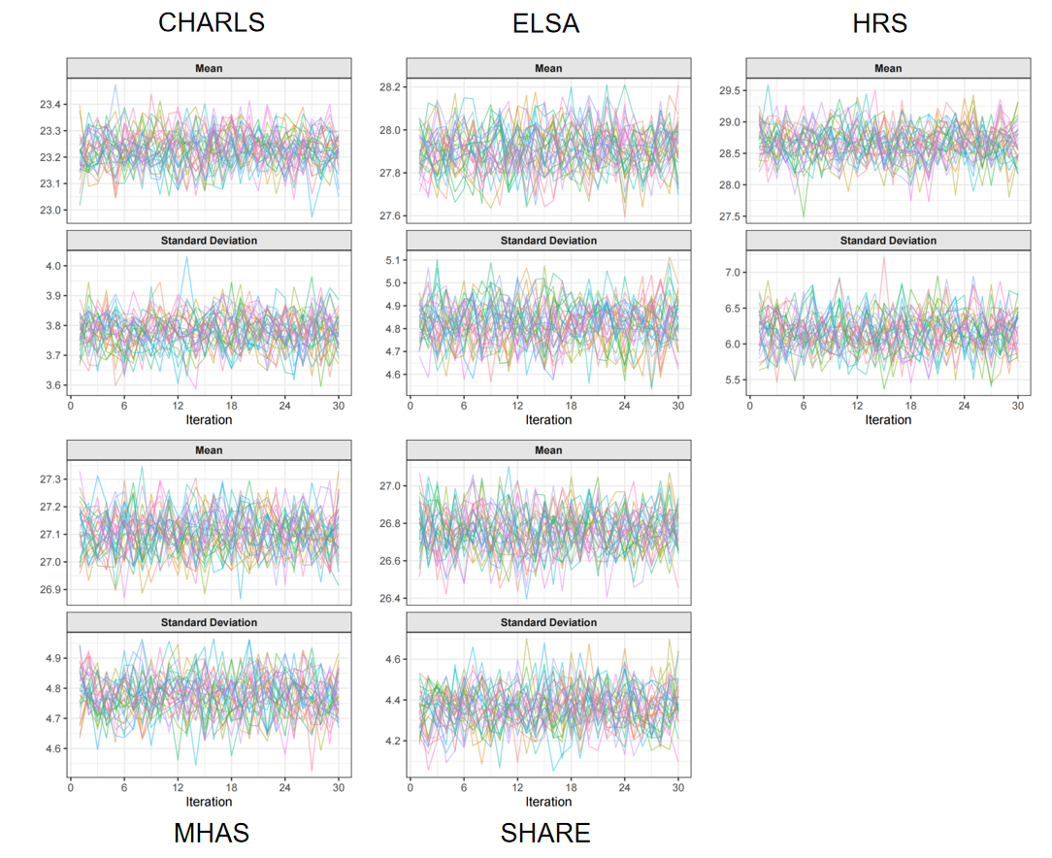

The plots illustrate the convergence of the Gibbs sampling algorithm over 30 iterations (maxit=30) for the 30 imputed datasets across the five cohorts.

