Supplementary Materials

Device-measured and self-reported physical activity and the trajectory of cardio-renal-metabolic multimorbidity: a prospective cohort study in UK Biobank
Figure S1. The flowchart of participant selection of the dual cohorts.
Figure S2. Numbers (percentages) of participants in transition pattern A and B of the questionnaire-based cohort.
Figure S3. Distribution of accelerometer-derived total physical activity (TPA) quartiles across IPAQ activity categories.
Figure S4. Effects of PA on the trajectory of cardio-renal-metabolic multimorbidity in pattern A (assumed interval between states was 30 days).
Figure S5. Effects of PA on the trajectory of cardio-renal-metabolic multimorbidity in pattern A (assumed interval between states was 90 days).
Figure S6. Effects of PA on the trajectory of cardio-renal-metabolic multimorbidity in pattern A (excluding events occurring within the first two years of follow-up).
Figure S7. Effects of PA on the trajectory of cardio-renal-metabolic multimorbidity in pattern A (excluding participants with prevalent cancer at baseline).
Figure S8. Effects of PA on the trajectory of cardio-renal-metabolic multimorbidity in pattern A (performing multiple imputation for the cohort with missing covariate data and retaining these cases).
Figure S9. Effects of PA on the trajectory of cardio-renal-metabolic multimorbidity in pattern A (mutually adjusted Cox models including LPA, MPA, and VPA).
Figure S10. Variance inflation factors (VIFs) for variables included in the supplementary mutually adjusted model.
Figure S11. Effects of PA on the trajectory of cardio-renal-metabolic multimorbidity in pattern A (models additionally adjusted for diet quality, sedentary time, and sleep duration).
Table S1. International Classification of Disease and procedure codes used to ascertain incident outcomes.
Table S2. Covariates definition.
Table S3. Source visits for covariate ascertainment and intervals between covariate assessment and accelerometer wear in the accelerometer-based cohort.
Table S4. Analytic sample sizes for the main and sensitivity analyses across transition patterns A and B in the accelerometer-based and questionnaire-based cohorts.
Table S5. Missing rate of single covariates.
Table S6. Population characteristics of the study population with questionnaire-reported PA categorized by PA level.
Table S7. Conventional Cox results of associations of PA with FCRMD, CRMM, and death.
Table S8. Pairwise comparisons of accelerometer-measured PA coefficients across transitions in pattern A.
Table S9. Association of questionnaire-reported PA with the trajectory of cardio-renal-metabolic multimorbidity in pattern A.
Table S10. Adjusted cumulative absolute risks and risk differences for the five direct transitions in transition pattern A by physical activity level in the accelerometer-based and questionnaire-based cohorts.
Table S11. Associations of WHO guideline-based categories of MPA and VPA with transition-specific risks in pattern A.
Table S12. Associations of WHO guideline-based categories of MPA and VPA with transition-specific risks in pattern B.
Table S13. Association of accelerometer-measured PA (Q4 vs Q1) with the trajectory of cardio-renal-metabolic multimorbidity in pattern B (assumed interval between states was 30 days).
Table S14. Association of accelerometer-measured PA (Q4 vs Q1) with the trajectory of cardio-renal-metabolic multimorbidity in pattern B (assumed interval between states was 90 days).
Table S15. Association of accelerometer-measured PA (Q4 vs Q1) with the trajectory of cardio-renal-metabolic multimorbidity in pattern B (excluding events occurring within the first two years of follow-up).
Table S16. Association of accelerometer-measured PA (Q4 vs Q1) with the trajectory of cardio-renal-metabolic multimorbidity in pattern B (excluding participants with prevalent cancer at baseline).
Table S17. Association of accelerometer-measured PA (Q4 vs Q1) with the trajectory of cardio-renal-metabolic multimorbidity in pattern B (performing multiple imputation for the cohort with missing covariate data and retaining these cases).
Table S18. Association of accelerometer-measured PA (Q4 vs Q1) with the trajectory of cardio-renal-metabolic multimorbidity in pattern B (mutually adjusted models including LPA, MPA, and VPA).
Table S19. Sensitivity analyses of associations of IPAQ-based PA with the trajectory of cardio-renal-metabolic multimorbidity in pattern B.
Table S20. Additional sensitivity analyses of IPAQ-based PA on the trajectory of cardio-renal-metabolic multimorbidity in pattern B.
Table S21. Additional sensitivity analyses of accelerometer-measured PA (Q4 vs Q1) on the trajectory of cardio-renal-metabolic multimorbidity in pattern B (additional adjustment for diet quality, sedentary time, and sleep duration).
Table S22. Additional sensitivity analyses of IPAQ-based PA on the trajectory of cardio-renal-metabolic multimorbidity in pattern B (additional adjustment for diet quality, sedentary time, and sleep duration).
Table S23. Follow-up time-stratified associations of accelerometer-measured PA with the trajectory of cardio-renal-metabolic multimorbidity in pattern A.
Table S24. Follow-up time-stratified associations of IPAQ-based PA with the trajectory of cardio-renal-metabolic multimorbidity in pattern A.
Table S25. The stratified analyses results of VPA in pattern A.
Table S26. The stratified analyses results of MPA in pattern A.
Table S27. The stratified analyses results of LPA in pattern A.

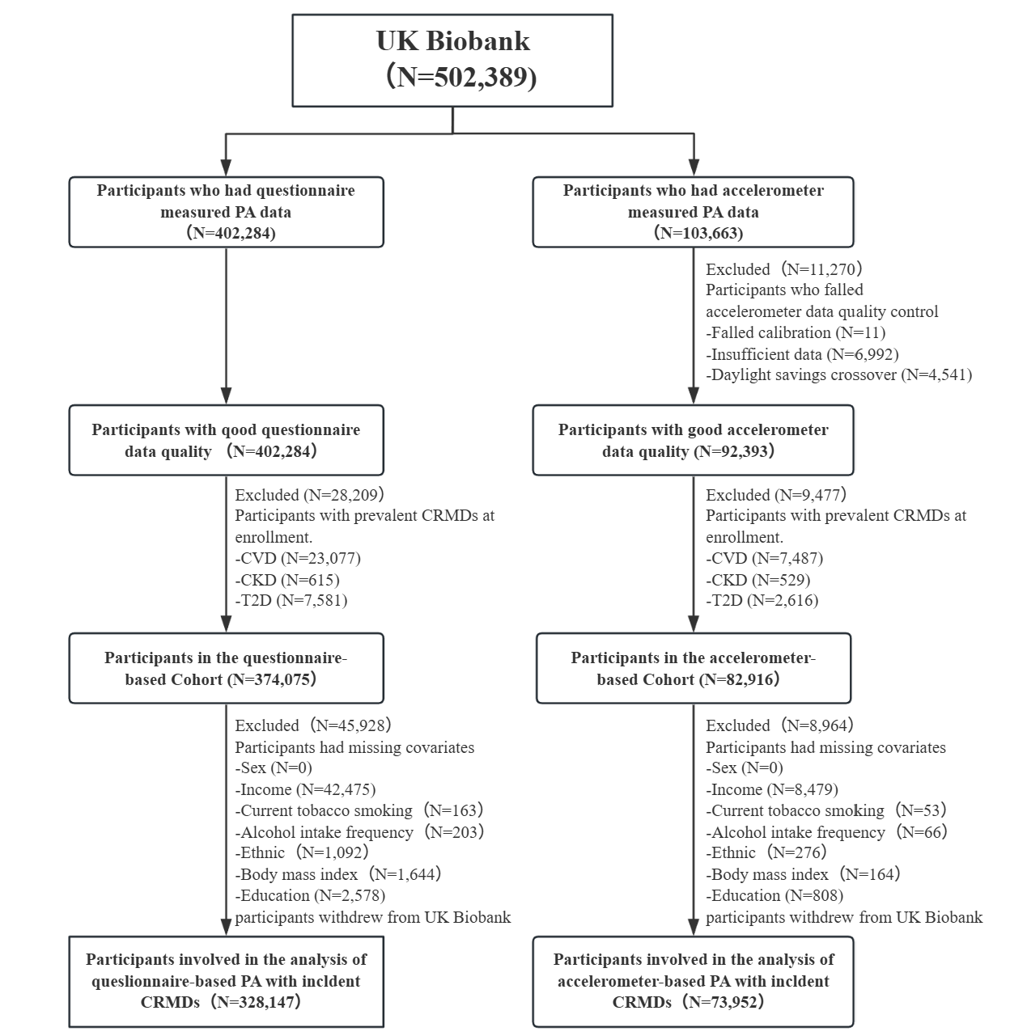
Figure S1. The flowchart of participant selection of the dual cohorts.
CVD: cardiovascular disease, CKD: chronic kidney disease, CRMDs: cardio-renal-metabolic diseases, PA: physical activity, T2D: type 2 diabetes.

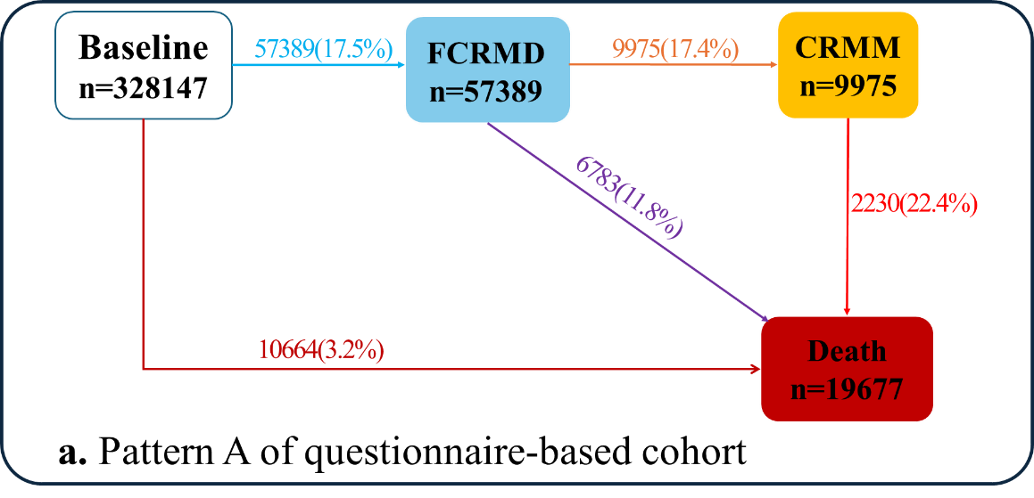
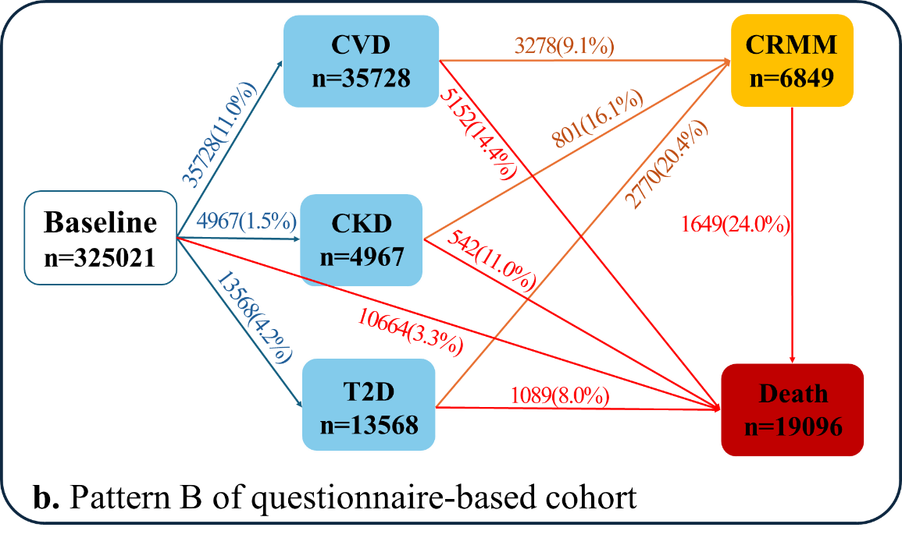
Figure S2. Numbers (percentages) of participants in transition pattern A and B of the questionnaire-based cohort.
CKD: chronic kidney disease, CVD: cardiovascular disease, CRMM: cardio-renal-metabolic multimorbidity, FCRMD: first cardio-renal-metabolic disease, T2D: type 2 diabetes. In both patterns, baseline → death denotes death occurring before any recorded cardio-renal-metabolic disease during follow-up, that is, without a prior transition to FCRMD (pattern A) or to CVD, CKD, or T2D (pattern B).
a. Pattern A from baseline to FCRMD, CRMM, and death; b. Pattern B from baseline to one of CVD, T2D, and CKD then to CRMM, and subsequently to death.

Figure S3. Distribution of accelerometer-derived total physical activity (TPA) quartiles across IPAQ activity categories.
IPAQ: International Physical Activity Questionnaire; PA: physical activity; TPA: total physical activity; Q1–Q4: quartiles. Stacked percentage bar chart showing the distribution of accelerometer-derived TPA quartiles (Q1–Q4) within IPAQ activity categories (low, moderate, high) among participants with both assessments available (n = 64,344). Higher IPAQ categories contained a larger proportion of participants in higher TPA quartiles, with a weak but positive ordinal association between the two measures (Spearman ρ = 0.19, P < 0.001).

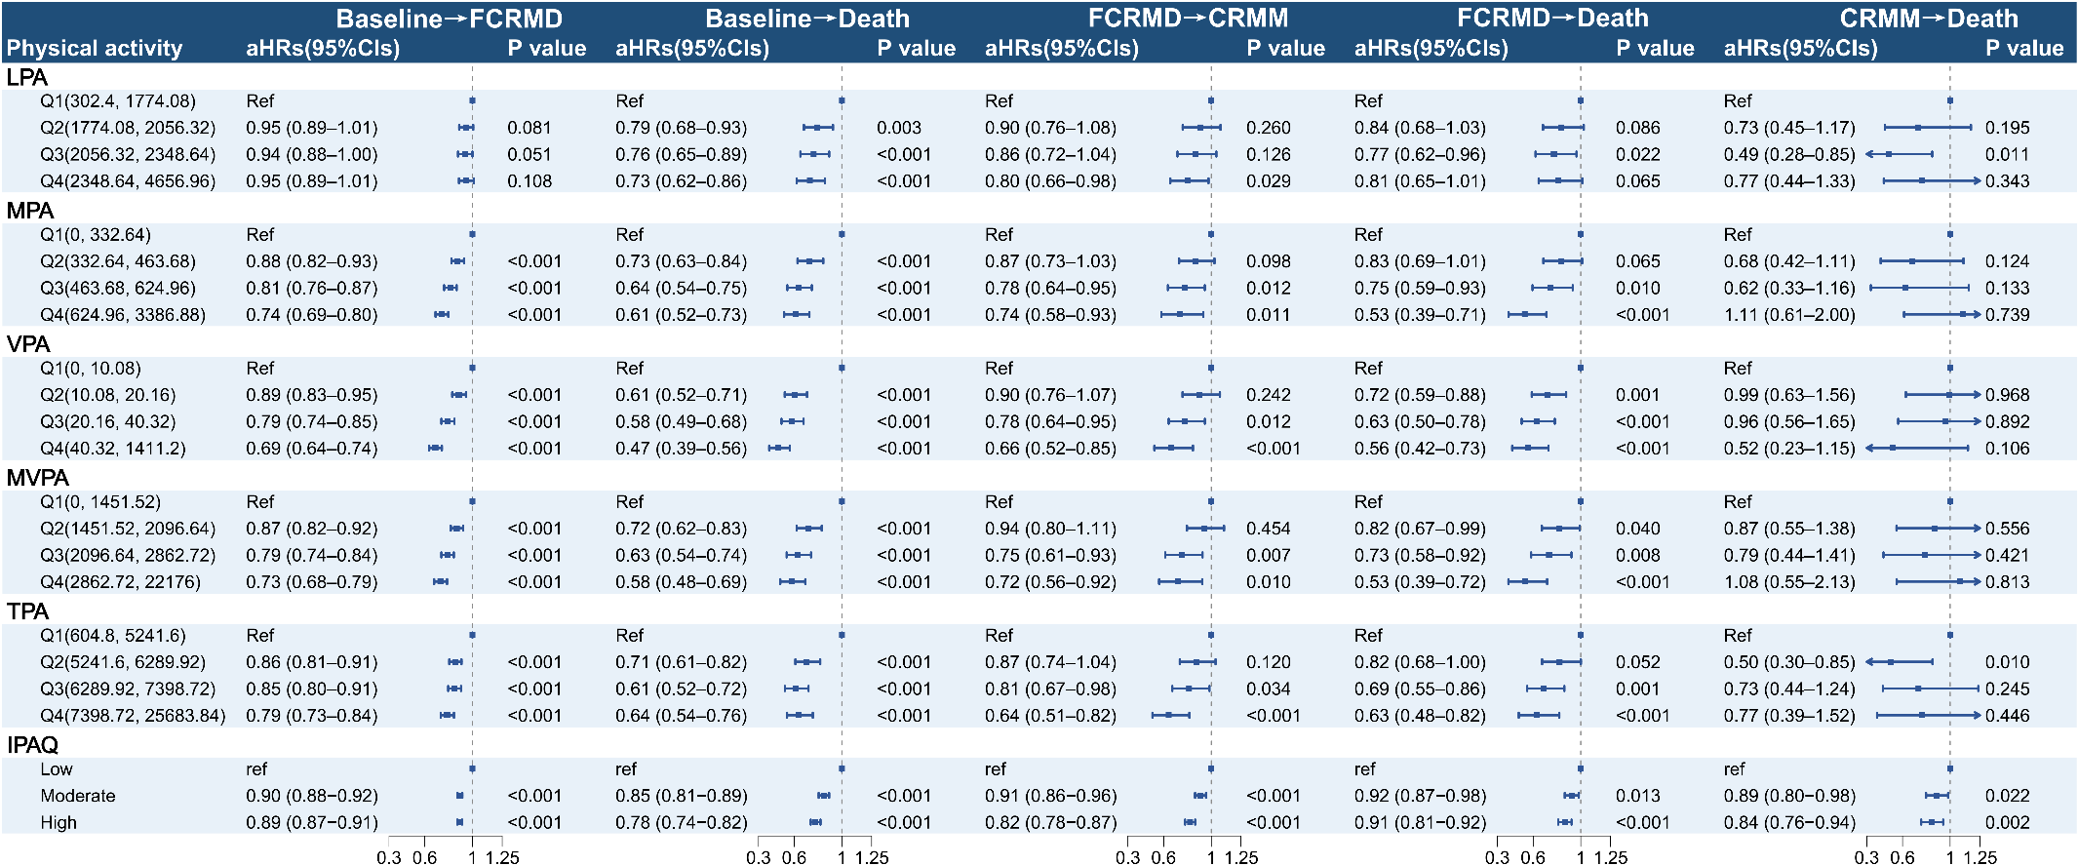
Figure S4. Effects of PA on the trajectory of cardio-renal-metabolic multimorbidity in pattern A (assumed interval between states was 30 days).
aHR: adjusted hazard ratio, CI: confidence interval, CRMM: cardio-renal-metabolic multimorbidity, FCRMD: first cardio-renal-metabolic disease, ref: reference, IPAQ: International Physical Activity Questionnaire, LPA: light-intensity PA, MPA: moderate-intensity PA, MVPA: moderate-to-vigorous-intensity PA, PA: physical activity, Q1–Q4: quartiles, TPA: total PA, VPA: vigorous-intensity PA.
Pattern A from baseline to FCRMD, CRMM, and death. All adjusted for age, sex, ethnicity, education, smoking status, alcohol intake frequency, household income, and BMI. Quartiles of LPA, MPA and VPA were presented as minutes per week, while MVPA and TPA as MET-minutes per week; P < 0.05 was considered significant.
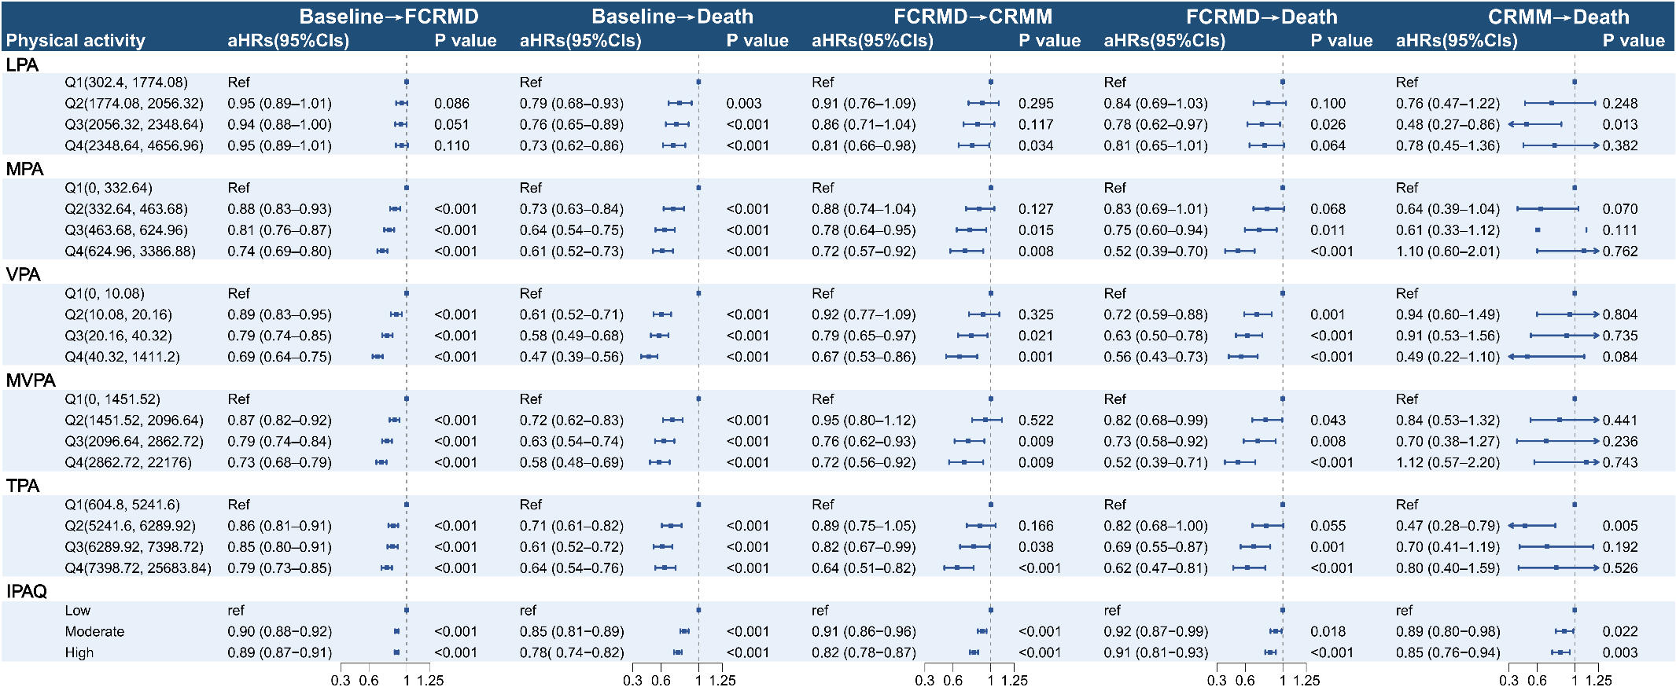
Figure S5. Effects of PA on the trajectory of cardio-renal-metabolic multimorbidity in pattern A (assumed interval between states was 90 days).
aHR: adjusted hazard ratio, CI: confidence interval, CRMM: cardio-renal-metabolic multimorbidity, FCRMD: first cardio-renal-metabolic disease, ref: reference, IPAQ: International Physical Activity Questionnaire, LPA: light-intensity PA, MPA: moderate-intensity PA, MVPA: moderate-to-vigorous-intensity PA, PA: physical activity, Q1–Q4: quartiles, TPA: total PA, VPA: vigorous-intensity PA.
Pattern A from baseline to FCRMD, CRMM, and death. All adjusted for age, sex, ethnicity, education, smoking status, alcohol intake frequency, household income, and BMI. Quartiles of LPA, MPA and VPA were presented as minutes per week, while MVPA and TPA as MET-minutes per week; P < 0.05 was considered significant.
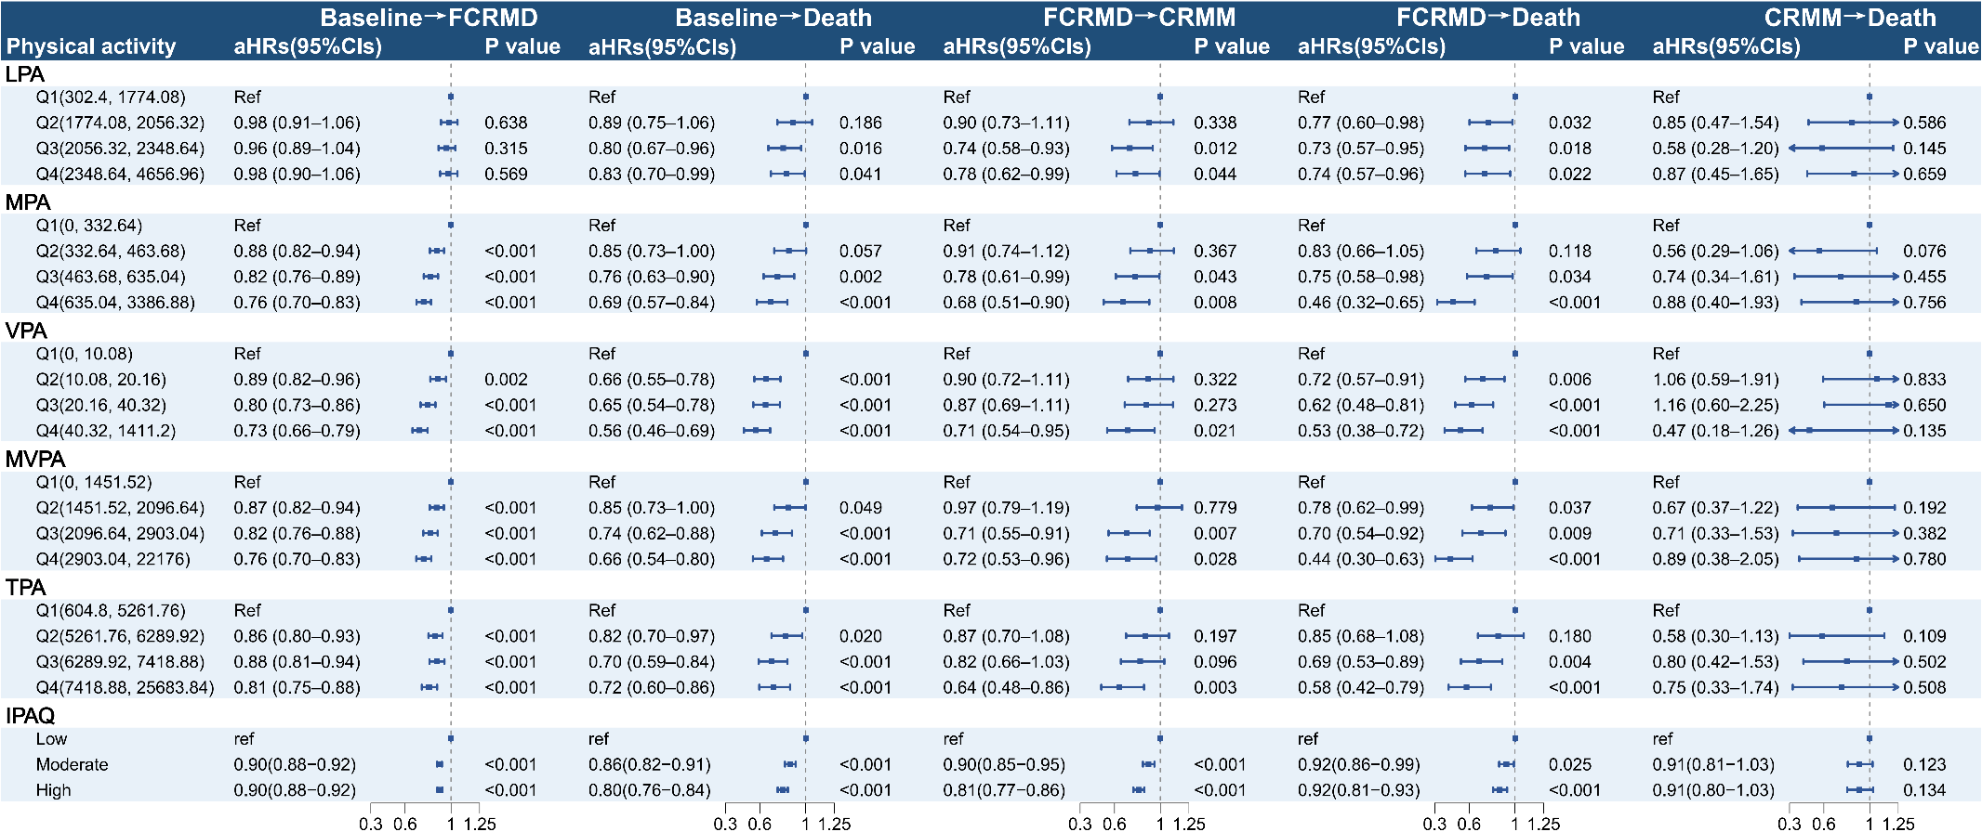Figure S6. Effects of PA on the trajectory of cardio-renal-metabolic multimorbidity in pattern A (excluding events occurring within the first two years of follow-up).
aHR: adjusted hazard ratio, CI: confidence interval, CRMM: cardio-renal-metabolic multimorbidity, FCRMD: first cardio-renal-metabolic disease, ref: reference, IPAQ: International Physical Activity Questionnaire, LPA: light-intensity PA, MPA: moderate-intensity PA, MVPA: moderate-to-vigorous-intensity PA, PA: physical activity, Q1–Q4: quartiles, TPA: total PA, VPA: vigorous-intensity PA.
Pattern A from baseline to FCRMD, CRMM, and death. All adjusted for age, sex, ethnicity, education, smoking status, alcohol intake frequency, household income, and BMI. Quartiles of LPA, MPA and VPA were presented as minutes per week, while MVPA and TPA as MET-minutes per week; P < 0.05 was considered significant.
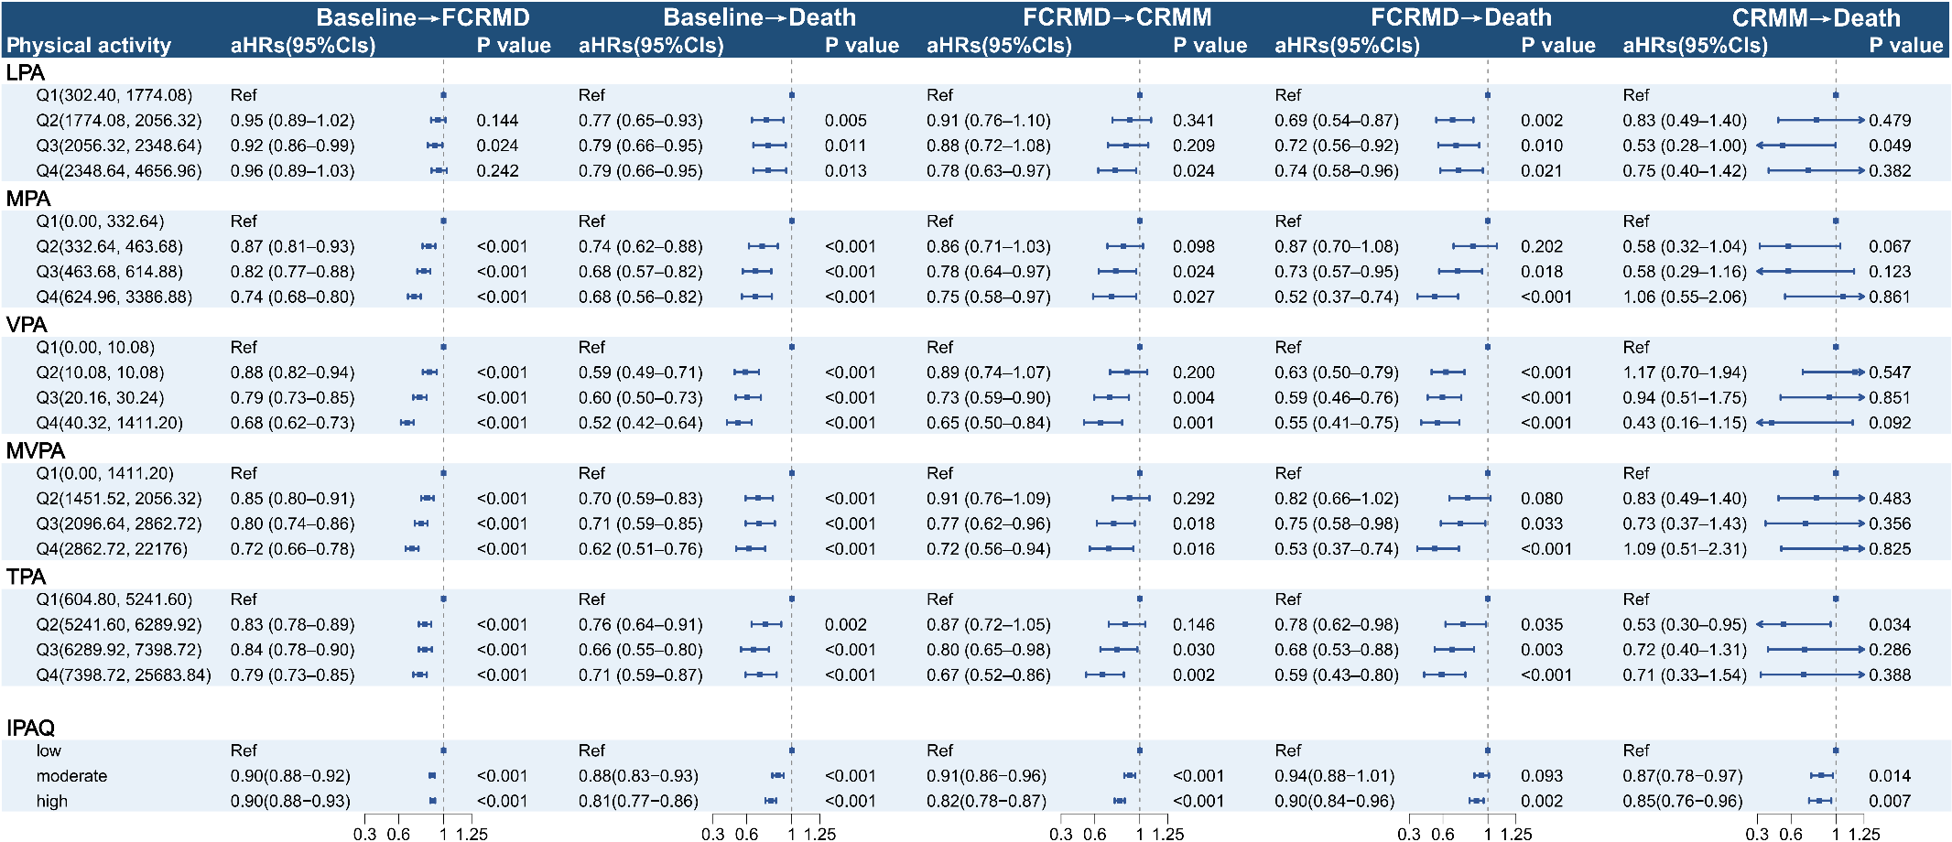
Figure S7. Effects of PA on the trajectory of cardio-renal-metabolic multimorbidity in pattern A (excluding participants with prevalent cancer at baseline).
aHR: adjusted hazard ratio, CI: confidence interval, CRMM: cardio-renal-metabolic multimorbidity, FCRMD: first cardio-renal-metabolic disease, ref: reference, IPAQ: International Physical Activity Questionnaire, LPA: light-intensity PA, MPA: moderate-intensity PA, MVPA: moderate-to-vigorous-intensity PA, PA: physical activity, Q1–Q4: quartiles, TPA: total PA, VPA: vigorous-intensity PA. Pattern A from baseline to FCRMD, CRMM, and death. All adjusted for age, sex, ethnicity, education, smoking status, alcohol intake frequency, household income, and BMI. Quartiles of LPA, MPA and VPA were presented as minutes per week, while MVPA and TPA as MET-minutes per week; P < 0.05 was considered significant.
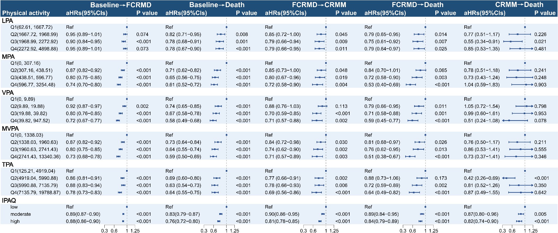
Figure S8. Effects of PA on the trajectory of cardio-renal-metabolic multimorbidity in pattern A (performing multiple imputation for the cohort with missing covariate data and retaining these cases).
aHR: adjusted hazard ratio, CI: confidence interval, CRMM: cardio-renal-metabolic multimorbidity, FCRMD: first cardio-renal-metabolic disease, ref: reference, IPAQ: International Physical Activity Questionnaire, LPA: light-intensity PA, MPA: moderate-intensity PA, MVPA: moderate-to-vigorous-intensity PA, PA: physical activity, Q1–Q4: quartiles, TPA: total PA, VPA: vigorous-intensity PA.
Pattern A from baseline to FCRMD, CRMM, and death. All adjusted for age, sex, ethnicity, education, smoking status, alcohol intake frequency, household income, and BMI. Quartiles of LPA, MPA and VPA were presented as minutes per week, while MVPA and TPA as MET-minutes per week; P < 0.05 was considered significant.
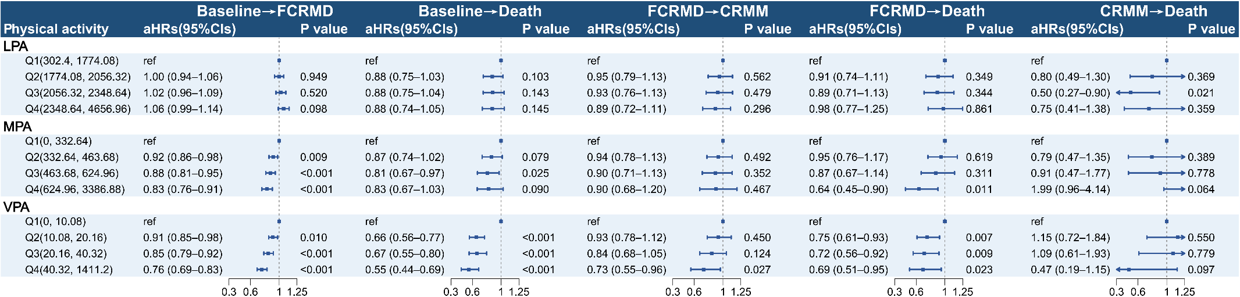
Figure S9. Effects of PA on the trajectory of cardio-renal-metabolic multimorbidity in pattern A (mutually adjusted models including LPA, MPA, and VPA).
aHR: adjusted hazard ratio, CI: confidence interval, CRMM: cardio-renal-metabolic multimorbidity, FCRMD: first cardio-renal-metabolic disease, ref: reference, LPA: light-intensity PA, MPA: moderate-intensity PA, PA: physical activity, Q1–Q4: quartiles, VPA: vigorous-intensity PA.
Pattern A from baseline to FCRMD, CRMM, and death. All adjusted for age, sex, ethnicity, education, smoking status, alcohol intake frequency, household income, and BMI. Mutual adjustment was performed across PA intensities; quartiles of LPA, MPA and VPA were presented as minutes per week; P < 0.05 was considered significant.

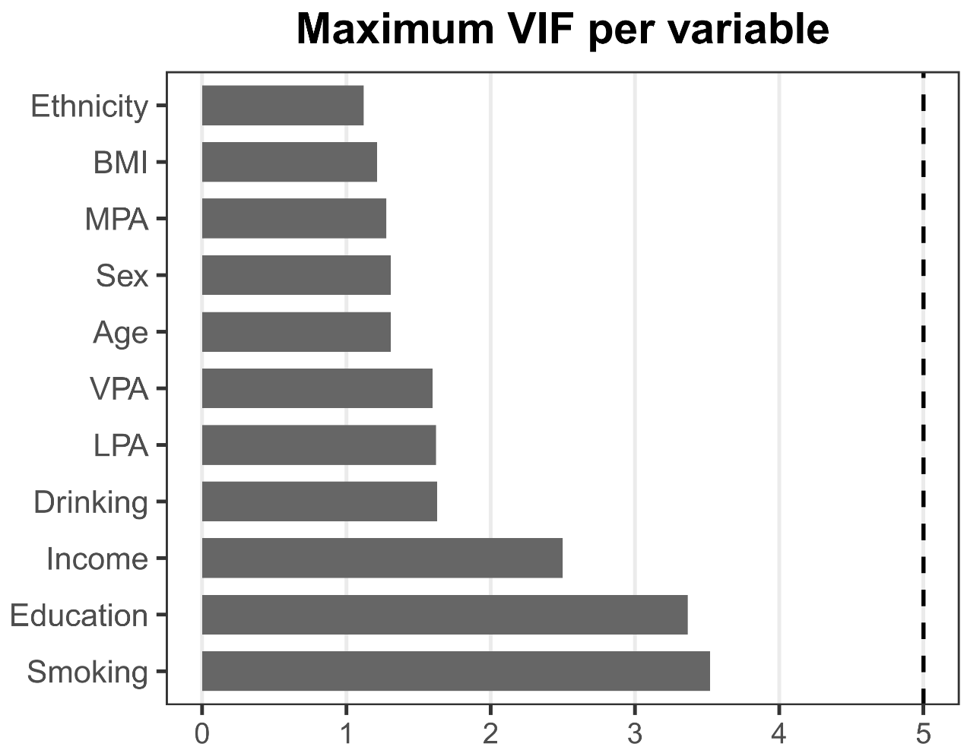
Figure S10. Variance inflation factors (VIFs) for variables included in the supplementary mutually adjusted model.
BMI: body mass index, LPA: light-intensity physical activity, MPA: moderate-intensity physical activity, VIF: variance inflation factor, VPA: vigorous-intensity physical activity. VIFs were calculated from the design matrix of the supplementary mutually adjusted Cox model including LPA, MPA, VPA, age, sex, ethnicity, education, smoking, drinking, BMI, and household income. The dashed line indicates VIF = 5.
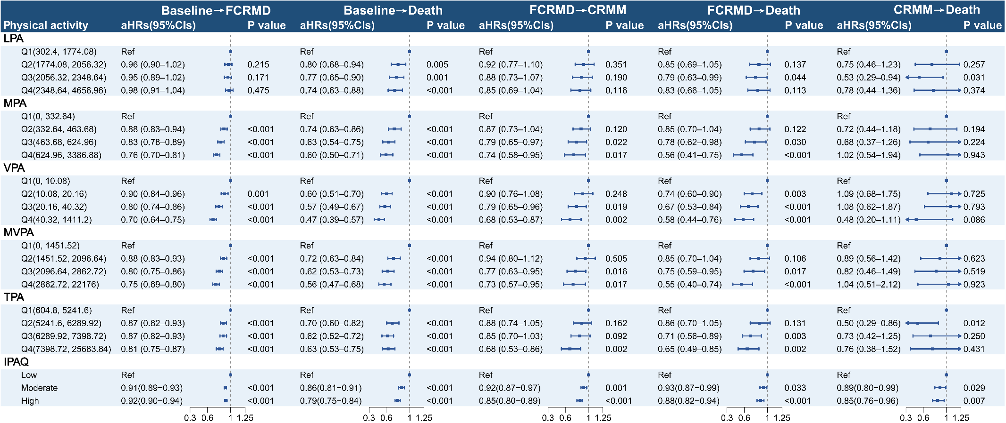
Figure S11. Effects of PA on the trajectory of cardio-renal-metabolic multimorbidity in pattern A (models additionally adjusted for diet quality, sedentary time, and sleep duration).
aHR: adjusted hazard ratio, CI: confidence interval, CRMM: cardio-renal-metabolic multimorbidity, FCRMD: first cardio-renal-metabolic disease, IPAQ: International Physical Activity Questionnaire, LPA: light-intensity PA, MPA: moderate-intensity PA, MVPA: moderate-to-vigorous PA, PA: physical activity, Q1–Q4: quartiles, ref: reference, TPA: total physical activity, VPA: vigorous-intensity PA.
Pattern A from baseline to FCRMD, CRMM, and death. All models were adjusted for age, sex, ethnicity, education, smoking status, alcohol intake frequency, household income, and BMI, with additional adjustment for diet quality, sedentary time, and sleep duration. Sedentary time was defined as the sum of time spent watching television, using a computer, and driving; sleep duration was categorized as <7, 7–8, and >8 hours/day; diet quality was represented by a composite dietary score. Quartiles of PA were presented as minutes per week for LPA, MPA, and VPA, and as MET-min/week for MVPA and TPA. P < 0.05 was considered significant.
Table S1. International Classification of Disease and procedure codes used to ascertain incident outcomes.
Outcome | ICD or procedural codes
CVD | ICD-10:  I11.0, I20, I20.0, I20.1, I20.8, I20.9, I21, I21.0, I21.1, I21.2, I21.3, I21.4, I21.9, I22, I22.0, I22.1, I22.8, I22.9, I23, I23.0, I23.1, I23.2, I23.3, I23.4, I23.5, I23.6, I23.8, I24, I24.0, I24.1, I24.8, I24.9, I25, I25.0, I25.1, I25.2, I25.5, I25.6, I25.8, I25.9, I42.0, I42.1, I42.5, I42.8, I42.9, I48, I49, I49.0, I49.1, I49.2, I49.3, I49.4, I49.5, I49.8, I49.9, I50, I50.0, I50.1, I50.9, I70.0, I70.00, I70.01, I70.2, I70.20, I70.21, I70.8, I70.80, I70.9, I70.90, I73.8, I73.9  OPCS-4:  K40, K40.1, K40.2, K40.3, K40.4, K40.8, K40.9, K41, K41.1, K41.2, K41.3, K41.4, K41.8, K41.9, K42, K42.1, K42.2, K42.3, K42.4, K42.8, K42.9, K43, K43.1, K43.2, K43.3, K43.4, K43.8, K43.9, K44, K44.1, K44.2, K44.8, K44.9, K45, K45.1, K45.2, K45.3, K45.4, K45.5, K45.6, K45.8, K45.9, K46, K46.1, K46.2, K46.3, K46.4, K46.5, K46.8, K46.9, K47, K47.1, K47.2, K47.3, K47.4, K47.5, K47.8, K47.9, K48.1, K48.2, K48.3, K48.4, K48.8, K48.9, K49, K49.1, K49.2, K49.3, K49.4, K49.8, K49.9, K50, K50.1, K50.2, K50.3, K50.4, K50.8, K50.9, K57.1, K62.1, K62.2, K62.3, K62.4, K63, K75, X09.3, X09.4, X09.5, L21.6, L51.3, L51.6, L51.8, L52.1, L52.2, L54.1, L54.4, L54.8, L59.1, L59.2, L59.3, L59.4, L59.5, L59.6, L59.7, L59.8, L60.1, L60.2, L63.1, L63.5, L63.9, L66.7, X50.1, X50.2
T2D | ICD-10: E11, E14
CKD | ICD-10: N18, N18.0, N18.1, N18.2, N18.3, N18.4, N18.5, N18.8, N18.9  OPCS-4: M01, M01.1, M01.2, M01.3, M01.4, M01.5, M01.8, M01.9
CKD: chronic kidney disease, CVD: cardiovascular disease, ICD: International Classification of Disease, OPCS-4: Office of Population Censuses and Surveys Classification of Interventions and Procedures, version 4, T2D: type 2 diabetes.

Table S2. Covariates definition.
Covariates | Description
Sex | Acquired from central registry at recruitment
Age | For the accelerometer-based cohort, age was calculated as the interval between date of birth and accelerometer wear date. For the questionnaire-based cohort, age at the initial assessment visit was used.
Body mass index | For the accelerometer-based cohort, BMI was obtained from the assessment visit closest in time to the accelerometer wear period when available. For the questionnaire-based cohort, BMI at the initial assessment visit was used.
Education level | Using touchscreen to chose answer with the question of "Which of the following qualifications do you have? (You can select more than one)"  College or University degree, NVQ or HND or HNC or equivalent, and Other professional qualifications eg: nursing, teaching were defined as High education level.  A levels/AS levels or equivalent, O levels/GCSEs or equivalent, and CSEs or equivalent were defined as Moderate education level.  None of the above was defined as Low education level.
Current tobacco smoking | Using touchscreen to chose answer with the question of "Do you smoke tobacco now?"  The choice included Most or all days, Occasionally and No.
Alcohol intake frequency | Using touchscreen to chose answer with the question of "About how often do you drink alcohol?"  The choice included Daily or nearly daily, 3-4 times weekly, 1-2 times weekly, 1-3 times monthly, Special occasions and Never.
Ethnicity | This is an amalgam of sequential branching questions asked during the initial Assessment Centre visit as part of the touchscreen questionnaire.  White, British, Irish, Any other white background were defined as White, while the rest were defined as Non-white.

Table S3. Source visits for covariate ascertainment and intervals between covariate assessment and accelerometer wear in the accelerometer-based cohort.
Characteristic | Value
Participants, n | 73,952
Source visit: initial assessment, n (%) | 66,994 (90.6)
Source visit: first repeat assessment, n (%) | 5,828 (7.9)
Source visit: imaging visit, n (%) | 1,130 (1.5)
Median interval, years (IQR) | 5.44 (4.56–6.29)
Mean interval, years (SD) | 5.26 (1.52)
Range, years | 0.00–8.58
≤ 1 year, n (%) | 1,101 (1.5)
1 to 3 years, n (%) | 5,749 (7.8)
3 to 5 years, n (%) | 19,890 (26.9)
> 5 years, n (%) | 47,212 (63.8)
IQR: interquartile range, SD: standard deviation. Covariate values in the accelerometer-based cohort were obtained from the assessment visit closest in time to, and at or before, the accelerometer wear period, when available. Source visit refers to the UK Biobank assessment visit from which covariate information was derived. Intervals were calculated as the time between the source visit and accelerometer wear.

 | Accelerometer-based cohort |  | Questionnaire-based cohort
Analysis set | Pattern A | Pattern B | Pattern A | Pattern B
Main analysis, n | 73,952 | 73,582 | 328,147 | 325,021
30-day interval, n | 73,949 | 73,582 | 328,138 | 325,020
90-day interval, n | 73,937 | 73,580 | 328,100 | 325,009
Excluding events within first 2 years, n | 71,765 | 71,491 | 320,126 | 317,328
Excluding prevalent cancer at baseline, n | 66,245 | 65,918 | 308,293 | 305,382
Multiple imputation analysis, n | 82,876 | 82,449 | 373,886 | 370,182
Table S4. Analytic sample sizes for the main and sensitivity analyses across transition patterns A and B in the accelerometer-based and questionnaire-based cohorts.
Pattern A from baseline to FCRMD, CRMM, and death.
Pattern B: from baseline to one of CVD, T2D, and CKD then to CRMM, and subsequently to death. The 30-day and 90-day interval analyses varied the assumed minimum interval between states. “Excluding events within the first 2 years” refers to exclusion of events occurring within the first 2 years of follow-up. “Excluding prevalent cancer at baseline” refers to exclusion of participants with cancer diagnosed before baseline, defined using ICD-10 codes C00–C97. Analytic sample sizes differed between Pattern A and Pattern B because the two transition structures had different pattern-specific eligibility criteria. In the multiple imputation analysis, participants with missing covariates were retained after imputation; therefore, the analytic sample size was larger than that in the complete-case main analysis.

Table S5. Missing rate of single covariates.
Covariates | missing rate (%)ª | missing rate (%)^{b}
Age | 0 | 0
Sex | 0 | 0
Ethnicity | 0.29 | 0.29
Body mass index | 0.2 | 0.44
Current tobacco smoking | 0.06 | 0.04
Alcohol intake frequency | 0.08 | 0.05
Education | 0.97 | 0.69
Average total household income before tax | 10.23 | 11.35
a: Missing rate of single covariates in accelerometer-based cohort.
b: Missing rate of single covariates in questionnaire-based cohort.

Table S6. Population characteristics of the study population with questionnaire-reported PA categorized by PA level.
 | Low | Moderate | High | P value
 | N=60629 | N=134759 | N=132759
Age (median, [IQR]) | 56.0 [49.0;61.0] | 57.0 [49.0;62.0] | 56.0 [49.0;62.0] | < 0.001
Sex (n, %) |  |  |  | < 0.001
Female | 31596 (52.1%) | 74569 (55.3%) | 65866 (49.6%)
Male | 29033 (47.9%) | 60190 (44.7%) | 66893 (50.4%)
Ethnic (n, %) |  |  |  | < 0.001
White | 55018 (90.7%) | 122922 (91.2%) | 121231 (91.3%)
Other | 5611 (9.25%) | 11837 (8.78%) | 11528 (8.68%)
Body mass index (median, [IQR]) | 27.5 [24.7;31.0] | 26.5 [24.0;29.5] | 26.1 [23.7;28.9] | < 0.001
Current tobacco smoking (n, %) |  |  |  | < 0.001
No | 53400 (88.1%) | 121703 (90.3%) | 119654 (90.1%)
On most or all day | 5493 (9.06%) | 9365 (6.95%) | 9235 (6.96%)
Occasionally | 1736 (2.86%) | 3691 (2.74%) | 3870 (2.92%)
Alcohol intake frequency (n, %) |  |  |  | < 0.001
Daily or almost daily | 12984 (21.4%) | 30254 (22.5%) | 28764 (21.7%)
Three or four times a week | 13495 (22.3%) | 34136 (25.3%) | 33338 (25.1%)
Once or twice a week | 15388 (25.4%) | 34108 (25.3%) | 35177 (26.5%)
One to three times a month | 7252 (12.0%) | 14627 (10.9%) | 14108 (10.6%)
Special occasions only | 6795 (11.2%) | 13237 (9.82%) | 12934 (9.74%)
Never | 4715 (7.78%) | 8397 (6.23%) | 8438 (6.36%)
Education (n, %) |  |  |  | < 0.001
Low | 7137 (11.8%) | 14761 (11.0%) | 18483 (13.9%)
Intermediate | 14235 (23.5%) | 29800 (22.1%) | 29015 (21.9%)
High | 39257 (64.7%) | 90198 (66.9%) | 85261 (64.2%)
Average total household income before tax (n, %) |  |  |  | < 0.001
Less than ￡18,000 | 11851 (19.5%) | 25919 (19.2%) | 27508 (20.7%)
￡18,000 to ￡30,999 | 13562 (22.4%) | 32551 (24.2%) | 34792 (26.2%)
￡31,000 to ￡51,999 | 16435 (27.1%) | 36689 (27.2%) | 35520 (26.8%)
￡52,000 to ￡100,000 | 15001 (24.7%) | 30933 (23.0%) | 27215 (20.5%)
Greater than ￡100,000 | 3780 (6.23%) | 8667 (6.43%) | 7724 (5.82%)
FCRMD during follow-up(n, %) |  |  |  | < 0.001
NO | 48502 (80.0%) | 111884 (83.0%) | 110372 (83.1%)
YES | 12127 (20.0%) | 22875 (17.0%) | 22387 (16.9%)
CRMM during follow-up (n, %) |  |  |  | < 0.001
NO | 58111 (95.8%) | 130782 (97.0%) | 129279 (97.4%)
YES | 2518 (4.15%) | 3977 (2.95%) | 3480 (2.62%)
Death during follow-up (n, %) |  |  |  | < 0.001
NO | 56352 (92.9%) | 126735 (94.0%) | 125383 (94.4%)
YES | 4277 (7.05%) | 8024 (5.95%) | 7376 (5.56%)
CRMM: cardio-renal-metabolic multimorbidity, FCRMD: first cardio-renal-metabolic disease.
Low, moderate and high mean PA levels.

Table S7. Conventional Cox results of association of PA with FCRMD, CRMM, and death.
PA | FCRMD |  |  | CRMM |  |  | Death
PA | aHRs (95% CIs) | P value |  | aHRs (95% CIs) | P value |  | aHRs (95% CIs) | P value
LPA(Q4 vs Q1) | 0.95 (0.89–1.01) | 0.101 |  | 0.77 (0.63–0.94) | 0.009 |  | 0.73 (0.64–0.83) | < 0.001
MPA(Q4 vs Q1) | 0.74 (0.69–0.80) | < 0.001 |  | 0.53 (0.42–0.68) | < 0.001 |  | 0.55 (0.48–0.64) | < 0.001
VPA(Q4 vs Q1) | 0.69 (0.64–0.74) | < 0.001 |  | 0.46 (0.36–0.59) | < 0.001 |  | 0.44 (0.38–0.51) | < 0.001
MVPA(Q4 vs Q1) | 0.73 (0.68–0.79) | < 0.001 |  | 0.51 (0.40–0.66) | < 0.001 |  | 0.53 (0.45–0.61) | < 0.001
TPA(Q4 vs Q1) | 0.79 (0.73–0.84) | < 0.001 |  | 0.52 (0.41–0.66) | < 0.001 |  | 0.59 (0.51–0.67) | < 0.001
IPAQ(High vs Low) | 0.89 (0.87–0.91) | < 0.001 |  | 0.75 (0.71–0.79) | < 0.001 |  | 0.76 (0.73–0.79) | < 0.001
aHR: adjusted hazard ratio, CI: confidence interval, CRMM: cardio-renal-metabolic multimorbidity, FCRMD: first cardio-renal-metabolic disease, IPAQ: International Physical Activity Questionnaire, LPA: light-intensity PA, MPA: moderate-intensity PA, MVPA: moderate-to-vigorous-intensity PA, PA: physical activity, Q1: the lowest quartile, Q4: the highest quartile, TPA: total PA, VPA: vigorous-intensity PA.
All adjusted for age, sex, ethnicity, education, smoking status, alcohol intake frequency, household income, and BMI. P < 0.05 was considered significant.
Table S8. Pairwise comparisons of accelerometer-measured PA coefficients across transitions in pattern A.
PA | Transition comparison | aHR1 (95%CI) | aHR2 (95%CI) | Raw P | BH-adjusted P
LPA | Baseline → FCRMD vs Baseline → Death | 0.95 (0.89–1.01) | 0.73 (0.62–0.86) | 0.004 | 0.090
 | Baseline → FCRMD vs FCRMD → CRMM | 0.95 (0.89–1.01) | 0.80 (0.65–0.97) | 0.112 | 0.356
 | Baseline → FCRMD vs FCRMD → Death | 0.95 (0.89–1.01) | 0.80 (0.64–1.00) | 0.164 | 0.417
 | Baseline → FCRMD vs CRMM → Death | 0.95 (0.89–1.01) | 0.83 (0.48–1.42) | 0.636 | 0.859
 | Baseline → Death vs FCRMD → CRMM | 0.73 (0.62–0.86) | 0.80 (0.65–0.97) | 0.494 | 0.749
 | Baseline → Death vs FCRMD → Death | 0.73 (0.62–0.86) | 0.80 (0.64–1.00) | 0.511 | 0.751
 | Baseline → Death vs CRMM → Death | 0.73 (0.62–0.86) | 0.83 (0.48–1.42) | 0.658 | 0.866
 | FCRMD → CRMM vs FCRMD → Death | 0.80 (0.65–0.97) | 0.80 (0.64–1.00) | 0.981 | 0.981
 | FCRMD → CRMM vs CRMM → Death | 0.80 (0.65–0.97) | 0.83 (0.48–1.42) | 0.897 | 0.960
 | FCRMD → Death vs CRMM → Death | 0.80 (0.64–1.00) | 0.83 (0.48–1.42) | 0.908 | 0.960
MPA | Baseline → FCRMD vs Baseline → Death | 0.74 (0.69–0.80) | 0.61 (0.52–0.73) | 0.045 | 0.248
 | Baseline → FCRMD vs FCRMD → CRMM | 0.74 (0.69–0.80) | 0.73 (0.58–0.93) | 0.922 | 0.960
 | Baseline → FCRMD vs FCRMD → Death | 0.74 (0.69–0.80) | 0.53 (0.40–0.71) | 0.031 | 0.218
 | Baseline → FCRMD vs CRMM → Death | 0.74 (0.69–0.80) | 1.13 (0.62–2.03) | 0.168 | 0.417
 | Baseline → Death vs FCRMD → CRMM | 0.61 (0.52–0.73) | 0.73 (0.58–0.93) | 0.231 | 0.487
 | Baseline → Death vs FCRMD → Death | 0.61 (0.52–0.73) | 0.53 (0.40–0.71) | 0.411 | 0.687
 | Baseline → Death vs CRMM → Death | 0.61 (0.52–0.73) | 1.13 (0.62–2.03) | 0.052 | 0.248
 | FCRMD → CRMM vs FCRMD → Death | 0.73 (0.58–0.93) | 0.53 (0.40–0.71) | 0.095 | 0.338
 | FCRMD → CRMM vs CRMM → Death | 0.73 (0.58–0.93) | 1.13 (0.62–2.03) | 0.185 | 0.420
 | FCRMD → Death vs CRMM → Death | 0.53 (0.40–0.71) | 1.13 (0.62–2.03) | 0.025 | 0.218
VPA | Baseline → FCRMD vs Baseline → Death | 0.69 (0.64–0.74) | 0.47 (0.39–0.56) | <0.001 | 0.008
 | Baseline → FCRMD vs FCRMD → CRMM | 0.69 (0.64–0.74) | 0.66 (0.52–0.84) | 0.740 | 0.949
 | Baseline → FCRMD vs FCRMD → Death | 0.69 (0.64–0.74) | 0.56 (0.42–0.73) | 0.143 | 0.396
 | Baseline → FCRMD vs CRMM → Death | 0.69 (0.64–0.74) | 0.52 (0.23–1.15) | 0.484 | 0.749
 | Baseline → Death vs FCRMD → CRMM | 0.47 (0.39–0.56) | 0.66 (0.52–0.84) | 0.028 | 0.218
 | Baseline → Death vs FCRMD → Death | 0.47 (0.39–0.56) | 0.56 (0.42–0.73) | 0.301 | 0.579
 | Baseline → Death vs CRMM → Death | 0.47 (0.39–0.56) | 0.52 (0.23–1.15) | 0.815 | 0.960
 | FCRMD → CRMM vs FCRMD → Death | 0.66 (0.52–0.84) | 0.56 (0.42–0.73) | 0.364 | 0.675
 | FCRMD → CRMM vs CRMM → Death | 0.66 (0.52–0.84) | 0.52 (0.23–1.15) | 0.567 | 0.810
 | FCRMD → Death vs CRMM → Death | 0.56 (0.42–0.73) | 0.52 (0.23–1.15) | 0.861 | 0.960
MVPA | Baseline → FCRMD vs Baseline → Death | 0.73 (0.68–0.79) | 0.58 (0.48–0.69) | 0.019 | 0.218
 | Baseline → FCRMD vs FCRMD → CRMM | 0.73 (0.68–0.79) | 0.72 (0.56–0.92) | 0.874 | 0.960
 | Baseline → FCRMD vs FCRMD → Death | 0.73 (0.68–0.79) | 0.53 (0.39–0.72) | 0.044 | 0.248
 | Baseline → FCRMD vs CRMM → Death | 0.73 (0.68–0.79) | 1.10 (0.56–2.16) | 0.240 | 0.487
 | Baseline → Death vs FCRMD → CRMM | 0.58 (0.48–0.69) | 0.72 (0.56–0.92) | 0.175 | 0.417
 | Baseline → Death vs FCRMD → Death | 0.58 (0.48–0.69) | 0.53 (0.39–0.72) | 0.632 | 0.859
 | Baseline → Death vs CRMM → Death | 0.58 (0.48–0.69) | 1.10 (0.56–2.16) | 0.073 | 0.303
 | FCRMD → CRMM vs FCRMD → Death | 0.72 (0.56–0.92) | 0.53 (0.39–0.72) | 0.135 | 0.396
 | FCRMD → CRMM vs CRMM → Death | 0.72 (0.56–0.92) | 1.10 (0.56–2.16) | 0.244 | 0.487
 | FCRMD → Death vs CRMM → Death | 0.53 (0.39–0.72) | 1.10 (0.56–2.16) | 0.054 | 0.248
TPA | Baseline → FCRMD vs Baseline → Death | 0.79 (0.73–0.84) | 0.64 (0.54–0.76) | 0.026 | 0.218
 | Baseline → FCRMD vs FCRMD → CRMM | 0.79 (0.73–0.84) | 0.64 (0.51–0.82) | 0.114 | 0.356
 | Baseline → FCRMD vs FCRMD → Death | 0.79 (0.73–0.84) | 0.62 (0.47–0.81) | 0.091 | 0.338
 | Baseline → FCRMD vs CRMM → Death | 0.79 (0.73–0.84) | 0.85 (0.44–1.64) | 0.820 | 0.960
 | Baseline → Death vs FCRMD → CRMM | 0.64 (0.54–0.76) | 0.64 (0.51–0.82) | 0.957 | 0.976
 | Baseline → Death vs FCRMD → Death | 0.64 (0.54–0.76) | 0.62 (0.47–0.81) | 0.843 | 0.960
 | Baseline → Death vs CRMM → Death | 0.64 (0.54–0.76) | 0.85 (0.44–1.64) | 0.412 | 0.687
 | FCRMD → CRMM vs FCRMD → Death | 0.64 (0.51–0.82) | 0.62 (0.47–0.81) | 0.826 | 0.960
 | FCRMD → CRMM vs CRMM → Death | 0.64 (0.51–0.82) | 0.85 (0.44–1.64) | 0.439 | 0.708
 | FCRMD → Death vs CRMM → Death | 0.62 (0.47–0.81) | 0.85 (0.44–1.64) | 0.383 | 0.684
aHR: adjusted hazard ratio, BH: Benjamini-Hochberg, CI: confidence interval, CRMM: cardio-renal-metabolic multimorbidity, FCRMD: first cardio-renal-metabolic disease, LPA: light-intensity PA, MPA: moderate-intensity PA, MVPA: moderate-to-vigorous-intensity PA, PA: physical activity, SE: standard error, TPA: total PA, VPA: vigorous-intensity PA.
Pattern A from baseline to FCRMD, CRMM, and death. Estimates compare the highest quartile (Q4) with the lowest quartile (Q1) for each accelerometer-measured PA metric. Pairwise comparisons of transition-specific coefficients were performed on the log(aHR) scale using Wald-type contrasts based on the variance-covariance matrix from the fitted multi-state Cox models. Raw P values were obtained from two-sided Wald tests. BH-adjusted P values were calculated using the Benjamini-Hochberg false discovery rate procedure across all pairwise comparisons shown in this table. All models were adjusted for age, sex, ethnicity, education, smoking status, alcohol intake frequency, household income, and BMI.
Table S9. Association of questionnaire-reported PA with the trajectory of cardio-renal-metabolic multimorbidity in pattern A.
PA | aHRs (95% CIs) | P value
PA | Low | Moderate |  |  | High
Baseline → FCRMD | ref | 0.90 (0.88–0.92) | < 0.001 |  | 0.89 (0.87–0.91) | < 0.001
Baseline → Death | ref | 0.85 (0.81–0.89) | < 0.001 |  | 0.78 (0.74–0.82) | < 0.001
FCRMD → CRMM | ref | 0.91 (0.86–0.95) | < 0.001 |  | 0.82 (0.78–0.86) | < 0.001
FCRMD → Death | ref | 0.93 (0.87–0.99) | 0.017 |  | 0.87 (0.81–0.93) | < 0.001
CRMM → Death | ref | 0.88 (0.79–0.97) | 0.014 |  | 0.84 (0.74–0.94) | 0.002
aHR: adjusted hazard ratio, CI: confidence interval, CRMM: cardio-renal-metabolic multimorbidity, FCRMD: first cardio-renal-metabolic disease, ref: reference, PA: Physical activity.
Pattern A from baseline to FCRMD, CRMM and death. All adjusted for age, sex, ethnicity, education, smoking status, alcohol intake frequency, household income, and BMI, P < 0.05 was considered significant.

Table S10. Adjusted cumulative absolute risks and risk differences for the five direct transitions in transition pattern A by physical activity level in the accelerometer-based and questionnaire-based cohorts.
PA | Time | Baseline→FCRMD |  |  | Baseline→Death |  |  | FCRMD→CRMM |  |  | FCRMD→Death |  |  | CRMM→Death
PA | Time | Low | High | RD (95% CI) | Low | High | RD (95% CI) | Low | High | RD (95% CI) | Low | High | RD (95% CI) | Low | High | RD (95% CI)
Accelerometer-based cohort
LPA | 5-year | 7.45 | 7.09 | -0.36(-0.85 to -0.00) | 1.28 | 0.94 | -0.34(-0.48 to -0.16) | 15.34 | 12.76 | -2.58(-4.66 to -0.02) | 11.27 | 9.38 | -1.88(-3.86 to 0.12) | 20.47 | 16.52 | -3.95(-11.84 to 4.92)
 | follow-up-end | 11.67 | 11.15 | -0.52(-1.25 to 0.02) | 2.45 | 1.81 | -0.64(-0.93 to -0.30) | 19.95 | 16.80 | -3.15(-6.00 to 0.44) | 19.35 | 16.51 | -2.84(-7.52 to 0.05) | 27.93 | 22.81 | -5.12(-14.60 to 6.88)
MPA | 5-year | 8.12 | 6.15 | -1.98(-2.42 to -1.48) | 1.37 | 0.86 | -0.51(-0.69 to -0.33) | 15.61 | 12.12 | -3.48(-5.95 to -0.73) | 11.58 | 6.51 | -5.07(-7.46 to -3.23) | 18.91 | 20.89 | 1.97(-7.78 to 13.01)
 | follow-up-end | 12.70 | 9.73 | -2.97(-3.64 to -2.21) | 2.61 | 1.66 | -0.95(-1.29 to -0.62) | 20.28 | 16.12 | -4.17(-8.00 to -0.76) | 19.54 | 11.48 | -8.06(-15.39 to -4.09) | 26.05 | 28.59 | 2.55(-8.77 to 15.23)
VPA | 5-year | 8.50 | 6.01 | -2.49(-3.02 to -2.01) | 1.65 | 0.80 | -0.85(-1.08 to -0.68) | 15.86 | 11.25 | -4.61(-7.30 to -1.49) | 13.04 | 7.80 | -5.24(-7.89 to -2.89) | 18.04 | 9.15 | -8.89(-17.18 to 0.16)
 | follow-up-end | 13.24 | 9.53 | -3.71(-4.54 to -2.98) | 3.14 | 1.55 | -1.59(-2.08 to -1.24) | 20.51 | 14.95 | -5.57(-10.10 to -1.40) | 21.87 | 13.77 | -8.10(-15.27 to -3.58) | 24.74 | 12.88 | -11.86(-22.61 to 0.92)
MVPA | 5-year | 8.19 | 6.11 | -2.07(-2.51 to -1.65) | 1.38 | 0.82 | -0.56(-0.75 to -0.39) | 15.42 | 11.63 | -3.79(-6.15 to -0.66) | 11.68 | 6.56 | -5.12(-7.64 to -3.03) | 18.02 | 18.19 | 0.18(-9.35 to 12.77)
 | follow-up-end | 12.79 | 9.68 | -3.11(-3.80 to -2.47) | 2.64 | 1.59 | -1.05(-1.39 to -0.71) | 20.04 | 15.48 | -4.56(-8.68 to -1.02) | 19.70 | 11.58 | -8.12(-15.57 to -4.06) | 24.92 | 25.15 | 0.23(-11.64 to 14.56)
TPA | 5-year | 8.02 | 6.42 | -1.60(-2.08 to -1.20) | 1.38 | 0.90 | -0.48(-0.68 to -0.32) | 15.79 | 10.91 | -4.88(-7.21 to -2.08) | 11.66 | 7.71 | -3.95(-6.62 to -1.80) | 20.20 | 16.74 | -3.45(-13.27 to 6.97)
 | follow-up-end | 12.53 | 10.14 | -2.39(-3.12 to -1.76) | 2.65 | 1.75 | -0.90(-1.28 to -0.57) | 20.51 | 14.51 | -6.00(-9.84 to -2.05) | 19.85 | 13.75 | -6.10(-12.89 to -2.26) | 27.65 | 23.16 | -4.49(-16.19 to 11.31)
Questionnaire-based cohort
IPAQ | 5-year | 6.50 | 5.85 | -0.65(-0.79 to -0.50) | 1.08 | 0.85 | -0.23(-0.29 to -0.18) | 16.78 | 14.18 | -2.59(-3.34 to -1.80) | 11.73 | 10.45 | -1.28(-1.95 to -0.55) | 26.17 | 22.25 | -3.91(-5.69 to -1.87)
 | 10-year | 14.57 | 13.26 | -1.31(-1.61 to -1.02) | 2.68 | 2.13 | -0.56(-0.69 to -0.43) | 25.62 | 22.08 | -3.54(-4.56 to -2.41) | 15.86 | 14.33 | -1.53(-2.40 to -0.58) | 39.06 | 33.78 | -5.28(-7.82 to -2.50)
 | follow-up-end | 20.68 | 18.98 | -1.70(-2.06 to -1.32) | 4.41 | 3.53 | -0.88(-1.07 to -0.68) | 32.23 | 28.20 | -4.03(-5.32 to -2.58) | 19.16 | 17.53 | -1.63(-2.61 to -0.57) | 47.94 | 41.99 | -5.95(-8.86 to -3.11)
CRMM: cardio-renal-metabolic multimorbidity; FCRMD: first cardio-renal-metabolic disease; IPAQ: International Physical Activity Questionnaire; LPA: light-intensity PA; MPA: moderate-intensity PA; MVPA: moderate-to-vigorous PA; PA: physical activity; RD: risk difference; TPA: total PA; VPA: vigorous-intensity PA.
Values are adjusted cumulative absolute risks (%) for the Low and High physical activity categories. RD represents the absolute risk difference between the High and Low categories. In the accelerometer-based cohort, Low and High correspond to the lowest and highest quartiles of each accelerometer-derived physical activity metric, respectively; in the questionnaire-based cohort, they correspond to the low and high IPAQ categories, respectively.
Table S11. Associations of WHO guideline-based categories of MPA and VPA with transition-specific risks in pattern A.
 | MPA | aHRs (95% CIs) | P value | VPA | aHRs (95% CIs) | P value
Baseline → FCRMD
 | < 150 min/week | Ref |  | < 75min/week | Ref
 | 150–300 min/week | 0.77 (0.70–0.85) | < 0.001 | 75–150min/week | 0.76 (0.68–0.85) | < 0.001
 | > 300 min/week | 0.64 (0.58–0.70) | < 0.001 | > 150min/week | 0.90 (0.75–1.07) | 0.234
Baseline → Death
 | < 150 min/week | Ref |  | < 75min/week | Ref
 | 150–300 min/week | 0.52 (0.42–0.64) | < 0.001 | 75–150min/week | 0.80 (0.61–1.05) | 0.106
 | > 300 min/week | 0.39 (0.32–0.47) | < 0.001 | > 150min/week | 0.72 (0.44–1.18) | 0.189
FCRMD → CRMM
 | < 150 min/week | Ref |  | < 75min/week | Ref
 | 150–300 min/week | 0.69 (0.56–0.87) | 0.001 | 75–150min/week | 0.92 (0.61–1.38) | 0.695
 | > 300 min/week | 0.65 (0.53–0.79) | < 0.001 | > 150min/week | 0.87 (0.43–1.74) | 0.689
FCRMD → Death
 | < 150 min/week | Ref |  | < 75min/week | Ref
 | 150–300 min/week | 0.77 (0.59–1.00) | 0.049 | 75–150min/week | 0.66 (0.38–1.14) | 0.135
 | > 300 min/week | 0.69 (0.54–0.89) | 0.003 | > 150min/week | 1.01 (0.48–2.13) | 0.973
CRMM → Death
 | < 150 min/week | Ref |  | < 75min/week | Ref
 | 150–300 min/week | 0.84 (0.51–1.38) | 0.487 | 75–150min/week | (-)
 | > 300 min/week | 0.88 (0.56–1.40) | 0.601 | > 150min/week | (-)
aHR: adjusted hazard ratio, CI: confidence interval, CRMM: cardio-renal-metabolic multimorbidity, FCRMD: first cardio-renal-metabolic disease, MPA: moderate-intensity PA, VPA: vigorous-intensity PA.
MPA was categorized as < 150, 150–300, and > 300 min/week; VPA was categorized as < 75, 75–150, and > 150 min/week. Associations are presented as aHRs (95% CIs) for each transition in pattern A, with < 150 min/week for MPA and < 75 min/week for VPA as the reference categories. All models were adjusted for age, sex, ethnicity, education, smoking status, alcohol intake frequency, household income, and BMI.

Table S12. Associations of WHO guideline-based categories of MPA and VPA with transition-specific risks in pattern B.
 | No of | aHRs (95% CIs)
 | Event | MPA  (150–300 min/week) | MPA  (> 300 min/week) | VPA  (75–150 min/week) | VPA  (> 150 min/week)
From Baseline to FCRMD
From Baseline to CVD | 4683 | 0.87 (0.76–1.00) | 0.77 (0.67–0.88) | 0.85 (0.74–0.97) | 1.14 (0.94–1.39)
From Baseline to CKD | 809 | 0.66 (0.50–0.88) | 0.54 (0.42–0.71) | 0.99 (0.72–1.37) | 0.40 (0.16–0.96)
From Baseline to T2D | 1441 | 0.71 (0.58–0.87) | 0.56 (0.46–0.68) | 0.35 (0.24–0.51) | 0.33 (0.16–0.66)
From FCRMD to CRMM
From CVD to CRMM | 244 | 0.82 (0.52–1.31) | 0.70 (0.45–1.11) | 0.55 (0.23–1.35) | 1.17 (0.43–3.20)
From CKD to CRMM | 97 | 0.67 (0.33–1.36) | 0.74 (0.39–1.41) | 1.42 (0.54–3.72) | (-)
From T2D to CRMM | 157 | 0.64 (0.41–1.02) | 0.56 (0.36–0.89) | 1.07 (0.26–4.39) | (-)
From Baseline to Death | 1212 | 0.49 (0.40–0.61) | 0.35 (0.28–0.42) | 0.83 (0.63–1.09) | 0.73 (0.45–1.21)
From FCRMD to Death
From CVD to Death | 479 | 0.75 (0.54–1.04) | 0.62 (0.45–0.84) | 0.70 (0.40–1.23) | 0.84 (0.39–1.78)
From CKD to Death | 66 | 0.53 (0.26–1.11) | 0.38 (0.19–0.78) | (-) | (-)
From T2D to Death | 96 | 0.82 (0.43–1.60) | 0.78 (0.41–1.48) | (-) | (-)
From CRMM to Death | 90 | 0.57 (0.30–1.08) | 0.53 (0.30–0.95) | (-) | (-)
aHR: adjusted hazard ratio, CI: confidence interval, CKD: chronic kidney disease, CRMM: cardio-renal-metabolic multimorbidity, CVD: cardiovascular disease, FCRMD: first cardio-renal-metabolic disease, MPA: moderate-intensity PA, VPA: vigorous-intensity PA. MPA was categorized as <150, 150–300, and >300 min/week; VPA was categorized as <75, 75–150, and >150 min/week. Pattern B: from baseline to one of CVD, T2D, and CKD then to CRMM, and subsequently to death. All adjusted for age, sex, ethnicity, education, smoking status, alcohol intake frequency, household income, and BMI.
Table S13. Association of accelerometer-measured PA (Q4 vs Q1) with the trajectory of cardio-renal-metabolic multimorbidity in pattern B (assumed interval between states was 30 days).
 | No of | aHRs (95% CIs)
 | Event | LPA | MPA | VPA | MVPA | TPA
From Baseline to FCRMD
From Baseline to CVD | 4683 | 1.04 (0.96–1.13) | 0.82 (0.75–0.89) | 0.80 (0.73–0.88) | 0.83 (0.76–0.91) | 0.88 (0.80–0.96)
From Baseline to CKD | 809 | 0.67 (0.55–0.83) | 0.66 (0.53–0.83) | 0.63 (0.50–0.79) | 0.68 (0.54–0.85) | 0.63 (0.51–0.79)
From Baseline to T2D | 1441 | 0.89 (0.77–1.03) | 0.56 (0.47–0.67) | 0.43 (0.36–0.52) | 0.47 (0.39–0.57) | 0.64 (0.54–0.75)
From FCRMD to CRMM
From CVD to CRMM | 242 | 0.91 (0.62–1.33) | 0.70 (0.45–1.07) | 0.69 (0.44–1.09) | 0.79 (0.51–1.20) | 0.74 (0.49–1.12)
From CKD to CRMM | 97 | 0.82 (0.45–1.53) | 1.09 (0.54–2.20) | 0.85 (0.44–1.62) | 1.41 (0.71–2.78) | 0.44 (0.19–1.06)
From T2D to CRMM | 157 | 0.80 (0.50–1.27) | 0.51 (0.25–1.04) | 0.97 (0.55–1.70) | 0.43 (0.18–1.02) | 0.62 (0.34–1.13)
From Baseline to Death | 1212 | 0.73 (0.62–0.86) | 0.61 (0.51–0.73) | 0.47 (0.39–0.56) | 0.58 (0.48–0.69) | 0.64 (0.54–0.76)
From FCRMD to Death
From CVD to Death | 481 | 0.85 (0.66–1.10) | 0.53 (0.38–0.74) | 0.51 (0.37–0.70) | 0.53 (0.38–0.74) | 0.63 (0.46–0.86)
From CKD to Death | 66 | 0.69 (0.33–1.44) | 0.47 (0.16–1.38) | 0.50 (0.21–1.22) | 0.46 (0.16–1.35) | 0.69 (0.29–1.61)
From T2D to Death | 96 | 0.66 (0.35–1.25) | 0.53 (0.22–1.29) | 0.79 (0.39–1.60) | 0.54 (0.21–1.41) | 0.56 (0.26–1.21)
From CRMM to Death | 88 | 0.87 (0.46–1.63) | 1.11 (0.55–2.27) | 0.52 (0.21–1.28) | 1.35 (0.63–2.89) | 0.99 (0.44–2.19)
aHR: adjusted hazard ratio, CI: confidence interval, CKD: chronic kidney disease, CRMM: cardio-renal-metabolic multimorbidity, CVD: cardiovascular disease, FCRMD: first cardio-renal-metabolic disease, LPA: light-intensity PA, MPA: moderate-intensity PA, MVPA: moderate-to-vigorous-intensity PA, PA: physical activity, Q1–Q4: quartiles, TPA: total PA, T2D: type 2 diabetes, VPA: vigorous-intensity PA.
Pattern B: from baseline to one of CVD, T2D, and CKD then to CRMM, and subsequently to death. All adjusted for age, sex, ethnicity, education, smoking status, alcohol intake frequency, household income, and BMI.

Table S14. Association of accelerometer-measured PA (Q4 vs Q1) with the trajectory of cardio-renal-metabolic multimorbidity in pattern B (assumed interval between states was 90 days).
 | No of | aHRs (95% CIs)
 | Event | LPA | MPA | VPA | MVPA | TPA
From Baseline to FCRMD
From Baseline to CVD | 4681 | 1.04 (0.96–1.13) | 0.81 (0.75–0.89) | 0.80 (0.73–0.88) | 0.83 (0.76–0.91) | 0.88 (0.80–0.96)
From Baseline to CKD | 809 | 0.67 (0.55–0.83) | 0.66 (0.53–0.83) | 0.63 (0.50–0.79) | 0.68 (0.54–0.85) | 0.63 (0.51–0.79)
From Baseline to T2D | 1441 | 0.89 (0.77–1.03) | 0.56 (0.47–0.67) | 0.43 (0.36–0.52) | 0.47 (0.39–0.57) | 0.64 (0.54–0.75)
From FCRMD to CRMM
From CVD to CRMM | 242 | 0.91 (0.62–1.33) | 0.70 (0.45–1.06) | 0.69 (0.44–1.09) | 0.79 (0.51–1.20) | 0.74 (0.49–1.12)
From CKD to CRMM | 97 | 0.82 (0.45–1.53) | 1.09 (0.54–2.20) | 0.85 (0.44–1.62) | 1.41 (0.71–2.78) | 0.44 (0.19–1.06)
From T2D to CRMM | 157 | 0.80 (0.50–1.28) | 0.51 (0.25–1.05) | 0.97 (0.55–1.70) | 0.43 (0.18–1.02) | 0.62 (0.34–1.13)
From Baseline to Death | 1212 | 0.73 (0.62–0.86) | 0.61 (0.51–0.73) | 0.47 (0.39–0.56) | 0.58 (0.48–0.69) | 0.64 (0.54–0.76)
From FCRMD to Death
From CVD to Death | 479 | 0.85 (0.66–1.10) | 0.52 (0.38–0.73) | 0.52 (0.38–0.71) | 0.52 (0.37–0.73) | 0.62 (0.46–0.85)
From CKD to Death | 66 | 0.69 (0.33–1.44) | 0.47 (0.16–1.38) | 0.50 (0.21–1.22) | 0.46 (0.16–1.35) | 0.69 (0.29–1.61)
From T2D to Death | 96 | 0.66 (0.35–1.25) | 0.53 (0.22–1.29) | 0.79 (0.39–1.60) | 0.54 (0.21–1.41) | 0.56 (0.26–1.21)
From CRMM to Death | 88 | 0.86 (0.46–1.62) | 1.12 (0.55–2.28) | 0.52 (0.21–1.28) | 1.36 (0.64–2.91) | 0.99 (0.44–2.19)
aHR: adjusted hazard ratio, CI: confidence interval, CKD: chronic kidney disease, CRMM: cardio-renal-metabolic multimorbidity, CVD: cardiovascular disease, FCRMD: first cardio-renal-metabolic disease, LPA: light-intensity PA, MPA: moderate-intensity PA, MVPA: moderate-to-vigorous-intensity PA, PA: physical activity, Q1–Q4: quartiles, TPA: total PA, T2D: type 2 diabetes, VPA: vigorous-intensity PA.
Pattern B: from baseline to one of CVD, T2D, and CKD then to CRMM, and subsequently to death. All adjusted for age, sex, ethnicity, education, smoking status, alcohol intake frequency, household income, and BMI.

Table S15. Association of accelerometer-measured PA (Q4 vs Q1) with the trajectory of cardio-renal-metabolic multimorbidity in pattern B (excluding events occurring within the first two years of follow-up).
 | No of | aHRs (95% CIs)
 | Event | LPA | MPA | VPA | MVPA | TPA
From Baseline to FCRMD
From Baseline to CVD | 3421 | 1.07 (0.97–1.18) | 0.84 (0.76–0.93) | 0.85 (0.76–0.95) | 0.87 (0.79–0.97) | 0.90 (0.82–1.00)
From Baseline to CKD | 636 | 0.67 (0.53–0.85) | 0.69 (0.54–0.88) | 0.62 (0.48–0.81) | 0.70 (0.54–0.90) | 0.65 (0.51–0.83)
From Baseline to T2D | 997 | 0.96 (0.80–1.14) | 0.56 (0.46–0.69) | 0.47 (0.37–0.58) | 0.46 (0.37–0.58) | 0.65 (0.54–0.80)
From FCRMD to CRMM
From CVD to CRMM | 146 | 0.95 (0.60–1.52) | 0.58 (0.33–1.02) | 0.88 (0.50–1.56) | 0.78 (0.46–1.31) | 0.70 (0.42–1.18)
From CKD to CRMM | 64 | 1.44 (0.68–3.03) | 1.45 (0.63–3.36) | 1.20 (0.54–2.68) | 1.50 (0.65–3.44) | 0.98 (0.38–2.50)
From T2D to CRMM | 88 | 0.62 (0.33–1.17) | 0.46 (0.18–1.20) | 1.01 (0.50–2.03) | 0.51 (0.18–1.49) | 0.53 (0.23–1.20)
From Baseline to Death | 1000 | 0.83 (0.70–0.99) | 0.69 (0.57–0.84) | 0.56 (0.46–0.69) | 0.66 (0.54–0.80) | 0.72 (0.59–0.86)
From FCRMD to Death
From CVD to Death | 355 | 0.70 (0.52–0.94) | 0.43 (0.30–0.64) | 0.47 (0.33–0.67) | 0.41 (0.28–0.61) | 0.52 (0.36–0.74)
From CKD to Death | 51 | 0.94 (0.41–2.14) | 0.50 (0.14–1.75) | 0.60 (0.21–1.72) | 0.49 (0.14–1.72) | 0.80 (0.31–2.04)
From T2D to Death | 57 | 0.59 (0.26–1.34) | 0.41 (0.12–1.40) | 0.73 (0.28–1.88) | 0.35 (0.08–1.53) | 0.57 (0.22–1.52)
From CRMM to Death | 55 | 0.93 (0.44–1.97) | 1.32 (0.48–3.63) | 0.57 (0.18–1.74) | 1.23 (0.45–3.33) | 1.14 (0.43–3.01)
aHR: adjusted hazard ratio, CI: confidence interval, CKD: chronic kidney disease, CRMM: cardio-renal-metabolic multimorbidity, CVD: cardiovascular disease, FCRMD: first cardio-renal-metabolic disease, LPA: light-intensity PA, MPA: moderate-intensity PA, MVPA: moderate-to-vigorous-intensity PA, PA: physical activity, Q1–Q4: quartiles, TPA: total PA, T2D: type 2 diabetes, VPA: vigorous-intensity PA.
Pattern B: from baseline to one of CVD, T2D, and CKD then to CRMM, and subsequently to death. All adjusted for age, sex, ethnicity, education, smoking status, alcohol intake frequency, household income, and BMI.

Table S16. Association of accelerometer-measured PA (Q4 vs Q1) with the trajectory of cardio-renal-metabolic multimorbidity in pattern B (excluding participants with prevalent cancer at baseline).
 | No of | aHRs (95% CIs)
 | Event | LPA | MPA | VPA | MVPA | TPA
From Baseline to FCRMD
From Baseline to CVD | 3997 | 1.04 (0.95–1.13) | 0.80 (0.73–0.88) | 0.79 (0.71–0.87) | 0.81 (0.74–0.89) | 0.87 (0.79–0.95)
From Baseline to CKD | 653 | 0.72 (0.57–0.90) | 0.64 (0.50–0.82) | 0.58 (0.45–0.75) | 0.62 (0.48–0.80) | 0.64 (0.50–0.81)
From Baseline to T2D | 1269 | 0.92 (0.79–1.07) | 0.58 (0.48–0.70) | 0.44 (0.36–0.53) | 0.49 (0.40–0.59) | 0.66 (0.56–0.79)
From FCRMD to CRMM
From CVD to CRMM | 207 | 0.92 (0.60–1.40) | 0.68 (0.43–1.08) | 0.61 (0.38–0.99) | 0.75 (0.47–1.18) | 0.76 (0.49–1.19)
From CKD to CRMM | 81 | 0.65 (0.30–1.41) | 1.31 (0.61–2.84) | 0.94 (0.46–1.94) | 1.63 (0.76–3.51) | 0.48 (0.18–1.28)
From T2D to CRMM | 134 | 0.87 (0.53–1.42) | 0.47 (0.22–1.00) | 0.95 (0.53–1.73) | 0.45 (0.19–1.08) | 0.65 (0.35–1.20)
From Baseline to Death | 907 | 0.79 (0.66–0.95) | 0.68 (0.56–0.82) | 0.52 (0.42–0.64) | 0.62 (0.51–0.76) | 0.71 (0.59–0.87)
From FCRMD to Death
From CVD to Death | 376 | 0.74 (0.56–0.98) | 0.48 (0.33–0.71) | 0.49 (0.35–0.69) | 0.48 (0.32–0.70) | 0.55 (0.38–0.78)
From CKD to Death | 40 | 0.66 (0.25–1.73) | 0.97 (0.30–3.16) | 0.66 (0.22–1.97) | 1.01 (0.31–3.27) | 1.08 (0.40–2.94)
From T2D to Death | 75 | 0.65 (0.33–1.28) | 0.54 (0.20–1.44) | 0.69 (0.30–1.57) | 0.53 (0.18–1.55) | 0.56 (0.24–1.28)
From CRMM to Death | 71 | 0.75 (0.36–1.54) | 0.97 (0.44–2.16) | 0.33 (0.10–1.03) | 1.20 (0.52–2.80) | 0.78 (0.31–1.94)
aHR: adjusted hazard ratio, CI: confidence interval, CKD: chronic kidney disease, CRMM: cardio-renal-metabolic multimorbidity, CVD: cardiovascular disease, FCRMD: first cardio-renal-metabolic disease, LPA: light-intensity PA, MPA: moderate-intensity PA, MVPA: moderate-to-vigorous-intensity PA, PA: physical activity, Q1–Q4: quartiles, TPA: total PA, T2D: type 2 diabetes, VPA: vigorous-intensity PA.
Pattern B: from baseline to one of CVD, T2D, and CKD then to CRMM, and subsequently to death. All adjusted for age, sex, ethnicity, education, smoking status, alcohol intake frequency, household income, and BMI.

Table S17. Association of accelerometer-measured PA (Q4 vs Q1) with the trajectory of cardio-renal-metabolic multimorbidity in pattern B (performing multiple imputation for the cohort with missing covariate data and retaining these cases).
 | No of | aHRs (95% CIs)
 | Event | LPA | MPA | VPA | MVPA | TPA
From Baseline to FCRMD
From Baseline to CVD | 5308 | 1.02 (0.95–1.10) | 0.80 (0.74–0.87) | 0.81 (0.74–0.87) | 0.80 (0.73–0.86) | 0.83 (0.77–0.90)
From Baseline to CKD | 971 | 0.71 (0.60–0.85) | 0.65 (0.54–0.80) | 0.72 (0.59–0.88) | 0.68 (0.55–0.83) | 0.67 (0.56–0.81)
From Baseline to T2D | 1648 | 0.86 (0.75–0.98) | 0.58 (0.49–0.68) | 0.43 (0.36–0.51) | 0.50 (0.42–0.59) | 0.64 (0.55–0.75)
From FCRMD to CRMM
From CVD to CRMM | 282 | 0.79 (0.63–0.99) | 0.70 (0.54–0.90) | 0.53 (0.39–0.70) | 0.67 (0.51–0.88) | 0.67 (0.52–0.87)
From CKD to CRMM | 112 | 0.71 (0.43–1.16) | 0.94 (0.53–1.67) | 1.27 (0.78–2.08) | 0.99 (0.57–1.74) | 0.82 (0.48–1.39)
From T2D to CRMM | 175 | 1.00 (0.67–1.51) | 0.66 (0.35–1.24) | 1.09 (0.64–1.85) | 0.66 (0.34–1.26) | 0.72 (0.42–1.25)
From Baseline to Death | 1396 | 0.78 (0.67–0.90) | 0.61 (0.52–0.72) | 0.58 (0.49–0.68) | 0.59 (0.50–0.69) | 0.64 (0.55–0.75)
From FCRMD to Death
From CVD to Death | 538 | 0.82 (0.64–1.04) | 0.48 (0.35–0.66) | 0.53 (0.39–0.72) | 0.45 (0.33–0.63) | 0.59 (0.44–0.79)
From CKD to Death | 71 | 0.58 (0.30–1.13) | 0.41 (0.14–1.20) | 0.42 (0.16–1.12) | 0.50 (0.19–1.32) | 0.78 (0.37–1.63)
From T2D to Death | 114 | 0.67 (0.37–1.21) | 0.88 (0.43–1.77) | 0.99 (0.49–1.99) | 0.87 (0.42–1.82) | 0.76 (0.40–1.45)
From CRMM to Death | 106 | 0.84 (0.53–1.34) | 1.04 (0.59–1.83) | 0.51 (0.24–1.08) | 0.73 (0.38–1.41) | 0.87 (0.49–1.55)
aHR: adjusted hazard ratio, CI: confidence interval, CKD: chronic kidney disease, CRMM: cardio-renal-metabolic multimorbidity, CVD: cardiovascular disease, FCRMD: first cardio-renal-metabolic disease, LPA: light-intensity PA, MPA: moderate-intensity PA, MVPA: moderate-to-vigorous-intensity PA, PA: physical activity, Q1–Q4: quartiles, TPA: total PA, T2D: type 2 diabetes, VPA: vigorous-intensity PA.
Pattern B: from baseline to one of CVD, T2D, and CKD then to CRMM, and subsequently to death. All adjusted for age, sex, ethnicity, education, smoking status, alcohol intake frequency, household income, and BMI.

Table S18. Association of accelerometer-measured PA (Q4 vs Q1) with the trajectory of cardio-renal-metabolic multimorbidity in pattern B (mutually adjusted Cox models including LPA, MPA, and VPA).
 | No of | aHRs (95% CIs)
 | Event | LPA | MPA | VPA
From Baseline to FCRMD
From Baseline to CVD | 5308 | 1.17 (1.08–1.28) | 0.81 (0.73–0.89) | 0.91 (0.83–1.01)
From Baseline to CKD | 971 | 0.81 (0.66–0.99) | 0.83 (0.65–1.07) | 0.78 (0.62–0.99)
From Baseline to T2D | 1648 | 1.05 (0.91–1.23) | 0.82 (0.67–1.00) | 0.48 (0.40–0.59)
From FCRMD to CRMM
From CVD to CRMM | 282 | 1.07 (0.74–1.55) | 0.82 (0.51–1.31) | 0.69 (0.42–1.12)
From CKD to CRMM | 112 | 0.84 (0.43–1.63) | 0.93 (0.39–2.21) | 1.14 (0.52–2.47)
From T2D to CRMM | 175 | 1.15 (0.72–1.85) | 0.56 (0.25–1.22) | 1.42 (0.77–2.62)
From Baseline to Death | 1396 | 0.96 (0.82–1.13) | 0.76 (0.62–0.93) | 0.69 (0.56–0.84)
From FCRMD to Death
From CVD to Death | 538 | 1.05 (0.81–1.37) | 0.57 (0.39–0.82) | 0.70 (0.50–0.98)
From CKD to Death | 71 | 0.75 (0.35–1.61) | 0.69 (0.19–2.50) | 0.59 (0.19–1.85)
From T2D to Death | 114 | 0.66 (0.35–1.28) | 1.04 (0.46–2.36) | 1.03 (0.47–2.26)
From CRMM to Death | 106 | 0.80 (0.43–1.48) | 1.65 (0.73–3.74) | 0.41 (0.15–1.08)
aHR: adjusted hazard ratio, CI: confidence interval, CKD: chronic kidney disease, CRMM: cardio-renal-metabolic multimorbidity, CVD: cardiovascular disease, FCRMD: first cardio-renal-metabolic disease, ref: reference, LPA: light-intensity PA, MPA: moderate-intensity PA, PA: physical activity, T2D: type 2 diabetes, VPA: vigorous-intensity PA.
pattern B: from baseline to one of CVD, T2D, and CKD then to CRMM, and subsequently to death.
All adjusted for age, sex, ethnicity, education, smoking status, alcohol intake frequency, household income, and BMI.
Mutual adjustment was performed across PA intensities; quartiles of LPA, MPA and VPA were presented as minutes per week.
Table S19. Sensitivity analyses of associations of IPAQ-based PA with the trajectory of cardio-renal-metabolic multimorbidity in pattern B.
 | No of | aHRs (95% CIs)ª |  | No of | aHRs (95% CIs)^{b} |  | No of | aHRs (95% CIs)^{c}
 | Eventª | Moderate | High | Event^{b} | Moderate | High | Event^{c} | Moderate | High
From Baseline to FCRMD
From Baseline to CVD | 35727 | 0.93 (0.90–0.95) | 0.97 (0.94–0.99) | 35716 | 0.93 (0.90–0.95) | 0.97 (0.94–0.99) | 31029 | 0.93 (0.90–0.95) | 0.97 (0.94–0.99)
From Baseline to CKD | 4967 | 0.83 (0.77–0.90) | 0.80 (0.74–0.87) | 4967 | 0.83 (0.77–0.90) | 0.80 (0.74–0.87) | 4838 | 0.83 (0.77–0.90) | 0.80 (0.74–0.87)
From Baseline to T2D | 13568 | 0.88 (0.85–0.92) | 0.80 (0.77–0.84) | 13568 | 0.88 (0.85–0.92) | 0.80 (0.77–0.84) | 11587 | 0.88 (0.85–0.92) | 0.80 (0.77–0.84)
From FCRMD to CRMM
From CVD to CRMM | 3271 | 0.89 (0.82–0.98) | 0.81 (0.74–0.89) | 3268 | 0.89 (0.82–0.98) | 0.81 (0.74–0.89) | 2491 | 0.89 (0.82–0.98) | 0.81 (0.74–0.89)
From CKD to CRMM | 796 | 0.90 (0.75–1.09) | 0.97 (0.81–1.17) | 795 | 0.90 (0.75–1.09) | 0.97 (0.81–1.17) | 762 | 0.90 (0.75–1.09) | 0.97 (0.81–1.17)
From T2D to CRMM | 2768 | 0.97 (0.88–1.06) | 0.95 (0.86–1.05) | 2764 | 0.97 (0.88–1.06) | 0.95 (0.86–1.05) | 2078 | 0.97 (0.88–1.06) | 0.95 (0.86–1.05)
From Baseline to Death | 10664 | 0.85 (0.80–0.89) | 0.78 (0.74–0.82) | 10664 | 0.85 (0.80–0.89) | 0.78 (0.74–0.82) | 9780 | 0.85 (0.80–0.89) | 0.78 (0.74–0.82)
From FCRMD to Death
From CVD to Death | 5158 | 0.95 (0.88–1.02) | 0.87 (0.81–0.94) | 5150 | 0.95 (0.88–1.02) | 0.87 (0.81–0.94) | 4419 | 0.95 (0.88–1.02) | 0.87 (0.81–0.94)
From CKD to Death | 547 | 0.84 (0.68–1.05) | 0.77 (0.62–0.97) | 548 | 0.84 (0.68–1.05) | 0.77 (0.62–0.97) | 510 | 0.84 (0.68–1.05) | 0.77 (0.62–0.97)
From T2D to Death | 1091 | 0.82 (0.71–0.96) | 0.82 (0.70–0.96) | 1095 | 0.82 (0.71–0.96) | 0.82 (0.70–0.96) | 892 | 0.82 (0.71–0.96) | 0.82 (0.70–0.96)
From CRMM to Death | 1635 | 0.95 (0.84–1.08) | 0.84 (0.74–0.96) | 1627 | 0.95 (0.84–1.08) | 0.84 (0.74–0.96) | 1246 | 0.95 (0.84–1.08) | 0.84 (0.74–0.96)
aHR: adjusted hazard ratio, CI: confidence interval, CKD: chronic kidney disease, CRMM: cardio-renal-metabolic multimorbidity, CVD: cardiovascular disease, FCRMD: first cardio-renal-metabolic disease, ref: reference, PA: physical activity, T2D: type 2 diabetes.
pattern B: from baseline to one of CVD, T2D, and CKD then to CRMM, and subsequently to death.
Low level was considered reference. All adjusted for age, sex, ethnicity, education, smoking status, alcohol intake frequency, household income, and BMI.
a, assumed interval between states was 30 days; b, assumed interval between states was 90 days; c, excluding events occurring within the first two years of follow-up.
Table S20. Additional sensitivity analyses of IPAQ-based PA on the trajectory of cardio-renal-metabolic multimorbidity in pattern B.
 | No of | aHRs (95% CIs)ª |  | No of | aHRs (95% CIs)^{b}
 | Eventª | Moderate | High | Event^{b} | Moderate | High
From Baseline to FCRMD
From Baseline to CVD | 32851 | 0.92 (0.90–0.95) | 0.97 (0.94–1.00) | 41491 | 0.92 (0.89–0.94) | 0.95 (0.93–0.98)
From Baseline to CKD | 4426 | 0.84 (0.77–0.91) | 0.81 (0.75–0.88) | 5967 | 0.82 (0.76–0.88) | 0.79 (0.74–0.85)
From Baseline to T2D | 12706 | 0.89 (0.85–0.93) | 0.81 (0.78–0.85) | 16096 | 0.87 (0.83–0.90) | 0.78 (0.75–0.82)
From FCRMD to CRMM
From CVD to CRMM | 2951 | 0.89 (0.80–0.97) | 0.81 (0.74–0.89) | 3921 | 0.88 (0.81–0.95) | 0.80 (0.73–0.87)
From CKD to CRMM | 691 | 0.88 (0.72–1.07) | 0.94 (0.77–1.15) | 963 | 0.89 (0.75–1.05) | 0.91 (0.77–1.07)
From T2D to CRMM | 2549 | 0.97 (0.88–1.07) | 0.93 (0.84–1.03) | 3317 | 0.98 (0.90–1.07) | 0.95 (0.87–1.04)
From Baseline to Death | 8809 | 0.87 (0.83–0.93) | 0.81 (0.76–0.86) | 12527 | 0.82 (0.78–0.86) | 0.76 (0.72–0.79)
From FCRMD to Death
From CVD to Death | 4559 | 0.95 (0.88–1.03) | 0.88 (0.81–0.95) | 6105 | 0.91 (0.85–0.97) | 0.84 (0.79–0.90)
From CKD to Death | 447 | 0.99 (0.77–1.26) | 0.91 (0.70–1.17) | 633 | 0.86 (0.70–1.05) | 0.78 (0.63–0.96)
From T2D to Death | 970 | 0.84 (0.71–0.98) | 0.88 (0.75–1.04) | 1303 | 0.81 (0.71–0.93) | 0.80 (0.70–0.93)
From CRMM to Death | 1428 | 0.91 (0.80–1.04) | 0.85 (0.74–0.97) | 1996 | 0.93 (0.83–1.03) | 0.81 (0.72–0.91)
aHR, adjusted hazard ratio; CI, confidence interval; CKD, chronic kidney disease; CRMM, cardio-renal-metabolic multimorbidity; CVD, cardiovascular disease; FCRMD, first cardio-renal-metabolic disease; IPAQ, International Physical Activity Questionnaire; PA, physical activity; T2D, type 2 diabetes. Pattern B was defined as progression from baseline to one of CVD, CKD, or T2D, then to CRMM, and subsequently to death. Low level of physical activity was used as the reference group. All models were adjusted for age, sex, ethnicity, education, smoking status, alcohol intake frequency, household income, and BMI.
a, excluding participants with prevalent cancer at baseline; b, based on multiple imputation for missing covariates.

Table S21. Additional sensitivity analyses of accelerometer-measured PA (Q4 vs Q1) on the trajectory of cardio-renal-metabolic multimorbidity in pattern B (additional adjustment for diet quality, sedentary time, and sleep duration).
 | No of | aHRs (95% CIs)
 | Event | LPA | MPA | VPA | MVPA | TPA
From Baseline to FCRMD
From Baseline to CVD | 4554 | 1.05 (0.97–1.14) | 0.82 (0.75–0.90) | 0.80 (0.73–0.88) | 0.84 (0.76–0.91) | 0.89 (0.81–0.97)
From Baseline to CKD | 782 | 0.73 (0.59–0.90) | 0.70 (0.56–0.88) | 0.64 (0.51–0.81) | 0.71 (0.56–0.90) | 0.67 (0.53–0.84)
From Baseline to T2D | 1373 | 0.93 (0.80–1.08) | 0.58 (0.49–0.70) | 0.44 (0.37–0.54) | 0.48 (0.39–0.58) | 0.67 (0.56–0.79)
From FCRMD to CRMM
From CVD to CRMM | 234 | 1.00 (0.67–1.47) | 0.68 (0.44–1.06) | 0.67 (0.42–1.06) | 0.77 (0.50–1.19) | 0.77 (0.51–1.18)
From CKD to CRMM | 93 | 0.95 (0.50–1.80) | 1.12 (0.53–2.36) | 0.95 (0.48–1.89) | 1.40 (0.68–2.89) | 0.45 (0.17–1.19)
From T2D to CRMM | 149 | 0.83 (0.52–1.33) | 0.54 (0.26–1.10) | 1.00 (0.56–1.76) | 0.47 (0.20–1.10) | 0.65 (0.35–1.19)
From Baseline to Death | 1174 | 0.74 (0.63–0.88) | 0.60 (0.50–0.71) | 0.47 (0.39–0.56) | 0.56 (0.47–0.68) | 0.63 (0.53–0.75)
From FCRMD to Death
From CVD to Death | 462 | 0.85 (0.66–1.11) | 0.56 (0.40–0.77) | 0.53 (0.39–0.73) | 0.54 (0.38–0.76) | 0.64 (0.47–0.88)
From CKD to Death | 63 | 0.82 (0.38–1.76) | 0.52 (0.17–1.58) | 0.58 (0.23–1.45) | 0.52 (0.17–1.57) | 0.81 (0.34–1.98)
From T2D to Death | 91 | 0.70 (0.37–1.34) | 0.59 (0.24–1.43) | 0.77 (0.37–1.62) | 0.61 (0.23–1.59) | 0.60 (0.28–1.30)
From CRMM to Death | 84 | 0.89 (0.47–1.71) | 1.16 (0.53–2.52) | 0.45 (0.17–1.19) | 1.43 (0.62–3.27) | 1.02 (0.45–2.30)
aHR: adjusted hazard ratio, CI: confidence interval, CKD: chronic kidney disease, CRMM: cardio-renal-metabolic multimorbidity, CVD: cardiovascular disease, LPA: light-intensity PA, MPA: moderate-intensity PA, MVPA: moderate-to-vigorous PA, PA: physical activity, Q1–Q4: quartiles, ref: reference, T2D: type 2 diabetes, TPA: total physical activity, VPA: vigorous-intensity PA.
Pattern B from baseline to CVD, CKD, T2D, CRMM, and death. All models were adjusted for age, sex, ethnicity, education, smoking status, alcohol intake frequency, household income, and BMI, with additional adjustment for diet quality, sedentary time, and sleep duration. Sedentary time was defined as the sum of time spent watching television, using a computer, and driving; sleep duration was categorized as <7, 7–8, and >8 hours/day; diet quality was represented by a composite dietary score. Quartiles of LPA, MPA, and VPA were presented as minutes per week; quartiles of MVPA and TPA were presented as MET-min/week.
Table S22. Additional sensitivity analyses of IPAQ-based PA on the trajectory of cardio-renal-metabolic multimorbidity in pattern B (additional adjustment for diet quality, sedentary time, and sleep duration).
 | No of | aHRs (95% CIs)
 | Event | Low | Moderate | High
From Baseline to FCRMD
From Baseline to CVD | 34560 | Reference | 0.94 (0.91–0.96) | 0.98 (0.95–1.01)
From Baseline to CKD | 4770 | Reference | 0.86 (0.80–0.93) | 0.86 (0.79–0.93)
From Baseline to T2D | 12987 | Reference | 0.91 (0.87–0.95) | 0.84 (0.80–0.88)
From FCRMD to CRMM
From CVD to CRMM | 3129 | Reference | 0.90 (0.82–0.99) | 0.85 (0.77–0.93)
From CKD to CRMM | 769 | Reference | 0.90 (0.75–1.09) | 0.98 (0.81–1.18)
From T2D to CRMM | 2638 | Reference | 0.97 (0.88–1.06) | 0.95 (0.86–1.05)
From Baseline to Death | 10274 | Reference | 0.86 (0.81–0.90) | 0.79 (0.75–0.83)
From FCRMD to Death
From CVD to Death | 4941 | Reference | 0.96 (0.89–1.03) | 0.89 (0.82–0.96)
From CKD to Death | 517 | Reference | 0.84 (0.68–1.06) | 0.74 (0.59–0.94)
From T2D to Death | 1042 | Reference | 0.84 (0.72–0.98) | 0.84 (0.71–0.98)
From CRMM to Death | 1575 | Reference | 0.94 (0.83–1.07) | 0.85 (0.74–0.97)
aHR: adjusted hazard ratio, CI: confidence interval, CKD: chronic kidney disease, CRMM: cardio-renal-metabolic multimorbidity, CVD: cardiovascular disease, IPAQ: International Physical Activity Questionnaire, PA: physical activity, ref: reference, T2D: type 2 diabetes.
Pattern B from baseline to CVD, CKD, T2D, CRMM, and death. All models were adjusted for age, sex, ethnicity, education, smoking status, alcohol intake frequency, household income, and BMI, with additional adjustment for diet quality, sedentary time, and sleep duration. Sedentary time was defined as the sum of time spent watching television, using a computer, and driving; sleep duration was categorized as <7, 7–8, and >8 hours/day; diet quality was represented by a composite dietary score. IPAQ-based PA was categorized as low, moderate, and high, with low PA as the reference group.
Table S23. Follow-up time–stratified associations of accelerometer-measured PA with the trajectory of cardio-renal-metabolic multimorbidity in pattern A.
Transition | PA | Comparison | Early-window aHR (95% CI) | Late-window aHR (95% CI) | P for interaction
Baseline → FCRMD
 | LPA | Q2 vs Q1 | 0.89 (0.82–0.97) | 1.00 (0.92–1.09) | 0.171
 |  | Q3 vs Q1 | 0.89 (0.81–0.97) | 0.99 (0.90–1.08)
 |  | Q4 vs Q1 | 0.89 (0.81–0.98) | 1.00 (0.92–1.10)
 | MPA | Q2 vs Q1 | 0.90 (0.82–0.97) | 0.85 (0.78–0.93) | 0.057
 |  | Q3 vs Q1 | 0.76 (0.70–0.84) | 0.86 (0.79–0.94)
 |  | Q4 vs Q1 | 0.71 (0.64–0.79) | 0.77 (0.70–0.85)
 | VPA | Q2 vs Q1 | 0.86 (0.79–0.94) | 0.91 (0.83–1.00) | 0.419
 |  | Q3 vs Q1 | 0.76 (0.70–0.84) | 0.82 (0.75–0.91)
 |  | Q4 vs Q1 | 0.65 (0.58–0.72) | 0.73 (0.66–0.81)
 | MVPA | Q2 vs Q1 | 0.87 (0.80–0.95) | 0.87 (0.80–0.94) | 0.091
 |  | Q3 vs Q1 | 0.74 (0.67–0.81) | 0.84 (0.77–0.92)
 |  | Q4 vs Q1 | 0.69 (0.63–0.77) | 0.77 (0.69–0.85)
 | TPA | Q2 vs Q1 | 0.80 (0.74–0.87) | 0.91 (0.84–0.99) | 0.034
 |  | Q3 vs Q1 | 0.79 (0.73–0.87) | 0.91 (0.83–0.99)
 |  | Q4 vs Q1 | 0.72 (0.66–0.80) | 0.85 (0.77–0.94)
Baseline → Death
 | LPA | Q2 vs Q1 | 0.57 (0.45–0.74) | 0.98 (0.81–1.20) | 0.009
 |  | Q3 vs Q1 | 0.65 (0.51–0.83) | 0.86 (0.70–1.06)
 |  | Q4 vs Q1 | 0.66 (0.52–0.85) | 0.79 (0.64–0.98)
 | MPA | Q2 vs Q1 | 0.55 (0.43–0.69) | 0.88 (0.73–1.06) | 0.008
 |  | Q3 vs Q1 | 0.50 (0.39–0.65) | 0.75 (0.61–0.92)
 |  | Q4 vs Q1 | 0.56 (0.43–0.72) | 0.66 (0.53–0.83)
 | VPA | Q2 vs Q1 | 0.58 (0.46–0.74) | 0.63 (0.51–0.77) | 0.409
 |  | Q3 vs Q1 | 0.49 (0.38–0.63) | 0.64 (0.52–0.79)
 |  | Q4 vs Q1 | 0.45 (0.34–0.60) | 0.48 (0.38–0.61)
 | MVPA | Q2 vs Q1 | 0.52 (0.41–0.66) | 0.88 (0.73–1.06) | 0.003
 |  | Q3 vs Q1 | 0.51 (0.40–0.66) | 0.73 (0.59–0.90)
 |  | Q4 vs Q1 | 0.56 (0.43–0.73) | 0.60 (0.47–0.75)
 | TPA | Q2 vs Q1 | 0.48 (0.38–0.62) | 0.90 (0.74–1.08) | <0.001
 |  | Q3 vs Q1 | 0.52 (0.41–0.67) | 0.69 (0.56–0.85)
 |  | Q4 vs Q1 | 0.62 (0.48–0.79) | 0.66 (0.53–0.83)
FCRMD → CRMM
 | LPA | Q2 vs Q1 | 0.70 (0.50–0.96) | 1.03 (0.83–1.29) | 0.119
 |  | Q3 vs Q1 | 0.74 (0.53–1.03) | 0.94 (0.74–1.19)
 |  | Q4 vs Q1 | 0.62 (0.43–0.89) | 0.92 (0.71–1.18)
 | MPA | Q2 vs Q1 | 0.93 (0.69–1.25) | 0.82 (0.66–1.02) | 0.167
 |  | Q3 vs Q1 | 0.58 (0.39–0.86) | 0.87 (0.69–1.10)
 |  | Q4 vs Q1 | 0.79 (0.52–1.20) | 0.71 (0.53–0.95)
 | VPA | Q2 vs Q1 | 0.95 (0.71–1.28) | 0.87 (0.70–1.09) | 0.088
 |  | Q3 vs Q1 | 0.72 (0.51–1.00) | 0.81 (0.63–1.03)
 |  | Q4 vs Q1 | 0.43 (0.27–0.70) | 0.77 (0.58–1.02)
 | MVPA | Q2 vs Q1 | 0.95 (0.71–1.27) | 0.92 (0.75–1.14) | 0.636
 |  | Q3 vs Q1 | 0.74 (0.51–1.07) | 0.76 (0.59–0.98)
 |  | Q4 vs Q1 | 0.56 (0.34–0.91) | 0.79 (0.59–1.06)
 | TPA | Q2 vs Q1 | 0.77 (0.57–1.05) | 0.92 (0.74–1.14) | 0.348
 |  | Q3 vs Q1 | 0.74 (0.53–1.05) | 0.84 (0.66–1.07)
 |  | Q4 vs Q1 | 0.47 (0.29–0.74) | 0.74 (0.56–0.98)
FCRMD → Death
 | LPA | Q2 vs Q1 | 0.84 (0.59–1.19) | 0.83 (0.64–1.08) | 0.302
 |  | Q3 vs Q1 | 0.56 (0.37–0.87) | 0.88 (0.67–1.15)
 |  | Q4 vs Q1 | 0.72 (0.48–1.07) | 0.85 (0.64–1.12)
 | MPA | Q2 vs Q1 | 0.63 (0.44–0.91) | 0.94 (0.74–1.19) | 0.204
 |  | Q3 vs Q1 | 0.72 (0.48–1.08) | 0.75 (0.57–0.99)
 |  | Q4 vs Q1 | 0.61 (0.37–1.00) | 0.50 (0.34–0.72)
 | VPA | Q2 vs Q1 | 0.57 (0.40–0.83) | 0.80 (0.62–1.02) | 0.326
 |  | Q3 vs Q1 | 0.61 (0.42–0.90) | 0.64 (0.49–0.84)
 |  | Q4 vs Q1 | 0.60 (0.38–0.96) | 0.54 (0.38–0.76)
 | MVPA | Q2 vs Q1 | 0.72 (0.50–1.03) | 0.87 (0.69–1.10) | 0.117
 |  | Q3 vs Q1 | 0.75 (0.49–1.14) | 0.72 (0.54–0.95)
 |  | Q4 vs Q1 | 0.78 (0.49–1.26) | 0.43 (0.29–0.64)
 | TPA | Q2 vs Q1 | 0.64 (0.44–0.93) | 0.92 (0.72–1.17) | 0.321
 |  | Q3 vs Q1 | 0.60 (0.39–0.90) | 0.74 (0.56–0.97)
 |  | Q4 vs Q1 | 0.66 (0.41–1.04) | 0.60 (0.43–0.85)
CRMM → Death
 | LPA | Q2 vs Q1 | 0.56 (0.18–1.68) | 0.88 (0.50–1.53) | 0.59
 |  | Q3 vs Q1 | 0.22 (0.05–1.03) | 0.64 (0.34–1.20)
 |  | Q4 vs Q1 | 0.68 (0.20–2.29) | 0.89 (0.47–1.67)
 | MPA | Q2 vs Q1 | 1.54 (0.61–3.87) | 0.52 (0.28–0.98) | 0.237
 |  | Q3 vs Q1 | 0.62 (0.14–2.85) | 0.70 (0.35–1.40)
 |  | Q4 vs Q1 | 1.24 (0.33–4.66) | 1.11 (0.56–2.18)
 | VPA | Q2 vs Q1 | 0.67 (0.25–1.83) | 1.16 (0.67–2.02) | <0.001
 |  | Q3 vs Q1 | 0.91 (0.30–2.79) | 0.97 (0.51–1.88)
 |  | Q4 vs Q1 | (-) | 0.64 (0.26–1.55)
 | MVPA | Q2 vs Q1 | 1.50 (0.59–3.78) | 0.75 (0.43–1.33) | 0.479
 |  | Q3 vs Q1 | 1.21 (0.38–3.84) | 0.79 (0.39–1.57)
 |  | Q4 vs Q1 | 0.62 (0.07–5.25) | 1.18 (0.56–2.50)
 | TPA | Q2 vs Q1 | 0.48 (0.15–1.52) | 0.52 (0.28–0.98) | 0.843
 |  | Q3 vs Q1 | 0.50 (0.14–1.72) | 0.84 (0.46–1.53)
 |  | Q4 vs Q1 | 0.50 (0.06–3.88) | 0.92 (0.44–1.93)
aHR: adjusted hazard ratio, CI: confidence interval, CRMM: cardio-renal-metabolic multimorbidity, FCRMD: first cardio-renal-metabolic disease, LPA: light-intensity physical activity, MPA: moderate-intensity physical activity, MVPA: moderate-to-vigorous physical activity, PA: physical activity, Q1-Q4: quartiles, TPA: total physical activity, VPA: vigorous-intensity physical activity.
Pattern A included transitions from baseline to FCRMD and death, from FCRMD to CRMM and death, and from CRMM to death. To assess whether associations of baseline-measured physical activity varied over follow-up time, supplementary follow-up time-stratified analyses were conducted by splitting person-time at the cohort-specific half-median follow-up time (3.5 years in the accelerometer-based cohort). Transition-specific associations were then estimated separately for the early and late follow-up windows, and P for interaction was used to assess heterogeneity across windows. Hazard ratios are presented for Q2, Q3, and Q4 versus Q1 for each accelerometer-measured PA metric. LPA, MPA, and VPA were categorized in minutes per week; MVPA and TPA were categorized in MET-min/week. Models were adjusted for age, sex, ethnicity, education, smoking status, alcohol intake frequency, household income, and BMI. This time-stratified approach was used to explore potential follow-up-time heterogeneity and possible reverse-causality-related attenuation of associations over time.

Table S24. Follow-up time–stratified associations of IPAQ-based PA with the trajectory of cardio-renal-metabolic multimorbidity in pattern A
Transition | Comparison | Early-window  aHR (95% CI) | Late-window  aHR (95% CI) | P for interaction
Baseline → FCRMD
 | Moderate vs Low | 0.86 (0.83–0.89) | 0.93 (0.90–0.96) | <0.001
 | High vs Low | 0.85 (0.82–0.88) | 0.93 (0.90–0.96)
Baseline → Death
 | Moderate vs Low | 0.75 (0.70–0.82) | 0.92 (0.86–0.99) | <0.001
 | High vs Low | 0.68 (0.62–0.74) | 0.86 (0.80–0.92)
FCRMD → CRMM
 | Moderate vs Low | 0.91 (0.82–1.00) | 0.91 (0.85–0.96) | 0.744
 | High vs Low | 0.80 (0.72–0.89) | 0.83 (0.78–0.88)
FCRMD → Death
 | Moderate vs Low | 0.95 (0.84–1.07) | 0.92 (0.85–0.99) | 0.588
 | High vs Low | 0.91 (0.81–1.04) | 0.85 (0.78–0.92)
CRMM → Death
 | Moderate vs Low | 0.87 (0.66–1.13) | 0.88 (0.78–0.99) | 0.398
 | High vs Low | 0.71 (0.53–0.96) | 0.86 (0.76–0.98)
aHR: adjusted hazard ratio, CRMM: cardio-renal-metabolic multimorbidity, FCRMD: first cardio-renal-metabolic disease, IPAQ: International Physical Activity Questionnaire, PA: physical activity.
Pattern A included transitions from baseline to FCRMD and death, from FCRMD to CRMM and death, and from CRMM to death. To assess whether associations of baseline-measured physical activity varied over follow-up time, supplementary follow-up time-stratified analyses were conducted by splitting person-time at the cohort-specific half-median follow-up time (6.8 years in the questionnaire-based cohort). Transition-specific associations were then estimated separately for the early and late follow-up windows, and P for interaction was used to assess heterogeneity across windows. IPAQ-based PA was categorized as low, moderate, and high, with low PA as the reference group. Models were adjusted for age, sex, ethnicity, education, smoking status, alcohol intake frequency, household income, and BMI. This time-stratified approach was used to explore potential follow-up-time heterogeneity and possible reverse-causality-related attenuation of associations over time.

Table S25. The stratified analyses results of VPA in pattern A.
Transition | VPA | aHRs (95% CIs) |  | P for  Interaction | aHRs (95% CIs) |  | P for  Interaction | aHRs (95% CIs) |  | P for  Interaction
Transition | VPA | male | female | P for  Interaction | <65 year | ≥65y | P for  Interaction | <25Kg/m² | ≥25Kg/m2 | P for  Interaction
Baseline → FCRMD |  |  |  | 0.715 |  |  | < 0.001 |  |  | 0.076
Q2(10.08, 20.16) |  | 0.88 (0.81–0.97) | 0.89 (0.81–0.98) |  | 0.96 (0.85–1.08) | 0.85 (0.79–0.92) |  | 0.85 (0.74–0.98) | 0.89 (0.83–0.96)
Q3(20.16, 40.32) |  | 0.79 (0.71–0.88) | 0.80 (0.72–0.88) |  | 0.86 (0.76–0.96) | 0.78 (0.72–0.85) |  | 0.82 (0.71–0.94) | 0.79 (0.73–0.85)
Q4(40.32, 1411.2) |  | 0.73 (0.65–0.82) | 0.67 (0.60–0.74) |  | 0.67 (0.60–0.77) | 0.74 (0.67–0.82) |  | 0.80 (0.70–0.92) | 0.65 (0.60–0.72)
Baseline → Death |  |  |  | 0.416 |  |  | 0.72 |  |  | 0.136
Q2(10.08, 20.16) |  | 0.64 (0.52–0.79) | 0.56 (0.45–0.71) |  | 0.56 (0.42–0.74) | 0.60 (0.50–0.72) |  | 0.48 (0.37–0.63) | 0.69 (0.57–0.83)
Q3(20.16, 40.32) |  | 0.61 (0.49–0.76) | 0.53 (0.42–0.67) |  | 0.53 (0.41–0.71) | 0.55 (0.46–0.67) |  | 0.52 (0.40–0.67) | 0.64 (0.52–0.78)
Q4(40.32, 1411.2) |  | 0.55 (0.42–0.71) | 0.40 (0.31–0.52) |  | 0.39 (0.29–0.52) | 0.46 (0.36–0.58) |  | 0.45 (0.34–0.59) | 0.51 (0.40–0.65)
FCRMD → CRMM |  |  |  | 0.364 |  |  | 0.252 |  |  | 0.581
Q2(10.08, 20.16) |  | 0.95 (0.73–1.25) | 0.84 (0.67–1.05) |  | 1.14 (0.79–1.66) | 0.87 (0.72–1.06) |  | 0.71 (0.44–1.13) | 0.94 (0.79–1.14)
Q3(20.16, 40.32) |  | 0.83 (0.61–1.14) | 0.71 (0.56–0.91) |  | 1.17 (0.79–1.72) | 0.70 (0.56–0.88) |  | 0.73 (0.46–1.17) | 0.75 (0.61–0.93)
Q4(40.32, 1411.2) |  | 0.81 (0.53–1.21) | 0.60 (0.45–0.82) |  | 0.89 (0.58–1.37) | 0.60 (0.44–0.81) |  | 0.65 (0.39–1.07) | 0.62 (0.47–0.82)
FCRMD → Death |  |  |  | 0.094 |  |  | 0.197 |  |  | 0.002
Q2(10.08, 20.16) |  | 0.85 (0.61–1.18) | 0.62 (0.48–0.80) |  | 0.66 (0.44–1.00) | 0.76 (0.60–0.95) |  | 0.78 (0.52–1.17) | 0.74 (0.59–0.93)
Q3(20.16, 40.32) |  | 0.80 (0.55–1.16) | 0.54 (0.41–0.71) |  | 0.60 (0.40–0.92) | 0.66 (0.51–0.85) |  | 0.67 (0.44–1.03) | 0.66 (0.51–0.84)
Q4(40.32, 1411.2) |  | 0.79 (0.49–1.28) | 0.46 (0.33–0.64) |  | 0.36 (0.22–0.59) | 0.70 (0.51–0.95) |  | 0.29 (0.17–0.51) | 0.81 (0.60–1.09)
CRMM → Death |  |  |  | 0.415 |  |  | 0.463 |  |  | 0.522
Q2(10.08, 20.16) |  | 1.81 (0.76–4.33) | 0.89 (0.52–1.52) |  | 0.73 (0.25–2.10) | 1.15 (0.69–1.90) |  | 0.36 (0.09–1.52) | 1.06 (0.64–1.73)
Q3(20.16, 40.32) |  | 1.59 (0.54–4.67) | 0.83 (0.44–1.55) |  | 0.61 (0.20–1.90) | 1.18 (0.66–2.14) |  | 0.49 (0.10–2.46) | 1.06 (0.59–1.89)
Q4(40.32, 1411.2) |  | 1.04 (0.24–4.48) | 0.39 (0.14–1.06) |  | 0.42 (0.08–2.21) | 0.58 (0.23–1.46) |  | 0.12 (0.02–1.01) | 0.66 (0.27–1.62)
aHR: adjusted hazard ratio, CI: confidence interval, CRMM: cardio-renal-metabolic multimorbidity FCRMD: first cardio-renal-metabolic disease, Q1, Q2, Q3, Q4 mean equal quartiles, VPA: vigorous-intensity PA. Pattern A from baseline to FCRMD, CRMM and death. All adjusted for age, sex, ethnicity, education, smoking status, alcohol intake frequency, household income, and BMI. Quartiles of VPA were presented as minutes per week, P < 0.05 was considered significant.
Table S26. The stratified analyses results of MPA in pattern A.
Transition | MPA | aHRs (95% CIs) |  | P for  Interaction | aHRs (95% CIs) |  | P for  Interaction | aHRs (95% CIs) |  | P for  Interaction
Transition | MPA | male | female | P for  Interaction | <65 year | ≥65y | P for  Interaction | <25Kg/m² | ≥25Kg/m2 | P for  Interaction
Baseline → FCRMD |  |  |  | 0.365 |  |  | 0.018 |  |  | 0.028
Q2(332.64-463.68) |  | 0.89 (0.81–0.97) | 0.87 (0.80–0.94) |  | 0.80 (0.72–0.88) | 0.85 (0.78–0.91) |  | 0.94 (0.83–1.06) | 0.79 (0.73–0.84)
Q3(463.68-624.96) |  | 0.80 (0.72–0.89) | 0.82 (0.75–0.89) |  | 0.74 (0.67–0.82) | 0.74 (0.68–0.80) |  | 0.81 (0.72–0.92) | 0.73 (0.67–0.78)
Q4(624.96-3386.88) |  | 0.81 (0.72–0.90) | 0.70 (0.63–0.77) |  | 0.62 (0.56–0.69) | 0.69 (0.62–0.76) |  | 0.80 (0.71–0.91) | 0.61 (0.56–0.66)
Baseline → Death |  |  |  | 0.648 |  |  | 0.804 |  |  | 0.721
Q2(332.64-463.68) |  | 0.66 (0.54–0.82) | 0.79 (0.64–0.98) |  | 0.70 (0.54–0.90) | 0.68 (0.57–0.82) |  | 0.67 (0.52–0.86) | 0.75 (0.62–0.90)
Q3(463.68-624.96) |  | 0.64 (0.51–0.80) | 0.63 (0.50–0.80) |  | 0.58 (0.44–0.75) | 0.59 (0.48–0.72) |  | 0.60 (0.47–0.78) | 0.64 (0.52–0.79)
Q4(624.96-3386.88) |  | 0.61 (0.48–0.77) | 0.61 (0.47–0.78) |  | 0.59 (0.45–0.76) | 0.49 (0.38–0.62) |  | 0.57 (0.44–0.73) | 0.63 (0.50–0.79)
FCRMD → CRMM |  |  |  | 0.985 |  |  | 0.971 |  |  | 0.175
Q2(332.64-463.68) |  | 0.84 (0.64–1.11) | 0.91 (0.73–1.13) |  | 0.80 (0.58–1.11) | 0.82 (0.67–1.01) |  | 0.50 (0.32–0.78) | 0.88 (0.73–1.05)
Q3(463.68-624.96) |  | 0.72 (0.52–1.00) | 0.80 (0.63–1.03) |  | 0.78 (0.56–1.07) | 0.73 (0.56–0.93) |  | 0.59 (0.38–0.92) | 0.74 (0.59–0.92)
Q4(624.96-3386.88) |  | 0.60 (0.41–0.89) | 0.82 (0.61–1.11) |  | 0.71 (0.49–1.02) | 0.66 (0.48–0.90) |  | 0.57 (0.36–0.91) | 0.64 (0.49–0.85)
FCRMD → Death |  |  |  | 0.664 |  |  | 0.258 |  |  | 0.021
Q2(332.64-463.68) |  | 0.91 (0.65–1.26) | 0.80 (0.63–1.02) |  | 0.80 (0.55–1.15) | 0.79 (0.63–0.99) |  | 0.87 (0.60–1.26) | 0.78 (0.62–0.99)
Q3(463.68-624.96) |  | 0.72 (0.48–1.07) | 0.75 (0.57–0.99) |  | 0.54 (0.36–0.81) | 0.80 (0.61–1.05) |  | 0.56 (0.36–0.87) | 0.80 (0.62–1.04)
Q4(624.96-3386.88) |  | 0.61 (0.39–0.97) | 0.48 (0.33–0.70) |  | 0.36 (0.22–0.60) | 0.56 (0.39–0.80) |  | 0.27 (0.15–0.48) | 0.68 (0.49–0.95)
CRMM → Death |  |  |  | 0.513 |  |  | 0.183 |  |  | 0.814
Q2(332.64-463.68) |  | 0.86 (0.34–2.18) | 0.66 (0.36–1.20) |  | 0.68 (0.25–1.87) | 0.61 (0.35–1.09) |  | 0.63 (0.15–2.53) | 0.75 (0.44–1.30)
Q3(463.68-624.96) |  | 1.59 (0.52–4.80) | 0.57 (0.27–1.21) |  | 0.19 (0.04–0.87) | 1.02 (0.53–1.96) |  | 0.37 (0.07–1.91) | 0.84 (0.43–1.64)
Q4(624.96-3386.88) |  | 1.74 (0.57–5.30) | 1.03 (0.50–2.12) |  | 0.88 (0.29–2.71) | 1.29 (0.65–2.59) |  | 1.66 (0.45–6.13) | 1.15 (0.58–2.29)
aHR: adjusted hazard ratio, CI: confidence interval, CRMM: cardio-renal-metabolic multimorbidity FCRMD: first cardio-renal-metabolic disease, MPA: moderate-intensity PA, Q1, Q2, Q3, Q4 mean equal quartiles, Pattern A from baseline to FCRMD, CRMM and death. All adjusted for age, sex, ethnicity, education, smoking status, alcohol intake frequency, household income, and BMI. Quartiles of MPA were presented as minutes per week, P < 0.05 was considered significant.
Table S27. The stratified analyses results of LPA in pattern A.
Transition | LPA | aHRs (95% CIs) |  | P for  Interaction | aHRs (95% CIs) |  | P for  Interaction | aHRs(95% CIs) |  | P for  Interaction
Transition | LPA | male | female | P for  Interaction | <65 year | ≥65y | P for  Interaction | <25Kg/m² | ≥25Kg/m2 | P for  Interaction
Baseline → FCRMD |  |  |  | 0.178 |  |  | 0.280 |  |  | 0.363
Q2(1774.08-2056.32) |  | 0.90 (0.81–0.99) | 0.97 (0.90–1.05) |  | 0.91 (0.83–1.00) | 0.86 (0.80–0.94) |  | 0.86 (0.76–0.98) | 0.86 (0.80–0.92)
Q3(2056.32-2348.64) |  | 0.89 (0.81–0.99) | 0.96 (0.89–1.05) |  | 0.84 (0.76–0.92) | 0.84 (0.78–0.92) |  | 0.86 (0.76–0.97) | 0.79 (0.74–0.86)
Q4(2348.64-4656.96) |  | 0.94 (0.85–1.04) | 0.93 (0.85–1.02) |  | 0.81 (0.73–0.89) | 0.82 (0.75–0.89) |  | 0.79 (0.70–0.89) | 0.78 (0.72–0.84)
Baseline → Death |  |  |  | 0.557 |  |  | 0.015 |  |  | 0.213
Q2(1774.08-2056.32) |  | 0.80 (0.63–1.00) | 0.79 (0.64–0.97) |  | 0.60 (0.46–0.79) | 0.88 (0.73–1.06) |  | 0.69 (0.54–0.89) | 0.82 (0.68–1.00)
Q3(2056.32-2348.64) |  | 0.79 (0.63–0.99) | 0.71 (0.57–0.90) |  | 0.82 (0.64–1.05) | 0.68 (0.56–0.84) |  | 0.61 (0.47–0.79) | 0.83 (0.68–1.01)
Q4(2348.64-4656.96) |  | 0.69 (0.55–0.86) | 0.81 (0.64–1.02) |  | 0.70 (0.54–0.90) | 0.69 (0.56–0.85) |  | 0.59 (0.46–0.75) | 0.78 (0.64–0.96)
FCRMD → CRMM |  |  |  | 0.951 |  |  | 0.864 |  |  | 0.132
Q2(1774.08-2056.32) |  | 0.88 (0.65–1.19) | 0.88 (0.71–1.09) |  | 0.91 (0.67–1.24) | 0.87 (0.70–1.07) |  | 0.90 (0.59–1.37) | 0.82 (0.68–1.00)
Q3(2056.32-2348.64) |  | 0.86 (0.63–1.17) | 0.82 (0.65–1.05) |  | 0.80 (0.57–1.13) | 0.83 (0.66–1.04) |  | 0.67 (0.43–1.05) | 0.79 (0.64–0.97)
Q4(2348.64-4656.96) |  | 0.76 (0.55–1.04) | 0.80 (0.61–1.04) |  | 0.69 (0.49–0.99) | 0.80 (0.63–1.02) |  | 0.44 (0.27–0.72) | 0.76 (0.62–0.94)
FCRMD → Death |  |  |  | 0.934 |  |  | 0.871 |  |  | 0.698
Q2(1774.08-2056.32) |  | 0.80 (0.55–1.17) | 0.85 (0.67–1.09) |  | 0.71 (0.48–1.05) | 0.85 (0.67–1.07) |  | 0.79 (0.51–1.23) | 0.80 (0.64–1.01)
Q3(2056.32-2348.64) |  | 0.80 (0.54–1.17) | 0.75 (0.57–0.99) |  | 0.64 (0.42–0.98) | 0.76 (0.59–0.99) |  | 0.75 (0.48–1.16) | 0.73 (0.56–0.94)
Q4(2348.64-4656.96) |  | 0.83 (0.58–1.21) | 0.78 (0.58–1.05) |  | 0.72 (0.48–1.08) | 0.77 (0.59–1.00) |  | 0.83 (0.54–1.27) | 0.69 (0.53–0.90)
CRMM → Death |  |  |  | 0.645 |  |  | 0.708 |  |  | 0.234
Q2(1774.08-2056.32) |  | 0.40 (0.14–1.17) | 0.93 (0.55–1.59) |  | 0.48 (0.15–1.56) | 0.86 (0.51–1.47) |  | 0.22 (0.05–0.96) | 0.94 (0.56–1.58)
Q3(2056.32-2348.64) |  | 0.62 (0.23–1.67) | 0.49 (0.24–0.98) |  | 0.33 (0.09–1.16) | 0.51 (0.27–0.98) |  | 0.20 (0.04–1.07) | 0.57 (0.31–1.03)
Q4(2348.64-4656.96) |  | 0.78 (0.31–1.99) | 0.94 (0.47–1.86) |  | 0.55 (0.17–1.79) | 0.89 (0.48–1.64) |  | 0.56 (0.16–2.05) | 0.79 (0.43–1.47)
aHR: adjusted hazard ratio, CI: confidence interval, CRMM: cardio-renal-metabolic multimorbidity FCRMD: first cardio-renal-metabolic disease, LPA: light-intensity PA Q1, Q2, Q3, Q4 mean equal quartiles, Pattern A from baseline to FCRMD, CRMM and death. All adjusted for age, sex, ethnicity, education, smoking status, alcohol intake frequency, household income, and BMI. Quartiles of LPA were presented as minutes per week, P < 0.05 was considered significant.

