Supplementary Table S1- Factors associated with influenza vaccine uptake, adults 65 years and over
 | OR (95%CI) | p. value
Age | 1.008 [1.007-1.01] | <0.001
Sex (female vs. male) | 0.85 [0.84-0.87] | <0.001
Socioeconomic status¹ (Med vs. Low) | 1.17 [1.13-1.20] | <0.001
Socioeconomic status (High vs. Low) | 1.70 [1.64-1.76] | <0.001
Sector (Arab vs. Other) | 0.89 [0.84-0.95] | <0.001
Sector (Orthodox Jewish vs. Other) | 0.89 [0.85-0.94] | <0.001
Homebound ² | 1.10 [1.02-1.29] | 0.012
Diabetes ² | 1.03 [1.01-1.06] | 0.006
Hypertension ² | 0.92 [0.90-0.95] | <0.001
Cardiovascular disease ² | 0.98 [0.95-0.99] | 0.045
Inflammatory bowel disease ² | 1.10 [0.99-1.21] | 0.069
Chronic obstructive pulmonary disease ² | 1.07 [1.02-1.11] | 0.002
Chronic kidney disease ² | 1.03 [1.01-1.06] | 0.027
High fall risk ² | 1.59 [1.55-1.64] | <0.001
Osteoporosis ² | 1.10 [1.08-1.13] | <0.001
Immunosuppression ² | 0.95 [0.91-0.99] | 0.018
Frailty ² | 1.02 [0.97-1.06] | 0.462
Dementia ² | 0.77 [0.75-0.80] | <0.001
Flu Vaccine in the previous season | 29.98 [29.36-30.62] | <0.001
Primary care physician visits in the preceding year (1-3 vs. none) ³ | 1.85 [1.71-2.01] | <0.001
Primary care physician visits in the preceding year (4+ vs. none) ³ | 2.79 [2.59-3.00] | <0.001
Hospitalizations in the preceding year | 0.91 [0.89-0.93] | <0.001

¹ Socioeconomic status defined by the Israel Central Bureau of Statistics [19]
² Comorbidities, as documented in the MHS registries, include homebound status, diabetes, hypertension, and inflammatory bowel disease
³ Total number primary care doctor visits registered in MSH in the year before the study, in person, by telephone, and/or digital encounters.

Supplementary Table S2- Factors associated with influenza vaccine uptake, adults 65 years and over with an affiliated spouse
 | OR (95%CI) | p. value
Age | 1.005 [1.002-1.008] | <0.001
Sex (female vs. male) | 0.72 [0.70-0.74] | <0.001
Socioeconomic status ¹ (Med vs. Low) | 1.05 [1.01-1.10] | 0.019
Socioeconomic status (High vs. Low) | 1.34 [1.28-1.41] | <0.001
Sector (Arab vs. Other) | 0.93 [0.85-1.01] | 0.078
Sector (Orthodox Jewish vs. Other) | 0.87 [0.81-0.93] | <0.001
Homebound ² | 0.95 [0.85-1.08] | 0.437
Diabetes ² | 1.08 [1.05-1.12] | <0.001
Hypertension ² | 0.93 [0.90-0.96] | <0.001
Cardiovascular disease ² | 0.98 [0.95-1.01] | 0.205
Inflammatory bowel disease ² | 1.02 [0.90-1.16] | 0.731
Chronic obstructive pulmonary disease ² | 1.18 [1.11-1.24] | <0.001
Chronic kidney disease ² | 1.05 [1.01-1.09] | 0.011
Immunosuppression ² | 0.97 [0.92-1.03] | 0.275
High fall risk ² | 1.59 [1.52-1.65] | <0.001
Osteoporosis ² | 1.04 [1.01-1.08] | 0.019
Frailty² | 0.99 [0.93-1.05] | 0.719
Dementia ² | 0.78 [0.74-0.83] | <0.001
Flu Vaccine in the previous season | 22.23 [21.60-22.88] | <0.001
Vaccination of a family member (spouse) ³ | 8.33 [8.09-8.57] | <0.001
Primary care physician visits in the preceding year (1-3 vs. none) ⁴ | 1.52 [1.36-1.71] | <0.001
Primary care physician visits in the preceding year (4+ vs. none) ⁴ | 2.08 [1.87-2.31] | <0.001
Hospitalizations in the preceding year | 0.94 [0.90-0.97] | <0.001

¹ Socioeconomic status defined by the Israel Central Bureau of Statistics [19]
² Comorbidities, as documented in the MHS registries, include homebound status, diabetes,
hypertension, and inflammatory bowel disease
³ Spouse vaccination in the same influenza season, 09/2022- 03/2023
⁴ Total number primary care doctor visits registered in MSH in the year before the study, in person, by telephone, and/or digital encounters.
Figure S1-Factors Influencing Influenza Vaccine Uptake Among Adults Aged ≥65 Years: Sensitivity Analysis Excluding Spousal Pairs (n=143,631)
Forest plot showing odds ratios (OR) and 95% confidence intervals for factors associated with influenza vaccine uptake among adults aged 65 years and older. The vertical line represents OR=1.

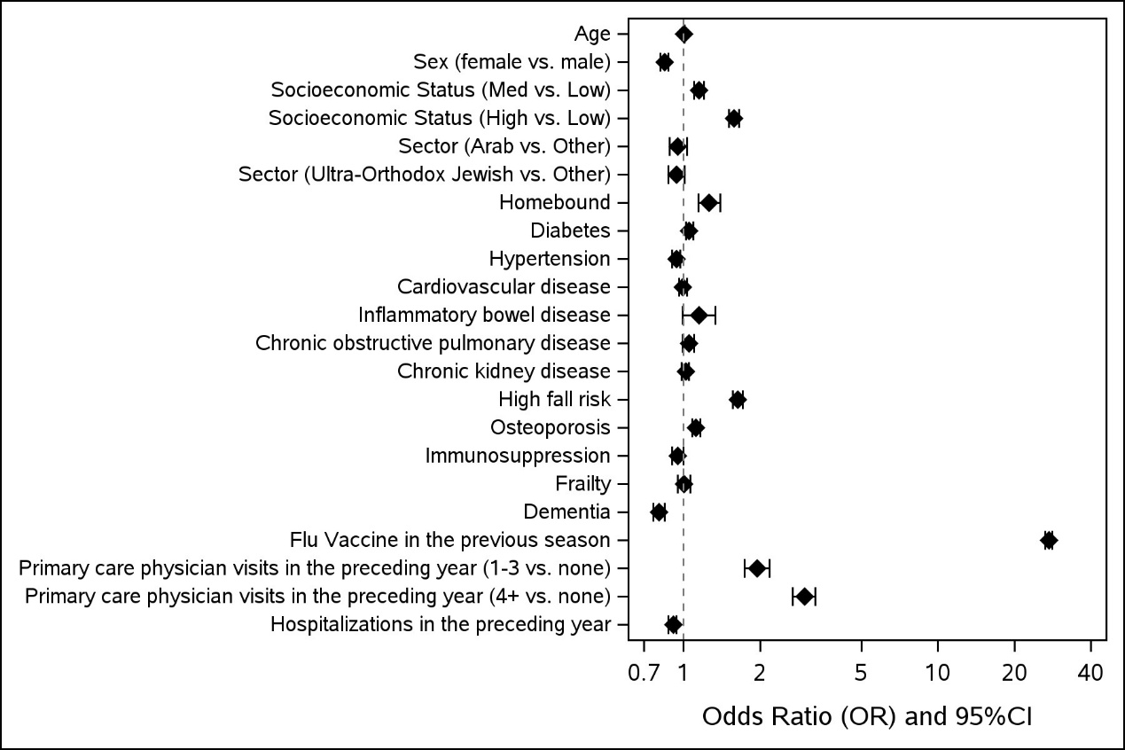

Figure S2- Fig 2b. Factors influencing influenza vaccine uptake among older adults aged 65 years and over with an affiliated spouse: Sensitivity Analysis Excluding Spousal Pairs (n=38,046 )
Forest plot showing odds ratios (OR) and 95% confidence intervals for factors associated with influenza vaccine uptake among adults with an affiliated spouse. The vertical line represents OR=1.

