Forest plots and funnel plots

Figure 4: Forest plot showing the change in Fasting Blood Glucose (FBG) levels in the Digital Health Intervention group compared to the control group
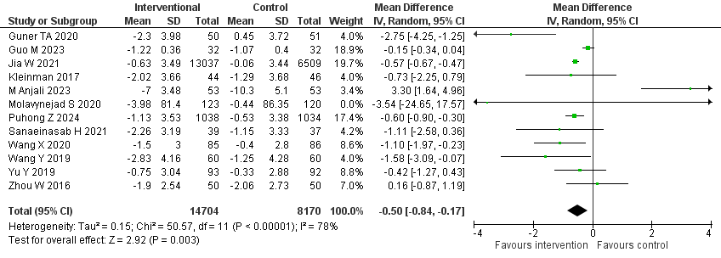

Figure 5: Forest plot showing the change in Body Mass Index (BMI) levels in the Digital Health Intervention group compared to the control group

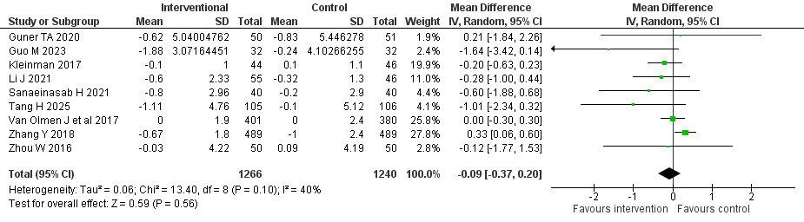

Figure 6: Forest plot showing the change in HDL levels in the Digital Health Intervention group compared to the control group

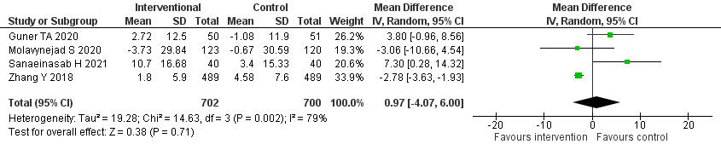
Figure 7: Forest plot showing the change in LDL levels in the Digital Health Intervention group compared to the control group

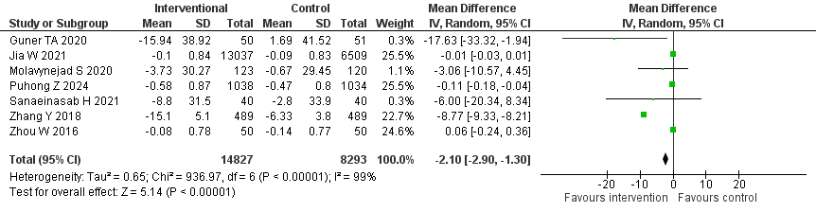

Figure 8: Forest plot showing the change in Triglyceride (TG) levels in the Digital Health Intervention group compared to the control group

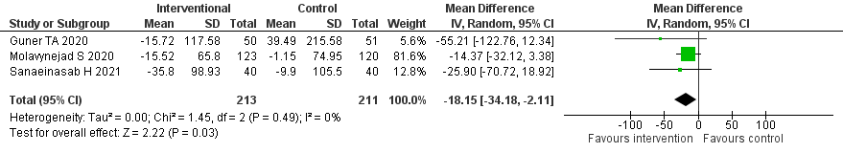

Figure 9: Forest plot showing the change in Total Cholesterol (TC) levels in the Digital Health Intervention group compared to the control group

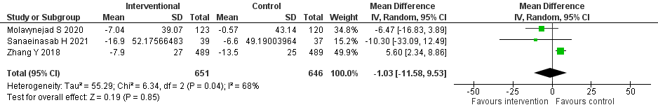

Figure 10: Forest plot showing the change in Blood Glucose Monitoring (BGM) in the Digital Health Intervention group compared to the control group

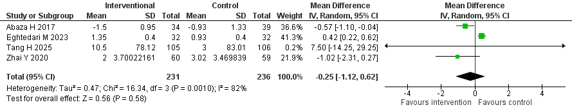

Figure 11: Forest plot showing the change in Physical Activity in the Digital Health Intervention group compared to the control group

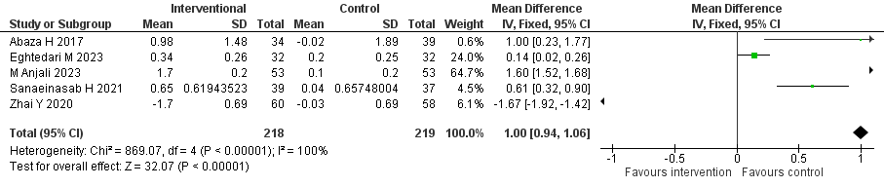

Figure 12: Forest plot showing the change in Medication Adherence in the Digital Health Intervention group compared to the control group

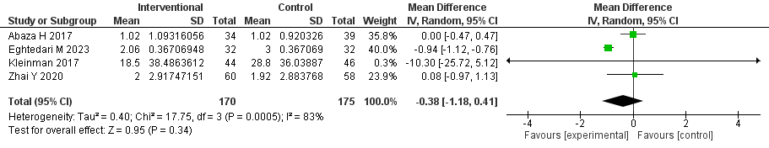

Funnel plots

Figure S1: Funnel plot showing the distribution of the studies on HbA1c as the outcome
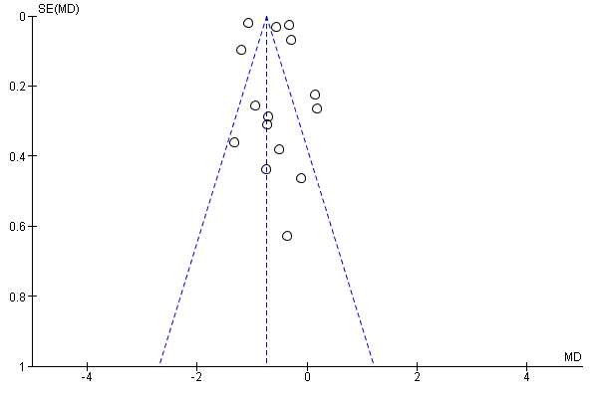

Figure S2: Funnel plot showing the distribution of the studies on FBG as the outcome
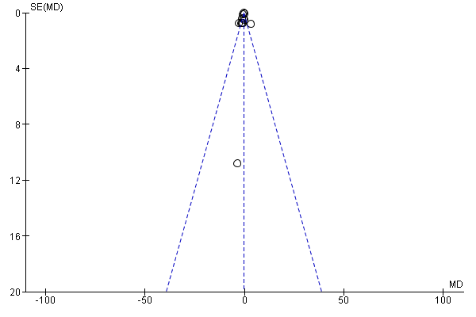

Figure S3: Funnel plot showing the distribution of the studies on BMI as the outcome
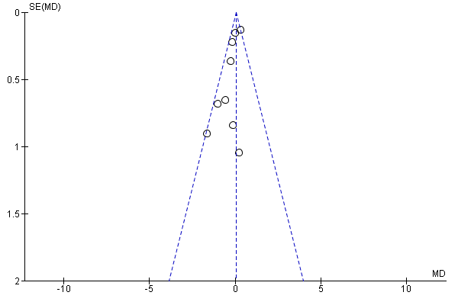

Figure S4: Funnel plot showing the distribution of the studies on HDL as the outcome
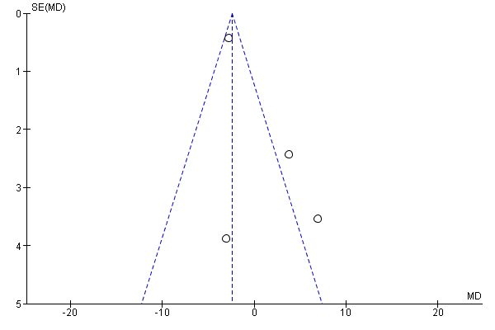

Figure S5: Funnel plot showing the distribution of the studies on LDL as the outcome

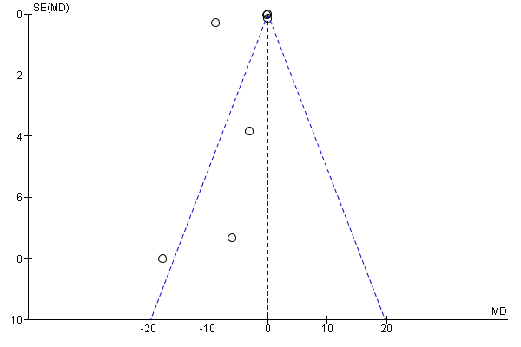

Figure S6: Funnel plot showing the distribution of the studies on TC as the outcome

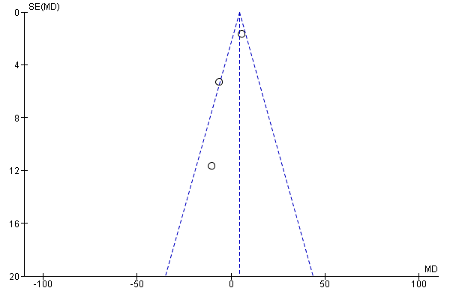

Figure S7: Funnel plot showing the distribution of the studies on TG as the outcome

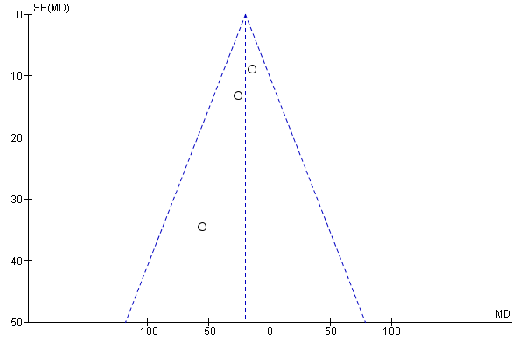

Figure S8: Funnel plot showing the distribution of the studies on BGM as the outcome

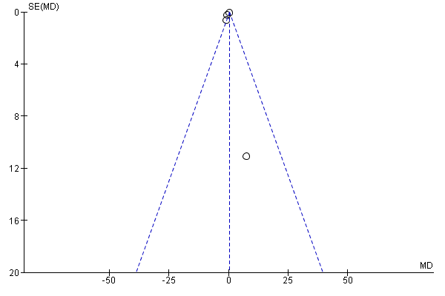

Figure S9: Funnel plot showing the distribution of the studies on Physical activity as the outcome

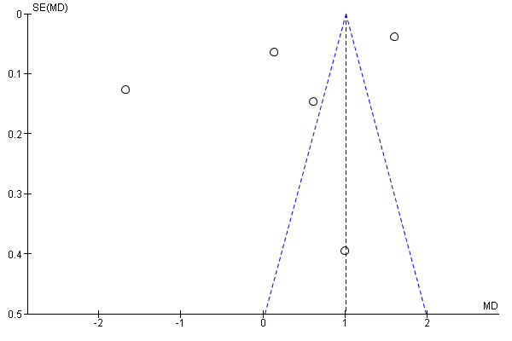

Figure S10: Funnel plot showing the distribution of the studies on Medication Adherence as the outcome
