The economic burden of road trauma injuries in Canada: A comparison of road user types

1. Data Description

Figure S1. Histogram of total costs.

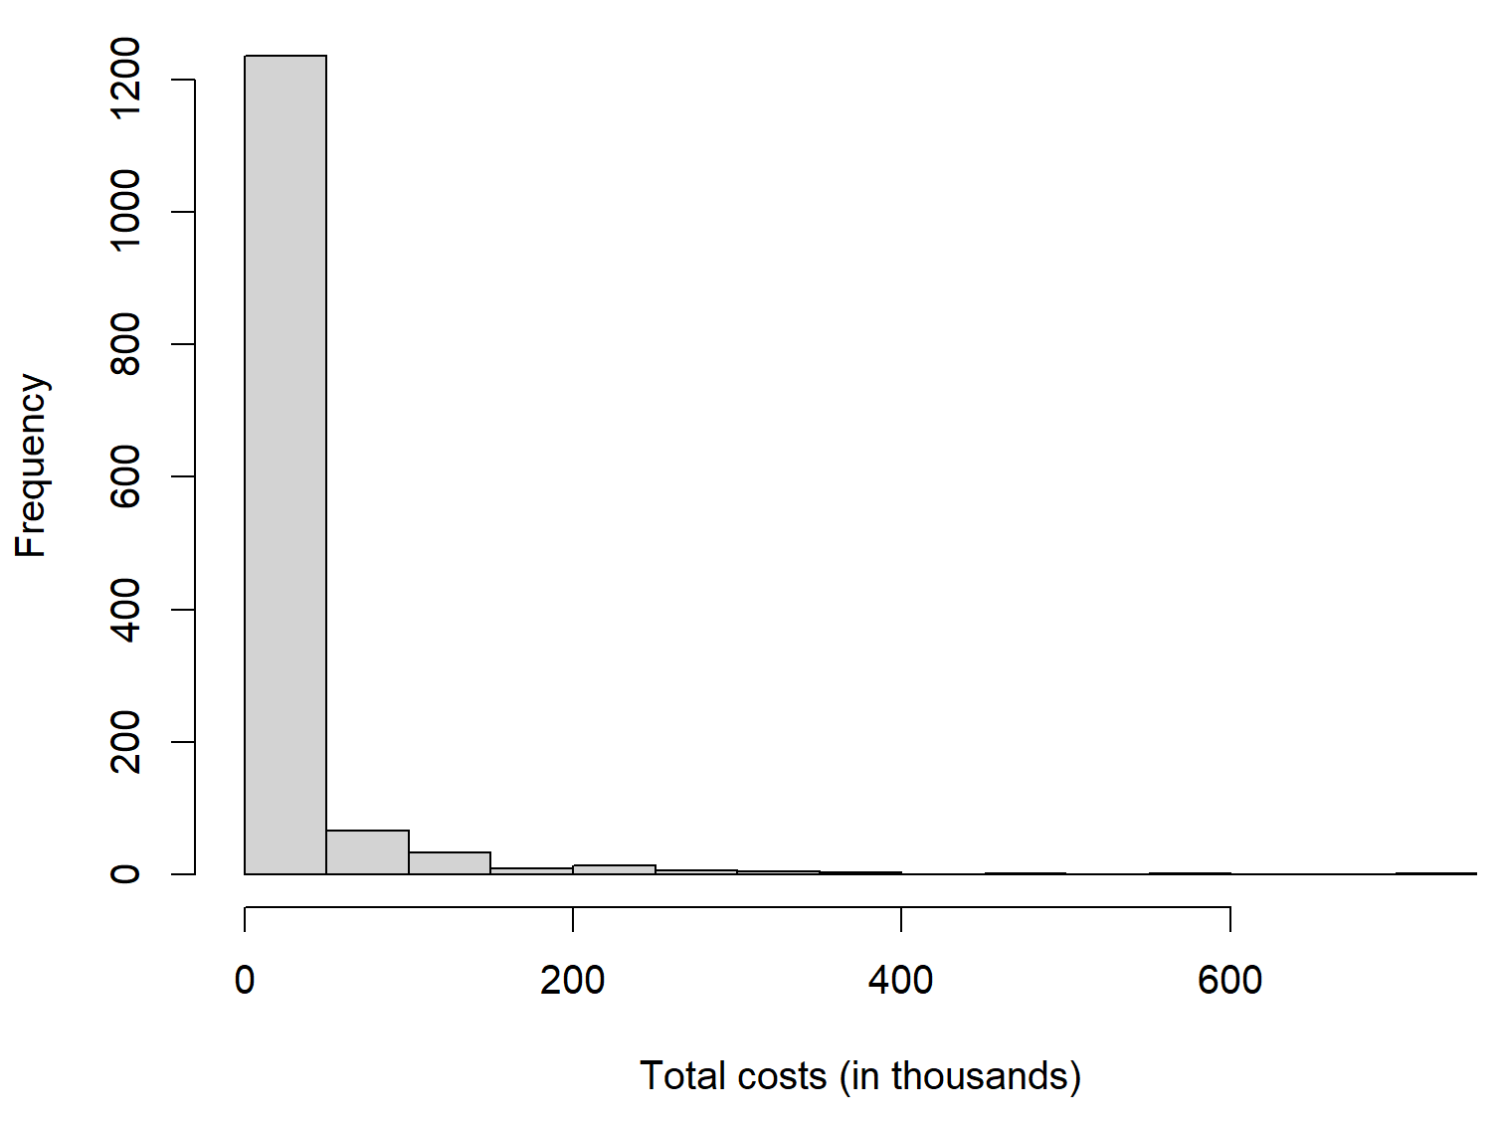

Table S1. The median and range values of costs by road user type, 2023 CAD dollar.

 | All Patients (n = 1372)
 | Driver (n = 629) |  | Passenger (n = 203) |  | Motorcyclist (n = 108) |  | Pedestrian (n = 265) |  | Cyclist (n = 167)
Type of costs | Median | Min-Max | Median | Min-Max | Median | Min-Max | Median | Min-Max | Median | Min-Max
Healthcare costs | 3142 | 209-579853 | 3506 | 245-491651 | 8503 | 198-317678 | 8478 | 250-699266 | 3091 | 198-379285
Productivity costs | 349 | 0-94964 | 168 | 0-39278 | 868 | 0-54837 | 124 | 0-77699 | 699 | 0-34261
Total costs | 6135 | 209-589066 | 5314 | 245-491651 | 12675 | 198-331705 | 11107 | 250-704160 | 7329 | 250-379285
 | Patients Discharged to Home (n = 1026)
 | Driver (n = 515) |  | Passenger (n = 162) |  | Motorcyclist (n = 62) |  | Pedestrian (n = 159) |  | Cyclist (n = 128)
Healthcare costs | 2531 | 209-81478 | 2286 | 245-244915 | 2936 | 198-16149 | 2844 | 250-135109 | 2374 | 198-178569
Productivity costs | 217 | 0-94964 | 70 | 0-39278 | 532 | 0-24280 | 255 | 0-77699 | 655 | 0-24856
Total costs | 4471 | 209-99078 | 4272 | 245-245363 | 4565 | 198-25588 | 4934 | 250-144306 | 5504 | 250-178569
 | Patients Admitted to Hospital (n = 344)
 | Driver (n = 113) |  | Passenger (n = 41) |  | Motorcyclist (n = 46) |  | Pedestrian (n = 105) |  | Cyclist (n = 39)
Healthcare costs | 34126 | 250-579853 | 29363 | 250-491651 | 28828 | 250-317678 | 26137 | 250-699266 | 15872 | 250-379285
Productivity costs | 1655 | 0-80491 | 2447 | 0-38106 | 1839 | 0-54837 | 0 | 0-42345 | 1168 | 0-34261
Total costs | 36768 | 250-589066 | 42273 | 4107-491651 | 34411 | 250-331705 | 34014 | 250-704160 | 19460 | 271-379285

2. Missingness
The percentage of missing data for baseline predictors is low (<3.9%), except for somatic symptoms (<5.6%) and GCS (<10.3%) among road user types. The missing values on the baseline covariates were imputed using the Markov chain Monte Carlo (MCMC) method. All baseline variables were considered in the imputation model. After conducting sensitivity analysis, the results using unimputed data were similar for drivers, pedestrians, and cyclists. However, the number of comorbidities lost its significance in the unimputed data among passengers, and both pain catastrophizing and the number of comorbidities lost their significance among motorcyclists (Supplementary Table S2).

Table S2. Results of multivariable generalized liner model on total costs following road trauma injury by road user types (unimputed data).

 |  | Driver (n = 557) | Passenger (n = 173) | Motorcyclist (n = 94) | Pedestrian (n = 236) | Cyclist (n = 145)
 |  | exp(β) (95% CI) | exp(β) (95% CI) | exp(β) (95% CI) | exp(β) (95% CI) | exp(β) (95% CI)
Age |  | − | − | − | 1.02 (1.01, 1.03)*** | −
Employment status (Ref: employed)
 | School | 0.43 (0.30, 0.65)*** | − | − | − | −
 | Retired/unemployed | 0.88 (0.67, 1.18) | − | − | − | −
Pain catastrophizing |  | − | − |  | − | −
Health-related quality of life (SF-12) |  | 0.98 (0.97,0.99)*** | − | − | − | −
Pre-injury comorbidities number |  | 1.16 (1.06, 1.28)** | 1.19 (0.97, 1.49) † | 1.14 (0.94, 1.42) † | 1.09 (0.96, 1.25)† | 1.19 (1.02,1.52)*
ISS |  | 1.08 (1.07, 1.10)*** | 1.08 (1.06, 1.12)*** | 1.09 (1.06, 1.13)*** | 1.07 (1.05, 1.10)*** | 1.06 (1.04, 1.10) ***
GCS |  | 0.86 (0.79, 0.93)*** | − | − | 0.91 (0.82, 1.01)† | −
† P<0.1 *P<0.05, **P<0.01, ***P<0.001
− Not selected
Ref: reference; SF-12: Short Form 12 survey; ISS: injury severity score; GCS: Glasgow Coma Scale.

