APPENDIX
Table A1. ANOVA for Emotional Loneliness (With Control Variables)
Source | SS | df | F | p
Age group | 5.67 | 1 | 16.11*** | < .001
Limitation status | 15.10 | 2 | 21.46*** | < .001
Gender | 1.78 | 1 | 5.06* | .024
Education | 15.93 | 2 | 22.65*** | < .001
Number of chronic conditions | 60.01 | 1 | 170.63*** | < .001
Age group × Limitation status | 0.84 | 2 | 1.19 | .303
Residuals | 1397.63 | 3974
Note. R² = .092, adjusted R² = .089. * p < .05, *** p < .001

Table A2. ANOVA for Social Loneliness (With Control Variables)
Source | SS | df | F | p
Age group | 6.16 | 1 | 17.49*** | < .001
Limitation status | 15.79 | 2 | 22.41*** | < .001
Gender | 47.60 | 1 | 135.12*** | < .001
Education | 0.26 | 2 | 0.37 | .694
Number of chronic conditions | 28.92 | 1 | 82.09*** | < .001
Age group × Limitation status | 3.81 | 2 | 5.41** | .004
Residuals | 1399.97 | 3974
Note. R² = .071, adjusted R² = .069. ** p < .01, *** p < .001

Figure A1. Emotional loneliness by 3 age groups and limitation status
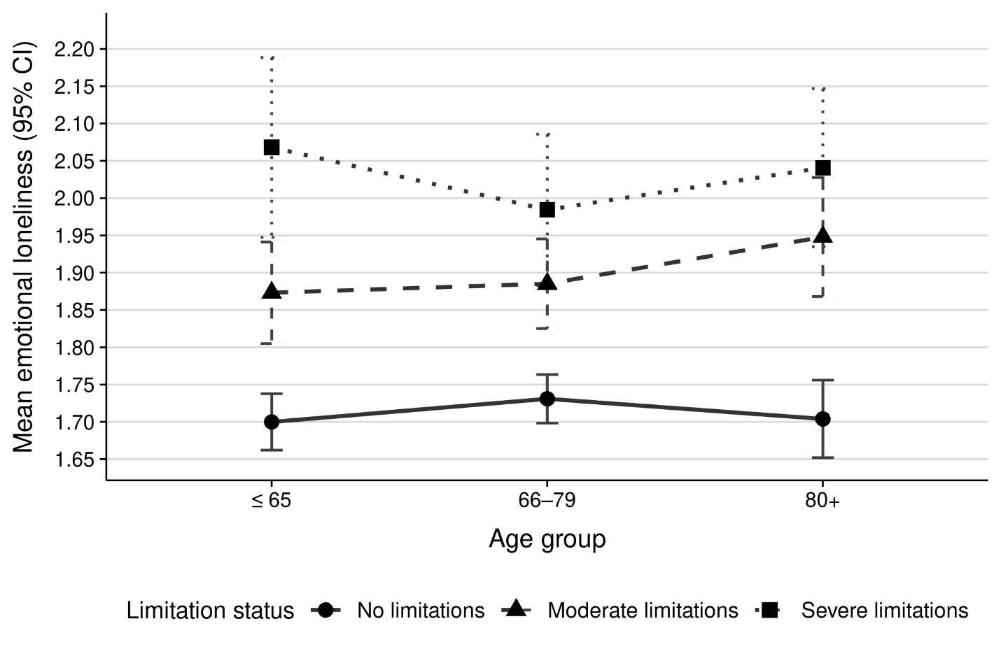
Figure A2. Social loneliness by 3 age groups and limitation status
