Supplmentary materials

Table S1 Proportional Hazards Assumption Test Results
Figure S1 Pollutant Exposure Patterns Identified via Trajectory Modeling (PM₁₀ and O₃)
Figure S2. Subgroup Analyses for Indoor Cooking Pollution and Incident sKOA
Figure S3. Subgroup Analyses for Indoor Healing Pollution and Incident sKOA

Table S1 Proportional Hazards Assumption Test Results
 | Chi-square | df | P-value
Cooking Pollution | 10.35 | 9 | 0.323
Heating Pollution | 9.07 | 9 | 0.431
Pollution Load | 9.62 | 10 | 0.474

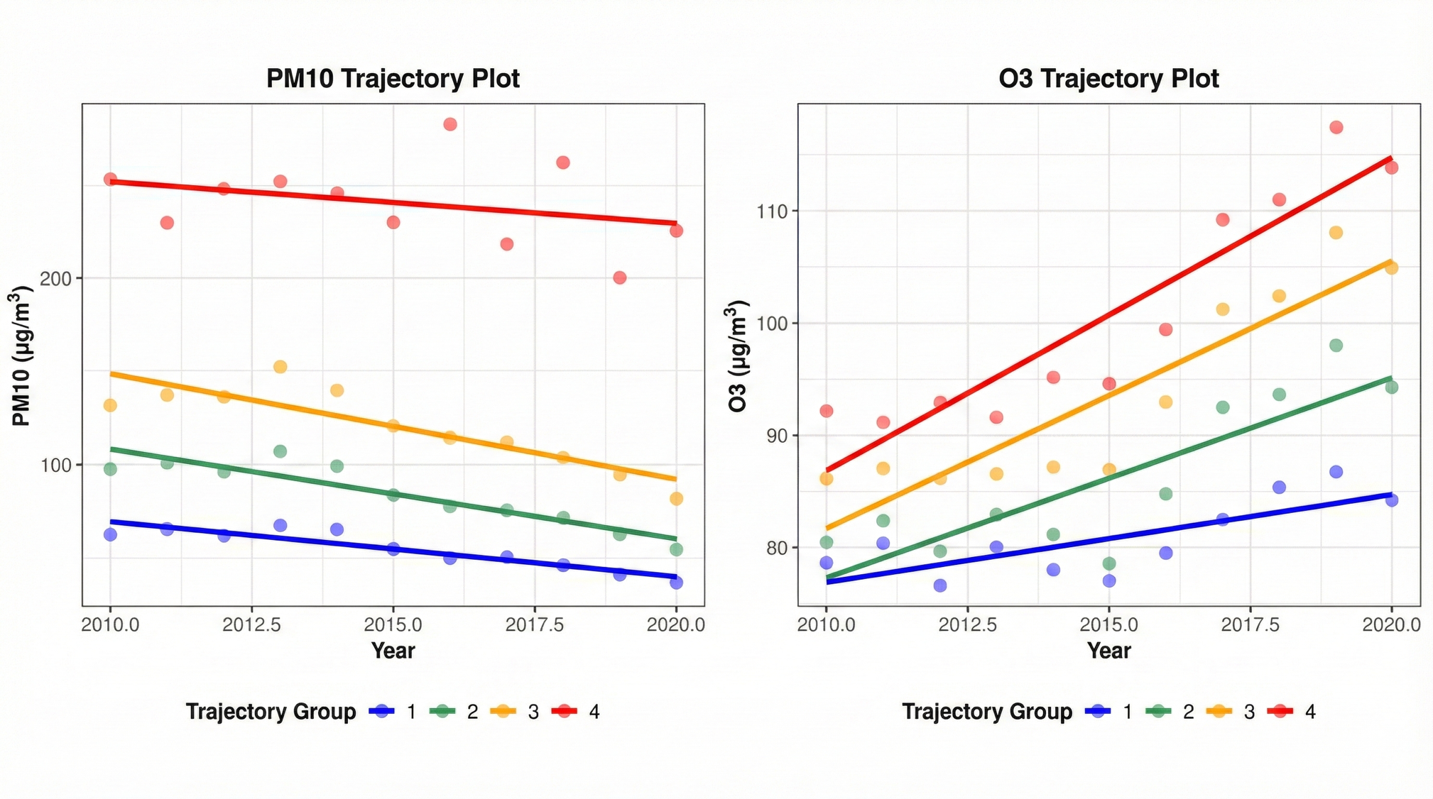
Figure S1 Pollutant Exposure Patterns Identified via Trajectory Modeling (PM₁₀ and O₃)

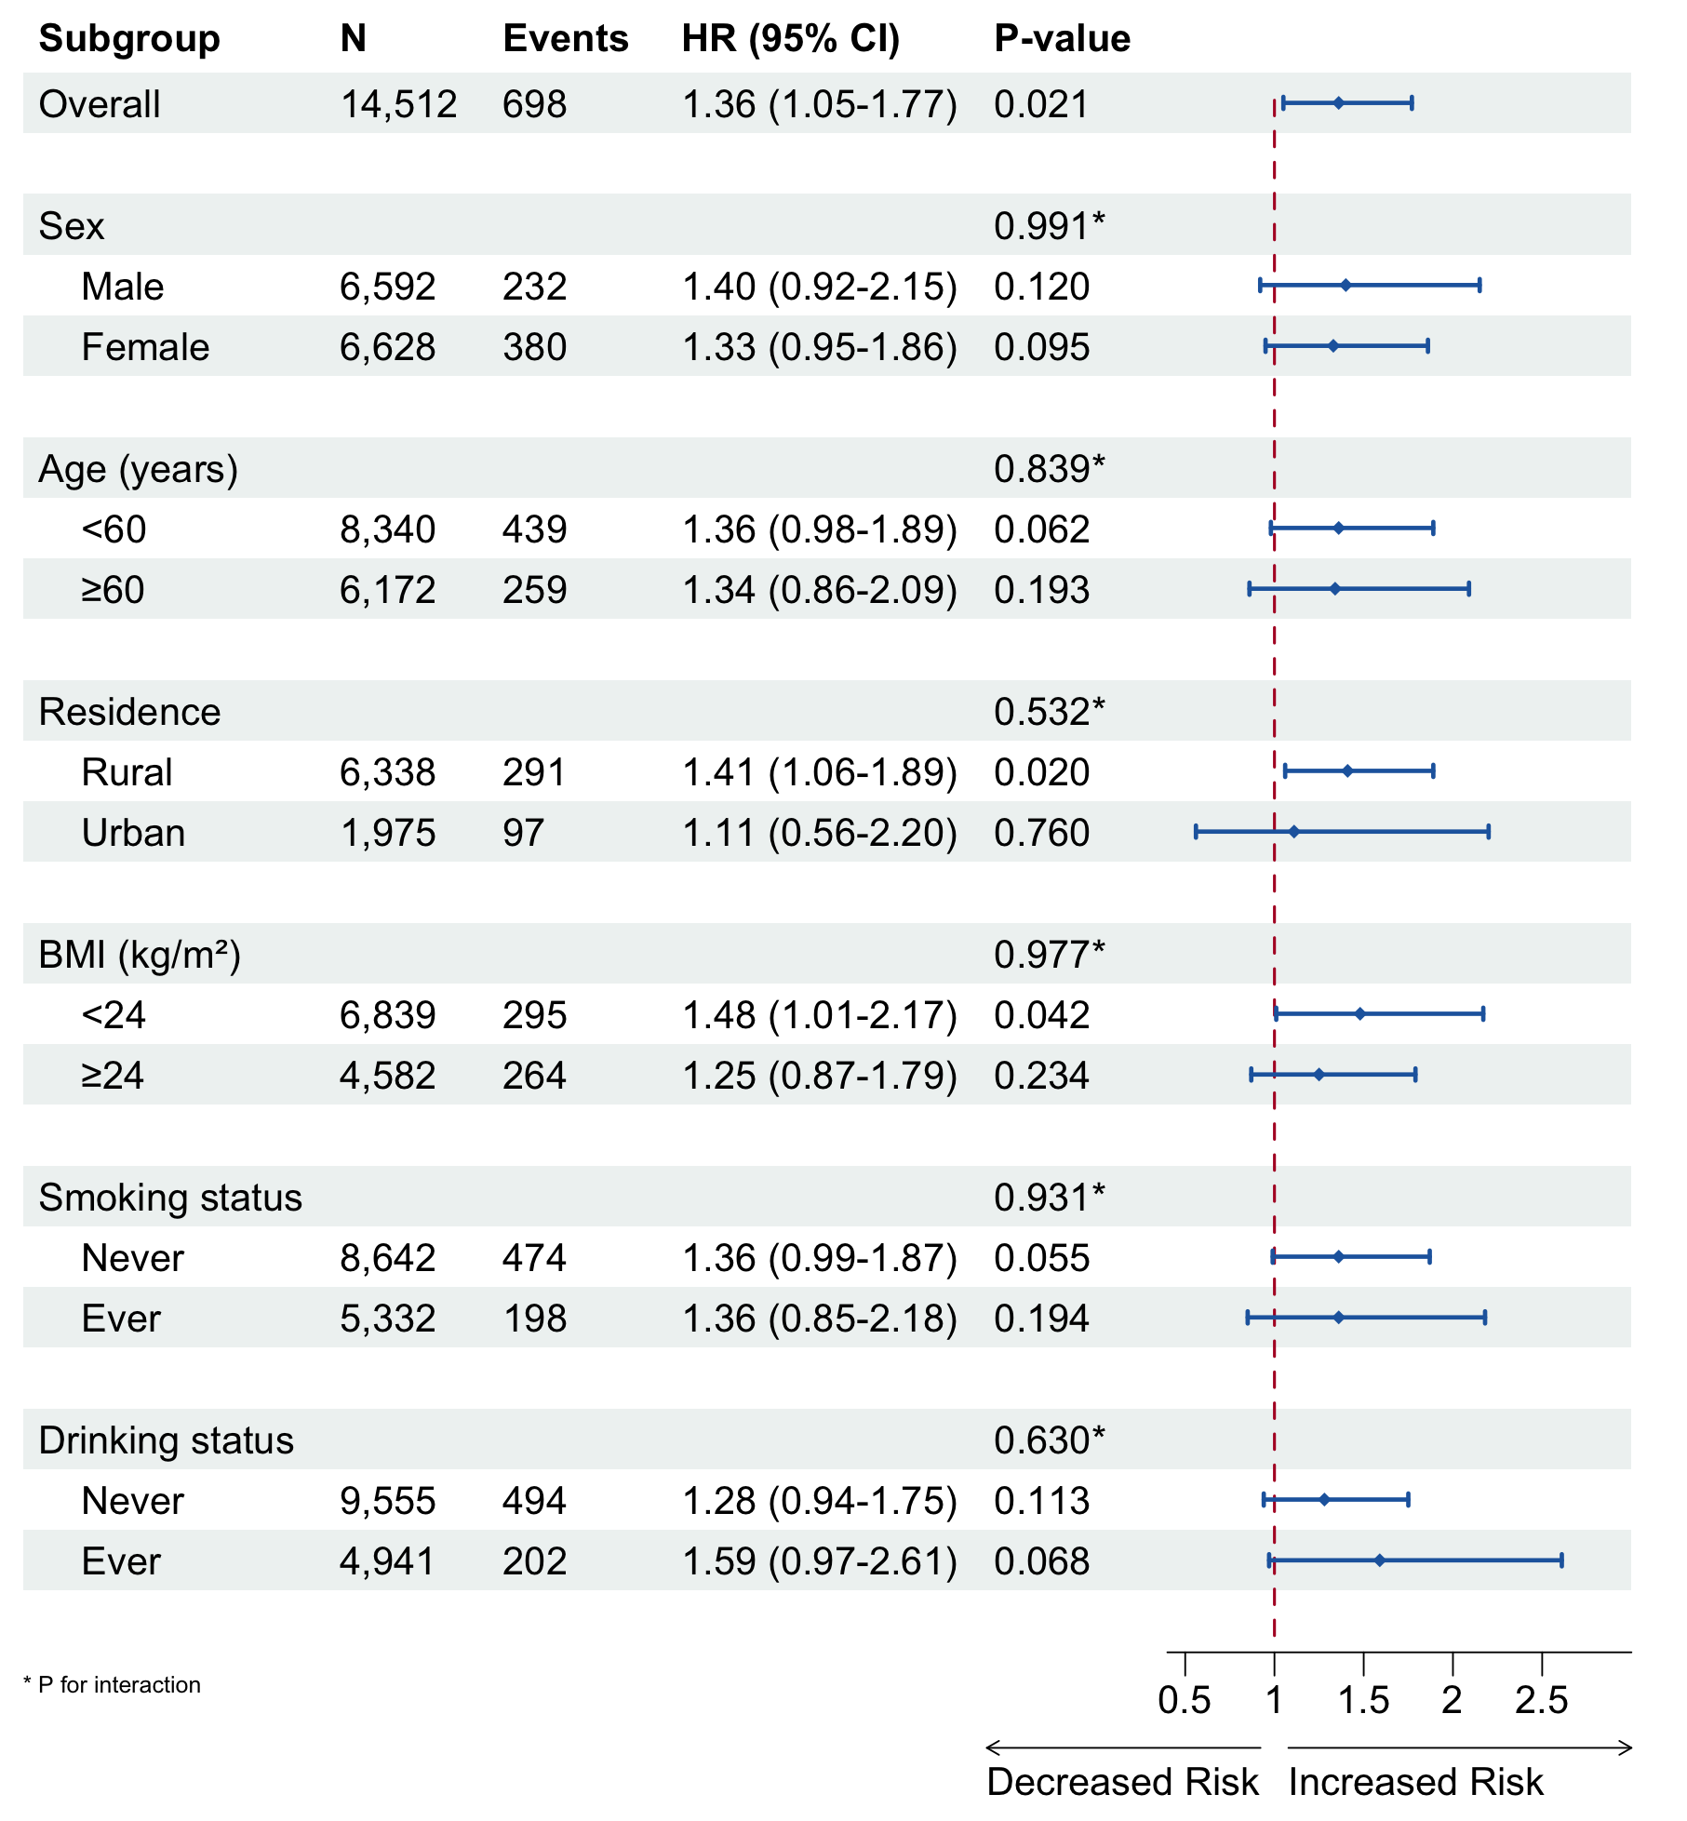
Figure S2. Subgroup Analyses for Indoor Cooking Pollution and Incident sKOA
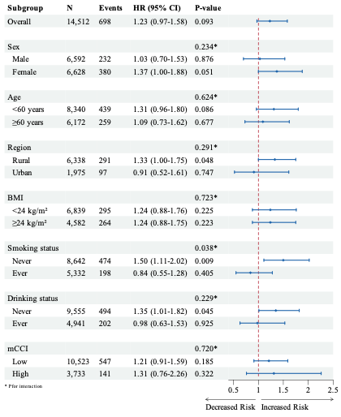
Figure S3. Subgroup Analyses for Indoor Healing Pollution and Incident sKOA

