Supplmentary materials

Table S1 Proportional Hazards Assumption Test Results
Table S2 Sensitivity Analyses for the Association Between Indoor Air Pollution and Incident sKOA
Figure S1 Pollutant Exposure Patterns Identified via Trajectory Modeling (PM10 and O3)
Figure S2. Subgroup Analyses for Indoor Cooking Pollution and Incident sKOA
Figure S3. Subgroup Analyses for Indoor Healing Pollution and Incident sKOA

Table S1 Proportional Hazards Assumption Test Results
 | Chi-square | df | P-value
Cooking Pollution | 10.35 | 9 | 0.323
Heating Pollution | 9.07 | 9 | 0.431
Pollution Load | 9.62 | 10 | 0.474

Figure S1 Pollutant Exposure Patterns Identified via Trajectory Modeling (PM10 and O3)
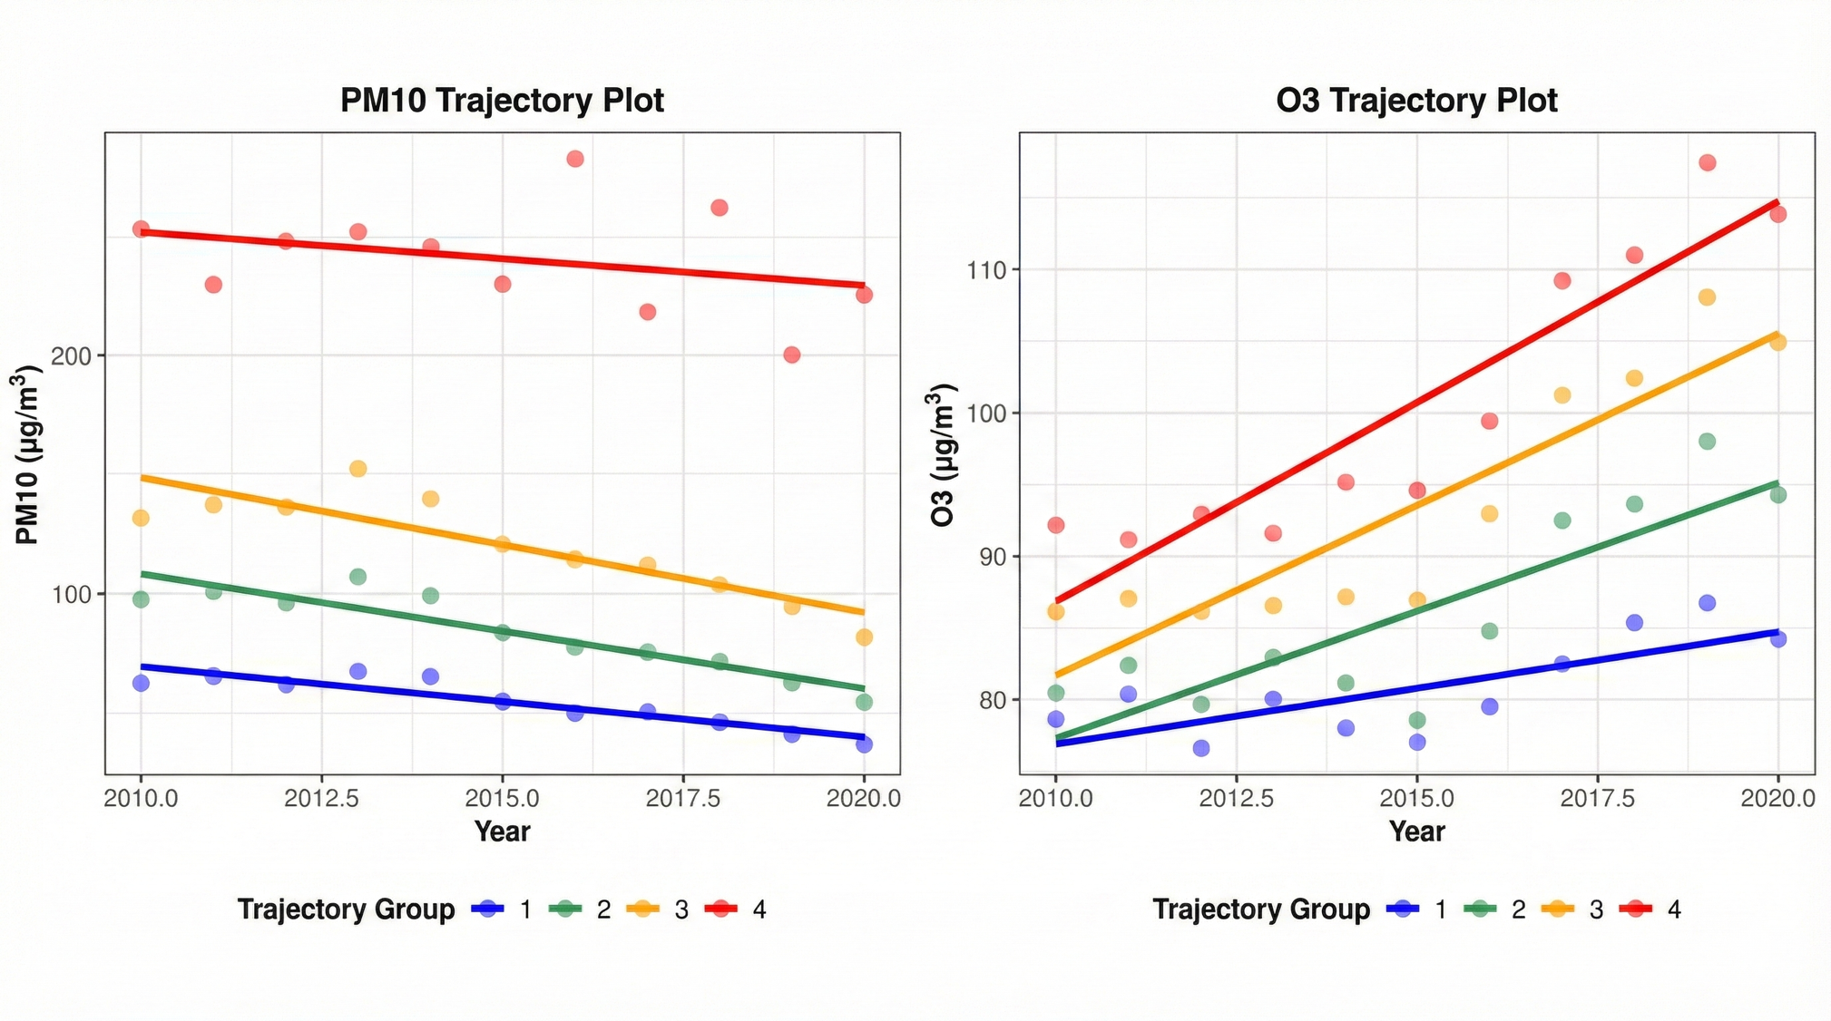

Figure S2. Subgroup Analyses for Indoor Cooking Pollution and Incident sKOA
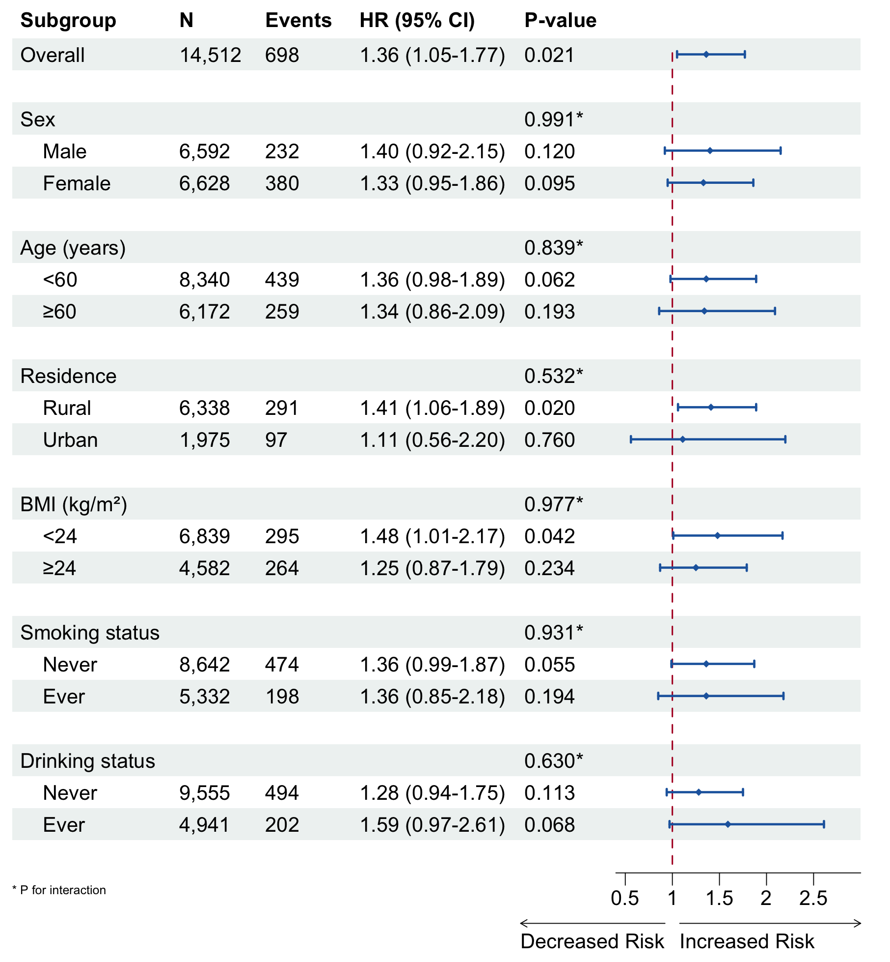

Figure S3. Subgroup Analyses for Indoor Healing Pollution and Incident sKOA
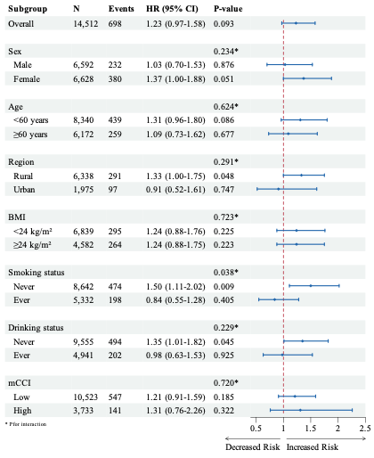

Table S2 Sensitivity Analyses for the Association Between Indoor Air Pollution and Incident sKOA
Exposure | Events | HR (95% CI) | P value
Additional adjustment for physical activity (MET, min/week)
Cooking pollution | – | 1.62 (1.09–2.42) | 0.017
Heating pollution | – | 1.43 (0.99–2.08) | 0.059
Pollution load (1 source) | – | 1.31 (0.80–2.16) | 0.288
Pollution load (2 sources) | – | 1.85 (1.15–2.97) | 0.012
Additional adjustment for agricultural work status
Cooking pollution | – | 1.37 (1.04–1.82) | 0.026
Heating pollution | – | 1.23 (0.95–1.60) | 0.116
Pollution load (2 sources) | – | 1.47 (1.05–2.05) | 0.025
Stratification by agricultural work status
Cooking pollution
Non-agricultural (n=6,418) | 264 | 1.47 (0.98–2.20) | 0.308†
Agricultural (n=6,256) | 329 | 1.28 (0.87–1.86)
Heating pollution
Non-agricultural (n=6,418) | 264 | 1.08 (0.74–1.57) | 0.508†
Agricultural (n=6,256) | 329 | 1.41 (0.97–2.05)
Pollution load (2 sources)
Non-agricultural (n=6,418) | 264 | 1.38 (0.86–2.22) | 0.170†
Agricultural (n=6,256) | 329 | 1.44 (0.90–2.32)
Abbreviations: HR, hazard ratio; CI, confidence interval; MET, metabolic equivalent of task; sKOA, symptomatic knee osteoarthritis. All models adjusted for age, sex, BMI, education, smoking, alcohol use, and region. – indicates Events column not applicable. †P interaction from multiplicative interaction terms in Cox regression models.

