Supplementary Materials (Table)
As shown in Supplementary Table S1, when total physical activity was treated linearly as a continuous variable (per 1,000 MET-min/w), it was not significantly associated with the risk of falls (P = 0.843). This lack of linear significance, contrasted with the significant findings in our primary categorical analysis, empirically demonstrates that the association between physical activity and falls is non-linear. Therefore, collapsing physical activity into LPA and MVPA is a more statistically appropriate and biologically plausible approach to capture the specific threshold effects of different activity levels.

Supplementary Table S1 Sensitivity analysis modeling total physical activity as a continuous variable
Variable | B | SE | Waldχ² | P-value | OR (95% CI)
Total physical activity (per 1,000 MET-min/w) | 0.001 | 0.006 | 0.039 | 0.834 | 1.001 (0.990-1.013)
Abbreviations OR Odds ratio, CI Confidence interval
Notes: Models were adjusted for age, gender, marital status, residence, education level, chronic disease history, smoking status, drinking status, napping behavior and sleep duration.

Supplementary Table S2 Multivariate logistic regression analysis of the interaction between physical activity and sleep duration on falls
Variable | B | SE | Waldχ² | P-value | OR (95% CI)
PA level (Ref: LPA)
MVPA | -0.227 | 0.089 | 6.525 | 0.011 | 0.797 (0.669–0.949)
Sleep duration (Ref: Short sleep, < 6 h)
Optimal (6-8 h) | -0.623 | 0.119 | 27.347 | < 0.001 | 0.536 (0.425–0.677)
Long (> 8 h) | -0.118 | 0.169 | 0.487 | 0.485 | 0.889 (0.639–1.237)
Interaction Terms (PA × Sleep duration)
MVPA by Optimal sleep | 0.205 | 0.133 | 2.385 | 0.123 | 1.227 (0.946–1.592)
MVPA by Long sleep | -0.228 | 0.199 | 1.310 | 0.252 | 0.796 (0.538–1.177)
Overall Interaction Test |  |  | 5.164 | 0.076
Abbreviations OR Odds ratio, CI Confidence interval, Ref Reference group, PA Physical activity, LPA Light physical activity, MVPA Moderate-vigorous physical activity
Notes: Models were adjusted for age, gender, marital status, residence, education level, chronic disease history, smoking status, drinking status, and napping behavior.
Supplementary Materials (Fig)
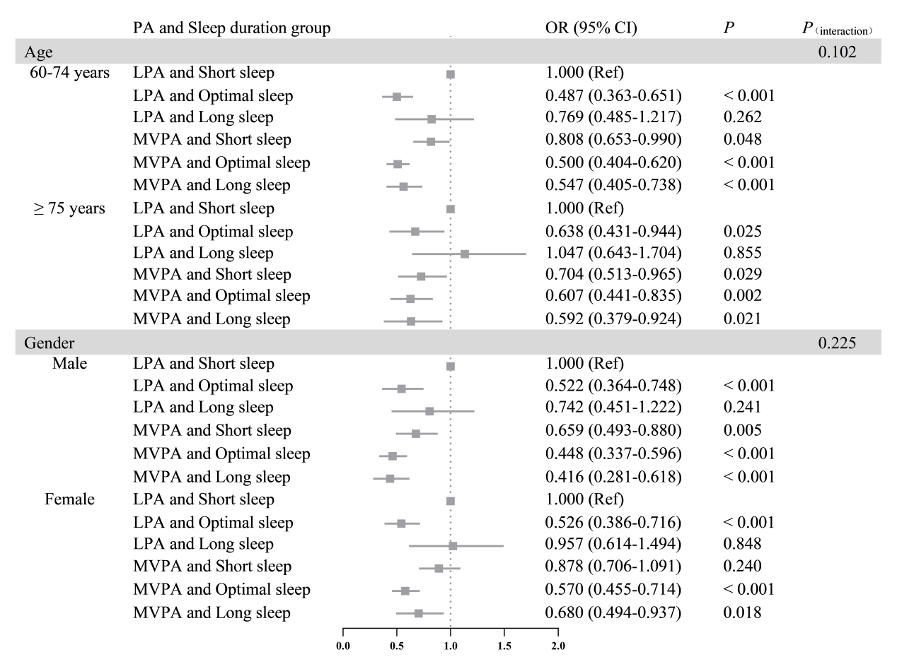
Abbreviations OR Odds ratio, CI Confidence interval, Ref Reference group, PA Physical activity, LPA Light physical activity, MVPA Moderate-vigorous physical activity
Notes: Models were adjusted for age, gender, marital status, residence, education level, chronic disease history, smoking status, drinking status, and napping behavior.
Supplementary Fig S1 Subgroup analysis of the joint associations of physical activity and sleep duration with falls, stratified by age and gender

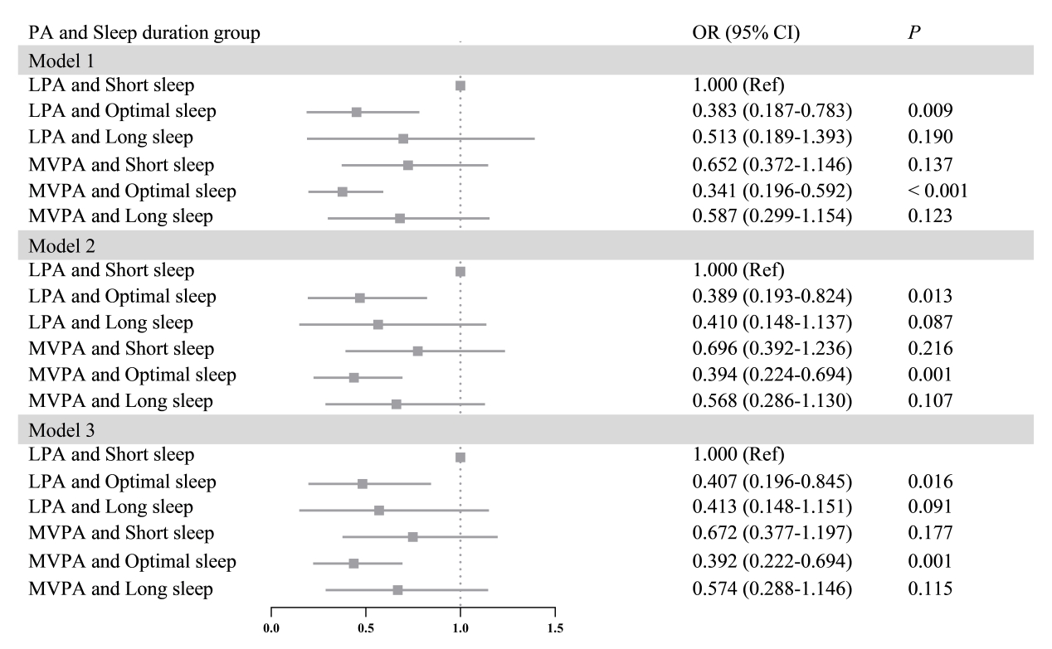
Abbreviations OR Odds ratio, CI Confidence interval, Ref Reference group, PA Physical activity, LPA Light physical activity, MVPA Moderate-vigorous physical activity
Notes: Model 1was unadjusted for any confounding factors; Model 2 was adjusted for age, gender, marital status, education level, and residence; Model 3 was further adjusted for chronic disease history, drinking status, smoking status, and napping on the basis of Model 2.
Supplementary Fig S2 Sensitivity analysis of the joint associations of physical activity and sleep duration with falls

