CDC’s Social Vulnerability Index Map
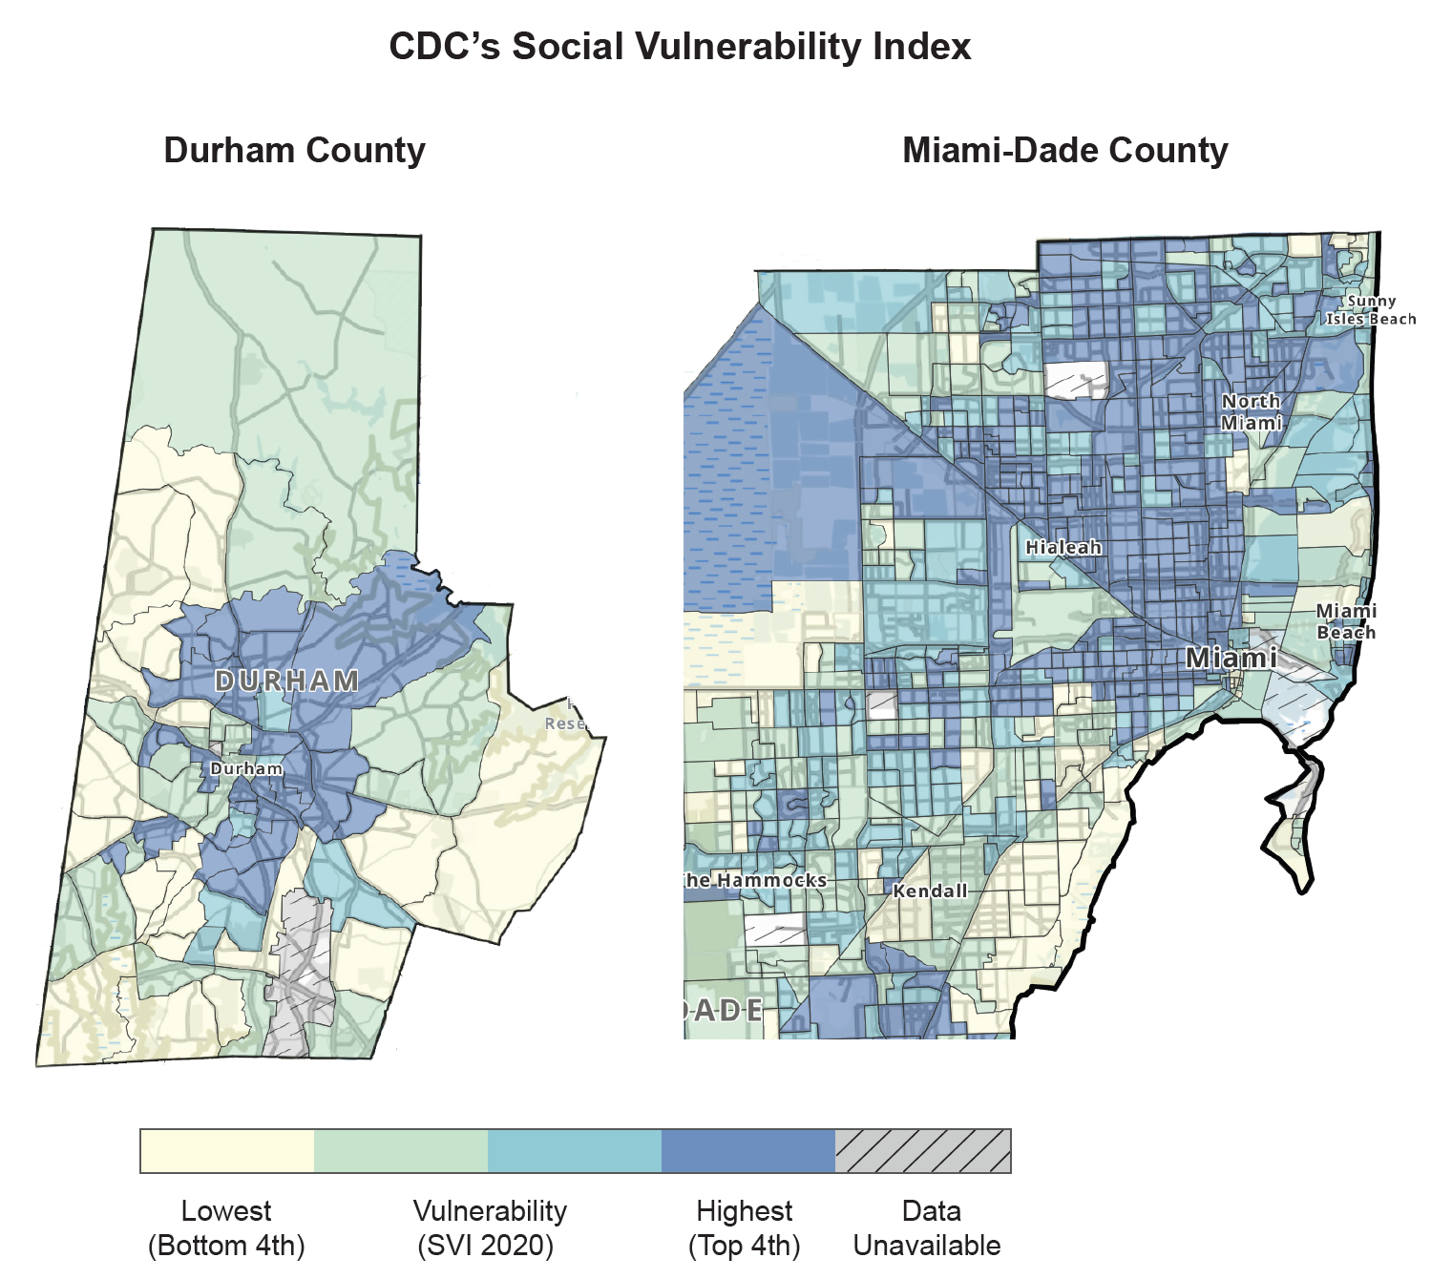

Source: Centers for Disease Control and Prevention; Agency for Toxic Substances and Disease Registry; Geospatial Research, Analysis, and Services Program. CDC/ATSDR Social Vulnerability Index 2020 Database U.S. Available at: https://www.atsdr.cdc.gov/placeandhealth/svi/data_documentation_download.html.

