Supplementary Table 1 Baseline characteristics of 109018 participants according to the cancer.
 | Non-Cancer | Cancer | p-value
N | 106903 | 2115
Age | 71.57 ± 6.94 | 73.83 ± 6.95 | <0.001
Height | 158.83 ± 8.41 | 160.57 ± 8.18 | <0.001
Sex (Female) | 57818 (54.08%) | 899 (42.51%) | <0.001
Education (High school or above) | 13500 (12.63%) | 233 (11.02%) | 0.027
Employment (Ever employment) | 55890 (52.28%) | 1045 (49.41%) | 0.009
Family history of cancer | 515 (0.48%) | 14 (0.66%) | 0.238
Hypertension | 57651 (53.93%) | 1120 (52.96%) | 0.374
Diabetes | 21141 (19.78%) | 425 (20.09%) | 0.716
CVD | 5260 (4.92%) | 131 (6.19%) | 0.007
BMI (18.5–24.9 kg/m²) | 48351 (45.23%) | 839 (39.67%) | <0.001
Exercise (Adequate) | 52430 (49.04%) | 793 (37.49%) | <0.001
Diet (Healthy) | 48573 (45.44%) | 700 (33.10%) | <0.001
Smoke (Current nonsmoking) | 86425 (80.84%) | 1590 (75.18%) | <0.001
Drink (Low-to-moderate) | 93730 (87.68%) | 1797 (84.96%) | <0.001
Healthy lifestyle score |  |  | <0.001
0-2 | 29097 (27.22%) | 874 (41.32%)
3 | 39219 (36.69%) | 755 (35.70%)
4 | 30230 (28.28%) | 400 (18.91%)
5 | 8357 (7.82%) | 86 (4.07%)
CVD：cardiovascular disease；BMI：body mass index.

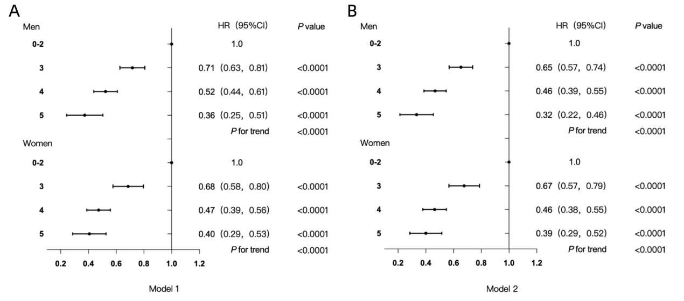
Supplementary Figure 1. Association between the healthy lifestyle score and cancer risk in male and female individuals. Dots represent hazard ratios (HRs), and horizontal bars represent 95% confidence intervals (CIs). The upper panel represents male participants, and the lower panel represents female participants. A:Model 1: included no covariate adjustments; B:Model 2: adjusted for age, employment, education, family history of cancer, hypertension, diabetes and cardiovascular disease.

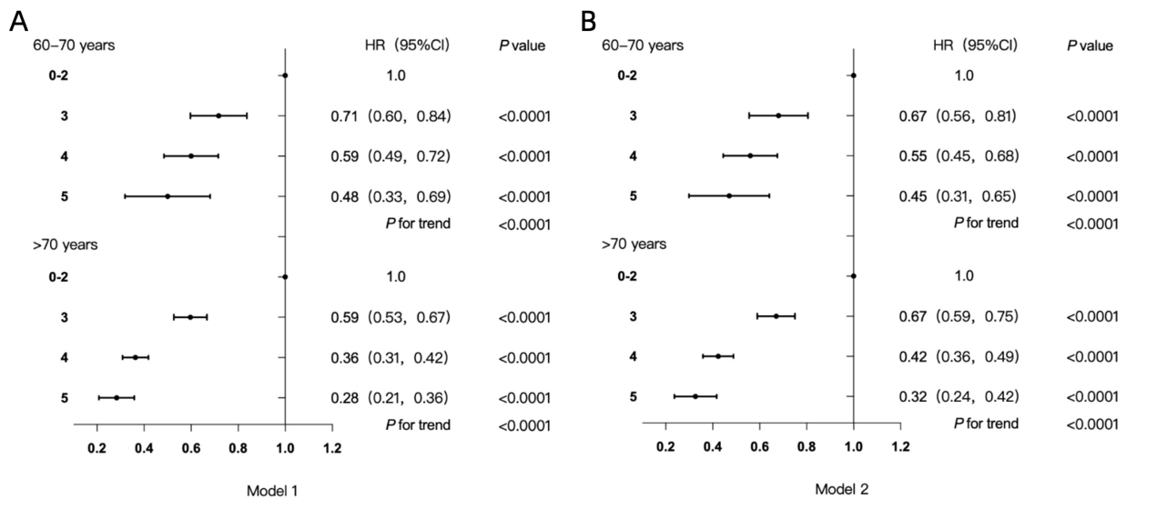
Supplementary Figure 2. Association between the healthy lifestyle score and cancer risk in 60-70 years and >70years individuals. Dots represent hazard ratios (HRs), and horizontal bars represent 95% confidence intervals (CIs). The upper panel represents participants aged 60–70 years, and the lower panel represents participants aged >70 years. A:Model 1: included no covariate adjustments; B:Model 2: adjusted for sex, empolyment, education, family history of cancer, hypertension, diabetes and cardiovascular disease.

Supplementary Table 2. Association between healthy lifestyle score and cancer risk, stratified by diabetes and hypertension status

 | Model 1 (HR, 95%CI, p) | Model 2 (HR, 95%CI, p)
healthy lifestyle score | without diabetes | without hypertension
0-2 | 1.0 | 1.0
3 | 0.67 (0.60, 0.75) <0.0001 | 0.71 (0.61, 0.82) <0.0001
4 | 0.46 (0.40, 0.52) <0.0001 | 0.53 (0.44, 0.63) <0.0001
5 | 0.36 (0.28, 0.46) <0.0001 | 0.47 (0.34, 0.66) <0.0001
p for trend | <0.001 | <0.001
healthy lifestyle score | with diabetes | with hypertension
0-2 | 1.0 | 1.0
3 | 0.69 (0.54, 0.87) 0.0015 | 0.64 (0.55, 0.73) <0.0001
4 | 0.49 (0.38, 0.64) <0.0001 | 0.42 (0.35, 0.49) <0.0001
5 | 0.40 (0.25, 0.62) <0.0001 | 0.30 (0.22, 0.41) <0.0001
p for trend | <0.001 | <0.001

Cox proportional-hazards models
Model 1: Association between the healthy lifestyle score and cancer risk in participants with and without diabetes，model adjusted for age, sex, employment, education, family history of cancer, hypertension and cardiovascular disease.
Model 2: Association between the healthy lifestyle score and cancer risk in participants with and without hypertension，model adjusted for age, sex, empolyment, education, family history of cancer, diabetes and cardiovascular disease.

