Private garden exposure and public park access in relation to type-2 diabetes incidence: a UK Biobank cohort study
Chinonso Christian Odebeatu*,ª Darsy Darssan,ª Charlotte Roscoe,^{b,c,d} Simon Reid,ª , Nicholas J Osborne*,^{a,e,f}

ª School of Public Health, Faculty of Health, Medicine and Behavioural Science, The University of Queensland, Herston, Brisbane, Australia.
^{b} Department of Environmental Health, Harvard T.H Chan School of Public Health, Channing Division of Network Medicine, Boston, MA, USA
^{c} Division of Population Sciences, Dana-Farber Cancer Institute, Boston, MA, USA
^{d} Environmental Systems and Human Health, Oregon Health & Science University Portland State University OHSU-PSU School of Public Health, Portland, OR, USA
^{e} European Centre for Environment and Human Health, University of Exeter, Truro, UK
^{f} School of Population Health, University of New South Wales, Sydney, New South Wales, Australia

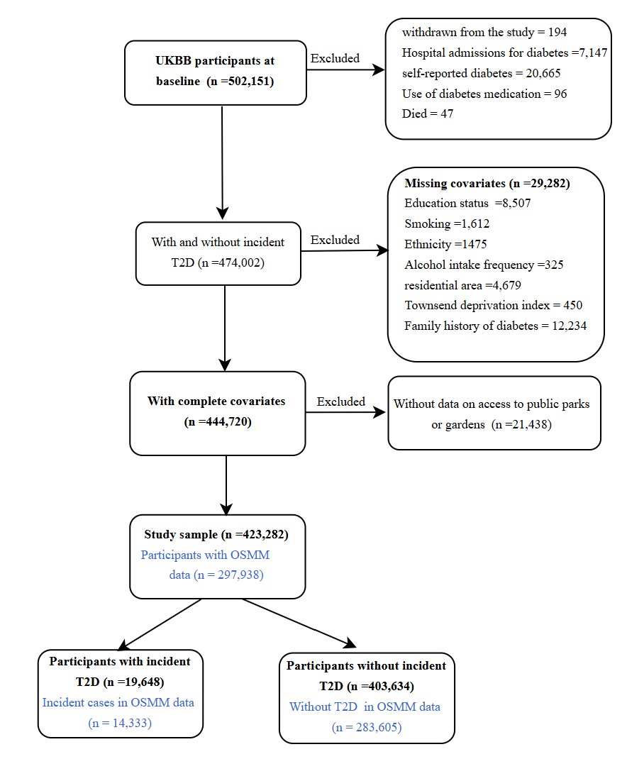
Figure S1. Study flow chart. T2D: type-2 diabetes; OSMM: Ordnance Survey MasterMapTM.

Table S1. Description of Ordnance Survey MasterMapTM Greenspace categories. Adapted from the Ordnance Survey (OS) MasterMapTM Greenspace Layer – Technical Specification. https://www.ordnancesurvey.co.uk/xml/codelists/GreenspaceFunctionValue.xml
S/N | Types of greenspaces | Detailed description
1. | Public Park or Garden | Areas of land that are usually constructed, designed, managed, and maintained as public parks or gardens. These spaces are primarily located in urban settings with defined boundaries and are freely accessible to the public. They may feature managed facilities such as benches and flowerbeds. Usage is generally unrestricted, allowing visitors to move beyond designed paths or tracks.
2. | Private Garden | Privately enclosed land areas associated with residential properties and designated for use by the occupants.
3. | Woodlands | Land areas densely populated with trees, spanning more than 0.1 hectares and exceeding 5 meters in width.
3 | Golf Course | A large area of land designed for playing golf.
4. | Allotments or Community Growing Spaces | Land area designated for growing fruits, vegetables, and other plants for personal use or community engagement. The produce from the land is primarily intended for subsistence rather than commercial purposes.
5. | Amenity – Residential or Business | Landscape areas providing visual amenities or separating different buildings or land uses for environmental, visual, or safety reasons. Where the area is better described by another category this will be used in preference (for example, playing field, public park, play space).
6. | Land Use Changing | Land areas undergoing construction, development, or designated for future development.
7. | Cemetery | Land areas designed for burials or crematoriums.
8. | Institutional grounds | Enclosed land areas linked to institutions, with access that may be restricted or designated for private use. These include universities, hospitals, care homes, prisons, military sites, museums, zoos, and theatres.
9. | Religious Grounds | Land areas associated with churches and other religious institutions.
10. | Bowling Green | Land area specially prepared for playing bowls.
11. | School Grounds | Enclosed land areas that are associated with a school and reserved for their use.
12. | Tennis Court | Land areas specially prepared for playing tennis.
13. | Playing Field | Large, flat areas of grass or specially designed surfaces, typically with marked pitches, and primarily used for outdoor sports such as football, rugby, or cricket.
14. | Play Space | A land area specifically designed for children’s play, which may be connected to residential areas or parks and equipped with purpose-built play equipment. It does not include lands within schools or those for paid tourist attractions.
15. | Camping or Caravan Park | A land area designated for tents or caravans intended for temporary use by holidaymakers.
16. | Natural | Land use areas with no other greenspace function but with form attribute of woodland, open semi-natural, open water, beach or foreshore.
17. | Other Sport Facility | Land used for other sports not explicitly described by other categories. It includes facilities for sports spectating and participation (stadium).
18. | Amenity - Transport | Landscaped areas providing visual amenity or separating different buildings or land uses for environmental, visual, or safety reasons when related to a transport function, such as a road or within a transport hub.

Table S2. Various types of relevant highways and their usage. (© OpenStreetMap https://www.openstreetmap.org/copyright)
 | Type of highway | Usage
1. | Path | Used mainly for walking.
2. | Pedestrian | Used mainly for pedestrians in shopping and some residential areas which may allow access to motorized vehicles only for very limited periods of the day.
3. | Footway | For designated footpaths, i.e., mainly/exclusively for pedestrians. This includes walking tracks and gravel paths.
4. | Residential | Roads that serve as an access to housing, without function of connecting settlements. Often lined with housing.
5. | Living-street | For living streets, which are residential streets where pedestrians have legal priority over cars, speed are kept very low.
6. | Road | A road/way/street/motorway/etc. of unknown type. It can stand for anything ranging from a footpath to a motorway.
7. | Trunk | The most important roads in a country’s system that aren’t motorways.
8. | Primary | The next most important roads in a country’s system. (often link larger towns)
9. | Secondary | The next most important roads in a country’s system. (often link towns)
10. | Tertiary | The next most important roads in a country’s system. (often link smaller towns and villages)
11. | Trunk_link | The link roads (slip roads/ramps) leading to/from a trunk road or lower class highway
12. | Primary_link | The link roads (slip roads/ramps) leading to/from a primary road or lower class highway
13. | Secondary_link | The link roads (slip roads/ramps) leading to/from a secondary road or lower class highway
14. | Tertiary_link | The link roads (slip roads/ramps) leading to/from a tertiary road or lower class highway
15. | Unclassified | The least important through roads in a country’s minor road of a lower classification than tertiary, but which serve a purpose other than access to properties.
16. | Bridleway | For horse riders. Pedestrians are usually permitted; cyclists may be permitted depending on local rules/laws.
17. | Steps | For flights of steps on footways
18. | Sidewalk | Sidewalk that runs typically along residential roads.
19. | Traffic island | The way between two crossings, safe spot for pedestrians
20. | Crossing | Crosswalk that connects two sidewalks on the opposite side of the road.
21. | Cycleway | Designated for cyclists.

Table S3. Description of Ordnance Survey (OS) Open Greenspace classifications. Adapted from the Ordnance Survey (OS) Open Greenspace Technical Specification. https://docs.os.uk/os-downloads/products/land-and-terrain-portfolio/os-open-greenspace/os-open-greenspace-technical-specification/code-lists/functionvalue
S/N | Types of greenspaces | Detailed description
1. | Public Park or Garden | Land areas that are designed, constructed, managed, and maintained as a public park or garden. These normally have a defined perimeter and free public access, and generally sit within or close to urban areas. Access is granted for a wide range of uses and is not usually restricted to paths or tracks within the area. May include areas with managed facilities, such as benches and flowerbeds, and more natural areas.
2. | Religious Grounds | Land areas associated with churches and other places of worship. These lands are only included where there are significant areas of greenspace (over 500 m² of natural space – identified as surfaces that are not manmade, such as grass, woodland, and bare earth).

OS Open Greenspace comprises ten classifications: public parks or gardens, allotments or community growing spaces, bowling greens, cemeteries, religious grounds, golf courses, other sports facilities, play spaces, playing fields, and tennis courts. With the exception of public parks or gardens and religious grounds, which are described in detail within OS Open Greenspace as shown in Table S3, all other classifications have similar or identical descriptions to those presented in Table S1.

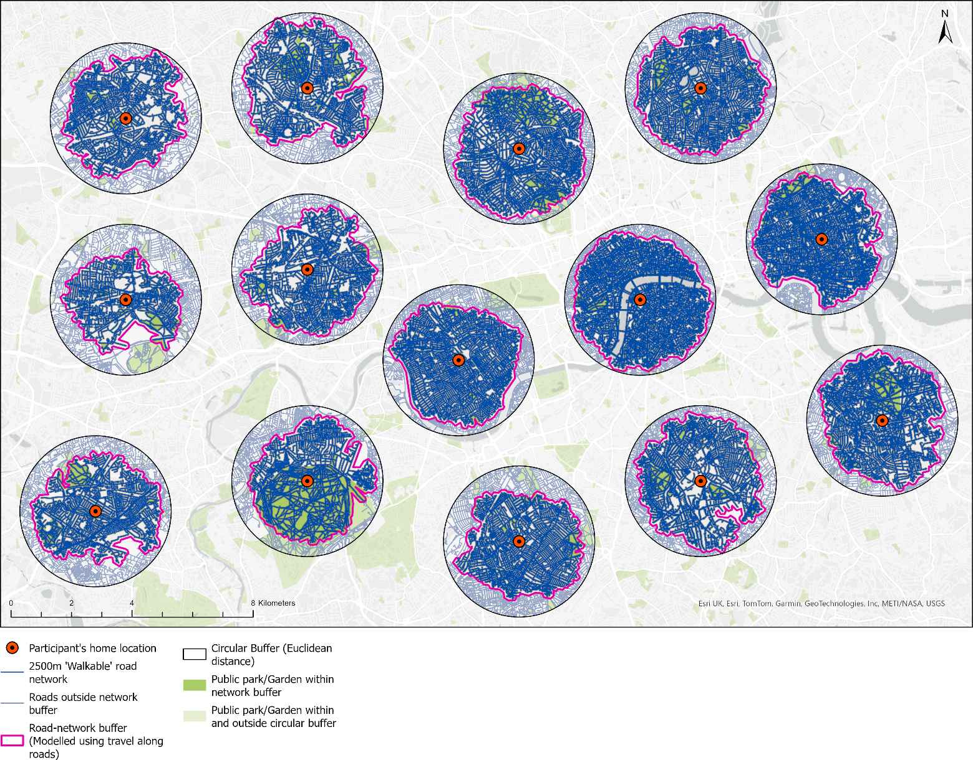

Figure S2. Spatial map displaying how the walkable road network route was constrained to a spatial extent around each participant's home locations for computational efficiency.

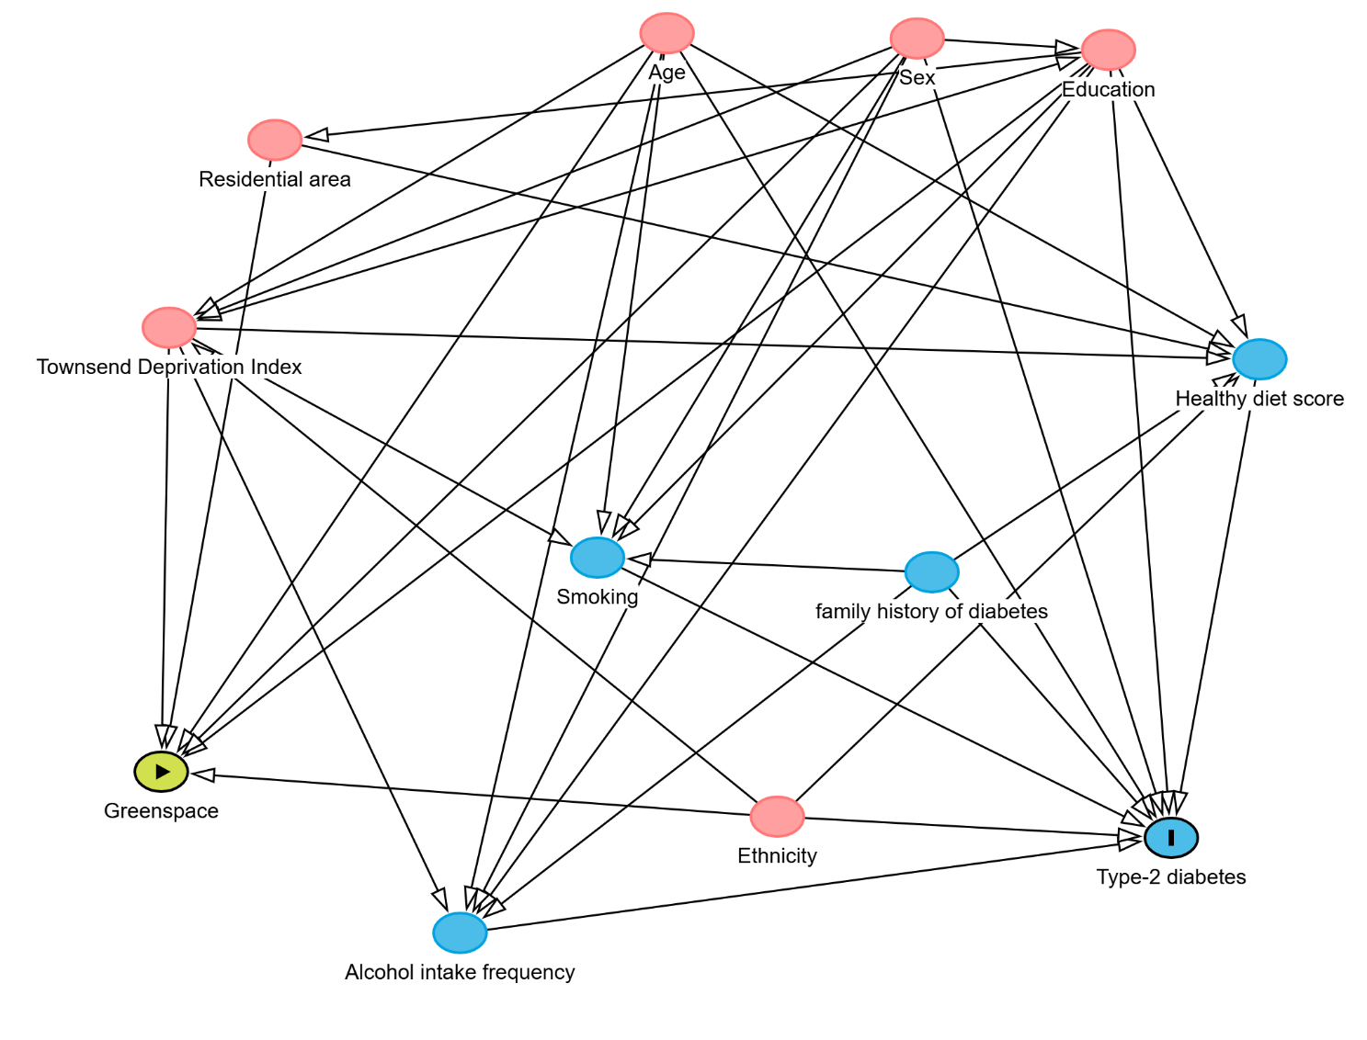
Figure S3. A directed acyclic graph (DAG) showing variable relationships
The green circle represents the exposure of interest; the blue circle represents the outcome of interest and lifestyle and health-related factors that may explain its variability; the red circle depicts potential confounders that are ancestral to both the exposure and outcome (relationship represented by black arrows). Based on DAG, the minimum set of variables required for adjustment in the main model includes age, sex, education status, ethnicity, residential area, and the Townsend deprivation Index

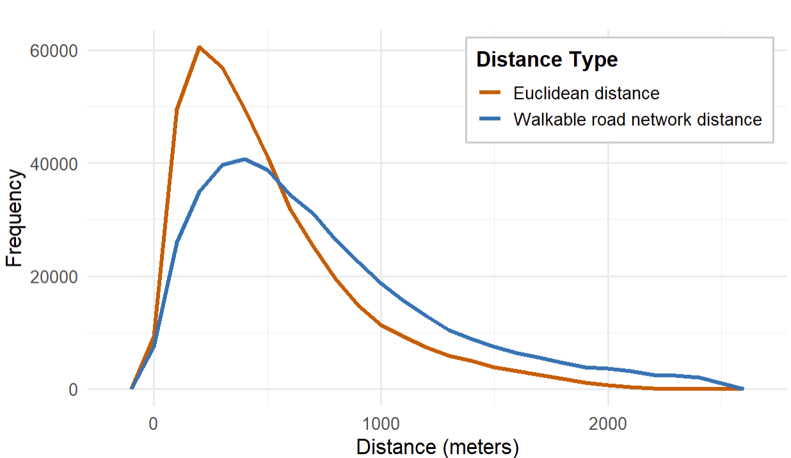

Figure S4. Distribution of objective measures of proximity to public parks or gardens.

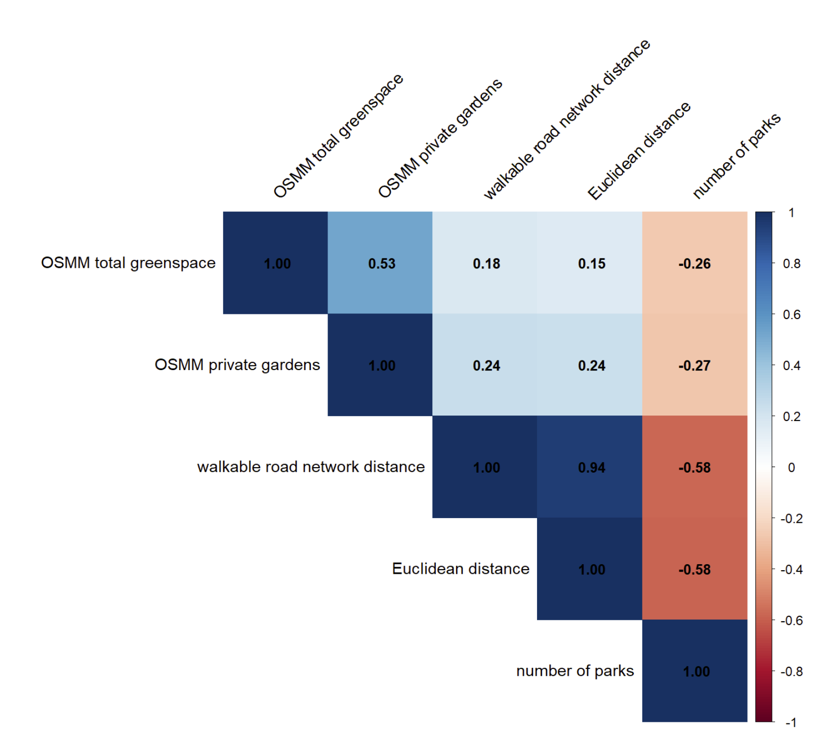Figure S5. Spearman correlation coefficient between total greenspace cover, private residential gardens, walkable road network distance, Euclidean distance, and number of parks OSMM: Ordnance Survey MasterMapTM. Number of parks: number of public parks or gardens within an 800 m buffer of participants’ home location.

Table S4. Effect modification of the associations between distance to public parks or gardens and the incidence of T2D.
 | Walkable road network distance |  | Euclidean distance
Modifying factors | T2D  HR (95% CI) | P-int. | T2D  HR (95% CI) | P-int.
Age
< 65 years
0 – 800 m | 0.964 (0.927, 1.003) | 0.291 | 0.952 (0.908, 0.998) | 0.692
>800 – 1500 m | ref | ref | ref | ref
>1500 m | 0.986 (0.926, 1.051) | 0.573 | 0.908 (0.824, 0.997) | 0.180
≥ 65 years
0 – 800 m | 1.003 (0.942, 1.069) |  | 0.969 (0.899, 1.043)
>800 – 1500 m | ref |  | ref
>1500 m | 1.019 (0.924, 1.124) |  | 1.017 (0.883, 1.172)
Sex
Female
0 – 800 m | 0.987 (0.938, 1.038) | 0.725 | 0.991 (0.905, 1.021) | 0.993
>800 – 1500 m | ref | ref | ref | ref
>1500 m | 1.022 (0.944, 1.106) | 0.326 | 0.971 (0.863, 1.092) | 0.439
Male
0 – 800 m | 0.975 (0.933, 1.020) |  | 0.962 (0.912, 1.014)
>800 – 1500 m | ref |  | ref
>1500 m | 0.969 (0.903, 1.041) |  | 0.913 (0.820, 1.015)
Townsend Deprivation Index
≤median value
0 – 800 m | 1.004 (0.954, 1.056) | 0.931 | 0.995 (0.923, 1.034) | 0.645
>800 – 1500 m | ref | ref | ref | ref
>1500 m | 0.958 (0.893, 1.029) | 0.187 | 0.909 (0.884, 1.143) | 0.220
>Median value
0 – 800 m | 1.007 (0.963, 1.053) |  | 0.977 (0.931, 1.031)
>800 – 1500 m | ref |  | ref
>1500 m | 1.029 (0.949, 1.116) |  | 1.005 (0.958, 1.069)
Family history of diabetes
Yes
0 – 800 m | 0.949 (0.890, 1.012) | 0.244 | 0.958 (0.887, 1.035)
>800 – 1500 m | ref |  | ref
>1500 m | 0.934 (0.842, 1.037) | 0.184 | 0.881 (0.751, 1.032)
No
0 – 800 m | 0.992 (0.954, 1.032) |  | 0.963 (0.919, 1.009)
>800 – 1500 m | ref |  | ref
>1500 m | 1.0132 (0.952, 1.078) |  | 0.958 (0.874, 1.050)

T2D: type-2 diabetes; HR: hazard ratio; CI: confidence interval; ref: reference category; p-int: p value for interaction.
Note: Cox proportional hazard model was used for the effect modification analyses. All models were adjusted for age, sex, education status, smoking status, alcohol intake frequency, ethnicity, residential area, healthy diet score, Townsend deprivation index, and family history of diabetes, except for the stratifying variable.

Table S5. Effect modification of the associations between the number of parks and the incidence of T2D.

 | Number of parks
Modifying factors | T2D  HR (95% CI) | P-int.
Age
< 65 years
0 – 1 | ref | ref
>1 – 3 | 0.979 (0.943, 1.017) | 0.913
>3 | 0.930 (0.888, 0.974) | 0.640
≥ 65 years
0 – 1 | ref
>1 – 3 | 0.975 (0.918, 1.036)
>3 | 0.949 (0.880, 1.023)
Sex
Female
0 – 1 | ref | ref
>1 – 3 | 0.975 (0.929, 1.023) | 0.730
>3 | 0.965 (0.911, 1.023) | 0.292
Male
0 – 1 | ref
>1 – 3 | 0.986 (0.945, 1.029)
>3 | 0.927 (0.880, 0.976)
Townsend Deprivation Index
≤median value
0 – 1 | ref | ref
>1 – 3 | 0.974 (0.927, 1.023) | 0.326
>3 | 1.086 (1.011, 1.167) | 0.18
>Median value
0 – 1 | ref
>1 – 3 | 1.006 (0.965, 1.050)
>3 | 0.980 (0.935, 1.027)
Family history of diabetes
Yes
0 – 1 | ref | ref
>1 – 3 | 0.974 (0.916, 1.036) | 0.791
>3 | 0.949 (0.882, 1.022) | 0.835
No
0 – 1 | ref
>1 – 3 | 0.984 (0.947, 1.021)
>3 | 0.941 (0.899, 0.985)

T2D: type-2 diabetes; HR: hazard ratio; CI: confidence interval; ref: reference category; p-int: p value for interaction.
Note: Cox proportional hazard model was used for the effect modification analyses. All models were adjusted for age, sex, education status, smoking status, alcohol intake frequency, ethnicity, residential area, healthy diet score, Townsend deprivation index, and family history of diabetes, except for the stratifying variable.

Table S6. Association between greenspace types and accessibility with the incidence of T2D after removing participants with diabetes within the first two years of follow-up.
Greenspace | T2D [HR (95% CI)]
Model 2
(main model)
For OSMM greenspace, N = 297,348, with 590 participants removed
Q₁ (low total greenspace cover) | ref
Q₂ | 1.064 (1.015, 1.115)
Q₃ | 1.067 (1.016, 1.121)
Q₄ (high total greenspace cover) | 0.977 (0.927, 1.029)
Q₁ (low private residential gardens) | ref
Q₂ | 0.985 (0.940, 1.033)
Q₃ | 0.975 (0.928, 1.025)
Q₄ (high private residential gardens) | 0.937 (0.888, 0.988)
For access to public parks or gardens, N = 422,478, with 804 participants removed
Walkable distance to the nearest public parks or gardens
0 – 800 m | 0.981 (0.927, 1.002)
>800 – 1500 m | ref
>1500 m | 0.999 (0.926, 1.051)
Euclidean distance to the nearest public parks or gardens
0 – 800 m | 0.956 (0.917, 0.995)
>800 – 1500 m | ref
>1500 m | 0.933 (0.860, 1.013)
Number of parks within or intersected at an 800 m buffer
(~ 10 minutes’ walk)
0 – 1 | ref
>1 – 3 | 0.980 (0.948, 1.012)
>3 | 0.941 (0.903, 0.981)

T2D: type-2 diabetes, HR: hazard ratio; CI: confidence interval.
Note: Cox proportional hazard model was used for the analyses. All models were adjusted for age, sex, education status, smoking status, alcohol intake frequency, ethnicity, residential area, healthy diet score, Townsend deprivation index, and family history of diabetes.

Table S7. Association between greenspace types and accessibility and the incidence of T2D with further adjustment for waist circumference – a marker of metabolic risk.
Greenspace | T2D [HR (95% CI)]
Model 2
(main model)
Q₁ (low total greenspace) | ref
Q₂ | 1.050 (1.002, 1.100)
Q₃ | 1.051 (1.001, 1.103)
Q₄ (high total greenspace) | 0.975 (0.926, 1.026)
Q₁ (low private residential gardens) | ref
Q₂ | 0.976 (0.932, 1.022)
Q₃ | 0.973 (0.927, 1.022)
Q₄ (high private residential gardens) | 0.939 (0.891, 0.989)
Walkable distance to the nearest public parks or gardens
0 – 800 m | 0.990 (0.957, 1.024)
>800 – 1500 m | ref
>1500 m | 0.995 (0.942, 1.050)
Euclidean distance to the nearest public parks or gardens
0 – 800 m | 0.973 (0.934, 1.013)
>800 – 1500 m | ref
>1500 m | 0.944 (0.871, 1.023)
Number of parks within or intersected at an 800 m buffer (~ 10 minutes’ walk)
0 – 1 | ref
>1 – 3 | 0.995 (0.963, 1.028)
>3 | 0.967 (0.929, 1.006)

T2D: type-2 diabetes, HR: hazard ratio; CI: confidence interval.
Note: Cox proportional hazard model was used for the analyses. All models were adjusted for age, sex, education status, smoking status, alcohol intake frequency, ethnicity, residential area, healthy diet score, Townsend deprivation index, and family history of diabetes.

Table S8. Association between greenspace types and accessibility with T2D incidence among participants residing at their baseline address for ≥10 years before study enrollment.
Greenspace | T2D [HR (95% CI)]
Model 2
(main model)
For OSMM greenspace, N = 205,714, with 92,224 participants removed
Q₁ (low total greenspace) | ref
Q₂ | 1.051 (0.992, 1.112)
Q₃ | 1.053 (0.993, 1.118)
Q₄ (high total greenspace) | 0.951 (0.894, 1.012)
Q₁ (low private residential gardens) | ref
Q₂ | 0.995 (0.940, 1.053)
Q₃ | 0.983 (0.927, 1.043)
Q₄ (high private residential gardens) | 0.925 (0.868, 0.985)
For access to public parks or gardens, N = 289,257, with 134,045 participants removed
Walkable distance to the nearest public parks or gardens
0 – 800 m | 0.979 (0.941, 1.019)
>800 – 1500 m | ref
>1500 m | 0.982 (0.921, 1.046)
Euclidean distance to the nearest public parks or gardens
0 – 800 m | 0.961 (0.916, 1.008)
>800 – 1500 m | red
>1500 m | 0.945 (0.860, 1.039)
Number of parks within or intersected at an 800 m buffer (~ 10 minutes’ walk)
0 – 1 | ref
>1 – 3 | 0.993 (0.955, 1.032)
>3 | 0.965, 0.917, 1.012)

T2D: type-2 diabetes, HR: hazard ratio; CI: confidence interval.
Note: Cox proportional hazard model was used for the analyses. All models were adjusted for age, sex, education status, smoking status, alcohol intake frequency, ethnicity, residential area, healthy diet score, Townsend deprivation index, and family history of diabetes.
Table S9. Association between greenspace types and accessibility with the incidence of T2D after excluding potential undiagnosed cases of diabetes based on glycated hemoglobin levels (HbA1c ≥48 mmol/mol).
Greenspace | T2D [HR (95% CI)]
Model 2
(main model)
For OSMM greenspace, N = 276,241, with 3,191 participants removed
Q₁ (low total greenspace) | ref
Q₂ | 1.072 (1.018, 1.128)
Q₃ | 1.075 (1.019, 1.134)
Q₄ (high total greenspace) | 0.975 (0.921, 1.032)
Q₁ (low private residential gardens) | ref
Q₂ | 0.987 (0.938, 1.038)
Q₃ | 0.981 (0.930, 1.035)
Q₄ (high private residential gardens) | 0.929 (0.877, 0.985)
For access to public parks or gardens, N = 393,407, with 29,875 participants removed
Walkable distance to the nearest public parks or gardens
0 – 800 m | 0.984 (0.948, 1.021)
>800 – 1500 m | ref
>1500 m | 0.979 (0.923, 1.039)
Euclidean distance to the nearest public parks or gardens
0 – 800 m | 0.975 (0.933, 1.019)
>800 – 1500 m | ref
>1500 m | 0.936 (0.857, 1.022)
Number of parks within or intersected at an 800 m buffer (~ 10 minutes’ walk)
0 – 1 | ref
>1 – 3 | 0.998 (0.963, 1.034)
>3 | 0.949 (0.908, 0.992)

T2D: type-2 diabetes, HR: hazard ratio; CI: confidence interval. Note: Cox proportional hazard model was used for the analyses. All models were adjusted for age, sex, education status, smoking status, alcohol intake frequency, ethnicity, residential area, healthy diet score, Townsend deprivation index, and family history of diabetes.
Table S10. Association between total greenspace cover, private residential gardens (within alternative buffers of participants’ home location) and the incidence of T2D
Greenspace | T2D [HR (95% CI)]
Model 2
(main model)
300 m buffer (n = 221,487)
Q₁ (low total greenspace) | ref
Q₂ | 1.117 (1.058, 1.180)
Q₃ | 1.142 (1.079, 1.209)
Q₄ (high total greenspace) | 1.023 (0.963, 1.087)
Q₁ (low private residential gardens) | ref
Q₂ | 0.971 (0.920, 1.024)
Q₃ | 0.978 (0.925, 1.034)
Q₄ (high private residential gardens) | 0.981 (0.923, 1.043)
500 m buffer (n = 180,610)
Q₁ (low total greenspace) | ref
Q₂ | 1.042 (0.979, 1.108)
Q₃ | 1.127 (1.058, 1.200)
Q₄ (high total greenspace) | 1.038 (0.971, 1.109)
Q₁ (low private residential gardens) | ref
Q₂ | 0.970 (0.914, 1.023)
Q₃ | 0.980 (0.921, 1.043)
Q₄ (high private residential gardens) | 1.015 (0.949, 1.085)
1000 m buffer (n = 116,031)
Q₁ (low total greenspace) | ref
Q₂ | 1.077 (0.999, 1.162)
Q₃ | 1.098 (1.014, 1.188)
Q₄ (high total greenspace) | 1.083 (0.996, 1.179)
Q₁ (low private residential gardens) | ref
Q₂ | 0.942 (0.876, 1.014)
Q₃ | 0.986 (0.914, 1.063)
Q₄ (high private residential gardens) | 1.016 (0.936, 1.103)

T2D: type-2 diabetes, HR: hazard ratio; CI: confidence interval.
Note: Cox proportional hazard model was used for the analyses. All models were adjusted for age, sex, education status, smoking status, alcohol intake frequency, ethnicity, residential area, healthy diet score, Townsend deprivation index, and family history of diabetes.

Table S11. Association between the park size near participants’ home location and the incidence of T2D
Greenspace | T2D [HR (95% CI)]
Model 2
(main model)
Park size per 2.47 acre increase | 0.999 (0.999, 1.000)
Park size categories (acres)
≤1 | ref
>1 to ≤5 | 0.978 (0.922, 1.038)
>5 to ≤10 | 1.010 (0.945, 1.080)
>10 | 0.979 (0.931, 1.030)

T2D: type-2 diabetes, HR: hazard ratio; CI: confidence interval.
Note: Cox proportional hazard model was used for the analyses. All models were adjusted for age, sex, education status, smoking status, alcohol intake frequency, ethnicity, residential area, healthy diet score, Townsend deprivation index, and family history of diabetes

