Table of contents
Appendix figure.....................................................................................................................................1
Appendix table.......................................................................................................................................3

Risk ratio of total population
 | Unadjusted | Model 1 | Model 2 | Model 3
Buddhism | 1 | 1 | 1 | 1
Christian | RR=1·27  [95%CI:1·13-1·42; ] | 1·27  [95%CI:1·13-1·42] | 1·16  [95%CI: 1·03-1·30] | 0·65  [95%CI: 0·57-0·75]
Hinduism | 1·74  [95%CI: 1·55-1·95] | 1·74  [95%CI: 1·55-1·94] | 1·73  [95%CI: 1·54-1·94] | 2·02  [95%CI: 1·82-2·24]
Islam | 0·56  [95%CI: 0·49-0·63] | 0·56  [95%CI: 0·50-0·63] | 0·53  [95%CI: 0·47-0·60] | 0·37  [95%CI: 0·33-0·42]
Others | 1·13  [95%CI: 1·01-1·27] | 1·16  [95%CI: 1·03-1·29] | 1·13  [95%CI: 1·00-1·26] | 0·70  [95%CI: 0·62-0·80]
Statistical correction | None | Year | Year, Income | Year, Income, Region

Appendix 1. Stepwise Poisson regression models examining the association between religion and suicide rates.
Unadjusted data includes religion. Model 1 additionally adjusts for year, Model 2 adjust for year and national income level. Model 3 further adjusts for geographic region. Risk ratios (RRs) and 95% confidence intervals (CIs) are presented. Suicide counts were modeled using Poisson regression with population size included as an offset.

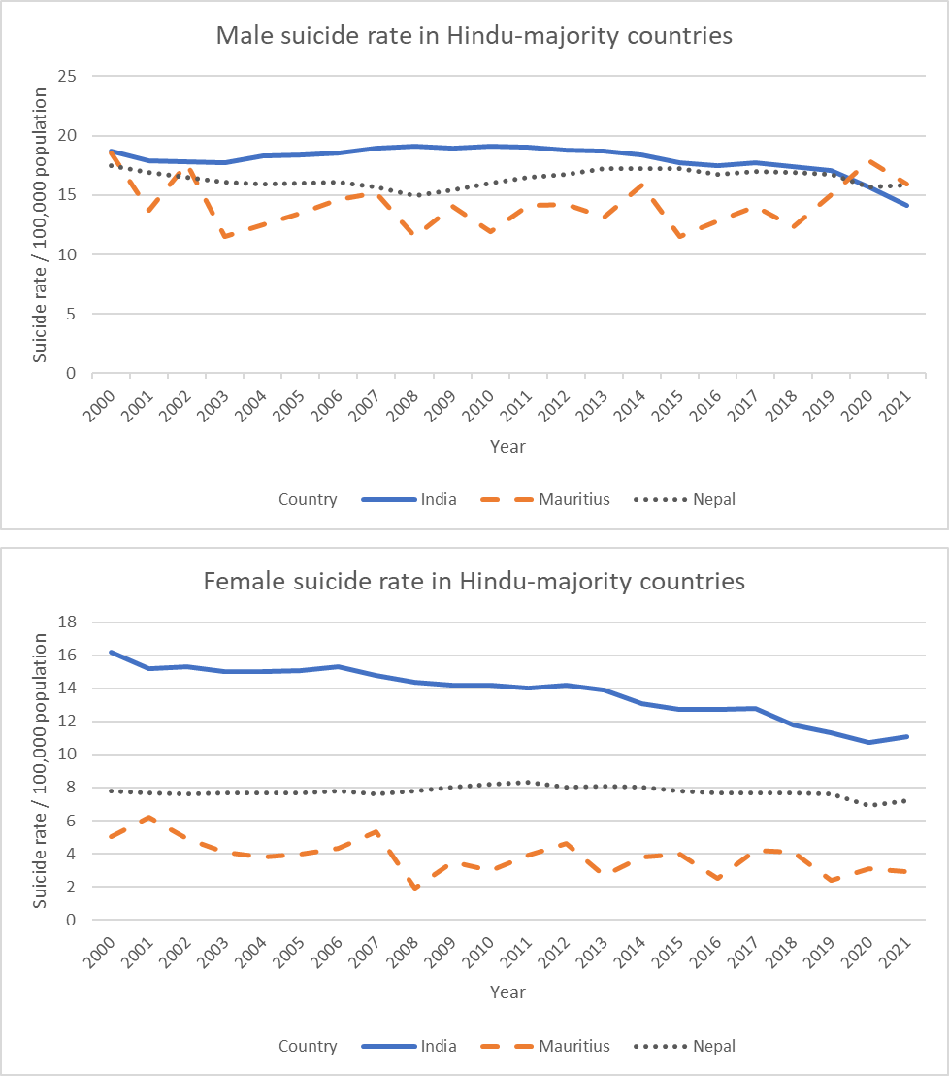

Appendix 2. Suicide rates in Hindu-majority countries (2000–2021)
This figure shows the age-standardized suicide rates over a 22-year period in Hindu-majority countries.

Religion | Region | β | SE | RR | 95% CI | p value
Others | Western Pacific | 0.13 | 0.05 | 1.14 | 1.02–1.26 | 0.02
Others | Europe | -0.02 | 0.15 | 0.99 | 0.74–1.31 | 0.92
Others | East Asia | -0.15 | 0.14 | 0.86 | 0.66–1.13 | 0.3
Others | Africa | 0.02 | 0.07 | 1.02 | 0.89–1.16 | 0.81
Islam | Western Pacific | -0.6 | 0.16 | 0.55 | 0.40–0.75 | <0.001
Islam | Europe | -0.15 | 0.07 | 0.86 | 0.75–1.00 | 0.04
Islam | Eastern Mediterranean | -0.63 | 0.06 | 0.53 | 0.47–0.60 | <0.001
Islam | East Asia | -1.27 | 0.08 | 0.28 | 0.24–0.33 | <0.001
Islam | Africa | -0.08 | 0.08 | 0.92 | 0.80–1.07 | 0.28
Hinduism | East Asia | 0.53 | 0.05 | 1.7 | 1.53–1.89 | <0.001
Hinduism | Africa | -0.09 | 0.54 | 0.91 | 0.31–2.65 | 0.87
Christian | Western Pacific | -0.6 | 0.09 | 0.55 | 0.47–0.65 | <0.001
Christian | Europe | 0.42 | 0.06 | 1.52 | 1.36–1.70 | <0.001
Christian | East Asia | -0.74 | 0.83 | 0.48 | 0.09–2.43 | 0.37
Christian | America | -0.13 | 0.06 | 0.88 | 0.79–0.98 | 0.02
Christian | Africa | 0.34 | 0.06 | 1.41 | 1.26–1.58 | <0.001
Buddhism | Western Pacific | -0.24 | 0.15 | 0.79 | 0.59–1.05 | 0.1
Buddhism | East Asia | 0 | - | 1.00 | - | -

Appendix 3. Stratified Poisson regression analysis by religion–region combinations, adjusted for year and income level

