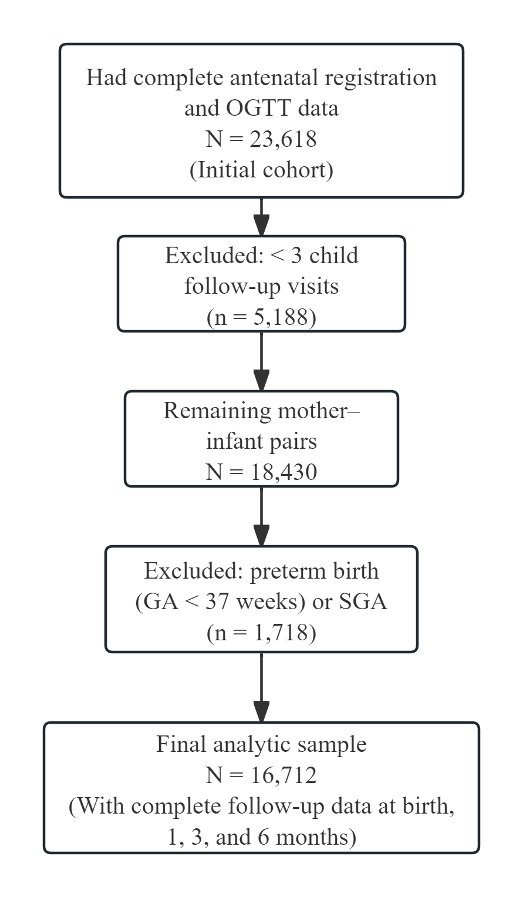
Figure S1. CONSORT-style flow diagram of participant selection.
Abbreviations: OGTT, oral glucose tolerance test; GA, gestational age; SGA, small for gestational age.

