Supplementary Material

Figure S1 Flowchart of participant selection in CHARLS
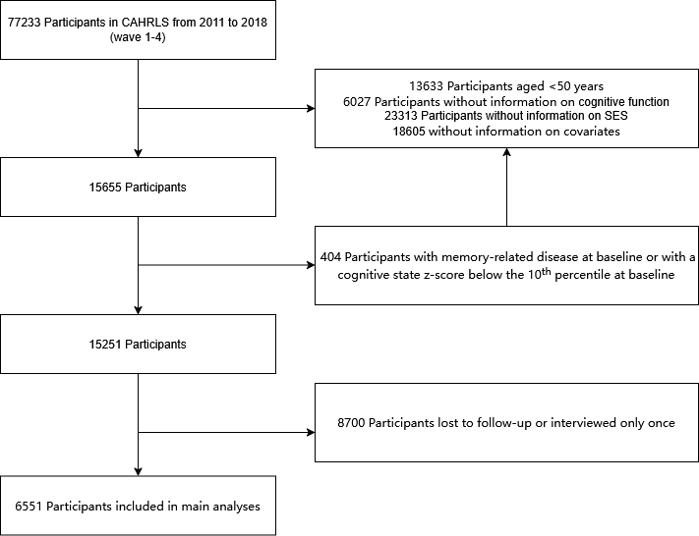
Numbers in the flowchart represent person-years.

Figure S2 Flowchart of participant selection in HRS
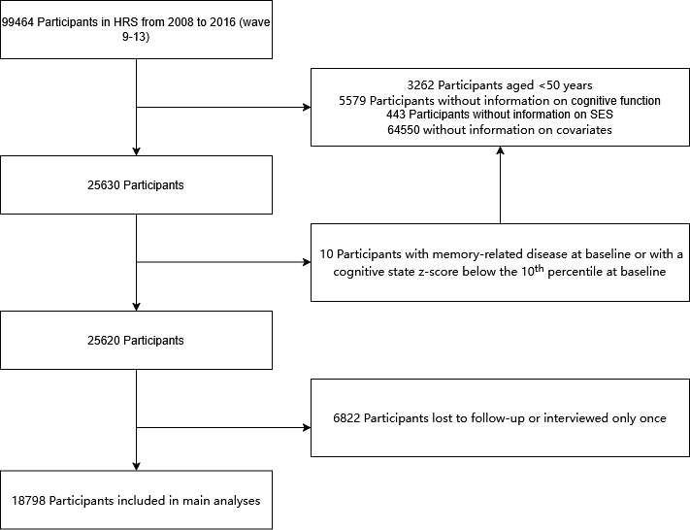
Numbers in the flowchart represent person-years.

Figure S3 Flowchart of participant selection in ELSA
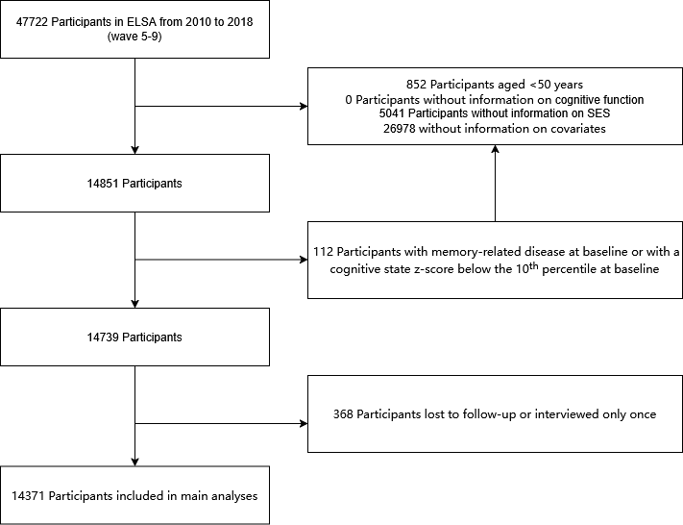
Numbers in the flowchart represent person-years.

Table S1 The descriptive statistics of the characteristics of the study population
Characteristic | Participants, No. (%) (N = 39720)
Characteristic | CHARLS | HRS | ELSA
Total | 6551 | 18798 | 14371
Age, mean (SD) | 64.37 ± 7.96 | 67.41 ± 9.20 | 70.55 ± 8.39
Number of non-communicable diseases, mean (SD) | 1.37 ± 1.18 | 2.01 ± 1.37 | 1.55 ± 1.20
Sex
Male | 3212 (49.0%) | 7694 (40.9%) | 6616 (46.0%)
Female | 3339 (51.0%) | 11104 (59.1%) | 7755 (54.0%)
Early-life conditions
Poor | 2586 (39.5%) | 6897 (36.7%) | 13998 (97.4%)
Fair | 3965 (60.5%) | 11901 (63.3%) | 373 (2.6%)
Current smoking
No | 4686 (71.5%) | 16667 (88.7%) | 13240 (92.1%)
Yes | 1865 (28.5%) | 2131 (11.3%) | 1131 (7.9%)
Alcohol consumption
No | 4438 (67.8%) | 7890 (42.0%) | 1791 (12.5%)
Yes | 2113 (32.3%) | 10908 (58.0%) | 12580 (87.5%)
Physical activity
Yes | 2142 (32.7%) | 13760 (73.2%) | 11347 (79.0%)
No | 4409 (67.3%) | 5038 (26.8%) | 3024 (21.0%)
Race
White | - | 15246 (81.1%) | 14151 (98.5%)
Non-white | - | 3552 (18.9%) | 220 (1.5%)
Educational level
Less than upper secondary | 5928 (90.5%) | 2042 (10.9%) | 3613 (25.1%)
Upper secondary | 544 (8.3%) | 11424 (60.8%) | 7623 (53.0%)
Tertiary | 79 (1.2%) | 5332 (28.4%) | 3135 (21.8%)
Family income
Quartile 1(highest) | 1638 (25%) | 4700 (25%) | 3593 (25%)
Quartile 2 | 1638 (25%) | 4700 (25%) | 3593 (25%)
Quartile 3 | 1638 (25%) | 4699 (25%) | 3592 (25%)
Quartile 4(lowest) | 1637 (25%) | 4699 (25%) | 3593 (25%)
Medical insurance coverage
Uninsured | 662 (10.1%) | 6823 (36.3%) | 12345 (85.9%)
Insured | 5889 (89.9%) | 11975 (63.7%) | 2026 (14.1%)
Employment status
Not working | 1835 (28.0%) | 3575 (19.0%) | 936 (6.5%)
Working | 3631 (55.4%) | 7087 (37.7%) | 2866 (20.0%)
Retired | 1085 (16.6%) | 8136 (43.3%) | 10569 (73.5%)
Social activity
Active | 4896 (74.7%) | 15212 (80.9%) | 9927 (69.1%)
Inactive | 1655 (25.3%) | 3586 (19.1%) | 4444 (30.9%)
Civic and advocacy organization
Active | 6380 (97.4%) | 12145 (64.6%) | 10072 (70.1%)
Inactive | 171 (2.6%) | 6653 (35.4%) | 4299 (29.9%)
Community and social organization
Active | 5265 (80.4%) | 12426 (66.1%) | 9745 (67.8%)
Inactive | 1286 (19.6%) | 6372 (33.9%) | 4626 (32.2%)
Personal development organization
Active | 6102 (93.2%) | 9973 (53.0%) | 7375 (51.3%)
Inactive | 449 (6.9%) | 8825 (47.0%) | 6996 (48.7%)
Loneliness
Not lonely | 4552 (69.5%) | 8316 (44.2%) | 7989 (55.6%)
Lonely | 1999(30.5%) | 10482 (55.8%) | 6382 (44.4%)

Abbreviations: CHARLS, the China Health and Retirement Longitudinal Study; ELSA, the English Longitudinal Study of Aging; HRS, the Health and Retirement Study

Table S2 Comparison of Baseline Characteristics between the Included Sample and the Excluded Sample after Listwise Deletion in the CHARLS
Characteristic | CHARLS
Characteristic | Included Sample (n=6551) | Excluded Sample (n=70682) | Absolute Difference | P
Number of non-communicable diseases, mean (SD) | 1.37 (1.18) | 1.19 (1.12) | - | <0.05
Sex |  |  |  | >0.05
Male | 3212 (49.0%) | 34634 (49.0%) | 0
Female | 3339 (51.0%) | 36048 (51%) | 0
Early-life conditions |  |  |  | <0.05
Poor | 2586 (39.5%) | 28343 (40.1%) | 0.6%
Fair | 3965 (60.5%) | 42339 (59.9%) | 0.6%
Current smoking |  |  |  | >0.05
No | 4686 (71.5%) | 51739 (73.2%) | 1.7%
Yes | 1865 (28.5%) | 18943 (26.8%) | 1.7%
Alcohol consumption |  |  |  | >0.05
No | 4438 (67.8%) | 46085 (65.2%) | 2.6%
Yes | 2113 (32.3%) | 24597 (34.8%) | 2.5%
Physical activity |  |  |  | <0.05
Yes | 2142 (32.7%) | 23961 (33.9%) | 1.2%
No | 4409 (67.3%) | 46721 (66.1%) | 1.2%
Race |  |  |  | -
White | - | - | -
Non-white | - | - | -
Educational level |  |  |  | <0.05
Less than upper secondary | 5928 (90.5%) | 61635 (87.2%) | 3.3%
Upper secondary | 544 (8.3%) | 7634 (10.8%) | 2.5%
Tertiary | 79 (1.2%) | 1413 (2.0%) | 0.8%
Family income |  |  |  | <0.05
Quartile 1(highest) | 1638 (25%) | 17671 (25%) | 0
Quartile 2 | 1638 (25%) | 17671 (25%) | 0
Quartile 3 | 1638 (25%) | 17670 (25%) | 0
Quartile 4(lowest) | 1637 (25%) | 17670 (25%) | 0
Medical insurance coverage |  |  |  | <0.05
Uninsured | 662 (10.1%) | 3817 (5.4%) | 4.7%
Insured | 5889 (89.9%) | 66865 (94.6%) | 4.7%
Employment status |  |  |  | >0.05
Not working | 1835 (28.0%) | 18872 (26.7%) | 1.3%
Working | 3631 (55.4%) | 40854 (57.8%) | 2.4%
Retired | 1085 (16.6%) | 10956 (15.5%) | 1.1%
Social activity |  |  |  | <0.05
Active | 4896 (74.7%) | 52093 (73.7%) | 1.0%
Inactive | 1655 (25.3%) | 18589 (26.3%) | 1.0%
Civic and advocacy organization |  |  |  | <0.05
Active | 6380 (97.4%) | 68137 (96.4%) | 1.0%
Inactive | 171 (2.6%) | 2545 (3.6%) | 1.0%
Community and social organization |  |  |  | <0.05
Active | 5265 (80.4%) | 56758 (80.3%) | 0.1%
Inactive | 1286 (19.6%) | 13924 (19.7%) | 0.1%
Personal development organization |  |  |  | <0.05
Active | 6102 (93.2%) | 64957 (91.9%) | 1.3%
Inactive | 449 (6.9%) | 5725 (8.1%) | 1.2%
Loneliness |  |  |  | <0.05
Not lonely | 4552 (69.5%) | 51032 (72.2%) | 2.7%
Lonely | 1999 (30.5%) | 19650 (27.8%) | 2.7%

Abbreviations: CHARLS, the China Health and Retirement Longitudinal Study

Data are in n(%), unless specified.

Table S3 Comparison of Baseline Characteristics between the Included Sample and the Excluded Sample after Listwise Deletion in the HRS

Characteristic | HRS
Characteristic | Included Sample (n=18798) | Excluded Sample (n=80666) | Absolute Difference | P
Number of non-communicable diseases, mean (SD) | 2.01 (1.37) | 2.10 (1.44) | - | <0.05
Sex |  |  |  | <0.05
Male | 7694 (40.9%) | 33638 (41.7%) | 0.8%
Female | 11104 (59.1%) | 47028 (58.3%) | 0.8%
Early-life conditions |  |  |  | <0.05
Poor | 6897 (36.7%) | 26136 (32.4%) | 4.3%
Fair | 11901 (63.3%) | 54530 (67.6%) | 4.3%
Current smoking |  |  |  | >0.05
No | 16667 (88.7%） | 67356 (83.5%) | 5.2%
Yes | 2131 (11.3%) | 13310 (16.5%) | 5.2%
Alcohol consumption |  |  |  | <0.05
No | 7890 (42.0%) | 38720 (48.0%) | 6.0%
Yes | 10908 (58.0%) | 41946 (52.0%) | 6.0%
Physical activity |  |  |  | <0.05
Yes | 13760 (73.2%) | 51788 (64.2%) | 9.0%
No | 5038 (26.8%) | 28878 (35.8%) | 9.0%
Race |  |  |  | <0.05
White | 15246 (81.1%) | 52594 (65.2%) | 15.9%
Non-white | 3552 (18.9%) | 28072 (34.8%) | 15.9%
Educational level |  |  |  | <0.05
Less than upper secondary | 2042 (10.9%) | 14762 (18.3%) | 7.4%
Upper secondary | 11424 (60.8%) | 45980 (57.0%) | 3.8%
Tertiary | 5332 (28.4%) | 19924 (24.7%) | 3.7%
Family income |  |  |  | <0.05
Quartile 1(highest) | 4700 (25%) | 20167 (25%) | 0
Quartile 2 | 4700 (25%) | 20167 (25%) | 0
Quartile 3 | 4699 (25%) | 20166 (25%) | 0
Quartile 4(lowest) | 4699 (25%) | 20166 (25%) | 0
Medical insurance coverage |  |  |  | <0.05
Uninsured | 6823 (36.3%) | 31460 (39.0%) | 2.7%
Insured | 11975 (63.7%) | 49206 (61.0%) | 2.7%
Employment status |  |  |  | <0.05
Not working | 3575 (19.0%) | 18795 (23.3%) | 4.3%
Working | 7087 (37.7%) | 31298 (38.8%) | 1.1%
Retired | 8136 (43.3%) | 30573 (37.9%) | 5.4%
Social activity |  |  |  | <0.05
Active | 15212 (80.9%) | 59612 (73.9%) | 7.0%
Inactive | 3586 (19.1%) | 21054 (26.1%) | 7.0%
Civic and advocacy organization |  |  |  | <0.05
Active | 12145 (64.6%) | 47190 (58.5%) | 6.1%
Inactive | 6653 (35.4%) | 33476 (41.5%) | 6.1%
Community and social organization |  |  |  | <0.05
Active | 12426 (66.1%) | 48803 (60.5%) | 5.6%
Inactive | 6372 (33.9%) | 31863 (39.5%) | 5.6%
Personal development organization |  |  |  | <0.05
Active | 9973 (53.0%) | 39042 (48.4%) | 4.6%
Inactive | 8825 (47.0%) | 41624 (51.6%) | 4.6%
Loneliness |  |  |  | <0.05
Not lonely | 8316 (44.2%) | 31540 (39.1%) | 5.1%
Lonely | 10482 (55.8%) | 49126 (60.9%) | 5.1%

Abbreviations: HRS, the Health and Retirement Study
Data are in n(%), unless specified.

Table S4 Comparison of Baseline Characteristics between the Included Sample and the Excluded Sample after Listwise Deletion in the ELSA
Characteristic | ELSA
Characteristic | Included Sample (n=14371) | Excluded Sample (n=33351) | Absolute Difference | P
Number of non-communicable diseases, mean (SD) | 1.55 (1.20) | 1.39 (1.23) | - | <0.05
Sex |  |  |  | >0.05
Male | 6616 (46.0%) | 14774 (44.3%) | 1.7%
Female | 7755 (54.0%) | 18577 (55.7%) | 1.7%
Early-life conditions |  |  |  | <0.05
Poor | 13998 (97.4%) | 32584 (97.7%) | 0.3%
Fair | 373 (2.6%) | 767 (2.3%) | 0.3%
Current smoking |  |  |  | <0.05
No | 13240 (92.1%) | 29082 (87.2%) | 4.9%
Yes | 1131 (7.9%) | 4269 (12.8%) | 4.9%
Alcohol consumption |  |  |  | <0.05
No | 1791 (12.5%) | 4569 (13.7%) | 1.2%
Yes | 12580 (87.5%) | 28782 (86.3%) | 1.2%
Physical activity |  |  |  | <0.05
Yes | 11347 (79.0%) | 26647 (79.9%) | 0.9%
No | 3024 (21.0%) | 6704 (20.1%) | 0.9%
Race |  |  |  | <0.05
White | 14151 (98.5%) | 31683 (95.0%) | 3.5%
Non-white | 220 (1.5%) | 1668 (5.0%) | 3.5%
Educational level |  |  |  | <0.05
Less than upper secondary | 3613 (25.1%) | 10039 (30.1%) | 5.0%
Upper secondary | 7623 (53.0%) | 16842 (50.5%) | 2.5%
Tertiary | 3135 (21.8%) | 6470 (19.4%) | 2.4%
Family income |  |  |  | <0.05
Quartile 1(highest) | 3593 (25%) | 8338 (25%) | 0
Quartile 2 | 3593 (25%) | 8338 (25%) | 0
Quartile 3 | 3592 (25%) | 8338 (25%) | 0
Quartile 4(lowest) | 3593 (25%) | 8337 (25%) | 0
Medical insurance coverage |  |  |  | >0.05
Uninsured | 12345 (85.9%) | 29249 (87.7%) | 1.8%
Insured | 2026 (14.1%) | 4102 (12.3%) | 1.8%
Employment status |  |  |  | <0.05
Not working | 936 (6.5%) | 2468 (7.4%) | 0.9%
Working | 2866 (20.0%) | 7504 (22.5%) | 2.5%
Retired | 10569 (73.5%) | 23379 (70.1%) | 3.4%
Social activity |  |  |  | <0.05
Active | 9927 (69.1%) | 21178 (63.5%) | 5.6%
Inactive | 4444 (30.9%) | 12173 (36.5%) | 5.6%
Civic and advocacy organization |  |  |  | <0.05
Active | 10072 (70.1%) | 24513 (73.5%) | 3.4%
Inactive | 4299 (29.9%) | 8838 (26.5%) | 3.4%
Community and social organization |  |  |  | <0.05
Active | 9745 (67.8%) | 24746 (74.2%) | 6.4%
Inactive | 4626 (32.2%) | 8605 (25.8%) | 6.4%
Personal development organization |  |  |  | <0.05
Active | 7375 (51.3%) | 18943 (56.8%) | 5.5%
Inactive | 6996 (48.7%) | 14408 (43.2%) | 5.5%
Loneliness |  |  |  | <0.05
Not lonely | 7989 (55.6%) | 16742 (50.2%) | 5.4%
Lonely | 6382 (44.4%) | 16609 (49.8%) | 5.4%

Abbreviations: ELSA, the English Longitudinal Study of Aging
Data are in n(%), unless specified.

Table S5 Model Fit Indices for Latent Class Analysis of Socioeconomic Status (SES) Based on CHARLS Data
Classes | LogLik | AIC | BIC | Entropy | BLRT val | BLRT p
1 | -18921.89 | 37855.78 | 37896.51 | 1.000 | NA | NA
2 | -17734.00 | 35487.99 | 35555.86 | 0.902 | 2375.781 | 0.01
3 | -17733.83 | 35495.66 | 35590.68 | 0.621 | 0.226 | 0.02
4 | -12208.40 | 24452.80 | 24574.98 | 0.643 | 11050.969 | 0.01

Table S6 Model Fit Indices for Latent Class Analysis of Socioeconomic Status (SES) Based on HRS Data
Classes | LogLik | AIC | BIC | Entropy | BLRT val | BLRT p
1 | -66630.46 | 133272.9 | 133320.0 | 1.000 | NA | NA
2 | -62072.50 | 124165.0 | 124243.4 | 0.881 | 9116.026 | 0.01
3 | -61426.22 | 122880.4 | 122990.2 | 0.832 | 1292.622 | 0.01
4 | -56184.89 | 112421.8 | 112625.7 | 0.992 | NA | NA

Table S7 Model Fit Indices for Latent Class Analysis of Socioeconomic Status (SES) Based on ELSA Data
Classes | LogLik | AIC | BIC | Entropy | BLRT val | BLRT p
1 | -61173.20 | 122358.4 | 122403.8 | 1.000 | NA | NA
2 | -58201.03 | 116422.1 | 116497.8 | 0.889 | 5944.479 | 0.01
3 | -58198.70 | 116425.4 | 116531.4 | 0.616 | 830.636 | 0.01
4 | -57968.35 | 115972.7 | 116109.0 | 0.703 | NA | NA

Table S8 Detailed Information for Cognitive Function Assessment
Domain | CHARLS | HRS | ELSA
Memory Function | The interviewers read out a set of 10 words “at a slow steady rate approximately one word every 2 seconds” and then ask the individual to “recall aloud as many of the words as you can, in any order”. Enough time was allowed to recall, approximately up to 2 minutes. After questions and tests on other aspects, the participants were again asked to recall the words as many as they could. Range: 0–10 for immediate recall, 0–10 for delayed recall; total score 0–20.
Orientation Function | Participants were asked to report the “Today’s date (the day of month, month, and year)” and “what day of the week it is today”. Range: 0–4.
Executive Function | Participants were asked to answer “What does 100 minus 7 equal? And 7 from that? And 7 from that? And 7 from that? And 7 from that?” (Range: 0–5) and interesting pentagon copying test (Range: 0 or 3). Total range: 0–8. | Participants were asked to answer “One hundred minus 7 equals what? And 7 from that? And 7 from that? And 7 from that? And 7 from that?” (Range: 0-2.) In addition, participants were asked to count backward as quickly as he or she could from 20. The correct response included counting down from 19 to 10 or from 20 to 11. (Range: 0-5.) Participants had two opportunities to perform the counting backwards test. Total range: 0-7. | Participants were asked to “name as many different animals as you can think of” in one minute. (Score = number of animals named). Range: ≥0, no upper limit.
Abbreviations: CHARLS, the China Health and Retirement Longitudinal Study; ELSA, the English Longitudinal Study of Aging; HRS, the Health and Retirement Study

Table S9 Detailed information of variables
Variables | Values | Surveys
Variables | Values | CHARLS | HRS | ELSA
Alcohol consumption | No | Participants never drink alcoholic beverage.
Alcohol consumption | Yes | Participants drink alcoholic beverage at present or previously.
Current smoking | Non-smoker | Participants never smoked.
Current smoking | smoker | Participants smoke at present.
Physical activity | No | Participants do vigorous/moderate physical activity for less than 10 minutes every week. | Frequency of taking part in vigorous/moderate physical activity: 1. One to three times a month; 2. Hardly ever or never.
Physical activity | Yes | Participants do vigorous/moderate physical activity for 10+ minutes at least 1 day a week. | Frequency of taking part in vigorous/moderate physical activity: 1. More than once a week; 2. Once a week.
Non-communicable diseases (NCDs) | Number of non-communicable diseases (range 0–7), including hypertension, heart problems, psychiatric problems, diabetes, lung diseases, cancer, and arthritis.
Early-life conditions | Poor | Self-reported childhood economic status: “A lot worse” or “Somewhat worse” than community average. | Parents’ education (highest of both): less than upper secondary. |  | Experienced severe financial hardship in childhood.
Early-life conditions | Fair | Self-reported childhood economic status: “Same”, “Somewhat better”, or “A lot better” than community average. | Parents’ education (highest of both): upper secondary and tertiary. |  | Did not experience severe financial hardship in childhood.
Civic and advocacy organization | Active | Participated in at least one social activity or group in the last month or year.  Activities: a) participating in volunteer or charity activities; b) caring for non-cohabiting patients or disabled persons. | Participated in at least one social activity or group in the last month or year.  Activities: a) do volunteer work with children or young people; b) do any other volunteer or charity work. |  | Participated in at least one social activity or group in the last month or year.  Activities: a) attend a political party; b) attend charitable associations.
Civic and advocacy organization | Inactive | Did not participate in any social activities in the last month or year. | Did not participate in any social activities in the last month or year. |  | Did not participate in any social activities in the last month or year.
Community and social organization | Active | Participated in at least one social activity or group in the last month or year.  Activities: a) playing mahjong, chess, cards, or attending community activities; b) participating in community-related organizations. | Participated in at least one social activity or group in the last month or year.  Activities: go to a sport, social, or other club. |  | Participated in at least one social activity or group in the last month or year.  Activities: a) attend a church or other religious groups; b) attend evening classes; c) attend sports clubs.
Community and social organization | Inactive | Did not participate in any social activities in the last month or year. | Did not participate in any social activities in the last month or year. |  | Did not participate in any social activities in the last month or year.
Personal development organization | Active | Participated in at least one social activity or group in the last month or year.  Activities: a) attending school or training courses; b) going to (community-organized) dancing, fitness, Chinese Qigong (a system of deep breathing exercises) and so on. | Participated in at least one social activity or group in the last month or year.  Activities: attend an educational or training course. |  | Participated in at least one social activity or group in the last month or year.  Activities: a) attend tenant groups; b) attend social clubs.
Personal development organization | Inactive | Did not participate in any social activities in the last month or year. | Did not participate in any social activities in the last month or year. |  | Did not participate in any social activities in the last month or year.
Loneliness | Not lonely | Participants felt lonely <1 day during the last week. | Total score of R-UCLA loneliness scale is equal to 3.
Loneliness | Lonely | Participants felt lonely >=1 day during the last week. | Total score of R-UCLA loneliness scale is 4 and above.

Table S10 Association between SES scores and cognitive status using linear mixed mode
Variable |  | β (95%CI) | P
CHARLS
SES scores |  | 0.115 (0.980 - 0.133) | <0.001
Time (years) |  | -0.040 (-0.060 - -0.020) | <0.001
SES × Time |  | 0.004 (-0.000009 - 0.008) | 0. 051
HRS
SES scores |  | 0.122 (0.108 - 0.137) | <0.001
Time (years) |  | -0.016 (-0.309 - -0.0003) | 0.046
SES × Time |  | -0.005 (-0.008 - 0.002) | 0.002
ELSA
SES scores |  | 0.039 (0.030 - 0.048) | <0.001
Time (years) |  | -0.0004 (-0.013 - 0.012) | 0.954
SES × Time |  | -0.0001 (-0.002 - 0.002) | 0.904
CI: Confidence Interval
Model: Adjust: Alcohol consumption, Current smoking, physical activity, Non-communicable diseases, Gender, Age, Early-life conditions, Medical insurance, Social activity, Civic and advocacy organizations, Community and social organizations, Personal development organizations, and Loneliness

Table S11 Reverse mediation analysis examining cognitive function as a predictor of SES
 | Path coefficients | β (95%CI) | P-value | Proportion mediated(%)
Loneliness
CHARLS | Indirect effect | 0.002 (-0.008 - 0.01) | 0.341 | 3.59
 | Direct effect | 0.054 (0.005 - 0.10) | 0.031 | 96.41
 | Total effect | 0.056 (0.008 - 0.10) | 0.022 | 100.00
HRS | Indirect effect | 0.018 (0.002 - 0.03) | 0.026 | 23.38
 | Direct effect | 0.095 (0.05-0.14) | <0.001 | 76.62
 | Total effect | 0.113 (0.07-0.16) | <0.001 | 100.00
ELSA | Indirect effect | 0.012 (-0.003 - 0.03) | 0.125 | 15.58
 | Direct effect | 0.065 (0.03 - 0.11) | <0.001 | 84.42
 | Total effect | 0.077 (0.02 - 0.13) | <0.001 | 100.00
Social activities
CHARLS | Indirect effect | 0.006 (-0.001 - 0.02) | 0.043 | 10.57
 | Direct effect | 0.050 (0.002 - 0.10) | 0.042 | 89.43
 | Total effect | 0.056 (0.008 - 0.10) | 0.022 | 100.00
HRS | Indirect effect | 0.021 (0.004-0.038) | 0.014 | 27.37
 | Direct effect | 0.056 (0.012-0.10) | 0.012 | 72.63
 | Total effect | 0.077 (0.031-0.123) | <0.001 | 100.00
ELSA | Indirect effect | 0.010 (-0.002 - 0.03) | 0.063 | 12.99
 | Direct effect | 0.067 (0.02 - 0.12) | <0.01 | 87.01
 | Total effect | 0.077 (0.02 - 0.13) | 0.004 | 100.00

Table S12 Sensitivity of mediation effects to unmeasured confounding
 | |ρ|
Loneliness
CHARLS | 0.23
HRS | 0.21
ELSA | 0.22
Social activities
CHARLS | 0.45
HRS | 0.41
ELSA | 0.46

