Supplementary Material
Socioeconomic gradients in hypertension prevalence and management: a cross-sectional study
Eunji Kim ^{1,2}, Hokyou Lee ^{3,4}, YunJae Jung ^{5,6,7}, and Hyeon Chang Kim ^{3,4}

¹ Department of Preventive Medicine, Gachon University College of Medicine, Incheon, Republic of Korea
² Artificial Intelligence and Big-Data Convergence Center, Gil Medical Center, Gachon University College of Medicine, Incheon, Republic of Korea
³ Department of Preventive Medicine, Yonsei University College of Medicine, Seoul, Republic of Korea
⁴ Institute for Innovation in Digital Healthcare, Yonsei University, Seoul, Republic of Korea
⁵ Department of Microbiology, Gachon University College of Medicine, Incheon, Republic of Korea
⁶ Lee Gil Ya Cancer and Diabetes Institute, Gachon University, Incheon, Republic of Korea
⁷ Department of Health Science and Technology, Gachon Advanced Institute for Health Science & Technology, Gachon University, Incheon, Republic of Korea

Additional Table S1. Association of household income with diagnosed hypertension and hypertension management outcomes by adjustment model
Additional Table S2. Subgroup analyses of the association between household income and hypertension-related outcomes
Additional Figure S1. Flowchart of study participants
Additional Table S1. Association of household income with diagnosed hypertension and hypertension management outcomes by adjustment model
Outcomes  / Household income |  | Odds ratio (95% confidence interval)
Outcomes  / Household income |  | Unadjusted | Model 1 | Model 2 | Model 3
Diagnosed hypertension
Low |  | 4.24 (4.09-4.40) | 1.42 (1.35-1.48) | 1.31 (1.25-1.37) | 1.31 (1.25-1.37)
Lower-middle |  | 2.01 (1.94-2.09) | 1.09 (1.04-1.14) | 1.06 (1.02-1.11) | 1.04 (1.00-1.09)
Upper-middle |  | 1.29 (1.24-1.34) | 1.07 (1.02-1.11) | 1.05 (1.01-1.10) | 1.03 (0.99-1.08)
High |  | 1.00 (reference) | 1.00 (reference) | 1.00 (reference) | 1.00 (reference)
Hypertension management
- Pharmacotherapy
Low |  | 3.09 (2.69-3.55) | 1.12 (0.95-1.32) | 1.20 (1.01-1.42) | 1.19 (1.00-1.42)
Lower-middle |  | 1.79 (1.56-2.04) | 1.02 (0.88-1.19) | 1.06 (0.90-1.23) | 1.04 (0.89-1.22)
Upper-middle |  | 1.31 (1.15-1.49) | 1.12 (0.97-1.28) | 1.13 (0.98-1.30) | 1.12 (0.97-1.28)
High |  | 1.00 (reference) | 1.00 (reference) | 1.00 (reference) | 1.00 (reference)
- Lifestyle modifications
Low |  | 0.55 (0.51-0.58) | 0.57 (0.53-0.62) | 0.63 (0.58-0.68) | 0.69 (0.64-0.74)
Lower-middle |  | 0.77 (0.72-0.82) | 0.79 (0.73-0.85) | 0.82 (0.76-0.88) | 0.84 (0.78-0.91)
Upper-middle |  | 0.89 (0.83-0.95) | 0.90 (0.83-0.96) | 0.91 (0.85-0.98) | 0.93 (0.86-1.00)
High |  | 1.00 (reference) | 1.00 (reference) | 1.00 (reference) | 1.00 (reference)
- Self-management education
Low |  | 0.34 (0.31-0.36) | 0.46 (0.43-0.51) | 0.51 (0.46-0.56) | 0.54 (0.49-0.59)
Lower-middle |  | 0.56 (0.52-0.60) | 0.69 (0.63-0.75) | 0.71 (0.66-0.77) | 0.73 (0.67-0.79)
Upper-middle |  | 0.73 (0.68-0.79) | 0.78 (0.72-0.84) | 0.79 (0.73-0.86) | 0.80 (0.74-0.87)
High |  | 1.00 (reference) | 1.00 (reference) | 1.00 (reference) | 1.00 (reference)
Model 1 adjusted for age and sex. Model 2 further adjusted for marital status, area of residence, and unmet healthcare needs. Model 3 additionally adjusted for body mass index, smoking status, and physical activity.
Additional Table S2. Subgroup analyses of the association between household income and hypertension-related outcomes
Outcomes | Adjusted odds ratio  (95% confidence interval)
/ Household income | Sex |  |  | Age |  |  | Area of residency |  |  | Healthcare needs
 | Male | Female |  | Age <65y | Age ≥65y |  | Urban | Rural |  | Met | Unmet
Diagnosed hypertension
Low | 1.24  (1.15-1.32) | 1.42  (1.32-1.51) |  | 2.18  (2.04-2.34) | 1.27  (1.17-1.37) |  | 1.35  (1.24-1.46) | 1.30  (1.23-1.37) |  | 1.31  (1.25-1.38) | 1.20  (0.97-1.50)
Lower-middle | 1.05  (0.99-1.11) | 1.10  (1.03-1.17) |  | 1.44  (1.37-1.52) | 1.08  (1.00-1.18) |  | 1.04  (0.96-1.12) | 1.05  (1.00-1.10) |  | 1.04  (1.00-1.09) | 1.02  (0.83-1.26)
Upper-middle | 1.04  (0.98-1.10) | 1.05  (0.98-1.12) |  | 1.12  (1.07-1.17) | 1.00  (0.91-1.09) |  | 0.99  (0.91-1.08) | 1.04  (0.99-1.09) |  | 1.04  (1.00-1.09) | 0.90  (0.73-1.11)
High | 1.00  (reference) | 1.00  (reference) |  | 1.00  (reference) | 1.00  (reference) |  | 1.00  (reference) | 1.00  (reference) |  | 1.00  (reference) | 1.00  (reference)
p for trend | <0.001 | <0.001 |  | <0.001 | <0.001 |  | <0.001 | <0.001 |  | <0.001 | 0.019
p for interaction | <0.001 |  |  | <0.001 |  |  | <0.001 |  |  | 0.143
Hypertension management
- Pharmacotherapy
Low | 1.15  (0.92-1.43) | 1.31  (0.99-1.73) |  | 1.87  (1.51-2.32) | 1.18  (0.80-1.74) |  | 0.76  (0.53-1.09) | 1.23  (1.02-1.48) |  | 1.25  (1.04-1.50) | 0.86  (0.46-1.61)
Lower-middle | 1.07  (0.88-1.31) | 1.04  (0.81-1.33) |  | 1.38  (1.16-1.63) | 1.02  (0.69-1.50) |  | 0.74  (0.52-1.04) | 1.07  (0.91-1.26) |  | 0.99  (0.85-1.17) | 2.47  (1.23-4.94)
Upper-middle | 1.13  (0.95-1.33) | 1.10  (0.86-1.41) |  | 1.29  (1.12-1.49) | 0.90  (0.58-1.39) |  | 0.86  (0.61-1.22) | 1.13  (0.98-1.31) |  | 1.12  (0.97-1.29) | 1.08  (0.62-1.87)
High | 1.00  (reference) | 1.00  (reference) |  | 1.00  (reference) | 1.00  (reference) |  | 1.00  (reference) | 1.00  (reference) |  | 1.00  (reference) | 1.00  (reference)
p for trend | 0.284 | 0.197 |  | 0.002 | 0.126 |  | 0.710 | 0.082 |  | 0.084 | 0.783
p for interaction | 0.825 |  |  | 0.128 |  |  | 0.435 |  |  | 0.234
- Lifestyle modifications
Low | 0.65  (0.58-0.73) | 0.73  (0.65-0.82) |  | 0.73  (0.64-0.84) | 0.69  (0.61-0.78) |  | 0.76  (0.65-0.89) | 0.68  (0.63-0.74) |  | 0.68  (0.63-0.74) | 0.81  (0.54-1.22)
Lower-middle | 0.80  (0.72-0.89) | 0.88  (0.79-0.99) |  | 0.83  (0.75-0.91) | 0.85  (0.75-0.96) |  | 0.93  (0.80-1.09) | 0.83  (0.77-0.90) |  | 0.84  (0.78-0.91) | 0.89  (0.61-1.31)
Upper-middle | 0.89  (0.81-0.98) | 0.98  (0.88-1.10) |  | 0.89  (0.81-0.97) | 1.00  (0.87-1.15) |  | 1.00  (0.85-1.17) | 0.92  (0.85-1.00) |  | 0.93  (0.86-1.00) | 0.86  (0.58-1.26)
High | 1.00  (reference) | 1.00  (reference) |  | 1.00  (reference) | 1.00  (reference) |  | 1.00  (reference) | 1.00  (reference) |  | 1.00  (reference) | 1.00  (reference)
p for trend | <0.001 | <0.001 |  | <0.001 | <0.001 |  | <0.001 | <0.001 |  | <0.001 | 0.311
p for interaction | 0.218 |  |  | 0.124 |  |  | 0.203 |  |  | 0.395
- Self-management education
Low | 0.53  (0.47-0.61) | 0.56  (0.49-0.64) |  | 0.53  (0.46-0.62) | 0.56  (0.48-0.64) |  | 0.77  (0.65-0.90) | 0.52  (0.47-0.58) |  | 0.53  (0.48-0.58) | 0.71  (0.46-1.10)
Lower-middle | 0.70  (0.62-0.78) | 0.80  (0.70-0.91) |  | 0.67  (0.60-0.75) | 0.78  (0.67-0.90) |  | 0.87  (0.75-1.02) | 0.72  (0.66-0.79) |  | 0.73  (0.67-0.79) | 0.73  (0.48-1.12)
Upper-middle | 0.79  (0.71-0.87) | 0.85  (0.74-0.97) |  | 0.75  (0.69-0.83) | 0.94  (0.79-1.10) |  | 0.93  (0.78-1.10) | 0.80  (0.73-0.87) |  | 0.79  (0.73-0.86) | 1.08  (0.71-1.63)
High | 1.00  (reference) | 1.00  (reference) |  | 1.00  (reference) | 1.00  (reference) |  | 1.00  (reference) | 1.00  (reference) |  | 1.00  (reference) | 1.00  (reference)
p for trend | <0.001 | <0.001 |  | <0.001 | <0.001 |  | <0.001 | <0.001 |  | <0.001 | 0.027
p for interaction | 0.123 |  |  | 0.855 |  |  | 0.052 |  |  | 0.162
Models were adjusted for age, sex, marital status, area of residence, unmet healthcare needs, body mass index, smoking status, and physical activity, except for the variable used for stratification in each subgroup analysis.

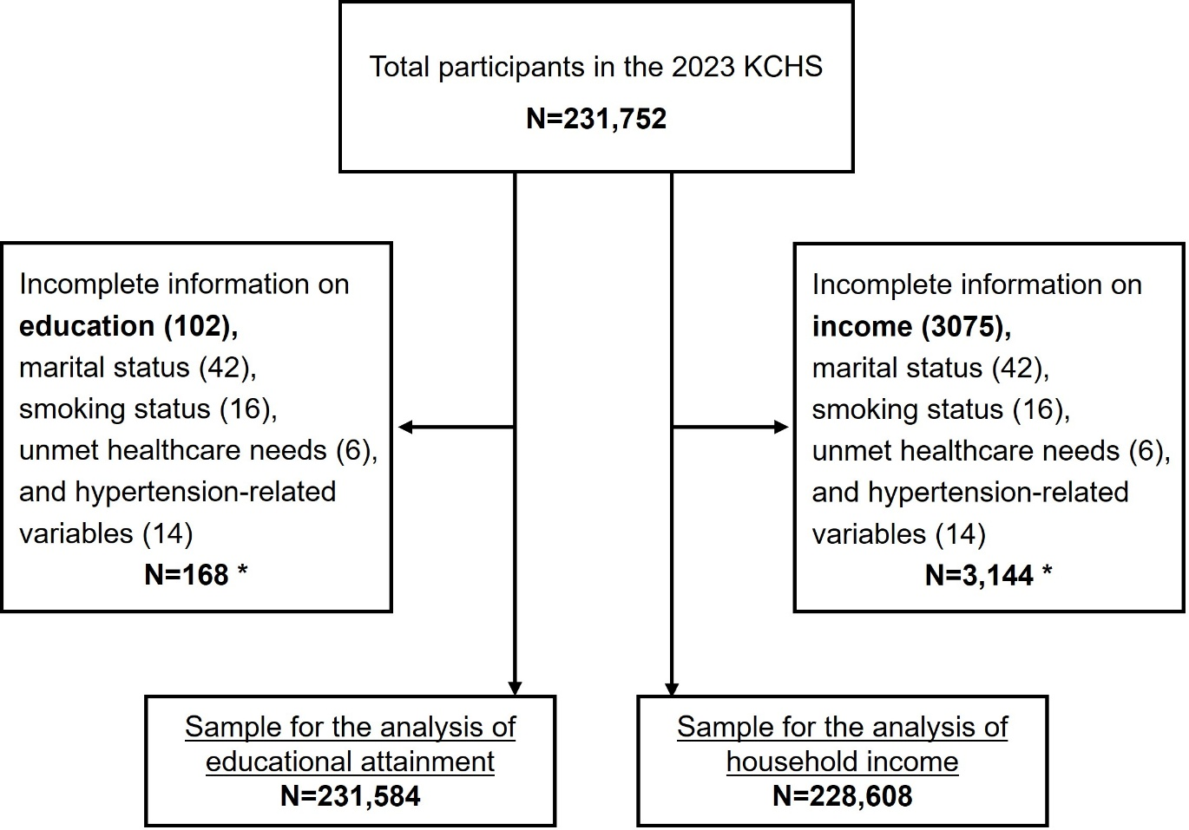

Additional Figure S1. Flowchart of Study Participants
Due to overlapping cases, the sum of the numbers in parentheses indicating missing data may exceed the total number of excluded participants

