Supplementary Materials for
Socio-economic factors and political status shape mortality risk from suicide attacks linked to climate variability
Kun Hou^{1*}, Xia Xu²

1. Supplementary Figures
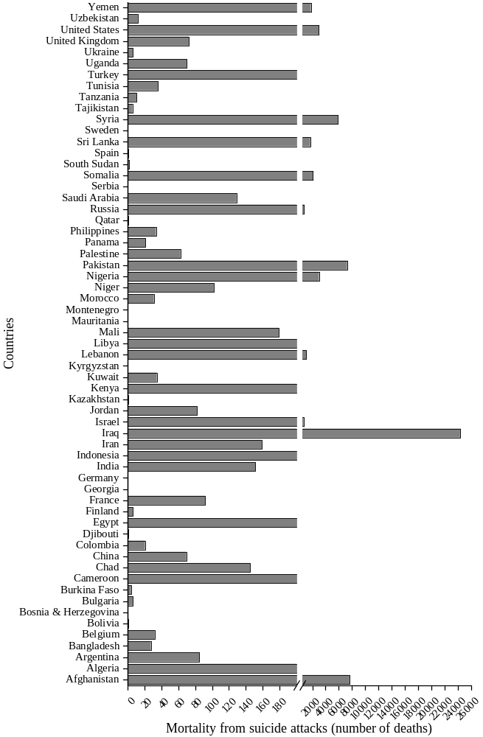

Fig. S1. Number of deaths from suicide attacks in different countries and regions. The Database on Suicide Attacks records the highest and lowest number of deaths reported by sources during a suicide attack event (news reports on the number of deaths in suicide attack incidents often differ). The average of the highest and lowest values is calculated to represent the deaths from a suicide attack, and the observed number of deaths from suicide attacks is 63,202 for the study.
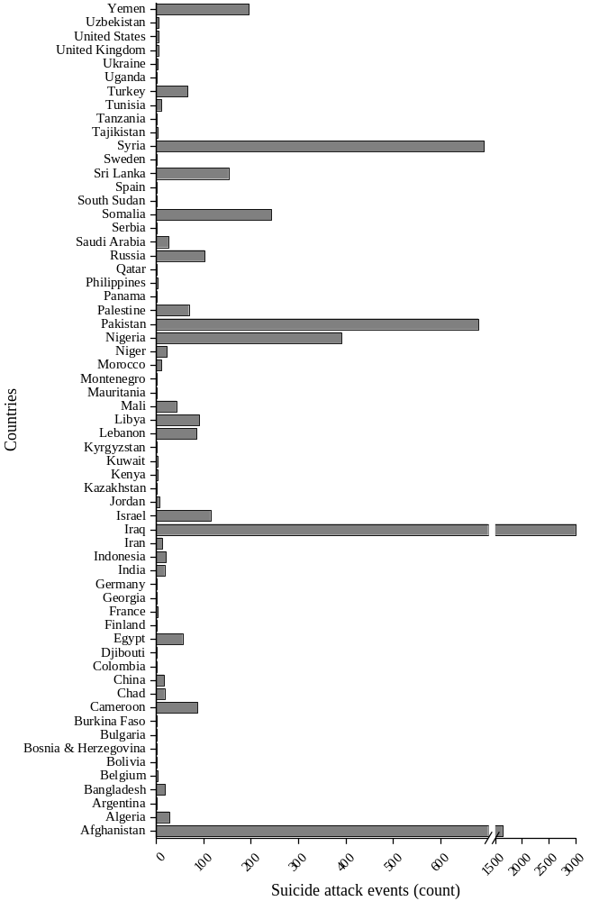

Fig. S2. Number of suicide attack events in different countries and regions. Observed number of the suicide attacks is 7,982 for the study.
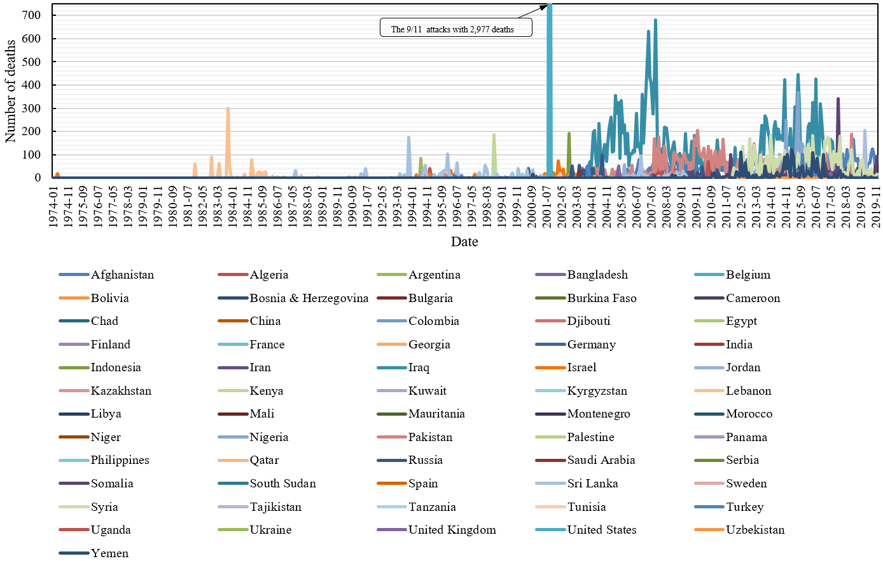

Fig. S3. Number of deaths from suicide attacks varies over time in different countries and regions. The Database on Suicide Attacks records the highest and lowest number of deaths reported by sources during a suicide attack event (news reports on the number of deaths in suicide attack incidents often differ). The average of the highest and lowest values is calculated to represent the deaths from a suicide attack, and the observed number of deaths from suicide attacks is 63,202 for the study.
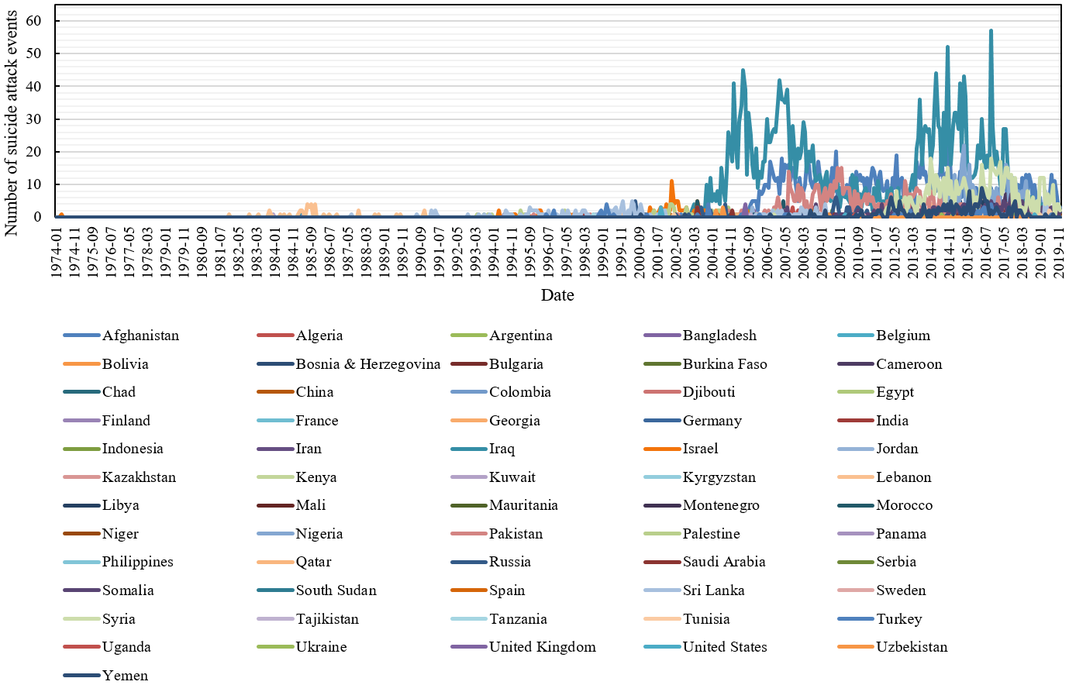

Fig. S4. Number of suicide attack events varies over time in different countries and regions. Observed number of the suicide attacks is 7,982 for the study.

A B
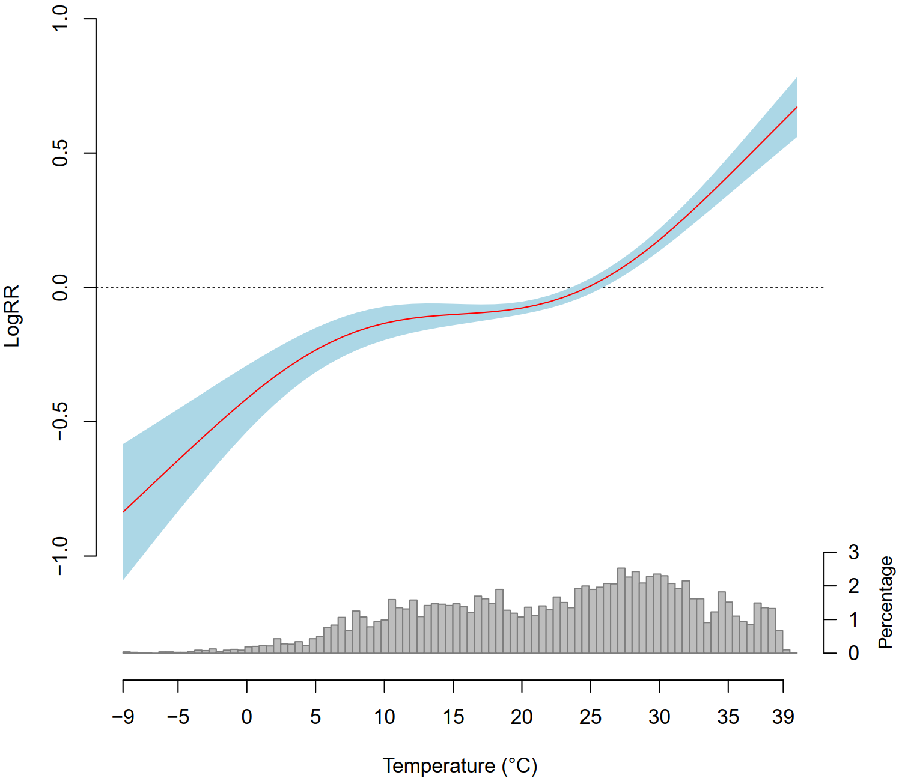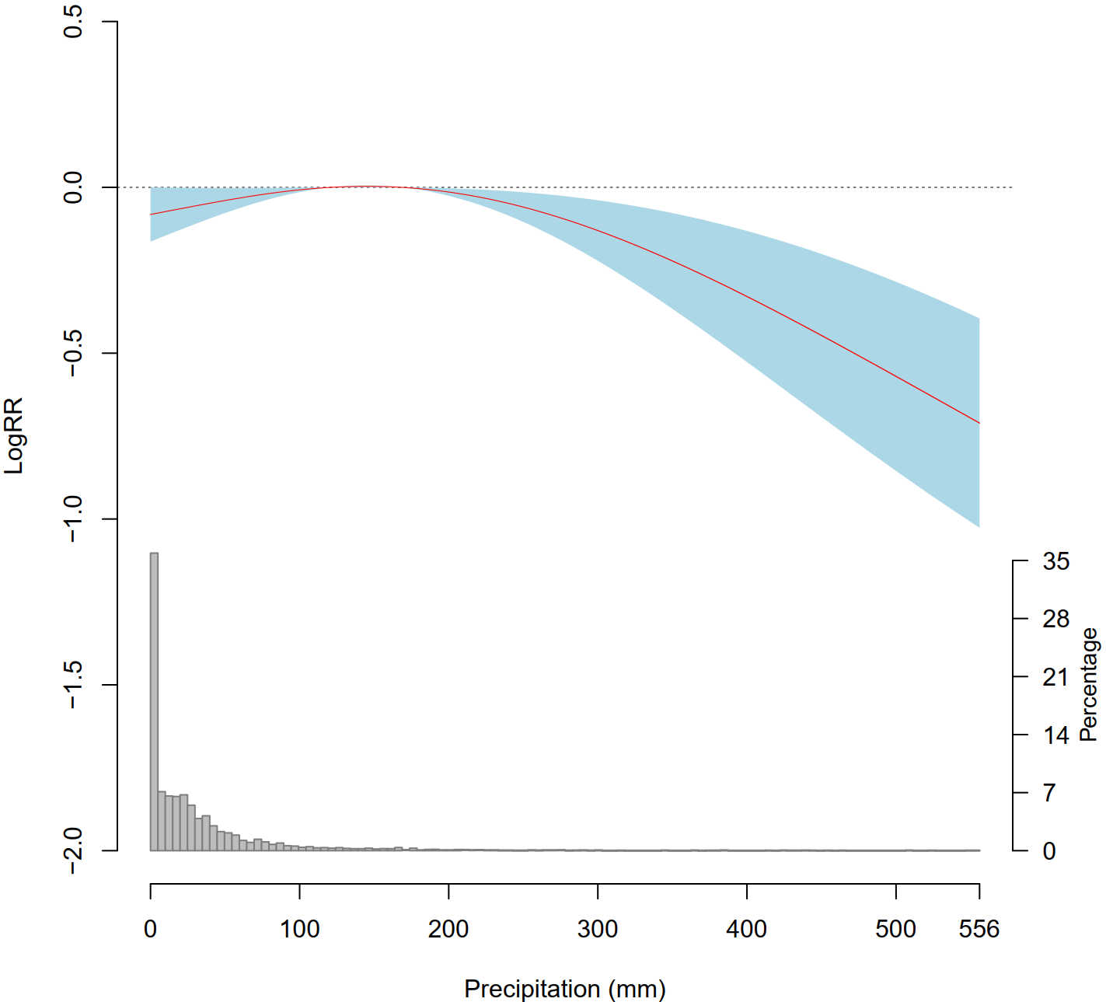

Fig. S5. Sensitivity check for the non-linear relationship between temperature variability and MFSA risk using alternative dependent variable definition of the minimum reported deaths. The red curve represents the estimated nonlinear effects at different values ​​of temperature or precipitation, the light blue area indicates the 95% confidence interval, and the gray histograms on the horizontal axis indicate the corresponding temperature and precipitation distribution, respectively. The ordinate represents the logarithm of the RR of MFSA. (A) Nonlinear curve of the relationship between temperature variability and MFSA risk. (B) Nonlinear curve of the relationship between precipitation variability and MFSA risk.

A B
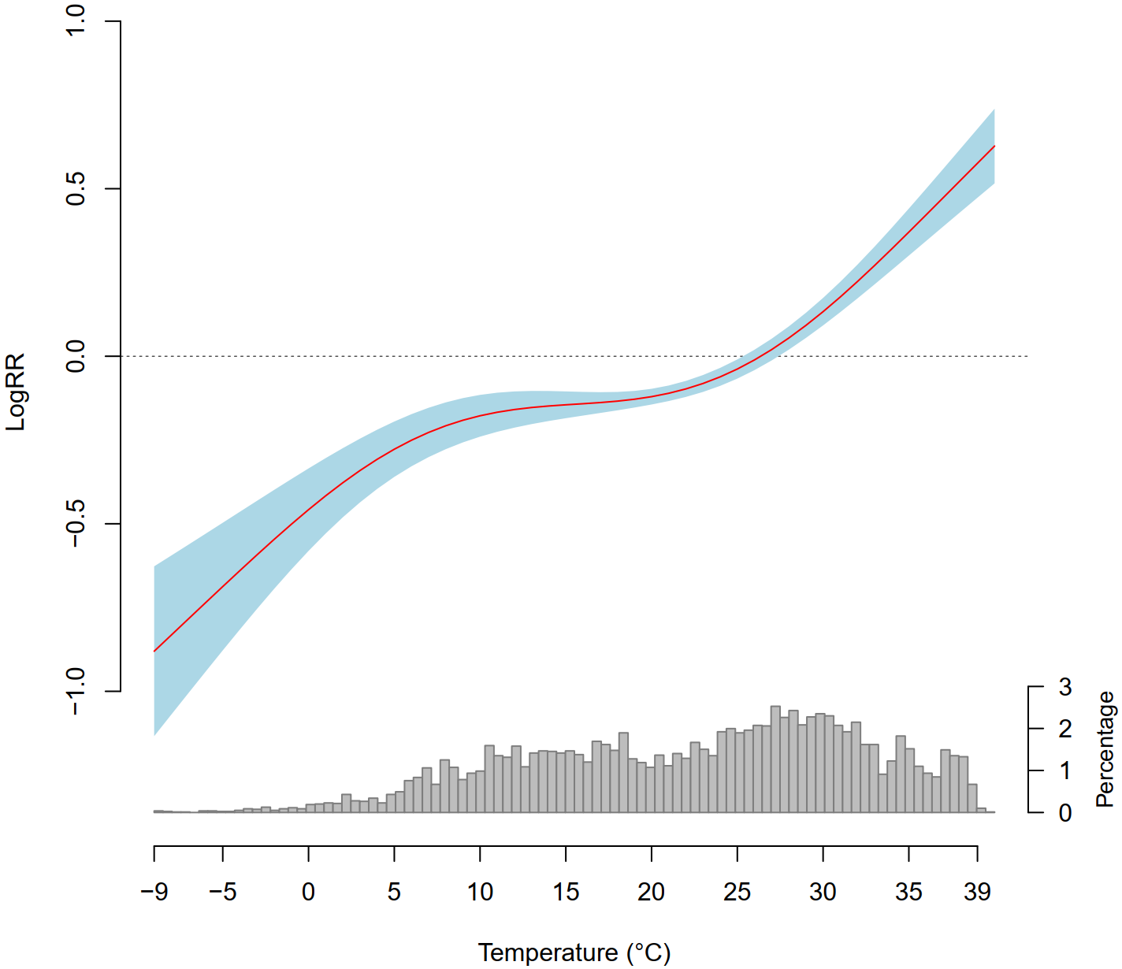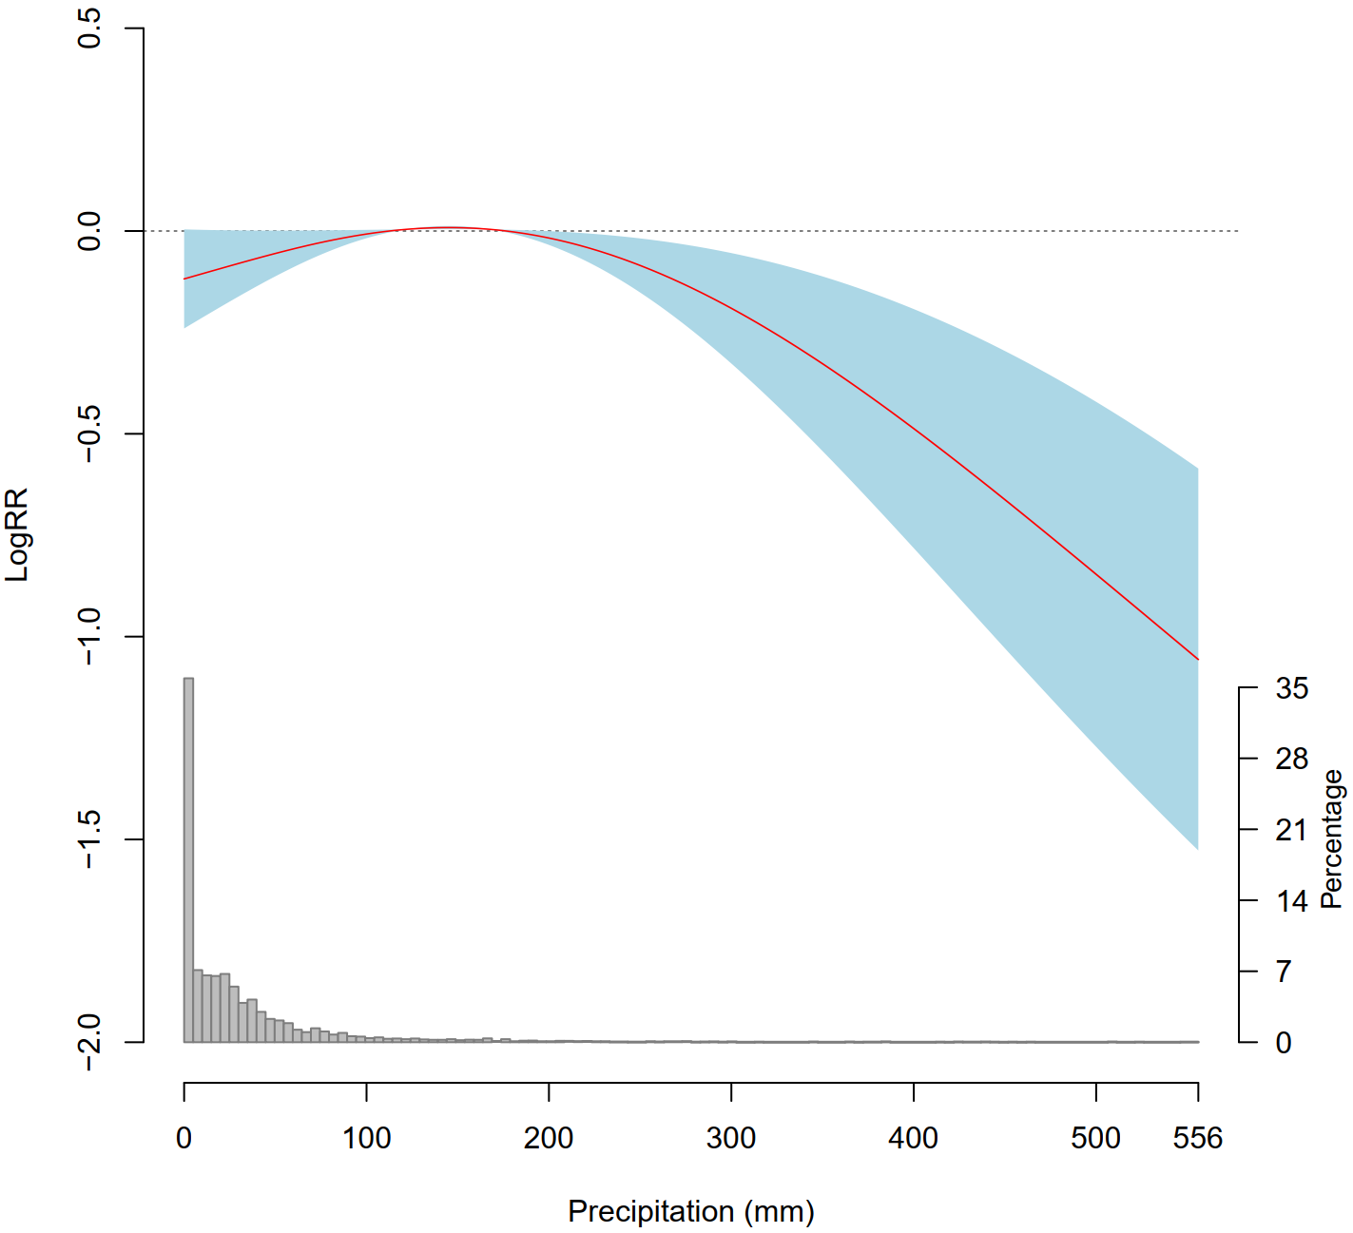

Fig. S6. Sensitivity check for the non-linear relationship between temperature variability and MFSA risk using alternative dependent variable definition of the median estimates. The red curve represents the estimated nonlinear effects at different values ​​of temperature or precipitation, the light blue area indicates the 95% confidence interval, and the gray histograms on the horizontal axis indicate the corresponding temperature and precipitation distribution, respectively. The ordinate represents the logarithm of the RR of MFSA. (A) Nonlinear curve of the relationship between temperature variability and MFSA risk. (B) Nonlinear curve of the relationship between precipitation variability and MFSA risk.

A B
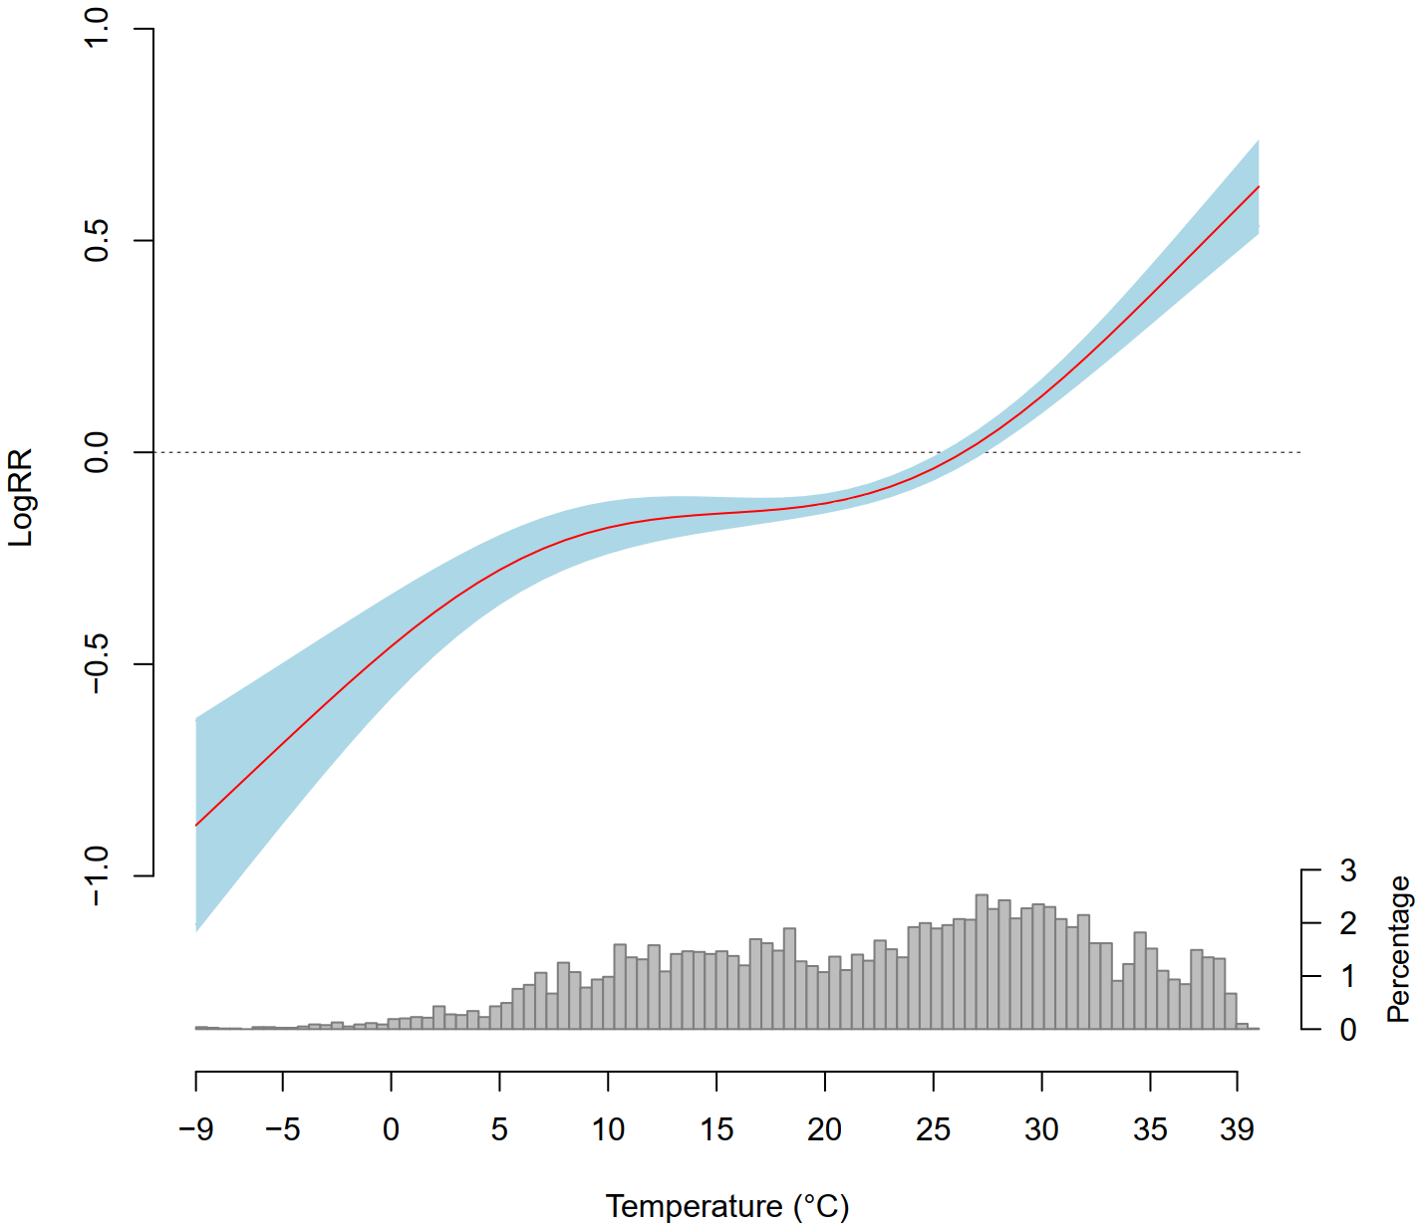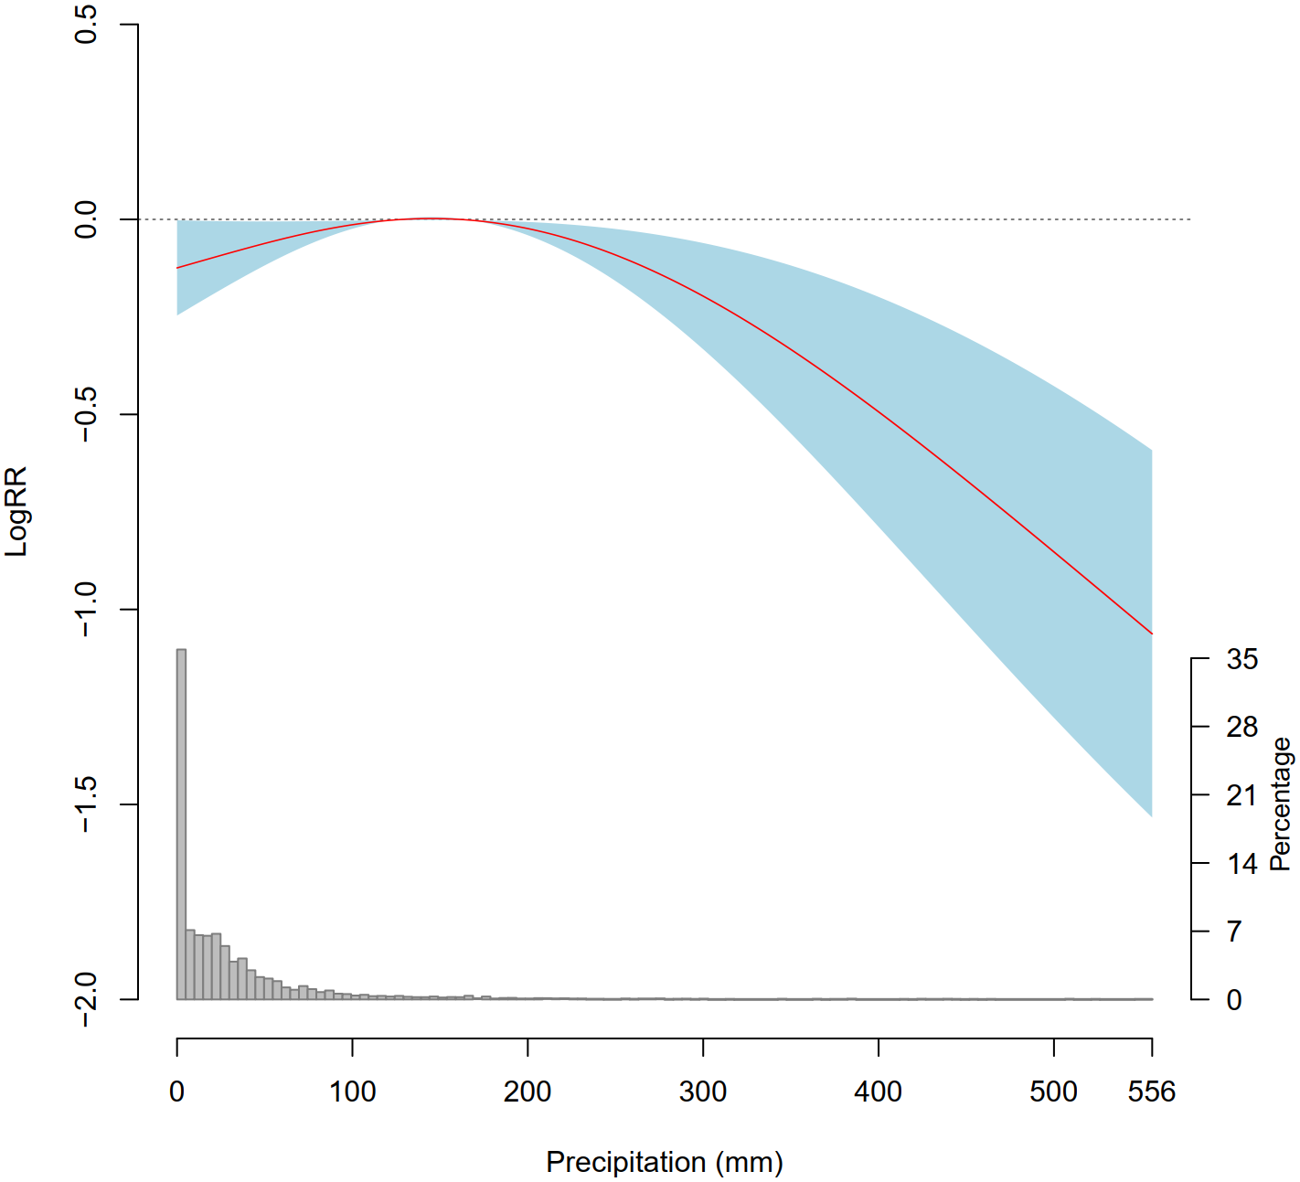

Fig. S7. Sensitivity check for the non-linear relationship between temperature variability and MFSA risk using alternative dependent variable definition of the maximum reported deaths. The red curve represents the estimated nonlinear effects at different values ​​of temperature or precipitation, the light blue area indicates the 95% confidence interval, and the gray histograms on the horizontal axis indicate the corresponding temperature and precipitation distribution, respectively. The ordinate represents the logarithm of the RR of MFSA. (A) Nonlinear curve of the relationship between temperature variability and MFSA risk. (B) Nonlinear curve of the relationship between precipitation variability and MFSA risk.
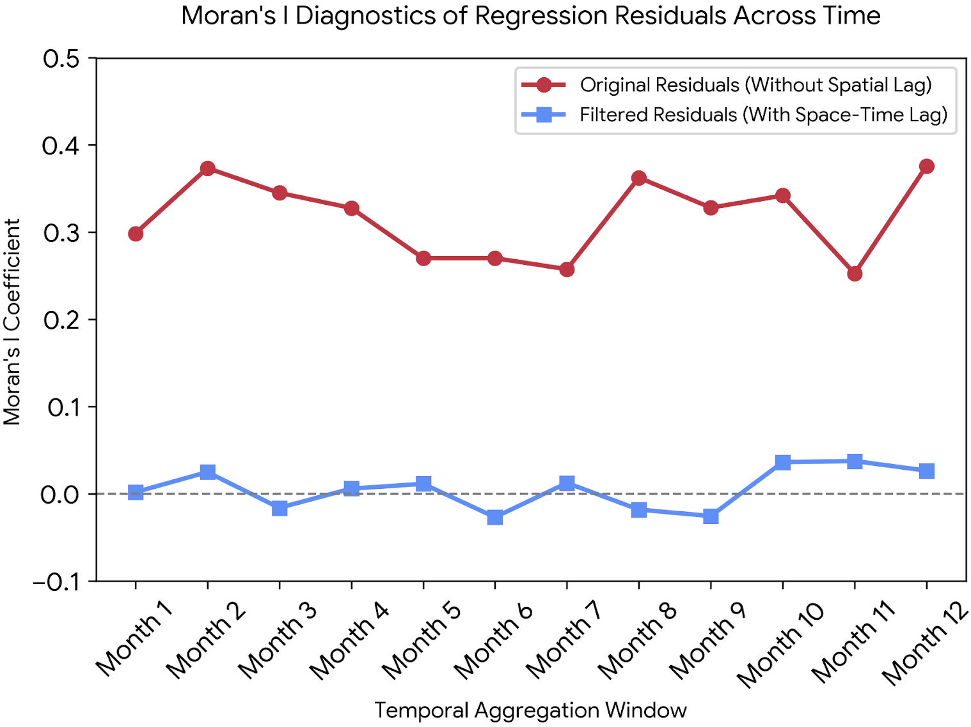

Fig. S8. Moran's I diagnostic results of residual spatial autocorrelation

2. Supplementary Tables

Table S1. Estimated effects of the regression model for temperature and precipitation variability and other variables.
Variable/Intercept | Estimated effect | 95% Confidence Interval | P-value
Temperature | 1.16 | (1.01-1.32) | 0.001*
Precipitation | 0.84 | (0.71-0.97) | 0.000*
Space-time lag | 0.86 | (0.73-1.02) | 0.024*
Consumer price index | 0.54 | (0.32-0.76) | 0.072
Gross domestic product per capita | 0.93 | (0.84-1.09) | 0.024*
People using safely managed drinking water services | 0.76 | (0.59-0.92) | 0.073
Number of refugees | 0.61 | (0.37-0.85) | 0.018*
Population | 0.68 | (0.41-0.88) | 0.082
Distance to the primary roads | 0.83 | (0.74-0.98) | 0.001*
Distance to the secondary roads | 0.91 | (0.83-1.12) | 0.024*
Distance to the border | 0.78 | (0.58-0.96) | 0.001*
Rating of political rights | 0.86 | (0.45-1.04) | 0.063
Rating of civil liberties | 0.78 | (0.62-0.97) | 0.071
Score of the electoral process | 0.75 | (0.63-0.84) | 0.003*
Score of the political rights | 0.82 | (0.64-1.05) | 0.001*
Score of the functioning of government | 0.59 | (0.34-0.89) | 0.078
Score of the freedom of expression and belief | 0.94 | (0.74-1.12) | 0.004*
Score of the associational and organizational rights | 1.14 | (0.83-1.29) | 0.076
Score of the rule of law | 1.09 | (0.95-1.23) | 0.086
Score of the personal autonomy and individual rights | 0.86 | (0.74-1.18) | 0.081
Within the ±3-month period of an presidential election | 1.17 | (0.98-1.36) | 0.002*
Within the ±3-month period of an parliamentary election | 1.07 | (0.91-1.25) | 0.069
Intercept | -8.26
Observed number of deaths is 63,202 for the model.
* indicates P < 0.05.

Table S2. Quantification of the overall effect of temperature and precipitation variability on MFSA risk with respect to different combinations of the confounding factors.
 | Relative risk of MFSA.
Variables of the confounding factors in the model | Temperature variability (℃) | Precipitation variability (mm)
Space-time lag  Gross domestic product per capita  Number of refugees  Population  Distance to the primary roads  Distance to the secondary roads  Distance to the border  Score of the electoral process  Score of the political rights  Score of the freedom of expression and belief  Within the ±3-month period of an presidential election | 1.24 | 0.84
Gross domestic product per capita  Number of refugees  Population  Distance to the primary roads  Distance to the secondary roads  Distance to the border  Score of the electoral process  Score of the political rights  Score of the freedom of expression and belief  Within the ±3-month period of an presidential election | 1.26 | 0.86
Number of refugees  Population  Distance to the primary roads  Distance to the secondary roads  Distance to the border  Score of the electoral process  Score of the political rights  Score of the freedom of expression and belief  Within the ±3-month period of an presidential election | 1.27 | 0.87
Population  Distance to the primary roads  Distance to the secondary roads  Distance to the border  Score of the electoral process  Score of the political rights  Score of the freedom of expression and belief  Within the ±3-month period of an presidential election | 1.23 | 0.83
Distance to the primary roads  Distance to the secondary roads  Distance to the border  Score of the electoral process  Score of the political rights  Score of the freedom of expression and belief  Within the ±3-month period of an presidential election | 1.25 | 0.85
Distance to the secondary roads  Distance to the border  Score of the electoral process  Score of the political rights  Score of the freedom of expression and belief  Within the ±3-month period of an presidential election | 1.26 | 0.84
Distance to the border  Score of the electoral process  Score of the political rights  Score of the freedom of expression and belief  Within the ±3-month period of an presidential election | 1.24 | 0.86
Score of the electoral process  Score of the political rights  Score of the freedom of expression and belief  Within the ±3-month period of an presidential election | 1.25 | 0.84
Score of the political rights  Score of the freedom of expression and belief  Within the ±3-month period of an presidential election | 1.24 | 0.86
Score of the freedom of expression and belief  Within the ±3-month period of an presidential election | 1.26 | 0.85
Within the ±3-month period of an presidential election | 1.22 | 0.84

Table S3. Estimated effects of the regression model for temperature and precipitation variability and other variables with respect to different methods of constructing the spatial weight matrix.
Spatial distance matrix |  |  | Inverse distance matrix |  |  | K-nearest neighbor matrix
Variable/Intercept | Estimated effect | P-value | Variable/Intercept | Estimated effect | P-value | Variable/Intercept | Estimated effect | P-value
Temperature | 1.18 | 0.001* | Temperature | 1.17 | 0.001* | Temperature | 1.18 | 0.001*
Precipitation | 0.82 | 0.000* | Precipitation | 0.83 | 0.000* | Precipitation | 0.82 | 0.000*
Space-time lag | 0.85 | 0.023* | Space-time lag | 0.84 | 0.022* | Space-time lag | 0.85 | 0.023*
Consumer price index | 0.56 | 0.075 | Consumer price index | 0.57 | 0.076 | Consumer price index | 0.56 | 0.075
Gross domestic product per capita | 0.95 | 0.022* | Gross domestic product per capita | 0.92 | 0.021* | Gross domestic product per capita | 0.95 | 0.023*
People using safely managed drinking water services | 0.73 | 0.056 | People using safely managed drinking water services | 0.77 | 0.052 | People using safely managed drinking water services | 0.73 | 0.056
Number of refugees | 0.64 | 0.017* | Number of refugees | 0.62 | 0.016* | Number of refugees | 0.64 | 0.018*
Population | 0.69 | 0.081 | Population | 0.65 | 0.083 | Population | 0.69 | 0.081
Distance to the primary roads | 0.85 | 0.001* | Distance to the primary roads | 0.82 | 0.001* | Distance to the primary roads | 0.85 | 0.001*
Distance to the secondary roads | 0.92 | 0.003* | Distance to the secondary roads | 0.93 | 0.002* | Distance to the secondary roads | 0.92 | 0.003*
Distance to the border | 0.79 | 0.001* | Distance to the border | 0.76 | 0.001* | Distance to the border | 0.79 | 0.001*
Rating of political rights | 0.83 | 0.065 | Rating of political rights | 0.82 | 0.062 | Rating of political rights | 0.83 | 0.065
Rating of civil liberties | 0.76 | 0.074 | Rating of civil liberties | 0.75 | 0.073 | Rating of civil liberties | 0.76 | 0.074
Score of the electoral process | 0.72 | 0.002* | Score of the electoral process | 0.74 | 0.004* | Score of the electoral process | 0.72 | 0.002*
Score of the political rights | 0.84 | 0.001* | Score of the political rights | 0.81 | 0.001* | Score of the political rights | 0.84 | 0.001*
Score of the functioning of government | 0.61 | 0.077 | Score of the functioning of government | 0.58 | 0.076 | Score of the functioning of government | 0.61 | 0.079
Score of the freedom of expression and belief | 0.95 | 0.003* | Score of the freedom of expression and belief | 0.92 | 0.004* | Score of the freedom of expression and belief | 0.95 | 0.002*
Score of the associational and organizational rights | 1.13 | 0.077 | Score of the associational and organizational rights | 1.12 | 0.076 | Score of the associational and organizational rights | 1.13 | 0.075
Score of the rule of law | 1.07 | 0.084 | Score of the rule of law | 1.06 | 0.082 | Score of the rule of law | 1.07 | 0.084
Score of the personal autonomy and individual rights | 0.84 | 0.082 | Score of the personal autonomy and individual rights | 0.83 | 0.081 | Score of the personal autonomy and individual rights | 0.84 | 0.083
Within the ±3-month period of an presidential election | 1.19 | 0.002* | Within the ±3-month period of an presidential election | 1.16 | 0.001* | Within the ±3-month period of an presidential election | 1.19 | 0.002*
Within the ±3-month period of an parliamentary election | 1.08 | 0.067 | Within the ±3-month period of an parliamentary election | 1.05 | 0.068 | Within the ±3-month period of an parliamentary election | 1.08 | 0.067
Intercept | -8.25 |  | Intercept | -8.26 |  | Intercept | -8.27
* indicates P < 0.05.

Table S4. The displacement effects of a larger range of temperature and precipitation variability on MFSA risk.
Month (t) | Estimation effect of temperature variability | 95% Confidence Interval | Estimation effect of precipitation variability | 95% Confidence Interval
t-7 | 0.92 | (0.79-1.22) | 0.93 | (0.82-1.05)
t-8 | 0.87 | (0.71-1.05) | 0.89 | (0.76-1.02)
t-9 | 0.94 | (0.81-1.07) | 0.97 | (0.86-1.08)
t-10 | 0.96 | (0.84-1.06) | 1.01 | (0.90-1.12)
t-11 | 0.89 | (0.75-1.03) | 1.03 | (0.92-1.14)
t-12 | 0.93 | (0.81-1.02) | 0.95 | (0.84-1.06)
t+7 | 1.02 | (0.89-1.15) | 1.04 | (0.93-1.15)
t+8 | 0.93 | (0.81-1.05) | 1.02 | (0.91-1.13)
t+9 | 0.89 | (0.77-1.01) | 0.96 | (0.85-1.07)
t+10 | 1.08 | (0.96-1.21) | 0.98 | (0.88-1.08)
t+11 | 1.04 | (0.92-1.16) | 1.03 | (0.93-1.13)
t+12 | 0.96 | (0.84-1.08) | 1.06 | (0.95-1.17)

Table S5. Multicollinearity diagnostics for the specific sub-items of political rights, civil liberties, and institutional event windows.
Variable category | Specific political dimension / Indicator | VIF | Tolerance (1/VIF)
Political rights (PR) | Electoral process | 3.14 | 0.318
Political rights (PR) | Political pluralism and participation | 3.42 | 0.292
Political rights (PR) | Functioning of government | 2.95 | 0.339
Civil liberties (CL) | Freedom of expression and belief | 2.81 | 0.356
Civil liberties (CL) | Associational and organizational rights | 3.26 | 0.307
Civil liberties (CL) | Rule of law | 3.08 | 0.325
Civil liberties (CL) | Personal autonomy and individual rights | 2.47 | 0.405
Aggregate indicator | Overall freedom rating (1 to 7 scale) | 3.65 | 0.274
Institutional event | Election window (±3 month) | 1.05 | 0.952

