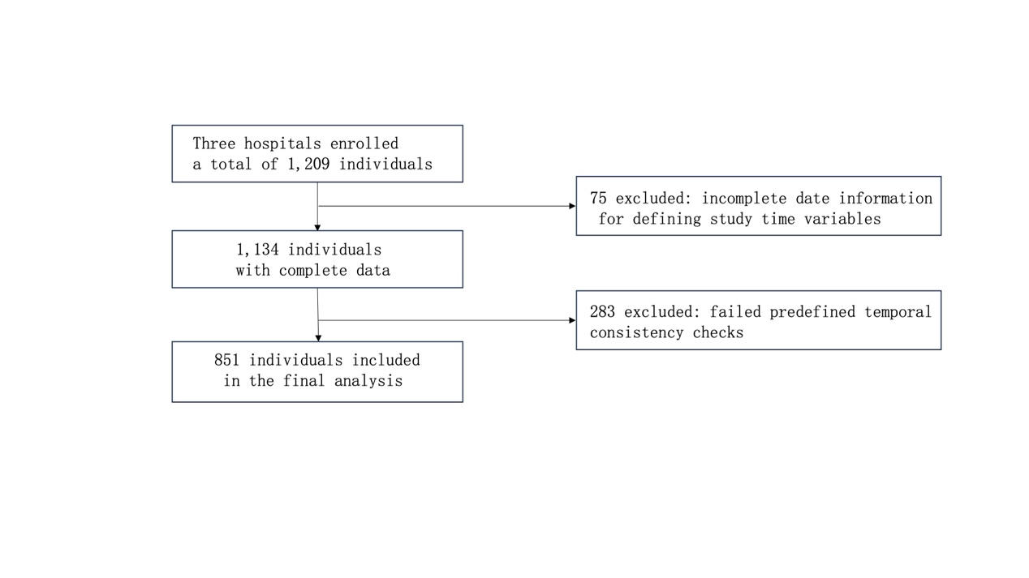
Appendix Figure S1：Patient Flowchart

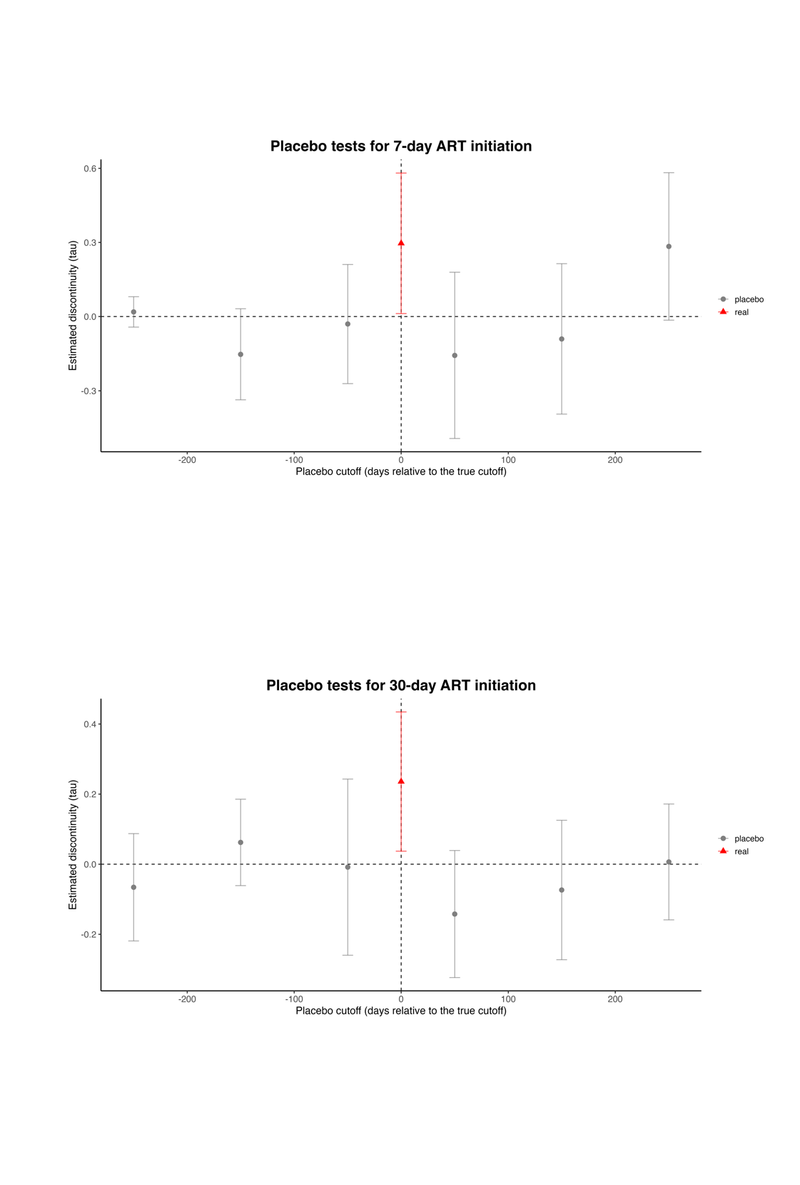
Appendix Figure S2：Placebo cutoff tests for regression discontinuity estimates.
Notes: Placebo regression discontinuity estimates at false cutoffs (±50, ±150, and ±250 days from the true cutoff) for three study outcomes. Effects are evident only at the true policy cutoff.

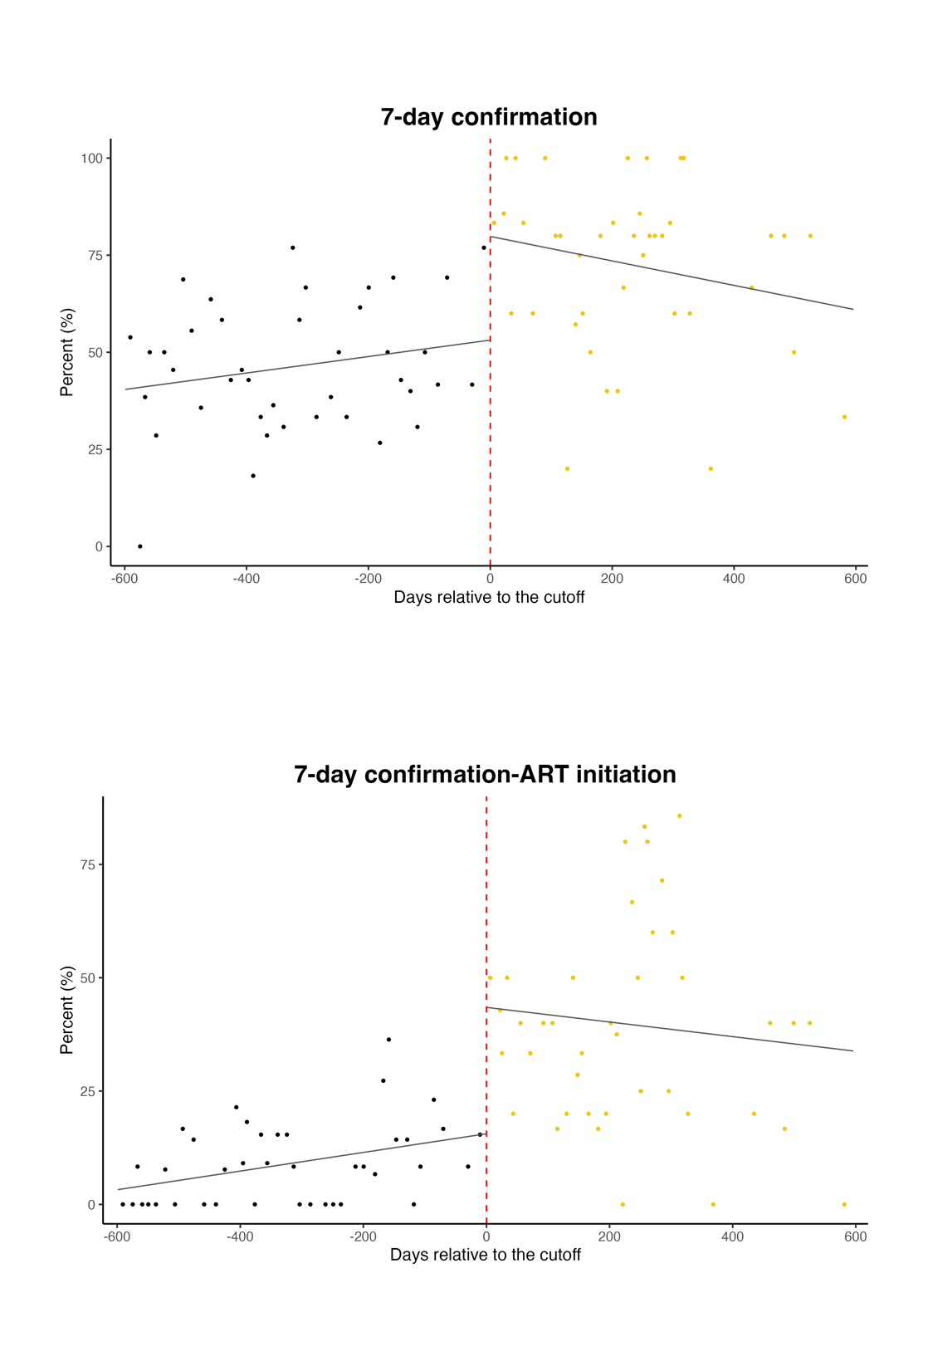
Appendix Figure S3: Regression discontinuity estimates of the effects of the hospital-based NAT-confirmation one-stop service model on 7-day confirmatory diagnosis and 7-day post-confirmation ART initiation.

Appendix Figure S4: Regression discontinuity estimates of the effects of the hospital-based NAT-confirmation one-stop service model on 30-day confirmatory diagnosis and 30-day post-confirmation ART initiation.
Appendix Table S1: Baseline characteristics of the extracted patients before and after the policy cutoff.
Variable | Overall (N=358) | Before cutoff (n=110) | After cutoff (n=248) | P value
Age group, years |  |  |  | 0.371
<50 | 235 (65.6%) | 68 (61.8%) | 167 (67.3%)
≥50 | 123 (34.4%) | 42 (38.2%) | 81 (32.7%)
Sex |  |  |  | 0.751
Male | 301 (84.1%) | 94 (85.5%) | 207 (83.5%)
Female | 57 (15.9%) | 16 (14.5%) | 41 (16.5%)
Marital status |  |  |  | 1.000
Married or partnered | 146 (40.8%) | 45 (40.9%) | 101 (40.7%)
Unmarried or other | 212 (59.2%) | 65 (59.1%) | 147 (59.3%)
Education |  |  |  | 0.003
High school or above | 180 (50.3%) | 42 (38.2%) | 138 (55.6%)
Middle school or below | 178 (49.7%) | 68 (61.8%) | 110 (44.4%)
Transmission route |  |  |  | 0.041
Same-sex transmission | 154 (43.0%) | 38 (34.5%) | 116 (46.8%)
Non-same-sex transmission | 204 (57.0%) | 72 (65.5%) | 132 (53.2%)
Study setting |  |  |  | <0.001
Dongguan | 109 (30.4%) | 47 (42.7%) | 62 (25.0%)
Qingyuan | 46 (12.8%) | 32 (29.1%) | 14 (5.6%)
Zhuhai | 203 (56.7%) | 31 (28.2%) | 172 (69.4%)
Enrollment CD4 count, cells/μL |  |  |  | 0.024
<200 | 135 (37.7%) | 48 (43.6%) | 87 (35.1%)
≥200 | 192 (53.6%) | 48 (43.6%) | 144 (58.1%)
Missing/other | 31 (8.7%) | 14 (12.7%) | 17 (6.9%)

Appendix Table S2. Covariate continuity tests at the cutoff
Covariate | RD estimate | SE | p value
Education | −0.075 | 0.219 | 0.731
Marital status | 0.101 | 0.279 | 0.716
Transmission route | 0.317 | 0.272 | 0.245
Sex | 0.464 | 0.217 | 0.032
Notes: Covariate balance around the cutoff was assessed using t tests for continuous variables and χ² tests for categorical variables. The results indicate no substantial discontinuities in most baseline covariates at the cutoff, supporting the validity of the regression discontinuity design. A modest imbalance was observed for sex; this variable was therefore adjusted for in all regression discontinuity models.

Appendix Table S3. Descriptive statistics and regression discontinuity estimates for key time intervals before and after policy implementation
Outcome | Pre- implementation,  median [P25, P75] (n) | Post-implementation,  median [P25, P75] (n) | RD estimate  (SE), days |  | 95% CI | P value
Initial reactive screening to confirmatory, days | 7 [5, 9] (578) | 4 [2, 7] (273) | -2.33 (4.12) | -10.4 to 5.74 |  | 0.571
Confirmatory to ART initiation, days | 7 [3, 14] (578) | 5 [2, 10] (273) | -21.6 (16.5) | -53.9 to 10.8 |  | 0.191
Notes: ART, antiretroviral therapy; CI, confidence interval; P25, 25th percentile; P75, 75th percentile; RD, regression discontinuity; SE, standard error. RD estimates were obtained from covariate-adjusted regression discontinuity models. Negative estimates indicate a reduction in the interval after policy implementation. Bandwidths and effective sample sizes are shown separately for observations to the left and right of the cutoff.

Appendix Table S4. Same-day ART initiation after confirmatory diagnosis before and after policy implementation
Period | Total participants, n | Same-day ART initiation, n (%)
Before implementation | 578 | 13 (2.25)
After implementation | 273 | 18 (6.59)
Notes: Same-day ART initiation was defined as ART initiation on the same calendar day as confirmatory diagnosis (interval = 0 days). Values are descriptive and are not regression discontinuity effect estimates.

Appendix Table S5. Bandwidth sensitivity analyses for ART initiation
Panel A. 7-day ART initiation
Bandwidth multiplier | τ | 95% CI | p value | N (left) | N (right)
0.6 | 0.308 | −0.050–0.666 | 0.091 | 58 | 54
0.8 | 0.311 | -0.016–0.590 | 0.051 | 92 | 77
1.2 | 0.284 | 0.041–0.526 | 0.021 | 1588 | 124
1.4 | 0.229 | 0.005–0.453 | 0.044 | 184 | 148
Panel B. 30-day ART initiation
Bandwidth multiplier | τ | 95% CI | p value | N (left) | N (right)
0.6 | 0.196 | −0.043–0.436 | 0.108 | 71 | 75
0.8 | 0.241 | 0.025–0.457 | 0.028 | 112 | 98
1.2 | 0.202 | 0.016–0.389 | 0.033 | 172 | 163
1.4 | 0.171 | -0.002–0.344 | 0.089 | 201 | 178
Notes: Estimates are from local linear regression discontinuity models with triangular kernels. Bandwidths are expressed as multiples of the MSE-optimal bandwidth. τ denotes the estimated discontinuity at the cutoff.

Appendix Table S6. Estimated pre- and post-implementation ART initiation rates and risk differences
Outcome | Pre-implementation (95% CI) | Post-implementation (95% CI) | Risk Difference  (95%CI) | p-value
Confirmatory within 7 days | 70.6% (53.5%–87.6%) | 96.8% (79.8%–100%) | 26.3% (0.0%–52.3%) | 0.048
ART initiation within 7 days after confirmatory | 14.4% (3.8%–25.1%) | 45.4% (29.5%–61.3%) | 31.0%  (4.3%–57.6%) | 0.023
Confirmatory within 30 days | 93.8% (85.7%–100.0%) | 99.0% (93.3%–100.0%) | 5.2%  (-5.0%-12.7%) | 0.390
ART initiation within 30 days after confirmatory | 70.3% (58.7%–81.9%) | 93.6% (84.4%–100.0%) | 23.3%  (3.4%–43.2%) | 0.022
Note: Values are percentages. Pre- and post-implementation estimates represent local outcome rates on either side of the cutoff. Risk differences and p-values were obtained from the main regression discontinuity analyses. Bandwidths are presented as left/right of the cutoff.

Appendix Table S7. Intraclass Correlation Coefficients (ICC) at the Hospital Level for Study Outcomes
Outcome | 7-day ART initiation | 30-day ART initiation
ICC | 0.143 | 0.018
Notes: Intraclass correlation coefficients (ICCs) were estimated from empty mixed-effects logistic models with a random intercept for hospital. The ICC represents the proportion of total outcome variance attributable to between-hospital differences. All three outcomes showed low levels of hospital-level clustering (ICC < 0.15), indicating minimal intra-hospital correlation. Therefore, hospital-level clustering was not explicitly accounted for in the main regression discontinuity analyses.

