Appendix A: Supplementary Data
Associations between individual-level factors and adherence to social distancing measures during the COVID-19 pandemic: A global meta-analysis

Dewan Md. Sumsuzzman,¹ Congjie Shi,^{2,3} Gergely Röst,³ Jianhong Wu,²
Seyed M. Moghadas¹
¹ Agent-Based Modelling Laboratory, Centre of Excellence in AI for Public Health Advancement, York University, Toronto, ON M3J 1P3, Canada
² Department of Mathematics and Statistics, Centre of Excellence in AI for Public Health Advancement, York University, Toronto, ON M3J 1P3, Canada
³ National Laboratory for Health Security, University of Szeged, 6720 Szeged, Hungary

TABLE OF CONTENTS
SEARCH STRATEGY 3
SUPPLEMENTARY METHODS 6
Operational definitions and data harmonisation 6
Eligibility criteria 10
Data transformation 11
SUPPLEMENTARY TABLES 12
Table S1. Excluded studies in full-text review. 12
Table S2: Quality assessment of included studies using the JBI critical appraisal tool. 14
Table S3: Subgroup analysis by WHO regions. 16
SUPPLEMENTARY FIGURES 18
Figure S1. Decision framework for transforming linear regression outputs to correlation. 18
Figure S2. Decision framework for transforming logistic regression outputs to correlation. 19
Figure S3. Forest plot showing the pooled correlation between education level and adherence to social distancing measures. 20
Figure S4. Forest plot showing the pooled correlation between increased age and adherence to social distancing measures. 21
Figure S5. Forest plot showing the pooled correlation between female sex and adherence to social distancing measures. 22
Figure S6. Forest plot showing the pooled correlation between being married and adherence to social distancing measures. 23
Figure S7. Forest plot showing the pooled correlation between greater risk and severity perceptions and adherence to social distancing measures. 23
Figure S8. Forest plot showing the pooled correlation between conservative political ideology and adherence to social distancing measures. 24
Figure S9. Forest plot showing the pooled correlation between urban residency and adherence to social distancing measures. 24
Figure S10. Forest plot showing the pooled correlation between comorbidity and adherence to social distancing measures. 25
Figure S11. Forest plot showing the pooled correlation between being essential worker and adherence to social distancing measures. 25
Figure S12. Forest plot showing the pooled correlation between appropriate government response and adherence to social distancing measures. 26
Figure S13. Forest plot showing the pooled correlation between smoking and adherence to social distancing measures. 26
Figure S14. Forest plot showing the pooled correlation between being employed and adherence to social distancing measures. 27
Figure S15. Forest plot showing the pooled correlation between knowledge and awareness and adherence to social distancing measures. 27
Figure S16. Forest plot showing the pooled correlation between higher income and adherence to social distancing measures. 28
Figure S17. Forest plot of subgroup meta-analysis by the adjustment status of the determinant across included studies. 29
Figure S18. Meta‑regression assessing temporal variation in determinants of adherence to social distancing measures. 30
Figure S19. Forest plot of sensitivity analyses restricted to studies in community settings. 30
Figure S20. Forest plot of sensitivity analyses restricted to studies in general populations. 31
Figure S21. Funnel plot for being married with trim-and-fill correction. 32

SEARCH STRATEGY
Database: Ovid MEDLINE(R) and Epub Ahead of Print, In-Process, In-Data-Review & Other Non-Indexed Citations, Daily and Versions <1946 to August 20, 2025>
1 exp Coronavirus Infections/ or exp Coronavirus/ or exp COVID-19/ or exp SARS-CoV-2/ 311554
2 ("2019 nCoV" or 2019nCoV or coronavir* or coronovir* or COVID or COVID19 or HCoV* or "nCov 2019" or "SARS CoV2" or "SARS CoV 2" or SARSCoV2 or "SARSCoV 2").ti,ab. 469968
3 1 or 2 480155
4 (("Social distance" or "Social distancing" or "physical distance" or "physical distancing") adj3 (compliance or compliancy or comply or complied or adherence or adherency or adhere or adhering or adhered or acceptance or follow or following or followed or rule or rules or guide or guidelines or guideline or guided or prevent or preventative or preventing or prevented or reason or reasons or associate or associated or associations or predict or predictors or predicted or explanatory or explained or explain or campaign or campaigns or factor or factors or facilitate or encourage or motivate or motivation or motivating or determinant or determinants)).mp. 1754
5 3 and 4 1669
6 limit 5 to dt="20200101 -20250820" 1669

Database: Embase <1974 to 2025 August 20, 2025>
1 exp Coronavirus Infections/ or exp Coronavirus/ or exp COVID-19/ or exp SARS-CoV-2/ 565792
2 ("2019 nCoV" or 2019nCoV or coronavir* or coronovir* or COVID or COVID19 or HCoV* or "nCov 2019" or "SARS CoV2" or "SARS CoV 2" or SARSCoV2 or "SARSCoV 2").ti,ab. 582295
3 1 or 2 650140
4 (("Social distance" or "Social distancing" or "physical distance" or "physical distancing") adj3 (compliance or compliancy or comply or complied or adherence or adherency or adhere or adhering or adhered or follow or following or followed or rule or rules or guide or guidelines or guideline or guided or prevent or preventative or preventing or prevented or reason or reasons or associate or associated or associations or predict or predictors or predicted or explanatory or explained or explain or campaign or campaigns or factor or factors or facilitate or encourage or motivate or motivation or motivating or determinant or determinants)).mp. 2019
5 3 and 4 1779
6 limit 5 to dt="20200101 -20250820" 1779
Database: Global Health <1973 to August 20, 2025>
1 exp Coronavirus Infections/ or exp Coronavirus/ or exp COVID-19/ or exp SARS-CoV-2/ 197413
2 ("2019 nCoV" or 2019nCoV or coronavir* or coronovir* or COVID or COVID19 or HCoV* or "nCov 2019" or "SARS CoV2" or "SARS CoV 2" or SARSCoV2 or "SARSCoV 2").ti,ab. 217328
3 1 or 2 220853
4 (("Social distance" or "Social distancing" or "physical distance" or "physical distancing") adj3 (compliance or compliancy or comply or complied or adherence or adherency or adhere or adhering or adhered or acceptance or follow or following or followed or rule or rules or guide or guidelines or guideline or guided or prevent or preventative or preventing or prevented or reason or reasons or associate or associated or associations or predict or predictors or predicted or explanatory or explained or explain or campaign or campaigns or factor or factors or facilitate or encourage or motivate or motivation or motivating or determinant or determinants)).mp. 1002
5 3 and 4 945

Database: APA PsycInfo <1806 to August 20, 2025>
1 exp Coronavirus Infections/ or exp Coronavirus/ or exp COVID-19/ or exp SARS-CoV-2/ 54438
2 ("2019 nCoV" or 2019nCoV or coronavir* or coronovir* or COVID or COVID19 or HCoV* or "nCov 2019" or "SARS CoV2" or "SARS CoV 2" or SARSCoV2 or "SARSCoV 2").ti,ab. 66268
3 1 or 2 67448
4 (("Social distance" or "Social distancing" or "physical distance" or "physical distancing") adj3 (compliance or compliancy or comply or complied or adherence or adherency or adhere or adhering or adhered or acceptance or follow or following or followed or rule or rules or guide or guidelines or guideline or guided or prevent or preventative or preventing or prevented or reason or reasons or associate or associated or associations or predict or predictors or predicted or explanatory or explained or explain or campaign or campaigns or factor or factors or facilitate or encourage or motivate or motivation or motivating or determinant or determinants)).mp. 943
5 3 and 4 662

Database: Web of Science Core Collection (August 20, 2025)
1 "TS=((Coronavirus Infections or Coronavirus or COVID-19 or SARS-CoV-2)) 680424
2 "TS=(("2019 nCoV" or 2019nCoV or coronavir* or coronovir* or COVID or COVID19 or HCoV* or ""nCov 2019"" or ""SARS CoV2"" or ""SARS CoV 2"" or SARSCoV2 or "SARSCoV 2")) 697660
3 "#1 OR #2 697660
4 "TS=(("Social distance" or "Social distancing" or "physical distance" or "physical distancing") NEAR/3 (compliance or compliancy or comply or complied or adherence or adherency or adhere or adhering or adhered or acceptance or follow or following or followed or rule or rules or guide or guidelines or guideline or guided or prevent or preventative or preventing or prevented or reason or reasons or associate or associated or associations or predict or predictors or predicted or explanatory or explained or explain or campaign or campaigns or factor or factors or facilitate or encourage or motivate or motivation or motivating or determinant or determinants)) 3322
5 "#3 AND #4 2659

Database: Scopus (August 20, 2025)
INDEXTERMS("Coronavirus Infections") OR INDEXTERMS(Coronavirus) OR INDEXTERMS(COVID-19) OR INDEXTERMS(SARS-CoV-2) OR TITLE-ABS("2019 nCoV" OR 2019nCoV OR coronavir* OR coronovir* OR COVID OR COVID19 OR HCoV* OR "nCov 2019" OR "SARS CoV2" OR "SARS CoV 2" OR SARSCoV2 OR "SARSCoV 2" ) AND TITLE-ABS-KEY(("Social distance" OR "Social distancing" OR "physical distance" OR "physical distancing" ) W/3 (compliance OR compliancy OR comply OR complied OR adherence OR adherency OR adhere OR adhering OR adhered OR acceptance OR follow OR following OR followed OR rule OR rules OR guide OR guidelines OR guideline OR guided OR prevent OR preventative OR preventing OR prevented OR reason OR reasons OR associate OR associated OR associations OR predict OR predictors OR predicted OR explanatory OR explained OR explain OR campaign OR campaigns OR factor OR factors OR facilitate OR encourage OR motivate OR motivation OR motivating OR determinant OR determinants )) AND PUBYEAR > 2019 AND PUBYEAR < 2026 3090

SUPPLEMENTARY METHODS

Operational definitions and data harmonisation
A. Outcome
Social distancing: Social distancing refers to a set of non-pharmaceutical measures designed to reduce close contact between individuals and thereby slow the transmission of infectious diseases (Sørensen et al., 2021). It involves avoiding congregate settings and mass gatherings, and maintaining a physical distance of approximately 6 feet (2 meters) from others whenever possible (Centers for Disease Control and Prevention, 2020). Congregate settings are defined as crowded public environments where close interpersonal contact may occur, such as shopping centers, movie theaters, stadiums, workplaces, and schools and other classroom settings.
B. Determinants of adherence
Determinants were classified into two groups to facilitate harmonisation and comparability across studies: (1) categorical determinants, typically reported as discrete variables (residency status, sex, marital status, comorbidity, essential worker status, government response, smoking, and employment status); and (2) mixed-format determinants, reported in both categorical and continuous formats (age, education, income, political ideology, knowledge and awareness, and risk and severity perceptions). This classification enabled harmonisation of categorical variables into standardised binary groupings while allowing continuous variables to be retained in their original form, minimising information loss and supporting robust meta-analysis.
Categorical determinants
We identified eight determinants consistently reported as categorical variables with sufficient data to estimate their association with adherence to social distancing. These included residency status, sex, marital status, comorbidity, essential worker status, government response, smoking, and employment status. Categories were harmonised using study-specific definitions to maximise comparability across studies, and reference categories are indicated in parentheses.
1. Residency status: Defined as participants’ living location according to study-specific classification. Categories were harmonised as urban vs rural (Reference: rural).
2. Sex: Defined as biological sex reported by participants. Categories were harmonised as female vs male (Reference: male).
3. Marital status: Defined as the current marital status of participants. Categories were harmonised as married vs unmarried (Reference: unmarried).
4. Comorbidity: Defined as the presence of one or more chronic health conditions. Categories were harmonised as comorbidity vs no comorbidity, (Reference: no comorbidity).
5. Essential worker: Defined as employment in a role considered critical to maintaining public health, safety, infrastructure, and basic services during the COVID-19 response, as per study-specific classification. This includes healthcare workers and other essential workers required to work outside the home during confinement periods. Categories were harmonised as essential vs non-essential worker (Reference: non-essential worker).
6. Government response: Defined as participants’ assessment of the adequacy and strictness of public health measures implemented by government authorities during the COVID-19 pandemic, including appropriateness of response, social distancing rules, and mask mandates. Categories were harmonised as yes response vs no response (Reference: no response).
7. Smoking status: Defined as self-reported cigarette or tobacco smoking behaviour by participants in the original study. Categories were harmonised as smoker vs non-smoker (Reference: non-smoker).
8. Employment status: Defined as the occupational status of participants at the time of data collection. Categories were harmonised as employed vs unemployed (Reference: unemployed). Employed includes full-time, part-time, self-employed, and government or private sector roles. Unemployed included individuals not engaged in paid work, including those who are jobless, retired, or unable to work due to illness or disability.
Mixed-format determinants
Six determinants were reported across studies in both categorical and continuous formats: political ideology, knowledge and awareness, age, education, income, and risk or severity perception. Categorical data were harmonised using study-specific definitions, with reference categories indicated in parentheses. For meta-analysis, effect estimates from both categorical and continuous formats were converted to a common metric (i.e., correlation coefficients, r) using established transformation formulas (see Data transformation section), following Cochrane guidance on harmonising mixed outcome types. All r values were transformed to Fisher’s z for pooling and back-transformed for interpretation. Continuous variables were retained in their original scale to avoid information loss, consistent with Cochrane recommendations (Deeks et al., 2019).
1. Political ideology: Defined as participants’ self-reported political orientation or party affiliation, reflecting their position on the political spectrum.
- Categorical data: Harmonised as conservative vs liberal (reference: liberal). Where multiple categories were reported (e.g., right-wing, left-wing), these were grouped into binary categories based on study definitions.
- Continuous data: Original scale or score retained (e.g., higher values indicating a shift toward left-wing ideology).
- Interpretation: Positive correlation values indicate greater liberal orientation, and negative values indicate greater conservative orientation. (Reference: liberal orientation)
2. Knowledge & awareness: Defined as participants’ understanding of COVID-19 transmission pathways, prevention measures, symptom recognition, and related public health guidance.
- Categorical data: Harmonised as good knowledge versus poor knowledge (reference: poor knowledge). Where multiple categories were reported (e.g., symptom recognition, awareness of preventive measures), these were grouped into binary categories based on study definitions. Examples include knowing one or more symptoms versus none, or reporting good knowledge of transmission versus poor knowledge.
- Continuous data: Original knowledge or awareness scores retained (e.g., higher values indicating greater knowledge).
- Interpretation: Positive correlation values indicate greater knowledge or awareness. (Reference: poor knowledge)
3. Age: Defined as participants’ chronological age, reported either continuously or in categories based on study-specific thresholds.
- Categorical data: Harmonised as older versus younger age groups (reference: younger age group). Where multiple categories were reported, effect estimates comparing the lowest and highest age groups were extracted.
- Continuous data: Original age values retained (e.g., higher values indicating older age).
- Interpretation: Positive correlation values indicate older age. (Reference: younger age)
4. Education level: Defined as participants’ highest level of formal education.
- Categorical data: Standardised using the International Standard Classification of Education (ISCED) framework (UNESCO Institute for Statistics, 2012). Education was grouped into two categories:
- Primary/secondary education (ISCED 0–3): Includes no formal schooling, early childhood education (ISCED 0), primary education (ISCED 1), lower secondary education (ISCED 2), and upper secondary education (ISCED 3).
- Post-secondary/tertiary education (ISCED 4–8): Includes all education beyond secondary level, such as post-secondary non-tertiary programs (ISCED 4), short-cycle tertiary (ISCED 5), and higher education degrees (ISCED 6–8), including bachelor’s, master’s, and doctoral programs.
Where multiple categories were reported, the lowest and highest education levels were extracted. Education level was harmonised as higher vs lower education (Reference: lower education corresponding to primary/secondary education).
- Continuous data: Original years of schooling or education scores retained.
- Interpretation: Positive correlation values indicate higher education level.
5. Income: Defined as participants’ socioeconomic status as measured by income, reported either as categorical or continuous.
- Categorical data: Harmonised as high income vs low income (Reference: low income).
- Low income: The low-income group comprised participants classified in the lowest income brackets or categories as defined by the original studies (e.g., “low,” “lowest,”).
- High income: The high-income group included participants in higher income study-specific income brackets (e.g., “high,” “moderate/high,” “higher”).
Where studies reported multiple income categories, effect estimates comparing the lowest and highest income groups were extracted. Original study thresholds and labels were retained to preserve contextual validity.
- Continuous data: Original income values retained (e.g., per unit increase).
Interpretation: Positive correlation values indicate higher income.
6. Risk and severity perceptions: Defined as participants’ subjective assessment of (a) their likelihood of contracting COVID-19 (perceived risk or susceptibility) and (b) the seriousness of its health consequences if infected (perceived severity).
- Categorical data: Harmonised as high vs low perceived risk and severity versus (Reference: low perception). Where multiple categories (e.g., “no risk,” “medium risk,” “high risk”) were reported, effect estimates comparing the highest and lowest perception groups were extracted.
- Continuous data: Original perception scores retained (e.g., higher values indicating greater perceived risk and severity).
- Interpretation: Positive correlation values indicate higher perceived risk and severity.

Eligibility criteria
- Inclusion criteria:
- Population: Studies assessing determinants of adherence to social distancing behaviours among individuals aged 18 years or older during the COVID-19 pandemic, regardless of sex, occupation, or geographical location. This broad inclusion was intended to capture behavioural determinants across diverse demographic and geographic contexts.
- Intervention/exposure: Studies examining social distancing behaviours implemented in response to the COVID-19 pandemic.
- Comparison: Not applicable. The meta-analysis focuses on associations between determinants and adherence to social distancing measures, not on the efficacy or effectiveness of such measures.
- Outcomes: Determinants associated with adherence to social distancing measures. This outcome aligns with the study objective of quantifying factors associated with adherence.
- Study design: We included cross-sectional studies in the meta-analysis. Cross-sectional designs are the most prevalent for assessing behavioural determinants during pandemics and allow rapid evaluation of associations in large populations. Other designs (e.g., cohort, case-control, or experimental studies) were infrequent and typically focused on intervention effects rather than behavioural determinants.
- Exclusion criteria:
- Studies evaluating the efficacy or effectiveness of interventions were excluded because our study focuses on determinants of adherence rather than intervention outcomes.
- Studies related to infectious outbreaks other than COVID-19 (e.g., SARS, Ebola, influenza, RSV, swine flu) were excluded to maintain relevance to COVID-19-specific behaviours.
- Qualitative studies were excluded because they do not provide quantitative effect estimates required for meta-analysis.
- Studies based solely on theoretical frameworks or structural equation modelling were excluded because they primarily report modelled or hypothetical relationships rather than empirically observed associations.
- Studies without a clear description of methodology were excluded to ensure validity and reliability of extracted data.
- Studies were excluded if the full text was unavailable through online repositories or interlibrary loan, or if the main text was not written in English.
- Studies lacking sufficient information on geographical setting and/or data collection timeframe were excluded.
- Ineligible study designs (e.g., mathematical modelling, simulation studies, case reports, case series, editorials, letter to editor, reviews, and conference abstract) were excluded.

Data transformation
Rationale
Across included studies, the associations between determinants and social distancing adherence were estimated using linear regression (continuous outcomes) and logistic regression (binary outcomes). Linear regression models typically report unstandardised (B) or standardised coefficients (β); logistic regression models frequently report odds ratios (ORs). Because these effect size metrics are not directly comparable, synthesising evidence across studies requires transforming to a common scale. We harmonised all effects to Pearson’s correlation coefficient (r), a unit-free, widely interpretable measure of association that can be meta-analysed on the Fisher’s z scale with variance-stabilising properties. This approach follows standard meta-analytic practice and allows consistent weighting and synthesis across diverse study designs (Borenstein et al., 2021). Model-specific statistics were first transformed to correlation coefficients r (preserving effect direction), then converted to Fisher's z for pooling and back-transformed for interpretation.
Decision framework
We implemented a structured workflow (Supplementary Figure S1 and S2) to select the most statistically robust transformation method available for each study. For linear regression models, the preferred approach uses the coefficient’s t-statistic—derived from the unstandardised B and its standard error—to calculate a partial correlation, preserving the adjusted relationship from the original model and providing a mathematically precise conversion when both t and degrees of freedom are available (van Aert, 2023; van Aert and Goos, 2023). When only standardised β coefficients were reported and no sampling statistics were available, we applied the Peterson-Brown empirical approximation to estimate the corresponding zero-order correlation (Peterson and Brown, 2005). For logistic regression models, the preferred approach converts the reported odds ratio (OR) into a standardised mean difference (Cohen’s d), and then into r, using distributional assumptions based on the Hasselblad–Hedges method. This method is widely recommended for meta-analytic applications because it accounts for the logistic distribution and enables comparability across studies (Borenstein et al., 2009).

SUPPLEMENTARY TABLES

Table S1. Excluded studies in full-text review.
SN | Study | Title | Excluded reason
1 | Ito, 2024 | Psychological predictors of social distancing during the COVID-19 emergency declaration in Tokyo | Inaccessible
2 | Kreslake, 2021 | Covid-19 risk perceptions and concerns as determinants of social distancing practices among young adults in the United States | Inaccessible
3 | Beeckman, 2020 | Adherence to the Physical Distancing Measures during the COVID-19 Pandemic: A HAPA-Based Perspective | Inaccessible
4 | Tomaz, 2021 | Loneliness, Wellbeing, and Social Activity in Scottish Older Adults Resulting from Social Distancing during the COVID-19 Pandemic | Lack of relevant outcome data
5 | Barbieri, 2021 | Political orientation and adherence to social distancing during the COVID-19 pandemic in Italy | Lack of relevant outcome data
6 | Caputo, 2021 | How has COVID-19 social distancing impacted physical activity patterns? Data from the PAMPA cohort, Brazil | Lack of relevant outcome data
7 | Wong, 2022 | COVID-19 risk factors and predictors for handwashing, masking, and social distancing among a national prospective cohort of US older adults | Lack of relevant outcome data
8 | Bussemakers, 2025 | Psychosocial determinants of handwashing and physical distancing behaviour during the COVID-19 pandemic in the Netherlands: A longitudinal analysis | Lack of relevant outcome data
9 | Im, 2021 | An Early Examination: Psychological, Health, and Economic Correlates and Determinants of Social Distancing Amidst COVID-19 | Lack of relevant outcome data
10 | Liebst, 2025 | Association Between Social Distancing Compliance and Public Place Crowding During the COVID-19 Pandemic: Cross-Sectional Observational Study Using Computer Vision to Analyze Surveillance Footage | Lack of relevant outcome data
11 | Hurtado-Cuba, 2021 | Sociodemographic factors related to the proper use of masks and appropriate social distancing to prevent the spread of SARS-CoV-2 in a food market in Lima, Peru | Non-English language
12 | Sewpaul, 2023 | Social distancing behaviour: avoidance of physical contact and related determinants among South Africans: twelve days into the COVID-19 lockdown | Qualitative study
13 | Anderson, 2021 | Pregnant women's experiences of social distancing behavioural guidelines during the Covid-19 pandemic 'lockdown' in the UK, a qualitative interview study | Qualitative study
14 | Moore, 2022 | Correlation of Population Factors, Compliance with Masking and Social Distance, Vaccination, and COVID-19 Infection in Central Appalachia | Study reported only descriptive data
15 | DeBacker, 2020 | An Evaluation of the COVID-19 Pandemic and Perceived Social Distancing Policies in Relation to Planning, Selecting, and Preparing Healthy Meals: An Observational Study in 38 Countries Worldwide | Study reported only descriptive data
16 | Mukhlis, 2022 | Study on awareness of COVID-19 and compliance with social distancing during COVID-19 pandemic in Indonesia | Study reported only descriptive data
17 | AlAdawi, 2021 | SocioCultural and Religious Impacts Upon Covid-19 Pandemic Physical Distancing Public Practices | Study reported only descriptive data
18 | Hagger, 2020 | Predicting Social Distancing Intention and Behavior During the COVID-19 Pandemic: An Integrated Social Cognition Model | Study used theoretical SEM model
19 | Hamilton, 2020 | Application of the Health Action Process Approach to Social Distancing Behavior During COVID-19 | Study used theoretical SEM model
20 | Thacker, 2022 | Predictors of social distancing compliance in an Australian sample | Study used theoretical SEM model
21 | Gibson, 2021 | Theory of Planned Behavior Analysis of Social Distancing During the COVID-19 Pandemic: Focusing on the Intention-Behavior Gap | Study used theoretical SEM model
22 | Hansen, 2021 | Exploring Predictors of Social Distancing Compliance in the United States during the COVID-19 Pandemic | Study used theoretical SEM model
23 | Matthews, 2021 | Attitudes towards social distancing in response to COVID-19 | Study used theoretical SEM model
24 | Wu, 2022 | COVID-19 social distancing compliance mechanisms: UK evidence | Study used theoretical SEM model
25 | Bieleke, 2023 | If-then planning, self-control, and boredom as predictors of adherence to social distancing guidelines: Evidence from a two-wave longitudinal study with a behavioral intervention | Study used theoretical SEM model
26 | Hong, 2023 | Psychometric properties of the Korean version of questionnaires on adherence to physical distancing and health beliefs about COVID-19 in the general population | Study used theoretical SEM model
27 | Tarr, 2022 | Cognitive factors influenced physical distancing adherence during the COVID-19 pandemic in a population-specific way | Study used theoretical SEM model
28 | Yu, 2021 | Levels and factors of social and physical distancing based on the Theory of Planned Behavior during the COVID-19 pandemic among Chinese adults | Study used theoretical SEM model
29 | Alabri, 2024 | Compliance with COVID-19 Physical Distancing Mandates in Oman: The Role of Health Literacy and Internal Health Locus of Control | Study used theoretical SEM model
SN, serial number.

Table S2: Quality assessment of included studies using the JBI critical appraisal tool.
Study ID | #1 | #2 | #3 | #4 | #5 | #6 | #7 | #8 | Overall | RoB†
Aldarhami, 2020 | Yes | Yes | Yes | Yes | Yes | Yes | Yes | Yes | 8 | Low
Alicea-Planas, 2021 | Yes | Yes | Unclear | Yes | Yes | Yes | Yes | Yes | 7 | Low
Anderson-Carpenter, 2022 | Yes | Yes | Yes | Yes | Yes | Yes | Yes | Yes | 8 | Low
Aspan, 2021 | Yes | Yes | Yes | Yes | Yes | Yes | Yes | Yes | 8 | Low
Bakry, 2020 | Yes | Yes | Unclear | No | Yes | Yes | Unclear | Yes | 5 | Moderate
Barrett, 2021 | Yes | Yes | Yes | Yes | Yes | Yes | Yes | Yes | 8 | Low
Bedewi, 2023 | Yes | Yes | Yes | Yes | Yes | Yes | Unclear | Yes | 7 | Low
Bignardi, 2025 | Yes | Yes | Yes | Yes | Yes | Yes | Unclear | Yes | 7 | Low
Bord, 2021 | Yes | Yes | Yes | Yes | Yes | Yes | Unclear | Yes | 7 | Low
Cassidy-Bushrow, 2021 | Yes | Yes | No | Yes | Yes | Yes | Unclear | Yes | 6 | Moderate
Chan, 2021 | Yes | Yes | Unclear | Yes | Yes | Yes | Unclear | Yes | 6 | Moderate
Christner, 2022 | Yes | Yes | Yes | No | Yes | Yes | Yes | Yes | 7 | Low
Coroiu, 2020 | Yes | Yes | Yes | Yes | Yes | Yes | Unclear | Yes | 7 | Low
Dempster, 2022 | Yes | Yes | Yes | Yes | Yes | Yes | Unclear | Yes | 7 | Low
Ebrahimi, 2021 | Yes | Yes | Yes | Yes | Yes | Yes | Yes | Yes | 8 | Low
Einberger, 2021 | Yes | Yes | Unclear | Yes | Yes | Yes | Unclear | Yes | 6 | Moderate
Fendrich, 2021 | Yes | Yes | Yes | Yes | Yes | Yes | Unclear | Yes | 7 | Low
Fikrie, 2021 | Yes | Yes | Yes | Yes | Yes | Yes | Yes | Yes | 8 | Low
Fracalossi de Moraes, 2022 | Yes | Yes | Yes | Yes | Yes | Yes | Yes | Yes | 8 | Low
Fridman, 2020 | Yes | Yes | Unclear | Yes | Yes | Yes | Yes | Yes | 7 | Low
Gerretsen, 2023 | Yes | Yes | Yes | Yes | Yes | Yes | Yes | Yes | 8 | Low
Ghasemi, 2023 | Yes | Yes | Yes | Yes | Yes | Yes | Yes | Yes | 8 | Low
Gouin, 2021 | Yes | Yes | Yes | Yes | Yes | Yes | Yes | Yes | 8 | Low
Gratz, 2021 | Yes | Yes | Yes | No | Yes | Yes | Yes | Yes | 7 | Low
Gray, 2021 | Yes | Yes | Unclear | Yes | Yes | Yes | Yes | Yes | 7 | Low
Guo, 2021 | Yes | Yes | Yes | Yes | Yes | Yes | Yes | Yes | 8 | Low
Hadizadeh-Talasaz, 2022 | Yes | Yes | Yes | Yes | Yes | Yes | Yes | Yes | 8 | Low
Hadizadeh-Talasaz, 2022 | Yes | Yes | Yes | Yes | Yes | Yes | Yes | Yes | 8 | Low
Hailu, 2021 | Yes | Yes | Unclear | Yes | Yes | Yes | Unclear | Yes | 6 | Moderate
Hills, 2021 | Yes | Yes | Yes | Yes | Yes | Yes | Yes | Yes | 8 | Low
Kim, 2024 | Yes | Yes | Unclear | Yes | Yes | Yes | Unclear | Yes | 6 | Moderate
Kim, 2024 | Yes | Yes | Unclear | Yes | Yes | Yes | Yes | Yes | 7 | Low
Limbers, 2021 | Yes | Yes | Unclear | Yes | Yes | Unclear | Yes | Yes | 6 | Moderate
Lloyd, 2021 | Yes | Yes | Yes | Yes | Yes | Yes | Yes | Yes | 8 | Low
Mendoza-Jiménez, 2021 | Yes | Yes | Yes | Yes | Yes | Yes | Yes | Yes | 8 | Low
Scholz, 2021 | Yes | Yes | Yes | Yes | Yes | Yes | Yes | Yes | 8 | Low
van Woudenberg, 2022 | Yes | Yes | Yes | Yes | Yes | Yes | Yes | Yes | 8 | Low
Mitchell Vaterlaus, 2024 | Yes | Yes | Yes | Unclear | Yes | Yes | Unclear | Yes | 6 | Moderate
Farias, 2021 | Yes | Yes | Unclear | Unclear | Yes | Yes | Yes | Yes | 6 | Moderate
Puttock, 2022 | Yes | Yes | Yes | Yes | Yes | Yes | Yes | Yes | 8 | Low
Mugeni, 2024 | Yes | Yes | Unclear | Yes | Yes | Yes | Yes | Yes | 7 | Low
Duan, 2022 | Yes | Yes | Yes | Yes | Yes | Yes | Yes | Yes | 8 | Low
Folayan, 2023 | Yes | Yes | Yes | Yes | Yes | Yes | Unclear | Yes | 7 | Low
Ghami, 2023 | Yes | Yes | Unclear | Yes | Yes | Yes | Yes | Yes | 7 | Low
Gomez, 2022 | Yes | Yes | Unclear | Unclear | Yes | Yes | Yes | Yes | 6 | Moderate
Hill, 2022 | Yes | Yes | Unclear | Yes | Yes | Yes | Yes | Yes | 7 | Low
Hundson, 2022 | Yes | Yes | Yes | Yes | Yes | Yes | Yes | Yes | 8 | Low
Lv, 2021 | Yes | Yes | Yes | Yes | Yes | Yes | Yes | Yes | 8 | Low
Salti, 2023 | Yes | Yes | Yes | Yes | Yes | Yes | Yes | Yes | 8 | Low
Trevas, 2023 | Yes | Yes | Yes | Yes | Yes | Yes | Yes | Yes | 8 | Low
Apanga, 2020 | Yes | Yes | Yes | Yes | Yes | Yes | Yes | Yes | 8 | Low
Apanga, 2021 | Yes | Yes | Yes | Yes | Yes | Yes | Yes | Yes | 8 | Low
Badman, 2022 | Yes | Yes | Unclear | Yes | Yes | Yes | Yes | Yes | 7 | Low
Erawati, 2022 | Yes | Yes | Yes | Yes | Yes | Yes | Yes | Yes | 8 | Low
Harapan, 2022 | Yes | Yes | Unclear | Yes | Yes | Yes | Yes | Yes | 7 | Low
Kawuki, 2023 | Yes | Yes | Yes | Yes | Yes | Yes | Yes | Yes | 8 | Low
Srithanissorn, 2022 | Yes | Yes | Yes | Yes | Yes | Yes | Yes | Yes | 8 | Low
Supriyati, 2022 | Yes | Yes | Yes | Yes | Yes | Yes | Unclear | Yes | 7 | Low
†RoB, risk of bias.
1. Were the criteria for inclusion in the sample clearly defined?
2. Were the study subjects and the setting described in detail?
3. Was the exposure measured in a valid and reliable way?
4. Were objective, standard criteria used for measurement of the condition?
5. Were confounding factors identified?
6. Were strategies to deal with confounding factors stated?
7. Were the outcomes measured in a valid and reliable way?
8. Was appropriate statistical analysis used?

Table S3: Subgroup analysis by WHO regions. ‘r’ indicates the pooled Pearson correlation coefficient between each determinant and adherence to social distancing measures within WHO regions, estimated using random‑effects meta‑analysis.
Determinant | WHO regions | Studies | I² | Correlation (r) | 95% CI
Age | African | 5 | 82.70% | -0.06 | -0.15, 0.04
Age | Western Pacific | 9 | 98.10% | 0.09 | 0.02, 0.16
Age | Eastern Mediterranean | 6 | 79.30% | 0.05 | -0.02, 0.12
Age | European | 7 | 95.50% | 0.07 | -0.01, 0.15
Age | South Americas | 2 | 85.60% | 0.03 | -0.03, 0.10
Age | North Americas | 8 | 93.80% | 0.08 | 0.04, 0.12
Age | Mixed | 4 | 94.30% | 0.12 | 0.03, 0.20
Female sex | North Americas | 8 | 98.80% | 0.04 | -0.08, 0.16
Female sex | African | 3 | 77.70% | 0.02 | -0.09, 0.13
Female sex | European | 8 | 94.80% | 0.08 | 0.03, 0.13
Female sex | Western Pacific | 8 | 97.30% | 0.08 | -0.01, 0.17
Female sex | Mixed | 4 | 94.50% | 0.06 | -0.01, 0.13
Female sex | Eastern Mediterranean | 6 | 94.90% | 0.19 | 0.10, 0.29
Female sex | South Americas | 2 | 0.00% | 0.04 | 0.02, 0.07
Post-secondary or tertiary education | European | 3 | 46.10% | 0.03 | 0.01, 0.05
Post-secondary or tertiary education | African | 5 | 90.00% | 0.09 | -0.05, 0.23
Post-secondary or tertiary education | Western Pacific | 4 | 97.50% | 0.13 | -0.04, 0.29
Post-secondary or tertiary education | Mixed | 4 | 99.80% | 0.12 | -0.13, 0.37
Post-secondary or tertiary education | South Americas | 2 | 86.35% | -0.02 | -0.09, 0.05
Post-secondary or tertiary education | Eastern Mediterranean | 7 | 97.60% | 0.11 | 0.00, 0.22
Post-secondary or tertiary education | North Americas | 2 | 91.20% | 0.11 | 0.01, 0.21
Employed | Western Pacific | 2 | 63.70% | -0.18 | -0.28, -0.09
Employed | Eastern Mediterranean | 5 | 91.00% | -0.06 | -0.15, 0.04
Employed | Mixed | 2 | 98.40% | 0.03 | -0.14, 0.20
Employed | European | 1 | 0.00% | -0.03 | -0.04, -0.01
Employed | North Americas | 1 | 0.00% | -0.02 | -0.05, 0.01
Employed | African | 2 | 97.30% | 0.24 | -0.15, 0.64
Employed | South Americas | 1 | 0.00% | 0.06 | 0.02, 0.10
Higher income | Eastern Mediterranean | 3 | 75.50% | 0.16 | 0.07, 0.24
Higher income | Mixed | 3 | 97.80% | 0.05 | -0.10, 0.20
Higher income | African | 1 | 0.00% | -0.05 | -0.14, 0.04
Higher income | Western Pacific | 3 | 36.60% | 0.02 | -0.01, 0.04
Higher income | South Americas | 2 | 30.30% | 0.04 | 0.01, 0.07
Higher income | North Americas | 1 | 0.00% | 0.06 | 0.01, 0.12
Higher income | European | 1 | 0.00% | 0.16 | 0.07, 0.25
Urban residency | African | 3 | 97.20% | -0.05 | -0.36, 0.26
Urban residency | European | 2 | 90.20% | 0.01 | -0.05, 0.06
Urban residency | Mixed | 3 | 67.40% | 0.03 | -0.01, 0.07
Urban residency | Eastern Mediterranean | 4 | 73.60% | 0.07 | 0.00, 0.15
Urban residency | Western Pacific | 1 | 0.00% | 0.12 | 0.08, 0.16
Comorbidity | African | 1 | 0.00% | -0.17 | -0.27, -0.07
Comorbidity | Eastern Mediterranean | 4 | 92.20% | 0.04 | -0.06, 0.14
Comorbidity | Mixed | 2 | 0.00% | -0.06 | -0.10, -0.02
Comorbidity | European | 1 | 0.00% | 0.01 | 0.00, 0.03
Comorbidity | Western Pacific | 2 | 0.00% | 0.16 | -0.12, 0.44
Comorbidity | North Americas | 2 | 9.00% | 0.08 | 0.01, 0.14
Being married | North Americas | 1 | 0.00% | -0.01 | -0.03, 0.02
Being married | Western Pacific | 3 | 0.00% | 0.03 | 0.03, 0.04
Being married | Eastern Mediterranean | 3 | 18.10% | 0.09 | 0.04, 0.13
Being married | European | 1 | 0.00% | 0.11 | 0.09, 0.12
Being married | African | 3 | 74.90% | 0.18 | 0.07, 0.28

SUPPLEMENTARY FIGURES

Figure S1. Decision framework for transforming linear regression outputs to correlation.
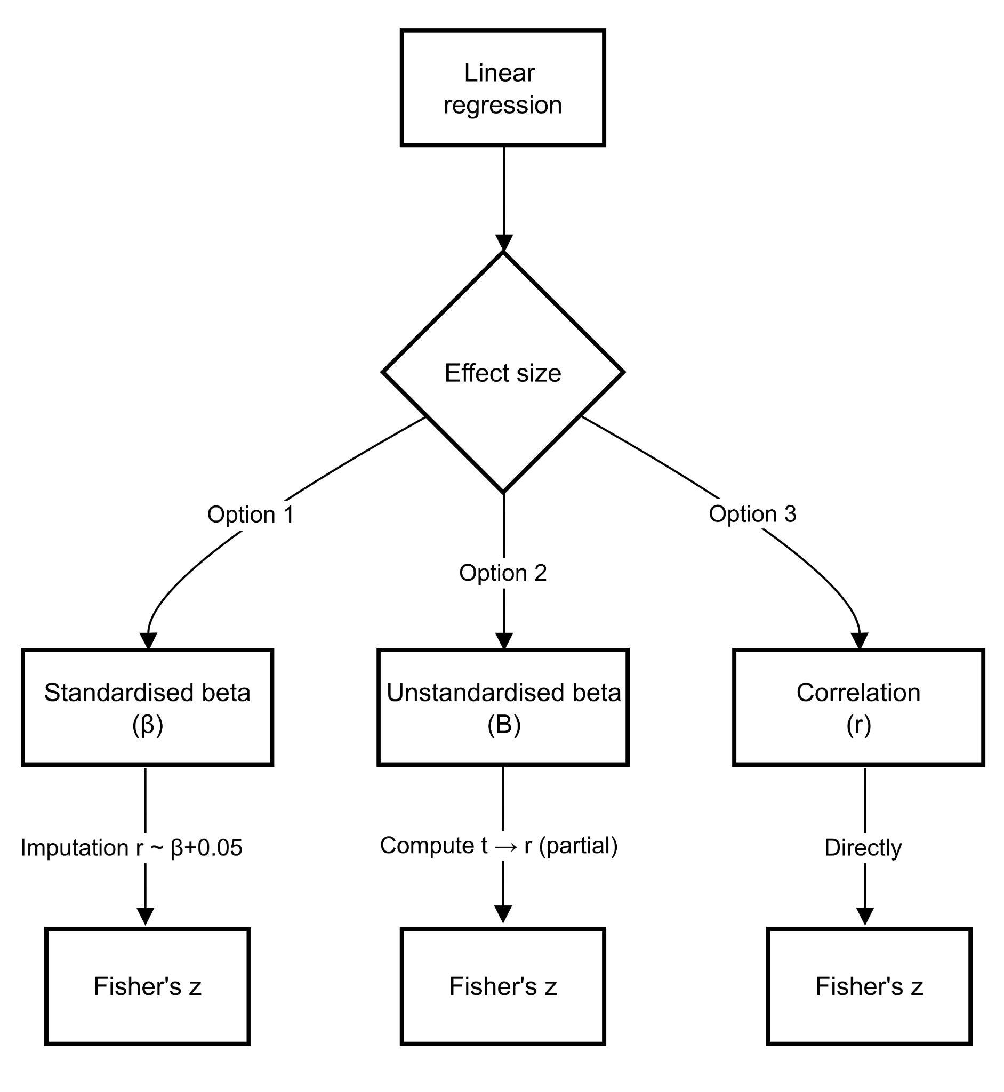

Figure S2. Decision framework for transforming logistic regression outputs to correlation.
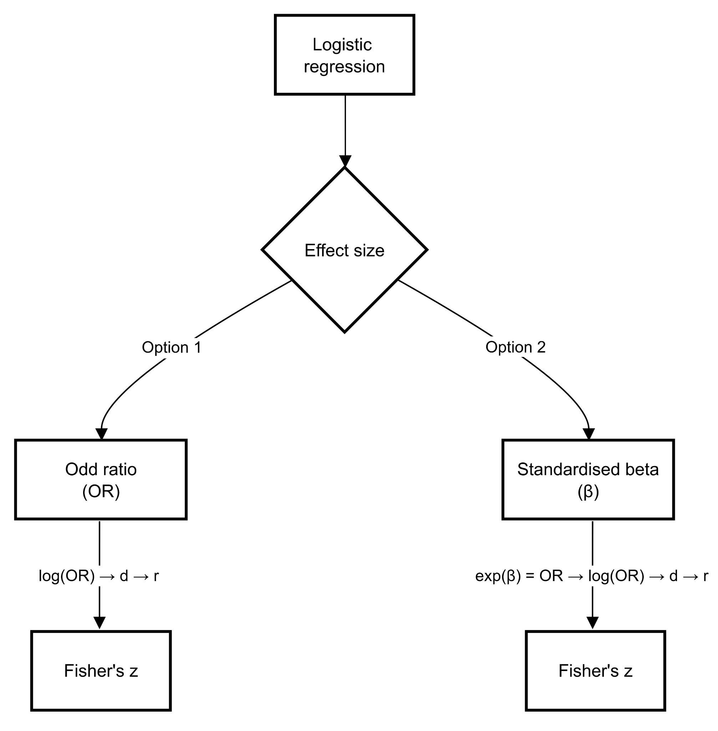

Figure S3. Forest plot showing the pooled correlation between education level and adherence to social distancing measures. ‘n’ represents sample size.
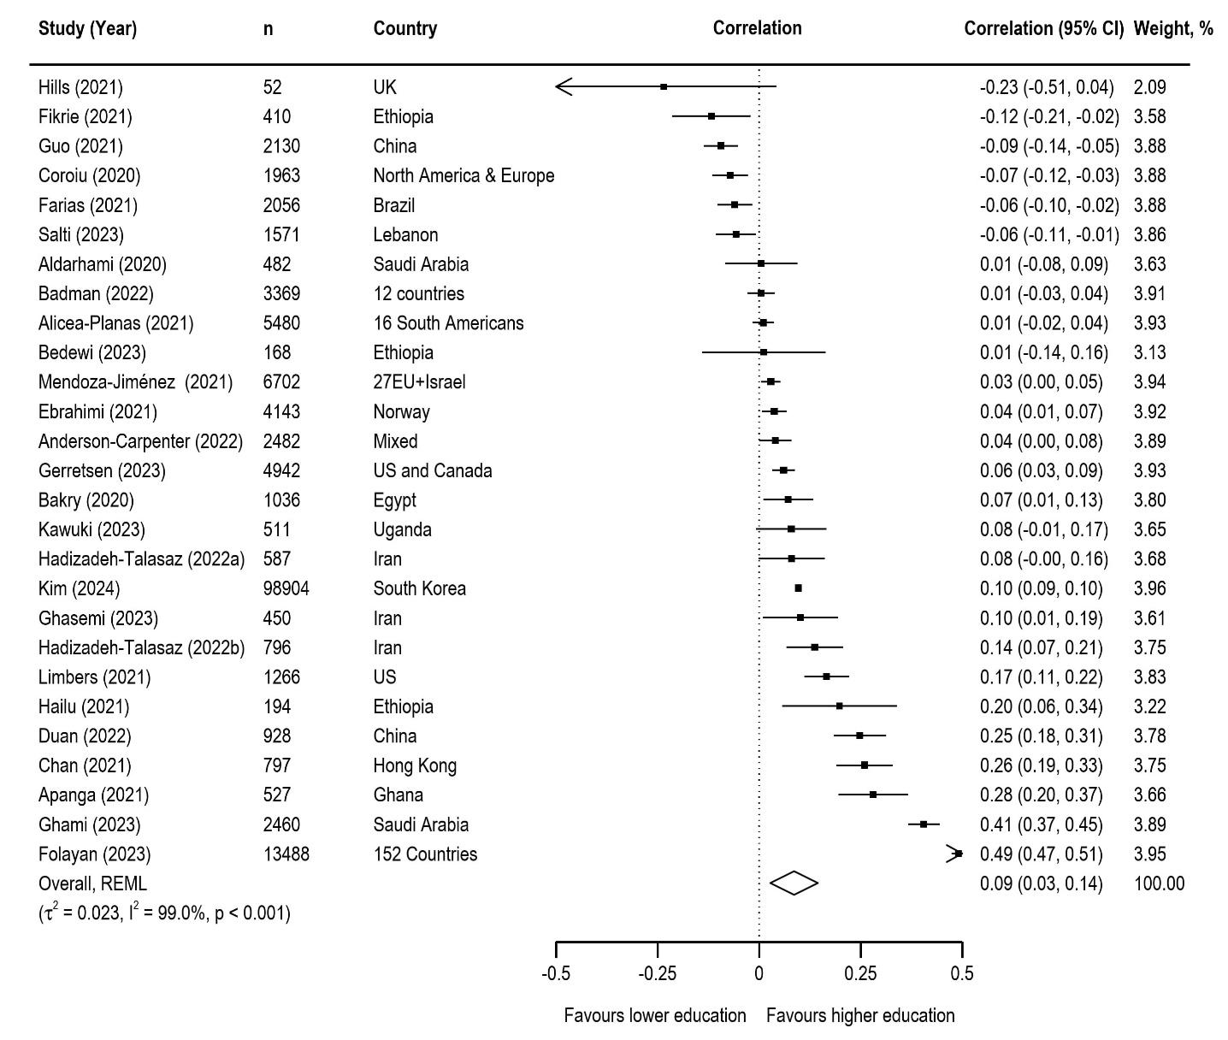

Figure S4. Forest plot showing the pooled correlation between increased age and adherence to social distancing measures. ‘n’ represents sample size.
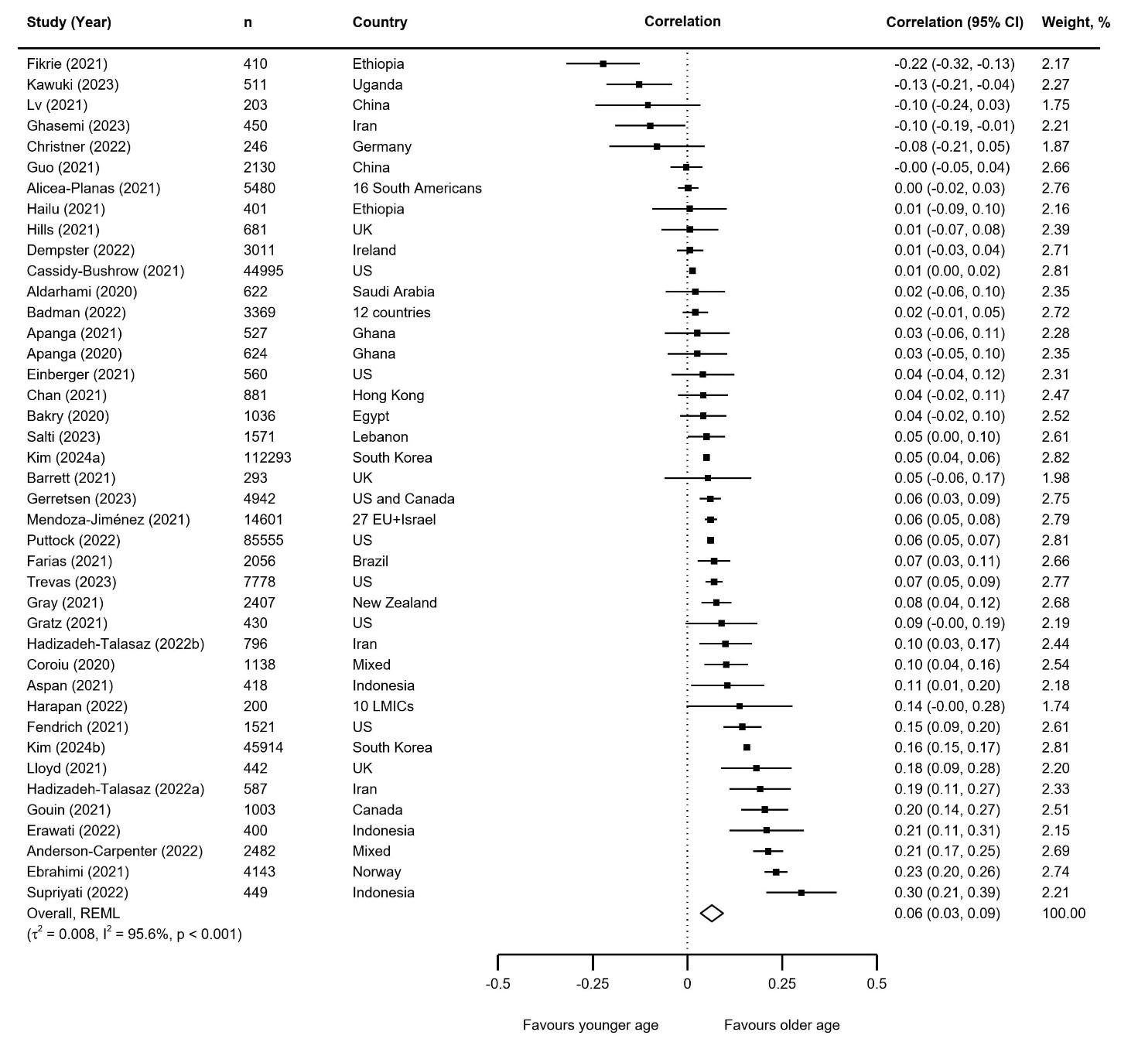

Figure S5. Forest plot showing the pooled correlation between female sex and adherence to social distancing measures. ‘n’ represents sample size.
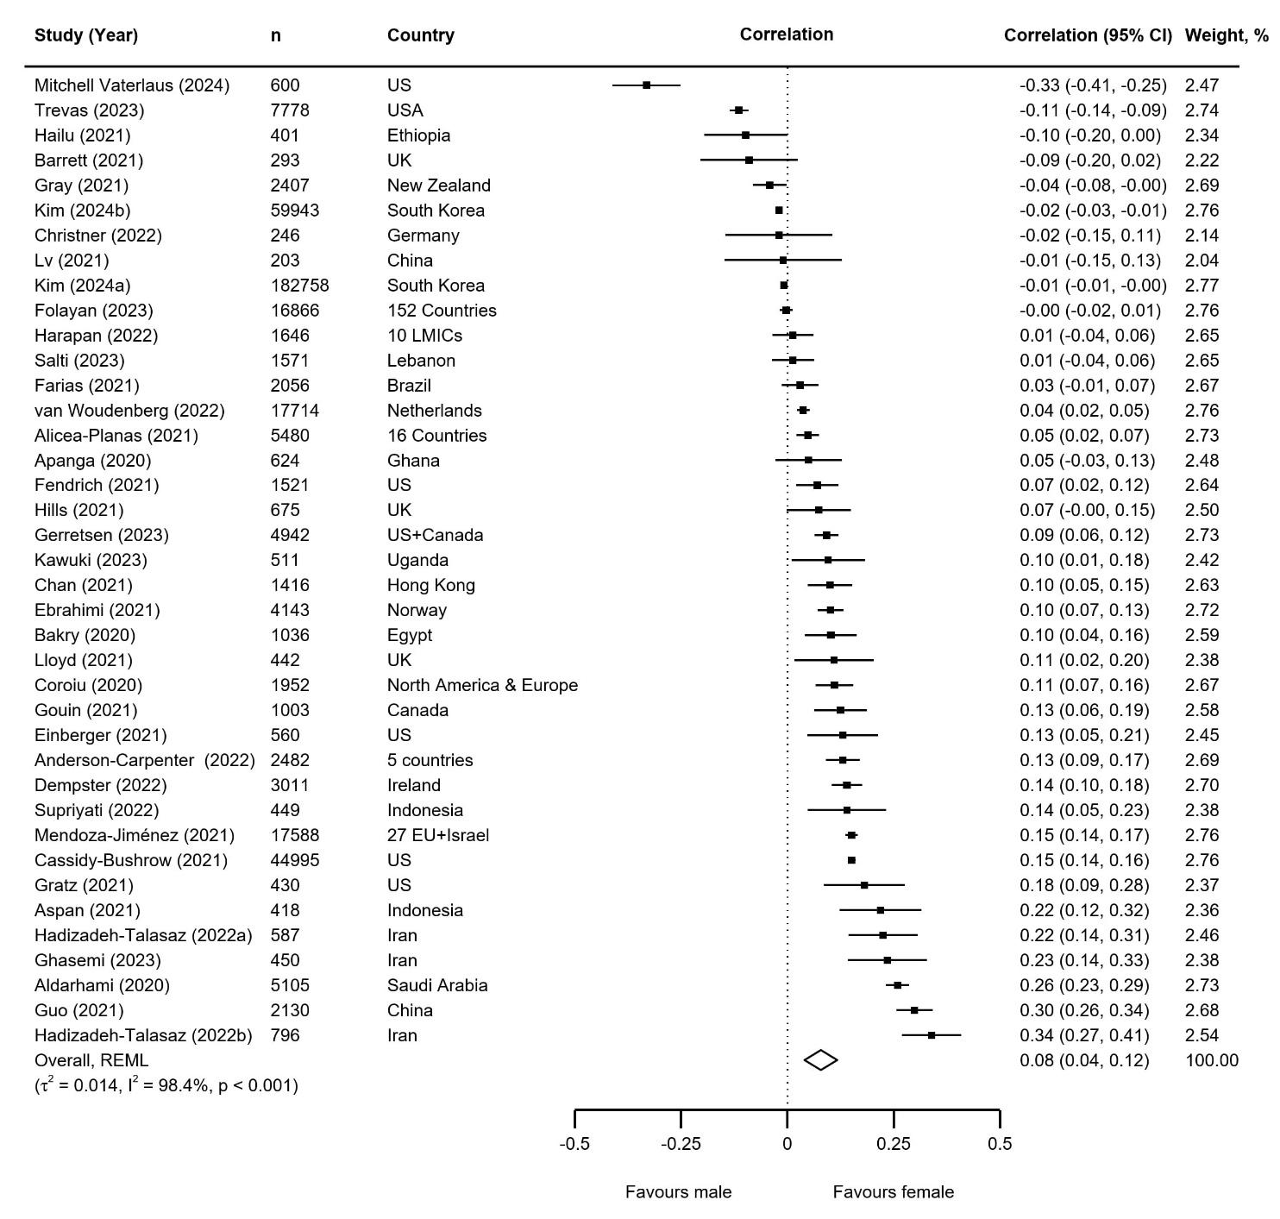

Figure S6. Forest plot showing the pooled correlation between being married and adherence to social distancing measures. ‘n’ represents sample size.
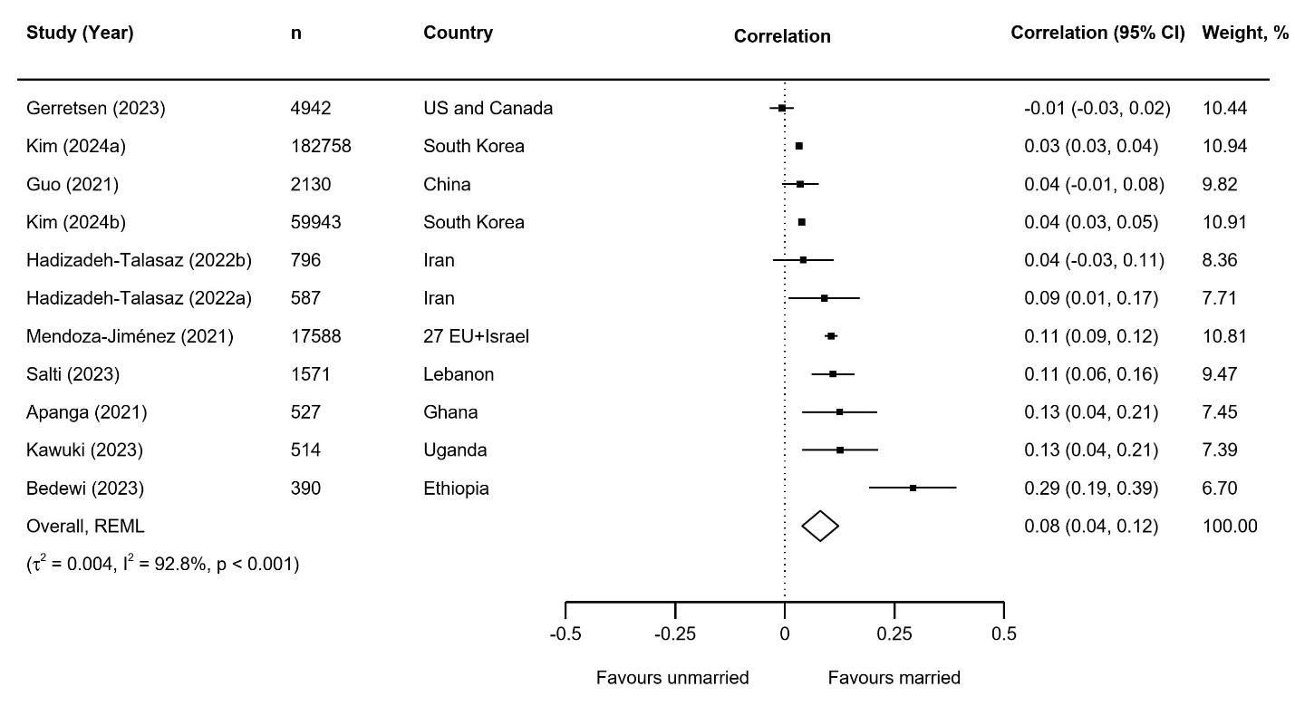

Figure S7. Forest plot showing the pooled correlation between greater risk and severity perceptions and adherence to social distancing measures. ‘n’ represents sample size.
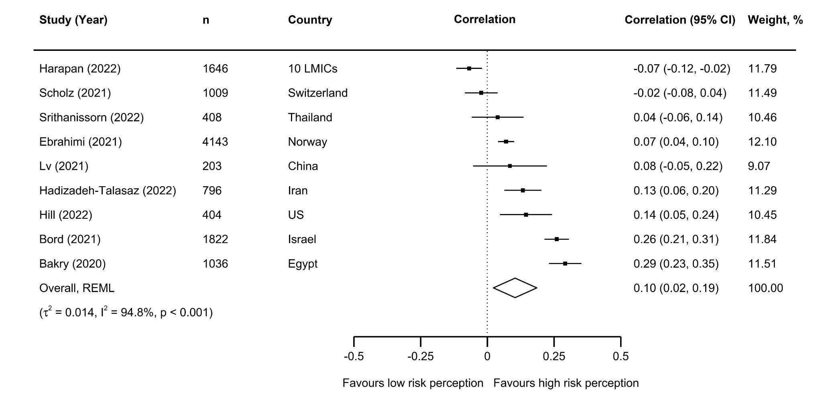

Figure S8. Forest plot showing the pooled correlation between conservative political ideology and adherence to social distancing measures. ‘n’ represents sample size.
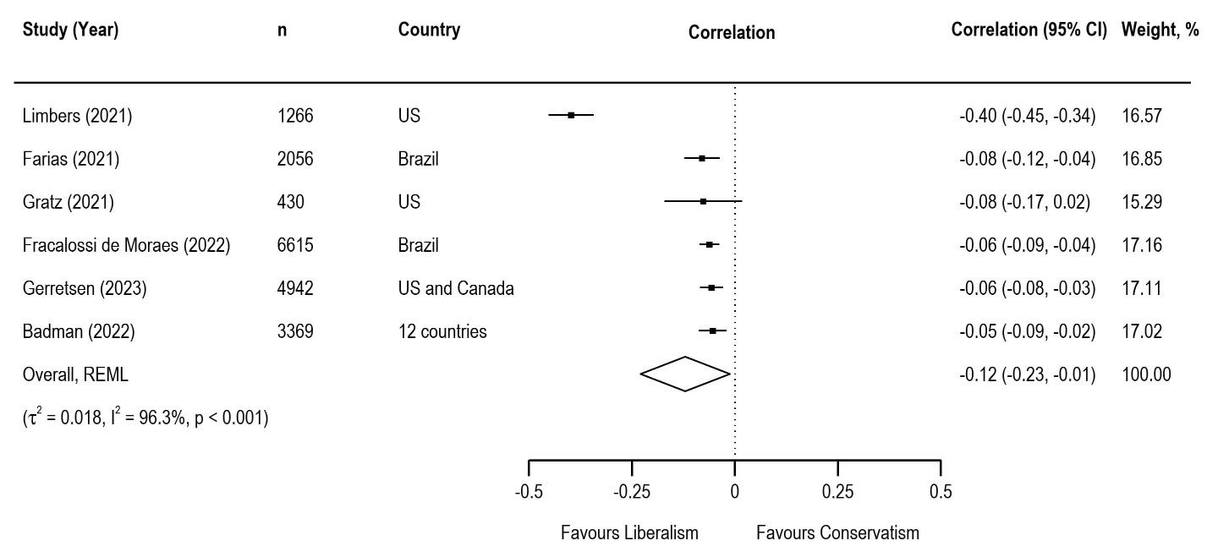

Figure S9. Forest plot showing the pooled correlation between urban residency and adherence to social distancing measures. ‘n’ represents sample size.
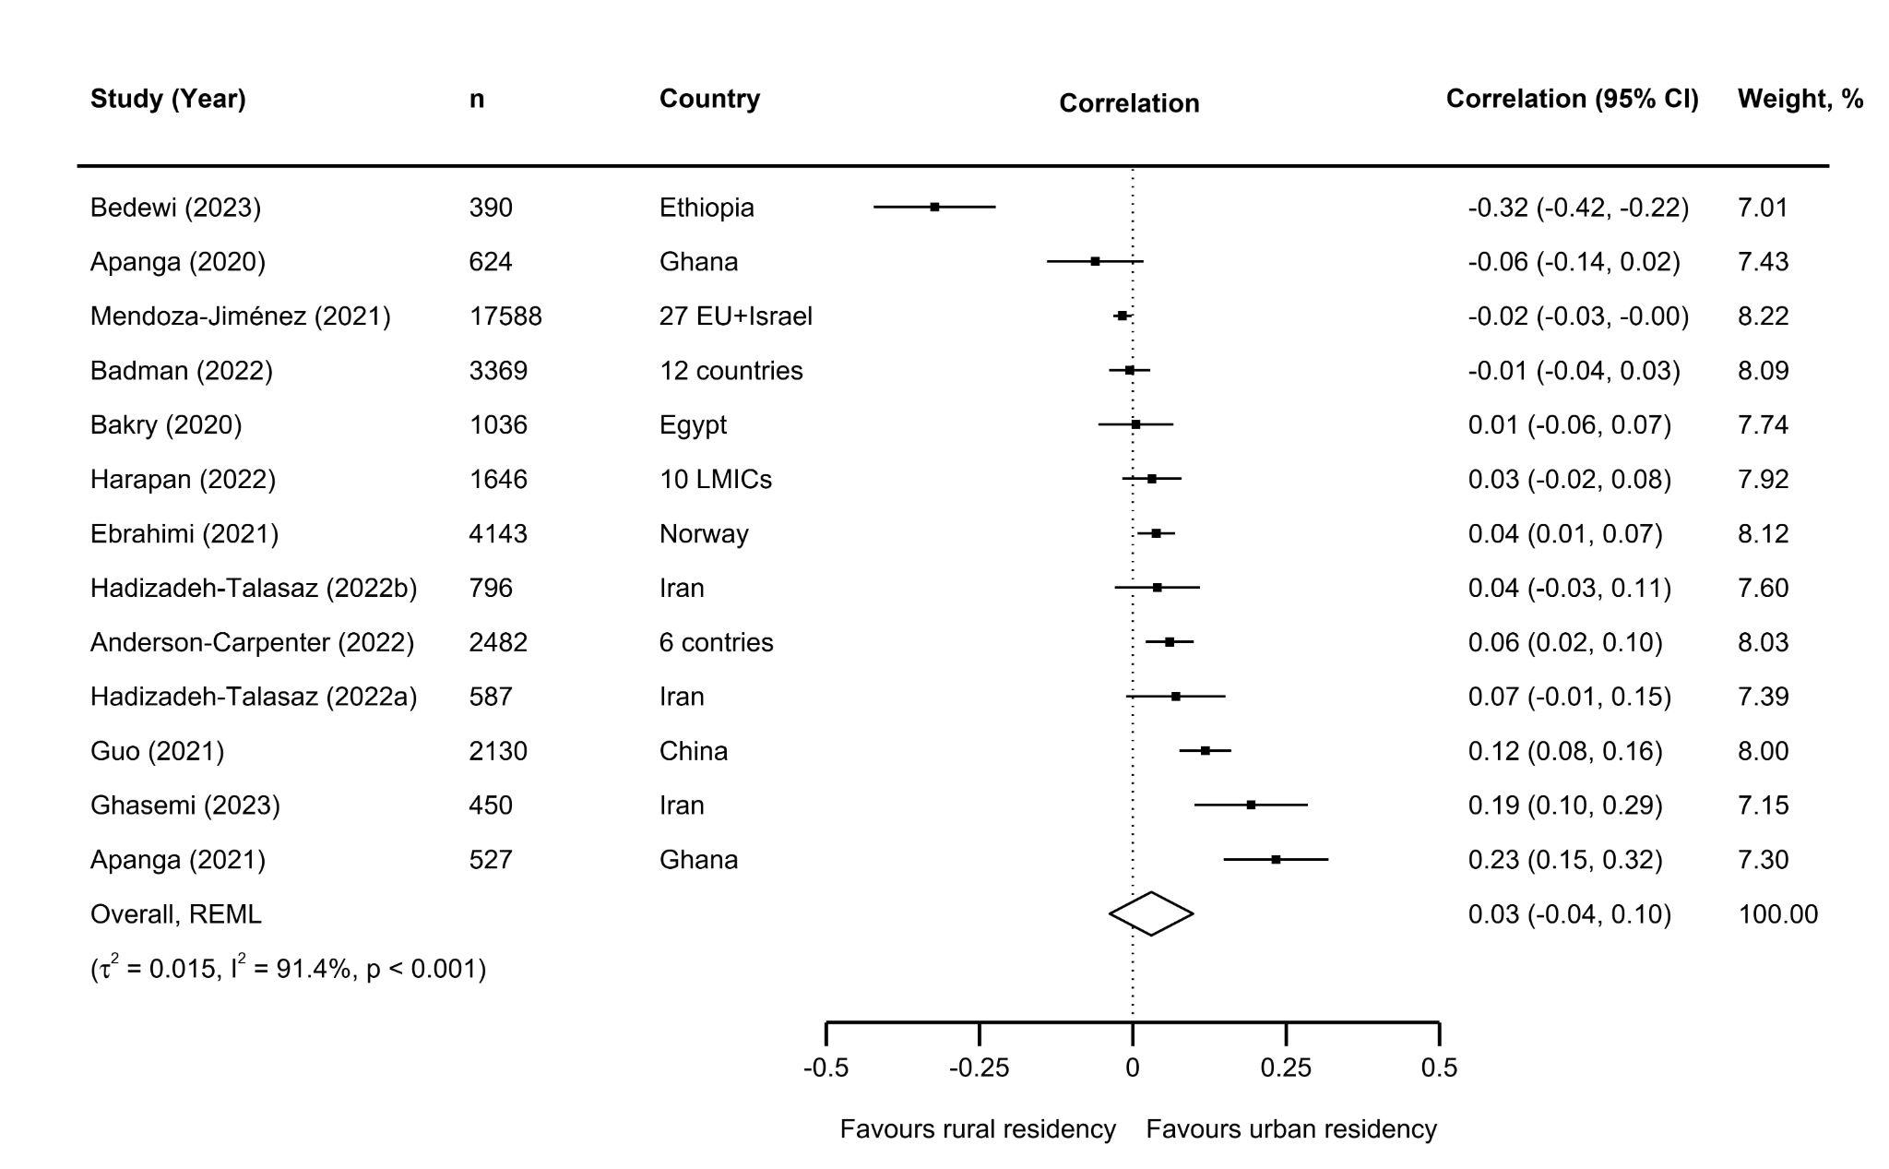

Figure S10. Forest plot showing the pooled correlation between comorbidity and adherence to social distancing measures. ‘n’ represents sample size.
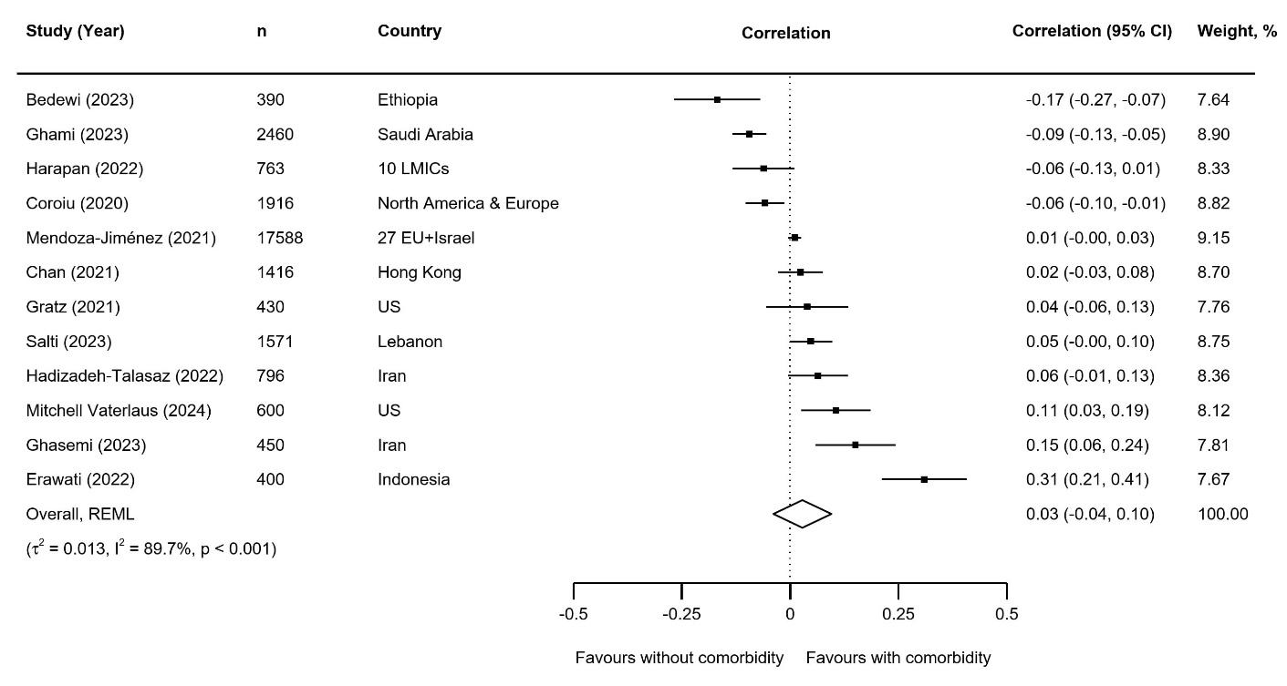

Figure S11. Forest plot showing the pooled correlation between being an essential worker and adherence to social distancing measures. ‘n’ represents sample size.
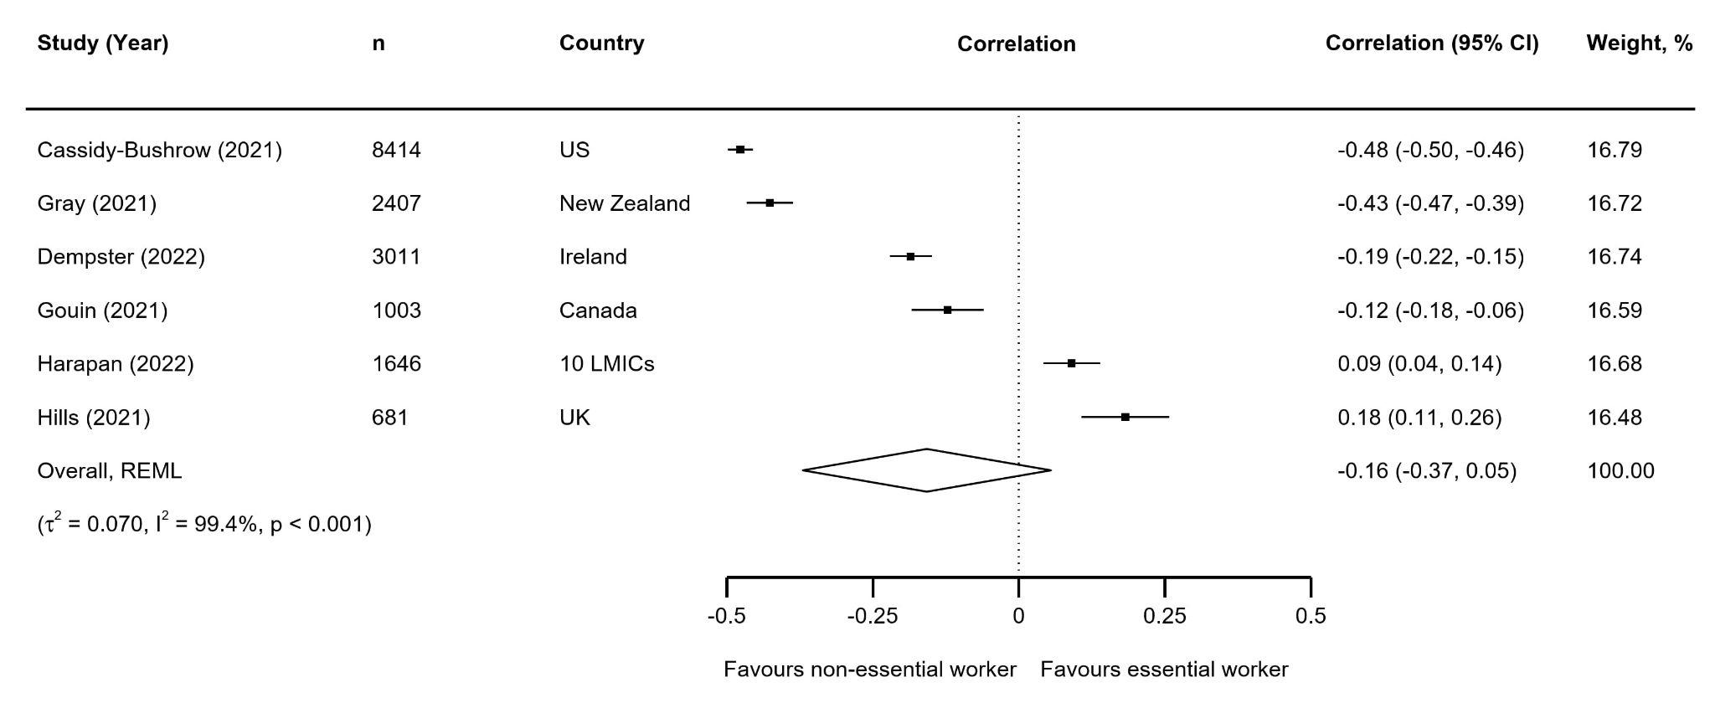

Figure S12. Forest plot showing the pooled correlation between appropriate government response and adherence to social distancing measures. ‘n’ represents sample size.
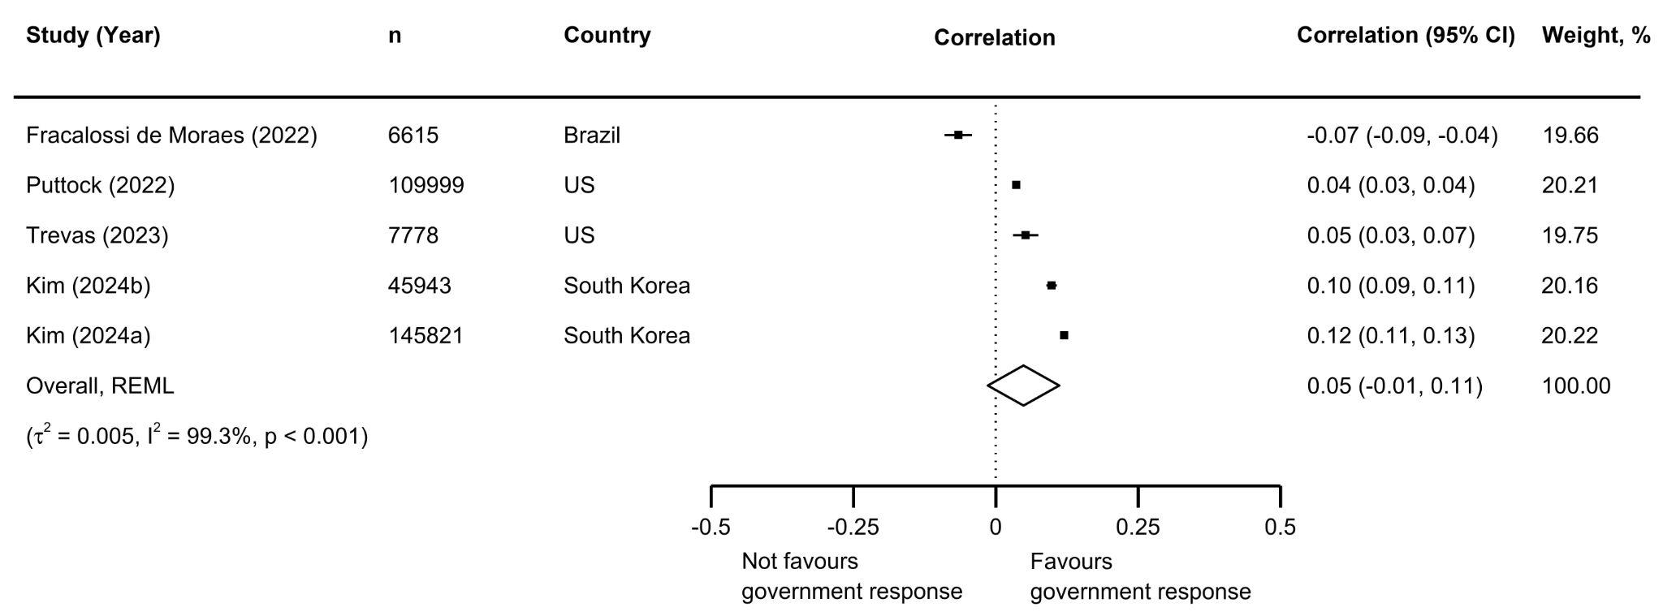

Figure S13. Forest plot showing the pooled correlation between smoking and adherence to social distancing measures. ‘n’ represents sample size.
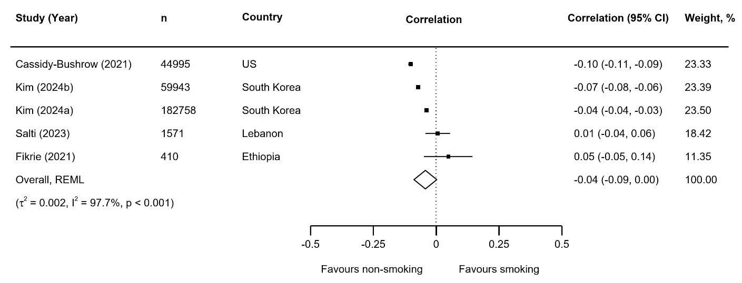

Figure S14. Forest plot showing the pooled correlation between being employed and adherence to social distancing measures. ‘n’ represents sample size.
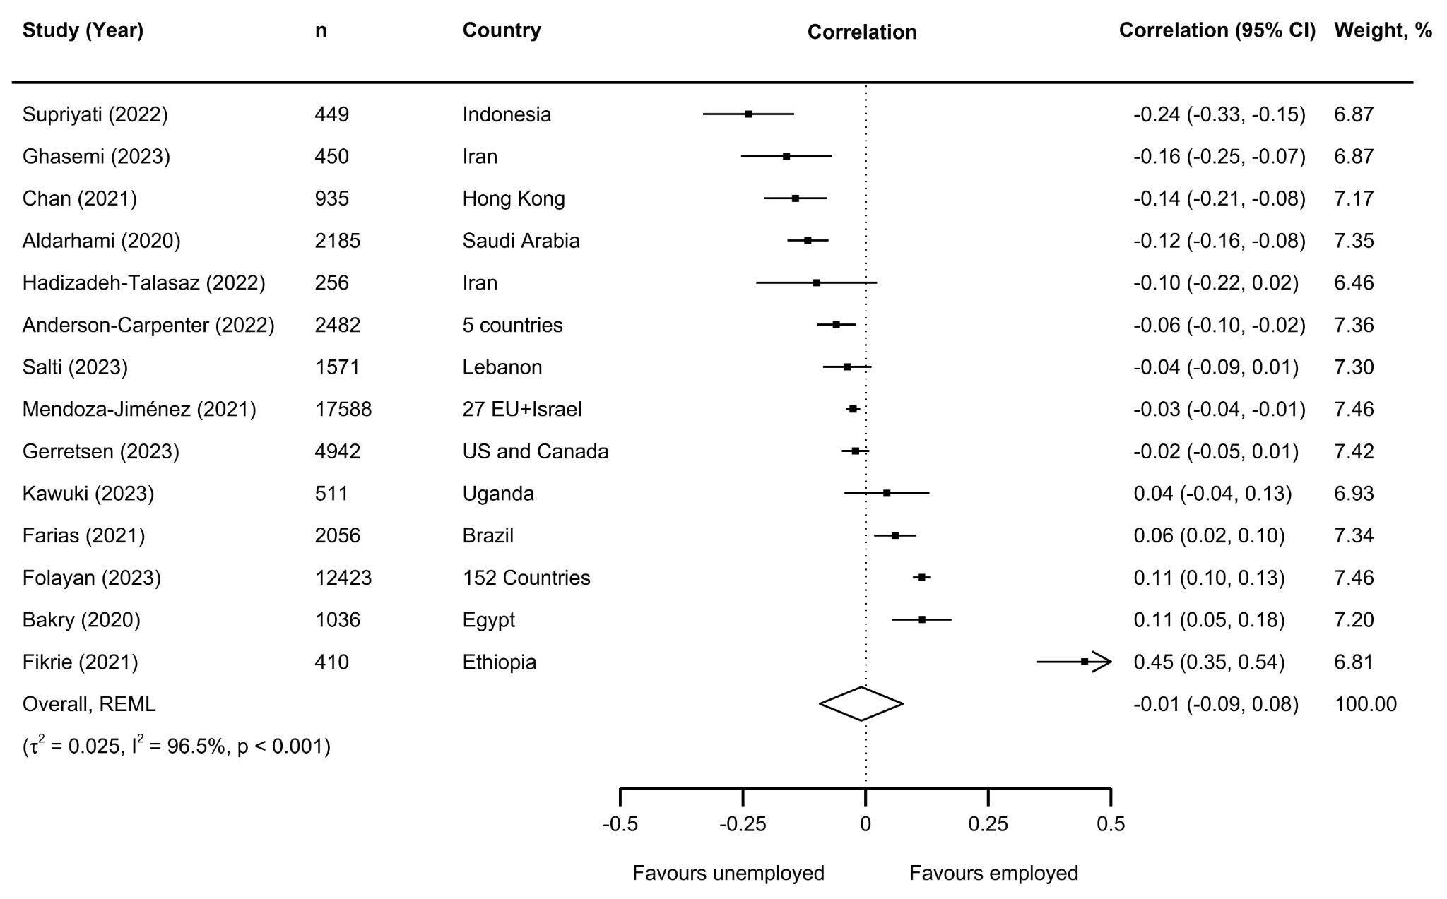

Figure S15. Forest plot showing the pooled correlation between knowledge and awareness and adherence to social distancing measures. ‘n’ represents sample size.
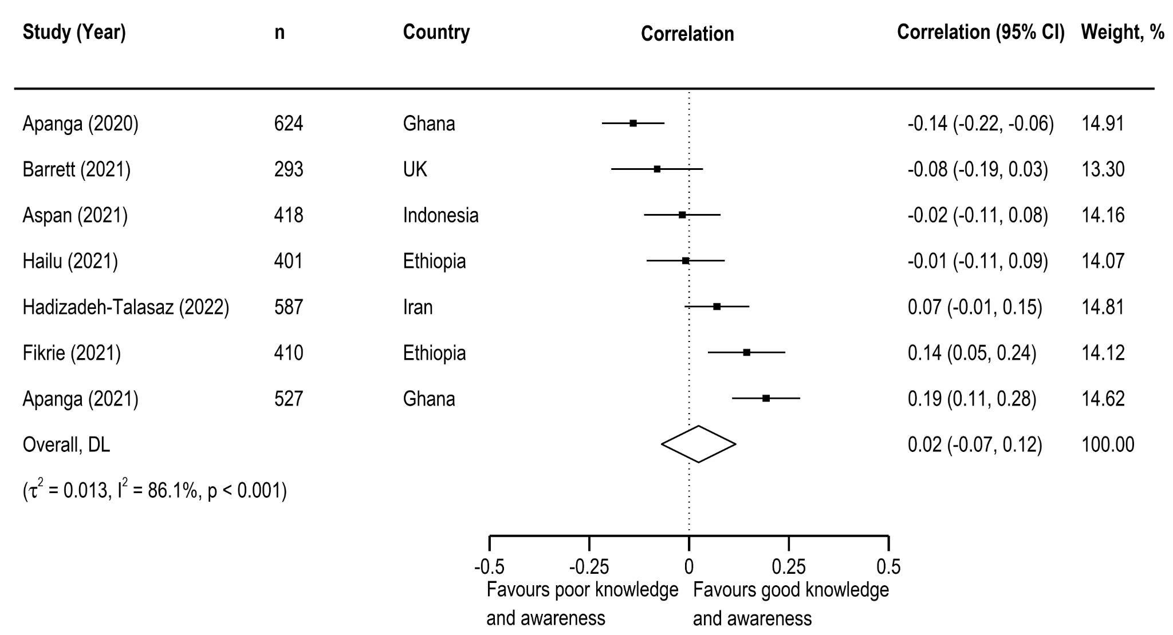

Figure S16. Forest plot showing the pooled correlation between higher income and adherence to social distancing measures. ‘n’ represents sample size.
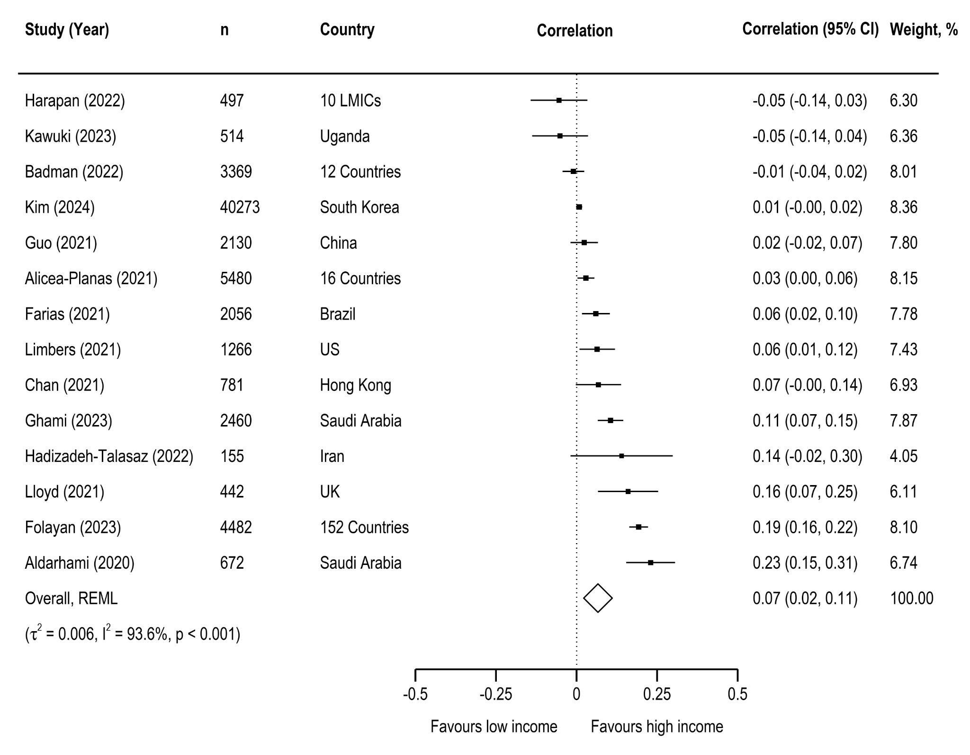

Figure S17. Forest plot of subgroup meta-analysis by the adjustment status of the determinant across included studies. 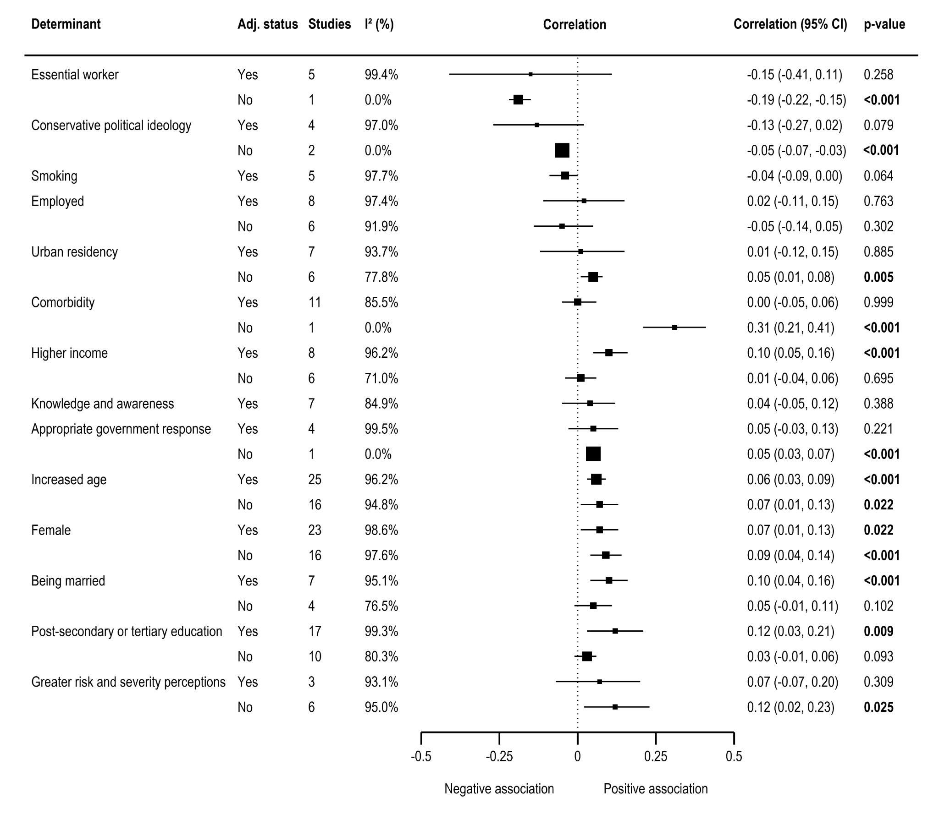

Figure S18. Meta‑regression assessing temporal variation in determinants of adherence to social distancing measures. ‘*’ indicates post-secondary or tertiary education.
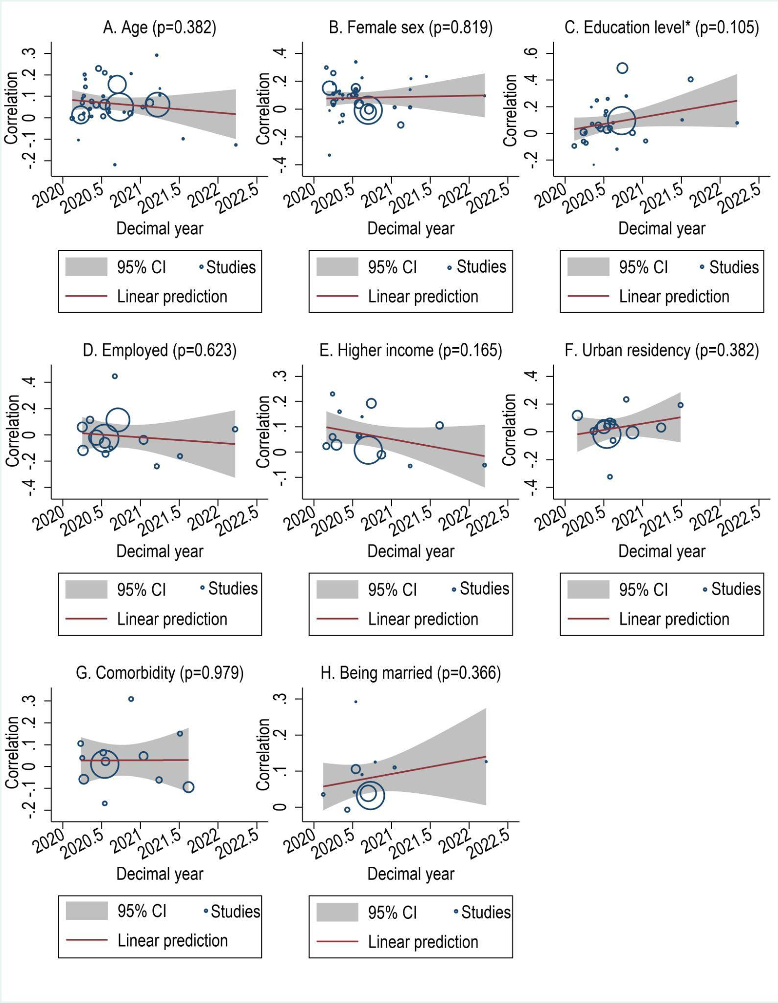

Figure S19. Forest plot of sensitivity analyses restricted to studies in community settings. ‘n’ represents sample size.
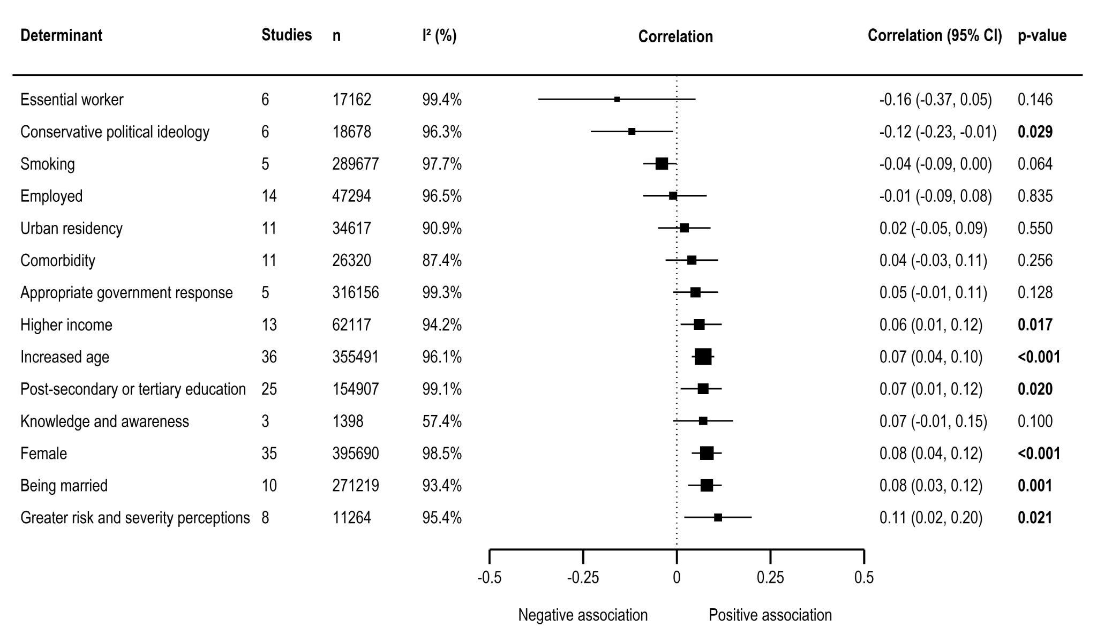

Figure S20. Forest plot of sensitivity analyses restricted to studies in general populations. ‘n’ represents sample size.
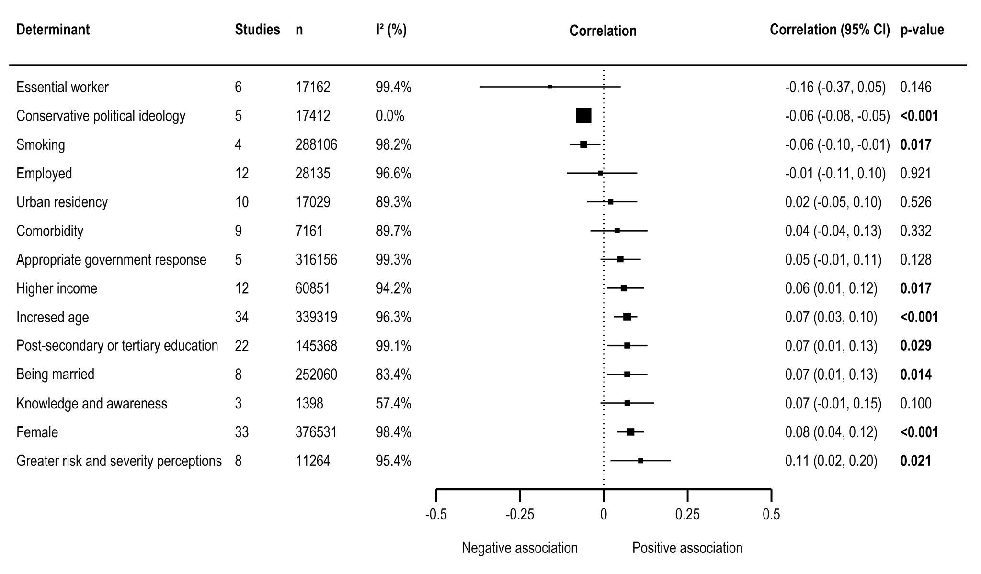

Figure S21. Funnel plot for being married with trim-and-fill correction.
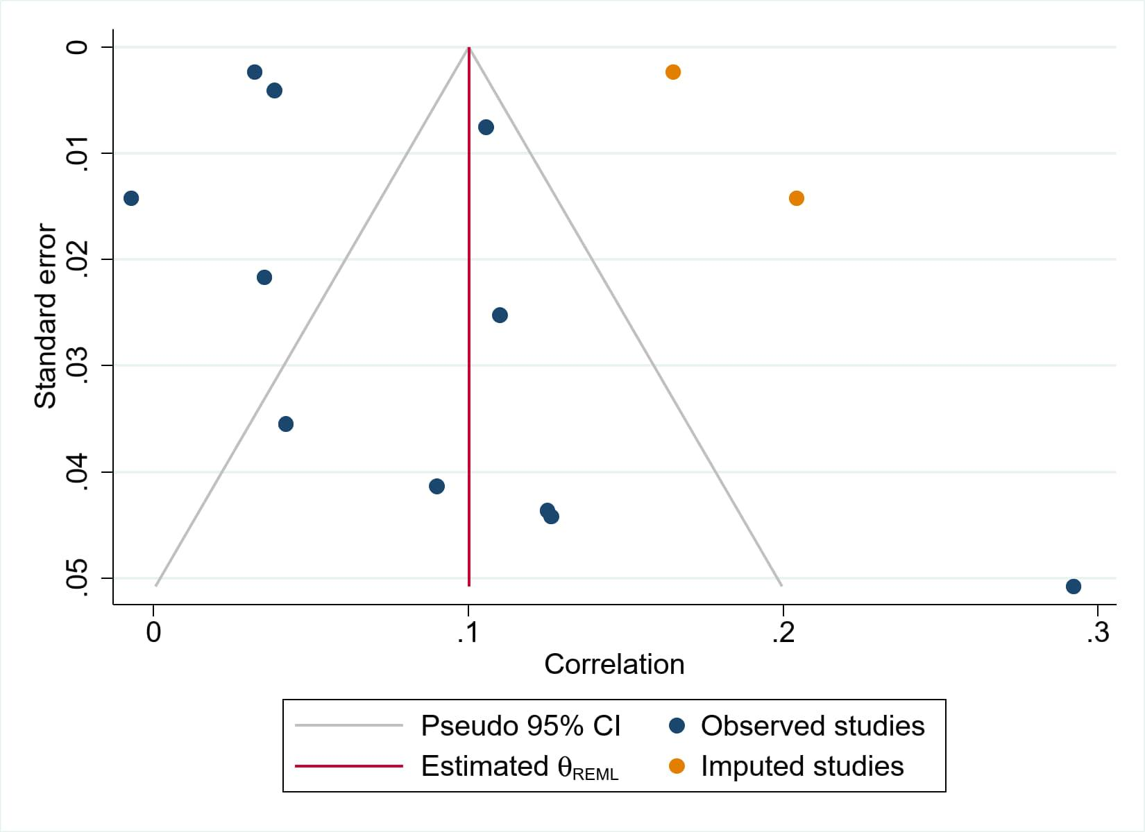

References
Borenstein, M., Hedges, L.V., Higgins, J.P., Rothstein, H.R., 2021. Introduction to meta-analysis. John wiley & sons.
Borenstein, M., Hedges, L.V., Higgins, J.P., Rothstein, H.R., 2009. Converting among effect sizes. Introduction to meta-analysis 147, 45–49.
Centers for Disease Control and Prevention, 2020. Interim US Guidance for Risk Assessment and Public Health Management of Persons with Potential Coronavirus Disease 2019 (COVID-19) Exposure in Travel-associated or Community Settings [WWW Document]. URL https://web.archive.org/web/20200304230223/https://www.cdc.gov/coronavirus/2019-ncov/php/risk-assessment.html (accessed 12.24.25).
Deeks, J.J., Higgins, J.P., Altman, D.G., Cochrane Statistical Methods Group, 2019. Analysing data and undertaking meta‐analyses. Cochrane handbook for systematic reviews of interventions 241–284.
Peterson, R.A., Brown, S.P., 2005. On the Use of Beta Coefficients in Meta-Analysis. Journal of Applied Psychology 90, 175–181. https://doi.org/10.1037/0021-9010.90.1.175
Sørensen, K., Okan, O., Kondilis, B., Levin-Zamir, D., 2021. Rebranding social distancing to physical distancing: calling for a change in the health promotion vocabulary to enhance clear communication during a pandemic. Glob Health Promot 28, 5–14. https://doi.org/10.1177/1757975920986126
UNESCO Institute for Statistics, 2012. International Standard Classification of Education, ISCED 2011. Canada.
van Aert, R.C.M., 2023. Meta-analyzing partial correlation coefficients using Fisher’s z transformation. Research Synthesis Methods 14, 768–773. https://doi.org/10.1002/jrsm.1654
van Aert, R.C.M., Goos, C., 2023. A critical reflection on computing the sampling variance of the partial correlation coefficient. Research Synthesis Methods 14, 520–525. https://doi.org/10.1002/jrsm.1632

