Association between the December 2020 mass long-lasting insecticidal net distribution campaign and reported malaria incidence in Kinshasa, Democratic Republic of the Congo: an interrupted time-series analysis of routine surveillance data.
Nanou Mbuku^{1,2}, Bien-aimé Mandja^{1,3,4}, Georges Muntenge⁵, Victoire Nsabatien⁶, Philippe Lukanu^{7,8}, Sandra Wanet^{1,2}, Thethé Mpongo^{1,2}, Baudouin Matela⁹, Josué Zanga⁶, Jean-Paul Gonzalez¹⁰, Christophe Luhata^{11,12}, Bobette Matulonga^{1,2,13}, Nono Mvuama^{6,12}

^{Author affiliations:}
- Franco-Congolese School of Advanced Studies in Public Health (EFCHESP), Protestant University of Congo, Kinshasa, Democratic Republic of the Congo
- Graduate School of Public Health, Paris-Saclay University, Le Kremlin-Bicêtre, France
- National Institute of Public Health, Kinshasa, Democratic Republic of the Congo
- Faculty of Medicine, University of Bandundu, Bandundu-Ville, Democratic Republic of the Congo
- Kinshasa Provincial Health Division, Kinshasa, Democratic Republic of the Congo
- Kinshasa School of Public Health, University of Kinshasa, Kinshasa, Democratic Republic of the Congo
- Primary Health Care in Rural Areas (Sanru asbl), Kinshasa, Democratic Republic of the Congo
- Department of Family Medicine and Primary Health Care, Protestant University of Congo, Kinshasa, Democratic Republic of the Congo
- National Malaria Control Program, Ministry of Public Health, Hygiene and Social Welfare, Kinshasa, Democratic Republic of the Congo
- School of medicine, Georgetown University, Washington DC, USA
- Expanded Program on Immunization (EPI), Ministry of Public Health, Hygiene and Social Welfare, Kinshasa, Democratic Republic of the Congo
- Clinical Epidemiology, Center for Epidemiology and Population Health (CESP), Paris-Saclay University, Villejuif, France
- Regional Health Observatory, Institut Paris Région, Paris, France

Corresponding authors:
Nanou Mbuku, nanou_mbuku@yahoo.fr
Nono Mvuama, Kinshasa School of Public Health, nono.mvuama@unikin.ac.cd

Supplementary materials
Overview
These supplementary materials provide additional methodological details and sensitivity analyses supporting the main findings of the interrupted time-series analysis.
Supplementary Table S1 presents sensitivity analyses using January 2021 and February 2021 as alternative intervention start dates to assess the robustness of the findings to possible uncertainty regarding the timing of the mass LLIN distribution campaign.
Supplementary Table S2 presents results obtained using heteroskedasticity- and autocorrelation-consistent (HAC/Newey – West) standard errors to evaluate the robustness of statistical inference in the presence of residual temporal autocorrelation.
Supplementary Table S3 presents an alternative interrupted time-series parameterization using an intervention-by-time interaction term. This model was fitted to evaluate whether the main conclusions were robust to alternative ITS specifications.
Supplementary Figures S1 and S2 present graphical residual diagnostics, including the autocorrelation function (ACF), partial autocorrelation function (PACF), and Ljung-Box test results used to assess residual temporal autocorrelation.

Supplementary Table S1: Sensitivity analysis using January 2021 and February 2021 as alternative intervention start dates
Characteristic | Segmented explicit ITS model
Characteristic | For intervention date at January 2021 |  |  | For intervention date at February 2021*
Characteristic | IRR | 95% CI | p-value | IRR | 95% CI | p-value
Intercept | 0.011 | 0.01 - 0.012 | < 0.001 | 0.0111 | 0.01 - 0.012 | < 0.001
Pre-distribution | 1 |  |  | 1
Post-distribution | 1.21 | 1.09 - 1.33 | 0.001 | 1.22 | 1.11 - 1.35 | 0.001
Time | 0.998 | 0.994 - 1.00 | 0.184 | 0.998 | 0.995 - 1.00 | 0.278
Rainy season | 1 |  |  | 1
Dry season | 0.954 | 0.823 - 1.11 | 0.533 | 0.949 | 0.819 - 1.10 | 0.493
Harmonic (month2,12) 1 | 1.07 | 1.00 - 1.15 | 0.039 | 1.08 | 1.00 - 1.15 | 0.037
Harmonic (month2,12) 2 | 1.05 | 0.997 - 1.11 | 0.061 | 1.06 | 1.00 - 1.12 | 0.037
Harmonic (month2,12) 3 | 1.02 | 0.956 - 1.09 | 0.516 | 1.02 | 0.958 - 1.10 | 0.473
Harmonic (month2,12) 4 | 1.06 | 1.03 - 1.10 | 0.001 | 1.07 | 0.958 - 1.10 | 0.473
Post-time | 1.01 | 1.01 - 1.02 | 0.001 | 1.01 | 1.01 - 1.02 | 0.001

Repeating the interrupted time-series analyses using January 2021 and February 2021 as alternative intervention start dates yielded estimates that were highly consistent with those obtained using December 2020. The intervention effect and the post-intervention trend remained statistically significant, indicating that the study conclusions were robust to plausible alternative assumptions regarding the timing of the LLIN campaign.
Supplementary Table S2: Sensitivity analysis using heteroskedasticity- and autocorrelation-consistent (HAC/Newey-West) standard errors
characteristic | estimate | Std error | Z value | P-value
intercept | -4.4967 | 0.0482 | -92.856 | <2.2e-16
Pre-distribution | 1
Post-distribution | 0.1697 | 0.0691 | 2.456 | 0.014
Time | -0.0025 | 0.0027 | -0.916 | 0.359
Rainy season | 1
Dry season | -0.0531 | 0.0202 | -2.630 | 0.008
Harmonic(mois,2,12)1 | 0.0693 | 0.0199 | 3.478 | 0.0005
Harmonic(mois,2,12)2 | 0.0539 | 0.0135 | 3.981 | 6.842e-05
Harmonic(mois,2,12)3 | 0.0154 | 0.0299 | 0.5148 | 0.6067
Harmonic(mois,2,12)4 | 0.0575 | 0.0147 | 3.901 | 9.567e-05
Post_time | 0.0139 | 0.0046 | 3.032 | 0.002

Application of HAC/Newey – West standard errors produced effect estimates that were very similar to those obtained in the primary segmented ITS model. The intervention and post-intervention time coefficients remained statistically significant, indicating that the principal findings were robust to residual temporal autocorrelation. Nevertheless, graphical diagnostics and Ljung-Box tests demonstrated that some residual serial dependence remained present.

Supplementary Table S3: Results of an alternative ITS specification including an intervention-by-time interaction term
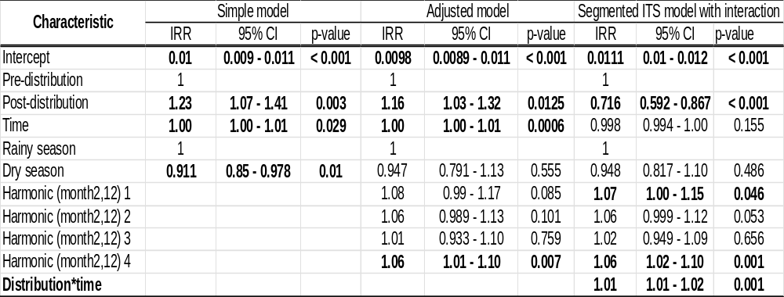
This alternative ITS specification was fitted as a sensitivity analysis to evaluate the robustness of findings to model parameterization. Although individual coefficient interpretation differs from that of the primary segmented ITS model, both parameterizations yielded substantively similar conclusions. Therefore, interpretation in the main manuscript is based on the explicit segmented ITS model including intervention and post-intervention time variables.

Supplementary Figure S1: Autocorrelation function (ACF) and partial autocorrelation function (PACF) of Pearson residuals from the primary segmented ITS model
The ACF shows significant positive autocorrelation at short lags with gradual decay, while the PACF is dominated by pronounced lag-1 correlation, indicating residual serial dependence. These findings are consistent with the Ljung-Box test and justify the use of heteroskedasticity and autocorrelation-consistent (HAC/Newey-West) standard errors in sensitivity analyses.

Supplementary Figure S2: Ljung – Box test p-values for Pearson residuals from the primary segmented ITS model across lags 1 – 12.
The Ljung – Box test consistently rejected the null hypothesis of no residual autocorrelation across all lags examined (all p < 0.001), indicating persistent serial dependance despite adjustment for seasonality and post-intervention temporal changes. These findings justified the use of heteroskedasticity and autocorrelation-consistent (HAC/Newey – West) standard errors in sensitivity analyses.

