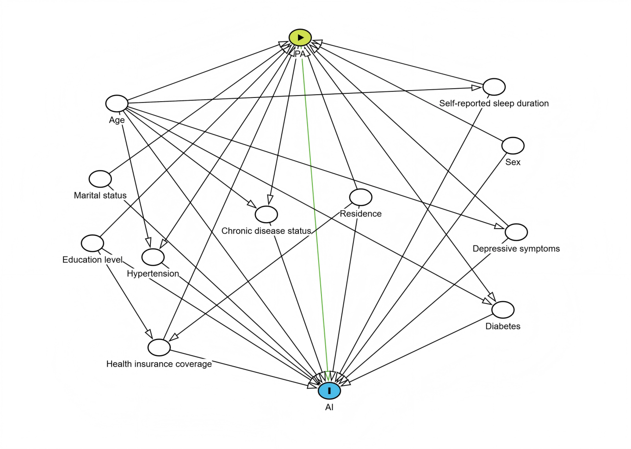
Supplementary Figure S1 | Directed acyclic graph. Abbreviations: PA, physical activity; AI, atherosclerosis index.

