Table S1 Graded response model item parameters for the HLS-EU-Q6
Item | a | b1 | b2 | b3
Assess when you need a second opinion from another doctor? | 1.449 | -2.93 | -0.704 | 1.758
Use the information that your doctor gives you to make decisions about your illness | 1.75 | -3.285 | -1.83 | 1.079
Find information on how to deal with mental health problems, such as stress or depression | 2.548 | -2.356 | -1.038 | 0.834
Assess whether the information on health risks available in the media is reliable? (e.g., TV, internet, or other means of communication) | 1.565 | -2.315 | -0.36 | 1.635
Find information about activities that are good for your mental well-being? (e.g., meditation, exercise, walking, pilates) | 2.219 | -2.777 | -1.597 | 0.485
Understand the information available in the media on how to stay healthier? (e.g., internet, newspapers, magazines) | 2.015 | -2.35 | -0.997 | 1.151
Note. a = discrimination parameter. b1–b3 = category thresholds estimated under the graded response model.
Table S2 Differential item functioning across age groups
Item | Omnibus χ² | df | BH p | Uniform DIF | Nonuniform DIF | Sequential DIF
Assess when you need a second opinion from another doctor? | 49.98 | 8 | <.001 | Yes | No | Yes
Use the information that your doctor gives you to make decisions about your illness | 11.4 | 8 | 0.18 | No | No | No
Find information on how to deal with mental health problems, such as stress or depression | 40.43 | 8 | <.001 | Yes | Yes | Yes
Assess whether the information on health risks available in the media is reliable? (e.g., TV, internet, or other means of communication) | 41.36 | 8 | <.001 | Yes | Yes | Yes
Find information about activities that are good for your mental well-being? (e.g., meditation, exercise, walking, pilates) | 65.1 | 8 | <.001 | Yes | Yes | Yes
Understand the information available in the media on how to stay healthier? (e.g., internet, newspapers, magazines) | 25.64 | 8 | 0.001 | Yes | No | No
Note. Omnibus DIF tested differences in both discrimination and thresholds. Uniform DIF refers to threshold differences only, whereas nonuniform DIF refers to discrimination differences. Sequential DIF represents the final robust DIF solution after iterative purification. P-values were adjusted using the Benjamini–Hochberg procedure.
Table S3 Item parameters of DIF items by age group
Age group | Item | a | b1 | b2 | b3
Youth | Assess when you need a second opinion from another doctor? | 1.248 | -3.191 | -0.619 | 1.784
Adults |  | 1.384 | -3.598 | -1.142 | 1.442
Older adults |  | 1.689 | -3.159 | -1.298 | 1.079
Youth | Find information on how to deal with mental health problems, such as stress or depression | 2.122 | -2.37 | -1.084 | 0.652
Adults |  | 2.457 | -2.857 | -1.508 | 0.462
Older adults |  | 2.839 | -2.904 | -1.532 | 0.396
Youth | Assess whether the information on health risks available in the media is reliable? (e.g., TV, internet, or other means of communication) | 1.51 | -2.453 | -0.49 | 1.349
Adults |  | 1.522 | -2.63 | -0.728 | 1.298
Older adults |  | 1.716 | -2.999 | -0.934 | 1.194
Youth | Find information about activities that are good for your mental well-being? (e.g., meditation, exercise, walking, pilates) | 1.602 | -3.545 | -2.079 | 0.208
Adults |  | 2.039 | -3.51 | -2.273 | 0.076
Older adults |  | 2.586 | -3.056 | -1.841 | 0.173
Note. Parameter estimates are reported from the final partial invariance model.
Table S4 Latent health literacy distribution and measurement precision across age groups
Age group | Latent mean | Marginal reliability | Maximum information | Reliable θ range
Youth | 0 | 0.789 | 4.65 | −3.30–1.30
Adults | −0.272 | 0.803 | 5.41 | −3.55–1.55
Older adults | −0.853 | 0.844 | 7.31 | −2.95–2.25
Note. Maximum information represents the highest value of the test information function.
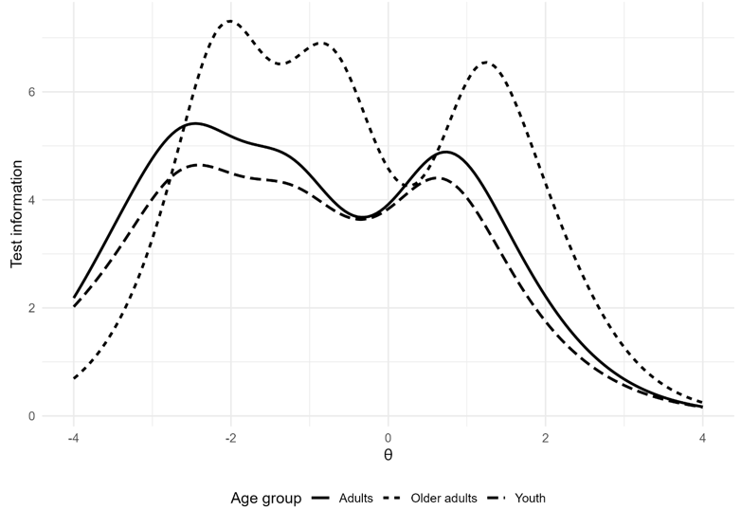
Figure S1 Test information curve for the HLS-EU-Q6 across age groups
Note. Test information functions were estimated separately for youth (18–30 years), adults (31–64 years), and older adults (65 years and older). Greater information values indicate higher reliability (lower conditional standard error) at each level of the latent health literacy trait (θ).
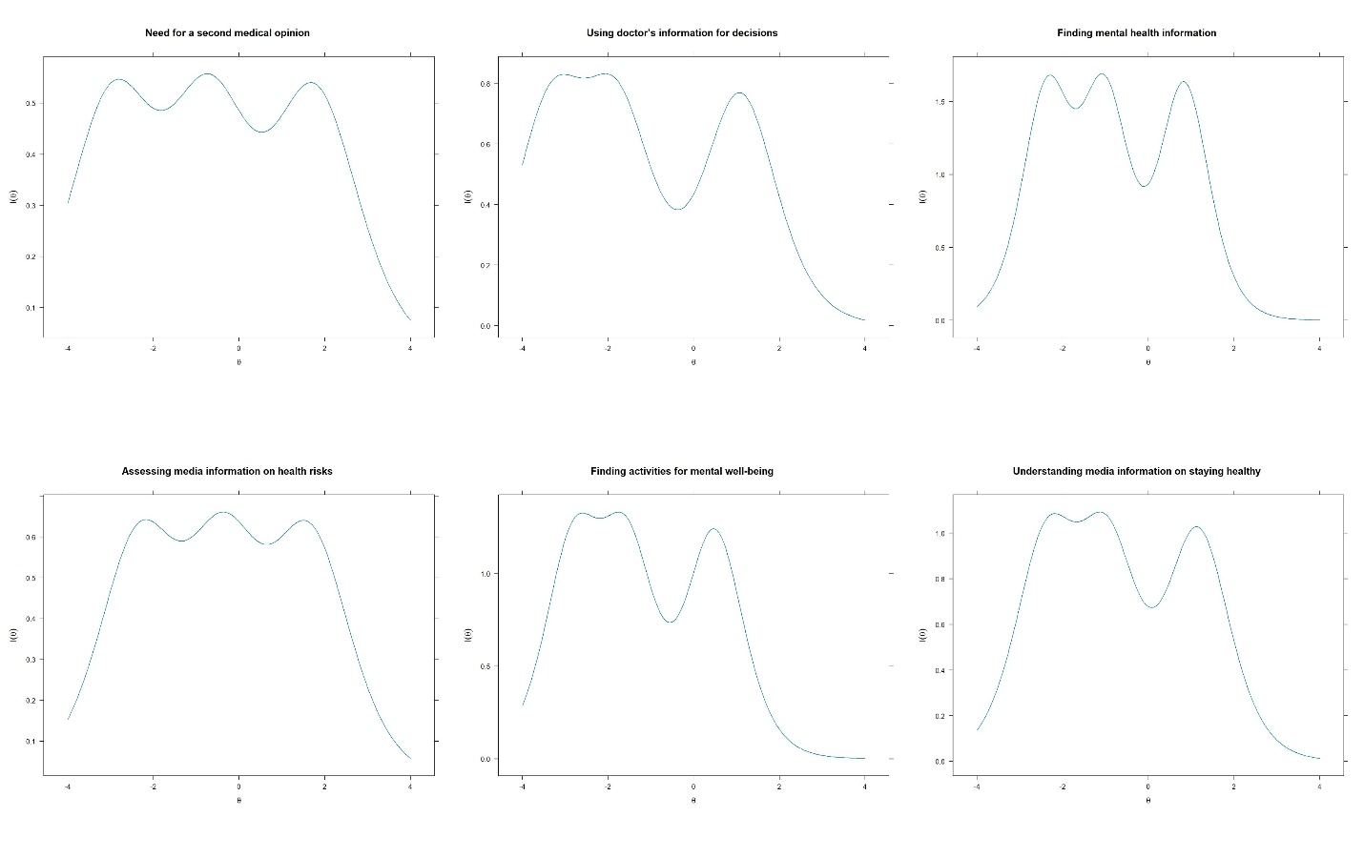
Figure S2 Item information functions for the six HLS-EU-Q6 items
Note. Item Information Functions estimated using Samejima's graded response model. Higher information values indicate greater measurement precision and lower conditional standard error at a given level of the latent health literacy trait (θ). Items with higher discrimination parameters contribute greater information across the latent continuum.

