Supplementary File

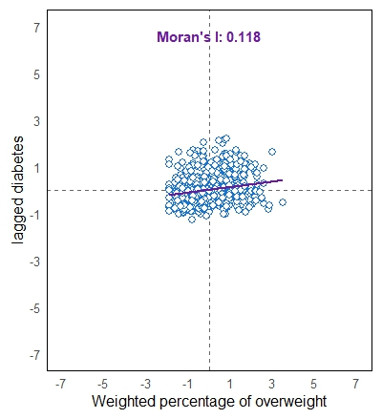 | 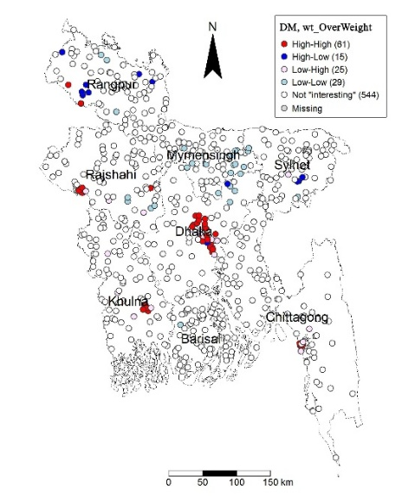 |  | 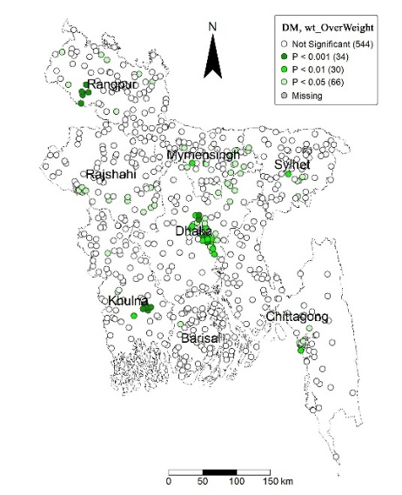
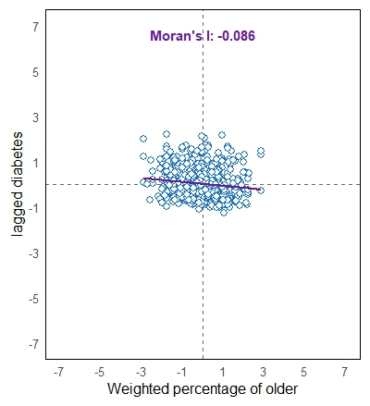 | 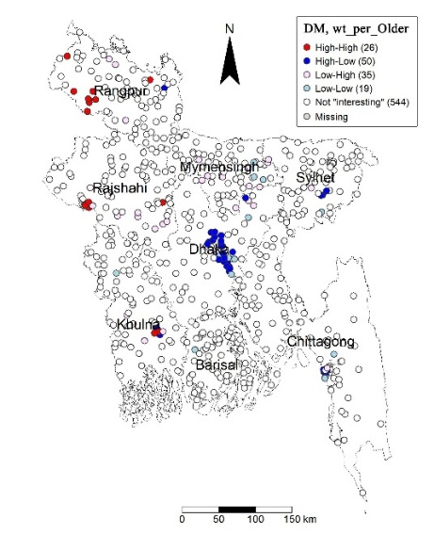 |  | 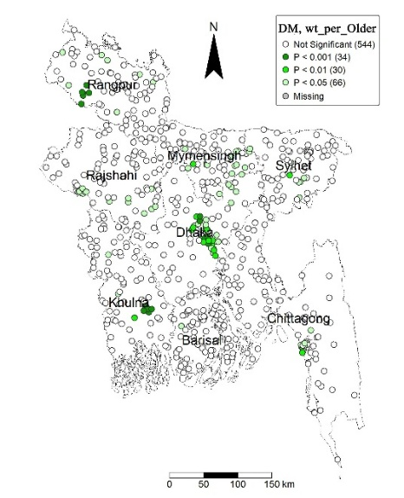
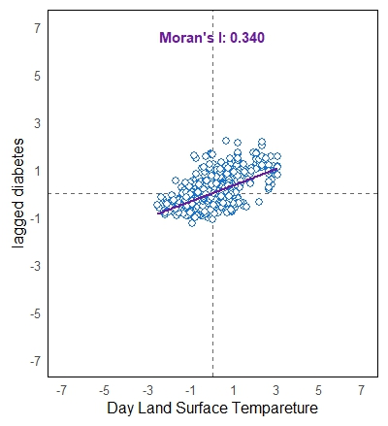 | 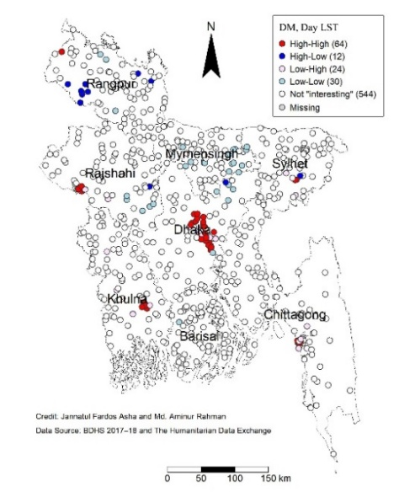 |  | 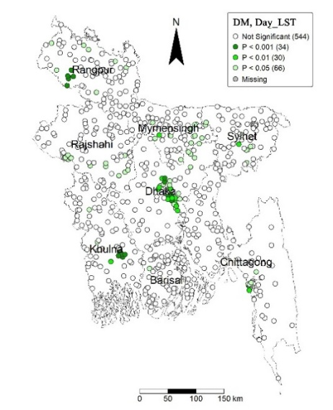
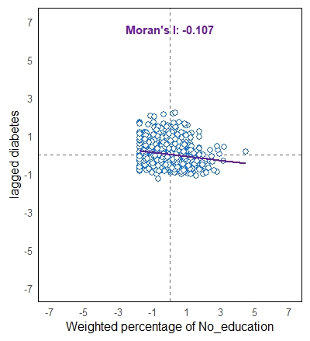 |  | 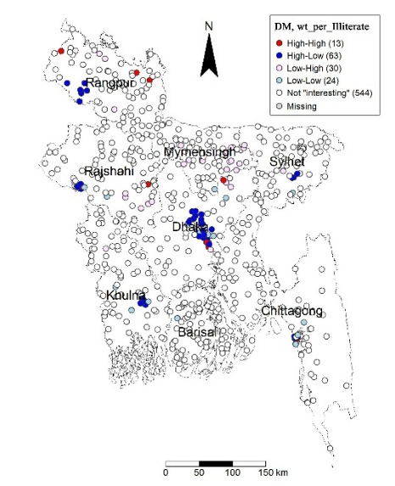 |  | 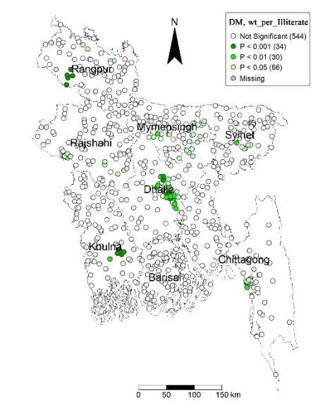
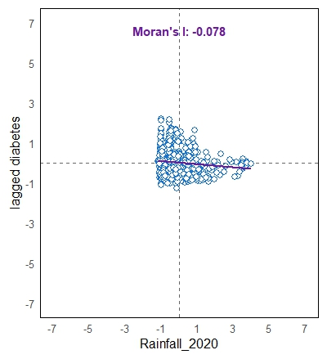 |  | 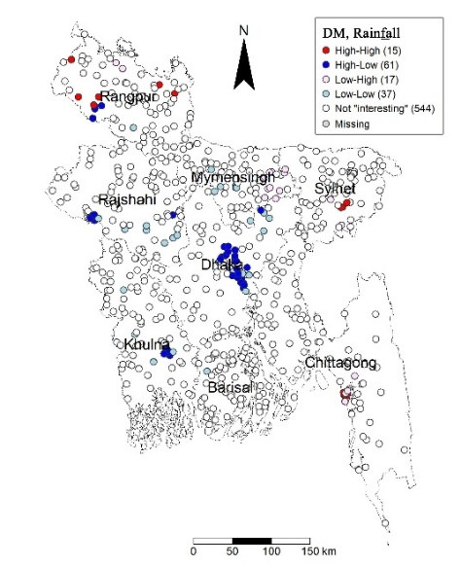 |  | 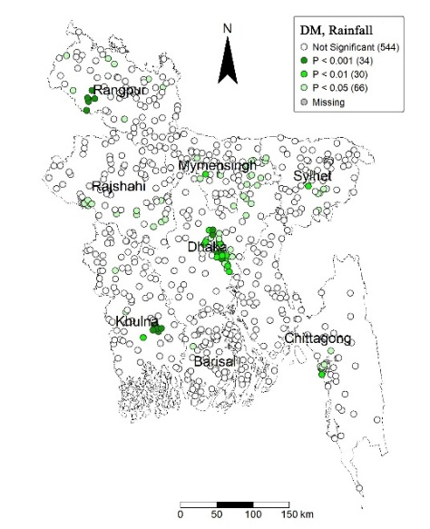
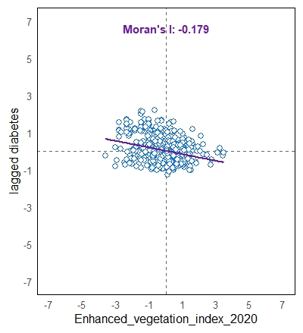 |  | 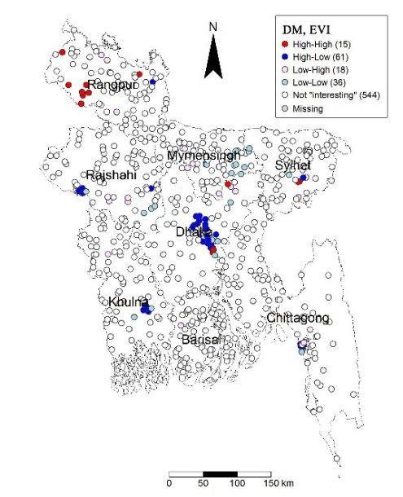 |  | 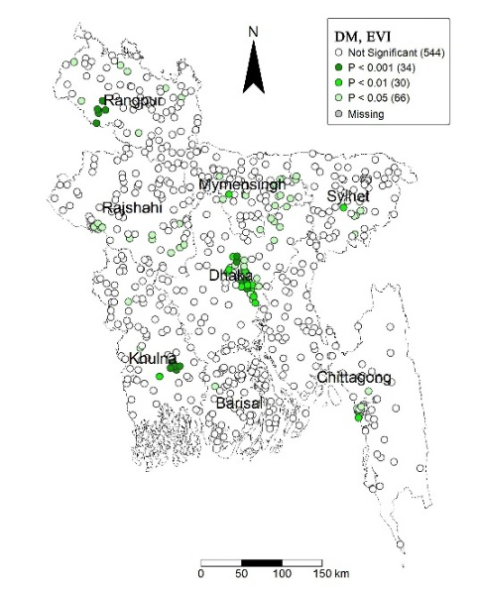

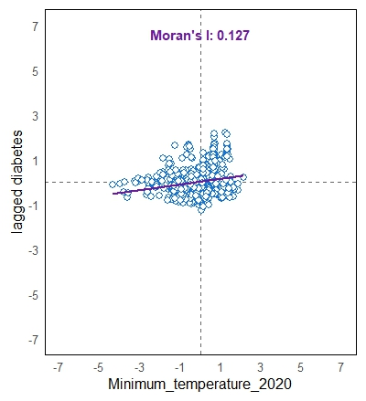 | 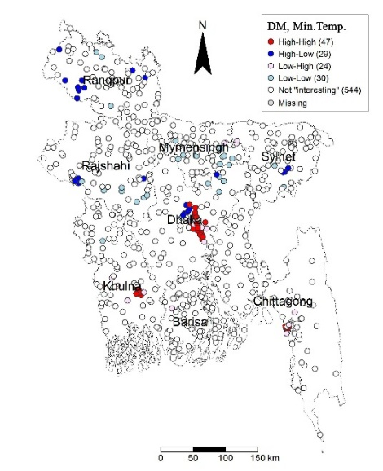 | 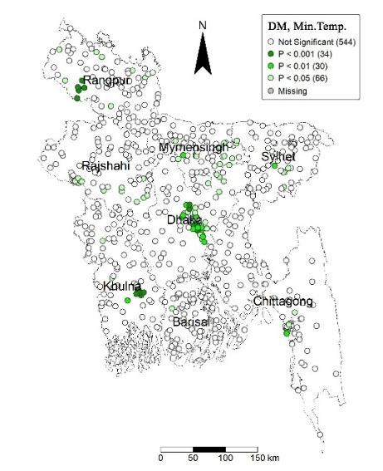
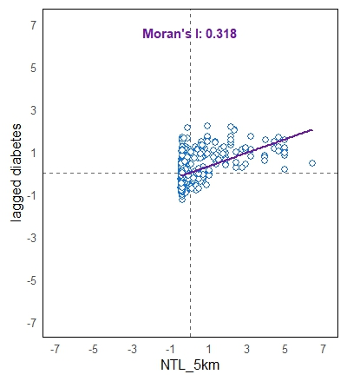 | 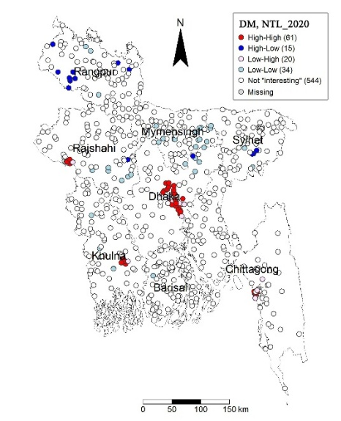 | 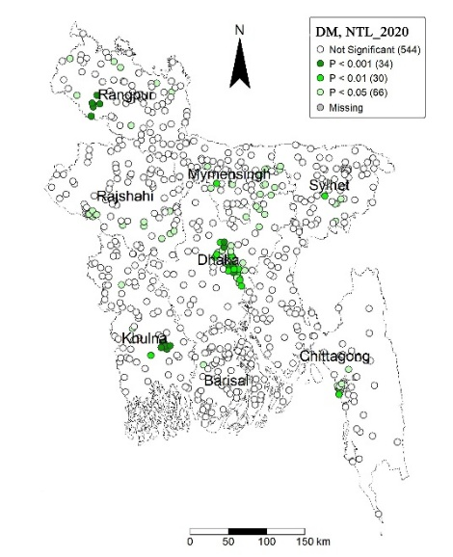
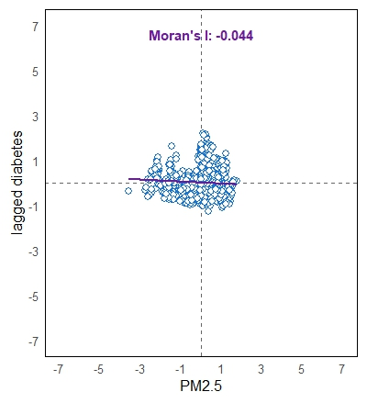 | 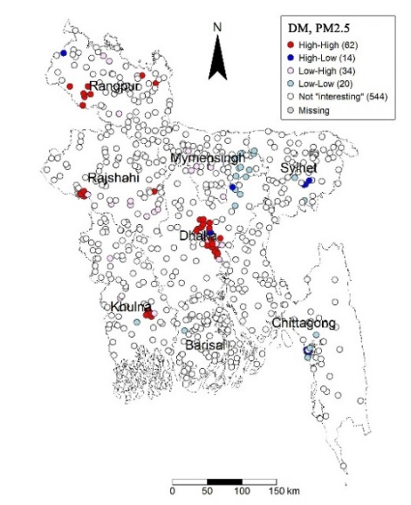 | 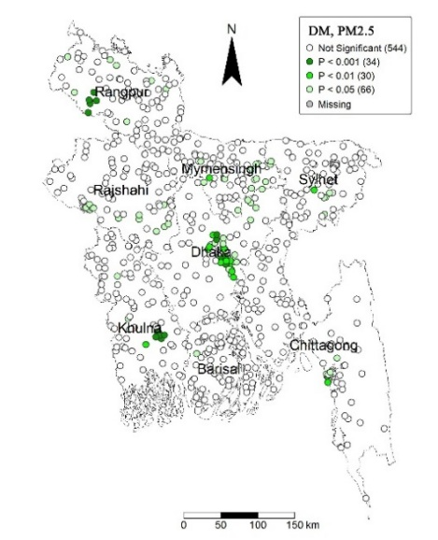
Figure S1: Bivariate LISA cluster and significant map between significant variable and Diabetes prevalence.

Table 1: Description of geographical and socio-demographical covariates
Covariates | Description of covariates | Range | Units | Year of extraction | source
Day Land Surface Temp | Annual daytime land surface temperature | 25.08-30.60 | Yearly average temperature in Degrees Celsius | 2020 | DHS Geospatial Covariates Datasets
Drought Episodes | Number of drought episodes (categorized) | 4 -10 | Individual classes between 1 (Low Drought) and 10 (High Drought) | 1980-2000 | DHS Geospatial Covariates Datasets
Elevation | Shuttle Radar Topography Mission (SRTM) near-global Digital Elevation Models (DEMs) | 0.89-206.38 | meters | 2000 | DHS Geospatial Covariates Datasets
Enhanced Vegetation Index | Enhanced vegetation index value ranging from least vegetation to most vegetation | 0.12- 0.537 | Vegetation index value between -1 (least vegetation) and 1 (most vegetation) | 2020 | DHS Geospatial Covariates Datasets
Land Surface Temperature | Annual land surface temperature | 23.01-26.65 | Yearly average temperature in Degrees Celsius | 2020 | MODIS
Livestock (cattle, chicken, ducks, goats, pigs, sheep) | Density of livestock | 1-16 | Heads of Livestock per square kilometers | 2006 | DHS Geospatial Covariates Datasets
Maximum Temperature | Maximum temperature | 29.43-31.95 | Degrees Celsius | 2020 | DHS Geospatial Covariates Datasets
Minimum Temperature | Minimum temperature | 19.38-22.64 | Degrees Celsius | 2020 | DHS Geospatial Covariates Datasets
Night Land Surface Temperature | Nighttime land surface temperature | 0.11-23.77 | Yearly average temperature in Degrees Celsius | 2020 | DHS Geospatial Covariates Datasets
Rainfall | Annual rainfall | 1639.16-5843.26 | Millimeters per year | 2020 | DHS Geospatial Covariates Datasets
Night Time Light (NTL) | A proxy for urbanization and economic activity, measured by satellite-detected luminosity. | 0.11-42.73 | radiance units of nW/cm²/sr | 2020 | SNPP–VIIRS dataset
Air pollution (PM2.5) | Annual average fine particulate matter concentration (μg/m³) within a 5 km buffer of each cluster | 20.90-51.90 | μg/m³ | 2020 | MODIS
Normalized Difference Vegetation Index (NDVI) | A remotely sensed index representing vegetation greenness, ranging | 1038.69-8012.66 | Vegetation index value between -1 (least vegetation) and 1 (most vegetation) | 2020 | MODIS
Precipitation | Average precipitation (per month) | 131.32-376.05 | Millimeters per month | 2020 | DHS Geospatial Covariates Datasets
Population Density_5km | Estimated population per square kilometer within a 5 km buffer around each cluster | 42.99-84314.69 | persons/km² | 2020 | Gridded Population of the World – NASA SEDAC
Weighted Percentage Normal Weight | Proportion of adults classified as having normal BMI (18.5–24.9 kg/m²) within each cluster. | 20-100 | Percentage (%) | 2022 | BDHS
Weighted Percentage Underweight | Proportion of adults classified as underweight (BMI <18.5 kg/m²) | 21.03-52.38 | Percentage (%) | 2022 | BDHS
Weighted Percentage Overweight | Proportion of adults classified as overweight or obese (BMI ≥25 kg/m²). | 0-80 | Percentage (%) | 2022 | BDHS
Weighted Percentage Unmarried | Share of individuals who have never been married | 0-42.31 | Percentage (%) | 2022 | BDHS
Weighted Percent Divorced | Proportion of individuals divorced or separated, included as a social determinant. | 0-38.46 | Percentage (%) | 2022 | BDHS
Weighted Percent Married | Share of individuals who have ever been married | 47.62-100 | Percentage (%) | 2022 | BDHS
Weighted Percentage Young | Proportion of the population aged <35 years within each cluster, capturing age-related risk for diabetes. | 0-50 | Percentage (%) | 2022 | BDHS
Weighted Percentage Older | Proportion of the population aged ≥35 years within each cluster, capturing age-related risk for diabetes. | 50-100 | Percentage (%) | 2022 | BDHS
Weighted Percentage No-Education | Proportion of adults with no formal schooling, reflecting lower socioeconomic status. | 0-88.89 | Percentage (%) | 2022 | BDHS
Weighted Percentage Primary Education | Share of adults completing some or full primary education. | 0-81.25 | Percentage (%) | 2022 | BDHS
Weighted Percentage Secondary Higher Education | Proportion of adults attaining at least secondary education or higher. | 0-100 | Percentage (%) | 2022 | BDHS
Weighted Percentage Female | Share of women in the cluster sample, included as a demographic structure variable | 33.33-100 | Percentage (%) | 2022 | BDHS
Weighted Percentage Male | Share of men in the cluster sample, included as a demographic structure variable | 0-66.67 | Percentage (%) | 2022 | BDHS

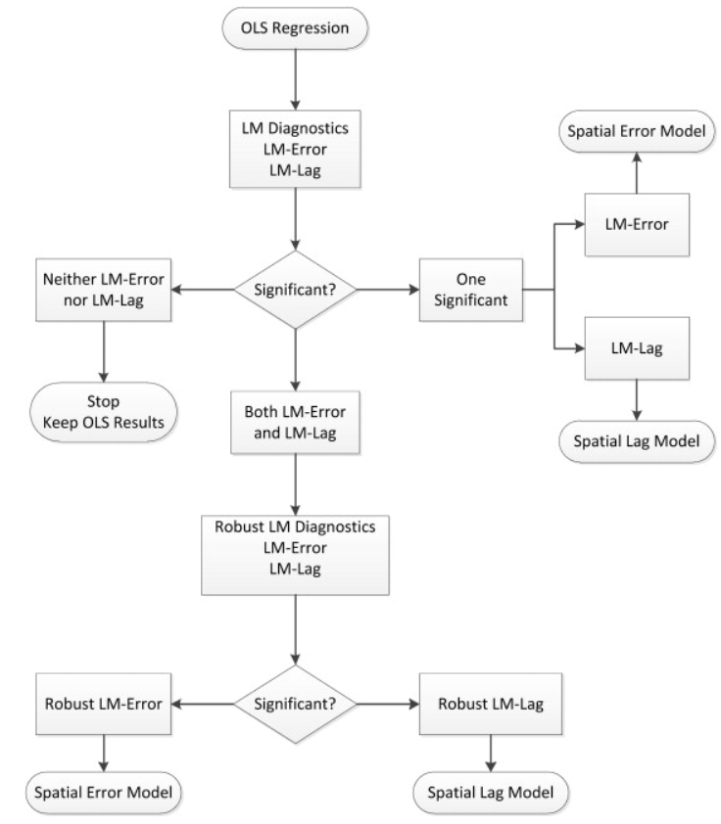
Figure S2: Decision tree of Spatial econometric model selection, developed by Dr. Luc Anselin.

Table S2: Descriptive statistics of study variables across 674 DHS clusters in Bangladesh
Variables | observation | Mean | Std. Dev | Min | Max
Diabetes Prevalence | 674 | 17.850 | 13.467 | 0 | 80
Overweight (%) | 674 | 27.948 | 14.842 | 0 | 80
No education | 674 | 25.316 | 14.265 | 0 | 88.889
Primary education | 674 | 25.277 | 12.083 | 0 | 81.25
Older $(≥35$) | 674 | 75.173 | 8.667 | 50 | 100
Female | 674 | 55.531 | 7.565 | 33.333 | 100
Day Land Surface Temperature | 674 | 27.628 | 0.981 | 25.082 | 30.598
Elevation | 674 | 16.031 | 14.369 | 0.893 | 206.855
EVI | 674 | 0.332 | 0.06
Maximum Temperature | 674 | 30.568 | 0.469 | 29.434 | 31.953
NTL | 674 | 3.087 | 6.215 | 0.1067 | 42.729
Minimum Temperature | 674 | 21.082 | 0.653 | 19.375 | 22.642
Rainfall | 674 | 2593.047 | 813.695 | 1639.158 | 5843.26
Drought Episodes | 674 | 6.309 | 2.627 | 4 | 10
PM2.5 | 674 | 41.717 | 5.812 | 20.9 | 51.9

Table S3: Variance Inflation Factor values for candidate covariates assessed for multicollinearity prior to multivariable model selection
Variable name | VIF
Weighted Percentage Normal Weight | 5.79
Weighted Percentage Underweight | 11.01
Weighted Percentage Overweight | 1.47
Weighted Percentage Unmarried | 14.0
Weighted Percent Divorced | 6.86
Weighted Percent Married | 5.93
Weighted Percentage Young | 8.7
Weighted Percentage Older | 1.48
Weighted Percentage No-Education | 1.38
Weighted Percentage Primary Education | 1.16
Weighted Percentage Secondary Higher Education | 7.5
Weighted Percentage Female | 1.67
Weighted Percentage Male | 9.3
Day Land Surface Temp | 2.72
Drought Episodes | 2.022
Elevation | 2.52
Enhanced Vegetation Index | 3.57
Land Surface Temperature | 13.6
Maximum Temperature | 2.80
Minimum Temperature | 4.73
Night Land Surface Temperature | 13.9
Rainfall | 2.79
Night Time Light (NTL) | 3.07
Air pollution (PM2.5) | 4.02
Normalized Difference Vegetation Index (NDVI) | 7.82
Precipitation | 6.77
Population Density_5km | 5.89
Livestock (cattle, chicken, ducks, goats, pigs, sheep) | 6.32

