Supplementary material

Content
Appendix 1. Survey Questionnaire - 2 -
Appendix 2. Definitions and Construction of Composite Variables and Indices - 10 -
Table S1. High-risk sexual behaviors characteristics of MSM - 14 -
Table S2. Accuracy of Responses to Monkeypox-Related Knowledge Items - 15 -
Fig. S1. Influencing factors of subjective–objective risk perception mismatch for monkeypox infection: stratified logistic regression results [P (95% CI)] (superscripts a and b indicate risk subjective underestimation and overestimation, respectively) - 16 -

Appendix 1. Survey Questionnaire

Dear Participant,
This survey is conducted by the National Center for AIDS/STD Control and Prevention, Chinese Center for Disease Control and Prevention. The purpose is to assess the level of mpox-related health knowledge among men who have sex with men (MSM). This survey is anonymous and does not collect any personally identifiable information. Your responses will be kept confidential. We encourage you to answer honestly. The survey will take approximately 10 minutes. Thank you for your support.
1. Do you agree to participate in this survey?
- Yes
- No → (End of survey)
2. What is your gender?
- Male
- Transgender
- Female → (End of survey)
3. In the past 12 months, have you had same-sex sexual behaviors (including oral, anal, or manual sex)?
- Yes
- No → (End of survey)
4. Are you 18 years of age or older?
- Yes
- No → (End of survey)

Section A: General Information
5. Year of birth: _______
6. Marital status (heterosexual marriage):
- A. Never married
- B. Married
- C. Cohabiting
- D. Divorced or widowed
7. Education level:
- A. Middle school or below
- B. High school/vocational school
- C. College/university
- D. Graduate degree or above
8. Current employment status:
- A. Student
- B. Cadre/administrative staff/public institution employee
- C. Commercial or service worker (hotel, bar, bathhouse, catering, sales, etc.)
- D. Worker or farmer
- E. Self-employed
- F. Healthcare worker
- G. Retired
- H. Unemployed/not working
- I. Other (please specify): _________
9. Average monthly income or living allowance:
- A. No income
- B. ≤ 3,000 RMB
- C. 3,001–5,000 RMB
- D. 5,001–10,000 RMB
- E. ≥ 10,001 RMB
10. Current city and province of residence: _______________

11. Type of current residence:
- A. Urban
- B. Rural
- C. Peri-urban
12. What is your sexual orientation?
- A. Homosexual
- B. Bisexual
- C. Heterosexual
- D. Unsure
13. Main way of finding sexual partners currently:
- A. Online (e.g., Blued, Aloha, WeChat/QQ apps)
- B. Offline (e.g., friend introduction, bars, clubs, bathhouses)
- C. Both online and offline equally
14. Before this survey, had you heard of mpox?
- A. Yes
- B. No

Section B-1: Core Mpox Knowledge
15. Is mpox an infectious disease caused by the mpox virus?
- A. Yes
- B. No
- C. Don't know
16. Are both humans and animals infected with mpox virus sources of infection?
- A. Yes
- B. No
- C. Don't know

17. Can mpox virus be transmitted through direct contact with the skin lesions or mucous membranes of mpox cases via touching, hugging, kissing, or sexual behaviors?
- A. Yes
- B. No
- C. Don't know
18. What is the usual incubation period from mpox virus infection to symptom onset?
- A. 1–4 days, usually 2–3 days
- B. 5–21 days, usually 6–13 days
- C. Don't know
19. Can mpox virus be transmitted through contact with bodily fluids of infected animals, or via bites or scratches from infected animals?
- A. Yes
- B. No
- C. Don't know
20. Can prolonged, close-range inhalation of respiratory droplets from mpox cases transmit the virus?
- A. Yes, it can transmit
- B. No, it cannot transmit
- C. Don't know
21. Are there currently specific antiviral drugs for mpox available in China?
A. Yes, there are specific drugs
B. No, there are no specific drugs
C. Don't know
22. Can mpox virus be transmitted through contact with contaminated objects?
- A. Yes
- B. No
- C. Don't know
23. Are all populations susceptible to mpox virus?
- A. Yes
- B. No
- C. Don't know
24. Do mpox virus infections present with symptoms such as fever, headache, and lymphadenopathy?
- A. Yes
- B. No
- C. Don't know
25. Does mpox virus infection cause itchy or painful rashes or mucosal lesions on the body?
- A. Yes
- B. No
- C. Don't know

Section B-2: Mpox Risk Perception and Behaviors
26. How high do you perceive your own risk of mpox infection?
- A. Very low
- B. Low
- C. Moderate
- D. High
- E. Very high
27. Have you recently experienced any new or unexplained rash or lesions, including in the oral, genital, or anal areas?
- A. Yes
- B. No
28. (If Q27 = Yes) After the symptoms appeared, which of the following measures did you take? (Select all that apply)
- A. Visited a relevant hospital department
- B. Consulted CDC medical staff
- C. Sought help from community-based organizations
- D. Purchased medication on one's own
- E. Reduced contact with others and self-isolated at home
- F. Disinfected surrounding environment and items
- G. Took personal protective measures when going out, avoiding skin exposure
- H. Did not take any measures
29. (If Q27 = No) If you were to develop such symptoms, what would you do? (Select all that apply)
- A. Visit a relevant hospital department
- B. Consult CDC medical staff
- C. Seek help from community-based organizations
- D. Purchase medication on one's own
- E. Reduce contact with others and self-isolate at home
- F. Disinfect surrounding environment and items
- G. Take personal protective measures when going out, avoiding skin exposure
- H. Take no measures
30. (If Q28 or Q29 selected any option other than hospital visit) Why did you choose not to visit a hospital? (Select all that apply)
- A. Not necessary; mild symptoms, could self-medicate
- B. Fear of mandatory quarantine
- C. Fear of privacy exposure if community notified
- D. Fear of privacy exposure if workplace disinfection required
- E. Worry about disclosing HIV status
- F. Worry about involuntary disclosure of sexual orientation
- G. Other (please specify): _________

Section C: Behavioral Information
Note: "Same-sex sexual behaviors" in the following questions include anal, oral, and manual sex.
31. In the past 3 months, on average, how many times per month did you have same-sex sexual behaviors?
- A. Once a month
- B. 2–4 times a month
- C. 5 or more times a month
- D. 0 times → Skip to Q36
32. In the past 3 months, have you used any of the following substances during same-sex sexual encounters? (Select all that apply)
- A. Rush poppers
- B. "Zero capsule" (5-MeO-DiPT)
- C. Heroin
- D. Methamphetamine
- E. Ecstasy (MDMA)
- F. Ketamine ("K powder")
- G. Magu (methamphetamine tablet)
- H. Cannabis
- I. None of the above
33. In the past 3 months, on average, how many same-sex sexual partners did you have per month?
- A. 1 partner per month
- B. 2–3 partners per month
- C. 4 or more partners per month
34. In the past 3 months, among your same-sex sexual partners, did any have rash symptoms?
- A. Yes
- B. No
- C. Did not notice / unsure
35. In the past 3 months, how many times did you engage in group same-sex sexual behaviors (with ≥2 partners simultaneously)?
- A. 0 times
- B. 1–2 times
- C. 3–4 times
- D. 5 or more times
36. In the past 3 months, have you traveled internationally?
- A. Yes
- B. No
37. (If Q36 = Yes) During your international travel in the past 3 months, did you have same-sex sexual behaviors locally?
- A. Yes
- B. No
38. (If Q37 = Yes) During your international travel, did any of your same-sex sexual partners have rash symptoms?
- A. Yes
- B. No
- C. Did not notice / unsure
39. In the past 3 months, have you been diagnosed with any of the following sexually transmitted infections? (Select all that apply)
- A. None
- B. Syphilis
- C. Gonorrhea
- D. Condyloma acuminatum (genital warts)
- E. Genital herpes
- F. Chlamydia trachomatis infection
- G. Other STIs (please specify): _________
40. What is your current HIV status?
- A. Positive
- B. Negative → Skip to end
- C. Unknown → Skip to end

Appendix 2. Definitions and Construction of Composite Variables and Indices
This appendix provides detailed, plain-language explanations of all composite variables and indices used in the Measures section of the main text. Each construct is defined in terms of its components, scoring rules, and classification criteria, to facilitate transparency and reproducibility.
1. Monkeypox Knowledge Score
This variable was constructed to measure participants' factual understanding of monkeypox (mpox). Seven questions were used, covering the following domains: (1) source of infection, (2) transmission routes, (3) susceptible populations, (4) typical symptoms, (5) rash or mucosal lesions, (6) incubation period, and (7) preventive measures.
For single-choice questions, each correct answer was assigned 1 point. For multiple-choice questions, each correct option contributed a fractional score equal to 1 divided by the total number of correct options for that question. Selecting an incorrect option yielded 0 points for that option. No points were deducted for incorrect selections. The total knowledge score was the sum of points across all seven questions, ranging from 0 to 7. A passing threshold was set at ≥60% of the maximum score, i.e., ≥4.2 points. Participants with scores ≥4.2 were classified as having adequate knowledge awareness; those with scores <4.2 were classified as having inadequate knowledge awareness.
2. High-Risk Men Who Have Sex with Men
This binary composite variable identified participants at elevated risk of mpox exposure based on recent behavioral and clinical indicators. A participant was defined as high-risk if they met at least one of the following criteria within the past 3 months:
- Frequent or group sexual behaviors, meeting any of:
- Average of ≥5 same-sex sexual acts per month; or
- Average of ≥4 male sexual partners per month; or
- Engaged in group sex (sexual activity with two or more male partners simultaneously).
- Male sexual partners with rash symptoms, reported that at least one same-sex partner had visible rash during the past 3 months.
- Overseas partners with rash symptoms, reported that, during international travel in the past 3 months, at least one same-sex partner had rash symptoms.

- HIV-positive status or recent STI diagnosis, self-reported HIV-positive status, or a diagnosis of at least one sexually transmitted infection (including syphilis, gonorrhea, condyloma acuminatum, genital herpes, or chlamydia) within the past 3 months.
Participants who did not meet any of the above conditions were classified as non-high-risk.
3. Subjective Risk Perception of Mpox Infection
This single-item measure captured participants' self-assessed likelihood of contracting mpox. Participants responded to the question: "How high do you think your risk of monkeypox infection is?" using a 5-point Likert scale:
- 1 = Very low
- 2 = Low
- 3 = Moderate
- 4 = High
- 5 = Very high
This variable was used as the subjective dimension in the subjective–objective risk discrepancy analysis.
4. Objective Risk Assessment (Among High-Risk MSM)
Objective risk was operationalized using two behavioral and clinical indicators collected from high-risk MSM participants:
- Presence of unexplained rash or lesions – response to the question: *"Have you developed any new unexplained rash or lesions (including in the genital or perianal areas) in the past month?"* (Yes/No).
(2) Healthcare-seeking behavior – for those who reported rash/lesions, response to: *"After experiencing these symptoms, what measures did you take?"* Options included visiting a hospital, consulting CDC staff, seeking community organization help, self-purchasing medication, self-isolation, disinfection, protective measures, or taking no action.
These two items together formed the basis for classifying the alignment or misalignment between objective risk indicators and subjective risk perception.
5. Subjective–Objective Risk Discrepancy Classification
This composite typology was constructed exclusively among high-risk MSM to categorize the degree of alignment or misalignment between subjective risk perception (self-assessed likelihood of mpox infection) and objective risk indicators (presence of unexplained rash/lesions and subsequent healthcare-seeking behaviors). The classification was based on a cross-tabulation of subjective risk ratings (five levels: Very low, Low, Moderate, High, Very high) against objective clinical/behavioral indicators, yielding four overarching categories with further gradations as specified below.
(1) Underestimation
This category applied to high-risk MSM who reported unexplained rash or lesions (an objective indicator of potential mpox infection) but rated their subjective infection risk as Low or Very low. These individuals objectively exhibited a clinical sign consistent with mpox but did not perceive themselves to be at meaningful risk. Based on the specific subjective rating, underestimation was stratified into three levels:
- High underestimation: rash/lesions present + subjective risk = Very low;
- Moderate underestimation: rash/lesions present + subjective risk = Low;
- Mild underestimation: rash/lesions present + subjective risk = Moderate.
(2) Matched Perception
This category applied when subjective risk ratings were consistent with objective indicators, reflecting accurate risk appraisal. Two matching levels were defined based on the direction of alignment:
- High match: rash/lesions present + subjective risk = Very high or no rash/lesions + subjective risk = Very low;
- Match: rash/lesions present + subjective risk = high or no rash/lesions + subjective risk = low.
(3) Overestimation
This category applied to high-risk MSM who did NOT report unexplained rash or lesions (no objective indicator of active infection) but rated their subjective risk as High or Very high. These individuals overestimated their infection risk in the absence of clinical signs. Based on the specific subjective rating, overestimation was stratified into three levels:
- High overestimation: no rash/lesions + subjective risk = Very high;
- Moderate overestimation: no rash/lesions + subjective risk = High;
- Mild overestimation: no rash/lesions + subjective risk = Moderate.
(4) Severe Mismatch Subgroup
This subgroup represented the most concerning discrepancy pattern. It comprised underestimators who had unexplained rash/lesions AND did NOT seek any medical advice or purchase medication following symptom onset. These individuals not only failed to recognize their risk but also took no active measures to address potential infection, posing potential risks to both themselves and others. Within this subgroup, the severity of subjective–objective discrepancy was further graded into five ordinal levels (Severe, Major, Moderate, Little, and Minimal).

Table S1. High-risk sexual behaviors characteristics of MSM
Variables | Number  (n) | Proportion (%)
Frequency of sexual activity with men//month
0 times | 3452 | 24.10%
1–5 times | 9448 | 65.95%
≥5 times | 1425 | 9.95%
Average monthly number of male sexual partners*
1-3 | 9649 | 88.74%
≥4 | 1224 | 11.26%
History of group sex with men*
No | 8457 | 77.78%
Yes | 2416 | 22.22%
Rash symptoms in male sexual partners*
Yes | 569 | 5.23%
No | 8793 | 80.87%
Not sure | 1511 | 13.90%
Rash symptoms in male sexual partners during overseas travel*
No history of overseas travel | 10282 | 94.56%
History of overseas travel | 591 | 5.44%
No male-male sexual activity | 253 | 1.77%
Yes | 158 | 1.10%
No | 136 | 0.95%
Not sure | 44 | 0.31%
STI Diagnosis*
No | 10309 | 94.81%
Yes (e.g., syphilis, gonorrhea, genital warts, genital herpes, genital chlamydia infection) | 564 | 5.19%
Current HIV status
Positive | 3357 | 23.43%
Negative | 9997 | 69.79%
Unknown | 971 | 6.78%
* Indicated MSM who engaged in sexual activity in the past 3 months.

Table S2. Accuracy of Responses to Monkeypox-Related Knowledge Items
Variables | Correct respondents (n) | Proportion (%)
Source of infection
Monkeypox can be transmitted from infected animals or humans. | 11838 | 82.64%
Routes of transmission (Multiple choices)
Sexual contact (under investigation); through mucous membranes or broken skin | 12458 | 86.97%
Contact with blood, bodily fluids, or bites from infected animals | 11827 | 82.56%
Close physical contact or contact with contaminated materials (e.g., bedding, surfaces) | 9131 | 63.74%
Respiratory droplets during prolonged face-to-face contact | 9862 | 68.84%
Susceptibility
All individuals are susceptible to monkeypox. | 7447 | 51.99%
Typical symptoms
Typical symptoms include fever, headache, and lymphadenopathy. | 10275 | 71.73%
Rash/mucosal lesions
Rash or mucosal lesions, often painful or pruritic, usually follow early symptoms. | 11019 | 76.92%
Incubation period
The incubation period ranges from 5 to 21 days, most commonly 6 to 13 days. | 7254 | 50.64%
Preventive Measures (Multiple choices)
Maintain a consistent sexual partner and use condoms correctly | 13163 | 91.89%
Perform hand hygiene and disinfect surfaces regularly | 11463 | 80.02%
Avoid travel to areas with active outbreaks | 11283 | 78.76%
Practice physical distancing and wear masks appropriately | 9997 | 69.79%
Receive vaccination when eligible | 8941 | 62.42%

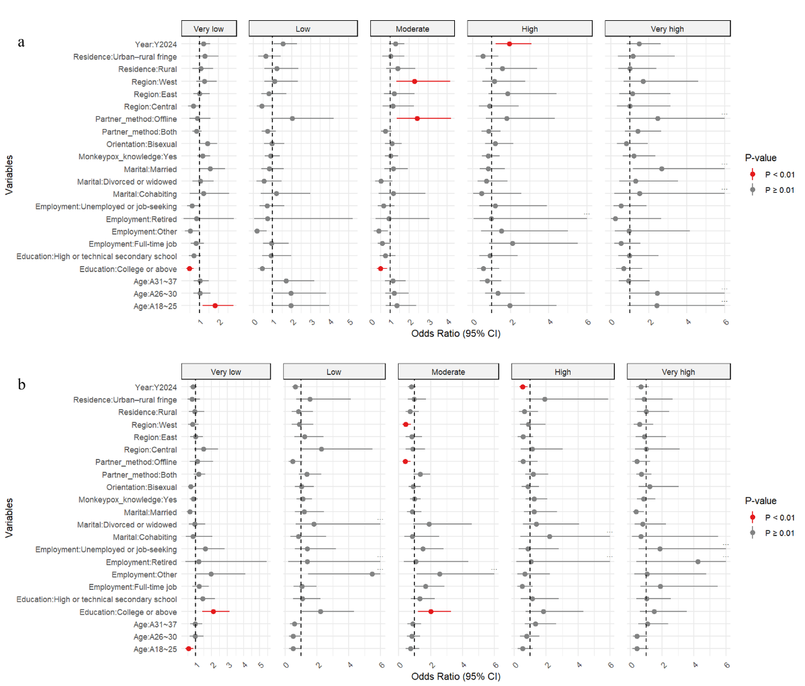

Fig. S1. Influencing factors of subjective–objective risk perception mismatch for monkeypox infection: stratified logistic regression results [P (95% CI)] (superscripts a and b indicate risk subjective underestimation and overestimation, respectively)

