Supplementary Material
Table S1. Attrition analysis: baseline comparison between completers and non-completers.
Characteristics | Overall  (N = 285) | Completers  (N = 209) | Non-completers (N = 76) | p-value
Age, years — n (%) |  |  |  | 0.21
6 | 4 (1.4) | 2 (1.0) | 2 (2.6)
7 | 11 (3.9) | 6 (2.9) | 5 (6.6)
8 | 73 (26) | 51 (24) | 22 (29)
9 | 59 (21) | 40 (19) | 19 (25)
10 | 64 (22) | 50 (24) | 14 (18)
11 | 70 (25) | 56 (27) | 14 (18)
12 | 4 (1.4) | 4 (1.9) | 0 (0)
Sex — n (%) |  |  |  | 0.45
Boys | 154 (54) | 110 (53) | 44 (58)
Girls | 130 (46) | 98 (47) | 32 (42)
BMI Z-score — mean (SD) | 0.88 (1.32) | 0.95 (1.32) | 0.65 (1.31) | 0.17
Weight status — n (%) |  |  |  | 0.32
Normal weight | 152 (56) | 114 (55) | 38 (60)
Thinness | 1 (0.4) | 0 (0) | 1 (1.6)
Overweight | 56 (21) | 45 (22) | 11 (17)
Obesity | 62 (23) | 49 (24) | 13 (21)
School — n (%) |  |  |  | 0.021
1 | 48 (17) | 28 (13) | 20 (26)
2 | 51 (18) | 44 (21) | 7 (9.2)
3 | 41 (14) | 31 (15) | 10 (13)
4 | 50 (18) | 35 (17) | 15 (20)
5 | 41 (14) | 27 (13) | 14 (18)
6 | 54 (19) | 44 (21) | 10 (13)
MVPA, min/day — mean (SD) | 56 (24) | 55 (22) | 59 (29) | 0.74
Sedentary time, min/day — mean (SD) | 512 (64) | 512 (64) | 511 (66) | >0.99
Standing long jump, cm — mean (SD) | 86 (21) | 85 (21) | 90 (23) | 0.19
Handgrip strength, kg — mean (SD) | 10.5 (4.1) | 10.4 (4.2) | 10.8 (3.8) | 0.39
Curl-ups, reps — mean (SD) | 20 (8) | 19 (8) | 20 (9) | 0.57
Note: Completers were defined as participants with valid data for at least one outcome at the post-intervention assessment. P-values from Fisher’s exact test, chi-squared test of independence or Wilcoxon rank-sum test, as appropriate. No statistically significant differences were observed except for the distribution across schools. BMI: body mass index; SD: standard deviation; MVPA: moderate-to-vigorous physical activity.

Table S2. Sensitivity of the BMI Z-score to the assumed follow-up interval.
Assumed interval (years) | Mean BMI Z-score at post-intervention | Obesity at post-intervention (%) | Overweight at post-intervention (%) | Coefficient for assessment phase
1.1 (value recorded in the database) | 1.056 | 26.0 | 24.0 | 0.248
1.5 | 0.933 | 23.0 | 24.0 | 0.188
2.0 | 0.785 | 21.6 | 22.5 | 0.118
Note: Chronological age was not re-measured at the post-intervention assessment. BMI Z-scores were recomputed against the WHO 2007 growth reference under three plausible follow-up intervals. Baseline values are unaffected by this assumption (21.8% obesity, 19.6% overweight). Because the classification at follow-up varies across assumptions, no conclusions are drawn regarding changes in weight status.

Table S3. Allometric scaling sensitivity analysis for lower-limb strength.
Normalisation approach | Assumed exponent | Coefficient for assessment phase
Simple ratio (performance / body mass) | 1.000 | -0.073
Allometric scaling (performance / body mass^b) | 0.105 (estimated at baseline) | 3.99
Note: The allometric exponent was estimated by regressing log(standing long jump) on log(body mass) at baseline. Simple ratio standardisation assumes an exponent of 1.0; the empirically estimated exponent was 0.105, indicating that dividing jump distance by body mass substantially over-corrects for body size. Ratio-standardised values for lower-limb strength should therefore be interpreted with caution.

Figure S1. Residual diagnostics for the linear mixed models.
Normal Q-Q plots and residuals versus fitted values for each outcome. Skewness ranged from -0.05 to 0.35 and excess kurtosis from 0.5 to 2.1 for all outcomes except vigorous physical activity (excess kurtosis 5.17), which did not show a statistically significant change.
Sedentary behavior
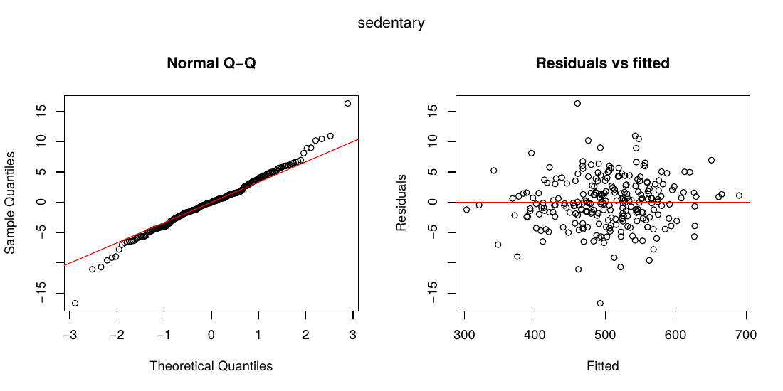
Light physical activity
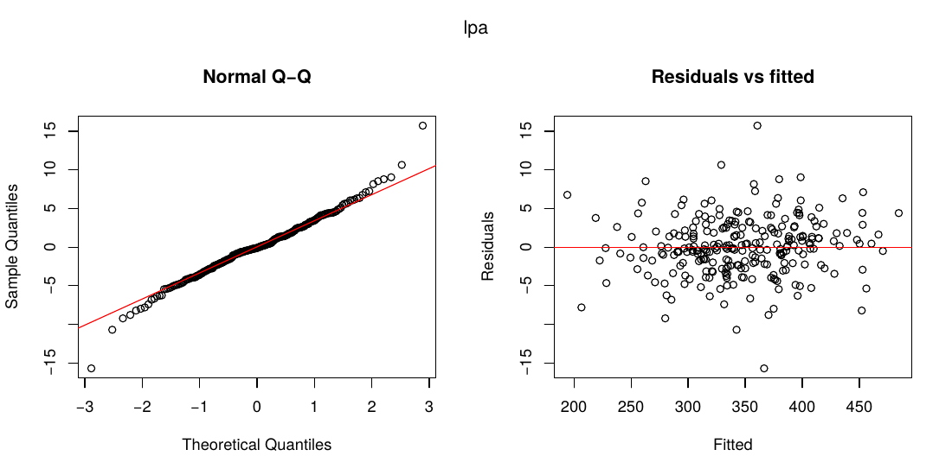

Moderate physical activity
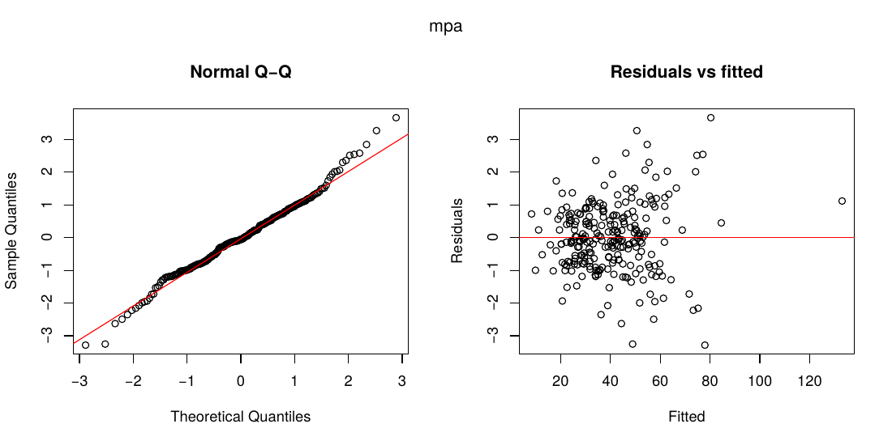

Vigorous physical activity
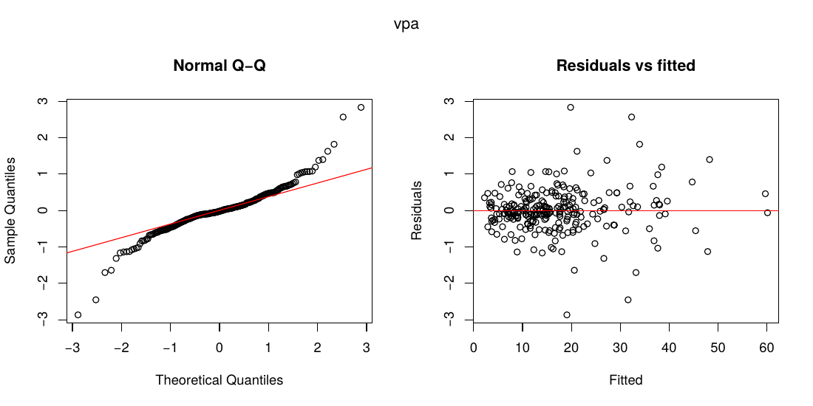
Moderate-to-vigorous physical activity
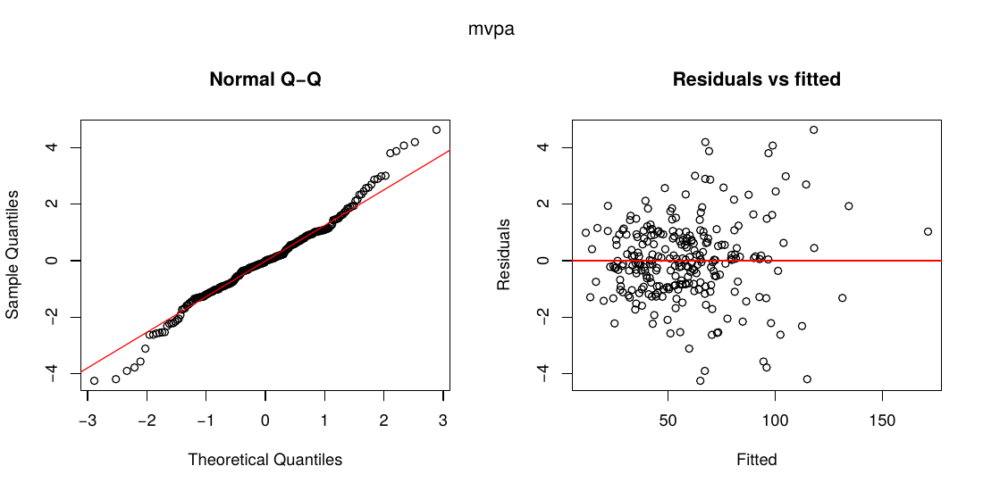

Lower limb strength
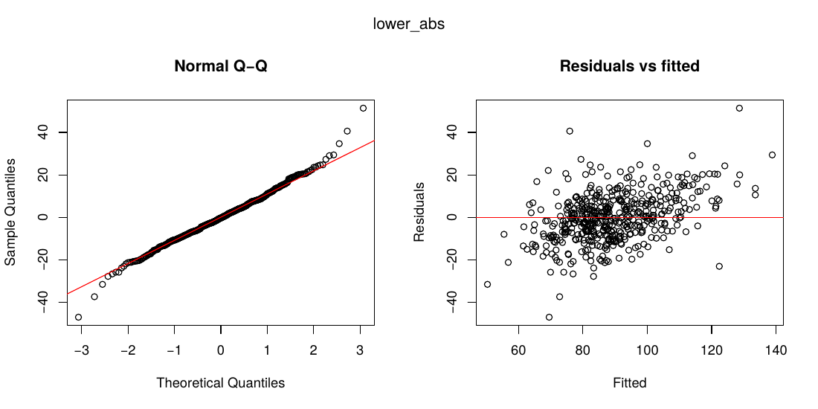

Upper limb strength
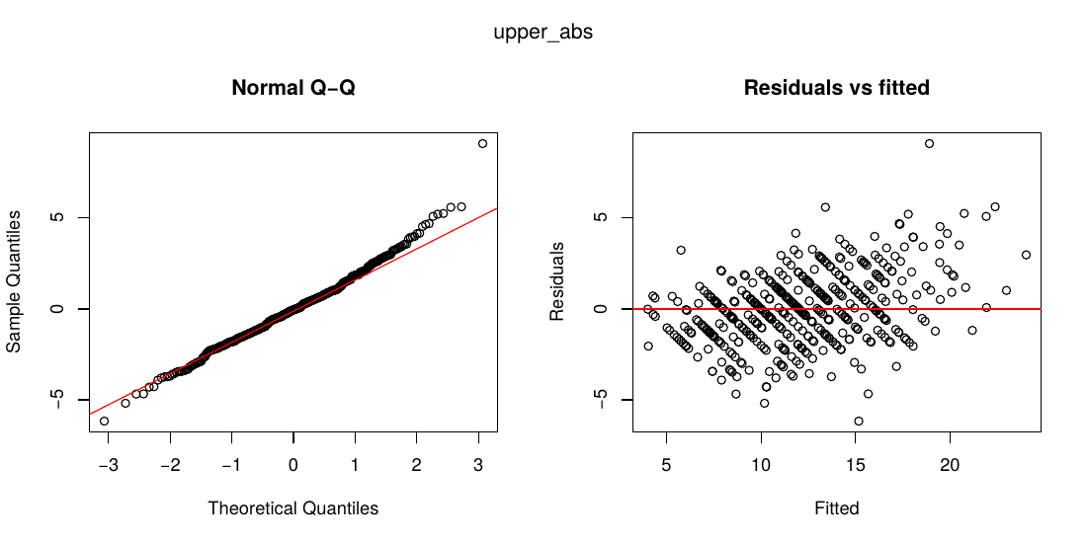
Abdominal muscle strength
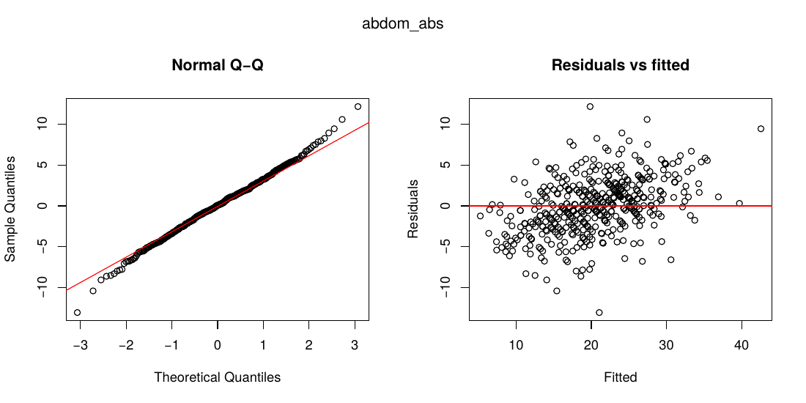

Relative lower limb strength
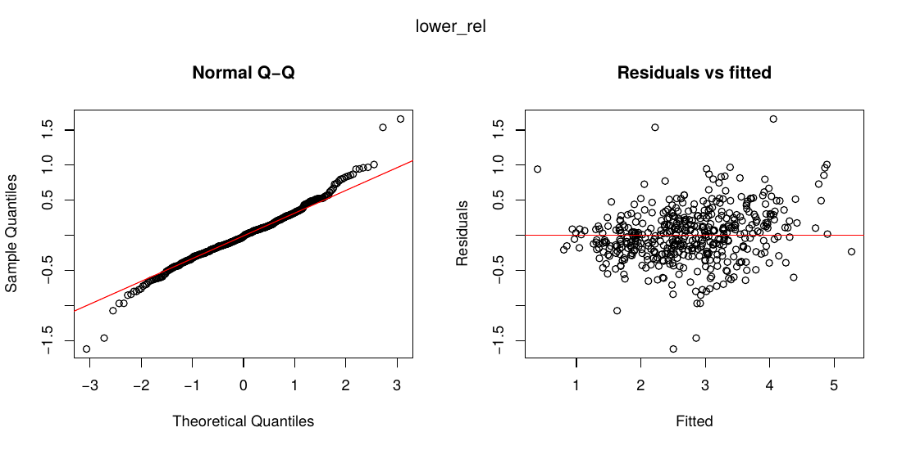
Relative upper limb strength
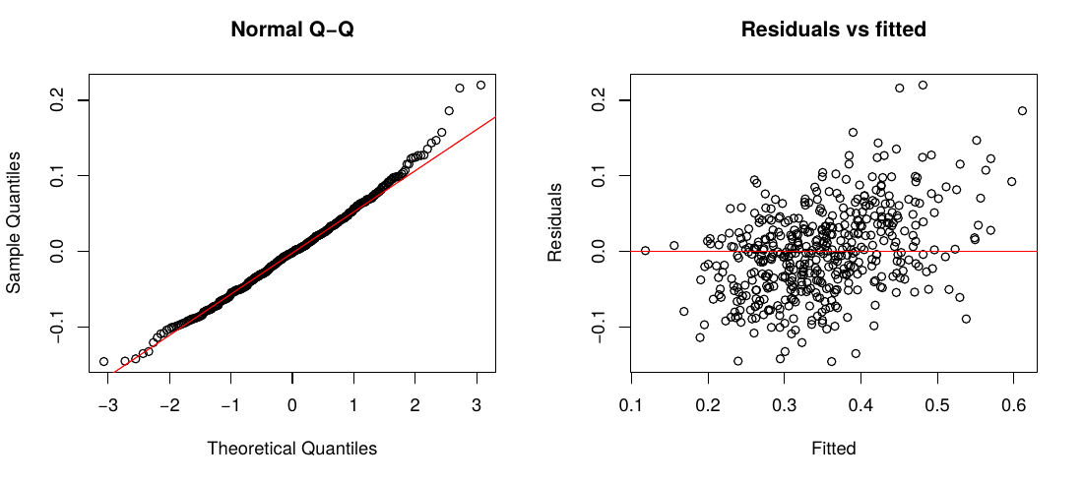
Relative abdominal muscle
