Survey Questions
Section 1: General Information

- Organization:
  - Which organization or local authority do you represent?
    - [Open-ended]

- Type of Vaping Prevention Initiative:
  - Has your local authority implemented any of the following initiatives to prevent or dissuade youth vaping? (Please select all that apply)
    - My local authority has not implemented any initiatives to prevent or dissuade youth vaping [This will direct respondents to Question 16 before ending the survey with the debrief.]
    - School-based educational campaign
    - Community-based educational campaign
    - Parent-focused educational campaign
    - Service provision (including clinics)
    - Counselling or behavioural support
    - Website / online information or support
    - Helpline / Quitline
    - A holistic school-based programme
    - Training for teachers
    - Other implementation (please describe)

- Resources:
  - Are you able to share any materials, resources, or documentation that could help us to describe or evaluate your vaping prevention initiative?
    - No
    - Yes
      - If yes, please provide links or upload documents. [Upload link]

Section 2: Detailed Information
Thank you! We would really appreciate it if you could provide some more details about the initiative(s) in your area. There are 12 more short questions. If you do not have time, or if you run out of time while completing the remainder of the survey, you can skip to the end and press ‘submit’.

- Local Authority:
  - In which local authority is the vaping prevention initiative being implemented?
    - [Open-ended]

- Target Age Group/Demographics:
  - Which ages are targeted by each initiative? (Please select all that apply)
    - Under 10
    - 11
    - 12
    - 13
    - 14
    - 15
    - 16
    - 17

- Integration with Other Programmes:
  - Is the vaping prevention initiative integrated with other prevention programmes (e.g., smoking, substance abuse, mental health)?
    - No
    - Yes
    - If yes, please describe how it is integrated.

Section 3: Programme Duration and Delivery
- Duration of Initiative:
  - How long has the vaping prevention initiative been running or how long did it run?
    - [Open-ended]

- Who Delivers the Programme?:
  - Who is responsible for delivering the vaping prevention initiative? (Select all that apply)
    - Trained specialists
    - Educators
    - Stop Smoking/Vaping Services
    - Researchers
    - Local authority members
    - Young people
    - School nurses
    - Other (please specify)

- Programme Delivery Format:
  - How is the initiative delivered? (Select all that apply)
    - In-person workshops or sessions
    - Online material
    - Printed materials
    - Social media outreach
    - Telephone-based
    - Slides for assemblies or lessons
    - In stop smoking/vaping services
    - Community based activities
    - Other (please specify)
Section 4: Evidence Basis and Effectiveness
- Evidence Base:
  - Have you used any evidence or information to create the initiative(s)? Please describe or provide a link to the research or evidence used.
    - No, we did not use any evidence or information to create this initiative
    - Yes (please describe)
    - [Upload link]

- Effectiveness of the Initiative:
  - Have you collected any data or conducted any research to assess how effective or well-accepted the initiative has been in preventing or dissuading vaping among young people?
    - No
    - Yes
      - If yes, please provide a summary of the results or a link to the results. [Upload link]

Section 5: Challenges and Improvements
- Challenges Faced:
  - What challenges or barriers have you faced in implementing the vaping prevention initiative?
    - [Open-ended]

- Improvements and Adjustments:
  - What improvements or adjustments do you believe are needed to make the initiative more effective?
    - [Open-ended]

- Future Plans:
  - Are there plans to expand/develop the vaping prevention initiative or create a new vaping prevention initiative in the future?
    - No
    - Yes
      - If yes, please describe any planned developments.

- Further Comments:
  - Is there anything else you would like to share regarding your vaping prevention initiative?
    - [Open-ended]

- Future Plans [Only asked participants who indicated they do not have vaping prevention initiative in Question 2]
  - Does your local authority have any future plans to implement a vaping prevention initiative?
    - No
    - Yes
      - If yes, please describe.

Figure S1:
The geographical distribution of the local authorities with a youth vaping prevention initiative
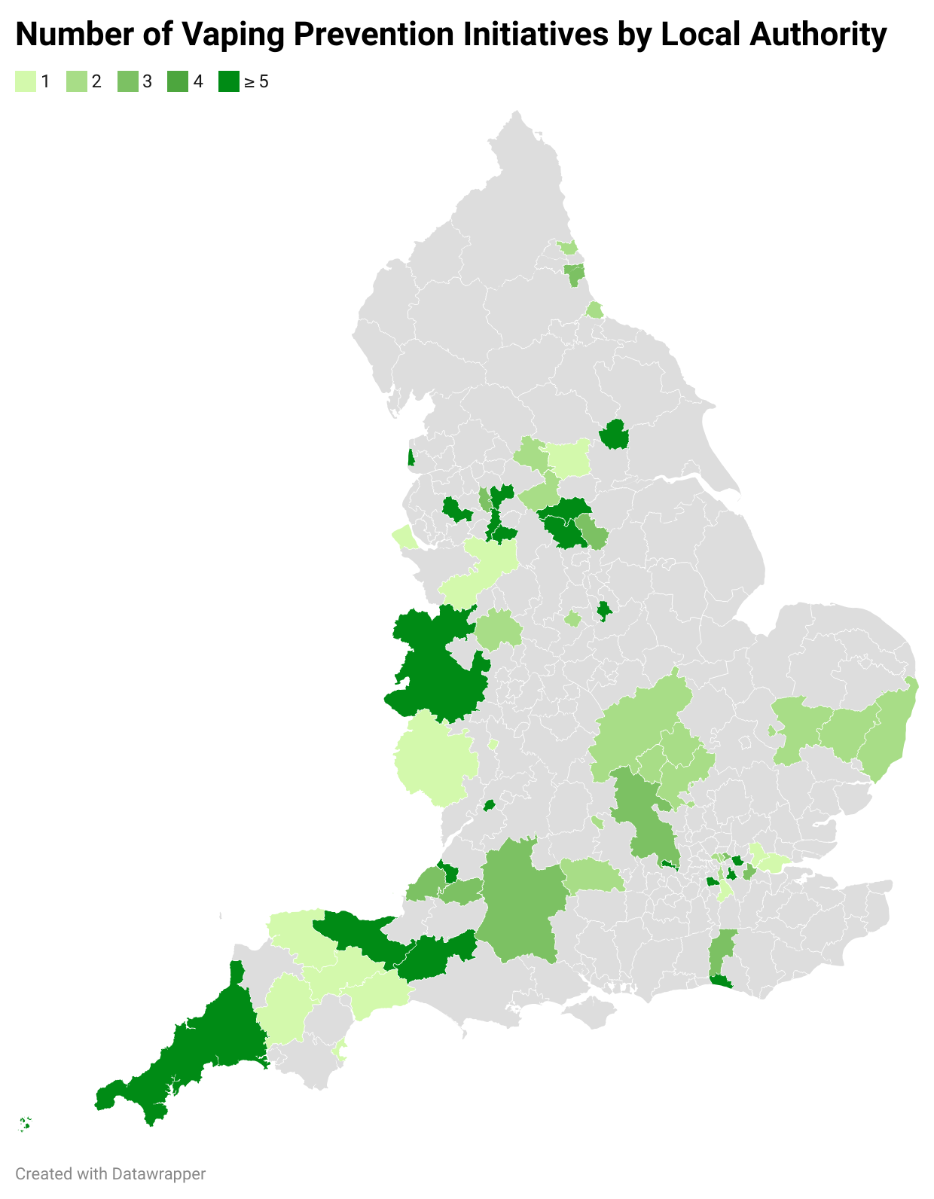

Table S1. Inaccurate or potentially overstated claims identified in materials provided by local authorities and the corresponding correct information.
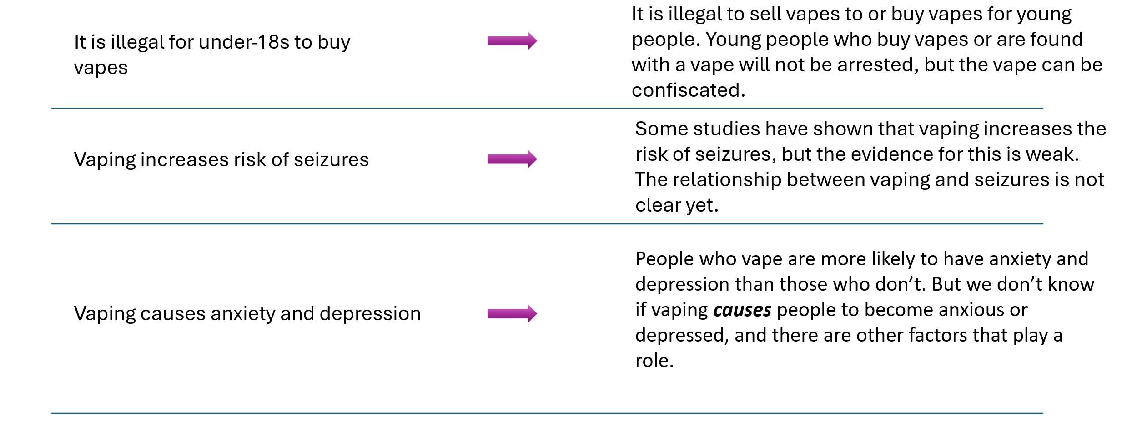
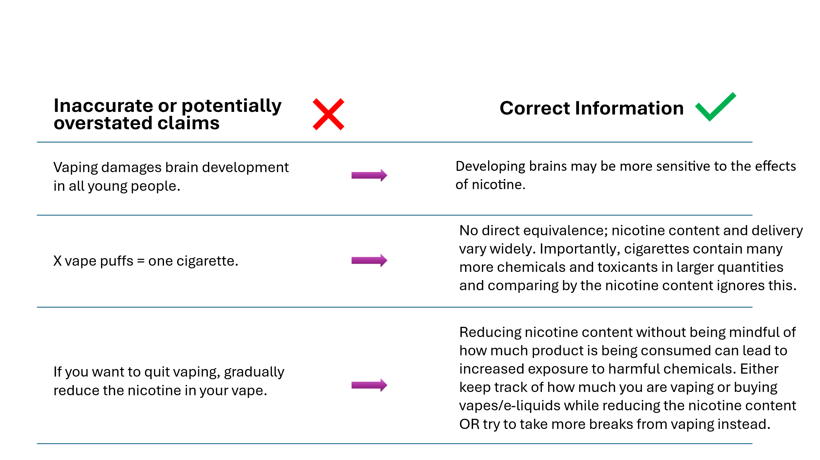

Notes: A range of sources were used to provide alternative statements and information. Nicotine exposure while the brain is still developing in adolescence may cause brain modifications (e.g., to the acetylcholine and dopaminergic systems) (Reynolds et al., 2025), but referring to this as “damage” potentially overstates the evidence, particularly as most of this evidence is from rodent models rather than observed in humans. Evidence in humans and animal models suggest that adolescents may develop dependence faster than adults, indicating an increased sensitivity to the effects of nicotine during this period (Goriounova & Mansvelder, 2012). There is no direct equivalence between the number of cigarettes and number of vapes/vape puffs for multiple reasons; vapes can contain various levels of nicotine, the amount of nicotine that reaches the brain is dependent on numerous factors beyond the mg contained in the e-liquid, the products contain different chemicals and toxicants and the relative quantities and harms vary considerably (Goniewicz et al., 2014). Gradual quitting by nicotine reduction is often recommended as this method is advised with traditional smoking cessation products (e.g., nicotine patches), but applying this method to vaping could lead to self-titration whereby the individual will intake more e-cigarette aerosol to reach their usual nicotine levels resulting in increased exposure to other constituents of the aerosol which could cause harm (e.g., formaldehyde) (Dawkins et al., 2016). The Nicotine Inhaling Products (Age of Sale and Proxy Purchasing) Regulations 2015 prohibit the sale or proxy sale of e-cigarettes to those under 18, but possession or purchasing of e-cigarettes by people under 18 years of age is not a criminal offence. There is limited evidence to suggest that vaping is causally linked to seizures; some case reports indicate that some individuals may be prone to e-cigarette provoked seizures (Liu-Zarzuela & Sun, 2022), but there is insufficient evidence to determine causality. Vaping has been shown in multiple studies to be associated with anxiety and depression but significant methodological limitations have been highlighted and there is insufficient evidence to determine causality (Becker et al., 2021).

Table S2: Markers of information appropriate for young people
Marker of Good Information | Description
Clear messaging about the harms of vaping | Relative harm: Vaping is less harmful than smoking.  Absolute harm: Vaping is not risk-free.
Youth-appropriate communication | Information for young people should be written for young people.
Youth-appropriate communication | Use simple, easy-to-understand language.
Youth-appropriate communication | Use images and videos to break up dense text.
Non-judgemental tone | Provide information without being judgemental or instructive.
Non-judgemental tone | Avoid telling young people what to do, as this is unlikely to change their minds.
Non-judgemental tone | Encourage young people to make informed decisions.
Honesty | Avoid overstating harms; exaggeration may reduce vaping in the short term, but if young people recognise the information as incorrect, credibility is lost.

Note: The advice provided here was developed through patient and public involvement with relevant stakeholders (e.g., young people with and without experience of vaping). The advice aligns with recommendations for harm reduction among young people who use drugs (Kimmel et al., 2021), adolescents preferences for tobacco control programs (Swart et al., 2006), and findings from a systematic review of health messaging strategies for vaping prevention and cessation among youth (Wu et al., 2025).
Evidence supports the need for clear messaging about relative and absolute harms in adults and young people as perceiving vaping as equally or more harmful is associated with a higher likelihood of smoking rather than vaping (East et al., 2026). Furthermore, highlighting absolute harms (e.g., “not harmless water vapour”) in vaping prevention adverts is associated with increased perceived message effectiveness in adolescents (Boynton et al., 2023).
Targeting messaging to the appropriate audience is associated with increased persuasive effect in smoking prevention (Kim et al., 2016). The language used can also impact perceived message effectiveness even when changing just one word of the message (Ma et al., 2024). Young people prefer simple and straightforward messaging, avoiding metaphors and word play (England et al., 2021). The use of images alongside key textual information can increase attention and recall of health information, but in the context of vaping prevention, imagery should be selected carefully to avoid incidentally promoting or marketing e-cigarettes to youth (Houts et al., 2006; Lazard, 2021). Involving young people in the development of vaping prevention campaigns has demonstrated that youth prefer adverts that include sufficient text to inform but dislike lengthy text as well as excessively short “click bait” style text (England et al., 2021).
Dogmatic language in anti-vaping messages could increase counter arguments and intentions to vape compared to suggestive language (Clayton et al., 2020). Youth prefer a non-judgemental tone; for example, youth rejected adult-preferred campaign concepts suggesting youth were “test dummies” or “guinea pigs” for the tobacco industry, and opted for campaigns containing factual information (England et al., 2021).
Fear-mongering or overstating the strength of evidence of the harms of vaping has been associated with changed beliefs regarding e-cigarettes (MacMonegle et al., 2024), but could impact on the perceived credibility of the source(Xuan & Choi, 2021), limiting the effectiveness of long-term prevention.

Table S3. Key terms and their clarifications
Term Distinction | Explanation and Example
“Associated with” vs “Causes” | If a study suggests something is associated with vaping, it does not mean that vaping causes that issue, just that the two are linked. E.g., ice cream sales and cases of sunburn are linked, but ice cream doesn’t cause sunburn; the sun causes increased ice cream sales and sunburn.
“Harm” vs “Risk” | Harm and risk are similar but not the same. In this context, harm is the actual damage, loss or injury that occurs in response to vaping. Risk is the chance of someone experiencing the harm. Increased risk of harm does not mean any harm experienced will be more severe.
“Prevention” vs “Treatment” | In this context, prevention initiatives target people who have never vaped with the aim of discouraging vaping, particularly for those who are thinking about vaping. Treatment initiatives target people who currently vape to support them to stop vaping.

References
Becker, T. D., Arnold, M. K., Ro, V., Martin, L., & Rice, T. R. (2021). Systematic Review of Electronic Cigarette Use (Vaping) and Mental Health Comorbidity Among Adolescents and Young Adults. Nicotine & Tobacco Research: Official Journal of the Society for Research on Nicotine and Tobacco, 23(3), 415–425. https://doi.org/10.1093/ntr/ntaa171
Boynton, M. H., Sanzo, N., Brothers, W., Kresovich, A., Sutfin, E. L., Sheeran, P., & Noar, S. M. (2023). Perceived effectiveness of objective elements of vaping prevention messages among adolescents. Tobacco Control, 32(e2), e228–e235. https://doi.org/10.1136/tobaccocontrol-2021-057151
Clayton, R. B., Leshner, G., Sanders-Jackson, A., & Hendrickse, J. (2020). When Counterarguing Becomes the Primary Task: Examination of Dogmatic Anti-Vaping Messages on Psychological Reactance, Available Cognitive Resources, and Memory. Journal of Communication, 70(4), 522–547. https://doi.org/10.1093/joc/jqaa010
Dawkins, L. E., Kimber, C. F., Doig, M., Feyerabend, C., & Corcoran, O. (2016). Self-titration by experienced e-cigarette users: Blood nicotine delivery and subjective effects. Psychopharmacology, 233(15–16), 2933–2941. https://doi.org/10.1007/s00213-016-4338-2
East, K., Simonavičius, E., Taylor, E. V., Brose, L., Robson, D., & McNeill, A. (2026). Interventions to change vaping harm perceptions and associations between harm perceptions and vaping and smoking behaviours: A systematic review. Addiction, 121(1), 8–43. https://doi.org/10.1111/add.70129
England, K. J., Edwards, A. L., Paulson, A. C., Libby, E. P., Harrell, P. T., & Mondejar, K. A. (2021). Rethink Vape: Development and evaluation of a risk communication campaign to prevent youth E-cigarette use. Addictive Behaviors, 113, 106664. https://doi.org/10.1016/j.addbeh.2020.106664
Goniewicz, M. L., Knysak, J., Gawron, M., Kosmider, L., Sobczak, A., Kurek, J., Prokopowicz, A., Jablonska-Czapla, M., Rosik-Dulewska, C., Havel, C., Jacob, P., & Benowitz, N. (2014). Levels of selected carcinogens and toxicants in vapour from electronic cigarettes. Tobacco Control, 23(2), 133–139. https://doi.org/10.1136/tobaccocontrol-2012-050859
Goriounova, N. A., & Mansvelder, H. D. (2012). Short- and Long-Term Consequences of Nicotine Exposure during Adolescence for Prefrontal Cortex Neuronal Network Function. Cold Spring Harbor Perspectives in Medicine, 2(12), a012120. https://doi.org/10.1101/cshperspect.a012120
Houts, P. S., Doak, C. C., Doak, L. G., & Loscalzo, M. J. (2006). The role of pictures in improving health communication: A review of research on attention, comprehension, recall, and adherence. Patient Education and Counseling, 61(2), 173–190. https://doi.org/10.1016/j.pec.2005.05.004
Kim, M., Shi, R., & Cappella, J. N. (2016). Effect of Character-Audience Similarity on the Perceived Effectiveness of Anti-Smoking PSAs via Engagement. Health Communication, 31(10), 1193–1204. https://doi.org/10.1080/10410236.2015.1048421
Kimmel, S. D., Gaeta, J. M., Hadland, S. E., Hallett, E., & Marshall, B. D. L. (2021). Principles of Harm Reduction for Young People Who Use Drugs. Pediatrics, 147(Suppl 2), S240–S248. https://doi.org/10.1542/peds.2020-023523G
Lazard, A. J. (2021). Social Media Message Designs to Educate Adolescents About E-Cigarettes. Journal of Adolescent Health, 68(1), 130–137. https://doi.org/10.1016/j.jadohealth.2020.05.030
Liu-Zarzuela, J. A., & Sun, R. (2022). Three Seizures Provoked by E-cigarette Use in a Five-Year Period: A Case Report. Cureus, 14(8), e27616. https://doi.org/10.7759/cureus.27616
Ma, H., Collins, M. K. R., Ritchie, C., Galper, E. F., Sheeran, P., Sutfin, E., & Noar, S. M. (2024). How Do Behavioral Framing, Linguistic Certainty, and Target Specification Impact Responses to Vaping Prevention Messages? Journal of Health Communication, 29(7), 420–431. https://doi.org/10.1080/10810730.2024.2355299
MacMonegle, A., Bennett, M., Speer, J. L., O’Brien, E. K., Pitzer, L., Jaarsma, A., Nguyen Zarndt, A., & Duke, J. (2024). Evaluating The Real Cost Digital and Social Media Campaign: Longitudinal Effects of Campaign Exposure on E-cigarette Beliefs. Nicotine and Tobacco Research, 26(Supplement_1), S19–S26. https://doi.org/10.1093/ntr/ntad185
Reynolds, L. M., Faure, P., & Barik, J. (2025). Adolescent nicotine exposure and persistent neurocircuitry changes: Unveiling lifelong psychiatric risks. Molecular Psychiatry, 30(11), 5534–5545. https://doi.org/10.1038/s41380-025-03110-0
Swart, D., Panday, S., Reddy, S. P., Bergström, E., & de Vries, H. (2006). Access point analysis: What do adolescents in South Africa say about tobacco control programmes? Health Education Research, 21(3), 393–406. https://doi.org/10.1093/her/cyl042
Wu, J., Benjamin, E. J., Ross, J. C., Fetterman, J. L., & Hong, T. (2025). Health Messaging Strategies for Vaping Prevention and Cessation Among Youth and Young Adults: A Systematic Review. Health Communication, 40(3), 531–549. https://doi.org/10.1080/10410236.2024.2352284
Xuan, Z., & Choi, J. N. (2021). Content analysis of the use of fear in The Real Cost Youth E-cigarette Prevention Campaign. Journal of Communication in Healthcare, 14(3), 206–215. https://doi.org/10.1080/17538068.2020.1860671

