Supplement
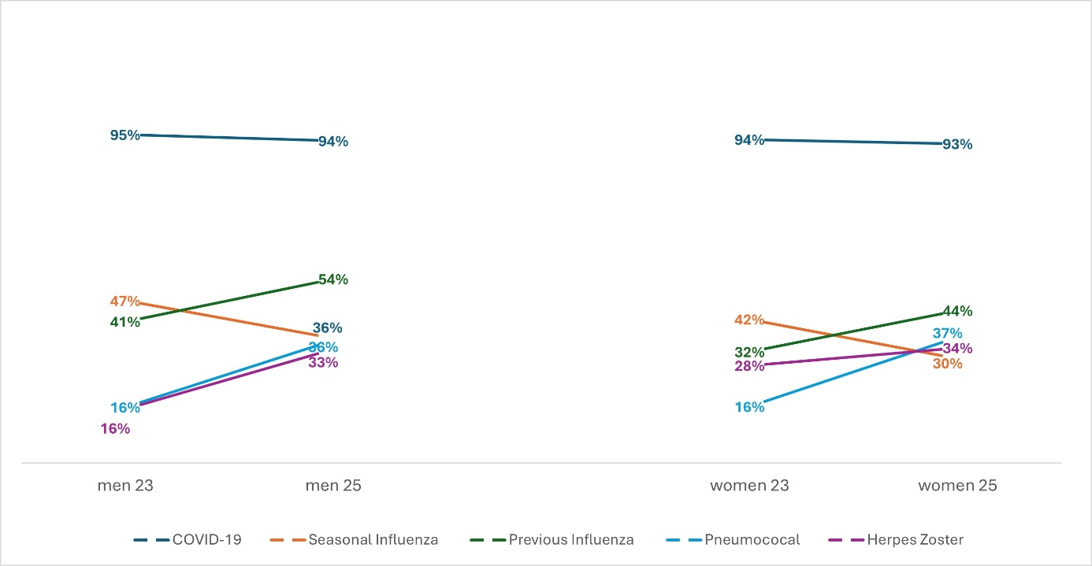

Supplemental Figure 1. Comparison of vaccinated patients by sex in 2023 and 2025.
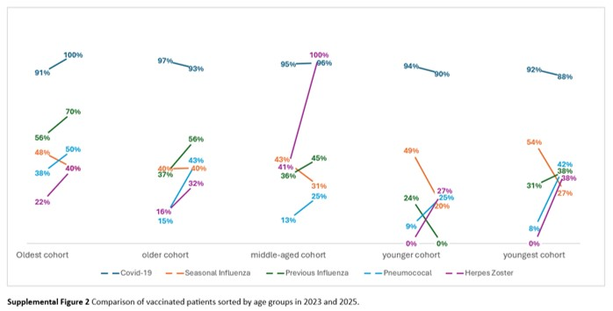

Supplemental Figure 2. Comparison of vaccinated patients by age groups in 2023 and 2025.

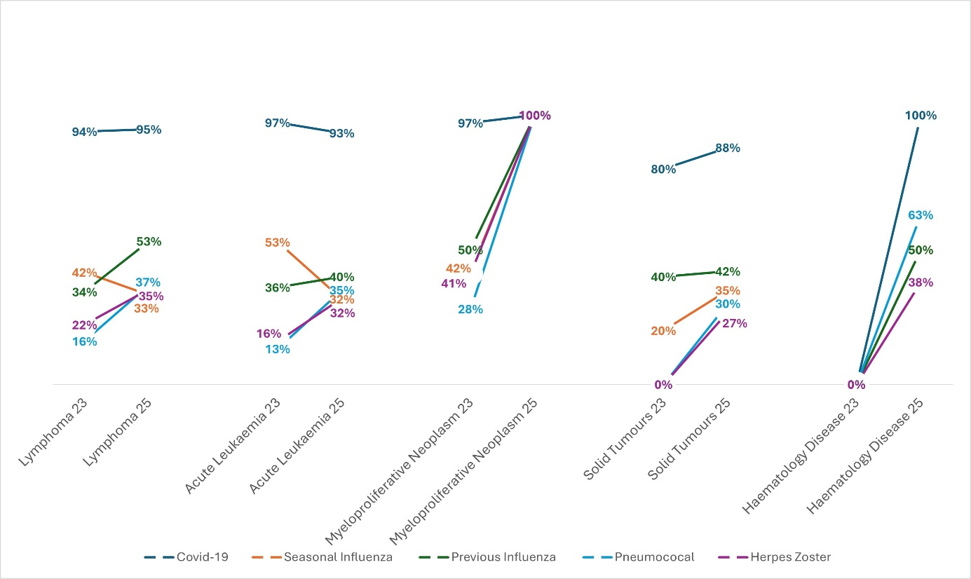

Supplemental Figure 3. Comparison of vaccinated patients by underlying disease in 2023 and 2025.

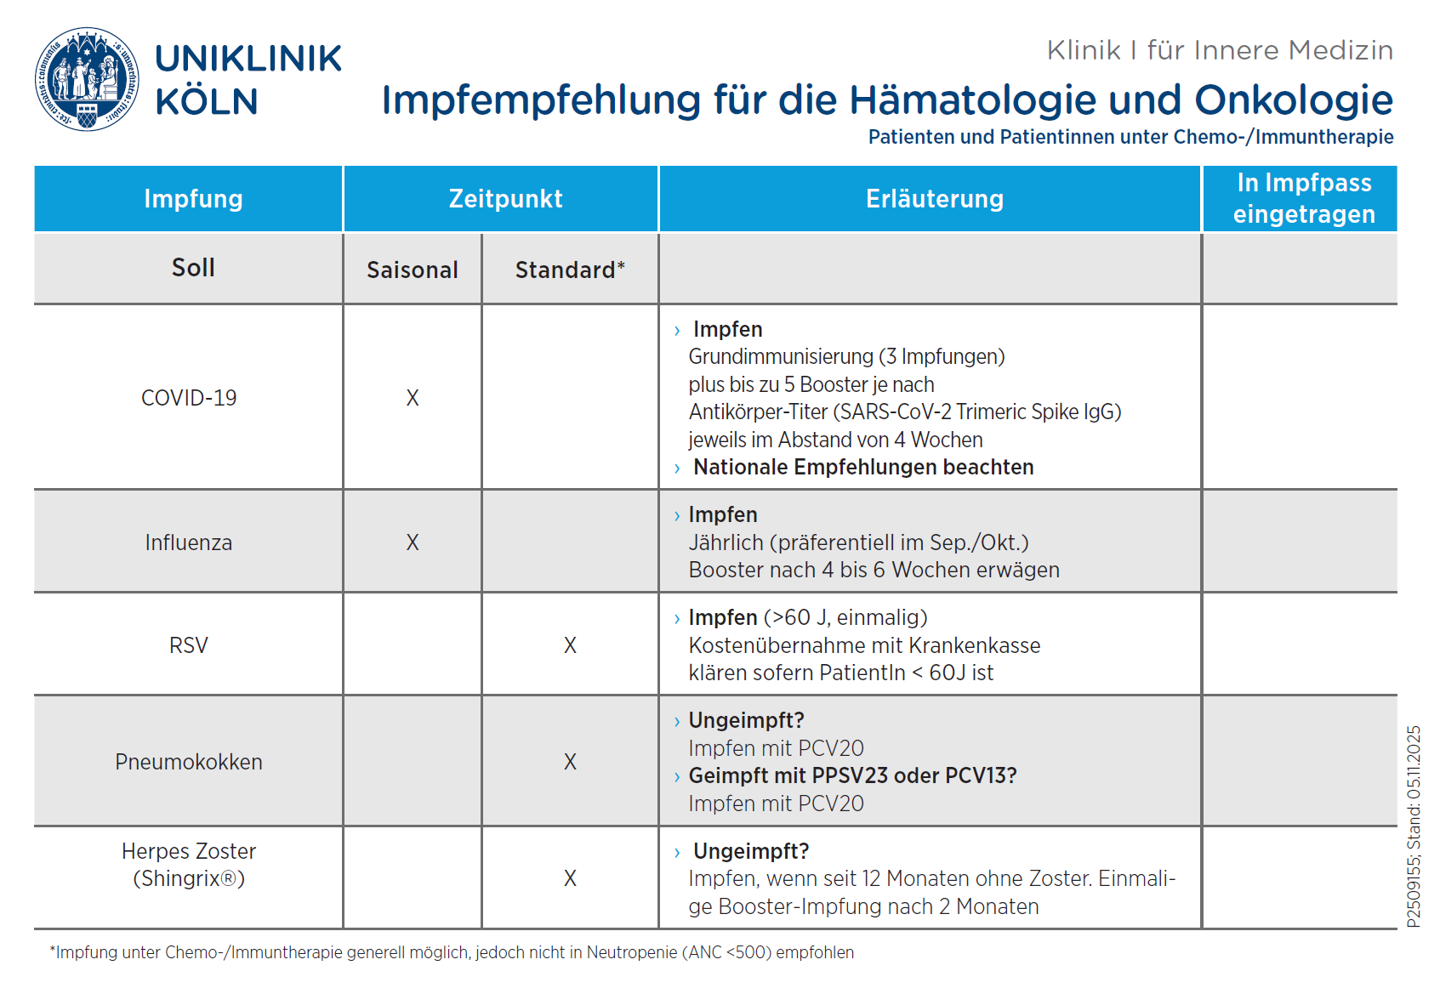
Supplemental Figure 4a. Pocket Card. Pocket Card with vaccination recommendations for patients undergoing chemo-/immunotherapy. Original version in German.

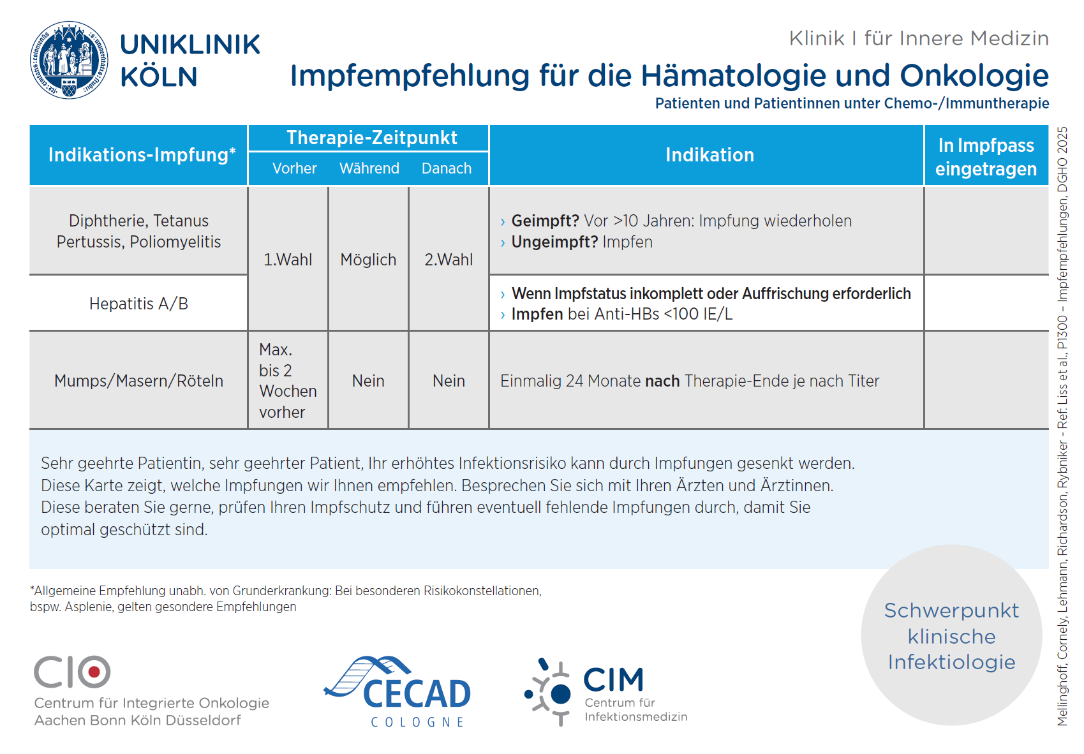
Supplemental Figure 4b Pocket Card. Pocket Card with vaccination recommendation for patients undergoing chemo-/immunotherapy. Original version in German.

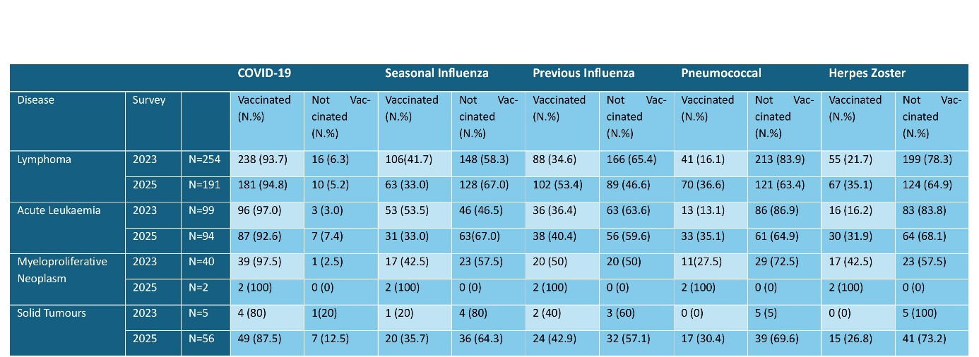
Supplemental Table 1 Vaccination rates 2023 and 2025 in relation to the underlying malignancy

