Supplementary Information
In-hospital mortality and survival outcomes among admissions with diabetes mellitus or hypertension at a tertiary hospital in southwestern Nigeria: a five-year retrospective cohort study
Oluwajuwonlo Emmanuel Owojori and John Olugbenga Abe
Supplementary Figure S1. STROBE flow diagram of cohort selection
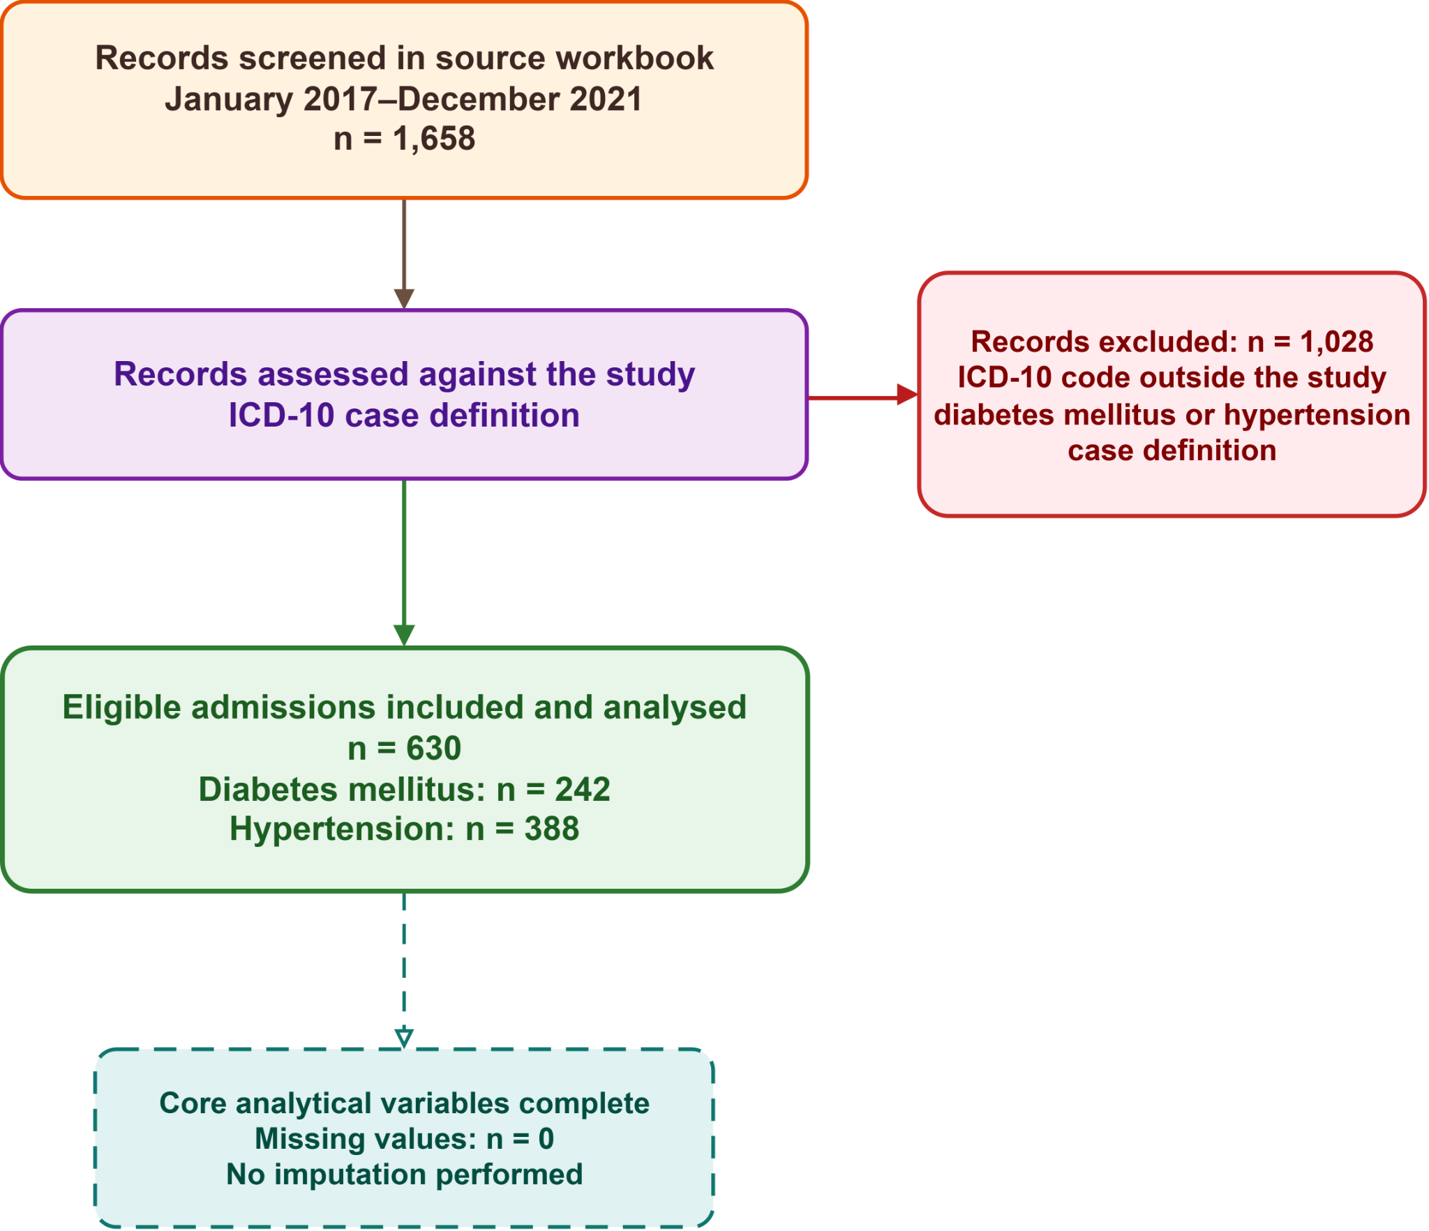

Supplementary Table S1. Sensitivity analyses of the diagnosis–mortality association
Analysis | N | Deaths | Estimate for hypertension versus diabetes mellitus (95% CI) | p value
Cause-specific Cox regression
Primary model: age continuous per 10 years | 630 | 83 | aHR 0.618 (0.397 to 0.960) | 0.032
Excluding all nine zero-duration admissions | 621 | 80 | aHR 0.635 (0.405 to 0.995) | 0.047
Original age classification: <50/≥50 years | 630 | 83 | aHR 0.641 (0.414 to 0.993) | 0.046
Expanded ICD-10 case definition | 650 | 88 | aHR 0.681 (0.443 to 1.044) | 0.078
Fine–Gray regression
Primary model | 630 | 83 | sdHR 0.499 (0.323 to 0.770) | 0.002
Expanded ICD-10 case definition | 650 | 88 | sdHR 0.548 (0.358 to 0.839) | 0.006
Note. CI = confidence interval; aHR = adjusted hazard ratio; sdHR = subdistribution hazard ratio. Adjusted models included recorded primary diagnosis, age and sex. The expanded case definition added hypertension codes I12.0, I12.9 and I13.9.

Supplementary Figure S2. Scaled Schoenfeld residual diagnostics for the adjusted Cox model
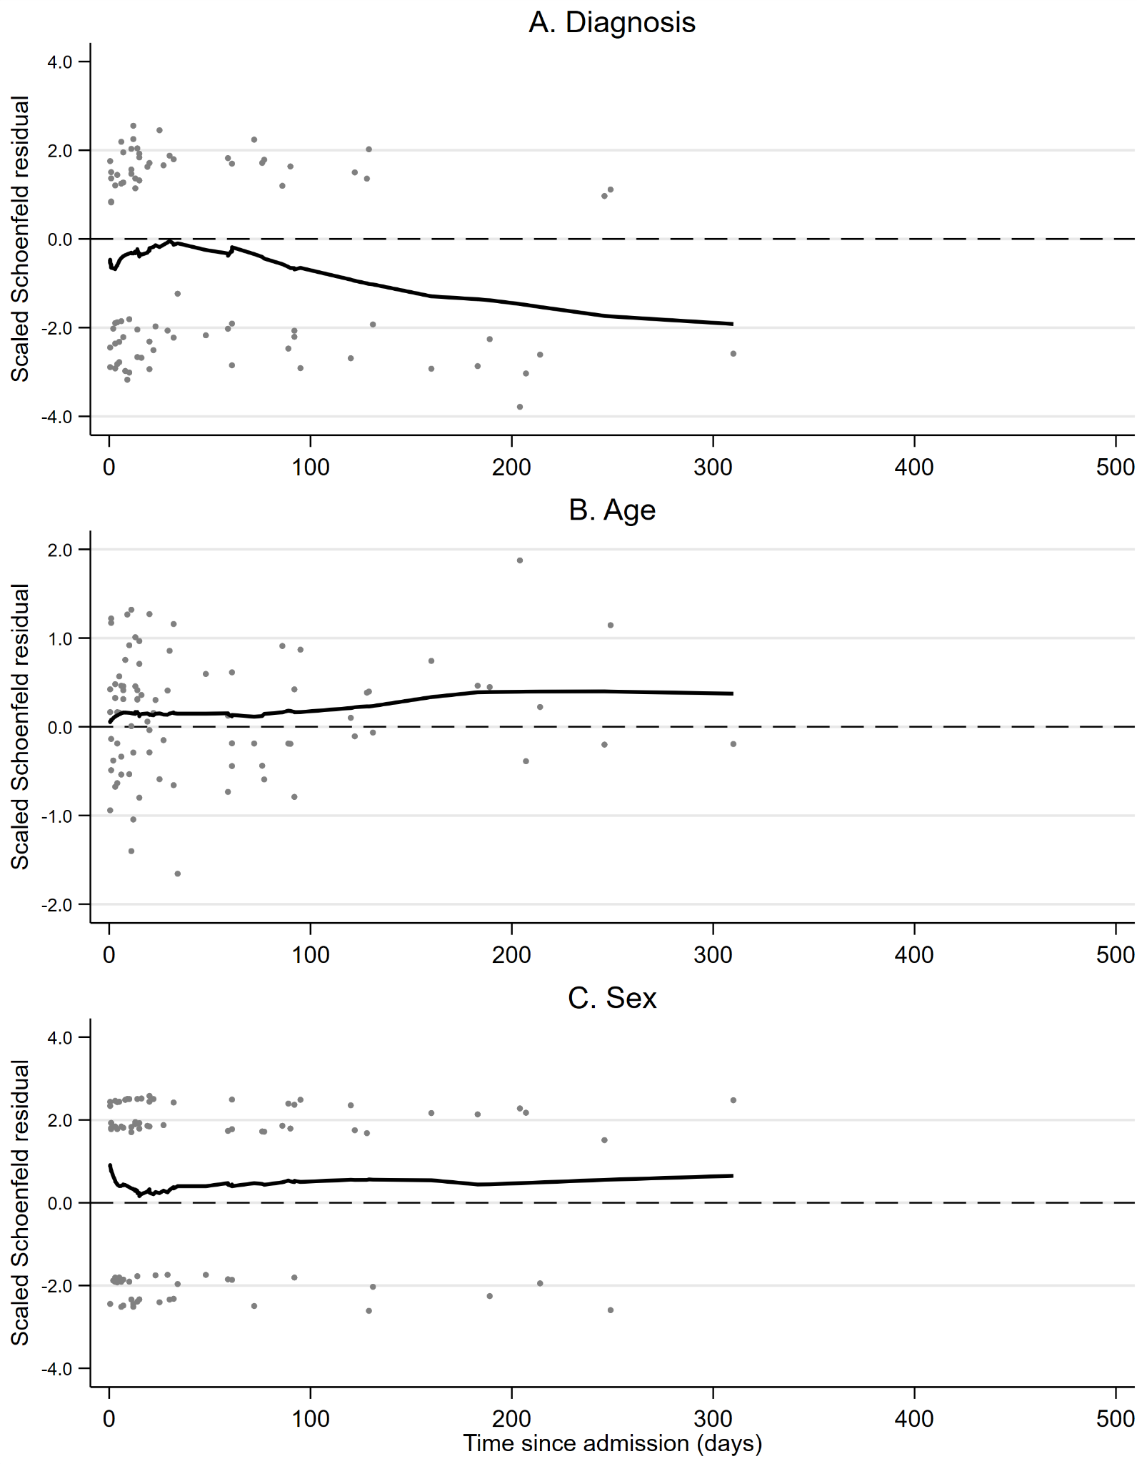
Panels show scaled Schoenfeld residuals for recorded primary diagnosis, age per 10-year increase and sex. The global proportional-hazards test was χ² = 3.032 (df = 3; p = 0.387). Covariate-specific p values were 0.098 for primary diagnosis, 0.476 for age and 0.636 for sex.

